ENGINEERING DESIGN PROJECT
DELIVERABLE B – CONCEPTUAL DESIGN, IN BASIC TECHNICAL DOCUMENT FORMAT
Jonathan Augustine Soliman, Rowan Kovacs, Ben Olaveson, Rotimi Akalusi
Group A04-13
GNG 1103 – Engineering Design
Professor Muslim Majeed
Friday, October 20TH, 2023

Abstract
This Basic Technical Document is the fourth deliverable of the Design Project for our GNG 1103 Class, in which we are to provide conceptual sketch design ideas (still without any metrics at this stage of the project) for the systems and subsystems of the building we are charged with designing for our client. The following includes drawings of these designs, and further includes details, characteristics, and individual strengths and weaknesses of each design, which ensures that our process of ideation and future prototyping is fully shown, rather than a finished product that lacks any background or information on the process taken to get to where it is, or how potential errors in the prototype can be remedied or mitigated (from editing and improving its design). The document goes on to conclude with a recommendation that one of the three systems presented will be chosen for the next phases of our project and in the implementation of the design process in our project.

Introduction
To begin, our problem statement that aims to remedy our client’s needs is as thus:
A need exists for the Algonquins of Pikwakanagan Neyagada Wabandangaki Guardian Program to acquire a building for laboratory work and processing, and community events and involvement, which would reflect the values of their community and will act as a multifunctional space for the work done by the Guardian Program.
This laid the ground for where our project would go with each of the successive deliverables we have completed so far. We have based our Design Criteria and the Conceptual Design in this document all on this Problem Statement that outlines the needs, provides an overview of specifications, restrictions, and functional requirements, and provides the reference point that we will use to complete this project.

Related Works & Accomplishments
We, as a group, have already completed 3 other deliverables for this project, including our Team Contract & Project Management Template, the creation of our Client’s Problem Statement based on the needs she outlined and a Needs Identification Assessment in order to create the Problem Statement. After this Deliverable (which covered the Empathize Phase of our Project), we worked on a third (which covered the Ideate Phase of the project), in which we performed Technical Benchmarking & Target Specifications for the optimization of our design. These deliverables all built on each other, and they built on the various concepts we learned in class about the design process.

Preliminary Ideas

Primary Idea No. 1: The Infinite Doughnut/Medicine Wheel by Jonathan Soliman

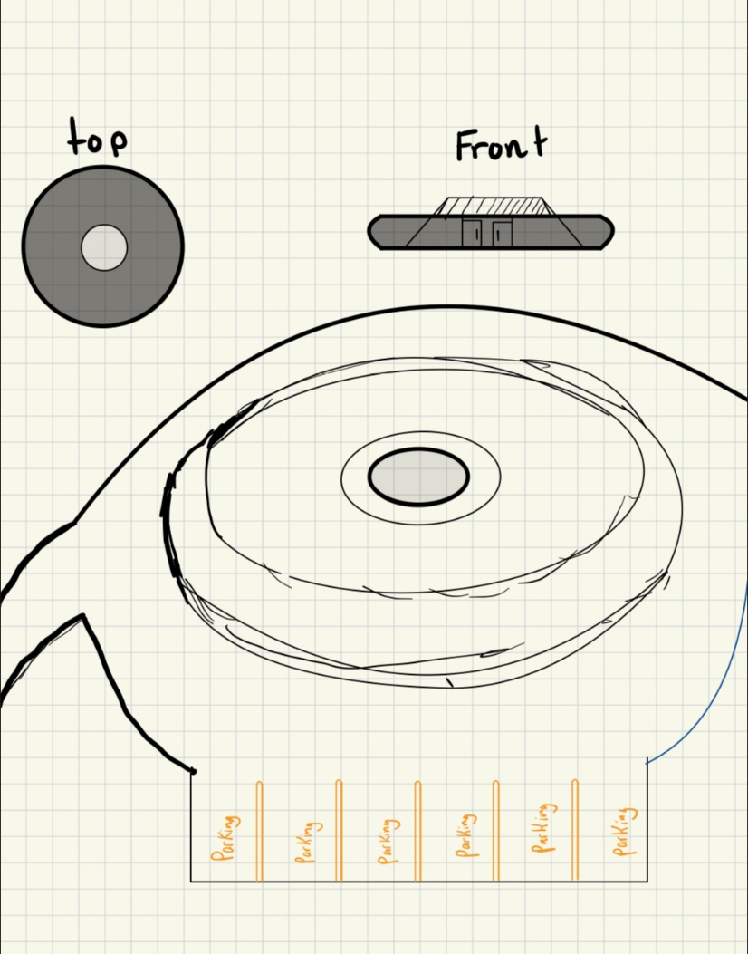
Main Characteristics
Beautiful circular futuristic design. Easy maneuverability in parking lot. The circular design is significant for the indigenous peoples, and has an optional medicine wheel color scheme. There is a covered frontal entrance as seen in the Front-facing photo on the top right, as well as an open patio area on in the middle with an optional electronically deployed shaded area. Finally, there is an optional roof patio to complete this design.

Strengths and Weaknesses

Strengths
- Easy vehicle maneuverability
- This design can be adapted to represent teaching, for example, with the medicine wheel concept
- The middle of the donut shape can be used as an outdoor patio seating or gathering area
- This design has an aura of futurism to it
- There can also be awning in the front to account for the extreme weather this building will have to endure

Weaknesses
- This building design does not take full advantage of the land, making it unoptimized for land use
- The building costs could be increased due to how many customizations are being made to its design

Preliminary Idea No. 2: The Free Wave by Rotimi Akalusi

Main Characteristics
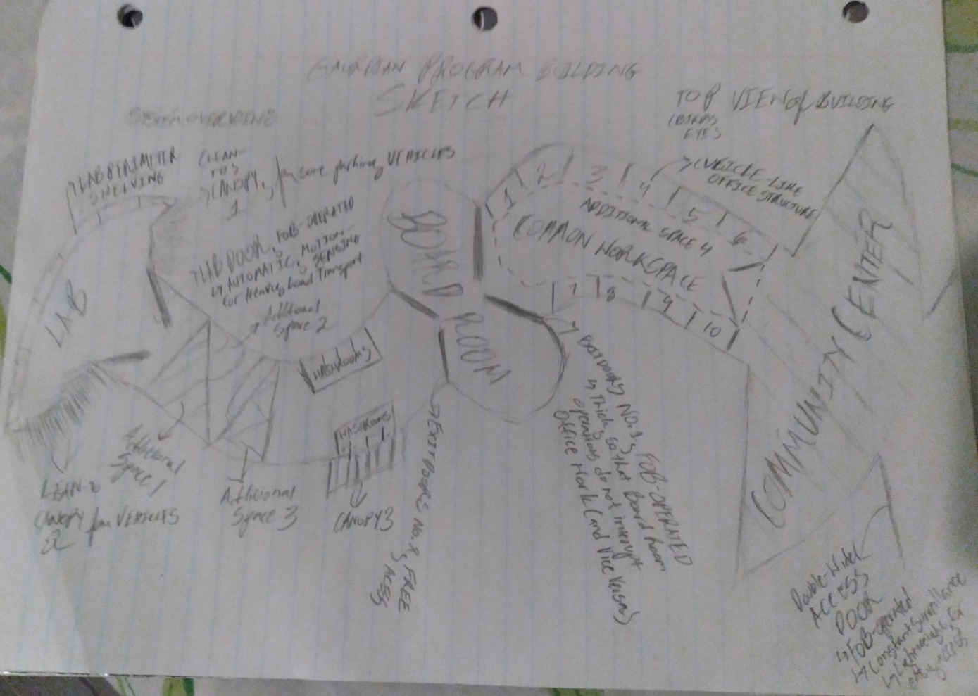
This building signifies the waves that the seasons ebb and flow to, and signifies the movement of wind through the earth and sky. Space in this building is optimally used, with 10 cubicle office spaces, a Lab on the end to be isolated from traffic, a centralized boardroom, 4 uniquely-shaped additional spaces and common areas, noise-reducing doors to facilitate focused work, constant surveillance through the entire interior and exterior of the building, several security options for doors in the building (such as being FOB-operated), and a colossal Community Centre, which is sized so that the whole community can partake in the work and success of the Guardian Program.

Strengths & Weaknesses

Strengths
- The Board Room being in the middle of the building seems like an appropriate location
- The Community Centre has the biggest space allotted to it, creating a welcome feel that the community will want to take advantage of
- The space in the building is maximally utilized, which would be using the budget in the most optimized way

Weaknesses
- The offices and additional spaces look cramped, and that may take away from any focus or independency that workers may want to have when trying to complete work
- The Canopy Lean-Tos are too far apart, making the organization seem too spaced and choppy
- Land Area use is not maximized with this design; the building takes up twice the space that a conventional rectangular one would

Preliminary Idea No. 3: Community, By Rowan Kovacs

Main Characteristics
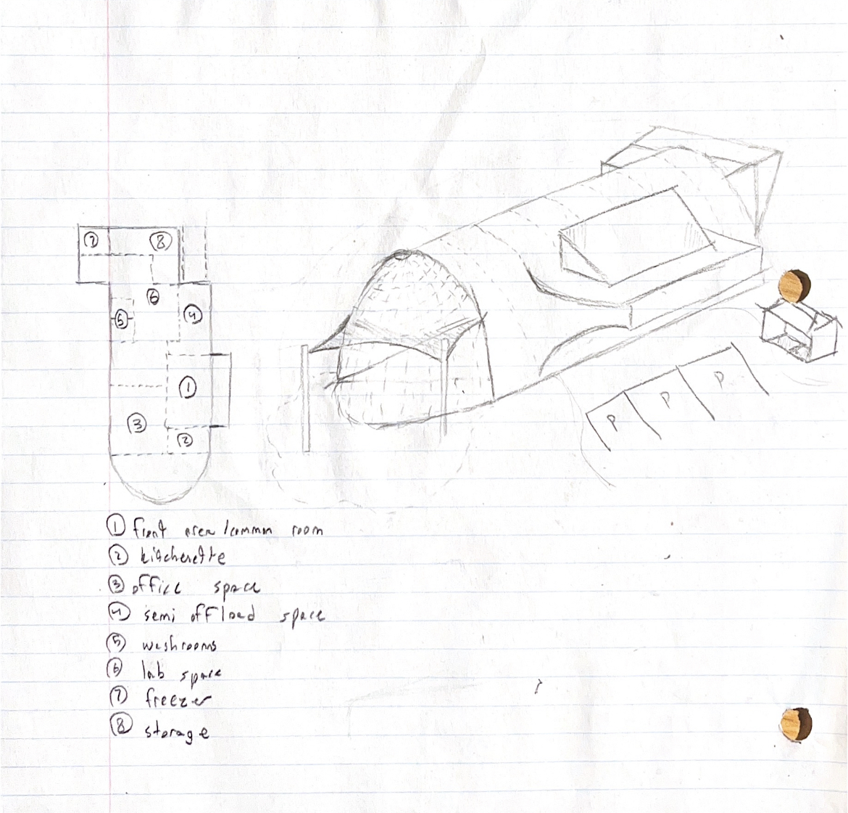
The building takes inspiration from several Algonquin houses and places of gathering; most notably, the longhouse and wigwam. Incorporating both natural and artificial resources like wood and glass respectively will play a large part in the project, making sure the building feels alive and breathing, an important concept to show in its structure. Additionally, the glass will provide natural light everywhere in the building, making it feel very open and welcoming to the whole community.

Strengths & Weaknesses

Strengths
- There is space, meaning plenty of room for both office space, lab space, and storage.
- The covered exterior at the front of the building optimizes the maximal magnitude community gatherings or other events can hold
- The rooms and offices are open, and can be re-arranged with ease, which optimizes on the functional requirement that the elements of the building must be dynamic and mobile

Weaknesses
- Cost is an issue here, because of the heavy reliance that this building will have to have on more expensive materials like wood and glass
- The walls in this design are sloped, which somewhat limits the amount of space available; this therefore makes it an unoptimized design in terms of space distribution

Final Optimized Design Choice: The Doughnut, By Jonathan Soliman

Intrinsic Design Elements & Properties
We, as a collective group of engineering students who have been educated on Design Principles and the Process of Engineering Design, think that, given the functional and non-functional requirements, various restrictions, constraints and preferences given to us in our first Client Meeting, and careful evaluation of the designs put forward by team members, the design put forward by Jonathan, The Doughnut/Medicine Wheel, should be the one to be implemented as our Final Design Choice for future deliverables, including, but not limited to, our Final Prototype.
We also feel, as a collective group, that the other design ideas put forward by other team members have intrinsic properties that could be employed and integrated to improve the final design choice when working on various Design Analyses and Design Implementations for our Prototype. This decision was made through discussion and deliberation on the efficacy of each design, and how optimized each design was to satisfy the Target Specifications we created based on our Problem Statement & Procured Design Criteria.

Subsystems
- Small Offices
- Computer Lab
- Kitchenette
- Washrooms
- Lab Setting
- Freezer
- Material Storage
- Drying Device

Primary Spaces
- Small Offices
- Computer Lab
- Lab Setting
- Freezer
- Material Storage
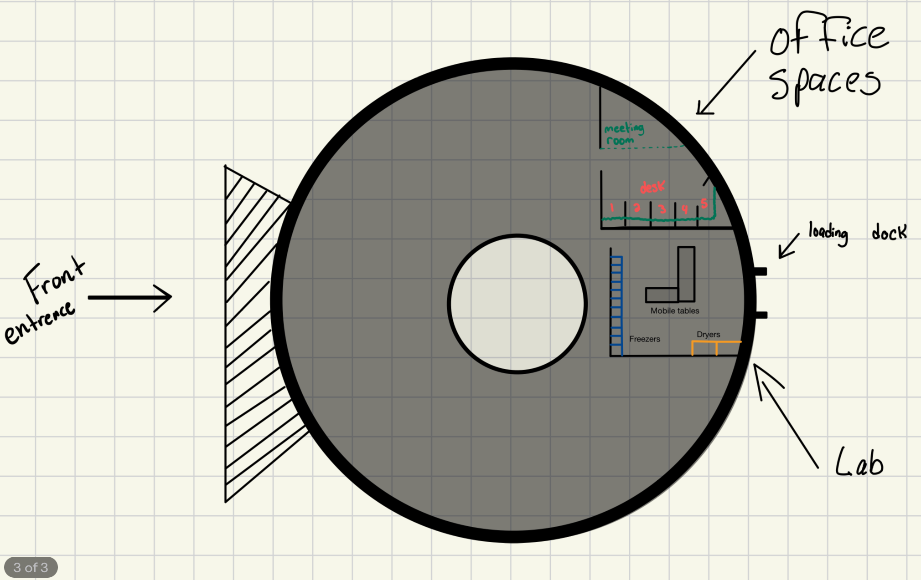
- Drying Device

Secondary Spaces
- Workplace Kitchenette
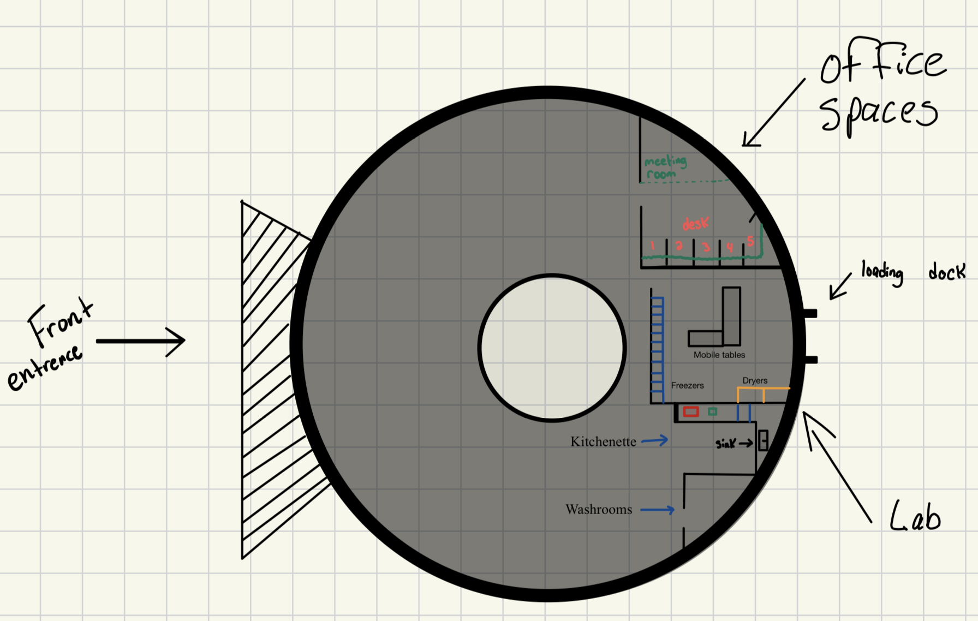
- Washrooms

Different Configurations & Overall Potential Space Distribution
We have decided that, although the idea of having an Open Middle Area within the building for all people in the building to have opportunities to get fresh air or to work in an outdoor space without leaving the premises or being away from the goings-on of the workers in the building is a good one, the size of the Open Area may be inappropriate, or our client may view the idea as not necessary or appropriate for the building design. These ideas and considerations will all be discussed with our client in the second Client Meeting, where we will show her this final design and ask for her feedback on the overall concept (and its subsystems), if it is wanted in the first place.
The locations of Labs, Loading Zones, Storage Area, and Community Areas may also need to be reconsidered, based on our client’s preferences and suggestions on improvement and optimization according to the needs she makes more abundantly clear during the meeting.
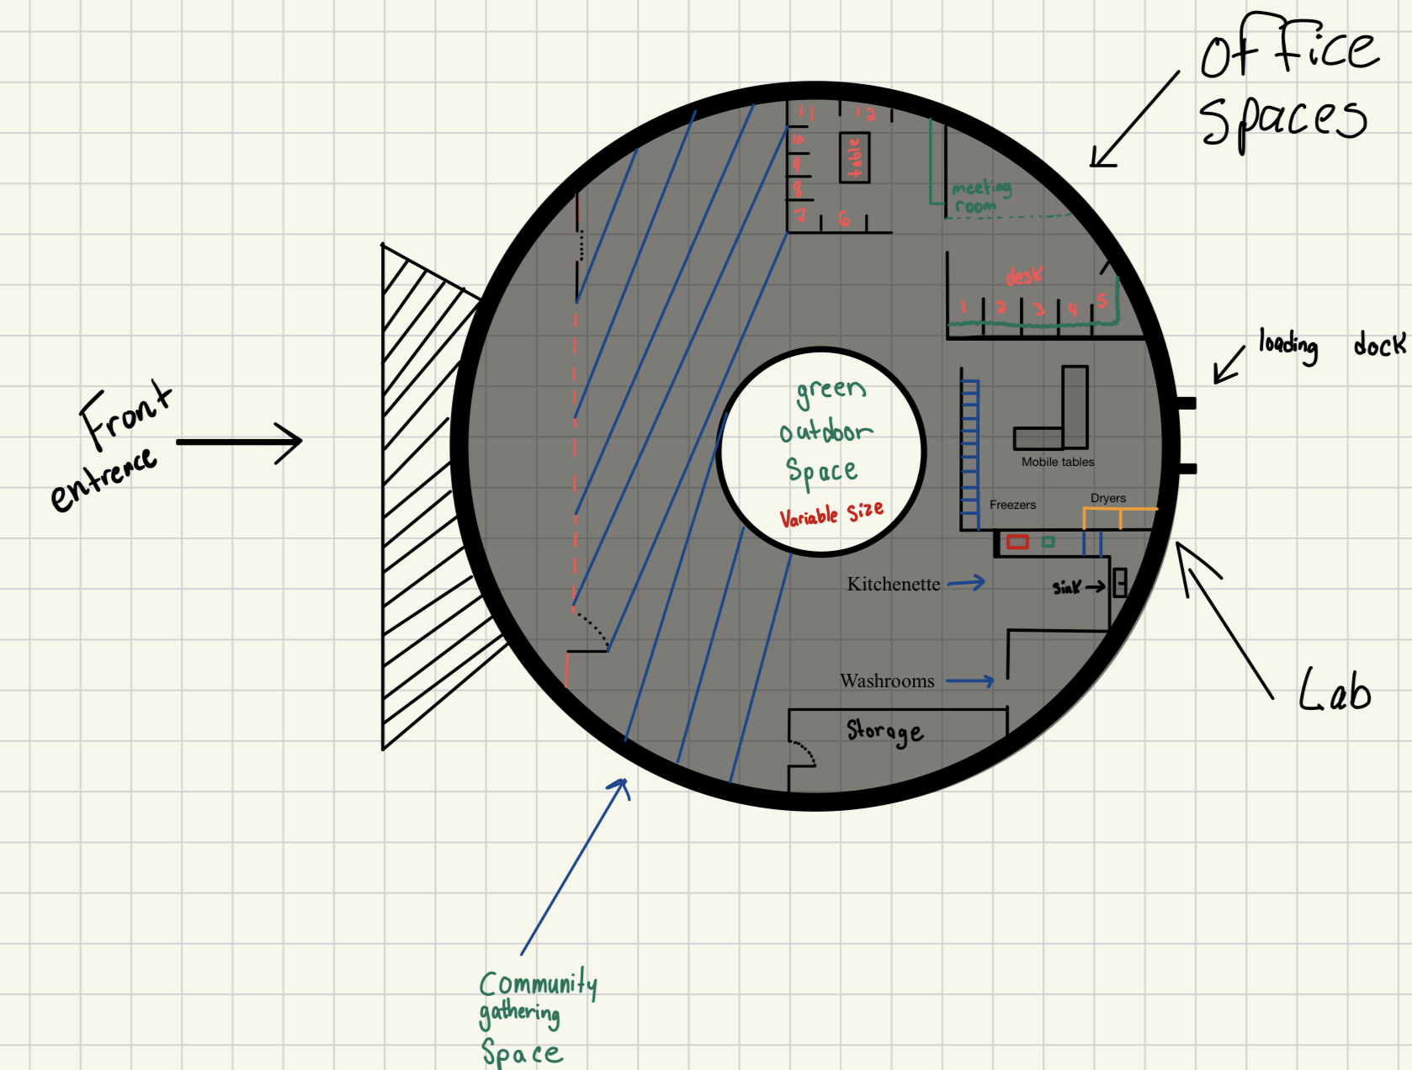
The properties and size of exterior weather coverage for the building will also need to be discussed with our client, as this part of the design (based on the extreme weather that will affect it) will need to be optimized to ensure maximal protection against the elements.

Final Design Structure Visualizations
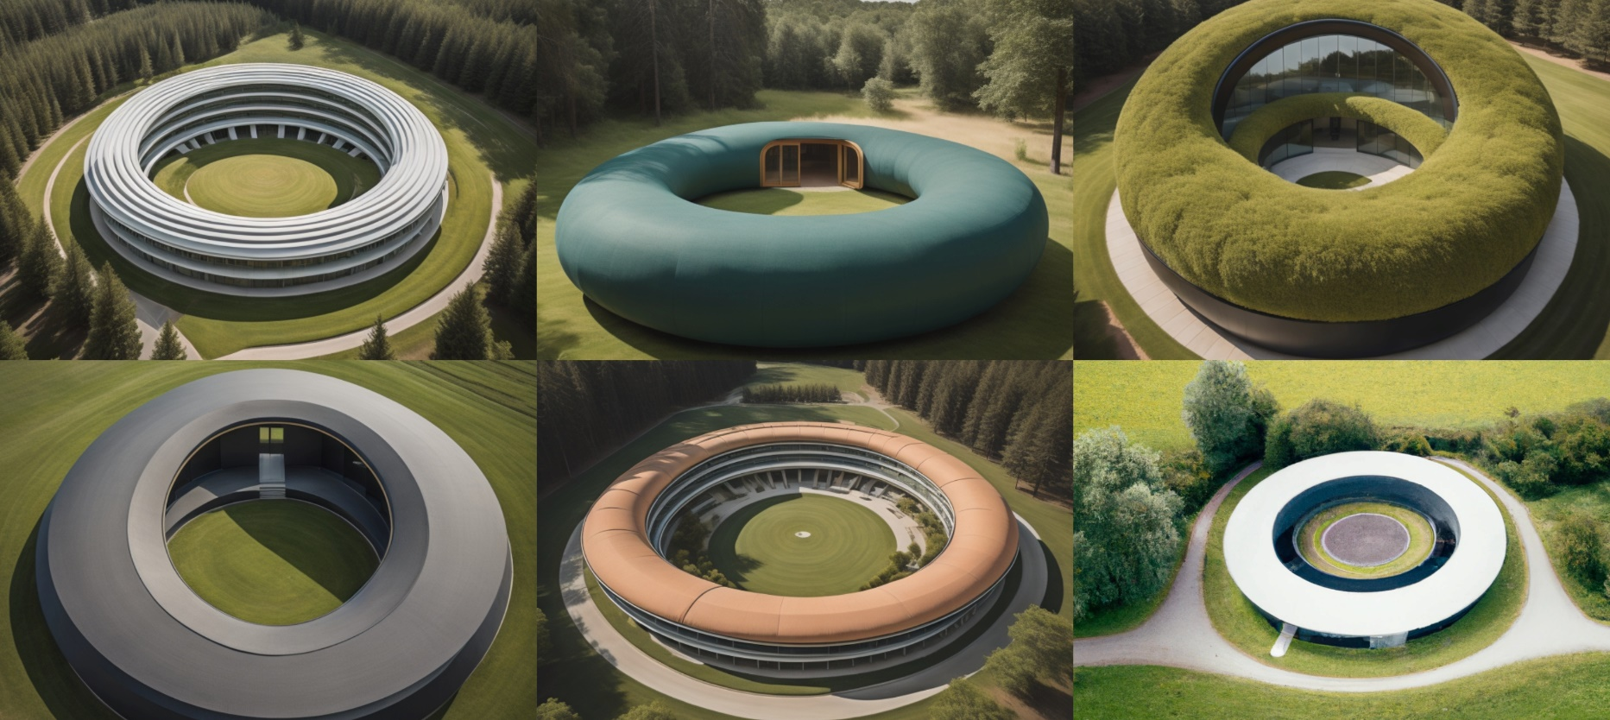
These are concepts, based on our Final Preliminary Design Choice, that represent what a true-scale structure would look like after completion. This reflects the kind of building our design will produce, and we can use these visualizations to guide our Design Implementation through the rest of the deliverables for the furtherance of the project’s completion and overall Solution Procurement for our client’s problem.

