Deliverable K - Intellectual Property Search

Intellectual Properties Related to our Product

1.1 All-Terrain, All-Weather Wheelchair (Patent #: CA 2166764)
This design is a new and different wheelchair all together, not just something that is attachable to an existing wheelchair. It includes wheelchair suspension, different wheel orientation and DC motors installed on the rear wheels. This Patent was found on the Canadian Intellectual Property Office website. Refer to Figure 1 for a visual representation of this product.

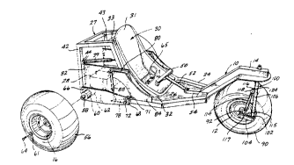
Figure 1 - Representative Drawing for design concept

http://brevets-patents.ic.gc.ca/opic-cipo/cpd/eng/patent/2166764/summary.html?query=wheelchair&start=1&num=50&type=basic_search

1.2 Attachment Means for Attaching a Wheelchair to a Motorized Apparatus (Patent #: CA 2490155)
This design has a mechanical device that pulls the wheelchair forward. The mechanical device is a powered propulsion apparatus that is attachable and detachable from a wide range of conventional wheelchairs without modification of the propulsion apparatus or the wheelchairs. The propulsion apparatus converts a conventional manually powered wheelchair into a power driven wheelchair. The clamping mechanism is adjustable to accommodate a wide range of wheelchair spacings and wheel sizes and accommodates an perfect alignment between the clamps and the wheelchair. The clamping mechanism secures the wheelchair to the propulsion apparatus without damage or stress to the wheelchair components. This Patent was found on the Canadian Intellectual Property Office website. Refer to Figure 2 for a visual representation of this product.

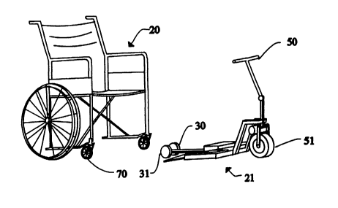
Figure 2 - Representative Drawing for design concept

http://www.ic.gc.ca/opic-cipo/cpd/eng/patent/2490155/summary.html?type=number_search&tabs1Index=tabs1_1

1.3 3-Wheeled All Terrain Wheelchair (Industrial Design #: 64154)
Similar to the design concept in section 1.1. This design includes two powered rear wheels and a 360 degree front wheel, along with all the usual functionalities of a wheelchair. Refer to Figure 3 for the industrial design drawings.

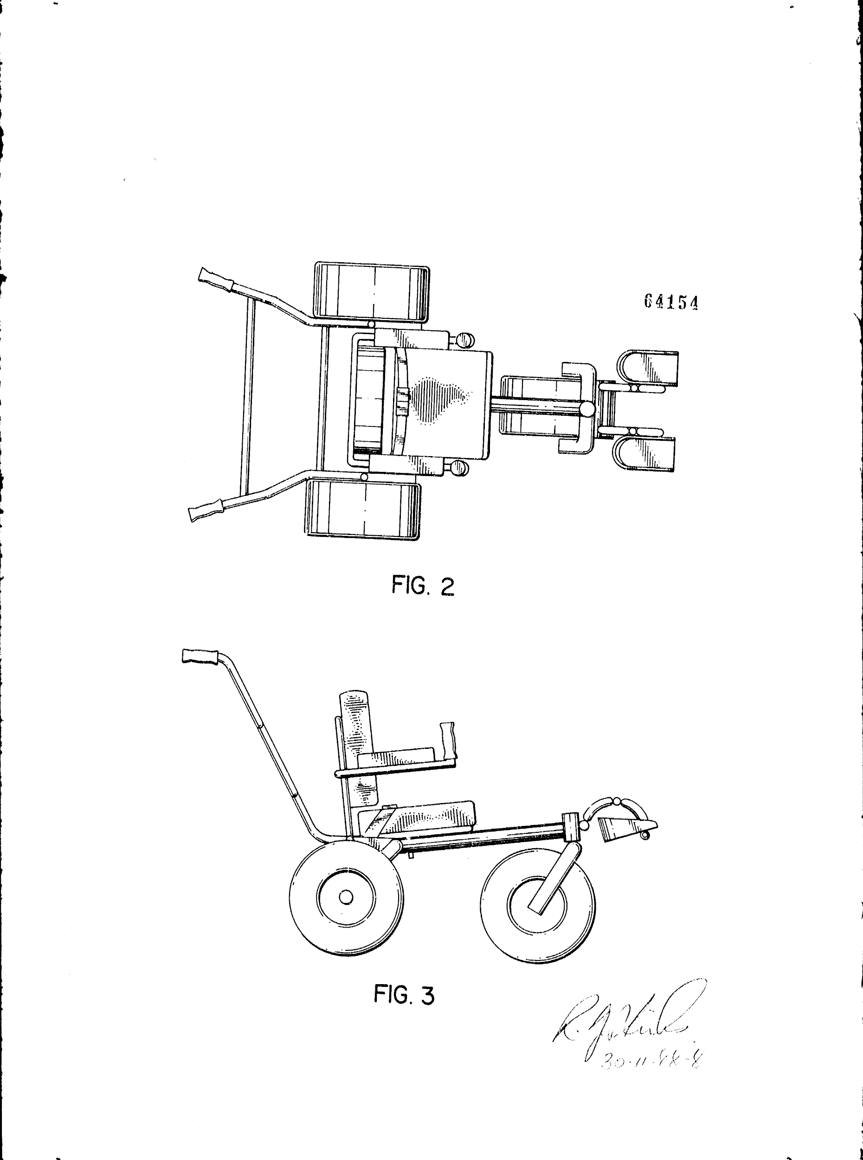

Figure 3 - Industrial Design Drawings (64154)
https://www.ic.gc.ca/app/opic-cipo/id/dsgnDtls.do?appNm=64154&lang=eng&status=OK&ordNum=1

Relationship of Properties

2.1 All-Terrain , All-Weather Wheelchair (Patent #: CA 2166764)

The relationship that exists between the All-Terrain, All-Weather Wheelchair and our product is the fact that both solutions are trying to solve the same problem, while simply taking a different approach to it. This design involves an entirely new wheelchair that is trying to make it easier for people with physical disabilities to get places they currently aren’t able to go, while our design involves an apparatus that is easily installable on an existing wheelchair that tries to solve the same problem.

2.2 Attachment Means for Attaching a Wheelchair to a Motorized Apparatus (Patent #: CA 2490155)

The relationship that exists between the Attachment Means for Attaching a Wheelchair to a Motorized Apparatus and our product is the fact that both solutions are trying to solve the same problem, while simply taking a different approach to it. This design uses a motorized vehicle to pull the wheelchair forward, and a motorized vehicle can definitely pull a wheelchair through snow because the motorized vehicle is powered by an electric motor which can output a lot of force instantaneously. Additionally, an electric motor can output a constant amount of force for over a long duration, and the motor will immediately stop when electricity is not powering the motor. Therefore, the properties of an electric motor can easily met the criteria for moving a wheelchair through the snow and stopping the wheelchair in the snow. However, our product is only mechanical, so someone has to push and stop the wheelchair at any given time. The pushing force will not be immediate and will require some time to push the wheelchair through the snow, and the stopping force will also require a little bit more time to be activated than an electric motor. Overall, this design is a good idea that tries to solve the same problem as our product.

2.3 3-Wheeled All Terrain Wheelchair (Industrial Design #: 64154)

Similar to the All-Terrain, All-Weather Wheelchair, this design is a completely new design of a wheelchair that solves the exact same problem we solved with our product.

Importance of the IPs
The IPs above are similar to our product in the sense that they are all trying to solve the same given problem. The method of solving this problem greatly differs between our product and each of the IPs. Two of the listed IPs act as complete changes for the wheelchair instead of building on it. This is not at all what our clients requested as they wished to stay in their wheelchair and not transferred. The second IP is not similar to our product either as it acts as a motor to pull the client along as opposed to increasing the maneuverability of the wheelchair through attachable skis. This method would simply move the client through the snow through sheer force but does not provide much control. The IP being attachable and optional is close to our product’s design as well as our product philosophy. Overall, these IPs would not have much impact on our success. This is because IP 1.1 and 1.3 are similar designs and require the client to be manually transferred into the other wheelchair. Additionally, IP 1.2 fulfills our client’s wish to move through snow and difficult terrain however it does not provide more control of the wheelchair. All in all, the presented IPs do accomplish the task at hand and that is why it could possibly have an impact on our own IP, however all three listed IPs have their own niche functions and markets which do not encroach on our own.

Intend to Manage the Created IP with Our Product

After researching the respective intellectual properties, we have come to the conclusion that it wouldn’t be worth the time and money to file for a patent, trademark, or copyright for our product. Through extensive research, we have determined that there are many other solutions on the market right now that solves the same problem we were trying to solve, but in a better and more efficient way. This is our initial decision, but we also have determined that there aren’t many products that are easily attachable like ours, so through product revision we think in the future it would be beneficial to file for a patent, trademark and copyright.

