Area 1: Solution/Final Product
Area 1 is on a powerpoint presentation.

Area 2: Product Development

Part 1: Evolution of our product
- Sketches
- Assumptions
- CAD drawings

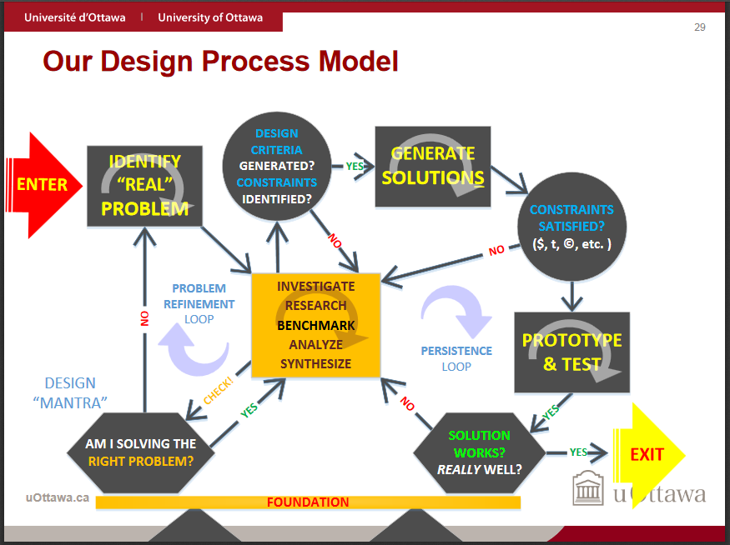

Sketch of Our Concept Design
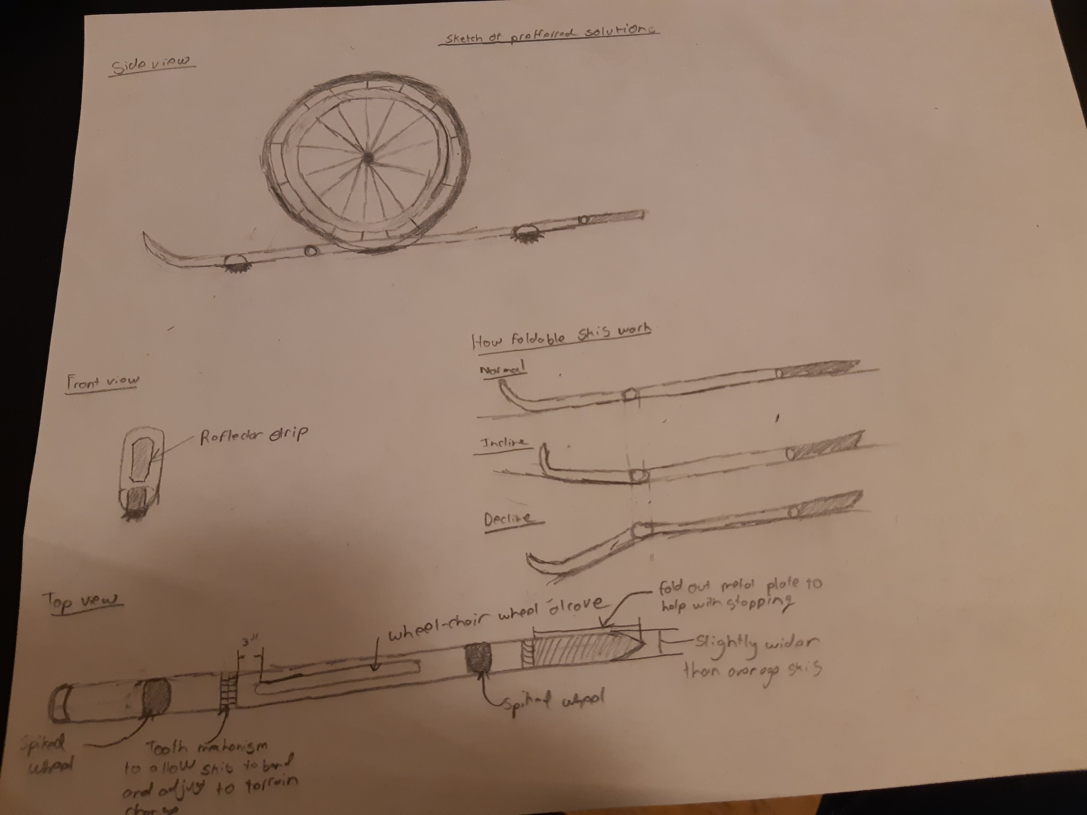

Prototype I
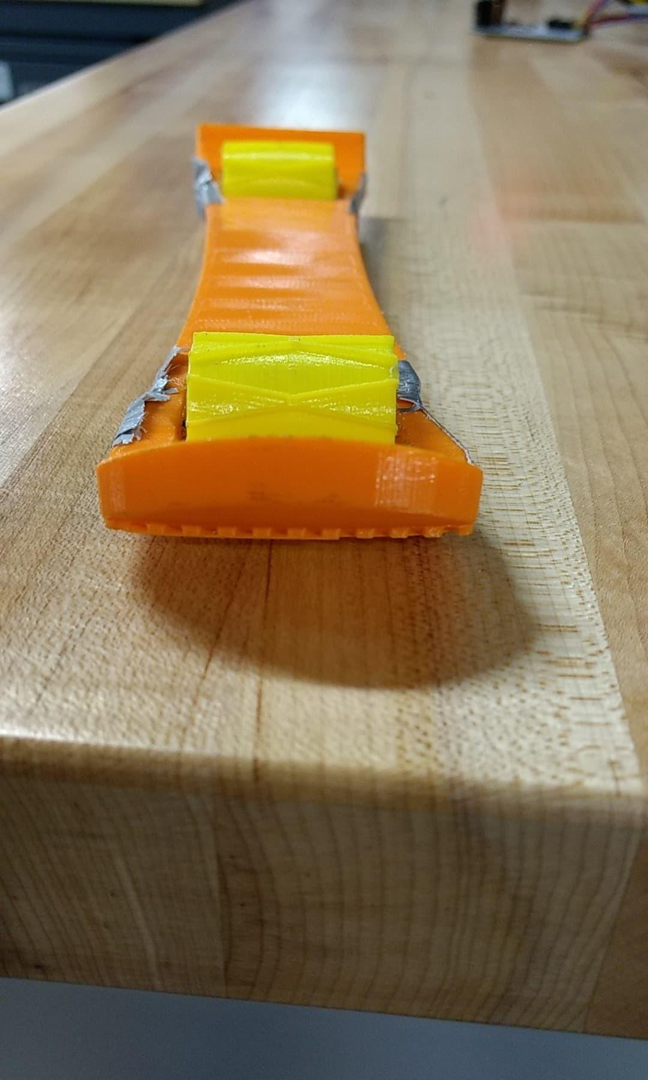

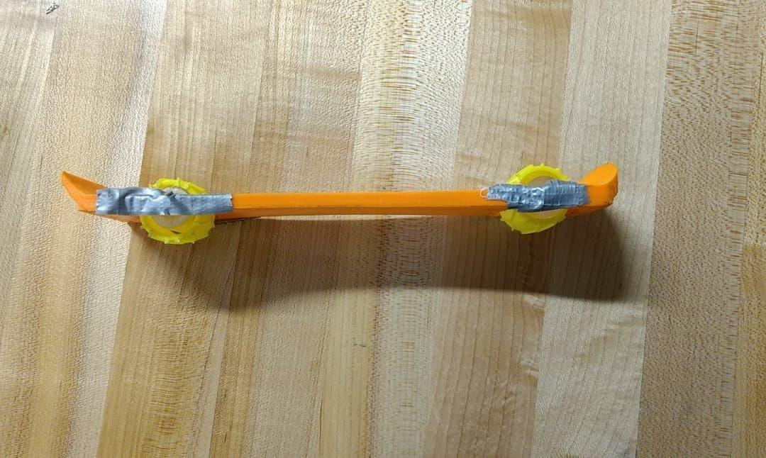

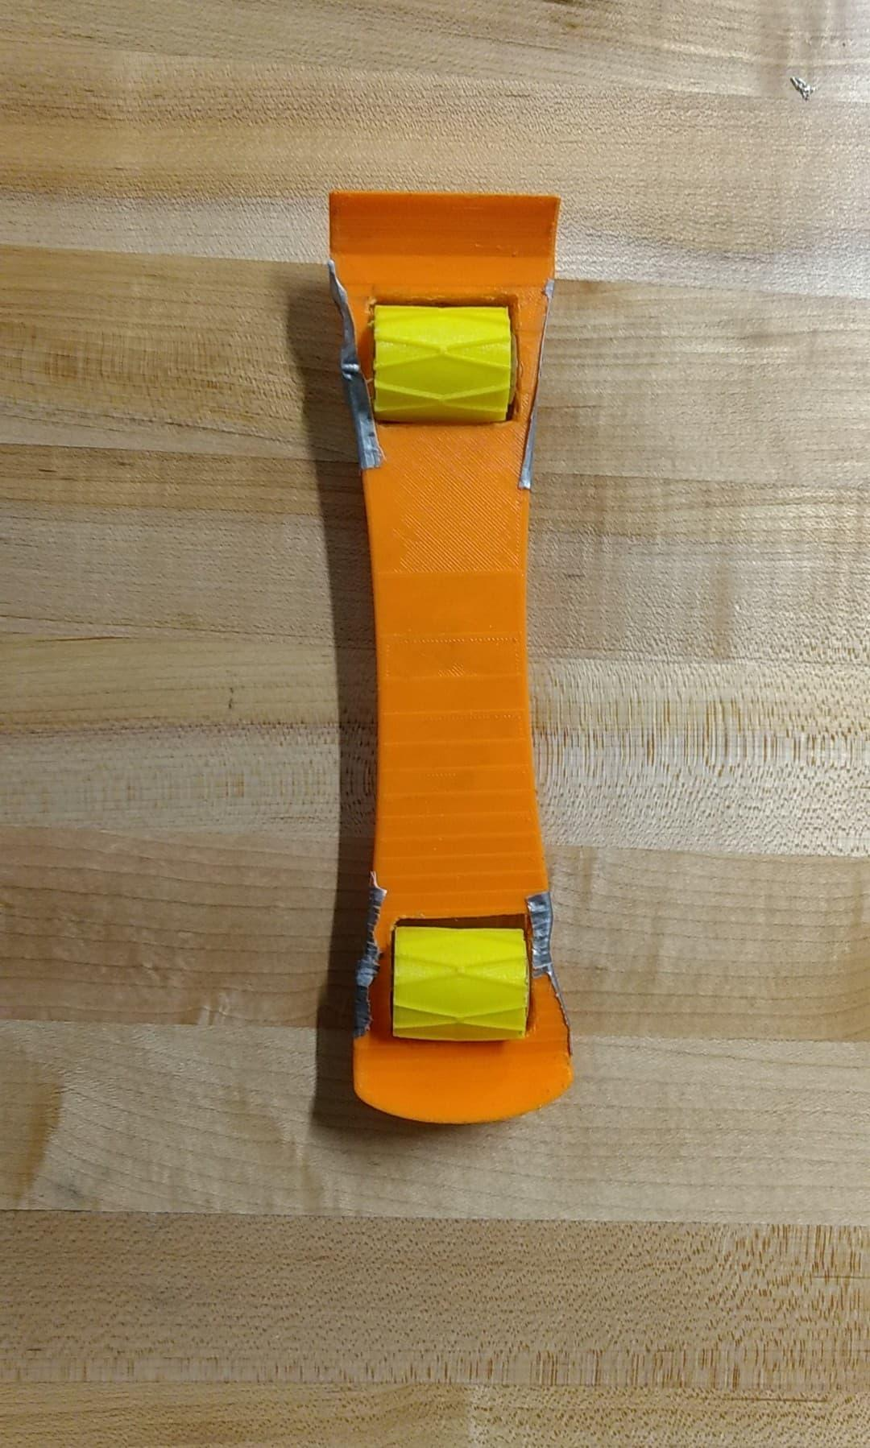

Prototype II
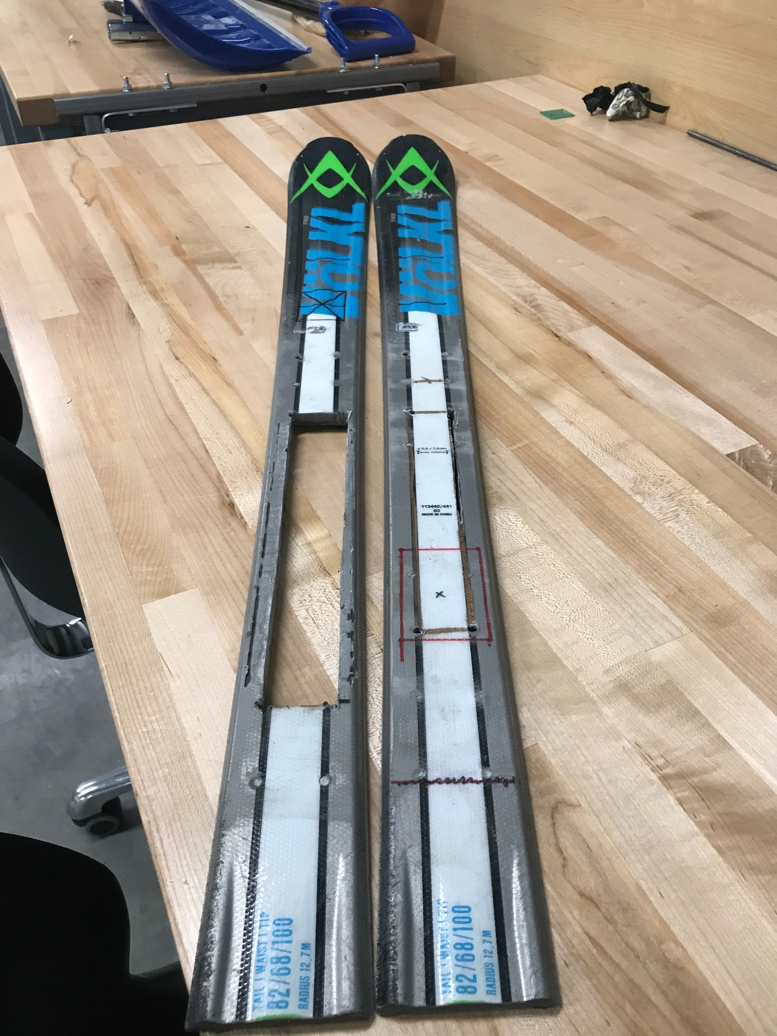

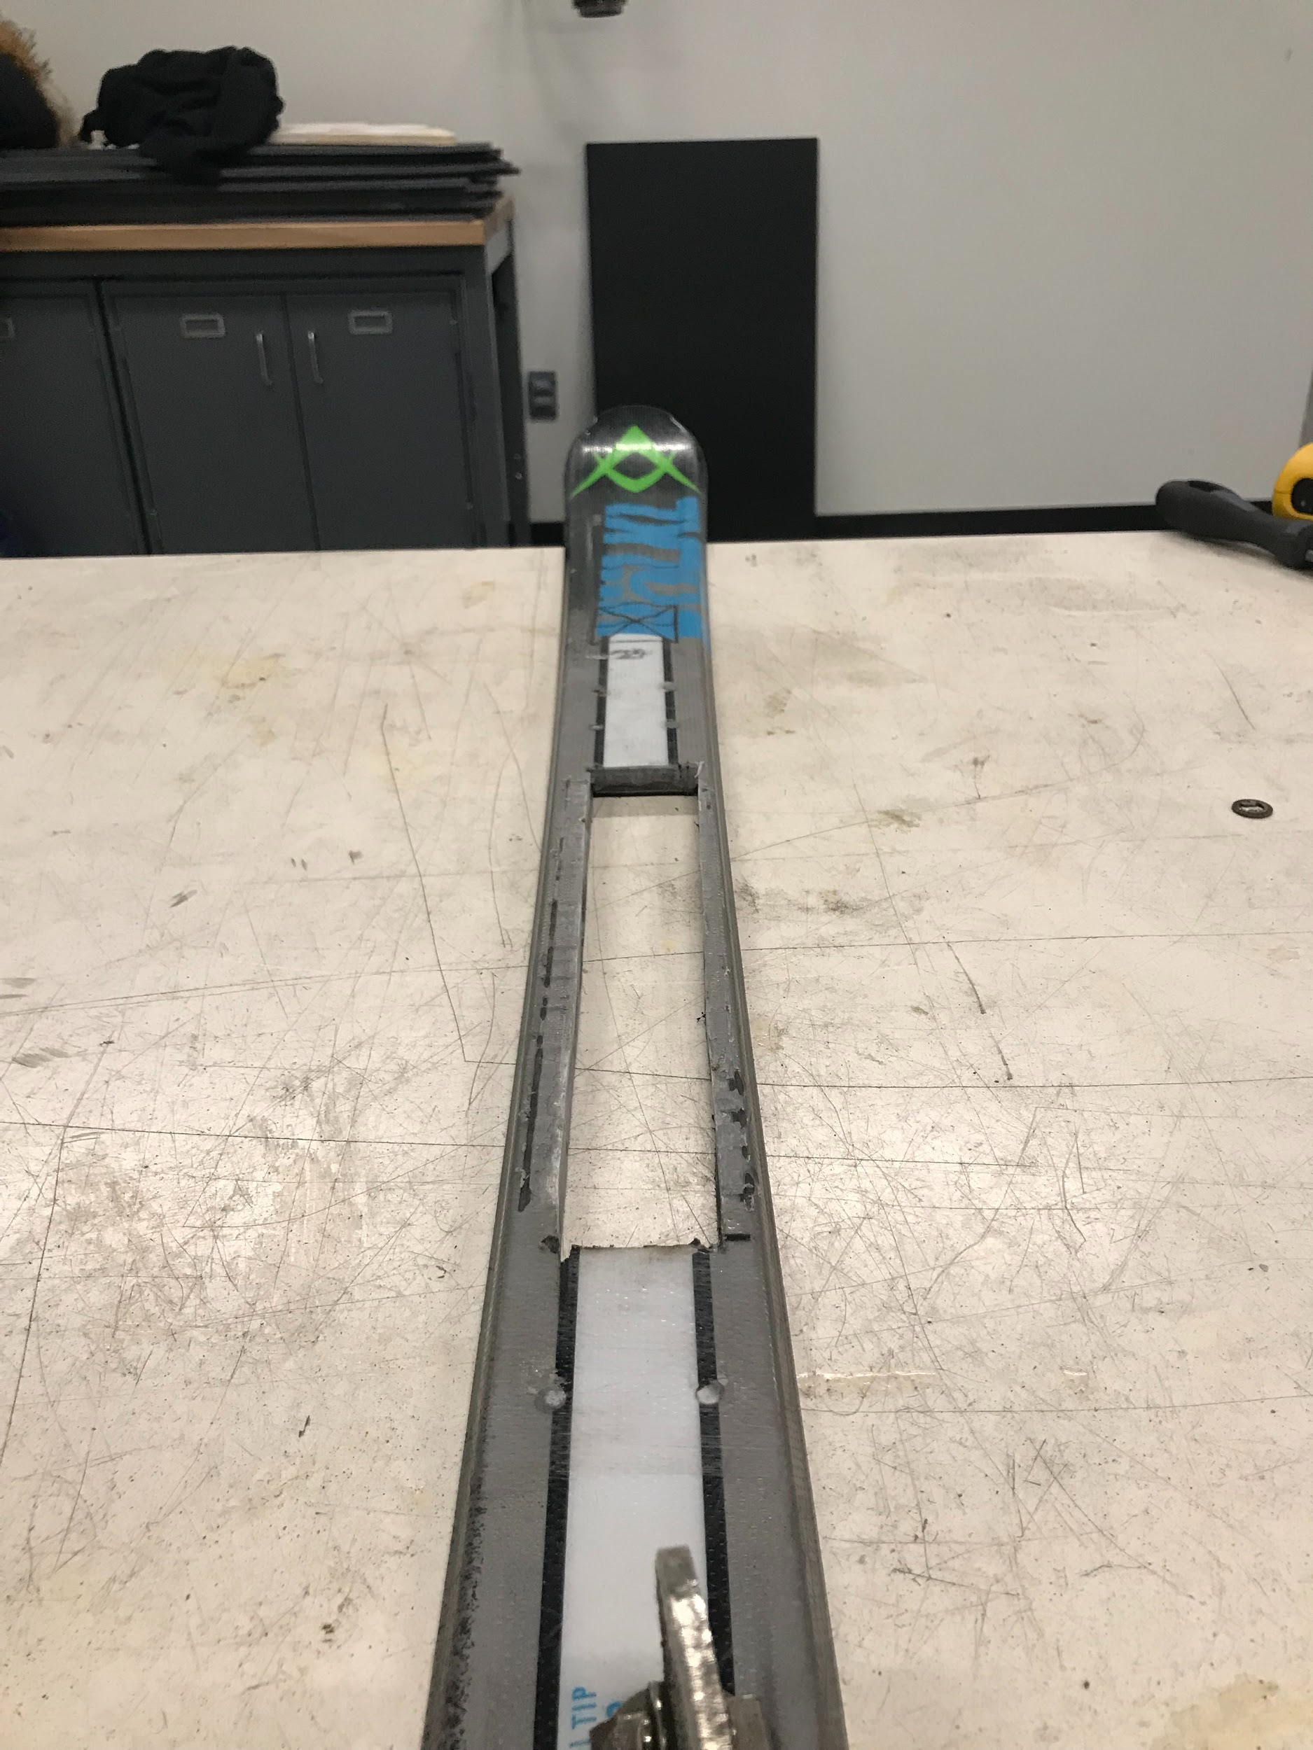

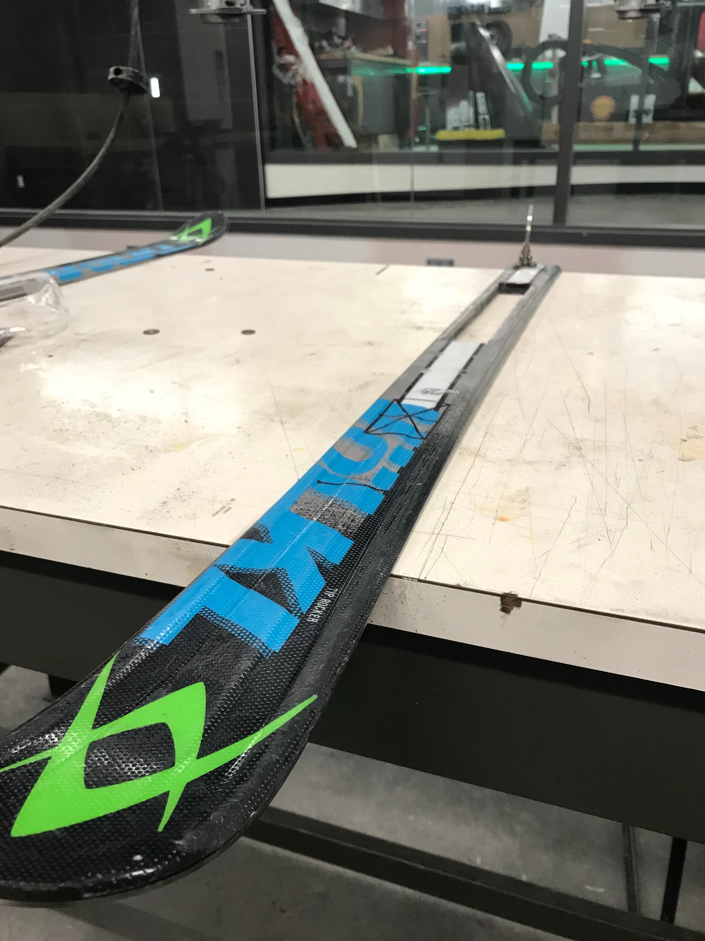

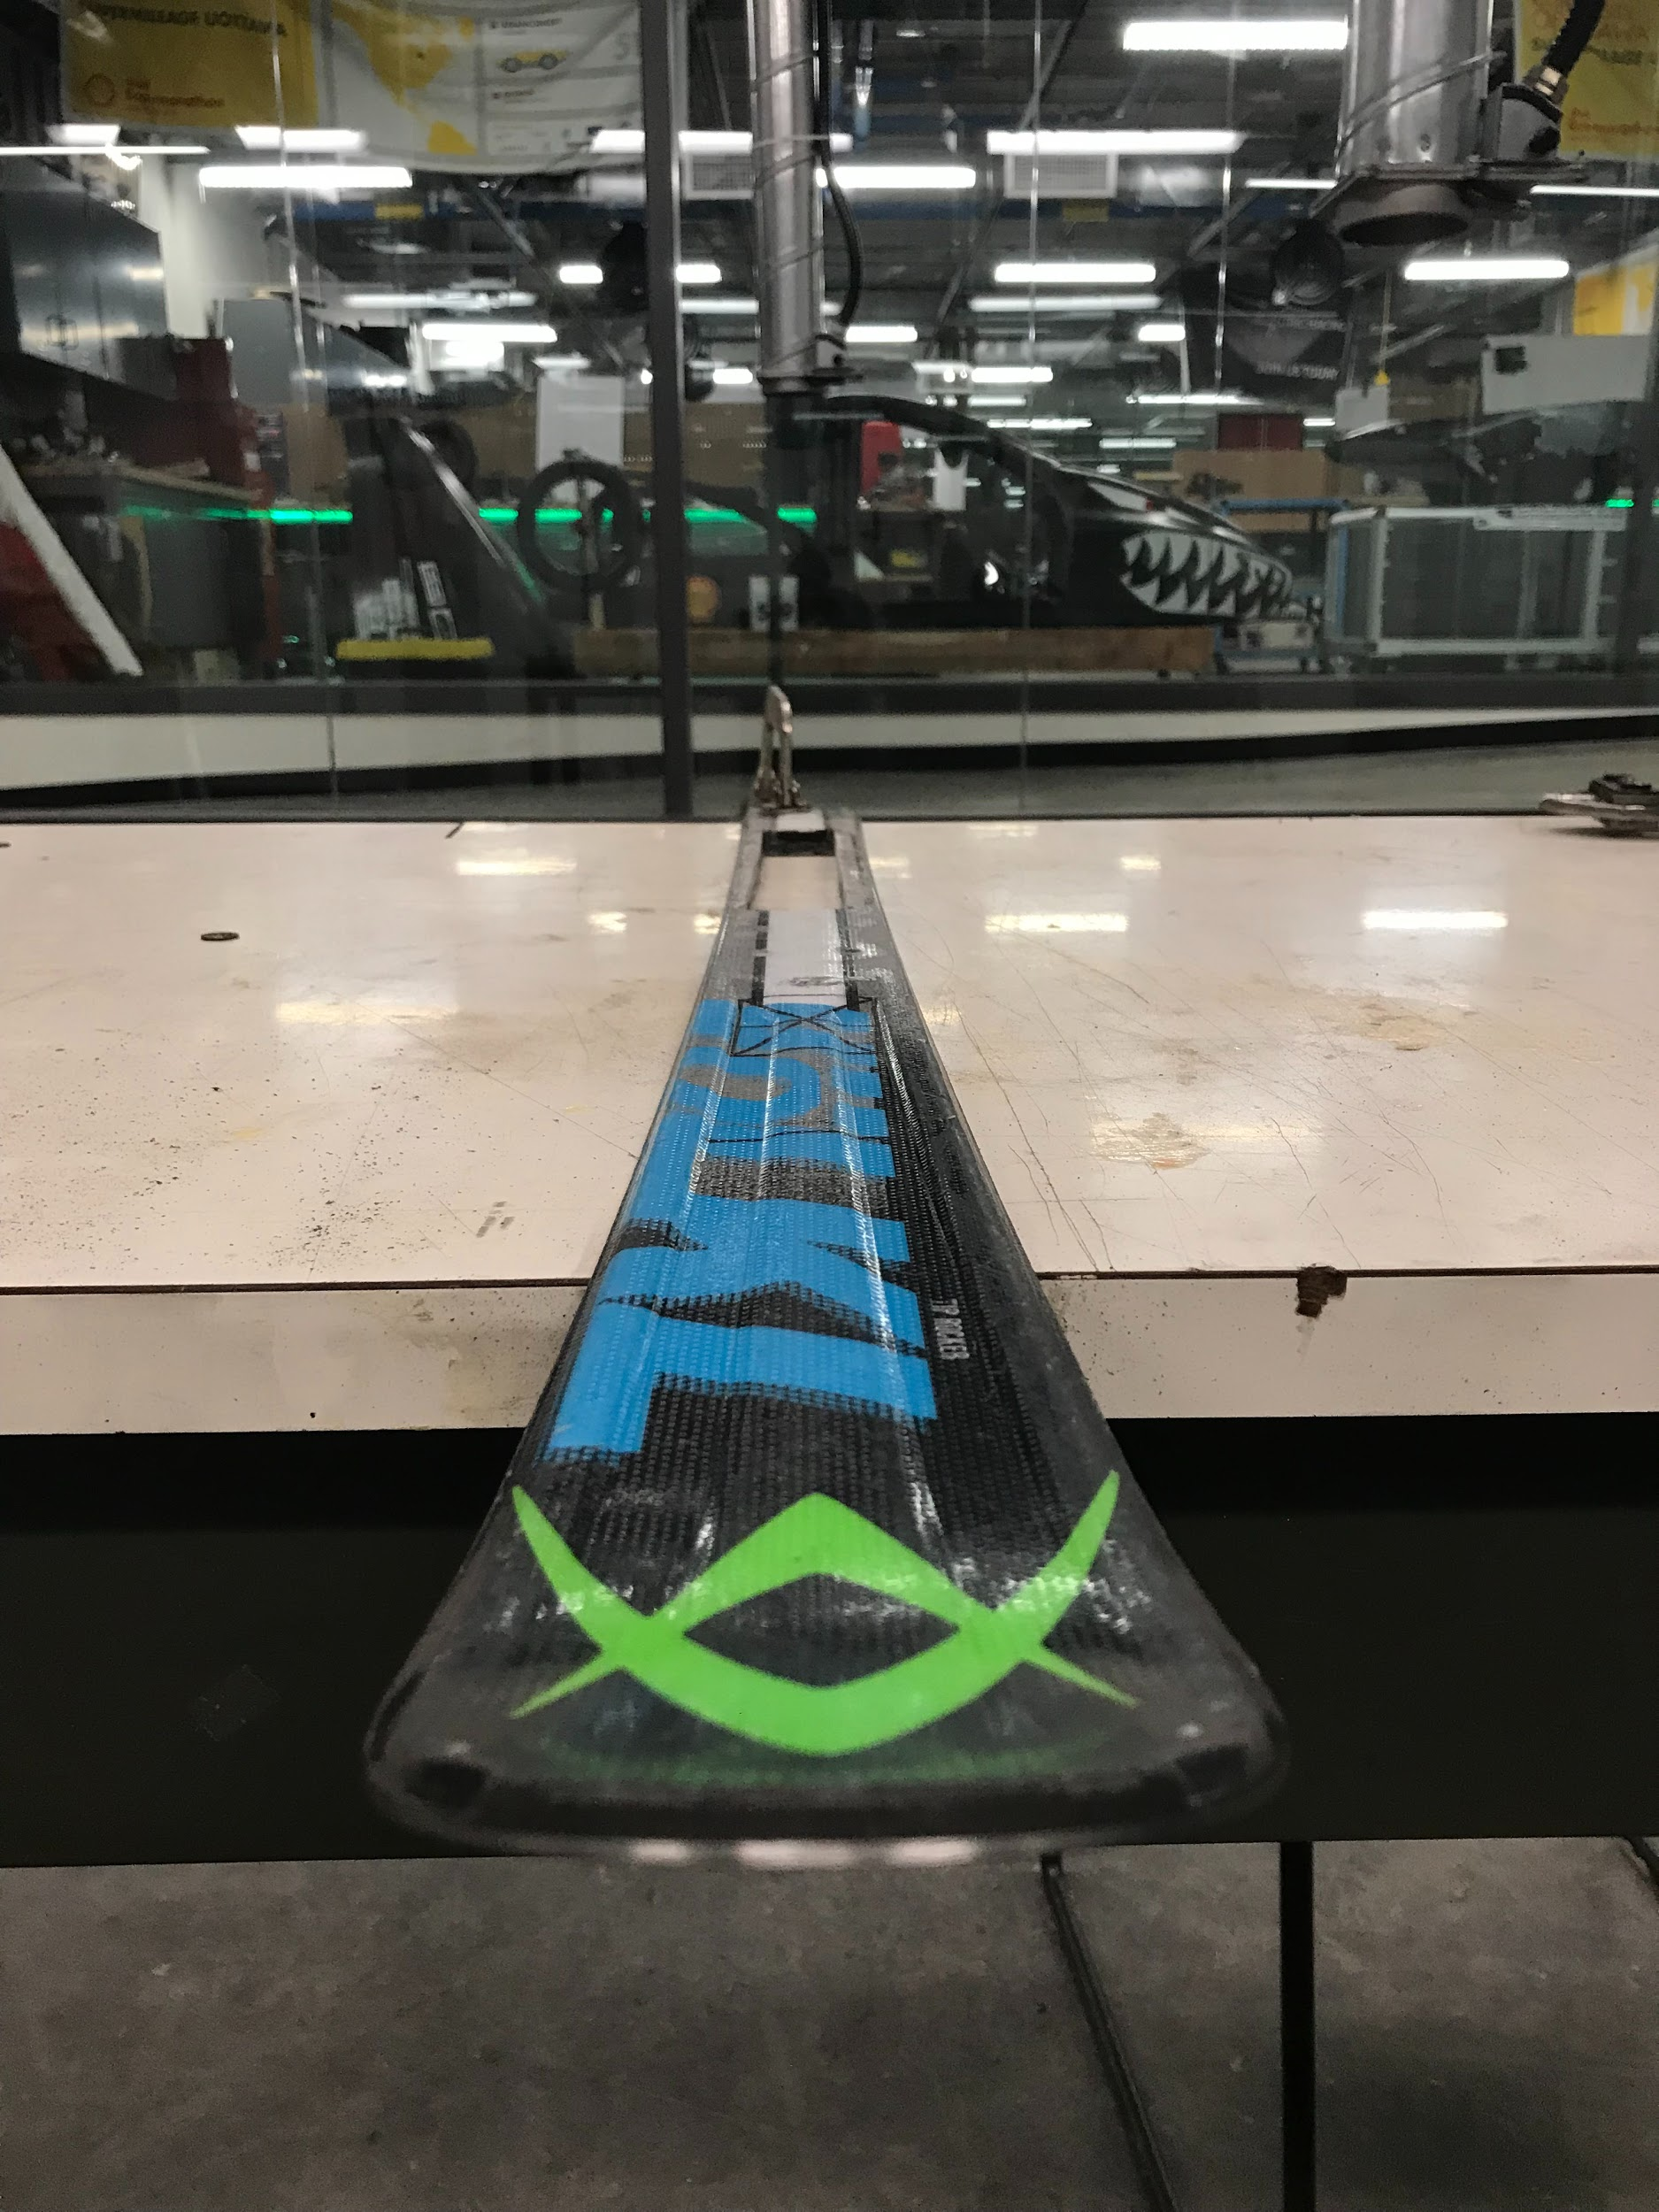

Part 2: Engineering Analysis
- Results
- Formulas
- Force diagrams
- Data
- Trade-off analysis
- Charts
- Graphs

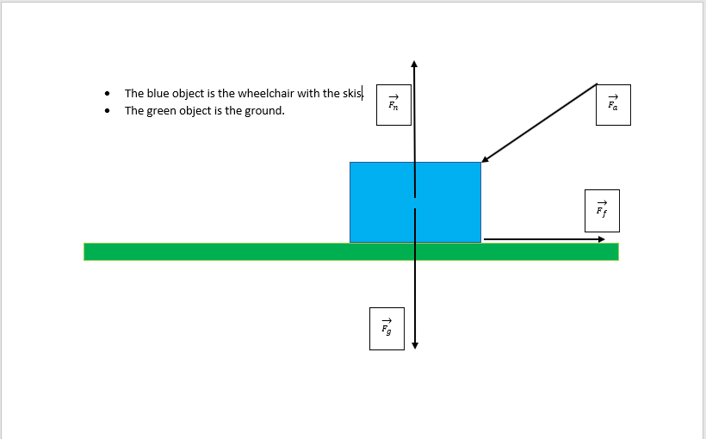

In order for the person to push the wheelchair through the snow with the attached skis, the applied force, , has to be bigger than the frictional force, .

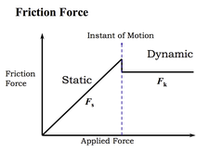

Part 3: Marketing Analysis
- Competitive analysis
- SWOT
- 4Ps
(We will not be putting any marketing analysis.)

Area 3: Non-technical Considerations
- Business model
- Validation board
- Income statement
- Any other considerations: legal, ethical, safety

(We will not be putting any validation board or income statement.)

Business Model
The best business model for our particular type of business would be the “Razor Blade” business model. We can sell our product for an affordable price (ie. less than $100), so we can sell our products in more quantities. We will also have more winter items (eg. winter gloves, boots, toque, etc..) for a cheap price to sell, so those winter items will be integrated as consumable supplies for our main product. For example, Gillette Fusion sells razors as their main product for $7 while also selling razor blade for $1 each, $4 per package.

Core Assumptions
Our core assumption is that we have a sustainable market for our company to make profit, and we assume that the market is willing to pay for our given price.

For our core assumption, our product is only targeted towards a very niche market, and that niche market is people who are in wheelchairs who want to easily travel through the snow. However, a very big possible problem is that we might not have enough people to buy our product, and this problem is very bad for us because we might not make enough money for our product to be sustainable and profitable for the future.
Furthermore, since our product is only targeted towards a very niche market, we would have to set a reasonable price on our product, so our customers will be willing to pay our given price. Likewise, if we do not set a reasonable price on our product, then our customers will look for other alternatives, and we definitely will not be able to make money.

How?
Key partners  Suppliers  - Our suppliers would be anyone would provide the following items:  - Rectangular gate hinges  - Aluminium sheet metal  - Cubed rode  - U-bracket  - Ski gloss/wax  - A pair of pre-built skis with no attachments  - For example, our suppliers could be with Home hardware, Rona, Home Depot, etc...  Partners  - Our partners could be with the University of Ottawa because they provide resources such as softwares, 3D printers, makerspace, brunsfield, etc... | Key activities  Activities  - We need the following criterias:  - people and/or machines to manufacture and/or to produce our product,  - professionals to create models and schematics,  - trained professionals to create our product in different segments,  - salesman to sell and advertise the product, and  - a delivery service (eg. Amazon) to deliver our product if our business grows really, really large.
Key resources

Resources
- Our potential resources are nuts, bolts, rubber treads, aluminum metal, carbon fiber, and 3D printer filament.

What?
Value Propositions

Addressing Problems or Needs
- Our clients’ problem is that they want a product that allows their wheelchair to move more freely through the snow.
- The proposed solution is to create skis for the wheelchair.
- The purpose of the product is to allow people in wheelchairs to move more freely through the snow.
- Our customers will love us because the cost to manufacture the product is very little, so we don’t need a lot of money to manufacture it, which brings down the total manufacturing price and cost price.

Who?
Customer Relationships  Relationship  - Our clients are our customers.  - We are the manufacturers. | Customer Segments  Value  - We are creating value for people who are in wheelchairs and who want to move more freely in the snow.  - Our product is only for a niche market, and our most important clients are our current clients and then anyone else who require our wheelchair skis product.
Channels

Delivery
- At the moment, we deliver our products to our clients in person, and we don’t need any third party delivery companies.

How much?
Cost Structure  Material cost  - The following materials that we need are  - Rectangular gate hinges  - Aluminium sheet metal  - Cubed rode  - U-bracket  - Ski gloss/wax  - A pair of pre-built skis with no attachments  Wages/employee benefits  - We give our employees at least minimum wage, and we cover employee healthcare, electricity, and insurance. | Revenue Streams  Method of Revenue  - Our business will make money by selling our wheelchair skis, and we can form a partnership with other skis companies to earn more profit by having them promote our product and vice versa.  - Our revenue system will be selling our product through our website such that anyone can buy it from there.  - We will set the pricing relative to the cost of manufacturing and cost of materials by multiplying the combined total price of manufacturing and materials by 1.5.  - For example, if the total cost of the manufacturing and materials is $50, then we’ll sell our product for $50 * 1.5 = $74.99.

Technical:
Our team has enough expertise and technical resources because our team is comprised of all second year students who have gained enough experience in hardware and software skills. Our team consists of an electrical engineer, a civil engineer, a software engineer, and a computer scientist, so we definitely have the expertise to accomplish this project. Since we were exposed to several resources in our first year, we can use and apply those given resources onto our project.

Economic:
The cost of our project is reasonable because we can purchase our materials from thrift stores for a really cheap price, and we can also use 3D printing machines and other machineries to prototype our product as many times as necessary for free. We can also buy our materials from online stores (eg. Kijiji, eBay, Amazon, Craigslist) for a really cheap price. Since we are not buying any new materials, the cost of our project is reasonable.

Legal:
We do not have any issues releasing our solution to the public because our product will not be released for sell. Since our product is mainly a project for our course, we do not have any intentions of mass producing and target advertising our product to people who are in need of a product such as ours. Also, our project is considered a non-profit product because the ultimate goal of our project is to create a product that is well-built and beneficial to our given clients.

Operational:
We do not have any organizational constraints that will prevent our success because we do not have any competitors who are competing against us. The market already has a company where people can buy wheelchair skis that are reliable and manufactured well. Since we are not creating a similar product, such as Wheelblades, we are not competing against others; in fact, we are creating a different type of product that can be put onto the market when our product is successful and reliable enough to be manufactured.

3 Minute Pitch
Introduction:
Hi, we are Skees, and we love helping people who face more adversities in their daily lives than most of the populace. This is the reason we are proud to present our project, which provides a much more convenient way for people in wheelchairs to get around in snowy and slippery conditions. The beauty of our product is that it does this while also maintaining the basic functionality of a standard wheelchair.

Main:
There are multiple solutions on the market but none are not quite as versatile as ours. Most alternatives require the user to completely change wheelchairs. Others only add skis onto the front flywheels of the wheelchair. Our product attaches the skis onto the rear and main wheel of the wheelchair. On top of this, our product is designed to be flexible with moving on different types of surfaces. It does this by allowing a very small portion of the wheel to make contact with the ground in order to allow smoother movement on surfaces such as pavement and asphalt. The function of the product changes while on snow as this is when the Skees kick in and majority of the weight will be transferred onto the Skees due to the small portion of the wheel sinking into the snow. It is this duality in our product that we believe makes it a very versatile and strong product overall. Additionally, the product is very easy to attach to and detach from the wheelchair base. It is this aspect alongside the fact that the product allows the wheel to touch the ground and thus provides versatility in function which distinguishes our product from the other alternatives.

