Client Feedback

- A new material needs to be thought of for the final development of skis, or instead the use of a regular set of downhill skis because the 3D printed plastic is not strong or durable enough to support the weight of the person and chair. Or we are looking at putting a support plate in the middle of the 3D printed skis for extra support and balancing the force of the weight on the ski.
- Portability: Staff member asked about the bar for the brake pedal and if it will protrude and come into contact with components of the wheelchair. She recommended the brake pedal bar be foldable so the entire system is foldable and portable (recommended using the same concept as setting up a tent with the bars having the spring loaded button clipping together).
- Client had concerns of the brake pedal and bar being too weak to the point where it could break if too much force is applied.
- Ski drive on mechanism has to be set at the specific width of the wheel base so it is easier to drive right onto.
- Front 360 degree wheels are narrower than the main wheel so we have to look at two seperate skis. Julian recommended attaching a bowl shaped piece to the 360 wheels so that the wheel is still able to move in every direction.
- Client likes the idea of the main wheel still being in contact with the ground
- Client recommended that the part where the skis fold be latched and include a handle for carrying. We could incorporate a handle or a carrying case for portability. Maybe look into another system that mounts to the back of the wheelchair and holds the skis off the chair.
- If we 3D print, we have to be careful with the sanding/grinding of the plastic as it will be fragile.
- We looked at the wheelchairs, and the locking bracket will have to attach to the bar that is directly behind the main wheel and runs along to the front which also holds the 360 degree wheel.
Overall, the client was very happy and excited with the idea we have come up with.

Prototype 1 Test Analysis

Notes:
- The first prototype was 3D printed almost identical to the shape of a real downhill ski

Tests:
- We would like to test how well the ski and the wheels together work through different terrain. We will conduct a test with this prototype by applying weight to the top of the ski and pushing it along a sidewalk (which is where our clients will be 99% of the time), snow and ice (artificial as we do not have snowfall yet), and over different sorts of bumps and potholes that could be found on the sidewalks.
- We would like to test how well the ski handles different weights on top of it. Because we are still trying to figure out if 3D printing is better, or if using a normal pair of downhill skis is better we want to test the quality and durability of the 3D printed plastic. We will do this by adding different amounts of weight while we put the ski to use, as well as a tensile strength test which will be conducted by simply bending it with our hands and using a force sensor attached to a string to pull on one end to determine a numerical value for Force applied.

Client Meeting 3

What we will present to the clients:
- We plan on presenting the client with our 3D printed model of the ski, while explaining to them the components we weren’t able to add to the model and where they will be added on our second prototype.
- We plan to present the tests we conducted for our prototype 1, which will be the same tests outlined above.
- We will explain how the tests will be conducted for our first prototype and how the tests will become more advanced and more helpful for us using our next and second prototype.

Prototype 1 Purpose and Function
In this specific prototype our focus was to create the basic shape of the ski along with one of its key feature that makes it extremely versatile. This feature would be the rollers as shown in the pictures. The design of the rollers will be very similar in the final prototype as the tread featured in this prototype excels at handling rough road conditions. The rollers would be much smaller in our final prototype and would ideally not protrude nearly as much on the top surface of the skis. This also helps prevent snow from being lodged within the cavity where the wheels are mounted.In our final prototype, the rollers would be made from rubber and be fixed in a much more rigid manner to ensure stability. The duct tape on the sides of the skis are meant to represent the reflective tape that will be added to the final prototype for visibility purposes. This prototype is meant to be a proof of concept and as such is made of scrap materials and things readily available within Brunsfield and the Makerspace. As such many functions such as the brakes, ski incline adjustment and the actual wheel mount mechanism have been omitted. This prototype solely focuses on the duality concept of the design and its adaptability.
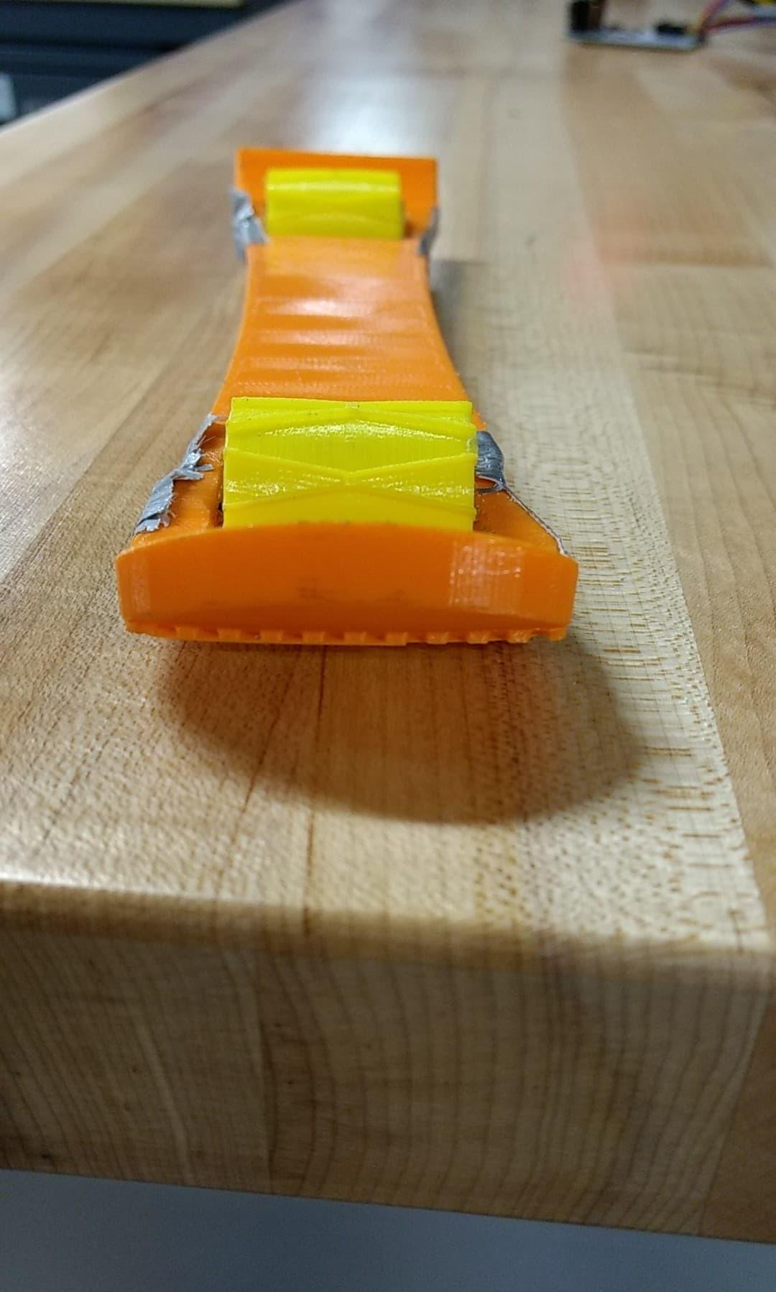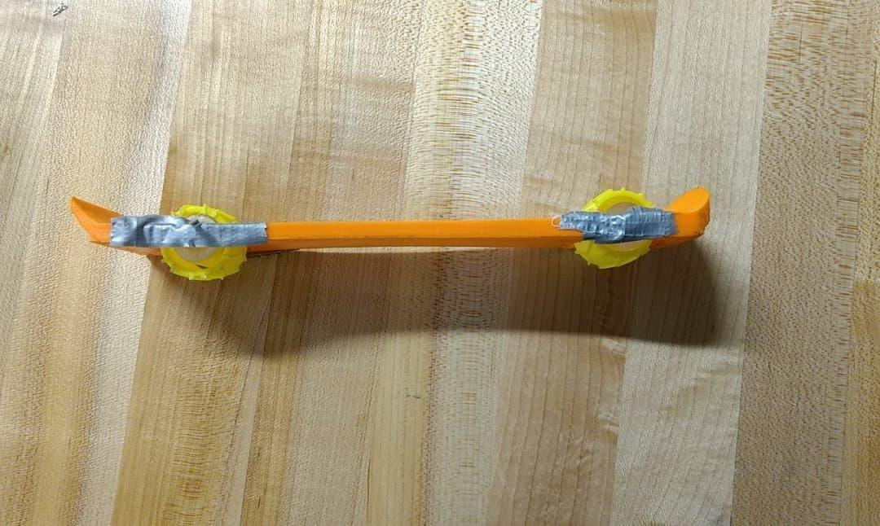
Figure 1&2: Front and Side Views of Prototype 1
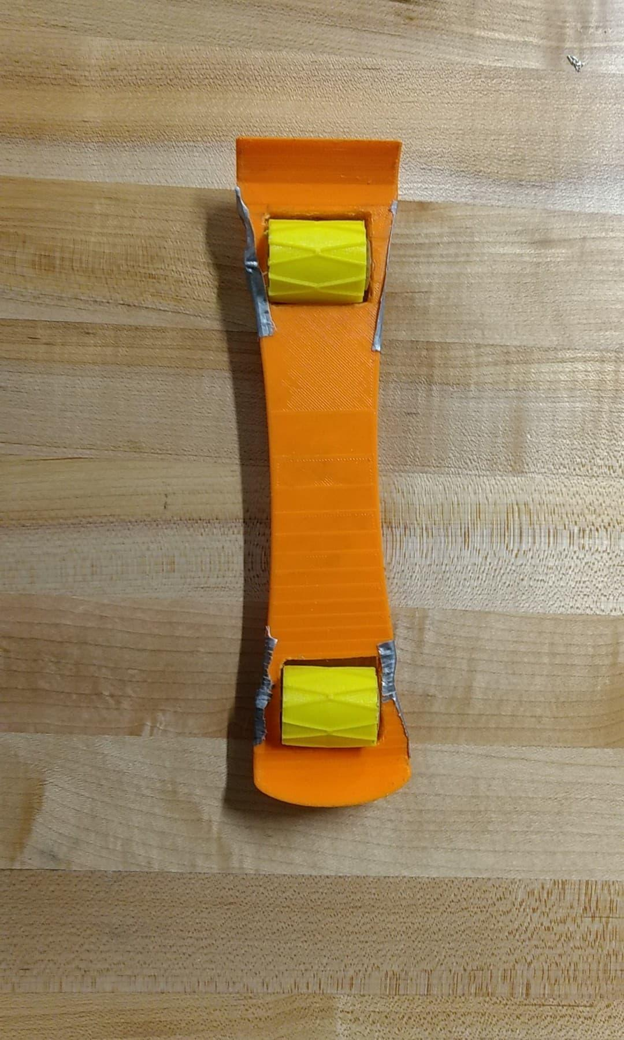

Figure 3: Top view of Prototype 1

