University of Ottawa
GNG 1103B: Engineering Design
Project Deliverable D:
Group members:
Name : Student number :
Ethan Langevin (300241099)
Dina Kaufmann (300232359)
Jean Cloete (300278812)
Amnol
Haolin Li (300315912)

October 7, 2022

1. Introduction
In this deliverable, we brainstormed together possible methods of measuring specific gravity, and possible subsystems for a final solution. We picked our top three potential solutions with their subsystems and presented the pro’s and con’s of each solution.
2. Ideal Solution
Ideal solution has three subsystems.
1st stage: Pressure sensor within fermentation tank.
2nd stage: Pressure is recorded, data is transferred to a computer, using fluid density formula, with depth manually inputted, density is used in specific gravity formula.
3rd stage: Data is stored and displayed.
Pros: Little cost, easy to install
Cons: Manual input
3. Other Potential Solutions
First Other Potential Solution
The next solution has 3 subsystems.
1st stage: Pressure sensor & hypersonic sensor within fermentation tank.
2nd stage: Pressure is recorded, data is transferred to computer, using fluid density formula, and depth measured with hypersonic sensor, density is used in specific gravity formula.
3rd stage: Data is stored and displayed.
Pros: Very little potential human error
Cons: Expensive, have to modify tank unless budget is increased for wireless ultrasonic sensor.
Cost for Parts:
Arduino Uno:
https://3dprintingcanada.com/products/arduino-uno-r3-with-usb-cable?variant=14108869001259&ab_version=A&gclid=Cj0KCQjw166aBhDEARIsAMEyZh5s8r77U55WWtbn67Xr_Pjd5ZFPTpeuqUimcWwUOjPX1f9XfN3N4d8aAlnyEALw_wcB
Is $16.95 for a cloned version at 3D printing Canada.
Laser Cutting Material:
https://makerstore.ca/shop/ols/products/mdf/v/M003-1-8-18-NCH
MDF sheets are $3. Is much cheaper than 3D printing plastic.
Wires:
https://makerstore.ca/shop/ols/products/jumper-cables-per-10
Wires come in 10 packs for a dollar on the Makerspace store.
Pressure sensor:
https://www.amazon.ca/Pressure-Transducer-0-5-4-5V-Transmitter-0-10PSI/dp/B07KJHRPLG/ref=asc_df_B07KJHRPLG/?tag=googleshopc0c-20&linkCode=df0&hvadid=459373244838&hvpos=&hvnetw=g&hvrand=7623527019706849480&hvpone=&hvptwo=&hvqmt=&hvdev=c&hvdvcmdl=&hvlocint=&hvlocphy=9000668&hvtargid=pla-680768994210&psc=1
Pressure sensor on Amazon. Is $30. Is made for measuring pressure in liquids so we will not have to worry about compatibility with our problem.
Water Proofing Material:
https://www.amazon.ca/Gorilla-Waterproof-Flexible-Rubberized-104058/dp/B093CCJ5QT/ref=asc_df_B093CCJ5QT/?tag=googleshopc0c-20&linkCode=df0&hvadid=459346807567&hvpos=&hvnetw=g&hvrand=16455699946412004230&hvpone=&hvptwo=&hvqmt=&hvdev=c&hvdvcmdl=&hvlocint=&hvlocphy=9000668&hvtargid=pla-1361105076162&psc=1
Gorilla waterproof spray on amazon for $20.
Ultrasonic Sensor:
https://www.amazon.ca/HC-SR04-Ultrasonic-Distance-Arduino-MEGA2560/dp/B01COSN7O6/ref=asc_df_B01COSN7O6/?tag=googleshopc0c-20&linkCode=df0&hvadid=292950548836&hvpos=&hvnetw=g&hvrand=11215646517062772435&hvpone=&hvptwo=&hvqmt=&hvdev=c&hvdvcmdl=&hvlocint=&hvlocphy=9000668&hvtargid=pla-493075951829&psc=1
Wired ultrasonic sensor on amazon for $14.
Picture of Concept Design:
https://drive.google.com/file/d/1f0FeJvM_3weWOxAuqqg6ie6VdAvhTXuV/view?usp=sharing
Second Other Potential Solution
The last solution has 3 subsystems.
1st stage: Pressure sensor within a sample section attached to fermentation tank.
2nd stage: Pressure is recorded, data is transferred to computer, using fluid density formula, with depth of sample section, density is used in specific gravity formula.
3rd stage: Data is stored and displayed.
Pros: Easy to use, no waste
Cons: Harder to clean, expensive, harder to install
Pressure sensor ($15-$20) https://www.amazon.ca/RP-S40-ST-Accuracy-Pressure-Intelligent-Induction/dp/B07FCLV5BJ/ref=asc_df_B07FCLV5BJ/?tag=googleshopc0c-20&linkCode=df0&hvadid=292953501307&hvpos=&hvnetw=g&hvrand=11232756650727439014&hvpone=&hvptwo=&hvqmt=&hvdev=c&hvdvcmdl=&hvlocint=&hvlocphy=9000668&hvtargid=pla-618017233412&psc=1
Pump ($14-$17)
https://www.amazon.ca/WayinTop-Submersible-Flexible-Fountain-Aquarium/dp/B07TMW5CDM/ref=asc_df_B07TMW5CDM/?tag=googleshopc0c-20&linkCode=df0&hvadid=293004366202&hvpos=&hvnetw=g&hvrand=12880445979950975127&hvpone=&hvptwo=&hvqmt=&hvdev=c&hvdvcmdl=&hvlocint=&hvlocphy=9000668&hvtargid=pla-810827634213&psc=1
https://www.amazon.ca/Gikfun-Submersible-Fountain-Aquarium-EK1893C/dp/B07BKXJXK1/ref=d_pd_sbs_sccl_3_1/136-9149179-8188024?pd_rd_w=9AnA3&content-id=amzn1.sym.cd949bb3-28b2-48f4-9c3b-7259e3470a97&pf_rd_p=cd949bb3-28b2-48f4-9c3b-7259e3470a97&pf_rd_r=FNJCEX8MQ779YGJBR0VB&pd_rd_wg=db7Er&pd_rd_r=3cc1e802-2b2d-4969-a49a-39a8b2008f74&pd_rd_i=B07BKXJXK1&psc=1
Load cell weighting sensor ($13-$16)
https://www.amazon.ca/Weight-Electronic-Kitchen-Weighing-Geekstory/dp/B079FQNJJH/ref=asc_df_B079FQNJJH/?tag=googleshopc0c-20&linkCode=df0&hvadid=335157143702&hvpos=&hvnetw=g&hvrand=254990251822397826&hvpone=&hvptwo=&hvqmt=&hvdev=c&hvdvcmdl=&hvlocint=&hvlocphy=9000668&hvtargid=pla-421323923408&psc=1
https://www.amazon.ca/Half-bridge-Weight-Weighting-Amplifier-Bathroom/dp/B07B4DNJ2L/ref=asc_df_B07B4DNJ2L/?tag=googleshopc0c-20&linkCode=df0&hvadid=459481149503&hvpos=&hvnetw=g&hvrand=254990251822397826&hvpone=&hvptwo=&hvqmt=&hvdev=c&hvdvcmdl=&hvlocint=&hvlocphy=9000668&hvtargid=pla-823819574599&psc=1
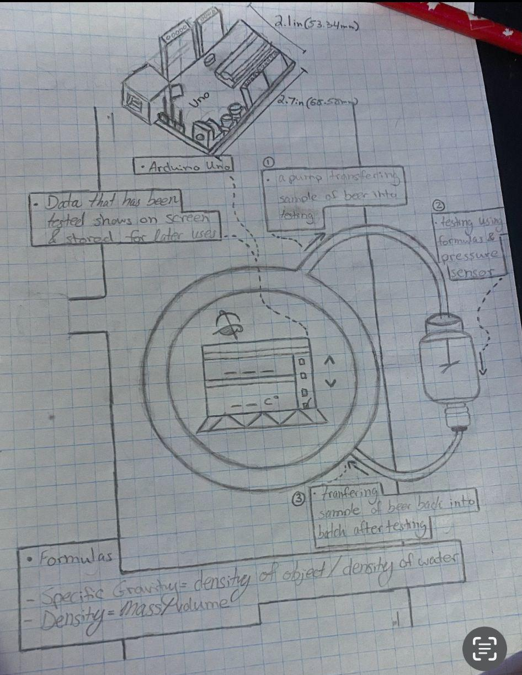

4. Extras
- Temperature sensors: As a extension of the system. Tells the temperature and display on the screen.
Options:
Waterproof DS18b20 Temperature Probe $8.95
5M DS1820 Stainless steel package Waterproof DS18b20 temperature probe temperature sensor 18B20 For Arduino $4.55
DS1820 Stainless steel package Waterproof DS18b20 temperature probe temperature sensor 18B20 for arduino $1.36
- Bluetooth/WiFi transmitter/receiver:As a extension of the system. Avoid problems such as cluttered lines.
NEW HC-05 HC 05 hc-06 HC 06 RF Wireless Bluetooth Transceiver Slave Module RS232 / TTL to UART converter and adapter $3.44
1Set UNO R3 Official Box ATMEGA16U2 / UNO+WiFi R3 MEGA328P Chip CH340G For Arduino UNO R3 Development Board WeMos ESP8266 $10.03
5. Conclusion
In conclusion we have an ideal solution with its pros and cons. With 2 other potential solutions and price tags for all major components.

