Deliverable M - Final Report
Authors: Julian Marra, Leo Tan, and Mihir Jakhi
Wheelchair Skis - Group A5
GNG2101 A00
Hanan Anis

Abstract
The following report is on GNG2101 group A5’s project. The project that our group was tasked with was to create a set of skis for our client to traverse through arduous terrain better. In its essence, our problem was one of accessibility and mobility.

Our solution was to create a pair of hybrid skis that would allow our client to seamlessly switch between snowy terrain and clear pavement. Through much prototyping we were able to achieve such effects and create a truly flexible pair of skis that would be easily able to attach onto the client’s wheelchair. Our group went through 3 sets of prototypes, testing and adjusting our design which at first involved many more aspects but through testing and refining we discovered that a simple design is better than an overly complicated design and would likely solve our problem in a simple manner.

Table of Contents

List of Figures
Figure 1 - WheelBlades flywheel attachment ………...………...………...………...………...……. 7
Figure 2 - Isolated view of the WheelBlades flywheel attachment ………...………...………...….. 8
Figure 3 - Group design concept initial drawings ………...………...………...……….……...…… 17
Figure 4 - Initial Concept Design (Screenshot of CAD file) ………...………...………...………….25
Figure 5 - Prototype I (Screenshot of CAD file) ………...………...………...………...…………….25

List of Tables
Table 1 - Tally of each design on different components on a scale of 1-3, 1 being satisfactory and 3 being excellent ………...………...………...………...……………...………...……...………...…..14
Table 2 - Bill of Materials ………...………...………...………...……………...………...………...….19
Table 3 - Business Model Canvas ...……………...………...………....……………...………...…...24

Introduction

Our clients in the LIFE program who are physically disabled people and require an assistant to move them anywhere; however, our clients want to go outside in the snow because they want to enjoy winter. Additionally, when their assistant pushes the wheelchair into the snow, the snow clogs up the wheels and prevents the wheelchair from moving forward. Therefore, our clients want a product that can help their wheelchair get through the snow very easily, and our clients suggested that we should create a product that have attachable skis to their wheelchair to enable the wheelchair to go through the snow.

Even though only our clients and the people in the LIFE program requires wheelchairs, the population in the world who need wheelchairs have gone up by a lot (Global Electric, 2018), so this problem is not limited to only just our clients and the people in the LIFE program. Also, the market has solution for what our client needs, but that product costs way too much; therefore, our team is here to create a product that is cheap and works well.

Our client requires a wheelchair ski design to be able to successfully get from point A to Point B throughout Ottawa's harsh winters, while minimizing the efforts of the staff members and persons in wheelchairs and maximizing safety and effectiveness.

The key aspect that makes our product different and better than other products is that our product lets the assistance have the full functionality and handling of the wheelchair in either winter or non winter conditions. Furthermore, the cost of our product is cheaper than the product on the market, and our product works just as well as the product on the market.

Main Body

2.1 Need Identification and Product Specification Process

2.1.1 Problem Statement

Our clients from the Partners in Parenting LIFE Program who require wheelchairs for transportation have trouble getting around in snowy or icy conditions on the sidewalks near their headquarters, even with the constant help of a staff member pushing them from behind. This problem arose when the City of Ottawa neglected the proper maintenance of the sidewalks.

2.1.2 Client Statements and Observations

- Client only goes for short walks down the street of the LIFE Program Centre, and they are always being pushed by a staff member rather than having to wheel themselves.
- City does not properly clean the sidewalks so there is usually snow and ice build-up.
- Staff members claim it is challenging for them to push the wheelchairs through heavy snow and ice because of snow build-up in the wheels of the chair.
- There is a difference between the manual chairs and the electric chairs, whereas the wheels are oriented differently. Will need a design change between the two chairs, if possible.
- Wheelchairs are heavy and hard to push.
- Client recommended skis as being the most efficient way to solve this issue; clients are never going out in their wheelchairs by themselves.
- Clients want an apparatus that is easily mountable to the wheelchairs, so that they don’t have to use the wheelchair lift every time they go for their walks.
- Staff members stressed the importance of having a braking system and emergency stops.
- Client does not have a specific preference for style of the system, but would appreciate a vibrant colour of the skis.
- Safety reflectors added to the apparatus so cars are easily able to see them.
- Client recommended the skis to be U shaped so snow doesn’t build up inside the skis and will allow for the skis to fit better onto the wheels of the chair.

2.1.3 Prioritized Customer Needs

- Clients’ wheelchairs need to be easily maneuvered in snowy and icy conditions
- Braking system and emergency braking system (Faster stopping force)
  - Has been achieved by allowing the rear wheel of the chair to be in contact with the ground, and maintaining the normal functionality of the wheelchair
- Skis rather than rubberized tracks to minimize the force of friction on snow and ice
- Needs to be able to push heavy snow out of the way to avoid build up in the skis or under the wheelchair
- Has to be able to move on hard surfaces (Concrete sidewalks, pavement) in case the sidewalks have been maintained in some areas. This needs to be done without risking the life of the product or causing damage to the skis.
  - Has been achieved by allowing the rear wheel of the chair to be in contact with the ground
- Safety reflectors installed on the system so passing cars are able to easily visualize the clients.
- Needs to be easy to install on the wheelchair, without the use of a chair lift.

2.1.4 Benchmarking
Products similar to what the clients require in this solution more than often only replace certain parts of the wheelchair such as the flywheels. Other models that appear commonly add attachments onto the main wheels of the wheelchair that allow them to function as skis as well as having the aforementioned flywheel replacements.The most immediate comparable product that is similar to what the clients require would be the Wheelblades S by Epical Solutions. These skis directly attach onto only the flywheels of the wheelchair in order to increase their mobility. The skis seems to have a rather generalized clip on system that simply slides on and locks on to the flywheels of the wheelchair. This product by WheelBlades, has been the only design that we have come across which is relevant to what we are designing. Refer to Figure 1 and Figure 2 below.

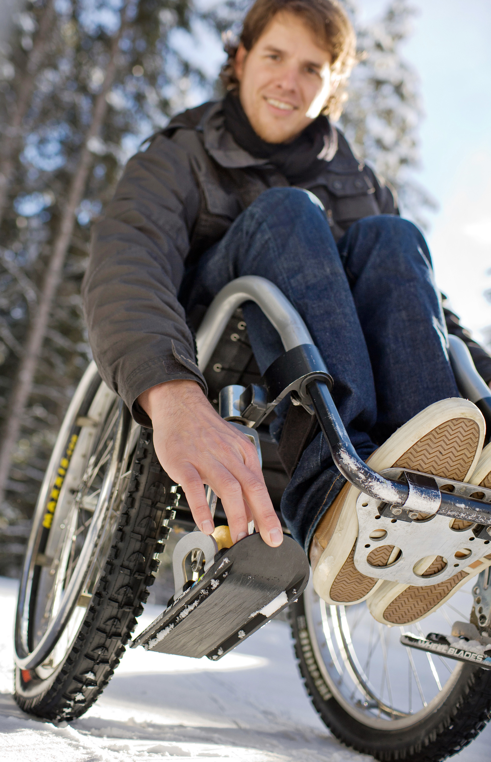
Figure 1 - WheelBlades flywheel attachment

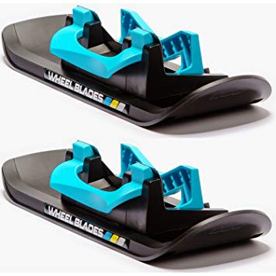
Figure 2 - Isolated view of the WheelBlades flywheel attachment

2.1.5 Metrics

According to our clients’ wishes, the wheelchair skis must have multiple important requirements:

Material

An important function that the chair must possess is that it must be able to slide across snow and pavement alike effortlessly. This means that the skis must be composed of a material that is both lightweight and durable enough to handle being scratched and scraped. Another key factor regarding the material is that it should not be susceptible to corrosion or rust, with the adubandance of road salt.

Size

The size of the skis also plays an important role in the overall design and the wishes of our clients. The skis must be large enough to effectively distribute all the weight that is put onto it. This is because if the skis are put under enough weight, they have the potential to completely sink into deeper snow and as such causing the client to possibly get stuck in the snow. The skis on the large wheels must also be short enough that they do not get interfere with the smaller skis that are on the flywheels and could thus block and motion taken by the smaller skis.

Visibility

The visibility of the client is another important issue that needs to be addressed. In low light and visibility conditions such as those seen in the winter can pose a real problem for our clients’ safety. By installing reflectors on the body of the skis, the client can be quite visible to drivers on the road and as such would be safer. The reflectors must allow the client to be visible from up to 25 metres or greater.

Braking

The safety of the client is another important aspect of the design. In slippery conditions, it is essential to be able to stop one’s momentum in order to lose control and risk possible injury. In the case of our client, this can be done by adding a braking system onto the skis which would allow the client to stop themselves within distance of 1 metre.

2.1.6 Target Specifications

Materials

The material of the skis should be light enough to not cause the individual pushing the wheelchair to struggle, but durable enough that it can support an individual and wheelchair combo while being pushed across potentially rough surfaces. Equally, because the skis are designed to be used on roads and sidewalks in snowy conditions, the material must not be sensitive to road salt.

Size
The skis affixed to the large wheels of the wheelchairs would be load bearing, and thus require a large enough surface area to the support the wheelchair without sinking overly deep into potential deep snow. The length of these main skis can extend at most from the back of the wheelchair to just short of the front flywheels, leaving room at the back for the individual person to hold and push the wheelchair, and enough room at the front for the flywheels to rotate.

Visibility

Reflective strips affixed to the attachment will cause the client to be visible to oncoming vehicles at a minimum distance of 25 metres, though ideally being visible at distances approaching 60-75 metres.

Braking

Brakes attached the skis will allow the client to stop themselves rapidly at a moment's notice. Unless in extreme circumstances (sliding down steep hill, moving at extremely high speed) the brake system will stop the client’s wheelchair moving within a metre of travel.

2.2 Conceptual Designs

2.2.1 Wheelchair Skis (Drivable)

The drivable wheelchair skis offer a wide range of benefits that satisfy our clients’ needs, including portability of the system, lightweight design, efficient and easy installation and effectiveness through snow and ice.

Design variables:
- Skis
The skis for this system will be 3D printed in portions which will include ‘dominos’ to easily connect one piece to the other, without having a protruding crease at the bottom. Once all connected, the skis will be ground down to a smooth finish and waxed the same way downhill skis are. The skis will be oriented in a convex shape to minimize friction through the snow and ice and to minimize the amount of snow that collects under and around the wheelchair. For this setup, the skis will also include rubber spiked rollers at the front and rear of the ski so that they’re not damaged if it comes into contact with ice or ashphalt. The top of the ski will be fitted to the thickness of the wheel, with a little bit of wiggle room to allow the wheel to still rotate on the ground through the inserts. We also plan for the skis to have two sections of ‘teeth’ that will allow the ski to move like a track along the y-axis. By doing this, the skis will make for less work while trying to turn and will also minimize the risk of getting stuck in heavy snow.

- Locking Mechanism
The locking mechanism will be mounted to the top of the ski and will grip the side frame of the wheelchair firmly. It will be a solid metal locking bracket with rubber padding within the grip to disallow damage to the wheelchairs exterior finish. We are not able to attach the mount to the wheel in this solution because we would like for the wheel to rotate freely through the insert in the ski. Exact mounting locations are still to be determined.

- Rubber Spiked Rollers
The rubber rollers will be mounted on a 360 degree rotating axle with 50% of the roller exposed at the bottom of the skis. These rollers will be mounted towards the front and rear sections of the skis, with the purpose of providing protection and extra traction to the skis on hard surfaces and through heavy snow. The tread pattern of the rubber rollers will be that of an all terrain car tire.

- Emergency Braking System
Two lockable metal plates will be installed to the rear of both skis which, with the step of a foot can be locked down into the ground. This system is for the staff member pushing from the rear to be able to step on a pedal in the middle of the chair that will cause both plates to be pushed into the ground, stopping the wheelchair. Additionally, depending on costs we plan on being able to use the rubber rollers as brakes to add to the braking power.

- Safety Reflectors
Safety reflectors will be installed onto the system for maximum roadside safety and to provide a far visual for oncoming traffic

2.1.2 Wheelchair Skis and Variations (Attachable)

The attachable wheelchair skis provide the client with increased maneuverability and control while also being quite simple in their design and implementation.

Design Variables:
- Skis
The skis for this concept would also be largely 3-D printed because this allows for maximum design flexibility. These skis would look largely the same as normal skis except for being slightly wider to accommodate for the increased load they would have to bear. This would allow for maximum weight dispersion and thus prevent sinkage. These skis would also be shaped in a convex shape in order to push snow out of the way.

- Locking Mechanism
Each of the skis would lock the the wheels by use of two solid metal arms, one on each side, with rubber grips on the ends. The arms would be flipped up and locked into place by the person attaching the skis, and the rubber grips on the arms would firmly hold the wheel in place and prevent it from sliding out or away from the skis.

- Emergency Braking System
The braking system is similar to that of the drivable wheelchair skis. A metal plate would be installed at the rear of each back ski, and when the person pushing the wheelchair steps on the provided foot pedal, the plate would be locked in a downwards position, pushing against the snow and ground underneath the skis and stopping the wheelchair in its tracks.

2.1.3 Wheelchair Sled

The Wheelchair Sled is a simple design, compared to some of the others, but it’s in its simplicity that it gets an advantage. A sled, unlike skis, is a singular piece of equipment that is not finicky or awkward to attach/detach, and, while it might be bulky to carry around detached from the wheelchair, it is easy to keep all of it together, as it exists only as a single piece.

Design Variables:
- Sled
The sled would consists of a single, continuous 3-D printed design (though it may be printed in multiple pieces and then attached). The sled would be wide enough to fit completely around the wheelbase of the wheelchair, and long enough to protrude with a slight up-slope in front of the wheelchair, allowing the wheelchair to mount rises in the snow. The front of the sled would be formed into a wedge, with the sides forming convex walls protecting the wheelchair from snow and forcing snow beneath and to the side of the sled.

- Attachment System
The sled would be attached to the wheelchair by use of straps and buckles. Ideally there would be four straps in place to secure the wheelchair. The first running from the back of the sled around the front wheels, the second running from the front of the sled around the back wheels. The last two would run from the back of the sled around the back wheels and from the front of the sled around the front wheels. This would prevent the wheelchair from sliding either forward or backwards, as well as reducing unnecessary forces pulling the wheels and potentially breaking the wheelchair.

- Braking System
The braking system for this design will consist of a metal plate fixed to the back of the sled and attached by an axle to a foot pedal. When the person pushing the wheelchair presses their foot down on the pedal, the metal plate will swing down and dig into the ground and snow, slowing the progress of the sled and stopping it quickly.

- Safety Reflectors
The sled will have reflectors fixed upon the upper rim of the design. This will give oncoming cars an additional visual cue that there is someone ahead of them and protect the safety of the individuals pushing and riding the wheelchair.

2.1.4 Wheelchair Wheel Plows

Wheelchair plows are different from all the other design concepts because their strategy is not moving the wheelchair over the snow, but rather moving it through the snow. This may be effective to some degree, but it has some drawbacks.

Design Variables:
- Plows
The plow would be made from a 3-D printed plastic waxed bottom, to allow it to easily slide over snow, and either hard plastic or metal high walls around it. The walls would be shaped such that it forms a wedge at the front of each plow, with walls around it. On each side of the plow, the walls would initially run up at around a 60° angle to the ground, and then curve upwards. The initial flat surface would compact and snow being forced around the plow, and the upper curve would serve to protect the front wheel from snow falling over the the top of the wall.

- Attachment System
The plows would be attached by metal clips which would protrude upwards from the base of plows and connect across the top of the front wheels, on either side of the wheel’s attachment point. This would prevent the wheelchair from sliding forward or backwards in the plow, and from jumping up out of the plows due to a sudden bump in the surface.

- Emergency Braking System
The braking system is similar to that of the drivable wheelchair skis. A metal plate would be installed at the rear of each back ski, and when the person pushing the wheelchair steps on the provided foot pedal, the plate would be locked in a downwards position, pushing against the snow and ground underneath the skis and stopping the wheelchair in its tracks.

- Safety Reflectors
The sled will have reflectors fixed upon the upper rim of the design. This will give oncoming cars an additional visual cue that there is someone ahead of them and protect the safety of the individuals pushing and riding the wheelchair.

2.1.5 Assessment of Conceptual Designs

Design | Portability | Cost | Weight | Meets Needs | Total /12
No. 1 | 3 | 2 | 2 | 3 | 10
No. 2 | 2 | 1 | 1 | 2 | 6
No. 3 | 1 | 3 | 1 | 2 | 7
No. 4 | 2 | 3 | 3 | 1 | 9
Table 1 - Tally of each design on different components on a scale of 1-3, 1 being satisfactory and 3 being excellent

2.1.6 Prefered Solution

Based on the analysis of all the different types of solutions, a consensus has been achieved in moving forward and further developing the drivable wheelchair skis. This design exceeds the needs/wants and expectations of our clients, and if developed correctly will be an extremely effective product not only for our clients at the LIFE program, but every person who is confined to a wheelchair. The drivable wheelchair skis were rated the best for every component in Table 1 and is the most innovative design out of the four.
Additionally, prototypes will be developed and tests will be conducted to expand our knowledge based on the design specifications we have already come up with and to improve the product as a whole.

2.1.7 Group Design Concept

For our group design concept, we plan on using the drivable wheelchair ski idea as the base of our concept while adding improvements and changes respectively.

- Ski Design and Features
Adapting the idea of the wheelchair sled and wheelchair plow, the two seperate skis will be designed wider than originally planned to be able to fit our mounting and braking components onto it, and to even out the weight distribution on the skis. Making the skis wider than original will also allow for more of a curvature in the skis convex shape, helping with the management of snow build up, like that of a plow. Merging the wheelchair tracks and wheelchair skis will be done by adding two rubber rolling wheels per ski, with a tread pattern similar to an all terrain tire. This will minimize damage to the skis if there is a rough patch of ice or a patch of concrete exposed on the sidewalk and will provide extra traction to the skis to tackle heavy amounts of snow. Additionally, we will be incorporating a rigid transmission belt approximately 3 inches in front of the wheelchairs main wheel on the ski to allow track like movement out of the rigid skis. These connectors are similar to that of a heavy duty conveyor belt connector and act like teeth that allow the ski to fluctuate up and down in the y-axis. This improvement will allow for smoother transitions into different terrain, better steering and stability and will allow the skis to be folded in half for portability off the wheelchair. The skis will be 3D printed in parts and will be assembled using ‘dominos’ to avoid having protruding creases at the bottom of the ski, and visually looks like an individual ski. Once the entire ski is assembled, it will be sanded to a smooth finish and waxed like a downhill ski for minimal friction. Skis will have to modified and adjusted for the difference in the manual and electric wheelchairs.

- Locking Bracket
The locking bracket will be directly mounted to the skis and attached firmly to the frame bar directly behind the wheel. The attachment piece to the bar will be of cylindrical shape that opens in half and clamps down and locks the skis in their proper place. The inside of the cylindrical clamp will be padded with rubber so that there is no damage to the exterior finish of the wheelchair. For this design, we cannot ​lock the skis in place onto the wheel as we would like for the main wheels to rotate freely. 5.3

- Safety Reflectors
3M stickable reflectors will be added to the system for maximum roadside safety.

- Braking System
The braking system adapted for this design concept will be that of the braking system mentioned by each group member in their solution ideas. There will be a foot pedal in the middle of the wheelchair which will be fixed to an axle that will engage a metal plate at the rear of each ski down into the ground, allowing the wheelchair to come to a full and complete stop. Through tests and prototyping, if this is not efficient enough then we will add a braking apparatus to the rubber rollers. Since the main wheel of the chair is in contact with the ground, the client will be able to add to the braking power by grabbing hold of the wheel and stopping it from rotating.

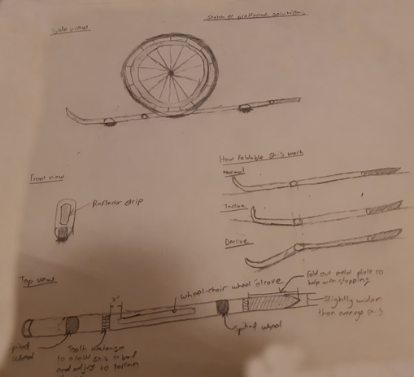
Figure 3 - Group design concept initial drawings

2.3 Project Planning and Feasibility Study

2.3.1 Feasibility Study

Technical:
Our team has enough expertise and technical resources because our team is comprised of all second year students who have gained enough experience in hardware and software skills. Our team consists of an electrical engineer, a civil engineer, a software engineer, and a computer scientist, so we definitely have the expertise to accomplish this project. Since we were exposed to several resources in our first year, we can use and apply those given resources onto our project.
Economic:
The cost of our project is reasonable because we can purchase our materials from thrift stores for a really cheap price, and we can also use 3D printing machines and other machineries to prototype our product as many times as necessary for free. We can also buy our materials from online stores (eg. Kijiji, eBay, Amazon, Craigslist) for a really cheap price. Since we are not buying any new materials, the cost of our project is reasonable.
Legal:
We do not have any issues releasing our solution to the public because our product will not be released for sell. Since our product is mainly a project for our course, we do not have any intentions of mass producing and target advertising our product to people who are in need of a product such as ours. Also, our project is considered a non-profit product because the ultimate goal of our project is to create a product that is well-built and beneficial to our given clients.
Operational:
We do not have any organizational constraints that will prevent our success because we do not have any competitors who are competing against us. The market already has a company where people can buy wheelchair skis that are reliable and manufactured well. Since we are not creating a similar product, such as Wheelblades, we are not competing against others; in fact, we are creating a different type of product that can be put onto the market when our product is successful and reliable enough to be manufactured.
Scheduling:
Our deadlines for this project are Prototype I that is due on October 10, Prototype II that is due on November 14, Design Day that is due on November 21, and a Final Presentation with Final Prototype that is due on November 28. We think that these dates are reasonable for our solution because we assume that most people generally are able to meet these deadlines with products that deliver average expectations.

2.3.2 Bill of Materials
Product Name | Cost/Unit  ($) | Quantity Purchased | Taxes (13%)  ($) | Total Cost  ($)
Set of Downhill Skis | 40.00 | 1 | 0.00 | 40.00
Square Rod  (“COLD ROLLED”) | 4.98 | 1 | 0.65 | 5.54
5 pack of Dremel blades (“EZ456”) | 21.58 | 1 | 2.81 | 24.39
Clamp Hose Mount single 1 | 9.99 | 2 | 2.60 | 22.58
Screws | 6.13 | 1 | 0.80 | 6.93
TOTALS | $92.67 | N/A | $6.86 | $99.53
Table 2 - Bill of Materials

2.5 Prototyping, Testing, and Customer Validation

2.5.1 Client Feedback Before Prototypes

The following client feedback was given after showing the clients the conceptual design and respective drawings, while explaining the idea of our design as a whole.

- A new material needs to be thought of for the final development of skis, or instead the use of a regular set of downhill skis because the 3D printed plastic (PLA) is not strong or durable enough to support the weight of the person and chair. Or we are looking at putting a support plate in the middle of the 3D printed skis for extra support and balancing the force of the weight on the ski.
- Portability: Staff member asked about the bar for the brake pedal and if it will protrude and come into contact with components of the wheelchair. She recommended the brake pedal bar be foldable so the entire system is foldable and portable (recommended using the same concept as setting up a tent with the bars having the spring loaded button clipping together.)
- Client had concerns of the brake pedal and bar being too weak to the point where it could break if too much force is applied.
- Ski drive on mechanism has to be set at the specific width of the wheel base so it is easier to drive right onto.
- Front 360 degree wheels are narrower than the main wheel so we have to look at two seperate skis.
- Client likes the idea of the main wheel still being in contact with the ground.
- Client recommended that the part where the skis fold be latched and include a handle for carrying. We could incorporate a handle or a carrying case for portability. Maybe look into another system that mounts to the back of the wheelchair and holds the skis off the chair.
- If we 3D print, we have to be careful with the sanding/grinding of the plastic as it will be fragile.
- We looked at the wheelchairs, and the locking bracket will have to attach to the bar that is directly behind the main wheel and runs along to the front which also hold the 360 degree wheel.

2.6 A clear and detailed description of your final solution and its features.
For our final solution, we came up with the idea of attaching the cut out skis to the chassis of the wheelchair by using metal arms on hinges that would be adjustable to different wheelbase widths. At the ends of these arms is a modified exhaust clip that would be able to attach onto the bars underneath the wheelchair and thus stay firmly on the wheelchair, moving along with the entire system and not impeding the movement of the wheels.

2.7 Final testing Results
Our final testing results yielded as expected because the wheelchair was able to move along the concrete floors of STEM without much friction from the skis thus accomplishing one of its functions. Due to the lack of heavy snow and inability to borrow a wheelchair for use outside we were not able to test the ski portion of the wheelchair but we assume that it should work without trouble.

2.8 Business Model. Include your Business Canvas Model.

Our business involves manufacturing wheelchair skis that allow people in wheelchairs to get through heavy snow and ice easily. Skees ™ is the name of our business and we pride ourselves in being able to help people who face challenges that most people may see as not challenging at all. We have developed a ski that is easily installed and works better than the typical wheelchairs wheels.

Business Model
The best business model for our particular type of business would be the “Razor Blade” business model. We can sell our product for an affordable price (ie. less than $100), so we can sell our products in more quantities. We will also have more winter items (eg. winter gloves, boots, toque, etc..) for a cheap price to sell, so those winter items will be integrated as consumable supplies for our main product. For example, Gillette Fusion sells razors as their main product for $7 while also selling razor blade for $1 each, $4 per package.

Core Assumptions
Our core assumption is that we have a sustainable market for our company to make profit, and we assume that the market is willing to pay for our given price.

For our core assumption, our product is only targeted towards a very niche market, and that niche market is people who are in wheelchairs who want to easily travel through the snow. However, a very big possible problem is that we might not have enough people to buy our product, and this problem is very bad for us because we might not make enough money for our product to be sustainable and profitable for the future.
Furthermore, since our product is only targeted towards a very niche market, we would have to set a reasonable price on our product, so our customers will be willing to pay our given price. Likewise, if we do not set a reasonable price on our product, then our customers will look for other alternatives, and we definitely will not be able to make money.

How?
Key partners  Suppliers  - Our suppliers would be anyone would provide the following items:  - Rectangular gate hinges  - Aluminium sheet metal  - Cubed rode  - U-bracket  - Ski gloss/wax  - A pair of pre-built skis with no attachments  - For example, our suppliers could be with Home hardware, Rona, Home Depot, etc...  Partners  - Our partners could be with the University of Ottawa because they provide resources such as softwares, 3D printers, makerspace, brunsfield, etc... | Key activities  Activities  - We need the following criterias:  - people and/or machines to manufacture and/or to produce our product,  - professionals to create models and schematics,  - trained professionals to create our product in different segments,  - salesman to sell and advertise the product, and  - a delivery service (eg. Amazon) to deliver our product if our business grows really, really large.
Key resources

Resources
- Our potential resources are nuts, bolts, rubber treads, aluminum metal, carbon fiber, and 3D printer filament.

What?
Value Propositions

Addressing Problems or Needs
- Our clients’ problem is that they want a product that allows their wheelchair to move more freely through the snow.
- The proposed solution is to create skis for the wheelchair.
- The purpose of the product is to allow people in wheelchairs to move more freely through the snow.
- Our customers will love us because the cost to manufacture the product is very little, so we don’t need a lot of money to manufacture it, which brings down the total manufacturing price and cost price.

Who?
Customer Relationships  Relationship  - Our clients are our customers.  - We are the manufacturers. | Customer Segments  Value  - We are creating value for people who are in wheelchairs and who want to move more freely in the snow.  - Our product is only for a niche market, and our most important clients are our current clients and then anyone else who require our wheelchair skis product.
Channels

Delivery
- At the moment, we deliver our products to our clients in person, and we don’t need any third party delivery companies.

How much?
Cost Structure  Material cost  - The following materials that we need are  - Rectangular gate hinges  - Aluminium sheet metal  - Cubed rode  - U-bracket  - Ski gloss/wax  - A pair of pre-built skis with no attachments  Wages/employee benefits  - We give our employees at least minimum wage, and we cover employee healthcare, electricity, and insurance. | Revenue Streams  Method of Revenue  - Our business will make money by selling our wheelchair skis, and we can form a partnership with other skis companies to earn more profit by having them promote our product and vice versa.  - Our revenue system will be selling our product through our website such that anyone can buy it from there.  - We will set the pricing relative to the cost of manufacturing and cost of materials by multiplying the combined total price of manufacturing and materials by 1.5.  - For example, if the total cost of the manufacturing and materials is $50, then we’ll sell our product for $50 * 1.5 = $74.99.
Table 3 - Business Model Canvas

2.9 Design Files: include all design files with explanations so the client or other students next term can take your project to the next level. Also provide location on MakerRepo.
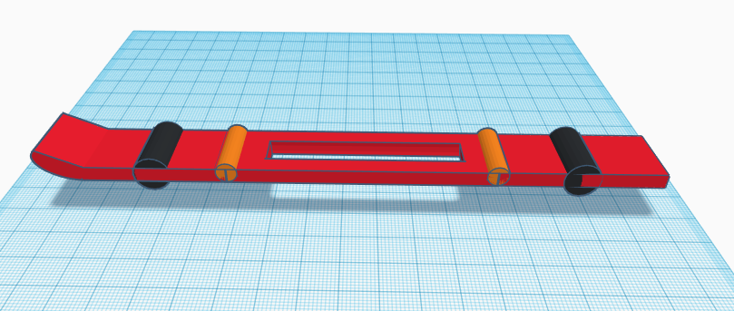
Figure 4 - Initial Concept Design (Screenshot of CAD file)

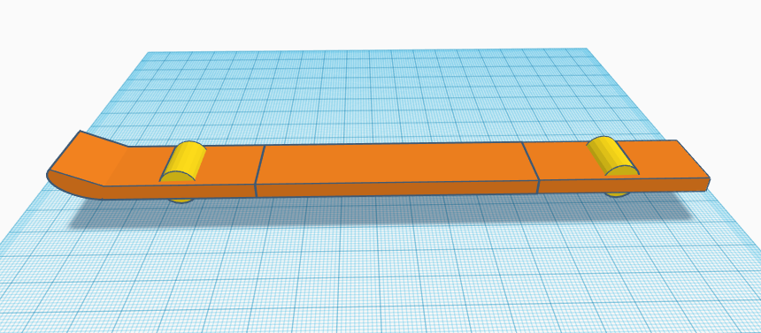
Figure 5 - Prototype I (screenshot of CAD file)

3.0 Conclusion & Recommendation for Future Work:

Conclusion:
This course taught us how to better plan out large group projects. It also taught us the logistics behind running a business as well as the design and problem refinement process. In terms of running a business, it taught us how to find a target market and then create a product to dominate said market. This course greatly improved our problem refinement skills because it pushed us to keep simplifying the problem to its raw essence and then solve this isolated idea. Once the problem was refined, thinking of a solution was very easy. Additionally, this course taught us key client interviewing skills that we can use to interact with our future clients in order to isolate their needs. Another great skill this course taught us was the process of economically assessing our business idea to determine its viability. This taught us how budgeting for projects in general works as well as other major aspects besides capital. These aspects include management, marketing and environmental impact.

Lessons Learned:
Team work, time management, management of priorities, how machines interact with various materials (e.g. how the strength and durability of the 3D printing filament can rapidly decrease when it has been milled) and generate simple and effective solutions for the given problem. Additionally, we also learned just how much work can go into making a simple piece of a larger project and just how time and energy consuming a well thought out project can be.

4.0 Bibliography

Global Electric Wheelchair Market Outlook 2018-2023. (2018, April/May). Retrieved December 3, 2018, from https://www.planetmarketreports.com/reports/global-electric-wheelchair-market-3009

