GNG2101 Report Template

Project Deliverable F: Prototype II

Submitted by
C23, TalkBox
Victoria Jancowski, 300203985
Kaiyi Yuan, 8617972
Michael Hetu, 300209299
Chuanzhi Li, 300055864

Date February 21, 2021
University of Ottawa

Abstract
This report details the organization of the various prototypes and prototyping tests to develop a fully functional prototype that fulfills the previously identified needs of clients, Roy, and Anthony. It includes both the physical and software prototypes, and the testing of these individual components, as well as the feedback from both Anthony and Roy from the third client meet. The final prototype will be based of both the tests and the protypes realized in this report and will be combined with the feedback from the clients to final a completed design. Also included are further recommendations to the prototypes and specified levels of testing that need to be completed for the final product.

Table of Contents
Abstract i
Table of Contents ii
List of Figures iv
List of Tables v
List of Acronyms vi
1 Introduction 7
2 Client Feedback Summary 8
3 Prototype II 9
3.1 Software Prototypes 9
3.1.1 Graphical User Interface 9
3.1.2 Joystick control code 12
3.2 Physical Prototypes 14
3.2.1 Raspberry Pi and Screen 14
4 Prototype II Testing 16
4.1 Software Testing 18
4.1.1 Graphical User Interface Testing 18
4.2 Physical Testing 21
4.2.1 Raspberry Pi Operating System 21
4.2.2 Software Test on the Hardware 22
5 Conclusions and Recommendations for Future Work 24
6 Bibliography 25
APPENDICES 26
APPENDIX I: Project Management 26

List of Figures
Figure 3.1.1.1 - GUI Code 9
Figure 3.1.1.2 - GUI Code 10
Figure 3.1.1.3 - GUI Code 10
Figure 3.1.1.4 - GUI Code 11
Figure 3.1.1.5 - GUI Code 11
Figure 3.1.1.6 - GUI Code 12
Figure 3.1.2.1 - Example of Joystick Configuration – Provided by RaspberryPi Spi 13
Figure 3.2.1.1 - Raspberry Pi with Installed Heatsinks 14
Figure 3.2.1.2 - Raspberry Pi with Installed Heatsinks 15
Figure 3.2.1.3 - LCD Screen on Raspberry Pi 15
Figure 3.2.1.4 Side View of Encased Raspberry Pi and Screen 16
Figure 4.1.1.1 - Main Menu Categories 18
Figure 4.1.1.2 – Social Interactions Phrases 19
Figure 4.1.1.3 - Smart Home Interaction Phrases 19
Figure 4.1.1.4 Caretaker Interactions Phrases 20
Figure 4.1.1.5 - Grocery Shopping Sub Menu 20
Figure 4.1.1.6 - Doctors Sub Menu 21
Figure 4.2.1.1 Raspberry Pi with OS and Screen On 22
Figure 4.2.2.1 - Software Test With Raspberry Pi and Python Code 23
Figure 4.2.2.2 Phrases Menu on the Assembled Hardware 23

List of Tables
Table 2.1 - Client Meet Feedback 8
Table 4.1 - Table of Cumulative Testing 16

List of Acronyms
Acronym | Definition
GUI | Graphical User Interface
LCD | Liquid Crystal Display
OS | Operating System

Introduction
This report outlines the integrated prototypes that were previously constructed into the beginnings of a fully functioning and comprehensive prototype. The software prototypes have been updated and the functions (text-to-speech, reading of the menu, navigating through menus) have been implemented into the main program. The physical components of the projects were combined by the installation of heatsinks to the raspberry pi, the uploading of the Raspbian operating system to the raspberry pi, and the connection of the LCD screen to the raspberry pi. As well prototype II includes the combination of the software components with the hardware components. This was achieved through uploading the current graphical user interface to the microSD card (inserted into the raspberry pi), that houses the operating system and uploading the Microsoft Excel sheet that contains both the categories and the phrases to the microSD as well.
Like the previous prototypes, prototype II was further tested and appraised based off of the client feedback provided in client meet three. Based on the analysis of this prototype, within the last few weeks of the design process, the final product is subject to debugging, completion of the joystick navigation system, and final adjustments. It will then be distributed to the clients for further testing.

Client Feedback Summary

The feedback provided by Roy and Anthony from client meet three is organized into Table 2.1. This takes the suggestions from the observations of the clients, and organizes them for a simple way to view their meaning and intent behind what would improve the TalkBox device.
Table 2.1 - Client Meet Feedback
Client Observation | Feedback
Too big a gap on the screen under welcome to TalkBox. | Remove welcome to talk box and the blank space under it. Fill it with the categories and phrases and make the font as big as possible.
No settings button. | Create a settings button so that people can change the joystick function, the size of the font, and the colors of the text(Black and Yellow, Day Mode, Night Mode).
Joystick will move fast. | Make sure the Joystick will be programmed to move slow.
Too much connecting with power supply. | Just use a USB connection to the wheelchair battery, for now just use computer power supplied from USB Port.
Bright screen on all the time can hurt eyes. | Consider an idle state. If someone has not used the program for a period of time, let the screen go black and awaken it with the joystick.
Gooseneck is too long and cumbersome. | Implement a smaller gooseneck in the design. (Locline or Rammount)

Prototype II

Software Prototypes

Graphical User Interface
The graphical user interface allows the user to navigate through the categories of phrases they would like to access, and upon selection shows the phrases that they can choose. When the desired category, or the desired phrase is selected, the text-to-speech function will be engaged, and a voice will speak the selection. At the end of the listed categories, there will be an exit application button, and on the phrases menu there will be a return to main menu button. This will allow the user the ability to navigate the program as well as speak through the program. Also included in this GUI is the caretaker modification ability that imports the desired phrases and categories from a modifiable Excel Document.

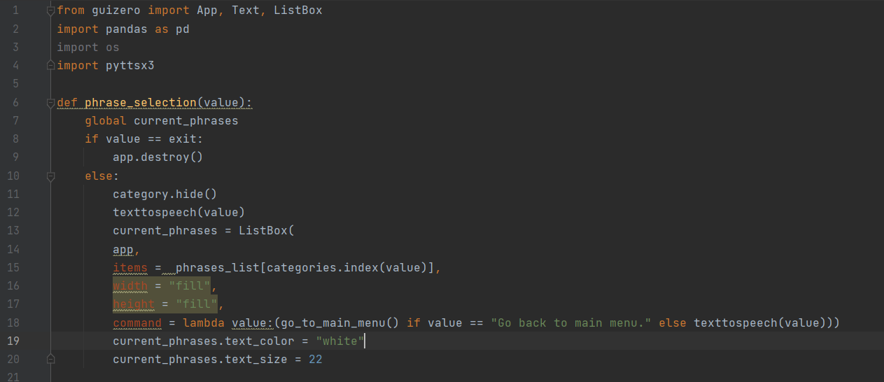
Figure 3.1.1.1 - GUI Code

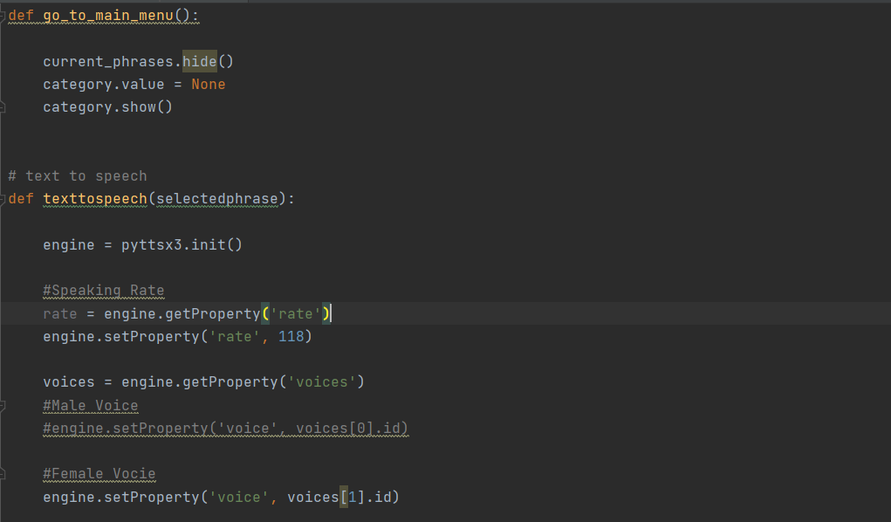
Figure 3.1.1.2 - GUI Code

Figure 3.1.1.3 - GUI Code

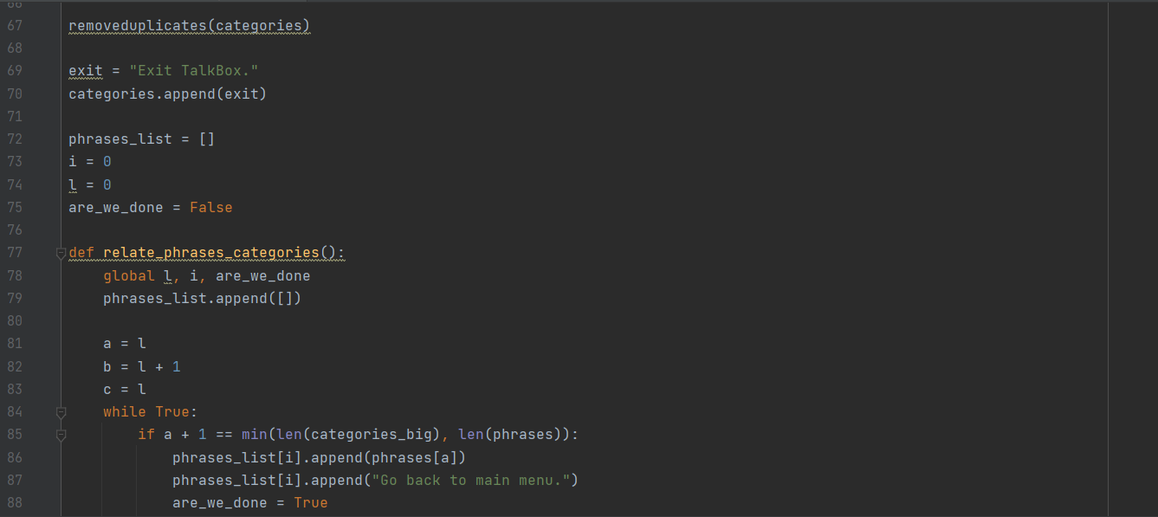
Figure 3.1.1.4 - GUI Code

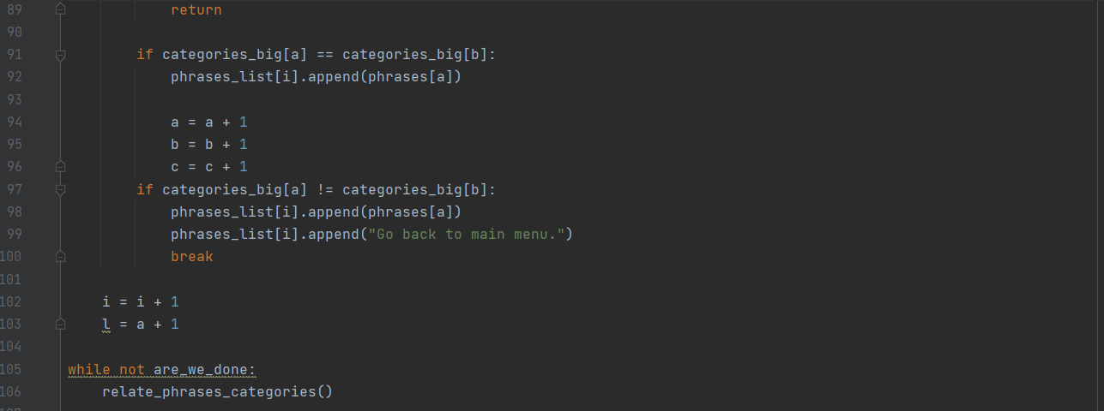
Figure 3.1.1.5 - GUI Code

Figure 3.1.1.6 - GUI Code

Joystick control code
This is the first attempt at creating a code that controls the joystick, and its functionality. The next step in prototyping with combine the code with the graphical user interface, so that the GUI will be completely navigable. The joystick will provide users with the ability to control the choices of categories and phrases that they desire to be spoken. And offer a way to scroll through the phrases and categories.
#!/usr/bin/python
import spidev #The spidev library is used in the script
import os
import time

# Define Axis Channels, Channel 3 to 7 can be assigned for more buttons or joysticks
swt_channel = 0
vrx_channel = 1
vry_channel = 2
#Time delay, the time it takes to read out the value
delay = 0.5

# Spi oeffnen
spi = spidev.SpiDev()
spi.open(0,0)
spi.max_speed_hz=1000000
# Function for reading the MCP3008 channel between 0 and 7
def readChannel(channel):
val = spi.xfer2([1,(8+channel)<<4,0])
data = ((val[1]&3) << 8) + val[2]
return data

# endless loop during the opeartion of the joystick
while True:
# Determine position of the targeted point on the screen
vrx_pos = readChannel(vrx_channel)
vry_pos = readChannel(vry_channel)
# SW determine
swt_val = readChannel(swt_channel)
# output
print("VRx : {} VRy : {} SW : {}".format(vrx_pos,vry_pos,swt_val))
# wait
time.sleep(delay)

#the MCP3008 returns a value between 0 and 1023. If the joystick is in the middle, around 512 will be returned. 0 is returned at one end of one axis and 1023 at the other end.

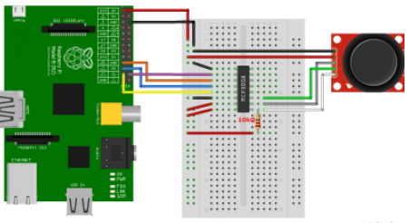
3.1.2: Code for scan menu and test
High lighting
We choose the label of tkinter as a highlighting way.
The label will show the ongoing the button
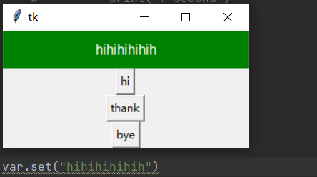
Time counter
We choose the time library to achieve the time counter
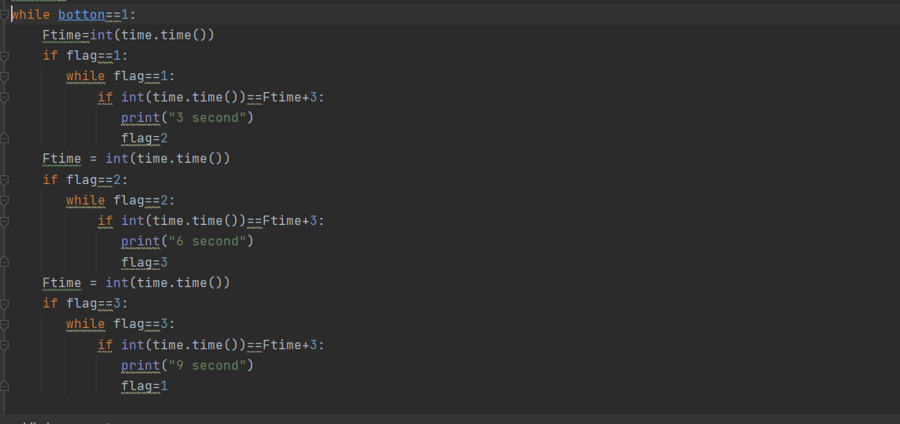
It can achieve that choosing the arbitrary time as one counter and counter loop of arbitrary phase.
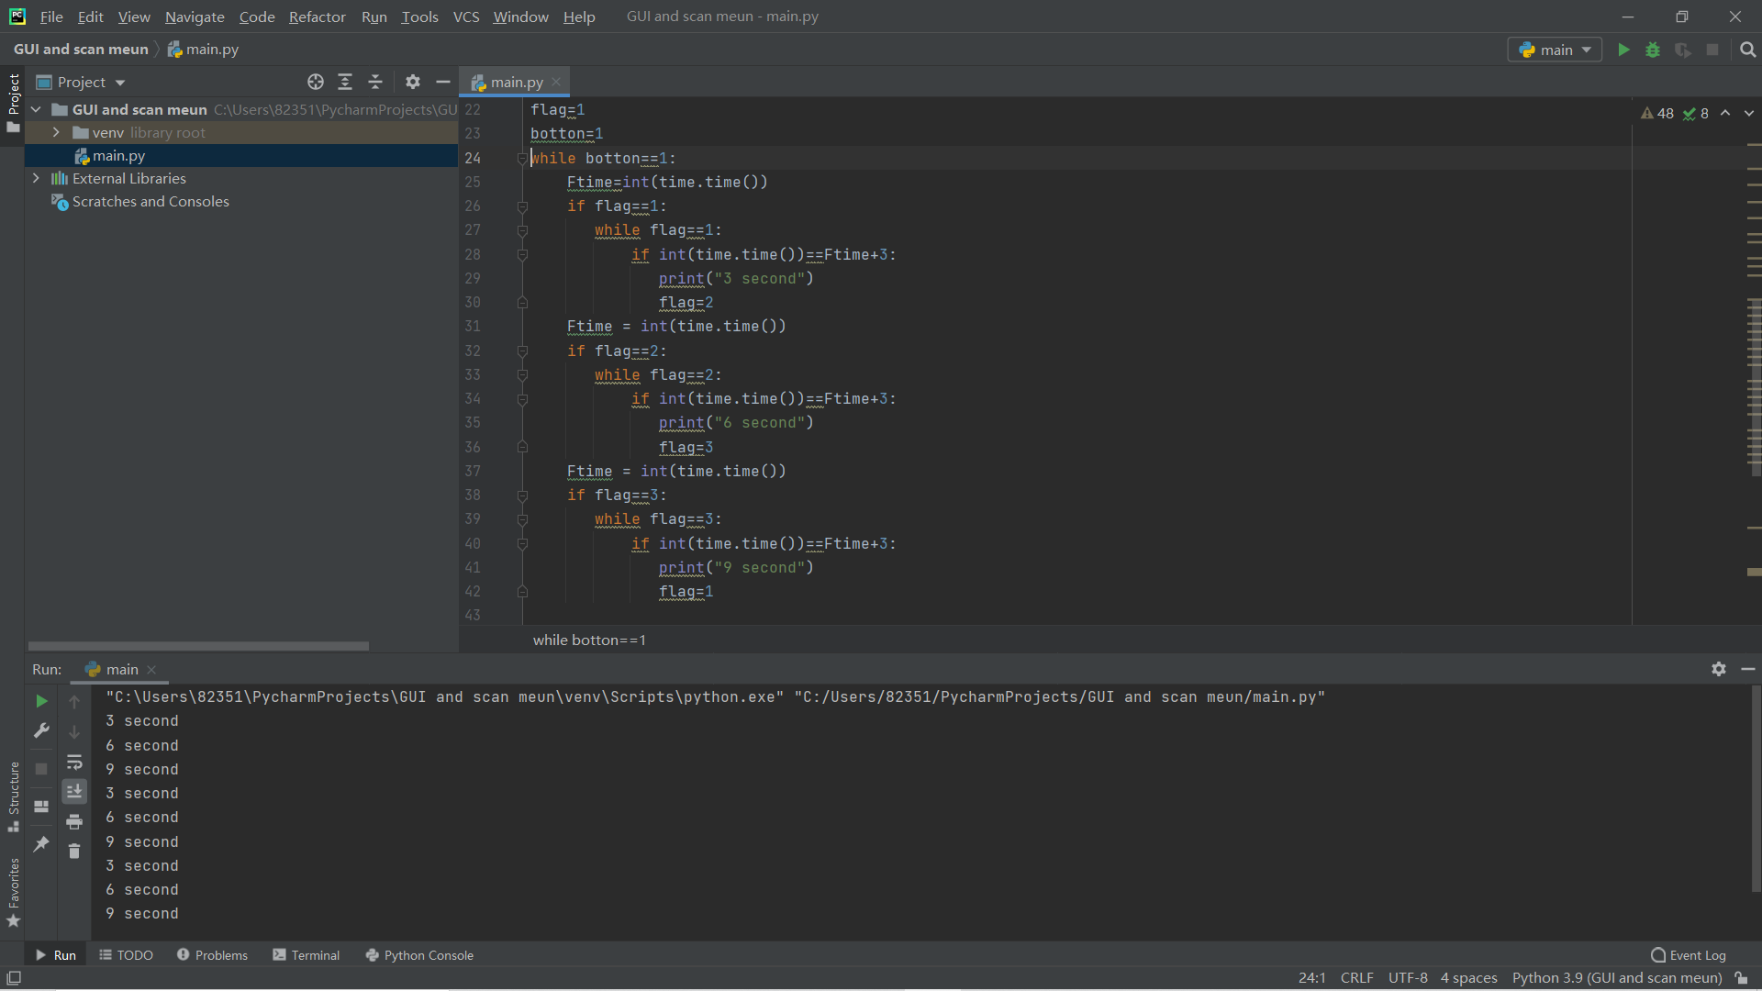
The phase “3 second” etc. can be replaced to any phase we want to.
Also, the print function can be replaced by ver.set to make change on label of GUI (achieve the requirement). However, the code seems unable to work with GUI at the same time.
For now, I am unable to combine it together because of some technical issues.

Figure 3.1.2.1 - Example of Joystick Configuration – Provided by RaspberryPi Spi

Physical Prototypes

Raspberry Pi and Screen
The combined components of the Raspberry Pi and the LCD allow the user to see the screen and make modifications to the Excel Document through touch. Both were attached together and secured using a case, encapsulating the two. A microSD card was also used to load the operating system (Raspbian), the python files, and the Excel Document. Two heat sinks were also installed: one on the CPU and one on the network card.
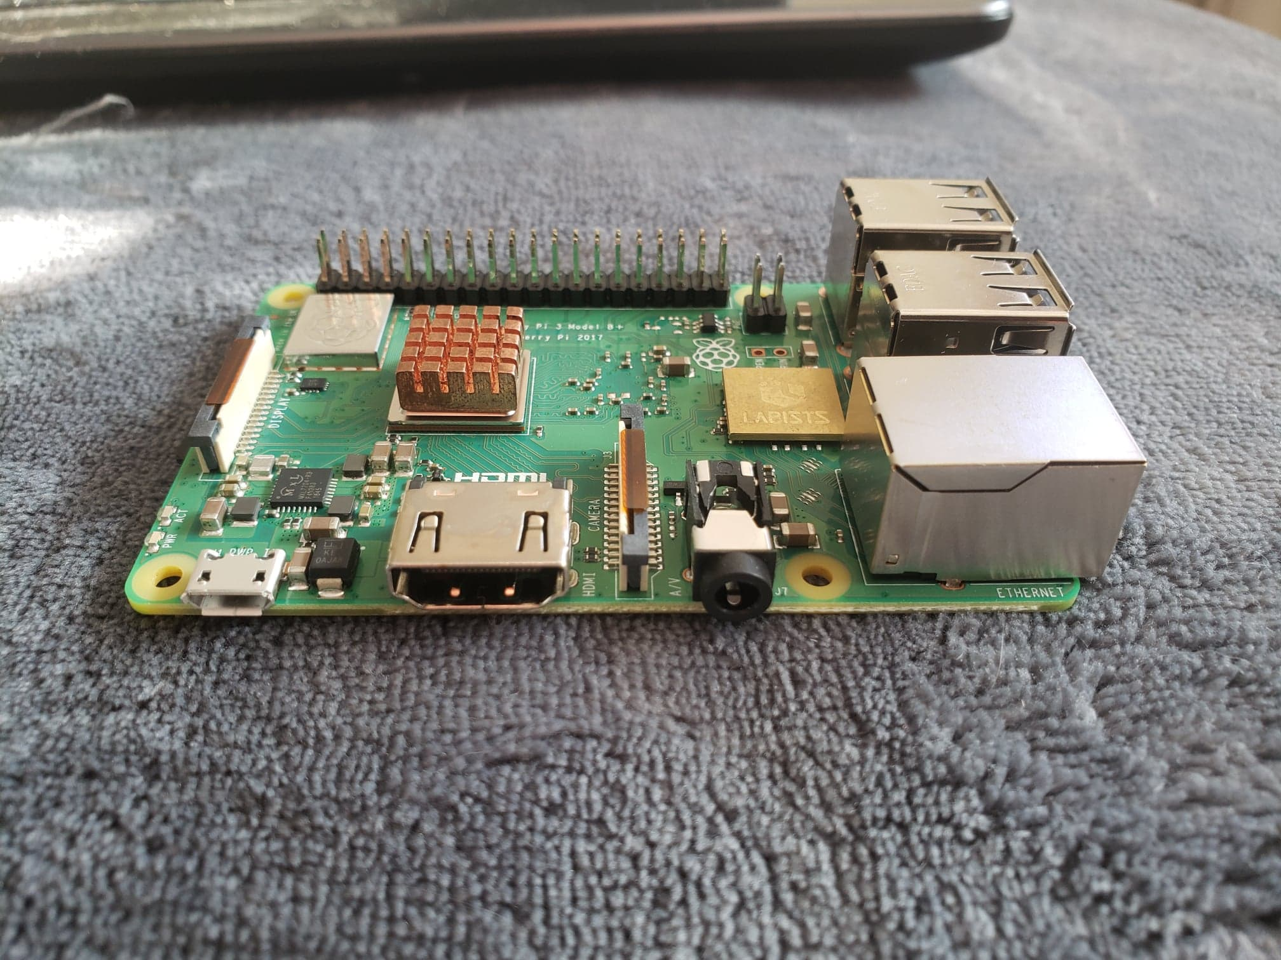
Figure 3.2.1.1 - Raspberry Pi with Installed Heatsinks
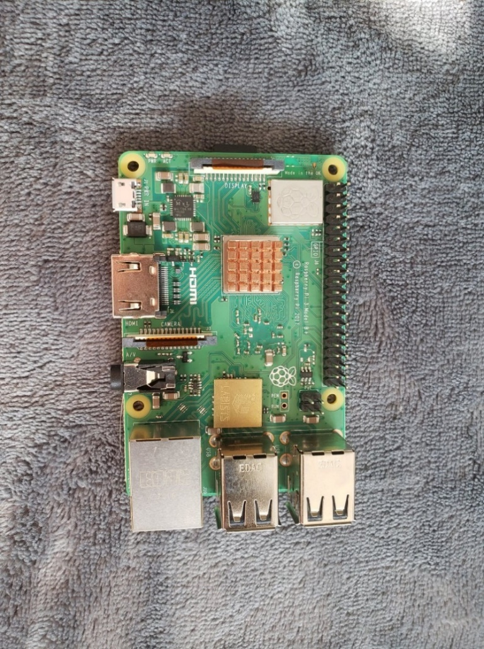
Figure 3.2.1.2 - Raspberry Pi with Installed Heatsinks

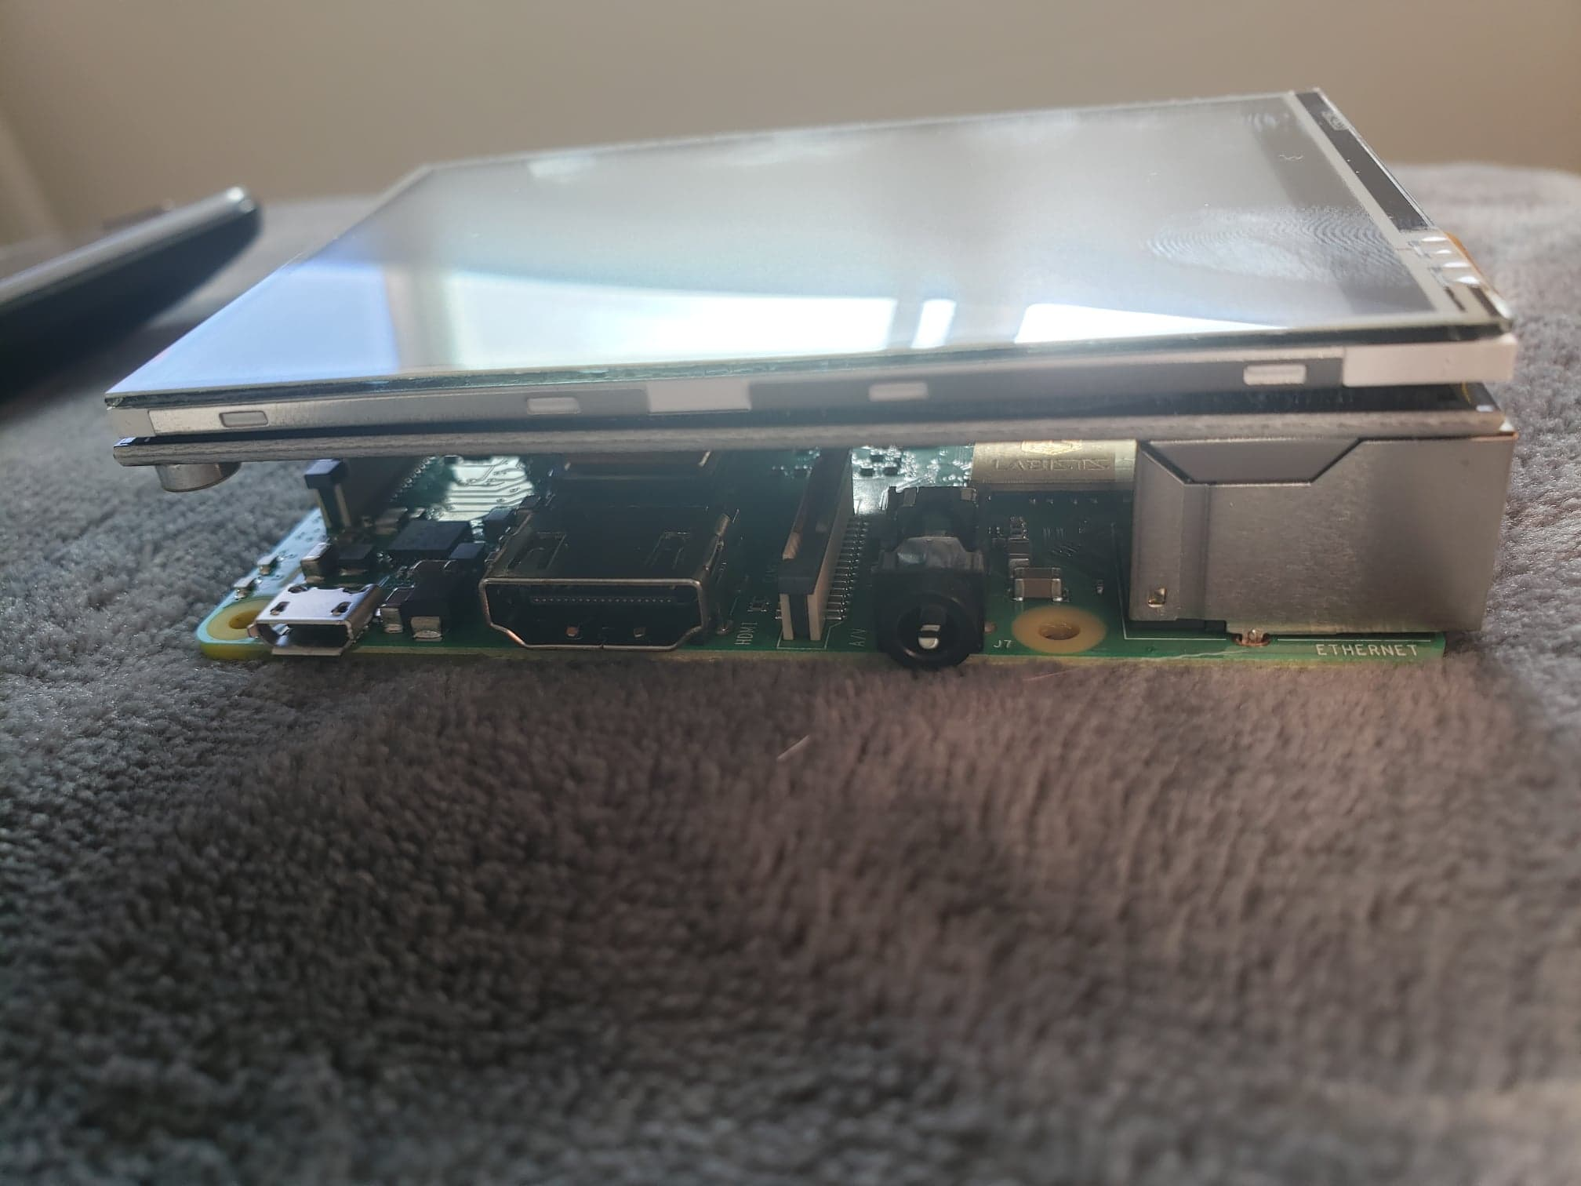
Figure 3.2.1.3 - LCD Screen on Raspberry Pi

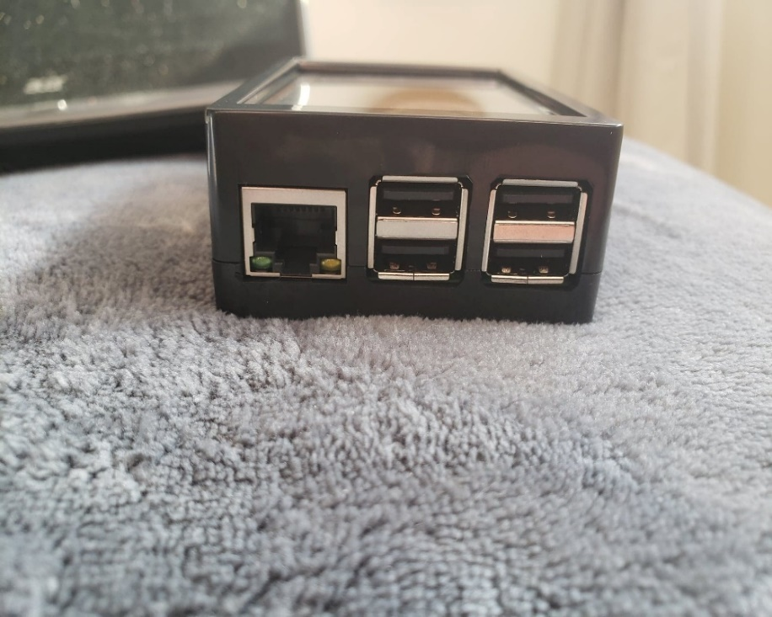
Figure 3.2.1.4 Side View of Encased Raspberry Pi and Screen

Prototype II Testing
Below is the table illustrating the current tests done, and to be done, and what has been tested and verified up until now. The testing conducted over the course of prototype II was of the continuously updated software, and of the construction of the physical device. It also tests the combination of the software and the hardware all in one.
Table 4.1 - Table of Cumulative Testing
Metric | Unit | Target Value | Actual Value | Justification | Verified Through Testing
Device will provide user with text on screen. | Y/N | Y | Y | Device will be easy to use and provide user with visual cues. | Yes
Button/switch will reset when user has lifted hand. | N | 3.5 | N | Important that the button functions for all types of users with all types of dexterity. | Not Yet
Software will be easily modified by users through settings button. | Y/N | Y | N | Important that software is easy to use for all persons. | Not Yet
Voice Interaction with Smart Devices | Y/N | Y | Y | Client requested that interaction with smart devices be available. | Yes
Device functions offline. | Y/N | Y | Y | Offline ability will allow user to operate anywhere. | Yes
Text-to-Speech Ability | Y/N | Y | Y | Prototype will have ability to provide user with simplified communication. | Yes
Requires a simple switch or a button. | Y/N | Y | N | Allows the user to navigate the program easily. | Not Yet
Simple User Interface | Y/N | Y | Y | Requested by the client for function ability. | Yes
Adaptable User Functionality | Y/N | Y | N | Allows user to modify the program according to individual needs. | Not Yet
Device possess large, diverse phrase bank. | kB | 1.5 | Y | Program will allow user to use as many or as little phrases as they desire. | Yes
The device is portable through mount. | Y/N | Y | N | Client requested the device be portable through use of wheelchair. | Not Yet
The device will charge through wheelchair. | kWh | .015 | Y | Client requested the device be chargeable through use of wheelchair battery. | Yes
Device is durable. | Y/N | Y | N | Device will be drop tested in order to ensure durability | Not Yet
Device is inexpensive. | $ | 0 | N | The cost for the user will be low. | Not Yet
Device is Eco-Friendly. | Y/N | Y | N | The device will provide a neutral or negative carbon footprint. | Not Yet

Software Testing

Graphical User Interface Testing
Below are the images of the graphical user interface being tested. The prototype meets the expected results by compiling successfully and completing the tasks designed for the TalkBox. The program navigates in the proper way upon selection of the categories and of the phrases and uses text-to-speech on the selected phrases and categories. The application also goes back to the previous menu upon selection and exits the app upon selection as well.
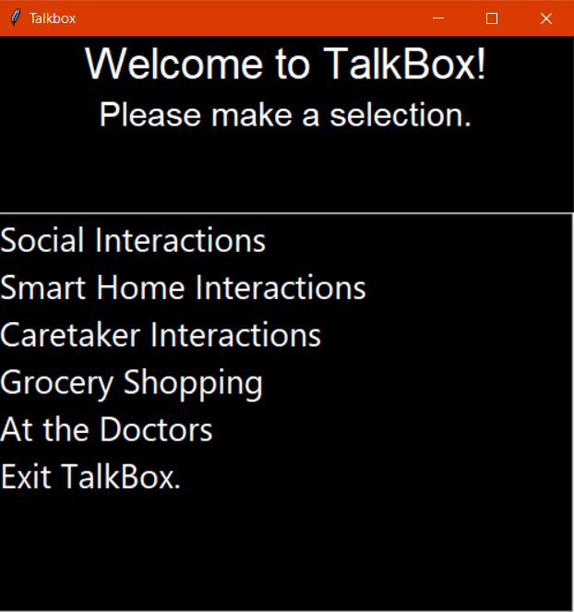
Figure 4.1.1.1 - Main Menu Categories

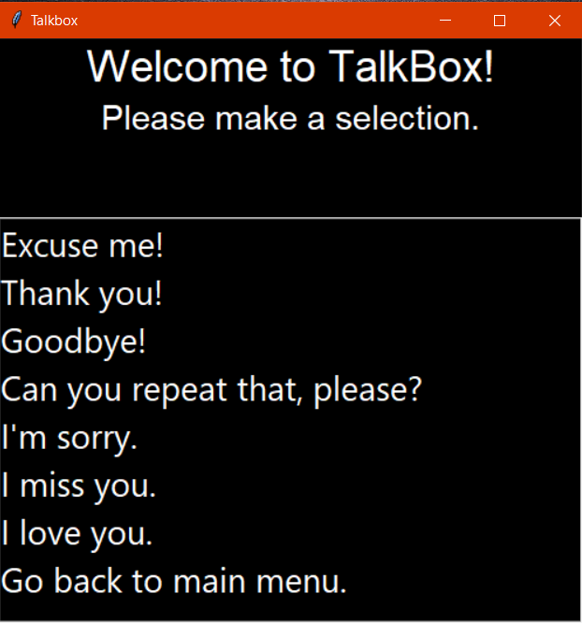
Figure 4.1.1.2 – Social Interactions Phrases
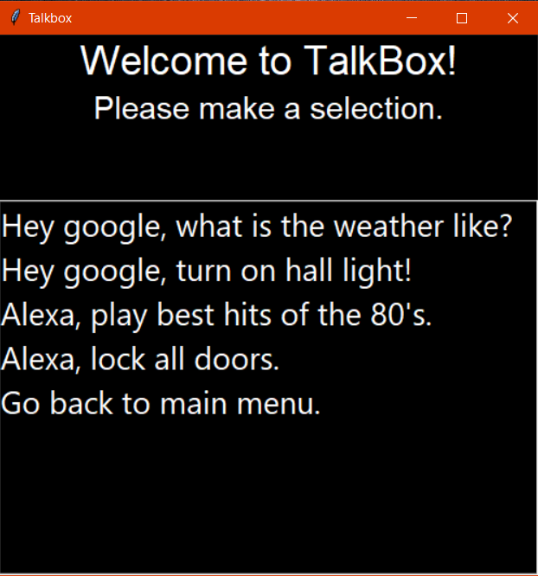
Figure 4.1.1.3 - Smart Home Interaction Phrases

Figure 4.1.1.4 Caretaker Interactions Phrases
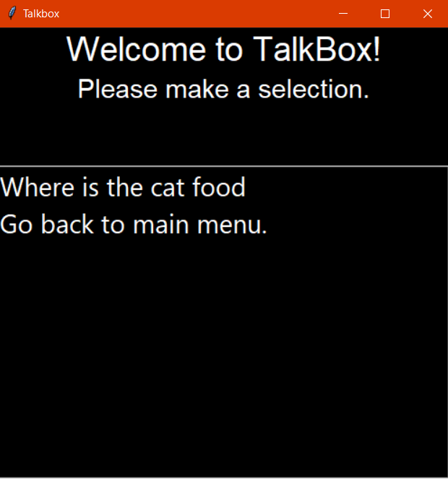
Figure 4.1.1.5 - Grocery Shopping Sub Menu

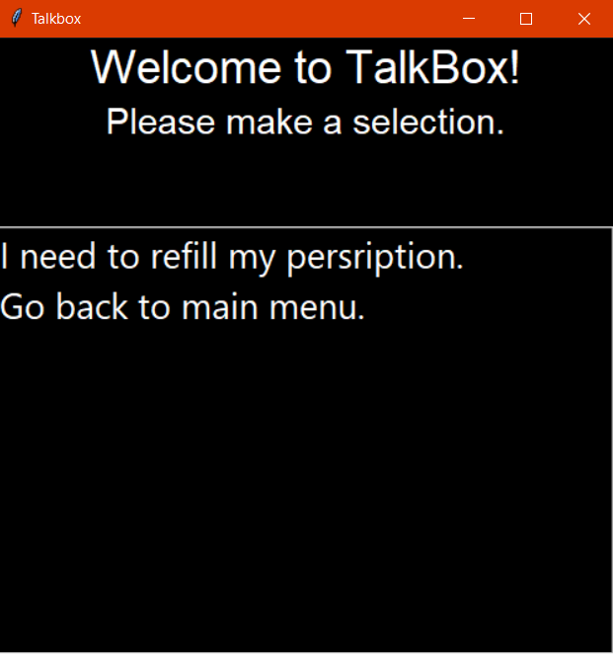
Figure 4.1.1.6 - Doctors Sub Menu

Physical Testing

Raspberry Pi Operating System
The first step in the physical testing was making sure all of the components worked together, and that the system turned on after installing all of the appropriate drivers and the operating system. This took multiple attempts due to missing drivers for the LCD screen and the need for a monitor to begin to program the raspberry pi.

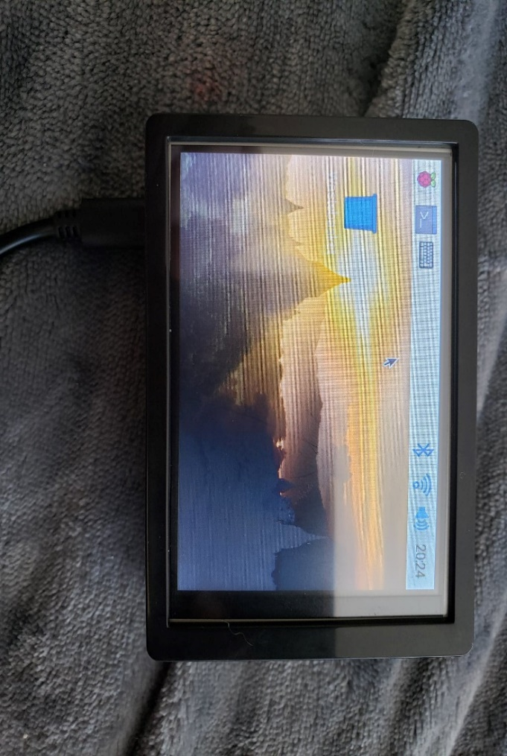
Figure 4.2.1.1 Raspberry Pi with OS and Screen On

Software Test on the Hardware
The software test on the assembled hardware was very buggy. There were multiple imports that needed to be done, a reworking of the code that provides the location of the excel file, and voice alterations to make the voice seem more human. The importing of the various installs proved very complicated an elusive as multiple exceptions were brought around in operating in Linux versus windows. This took lots of time of researching and installing and uninstalling different modules and packages. The voice sounds a bit too robotic, but Linux only runs espeak for the pyttsx3 module that is being used as the text to speech function. In the future, work arounds will be explored to make the voice seem more human. The placement of the online widgets will also need to be moved around for better visibility and accessibility while using the product.
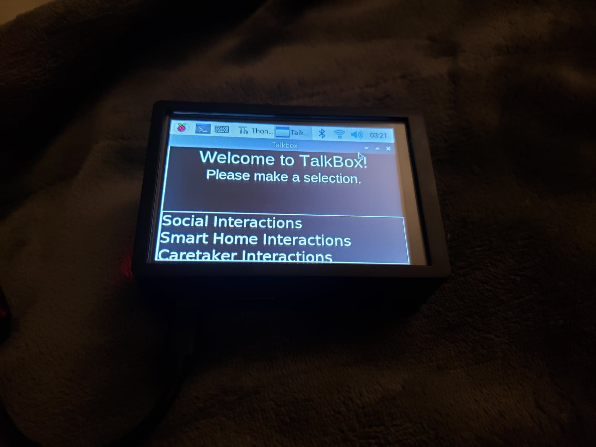
Figure 4.2.2.1 - Software Test With Raspberry Pi and Python Code

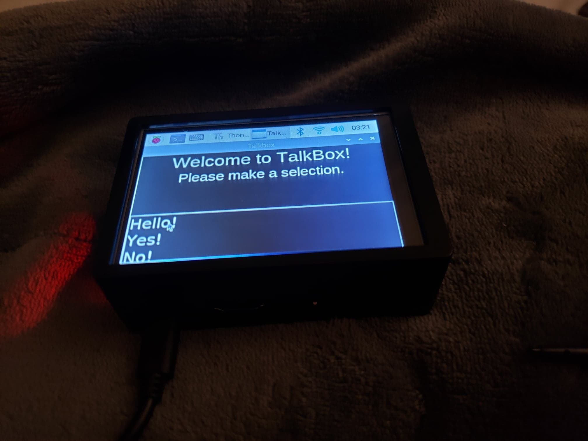
Figure 4.2.2.2 Phrases Menu on the Assembled Hardware

Conclusions and Recommendations for Future Work

In conclusion, by creating and following a thorough a rapid iterative prototype plan, both software and physical prototypes were created. The conceived final prototype as outlined in this document, is a high-fidelity comprehensive prototype of an application that fulfills the needs of the clients, Patrick, and Roy. The implementation of feedback received from the first prototype resulted in the development of the second and final prototype which exceeds the targeted metrics in ease of navigation and user experience.
In the future, the joystick with be created and the joystick programming will be added to the final program. The team will also refine the enclosure of the physical components and alter the aesthetics of both the software and physical hardware.

Bibliography

Man, Average, et al. “Using A Joystick On The Raspberry Pi Using An MCP3008.” Raspberry Pi Spy, 25 Feb. 2016, www.raspberrypi-spy.co.uk/2014/04/using-a-joystick-on-the-raspberry-pi-using-an-mcp3008/.

APPENDICES

APPENDIX I: Project Management

Here is the snapshot of the Gannt Chart.
https://www.wrike.com/frontend/ganttchart/index.html?snapshotId=c6R3Q39PywG1fFWp8bk0aW8R8aR5jQSC%7CIE2DGNBUHAYDALSTGE3A

