Project Deliverable H: Group 8

Eunhyo Jung, George Lai, Anuar Magauya, Ines Senhadji, Ronan William Thomas
March 24, 2024

Abstract
Group 8 has the following problem statement: Mines Action Canada wants a story-driven video in a VR envirnment that will convince politicians to ban autonomous weapons, by showing how non-combatants will be affected by these weapons. Previously, Group 8 has produced a plan for a first prototype: a VR environment with a player that can move and interact with the environment. This was made so that our team would be sure our VR environment could be set up and be stable when using the virtual reality equipment. Prototype 2 has improved on the shortcomings of prototype 1 and enhanced the environment through subtitles, a cinematic mode, an animated NPC, more detailed box colliders, a nighttime skybox and enhanced lighting. Prototype 3 aims to improve the story and introduce better animations. A working game menu and objective waypoints to direct the player and trigger events were also introduced to prototype 3.

Table of Contents

Introduction 4
Prototype 3 – Analysis 4
Working Towards the Finished Project 6
Conclusion 6

Introduction
Group 8 has the following problem statement: Mines Action Canada wants a story-driven video in a VR environment that will convince politicians to ban autonomous weapons, by showing how non-combatants will be affected by these weapons. Prototype 3 introduced an improved story and better animations. It also included a game menu and objective waypoints to direct the player and trigger events. With all our prototypes now being completed we can now focus entirely on working towards our final project. We are aiming to complete this project to the best of our ability, and we are making sure it delivers on all fronts. We want to create something that we are proud of and will impress and stand-out on design day.

Prototype 3 – Analysis
Figure 1
Updated Model for NPC
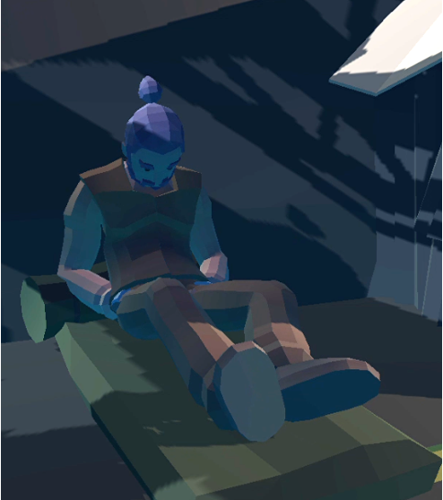

Figure 1 shows off the new model for the NPC introduced in Prototype 3. With this new model that fits the setting better also comes improved animations that are completely functional and draw the player into this world. This is a significant improvement of both the previous model and animations.

Figure 2
In-game Menu
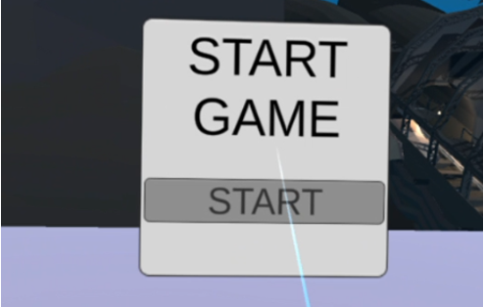
Figure 2 includes the in-game menu developed for prototype 3 that enables the player to start the game at their choosing instead of beginning immediately on boot-up. This gives the players a chance to start at their leisure and give them time to get adjusted to the VR environment.

Figure 3
Objective Waypoint
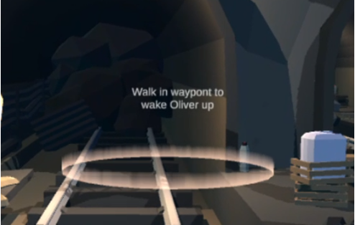
Figure 3 highlights objective waypoints that will be used to direct the player through the environment and give hints as to where they should go. These will not be used to restrict the player as the player can still explore the environment at their own pace. They will simply be used to guide the player through the story.

Working Towards the Finished Project

- improved story and animations: To effectively convey the impact of autonomous weapons on non-combatants, we are committed to constantly refining and rewriting our narrative. Additionally, we will dedicate more effort to enhancing the animations to create a truly immersive and captivating experience for our users.

- enhanced user experience: we understand the significance of providing a seamless and intuitive user experience in virtual reality environments. To achieve this, our focus will be on ensuring that the in-game menu introduced in Prototype 3 is easy to navigate and user-friendly. Moreover, we will continue to enhance the objective waypoints to provide clear guidance to players while also granting them the freedom to explore the environment at their own pace.

- technical optimization: as we approach the final stages of development, we must prioritize the stability and performance of our solution. To achieve this, we will conduct meticulous testing to identify and address any potential glitches or performance issues, ultimately ensuring a smooth-running environment.

- integration of feedback: gathering feedback from a variety of sources, including users and clients, is an integral part of our development process. We will actively seek opportunities to obtain insights and perspectives from diverse individuals, including friends, TAs, and other relevant parties.

Conclusion

Prototype 3 represents an important step in the development of our solution for Mines Action Canada. Following our previous progress made in our previous prototypes, we improved story content, game visuals, user interface, and overall user experience. Our team is fully committed to finding solutions to best align with our client's goals as we work towards the final project. We prioritized key elements such as clear storytelling, user engagement, technological advancements and additive feedback to create an engaging and impactful virtual reality experience.

