Cost Estimate and Project Plan for “Hot Car Emergency”
Deliverable E

Project Group B2
Jacob Williams, Qaswar Al-Hindawi, Lauren Juneau, Navi Selvaratnam

October 26, 2021

Table of Contents
1.0 Introduction 1
2.0 Design Overview 2
3.0 Schedule for Prototyping and Testing 3
3.1 Wrike Update 3
3.2 Risk and Contingency Plan 3
4.0 Bill of Materials 4
5.0 Conclusion 4

1.0 Introduction
The client was very satisfied with our presentation, and provided brief, but helpful feedback during our meeting held October 19th. Since then, a final design plan has been materialized by means of a series of detailed sketches, as well as a comprehensive agenda and contingency plan for the project going forward. This ensures efficiency and minimal hiccups. Furthermore, a thorough assessment of the parts necessary for the prototypes was conducted (in other words, a bill of materials was formulated) to remain on budget and accurately account for the specific parts needed to purchase. With these exhaustive tasks accomplished, the group is well set-up for success in future deliverables.

2.0 Design Overview
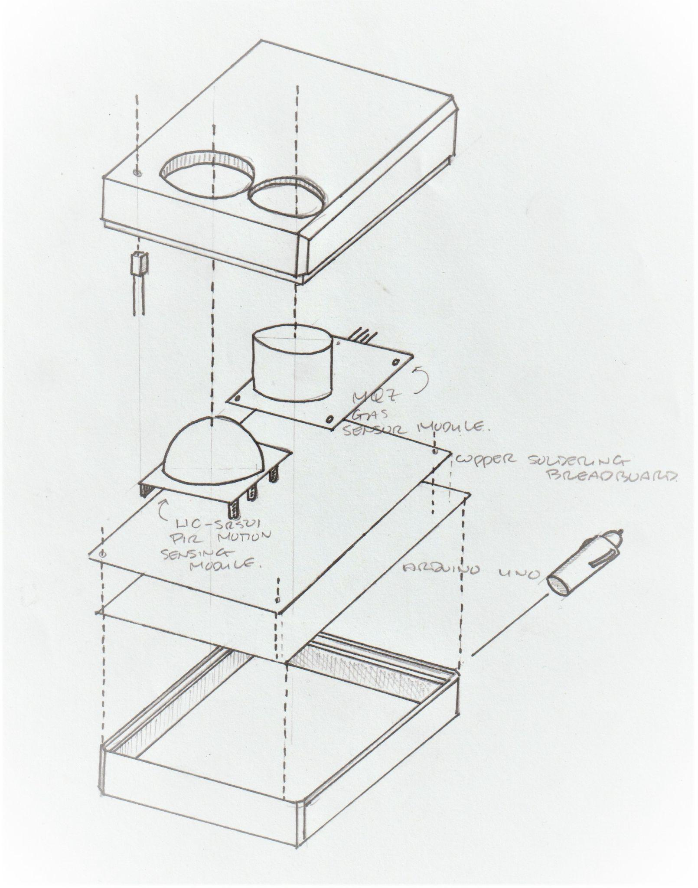
Figure 1: exploded view of the prototype design

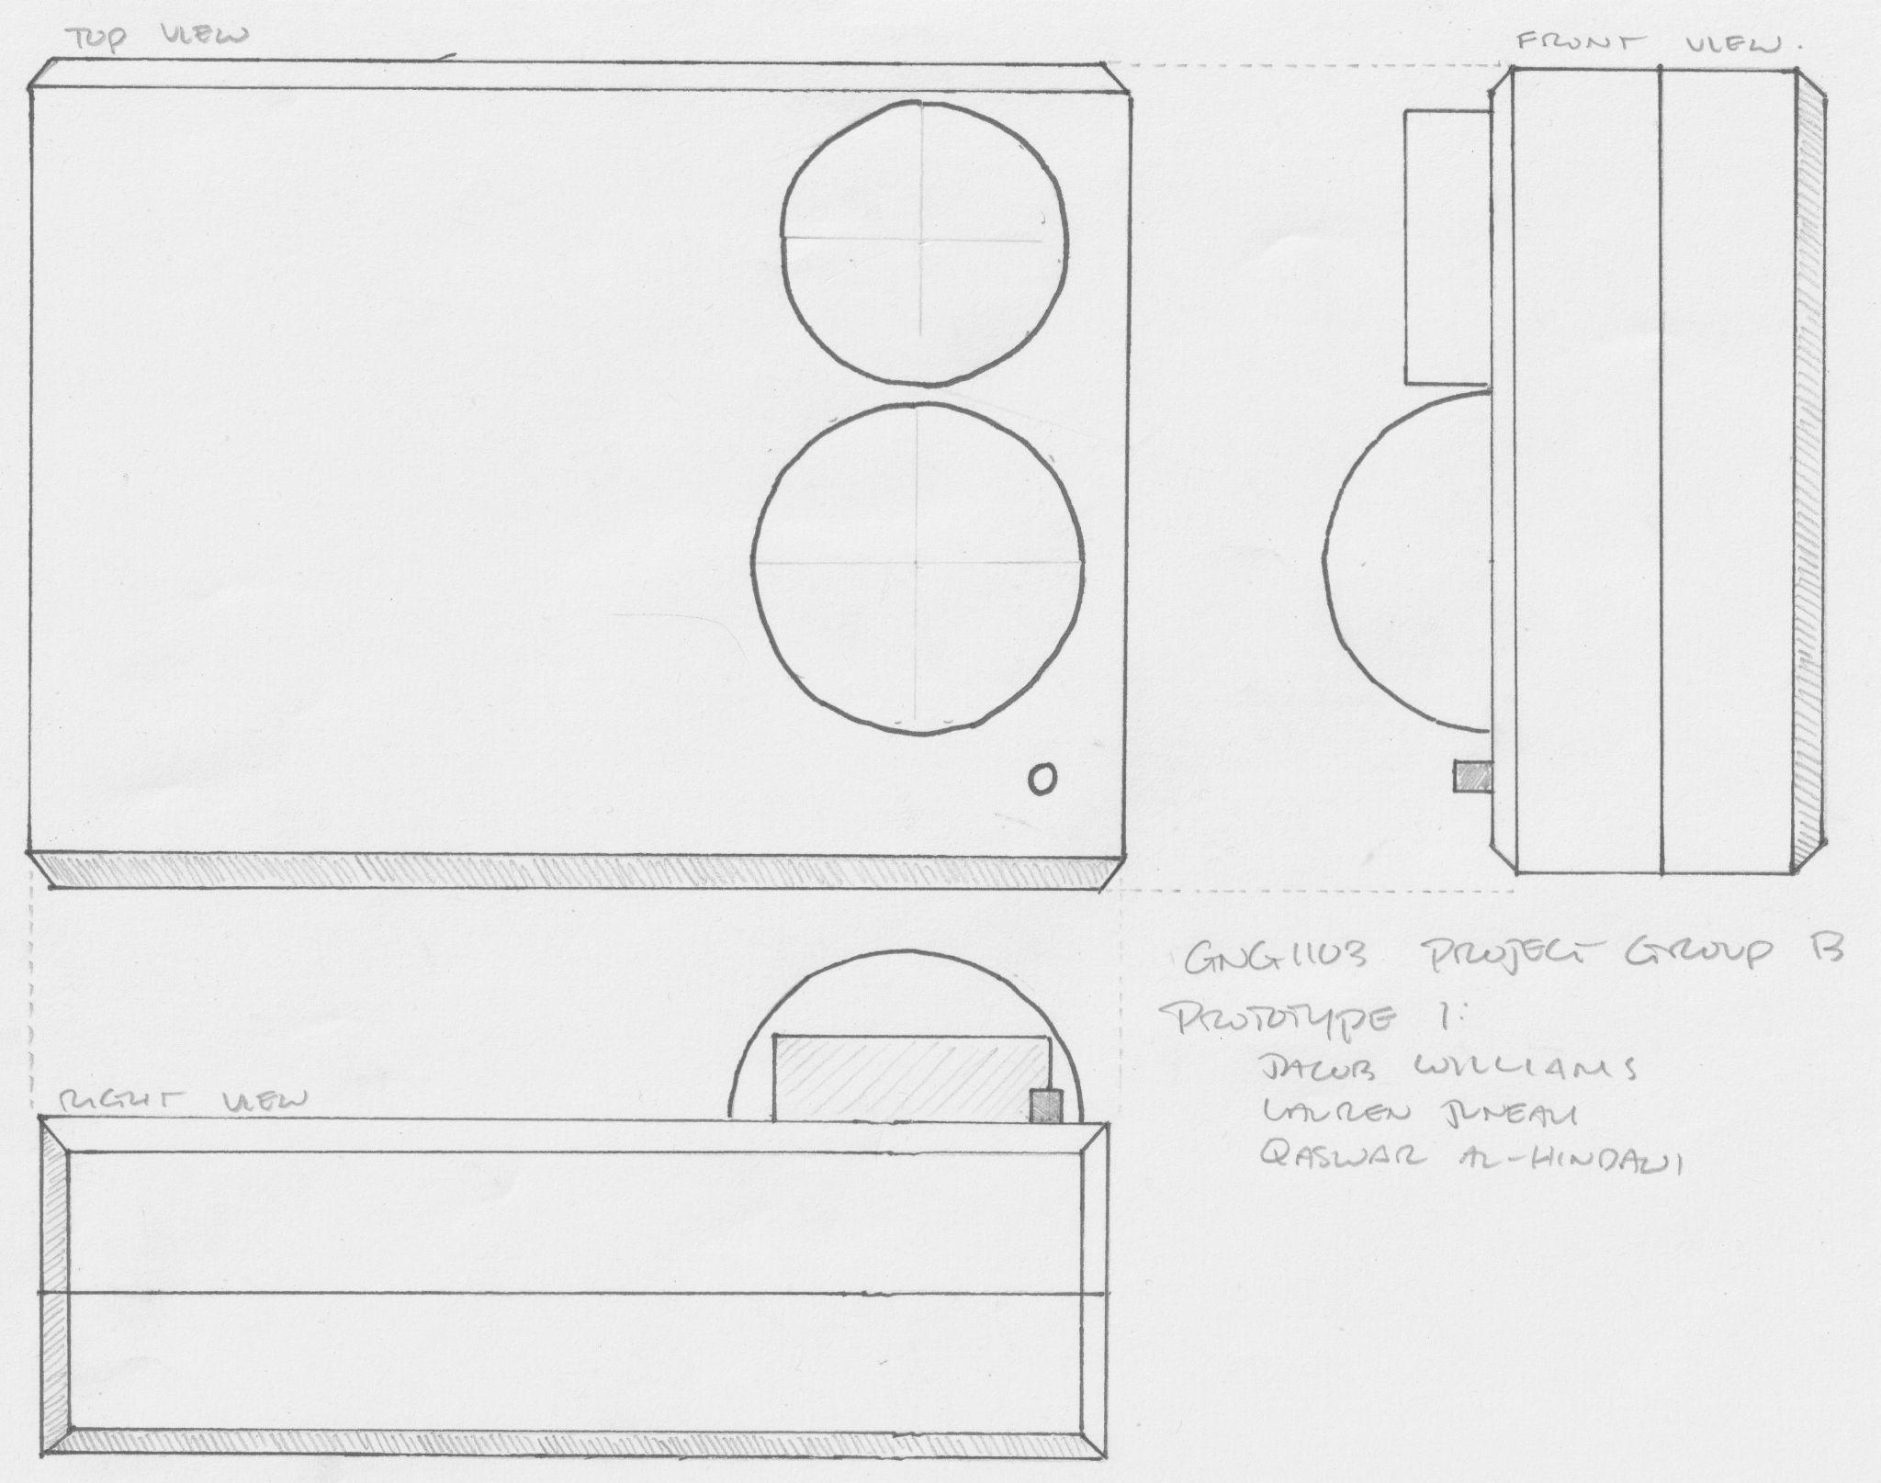

Figure 2: Third-angle projection drawing of the prototype design

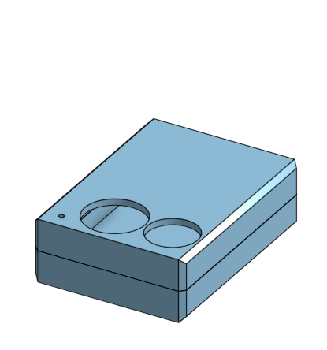
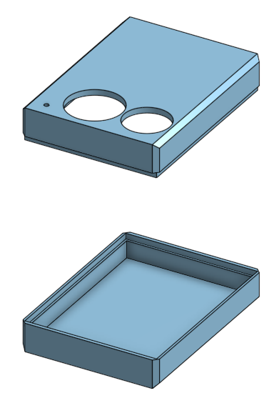

Figure 3: Prototype case render

3.0 Schedule for Prototyping and Testing
Task Name | Sub Tasks | Dependencies | Estimated Duration (days) | Owner(s) | Due Date
Deliverable E: Project Schedule and Cost |  |  |  |  | Oct 26th
 | Refine Drawings | N/A | 1 | Jake | Oct 23rd
 | Draw and Describe Solution | Refine Drawings | 2 | Jake | Oct 24th
 | Flow Chart | Draw and Describe Solution | 1 | Jake | Oct 24th
 | Parts List | Describe Solutions | 1 | Jake | Oct 25th
 | Contingency Plan | N/A | 1 | Lauren | Oct 25th
 | Product/Project Cost Spreadsheet | Parts List | 1 | Jake | Oct 25th
 | Software and Hardware List | Parts list and Project Cost Spreadsheet | 1 | Jake | Oct 26th
 | Prototyping Test Plan | Software and Hardware List | 3 | Qaswar | Oct 26th
 | Wrike | N/A | 1 | Lauren | Oct 26th
Deliverable F: Prototype I and Customer Feedback |  | Previous Deliverables |  |  | Nov 4th
 | Develop Initial Prototype | Previous Deliverable | 5 | All | Nov 2nd
 | Critical Analysis of Each System | Previous Deliverables | 2 | Jake and Lauren | Oct 29th
 | Client/User Feedback | Critical Analysis of Each System | 1 | Qaswar | Nov 2nd
 | Update Design, BOM, and Specifications if needed | Critical Analysis of Each System | 1 | Jake | Nov 1st
 | Outline Prototyping Test Plan | N/A | 2 | Qaswar and Navi | Nov 2nd
 | Wrike Update | N/A | 1 | Lauren | Nov 3rd
Deliverable G: Prototype II and Customer Feedback |  | Previous Deliverables |  |  | Nov 11th
 | Improve on Initial Prototype | Previous Prototype | 2 | All | Nov 7tth
 | Prototype Testing and Data Collection | Improve on Initial Prototype | 2 | Jake and Lauren | Nov 9th
 | Testing Results | Prototype Testing and Data Collection | 2 | Lauren | Nov 10th
 | Client/User Feedback | Improve on Initial Prototype  &  Testing Results | 1 | Qaswar | Nov 11th
 | Update Design, BOM, and Specifications if needed | Previous Tasks | 2 | Jake | Nov 11th
 | Outline Prototyping Test Plan | N/A | 4 | Qaswar | Nov 10th
 | Wrike Update | N/A | 1 | Lauren | Nov 11th
Deliverable H: Prototype III and Customer Feedback |  | Previous Deliverables |  |  | Nov 25th
 | Improve and Finalize Prototype | Previous Prototype | 6 | All | Nov 22nd
 | Testing | Improve and Finalize Prototype | 3-4 | Jake and Lauren | Now 23rd
 | Document the Tests and Results | Testing | 1 | Jake and Lauren | Nov 23rd
 | Feedback | Improve and Finalize Prototype  &  Document the Tests and Results | 1 | Qaswar | Nov 24th
 | Wrike | N/A | 1 | Navi | Nov 24th
Deliverable I: Design Day Presentation Material |  | Previous Deliverables |  |  | Dec 1st
 | Prepare Pitch |  | 5 | All | Dec 1st
 | Current Solutions and Alternate Solutions |  | 2 | Jake | Nov 28th
 | Explain our product and its advantages |  | 2 | Lauren | Nov 29th
 | Wrike |  | 1 | Lauren | Nov 30th
Deliverable J: Project Presentations |  | Previous Deliverables |  |  | N/A
 | Problem Definition and Needs |  | 1 | Lauren and Navi | N/A
 | Design Process Explanation |  | 2 | Jake | N/A
 | Prioritization of Issues and Constraints |  | 1 | Jake | N/A
 | Design Specifications |  | 2 | Lauren | N/A
 | Initial Prototype vs Final Prototype Comparison |  | 2 | Jake | N/A
 | Conclusion and Question Period |  | 1 | Qaswar | N/A
 | Edit Final Presentation |  | 2 | All
Deliverable K: User and Product Manual |  | Previous Deliverables |  |  | Dec 8th
 | Document Design |  | 4 | All | Dec 8th
Table 1: Projected Tasks and Completion Dates for the Duration of the Project

3.1 Wrike Update

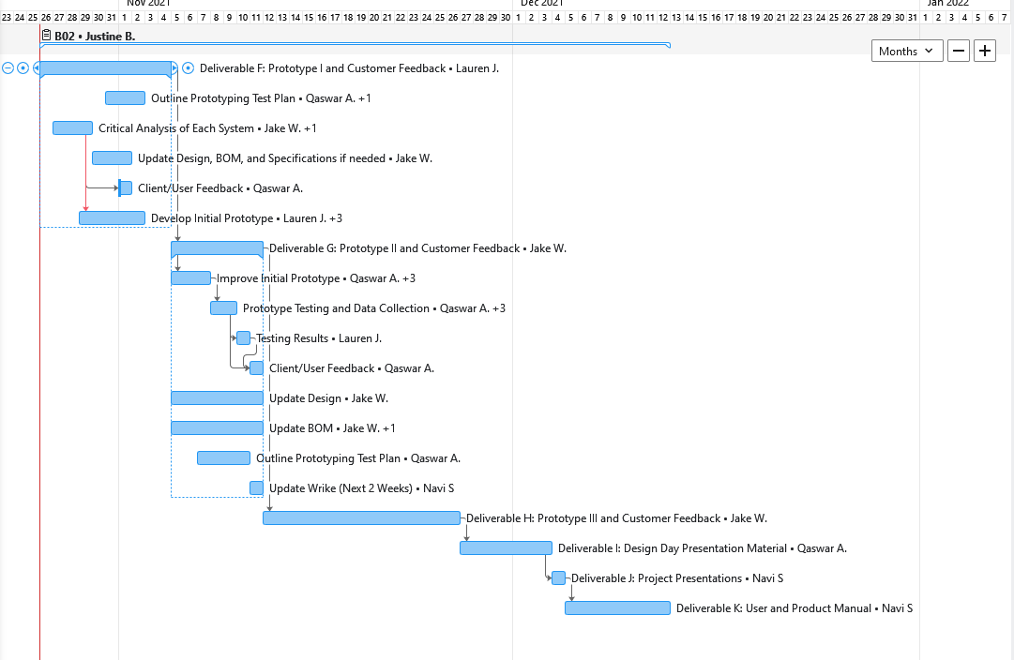

Figure 4: Wrike Gantt Chart for Next Two Weeks

3.2 Risk and Contingency Plan
Risk Factors | Likelihood | Impact | Contingency
Technical Issues
Circuitry Connection Issues | 4 | 2 | This likely issue can be properly addressed by prototyping as early as possible, to give time to fix the issues. Alternatively, circuitry should be designed on TinkerCAD beforehand to save time with trial and error processes.
Unfamiliarity with Pushsafer | 4 | 2 | Pushsafer is an open-source arduino system in beta stages. A good solution to getting a better understanding of the resource is to get in contact with the creator (as this is a small unique system). This is something we should look into within the time frame of buying our arduino parts.
Pushsafer Mobile Connection Issues | 3 | 4 | For these two risks, managing them is not a binary task. If Pushsafer ends up being an impossible task there are two options; resort to one of the other solutions outlined in the previous deliverable, or continue with this aspect of the prototype as a hypothetical (which is less desirable than the former).
Pushsafer Plug-In Incompatibility | 3 | 5
Late Parts Shipment | 2 | 4 | This can easily be mediated by ordering early, or buying parts from brick-and-mortar stores. If this ends up being an issue it is either due to a group failure of misplanning, ordering too late, or shipment issues within the company we ordered from. With regards to shipment issues, we must ensure we have a rigorous plan outlined as well as our code primarily finalized, so that when we receive the parts, we are fully ready to assemble them.
Over Budget | 3 | 5 | This should be mediated in preliminary outlines for this project. Essentially, this should be taken care of in this deliverable. We should be at least 3-5 dollars under the budget to account for any unforeseen costs.
Interpersonal
Group Conflicts | 3 | 3 | Group conflicts may arise for a multitude of reasons; such as members not completing their tasks and the high-pressure aspects of the project, among other things. Regardless of the reason, they must be mediated to avoid time delays and resting conflict. This can be done by delivering proper feedback to the member who is at fault (ie. a member who is not completing their tasks must be told that this is not sufficient), if a change is not made, higher action like notifying a superior must be taken. For members who are not agreeing on certain aspects of the project, as outlined in our team contract, decisions are made through majority vote  It is also important to address the fact that all team members are expected to deliver a certain quality of team work. It is our responsibility to take everyones opinion and ideas into consideration. However, if you are not a part of these conversations, decisions must be made regardless to ensure efficiency.
Incompletion of Subtasks by a Member | 3 | 4 | Contingencies for this problem are outlined in the above paragraphs.
Intrapersonal
Time Crunch | 3 | 4 | Time crunch issues can be adequately addressed by ensuring we continue to do our weekly meetings where everyone shares their schedules to assign tasks based on availability (and of course strengths).
Busy Schedules | 3 | 3 | An inevitable issue that will arise during the final weeks of this project is that our team members will be busy with midterms, finals, and other projects. This must be taken into consideration when assigning tasks. And if someone concludes that their schedule will conflict with getting their assigned task done, the team must be notified. It is fine to ask that you switch tasks with someone based on your schedule, but it is not acceptable to be done last minute.
External
COVID-19 | 1 | 2 | COVID-19 can impact the health of a member. The easiest fix is for the other members to finish that member's work. It is not the members fault they got a virus as a result of a global pandemic.  COVID-19 can also impact the availability of certain members, or the wish to come in person. This should not require a contingency as each member can complete their tasks from home. However, since only 1 member lives close by, having only 1 person in person might impact the rate at which the physical prototype is created. To mediate this, a structured plan should be formulated for that person with regards to the prototype model to ensure that the production is swift.
Time/Location Difference | 3 | 4 | Some members are currently not in the Ottawa region, and therefore the 2 members who are must be tasked with physical prototyping, while the members who cannot attend in person must take a larger workload of designing and planning.  Some members are burdened with a time difference, which may impact participation. This is an unfortunate circumstance that must be met with understanding (in terms of meeting times and deadlines). However, to be a student in this class, it is still up to them to get their work done properly and in a timely manner.
Table 2: Contingencies to Possible Risks

4.0 Bill of Materials
Materials & Equipment | Cost
HSCR-501 | $ 3.95
Generic NTC | $ 1.95
MQ7 | $ 9.95
AA batt. (x4) | $ 2
12v car plug | $ 1.5
Super-bright LED | $ 1.45
Soldering board | $ 0.95
Arduino uno | $ 26.95
3D printing | Up to $ 2.30
Pushsafer | Free
Aprox. Total Cost | $ 50

5.0 Conclusion
This deliverable allowed us to foster a better understanding of the final steps of our project, as well as the most efficient manner to execute them. We crafted a detailed list of possible risks to fully prepare ourselves. A bill of materials was also created to ensure the final solution will be under budget. As a whole, our solution is well thought-out, detailed, and appreciated by the client. We have created an excellent framework for moving forward.

