University of Ottawa

GNG 1103: Engineering Design
Deliverable G – Prototype 2 and Customer Feedback

Presented to:
Dr. David Nox

Presented by Group 14:
Wissal Assi – 300146551
Xiyu Bo – 300188288
Jacob Nolan – 300337194
Milo Murillo – 300381208
Chiemelie Osigwe – 300325153

November 12, 2023
Table of Contents
1. Introduction: 3
2. Feedback received from your client: 3
3. Prototype new objectives 3
4. Prototype Images 4
5. Test Plan 5
6. Analysis 5
7. Results 6
8. Feedback and comments: 6
9. Target Specifications 6
10. Prototyping test plan: 6
11. Conclusion 7

Introduction:
The purpose of this deliverable is very similar to the previous, but for the second prototype. Its purpose is therefore to document and analyse the second prototype, and the same for feedback received from both the client and other users. Drawings of the second prototype are provided, along with the testing of the prototype. There is also a prototype test plan for the 3rd prototype.

Feedback received from your client:
- First, the information is not clear. The current information of the prototype cannot make customers feel the inhumanity of autonomous weapons at the first time, and it does not well reflect the series of threats of robots. These elements should be added in the future.
- The second point is that the traffic depiction of the entire scene is not obvious, and it does not allow customers to easily distinguish the destroyed and parked stations in the prototype. However, we still need to discuss with the team members whether we want to show the traffic after the war, because we originally wanted to Use one person's perspective to show a city before and after the war, further discussion is needed on subsequent elements.

Prototype new objectives
- Loudspeaker voice in the background announcing the killer robot invasion.
- Adding a fogy environment to increase the immersion.
Why: We are testing these prototypes to verify that the simulation works and appears as expected.
What: There will be two prototypes. The first must be comprehensive and physical (An actual Unity simulation). The second prototype is a series of drawings to visually conceptualize how each of the tested features in the final product will appear. This prototype will have less fidelity (being a focused and analytical prototype.)
When: The prototypes must be ready by the specified for the tests.

Prototype Images
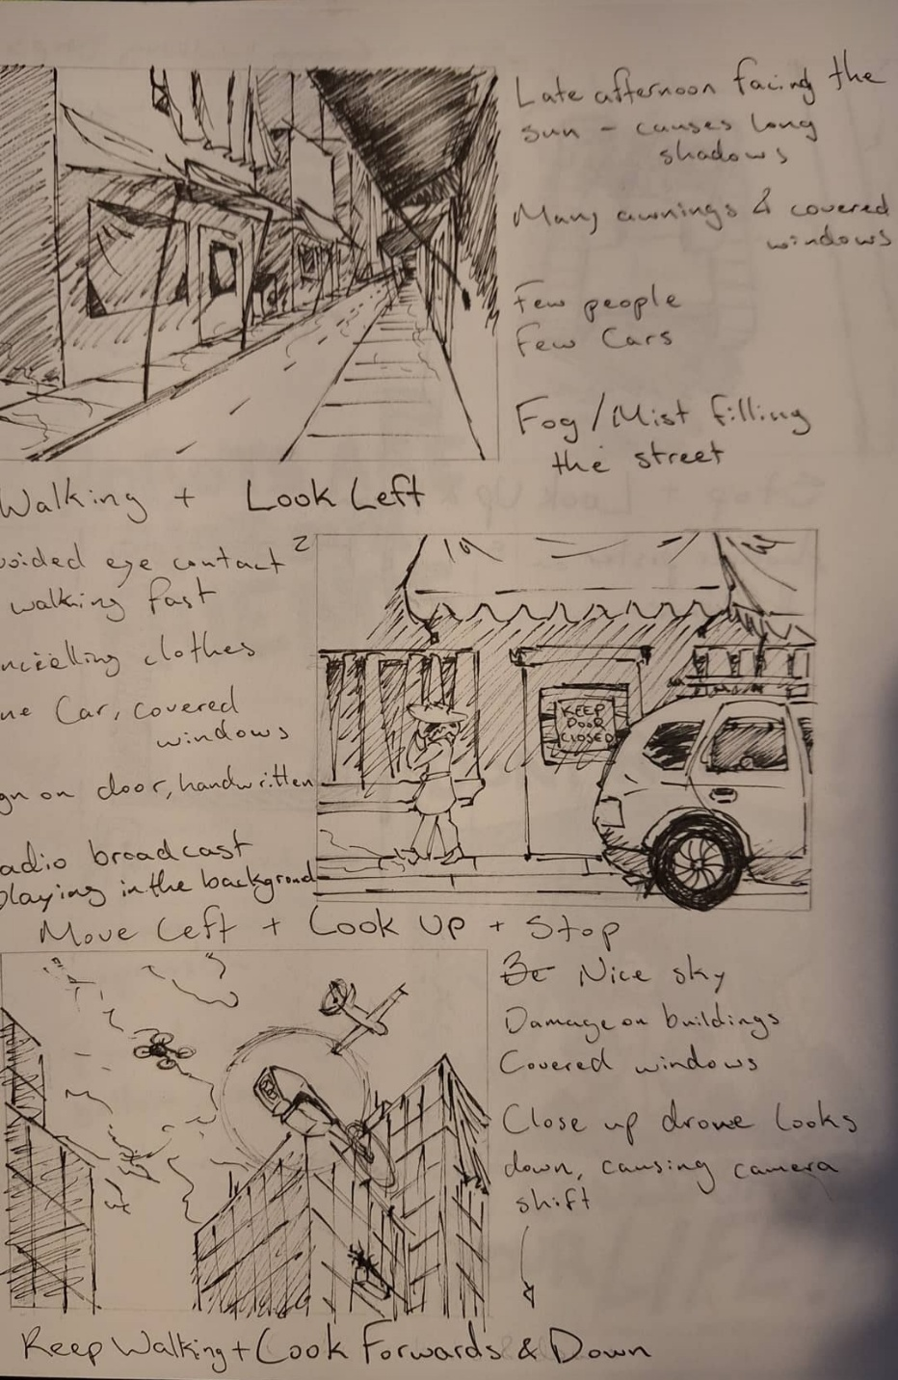

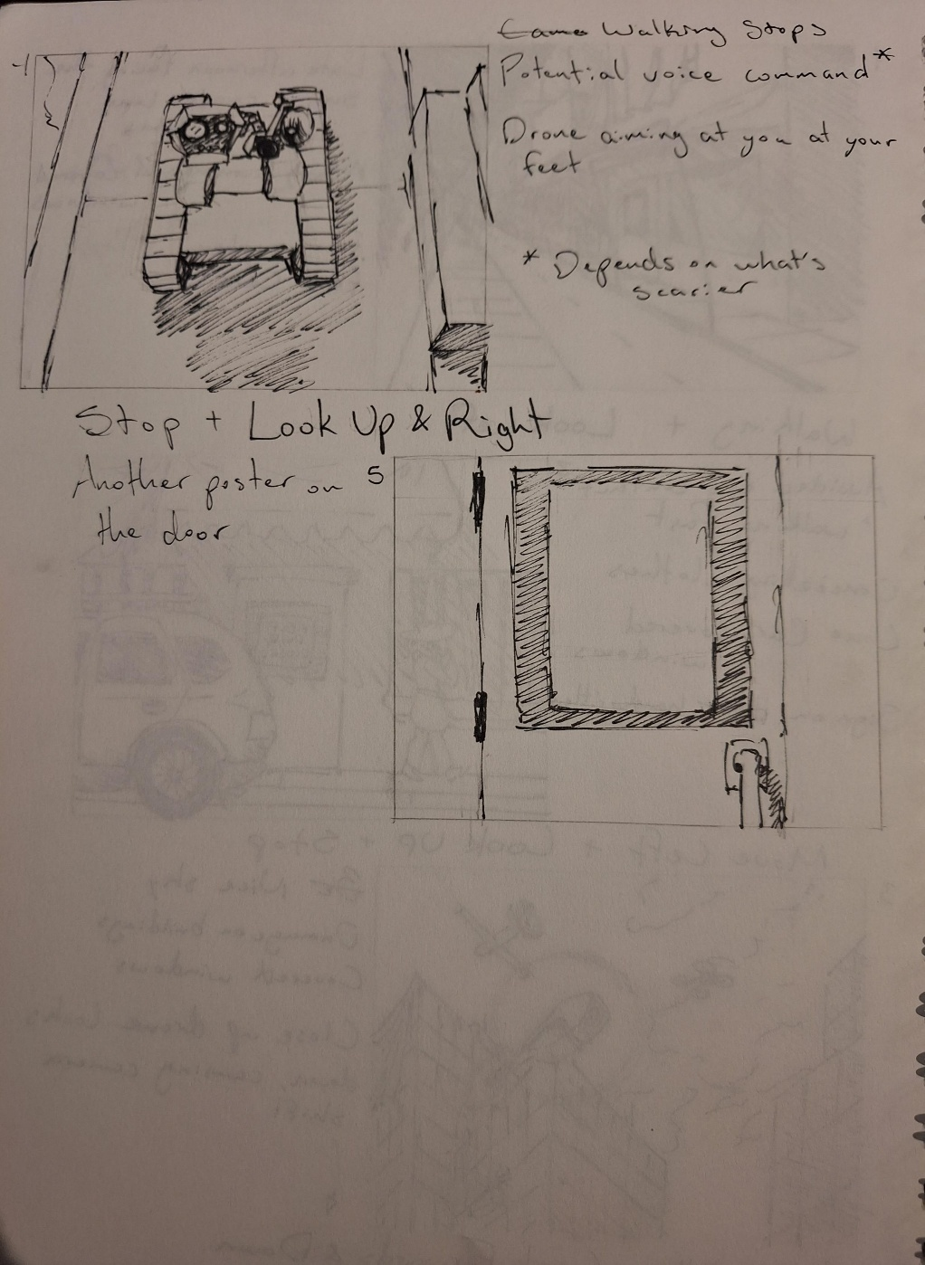

Test Plan
Based on customer feedback, the initial prototype design has been finalized, and comprehensive testing has been conducted to assess the timeline and specific details of the entire prototype.

Analysis
- User testing sessions conducted to evaluate clarity and emotional impact.
- Observations recorded regarding users' ability to distinguish traffic scenes.
- Collected feedback on unclear information and lack of emotional impact.
- Recorded user comments on difficulties in distinguishing destroyed and parked stations.
- Clarity and emotional impact need improvement.
- Adjustments to autonomous weapons portrayal to increase emotional impact.

Results
- users appreciated enhanced clarity and emotional resonance.
- Prototype now clearer and more emotionally impactful.
- Explore alternative methods to convey the inhumanity of autonomous weapons.

Feedback and comments:

- The message being conveyed was very easily understood.
- It’s an interesting look into

Target Specifications

Table 1: Target specifications for prototype 2
Design Specification | Relation  (=, < or >) | Value | Units | Verification Method
Functional Requirements
Loud speaking voice | = | Yes | N/A | Test, Feedback
Non-Functional Requirements
Fogy environment | = | Yes | N/A | Test, Feedback

Prototyping test plan:
Table 2: Prototyping test plan for prototype 3
Test ID | Why | What | Estimated Test  duration and  planned start  date
1 | See if the loudspeaker voice plays and is easily recognizable. This is a learning test. | This is a focused physical test. The test involves putting the sound in adobe and playing it. | Duration: 1 day  Start: November 20th (All we need is the voice recording as this is a focused test)
2 | See if the fog fits in and is immersive. This is also a learning test. | This is a comprehensive analytical test. The test involves visualising the fog (via drawing) and seeing if it fits in. | Duration: 1 day  Start: November 22nd (Drawing must be complete, potential user must be found)

Conclusion
To conclude, just as done for the first prototype, the second prototype has been created, analysed and tested. In addition, the feedback from the client and from potential users has been written down and analysed. Using this, we will proceed to the development of the third prototype with useful information that will contribute to its improvement.

