Project Deliverable G: Group 8

Eunhyo Jung, George Lai, Anuar Magauya, Ines Senhadji, Ronan William Thomas
March 10, 2024

Abstract
Group 8 has the following problem statement: Mines Action Canada wants a story-driven video in a VR environment that will convince politicians to ban autonomous weapons, by showing how non-combatants will be affected by these weapons. Previously, Group 8 has come up with a plan for a first prototype: a VR environment with a player that can move and interact with the environment. This was made so that our team would be sure our VR environment could be set up and be stable when using the virtual reality equipment. Prototype 2 improves on the shortcomings of prototype 1 and enhances the environment through captions, UI events, better environment, and object interactions.

Table of Contents
Introduction 5
Prototype 2 – Analysis 5
Prototype 3 – Planning 7
Conclusion 8

Introduction
Group 8 has the following problem statement: Mines Action Canada wants a story-driven video in a VR environment that will convince politicians to ban autonomous weapons, by showing how non-combatants will be affected by these weapons. With prototype 1 successful and prototype 2 being completed we are now planning prototype 3 which will be the culmination of our work thus far. Prototype 2 introduces captions, interactable objects to immerse the viewer, UI events and better assets for the environment.

Prototype 2 – Analysis
Figure 1
Animated NPC
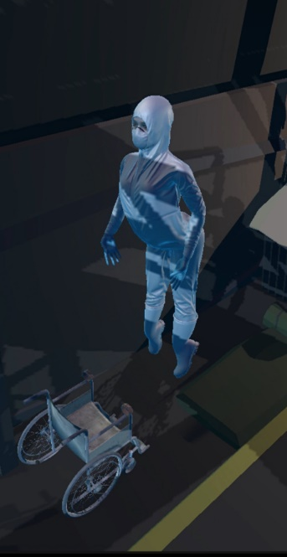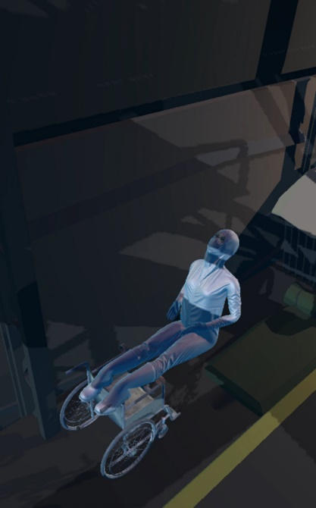
In figure 1, we see an animated NPC was added to the prototype. This was done to figure out how well we could program an NPC to move around in our world. However, we were going through some issues to properly set up the movements. As we can see, the character is distorted when going through her animations.
Figure 2
Start Menu
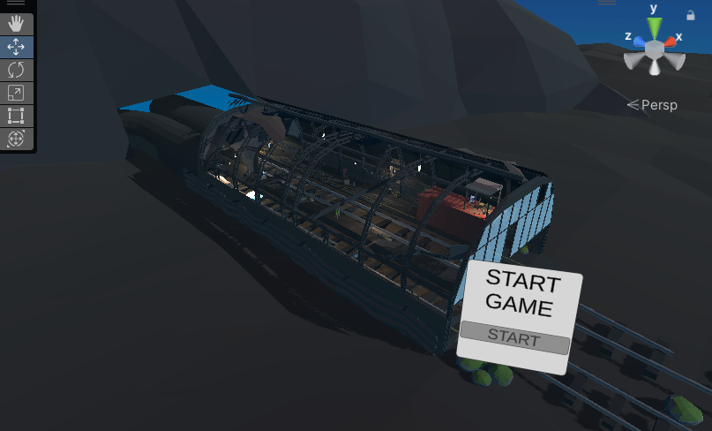
Figure 2 shows a start menu the player can see before starting the game. This way our player won’t be put straight into the action. We are still in the process of hooking up the button to start the game, but this should be simple as we simply need to use the button to teleport the player into the scene and then trigger the activation timelines to progress the intro cutscene.
Figure 3
Cutscene Screenshots
a)
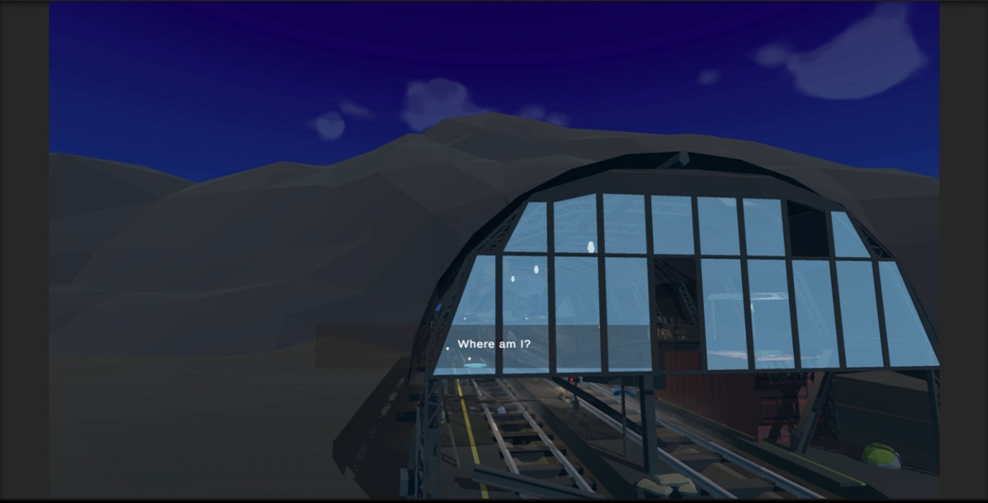
b)
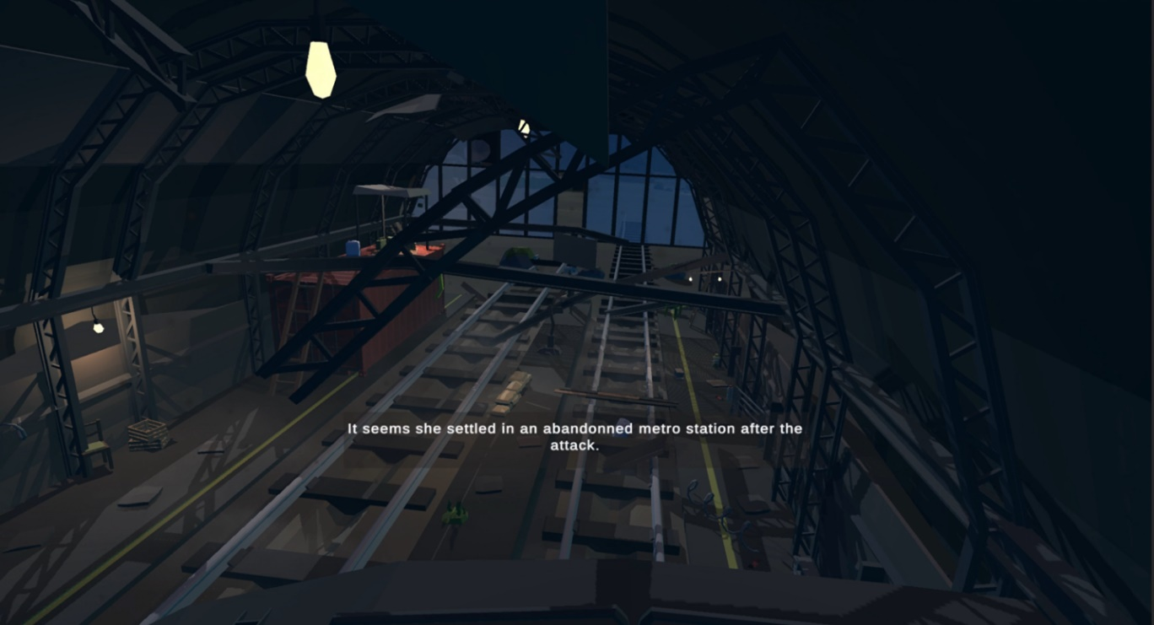
c)
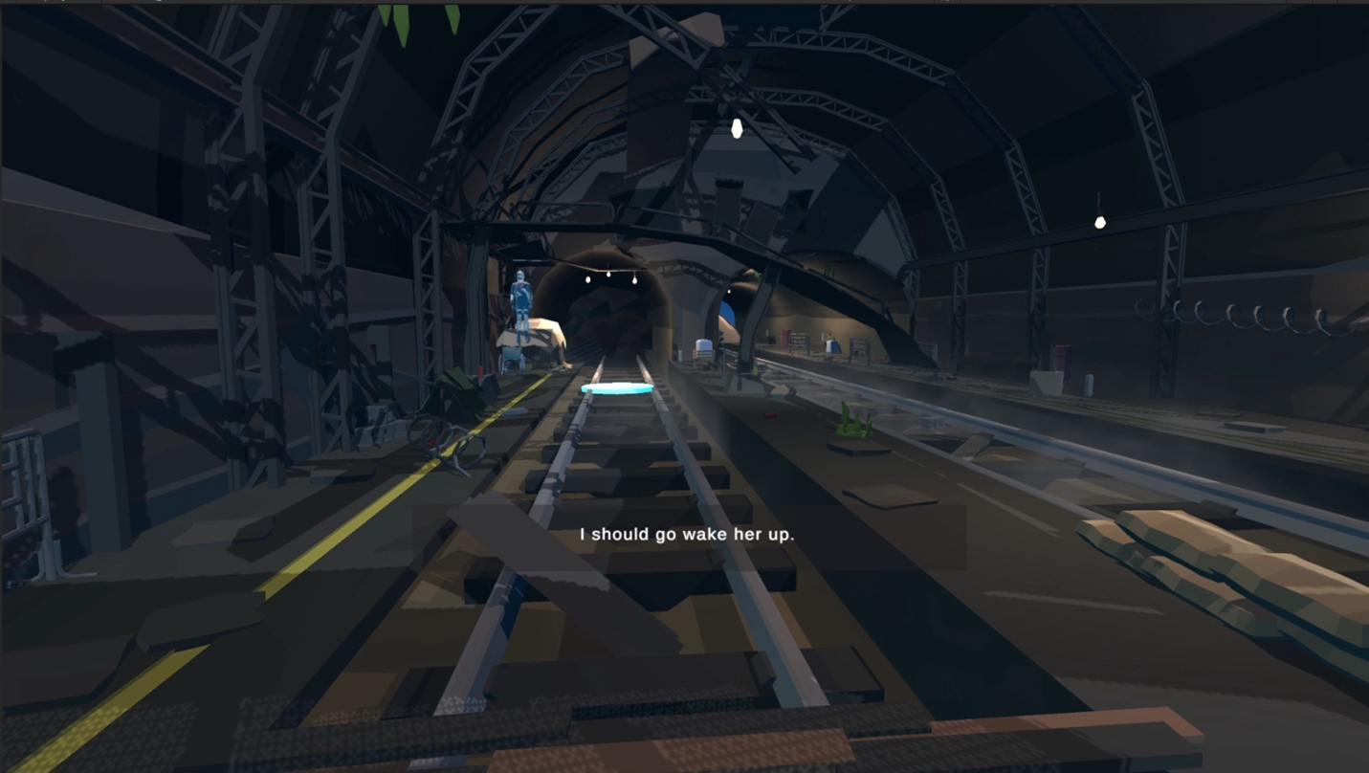
In figure 3, we can see the progression of a cutscene. This is the introduction cutscene, and this prototype confirms for us that we can set up a cutscene with a moving camera, where the player has no ability to input movement (except for moving the head). This allows us to go on with making a more cinematic game rather than a simple first-person experience.
To summarize what we have done and learned for Prototype 2, we introduced animated characters, but they still need to be worked on to figure out how to move them, how to fix the distortion of the characters, and how to trigger the animations using a trigger. Also, we added a simple UI foundation for a game menu that the player can start the experience in. For this, we still need to add the connection between the intro cutscene, and the button trigger so that the button will actually start the game. Finally, a cinematic mode was achieved in VR using CineMachine. This allows us to progress with more cinematic cutscenes in our game.
Small bug fixes and improvements included adding more detailed box colliders in the floor (ground vs platform elevation), adding a nighttime skybox, and fixing the lighting to be more visible (lamps were previously too weak intensity).

Prototype 3 – Planning
As the due date for the final product approaches, prototype three should focus on ironing out kinks in our product and polishing the product to get it to a place that feels very similar to our vision of the final product.
That said, implementing greater quality audio is important for enhancing the storyline. Radio cues and prompts are planned in the works to provide exposition of the world. Higher quality audio of outside robots causing destruction and severity of moment. As the robots near the tunnel entrance, allowing for the characters' breath and panic to be heard to add emotion.
Next segment for prototype three is timing the scenes correctly. The segments of the game must be created in a way that allows for correct timing for the video. In the sense that certain segments of the game cannot drag on for too long or cannot be too short for this to work with the video. This means prompts must be created to be triggered at correct times and timing must be fine-tuned within the game.
Another thing for prototype three is the disabled character still must be fleshed out correctly as this is a critical aspect of the story. This was originally a minor aspect in prior prototypes and drafts but, due to feedback, the decision was to have this part be more important. In that sense, this part needs to be fleshed out more to be fully incorporated into the story rather than being just included for the sake of showcasing disabled people in the product.
Last thing for prototype three is technical capabilities. This has not been a critical element design for the product and not much consideration has gotten into this so far but as this is close to the final product, it is essential that this part goes smoothly so as to not delay the product any further. Glitches in the gameplay must be ironed out if there are any as to make sure the environment can run properly. All textures must be visible so that the product does not look sloppy or unfinished. Framerate must be at an acceptable level so that the game is playable.
There are still more aspects to consider when creating the third prototype, but these are some of the main points to get across when developing the prototype.

Conclusion
Prototype 2 is an improvement over prototype 1. It has improved in where prototype 1 was lacking and is a lot closer to the final product than prototype 1. As an experience aimed to demonstrate the caution that we as humans need to have regarding weapons with artificial intelligence, it is significantly stronger in portraying our vision of what a potential future could be. Prototype 3 will attempt to fully bring our project as close as we can to the final product. With prototype 3, we want our vision to be clear, but it does not have to be perfect yet.

