Design Criteria and Target Specifications

In the previous deliverable, a list of interpreted needs was drafted on behalf of our client. The client’s own statements were analyzed, and desired features and functionality identified. This deliverable contains the design criteria drafted with respect to the needs outlined previously. Included within this deliverable is a benchmarking study of the currently available solutions, competing with our future design. Target specifications have been assembled to fully define and showcase the most important functions and constraints for our solution.

Design Criteria:
 | Interpreted Needs | Design Criteria
1 | The solution must feature communications able to send alerts to mobile devices. | Communication Device  Mobile Alerts
2 | The solution must feature an alarm system audible from outside the vehicle, to alert bystanders | Bystander Alarm  Recorded Voice Alarm (alerting bystanders of the stuck child)
3 | The solution must feature a rear occupant alert that senses the presence of a child. | Motion Sensor  Body Heat  Signals device inorder to take safety measures
4 | The solution should know if the child is left unattended | Door Sensors (tracks when door was last opened)
5 | The solution must prioritize the safety of the child while assistance is en-route. | Takes action to lower temperature  Ensures child is not panicking (entertainment)  Add clean air to the car
6 | The solution needs to be compatible with most vehicles and smart phones. | Compatible with all/most vehicle types  Compatible with all/most phone types
7 | The solution needs to be easy to install, and should operate adequately without requiring technicians, advanced tools or advanced knowledge for installation. | Simple Installation  Easy Setup  Step by Step Installation Guide  No maintenance required
8 | The solution needs to be able to detect potentially dangerous CO levels within the vehicle. | Carbon Monoxide Detector  Signals device inorder to take safety measures
9 | The solution needs to be able to lower the temperature to ensure the safety of the occupant. | Adjustable Car Temperature (Turns on AC)  Takes action to lower temperature
10 | The solution needs to be able to detect the temperature to determine if conditions are unsafe. | Thermistor  Signals device inorder to take safety measures
11 | The solution needs to be able to withstand high temperatures while operating adequately. | Heat Resistant Materials  Functions Under High Temperatures  Operating Temperature (C)
12 | The solution should feature a redundant, rechargeable power system to ensure continual operation. | Rechargeable Battery  Operates Continuously
13 | The initial prototype must cost no more than $50.00 CAD to develop. | Cost ($)
14 | The solution must be affordable to consumers in the UAE, as well as the rest of the Middle East. | Cost ($)  Quality  Materials
Table 1: Design Criteria

Updated Needs
Two changes to interpreted needs were made since Deliverable B. We removed repetitive needs and added the need for motion sensors to detect the presence of someone in the car at undesirable conditions.

Technical Benchmarking:

 | Kia system | Nissan system | GM shared system | Tesla system
Company | Kia motor company | Nissan motor company | General motors group | Tesla, inc.
Variant | Standard version | Standard version | Standard version | Experimental version
Status | Available | Available | Available | in-development
Availability | Standard on select models | Standard on 12 models | Optional extra on all models for all subsidiary manufacturers | N/A
Cost | No additional cost | No additional cost | Information unavailable | N/A
Sensor | Ultrasonic motion sensor | Door sequence logic | Door sequence logic (rear doors only) | Millimeter-wave radar array
Alert(s) | -Sounds horn continually  -Alert on instrument cluster  -Lights flash  -Alert message sent to smartphone | -Alert on instrument cluster  -Sounds horn intermittently | -Alert on instrument cluster  -Chime audible in the car | TBA
Table 2: Technical Benchmarking

 | Hyundai systems
Company | Hyundai motor group
Variant | Premium version | Basic version | Advanced version
Status | Available | Available | In-development
Availability | Optional extra | Standard on select vehicles | N/A
Cost | ≥5000$ CAD increase for trim level | No additional cost | N/A
Sensor | Ultrasonic motion sensor array | Door sequence logic | High resolution radar array
Alert(s) | -Sounds horn continually  -Alert on instrument cluster  -Lights flash  -Alert message sent to smartphone | -Sounds horn continually  -Alert on instrument cluster  -Lights flash  -Alert message sent to smartphone | TBA
Table 3: Technical Benchmarking (continued)

Company | Kia | Nissan | GM | Tesla | Hyundai basic | Hyundai premium | Hyundai advanced
Availability | Standard on all models | Standard on 12 models | Optional extra | unavailable | Standard on select models | Optional extra | unavailable
Sensor | Ultrasonic motion sensor | Door sequence logic | Door sequence logic | Millimeter wave radar array | Door sequence logic | Ultrasonic motion sensor | High resolution radar array
Alert | -Alert on instrument cluster;  -Headlights flash;  -Message sent to owner’s smartphone;  -Car horn sounded continually; | -Alert on instrument cluster;  -Car horn sounded continually; | -Alert on instrument cluster;  -Chime sound inside car | TBA | -Alert on instrument cluster;  -Headlights flash;  -Message sent to owner’s smartphone;  -Car horn sounded continually; | -Alert on instrument cluster;  -Headlights flash;  -Message sent to owner’s smartphone;  -Car horn sounded continually; | -Alert on instrument cluster;  -Headlights flash;  -Message sent to owner’s smartphone;  -Car horn sounded continually;
Table 4: Technical benchmarking feature evaluation
Company | Importance (weight) | Kia | Nissan | GM | Tesla | Hyundai basic | Hyundai premium | Hyundai advanced
Availability | 2 | 3 | 2 | 1 | 1 | 2 | 1 | 1
Sensor | 3 | 2 | 1 | 1 | 3 | 1 | 2 | 3
Alert | 1 | 3 | 2 | 2 | 1 | 3 | 3 | 3
Total |  | 15 | 9 | 7 | 12 | 10 | 11 | 14
Table 5: Technical benchmarking competitor general evaluations

Target Specifications:
Design Specification | Relation | Value | Units | Verification Method
Functional Requirements
Thermistor | = | Yes | °C | Test
Carbon Monoxide Detector | = | Yes | PPM | Test
Operates continuously | = | Yes | N/A | Test
Functions Under High Temperatures | = | Yes | N/A | Test
Child Sensor | = | Yes | N/A | Test
Bystander Alarm | = | Yes | N/A | Test
Mobile Communication | = | Yes | N/A | Test
Constraints
Cost (Prototype) | < | 50 | CAD | Given
Cost (Final Product) | > | Unlimited | UAE dirham | Given
Materials | = | 3D Printing PLA plastic | ${mm}^{3}$ | Test
Time to Complete | < | 4 | Months | Given
Non-Functional Requirements
Easy Setup and Installation | < | Yes | N/A | Test
Heat Resistant | > | Yes | N/A | Test
Battery Powered | = | Yes | N\A | Design
Volume | N/A | 20x10x5 | cm | Design
Compatibility to varying vehicles | = | Yes | N/A | Design
Table 6: Target Specifications

Project Management:
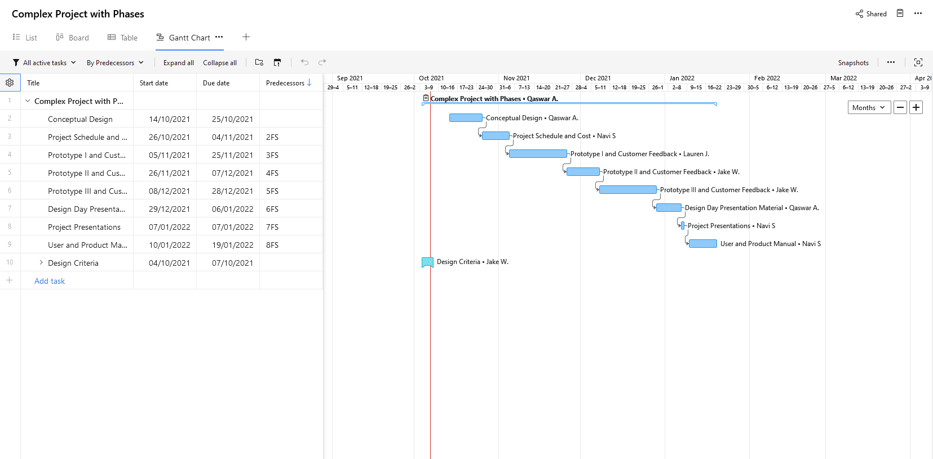

Fig 1: Wrike Gantt Chart
Higher Quality Image will be Submitted Along-side this Document

Fig 2: New Wrike Sub-Tasks
Higher Quality Image will be Submitted Along-side this Document

Conclusion:
In this deliverable we drafted the design criteria needed for our solution. The criteria was based on the needs outlined in the previous step. In order to further develop our understanding of the problem, we studied several occupant detection systems offered by a number of different auto manufacturers - some currently available, and some still in development. Due to the limited availability of the after-market or third party accessories capable of detecting occupants abandoned in vehicles, our benchmarking study was limited to solutions created by major automotive manufacturers, notably: Kia, Nissan, the General motors group, Tesla and Hyundai. We evaluated these solutions based on their availability to vehicles in the manufacturer’s range, their additional cost to consumers, their detection technology, and the sequence of alerts they give in the case of an abandoned occupant. Based on each solution’s features, and the relative importance of those features, we ranked the existing devices - ultimately finding the Kia motor company’s “rear seat reminder” to be the strongest competitor in the range.

Bibliography

Baldwin, Roberto. “Tesla Looks To Airport-Style Scanning So Kids Aren’t Left In Cars.” Car and Driver, Car and Driver, 21 Aug. 2020, https://www.caranddriver.com/news/a33668647/tesla-kids-hot-cars-millimeter-wave-technology/

“Hyundai Canada | Cars, SUVs, Hybrid and Electric Vehicles | Hyundai Canada”, Hyundai Canada, https://www.hyundaicanada.com/, Accessed Oct. 7th 2021.

Hyundai Motor Group. “The New Radar-Based Occupant Alert System To Keep Your Children Safe - Hyundai Motor Group TECH.” Hyundai Motor Group TECH, https://tech.hyundaimotorgroup.com/article/the-new-radar-based-occupant-alert-system-to-keep-your-children-safe/. Accessed 7 oct. 2021

Hyundai Motors America. “Hyundai Motors Announces New Rear Occupant Alert, Reducing Child Heat Hazards.” Hyundai News, Hyundai media center, 3 Oct. 2017. https://www.hyundainews.com/en-us/releases/2383

Kia Motors, Inc. 2020 Kia Telluride - Vehicle Feature Tips. Kia Motors America, Inc. 2019, https://owners.kia.com/content/dam/kia/us/owners/pdf/2020/2020-Kia-Telluride-Vehicle-Feature-Tips.pdf

Masterson, Patrick. “How Does The Rear Door Alert Work on Our 2020 Hyundai Palisade?” Cars.com, 19th Oct. 2020, https://www.cars.com/articles/how-does-the-rear-door-alert-work-on-our-2020-hyundai-palisade-426478/

Whited, Jeannie. “Nissan Rear Door Alert Now Available on 12 Models, Including the Affordable Versa, Sentra and Kicks.” Official U.S. Newsroom, 10 July 2020, https://usa.nissannews.com/en-US/releases/release-f6290185963065147d2c7162ad000f67-nissan-rear-door-alert-now-available-on-12-models-including-the-affordable-versa-sentra-and-kicks

White, Rebecca. “GM Expands Availability of Rear Seat Reminder Technology.” Media.GM.Com, 6 Dec. 2016, https://plants.gm.com/media/us/en/gm/news.detail.html/content/Pages/news/us/en/2016/dec/1206-rsr1.html

Hyundai rear occupant alert (ROA) is available as standard on the 2020 Palisade, Sonata and Santa Fe models, and is set to be available as standard on all vehicles by 2022,
Nissan rear occupant alert (ROA) is available as standard on the 2020 Altima, Armada, Kicks (SV and SR variants), LEAF, Murano, Maxima, Pathfinder, Rogue (standard and sport variants), Sentra, TITAN (king cab and crew cab variants) and Versa (SV and SR variants), and will be available as standard on all vehicles by 2022,
Subsidiaries of GM include: Buick, Cadillac, Chevrolet, and GMC
The Kia system is available as standard on the Telluride model range.

