Deliverable B

Group A5
Julian Marra
Mihir Jakhi
Kieran Moynihan
Introduction
Our group, having chosen to design “wheelchair skis” for our clients, could attempt to identify the problem and develop solutions to the problem from the product information sheet given with the project, but the information sheet lacks personal information and ideas which may have provided insight into the product which is really needed by the clients. On Wednesday, September 19, our group members met with our clients and talked with them, getting their ideas and insights, as well as a better understanding of the personal challenges they—and their caretakers—had faced which in relation to the product idea. The information provided to our group, as well as an analysis of how it relates to our product follows in the body of this document.
Client Statements and Observations
- Client only goes for short walks down the street of the LIFE Program Centre, and they are always being pushed by a staff member rather than having to wheel themselves.
- City does not properly clean the sidewalks so there is usually snow and ice build-up.
- Staff members claim it is challenging for them to push the wheelchairs through heavy snow and ice because of snow build-up in the wheels of the chair.
- There is a difference between the manual chairs and the electric chairs, whereas the wheels are oriented differently. Will need a design change between the two chairs.
- Wheelchairs are heavy to push, will need a design that minimizes friction between our design apparatus and snow/ice.
- Client recommended skis as being the most efficient way to solve this issue; clients are never going out in their wheelchairs by themselves.
- Clients want an apparatus that is easily mountable to the wheelchairs, so that they don’t have to use the wheelchair lift every time they go for their walks.
- Staff members stressed the importance of having a braking system and emergency stops.
- Client does not have a specific preference for style of the system, but if possible would appreciate the apparatus in a vibrant colour.
- Safety reflectors added to the apparatus so cars are easily able to see them.
- Client recommended the skis to be U shaped so snow doesn’t build up inside the skis and it will allow for the skis to fit better onto the wheels of the chair.

Translated and Prioritized Customer Needs
- Clients’ wheelchairs need to be easily maneuvered in snowy and icy conditions
- Braking system and emergency braking system (Faster stopping force)
- Skis rather than rubberized tracks to minimize the force of friction on snow and ice
- Needs to be able to push heavy snow out of the way to avoid build up in the skis or under the wheelchair
- Has to be able to move on hard surfaces (Concrete sidewalk, pavement) in case the sidewalks have been maintained in some areas. This needs to be done without risking to life of the product or causing damage.
- Safety reflectors installed on the system so passing cars are able to easily visualize the clients.
- Needs to be easy to install on the wheelchair, without the use of a chair lift.

Problem Statement
Our clients from the LIFE Program who require wheelchairs for transportation have trouble getting around in snowy or icy conditions on the sidewalks near their headquarters, even with the constant help of a staff member pushing them. A wheelchair ski design is required to allow the clients to be able to successfully get from point A to Point B throughout Ottawa's harsh winters, while minimizing the efforts of the staff members and persons in wheelchairs and maximizing safety and effectiveness.

Benchmarking
Products similar to what the clients require in this solution more than often only replace certain parts of the wheelchair such as the flywheels. Other models that appear commonly add attachments onto the main wheels of the wheelchair that allow them to function as skis as well as having the aforementioned flywheel replacements.The most immediate comparable product that is similar to to what the clients require would be the Wheelblades S by Epical Solutions. These skis directly attach onto only the flywheels of the wheelchair in order to increase their mobility. The skis seems to have a rather generalized clip on system that simply slides on locks on to the flywheels of the wheelchair.
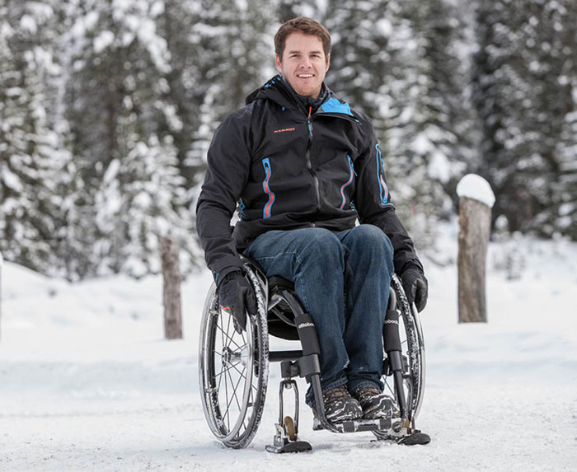
Complete view of a similar product while attached to the flywheels

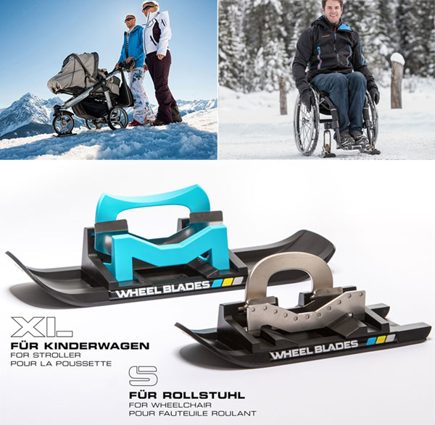
A more direct view of a similar product
Metrics
According to our clients’ wishes, the chair must have multiple important requirements:

Material
An important function the chair must have is that it must be able to slide around on snow and pavement alike effortlessly. This means that the wheelchair’s skis must be composed of a material that is light enough yet durable enough that being scratched up by being slid around on pavement would not cause them to erode or out right break. Another key factor concerning the material that the skis would be made out of would be how resistant to corrosion the skis are.
This is because in the winter conditions that the skis would be facing, there would be an abundance of road salt, which is known to cause corrosion and the general breakdown of many materials.

Size
The size of the skis also plays an important role in the overall design and the wishes of our clients. The skis must be large enough to effectively distribute all the weight that is put onto it. This is because if the skis are put under enough weight, they have the potential to completely sink into deeper snow and as such causing the client to possibly get stuck in the snow. The skis on the large wheels must also be short enough that they do not get interfere with the smaller skis that are on the flywheels and could thus block and motion taken by the smaller skis.

Visibility
The visibility of the client is another important issue that needs to be addressed. In low light and visibility conditions such as those seen in the winter can pose a real problem for our clients’ safety. By installing reflectors on the body of the skis, the client can be quite visible to drivers on the road and as such would be safer. The reflectors must allow the client to be visible from up to 25 metres or greater.

Braking
The safety of the client is another important aspect of the design. In slippery conditions, it is essential to be able to stop one’s momentum in order to lose control and risk possible injury. In the case of our client, this can be done by adding a braking system onto the skis which would allow the client to stop themselves within distance of 1 metre.

Target Specifications
Materials
The material of the skis should be light enough to not cause the individual pushing the wheelchair to struggle, but durable enough that it can support an individual and wheelchair combo while being pushed across potentially rough surfaces. Equally, because the skis are designed to be used on roads and sidewalks in snowy conditions, the material must not be sensitive to road salt.

Size
The skis affixed to the large wheels of the wheelchairs would be load bearing, and thus require a large enough surface area to the support the wheelchair without sinking overly deep into potential deep snow. The length of these main skis can extend at most from the back of the wheelchair to just short of the front flywheels, leaving room at the back for the individual person to hold and push the wheelchair, and enough room at the front for the flywheels to rotate.

Visibility
Reflective strips affixed to the attachment will cause the client to be visible to oncoming vehicles at a minimum distance of 25 metres, though ideally being visible at distances approaching 60-75 metres.

Braking
Brakes attached the skis will allow the client to stop themselves rapidly at a moment's notice. Unless in extreme circumstances (sliding down steep hill, moving at extremely high speed) the brake system will stop the client’s wheelchair moving within a metre of travel.

Reflection
The product information sheets provided from the beginning of the project are, while helpful, rather basic, and don’t provide very detailed information about the clients, the potential product, or various circumstances surrounding the product’s use. Meeting with the clients allowed us to ask the clients specific information about where the idea came from, what they envisioned as a potential solution, in what circumstances the product would be used, and many other topics.
Through asking ranging questions about the clients, their situations, the difficulties they face, and their experience, we were more easily able to identify what the real problem our clients are facing is, which makes it more likely that our designs will solve the problem for our clients.

Conclusion
Our client meeting provided us with a pool of data and we’ve converted it from a set of statements, to a list of needs, then to a list of metrics, and finally a set of target specifications. This will aid us in developing successful products, as any product that is designed to meet the target specifications laid out in the document will have been designed to fulfill the needs described by the clients, and should then be a good solution to the problem. This demonstrates the importance of the client meeting to the development process, as without the meeting, our group could design a product that successfully meets the criteria described in the product information sheet, but does not fix the specific problem described by our client, and it thus unhelpful to them.

