Deliverable D – Detailed Design, Prototype 1, BOM, Peer Feedback and Team Dynamics

Group Z8
Nicoll, Sebastian (300187458)
Yang, Ze (300148346)
Baraka, Naomi-Prisca (300170434)
Nasr, Abdelrahman (0300132777)
Xie, Zhenqian (300106429)

May 30, 2021
University of Ottawa
Department of Engineering
Ottawa, Ontario

Table of Contents
List of Figures 3
Introduction 4
Client Feedback 4
Detailed Design 6
Critical Product Assumptions 6
First Prototype 7
Prototype Testing 16
Next Client Meeting Preparation 17
Bill of Materials 18
Conclusion 19
Appendix 20

List of Figures

Figure 1: Detailed design flow chart for app.
Figure 2: The application welcome page.
Figure 3: The application loading page.
Figure 4: The application pain questionnaire.
Figure 5: The application pain location questionnaire.
Figure 6: The application exercise list.
Figure 7: The application exercise video tutorial page.
Figure 8: The application timer countdown.
Figure 9: The application congratulations page.
Figure 10: Prototype testing.
Figure 11: Current prototype costs.
Figure 12: Projected final prototype costs.

Introduction

The goal of deliverable D is to create the first prototype using the client’s needs and information gathered. The design of the application has been explained in the detailed design as a flow chart demonstrating the various paths the user can take when using the app. The team received feedback from the client during the second client meeting. Consequently, the team was able to analyze what the client said to apply the suggested improvements to future prototypes. The first prototype has also been compared against the metrics to determine points of improvement as well. Deliverable D also includes the bill of material detailing the cost of creating this prototype and the whole project. The first prototype sets a baseline for future prototypes allowing the group to build on the feedback received.

Client Feedback

Our second client meeting was successful. The team discussed the generated concepts including the group concept. Later the team presented the first prototype to receive feedback and help understand what improvements can be made.

Client Statements
-The exercises she did within the week, which were proposed by the survey, can be stored as a line graph. The data that can be sent to Google drive; the client would like to have a general overview of what she is doing.
- The client would like to have the ability to add exercises to customize the workout. She mentioned that it would be potentially nice to change the customize the exercises mid-workout or have another option available. This way she can treat the pain more accurately without having to wait for the timer to end. The application would be customisable, the question and the exercises can be changed.
-She prefers using dark mode for her apps, thus a reflective colour scheme would be good for this app.
-The client would like to add some links that can lead her to videos showing her the exercises she needs to do. She would like to be able to change the links of the videos.
-The client appreciated the video side of the first prototype.
-The client would like an option that may allow her to pause the exercises while doing something else. The unfinished exercise will lock the app and not allow the user to complete the workout, but the entire phone will remain unlocked.
-The client mentioned a feedback function for the workout. The feedback for the workout might include 3 options: neutral, useful, or bad.
-Customize the survey by choosing some “favourites” exercises so she does not have to scroll through the survey.
-The ending reward can be pictures of any animal because she likes animals. It would be nice to have a way to link google photos so she can change images.

Client Feedback Analysis
The team will make an effort to include all the improvements in the next prototype. Moving forward we intend on integrating the feedback into the design of our application. To start we will try to make the app using dark colours since she prefers to use applications in dark mode. In our presentation of the prototype, we had a function where it showed a video of the exercise. The client would like to have a function where she can add her own videos and be able to favourite things for ease of access. Moving forward with the prototype, we will try to add those functions. We will also try to app a function where she can pause the timer for the exercises. The client also mentioned a feedback option for the workouts, she suggested we have 3 options: neutral, useful or bad. This way she can determine which workouts are most helpful. We will also try to add a way for the client to have photos of cute animals or any photos she wants to be displayed in the app.

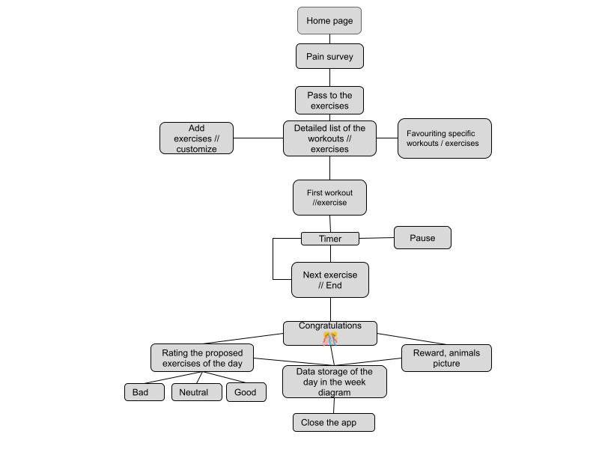
Detailed Design
Figure 1: Detailed design flow chart for app.

Critical Product Assumptions

The critical product assumptions are instrumental in the design of prototypes. They influence the direction of a prototype and ultimately impact its success in meeting the client’s needs.
- The user can easily understand how to use the app and all its functions.
- The user will listen to the reminders sent by the app to do the daily exercises.
- The user will input will respond to the questionnaire and answer honestly to allow the app to suggest appropriate exercises.
- The user listens to the tutorial video if they do not understand how to perform a specific exercise.
- The user will skip the video (meaning that they will not get frustrated by the time consumed) if they already understand how to perform the exercise.
- The app recommends the appropriate workout in response to the questionnaire.
- The timer starts only when the user reaches the timer page and does not continue when the user presses the stop button.
- The user actually performs the exercises/workouts.
- The user responds honestly to the rating questionnaire regarding the workout they just completed.
- The daily statistic will be provided after the user completed the exercises.
- The accomplishment will be visible to users based on their specific accomplishments like “First workout”.

First Prototype

In the first prototype, a skeleton form of the application was created with working features. UI screens were created with various functions and components leading to other screens.

The prototype objectives were:
-Create a proof of concept for the app.
-Create a skeleton version of the application with possible UI screens.
-Link the UI screens together.
-Understand how to allow the user to perform the questionnaire.
-Start incorporating the client’s needs into the app (ex. Survey, video tutorial…)

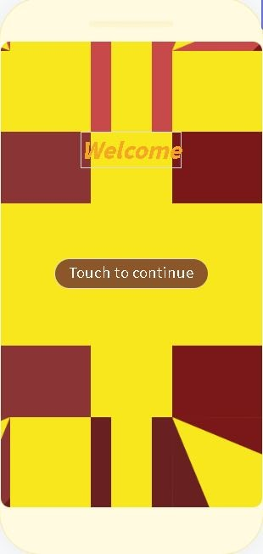
Figure 2: The application welcome page.
The first page is the welcome page for the application. The page was created as a test for the app and a base model. The user is greeted with a welcome text field as well as a button that the user must touch to continue onto the next screen. The home page allowed the design of background and helped understand the logic required to continue to another page, therefore, linking different screens together. In the future, the home page will be redesigned so that the user does not have to click a button to get started with their workout or questionnaire. One metric was the complexity or number of user actions it takes to complete the entire workout or get from point A to point B. The addition of the “Touch to continue” button adds an unnecessary step and unnecessary complexity to the app instead of starting with data or a workout page.

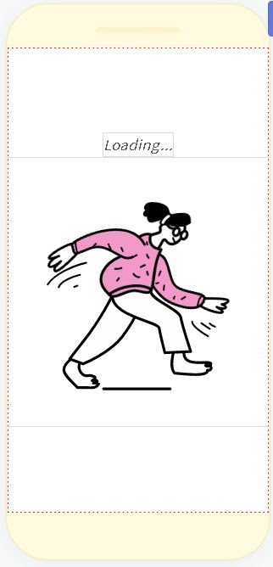
Figure 3: The application loading page.
The loading page was also used to help understand the logic behind connecting various screens together. In the event that the app does not load the appropriate screen quickly in response to the user’s actions, the loading screen will appear. In this case, the loading screen was between the home page and the questionnaire. At the top of the screen, the user will see a loading sign and then an animated gif of a woman walking across the screen. To reduce complexity and time performance, the screen will only be present when the app is not loading correctly in future prototypes.

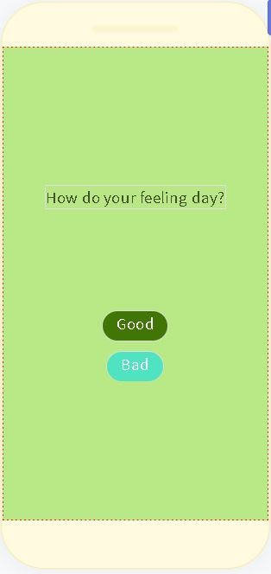
Figure 4: The application pain questionnaire.
The pain questionnaire serves as one of the multiple survey pages. The user in this instance is asked about how they are feeling today and have buttons to respond. Regardless of the choice, the app will proceed to the following questionnaire. Eventually, all this information will be taken into consideration to customize the workouts based on the answers. For this UI screen, the user had the option to answer one of two things in reference to the question asked, which is accomplished by pressing the button.

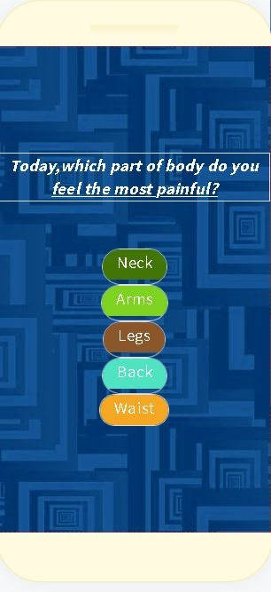
Figure 5: The application pain location questionnaire.
The pain location questionnaire was the second survey of the app. During the client meetings, it was understood that the ability to customize the workouts was important especially based on the severity of the pain and the location among other things. Consequently, the second survey was about the location of the pain. Serving as another skeleton for what the app will eventually resemble. Once again as with the pain questionnaire, the user is presented with a question and then answers in the form of buttons. The options for the locations included: neck, arms, legs, back and waist. More options will be added in the future. For the first prototype, the app does not yet customize the workouts based on the answers given. Ergo, despite the fact that the user may pick one option all options lead to the same following page.

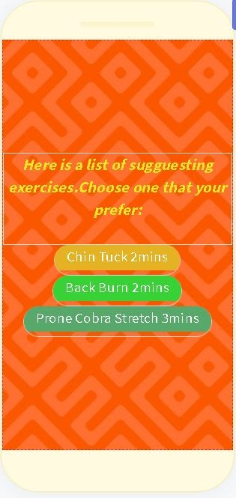
Figure 6: The application exercise list.
The exercise page provides a handful of options for the user to choose from to complete the workout. In this instance, the suggested time frame has been added alongside the exercise. The time for the workouts will eventually be a separate field that the user can enter. The screen explains to the user that they may choose from the following options and below there are three options of exercises: chin tucks 2min, back burn 2min, prone cobra stretches 3min. Based on the exercise the following page will be a video tutorial on how to perform the exercises. In future prototypes, options or customizations for the workouts will be on one page.

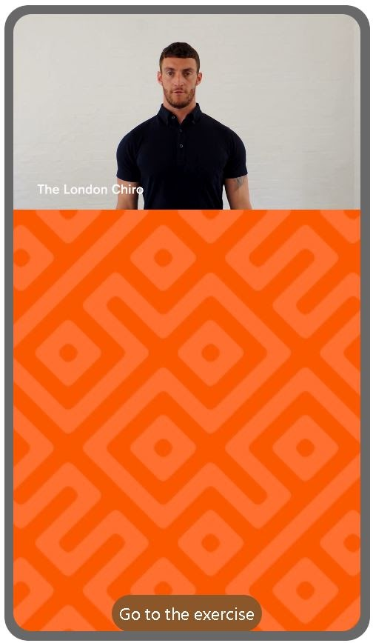
Figure 7: The application exercise video tutorial page.
The video tutorial page presents the user with an explanation of the exercises. A video is available on the page based on which exercise was selected. The video is currently integrated into the app itself meaning that the user does not need to open a page in their browser to access the video. Whether the user decides to watch the video or skip the tutorial, a button at the bottom of the page allows the user to proceed to the exercise and next UI screen.

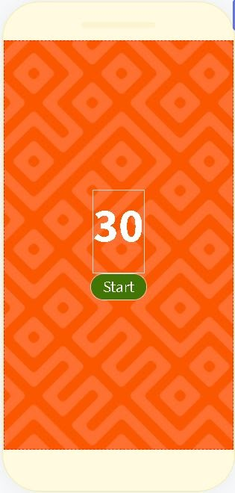
Figure 8: The application timer countdown.
The timer page displays a timer and allows the user to start the countdown timer. The number of seconds will decrease on the screen once the start button is clicked. At the moment the timer is not customizable, and the time was not based on the exercises. In the future, a stop button will also be included. For the time being there is only a start button meaning that the user does not have the option to exit the app with the timer continuing (in the case of an important call etc) even if they are not performing the exercise. However, the timer does accomplish one of the goals set by the client and group. The client needs to be motivated and the group decided on a timer-based app where the timer must be completed before moving onto the next exercise and then finally completing the workout. The app accomplishes this goal meaning the timer must be completed to move onto the next and final page which is the congratulations page.

Figure 9: The application congratulations page.
The congratulations page appears after the user has finished the workout to congratulate them on their effort. The congratulations page is only available after the workout is completed meaning after all the timers for all the exercises associated with the workout have been completed. This page serves no functional purpose other than congratulating the user.

Prototype Testing

How the tests were conducted:
The app was tested based on the chosen metrics and compared to the expected results. For the application response time the app response time was timed by the team to determine how long the app took to respond to the command given by the user. In other words, the app was timed to see how long it took for the app to perform the said function after the user had pressed the button to initiate the app to perform said function. Five trials were conducted the times were: 3.15s, 3.5s, 4.2s, 4.21s, and 3.01s. Thus, the average time was approximately 3.6s or between 3-4 seconds. The application size was tested by looking at the stored data and writing down the result. The number of data tracking features was tested by looking at the features that the app was exporting to the specified data sheet. Since this feature was not part of the first prototype the result was that there was no tracking. The complexity of actions relates to the number of actions the user needs to perform to complete the workout. This was measured simply by going through the application and counting the number of actions or for this prototype the number of buttons pushed. The customizability was tested by counting the number of features that the user could change. User friendliness was tested by asking the client how they felt about the prototype and relating the response to a scale from 1-10. Lastly, the performance time which is the time it takes the user to reach the workout was measured in the same way as the response time. The average time from the five trials conducted averaged to 30.15 seconds or approximately 30s.

Explanation for the results:
To start, the app will respond to users in around 3-4 seconds. This we believe to be in part because of the platform Thunkable and the possible inefficiencies to the code. The less direct the path is the more time it will take the app to reach the end destination. The size of our apps may be beyond 25MB as we initially expected because we added a video tutorial feature into our app. The more data that is stored in the app the larger the application size will be. Since the user was very happy about including video tutorials in the application it is possible that the metric specification changes to accommodate this new need. The congratulation page will add some picture elements for awarding purposes. Instead of providing data diagrams, and analysis data report will be provided. These factors also influence the app size. For the complexity, the app hit the target of 10 questions. However, because there were not as many questions as we need there to be for the user, the complexity metric may need to have its specification modified as well. We must balance the customer needs here and the ease of use. The data tracking feature was not added therefore the result is not applicable or rather the lack of the feature explains the lack of the tracking. Some of the functions for the app were not created, and the client asked us to add them. For this reason, the user-friendly range is marking lower than our expected results.
Metric | Expected results | Actual results
Application response time | 4ms | 3-4s
Application size | 25MB | 125MB
Data tracking (#factors) | 2+ factors | 0 (N/A) factors
Complexity (# of actions needed to finish workout) | 10 actions | 10 actions
Customizability (# of customizable features) | 2+ features | 3 features
User friendliness (1-10) | 8-10 rating (stars) | 7 rating (stars)
Performance time (Time to reach workout) | 30s | 30s
Figure 10: Prototype testing.

Next Client Meeting Preparation

The team plans on discussing the second prototype during the next client meeting. The team will give a demonstration of the second prototype and show the improvements made. During the second client meeting the client suggested changes to the first prototype which have been taken into consideration by the team. Any changes that occur will be shown to the client. Additionally, because any change to the app will also impact metrics such as customizability or complexity (user friendliness), the client will be asked about their opinion regarding the effects on the metrics. A presentation will be prepared in advance to show to the client the progress that has been made. At the end, the team will ask questions and ask for feedback to improve on the second prototype before the final product is created.
The team is thinking about asking the following questions among others to guide the next client meeting.
- Is the structure of the app user friendly?
- Are there enough customizable options?
- What do you think of the colours we used for the app?
- What is your opinion on the app’s data tracking capabilities?
- What do you like about this prototype? Which features would you like us to keep?
- What are some negative aspects of the app that we could change?
- Do you see yourself using this app in the future?
- How can we make this app more user friendly?

Bill of Materials

The application is being built using a free software that does not require any external purchases. Additionally, the app does can be launched for free and used on the user’s device without needing to go through any app stores thus avoiding those fees. The devices and means used to the app did not need to be purchased either. In conclusion, the app can be built without incurring any costs.

Current Prototype Costs
Item number | Part Name | Description | Quantity | Unit Cost (CAD) | Extended Cost (CAD)
1 | Thunkable | The software that will be used to design the application. | 1 | 0 | 0
2 | Phone | The device that will be used to test the application. | 1 | 0 | 0
3 | Laptop | The device used to design and test the application. | 1 | 0 | 0
 |  |  |  |  | 0
Figure 11: Current prototype costs.

Projected Final Prototype Costs
Item number | Part Name | Description | Quantity | Unit Cost (CAD) | Extended Cost (CAD)
1 | Thunkable | The software that will be used to design the application. | 1 | 0 | 0
2 | Phone | The device that will be used to test the application. | 1 | 0 | 0
3 | Laptop | The device used to design and test the application. | 1 | 0 | 0
 |  |  |  |  | 0
Figure 12: Projected final prototype costs.

Conclusion

In conclusion, the team was able to create the first prototype. A skeleton version of the application was created with functioning features. During the client meeting, the group concept and individual concepts were presented followed by a demonstration of the prototype. The client provided feedback which will be taken into consideration for the next prototype. The first prototype was made with the client’s specific criteria in mind and then the prototype was compared against the metrics. The testing will focus the team’s efforts to ensure that the future prototypes meet the expectations set for the application. It is vital to understand the first prototypes weaknesses before continuing with the second prototype. Finally, the bill of materials was generated for the first prototype and the projected cost of the final prototype. The group was able to create a first prototype and receive improvements from the client to refine the prototype and create a viable solution.

Appendix
WRIKE - Snapshot
https://www.wrike.com/frontend/ganttchart/index.html?snapshotId=EUvUThey2jjDCLwI07qNgdICWhGZ9rct%7CIE2DGMZZGQZTILSTGE3A

