MOVING WEBSITE SOFTWARE FLOW

Various examples extracted from the Jason’s Moving Inc. website and the Moveogo website.

Step #1: Go to www.jasonsmoving.com and click “Get An Estimate”

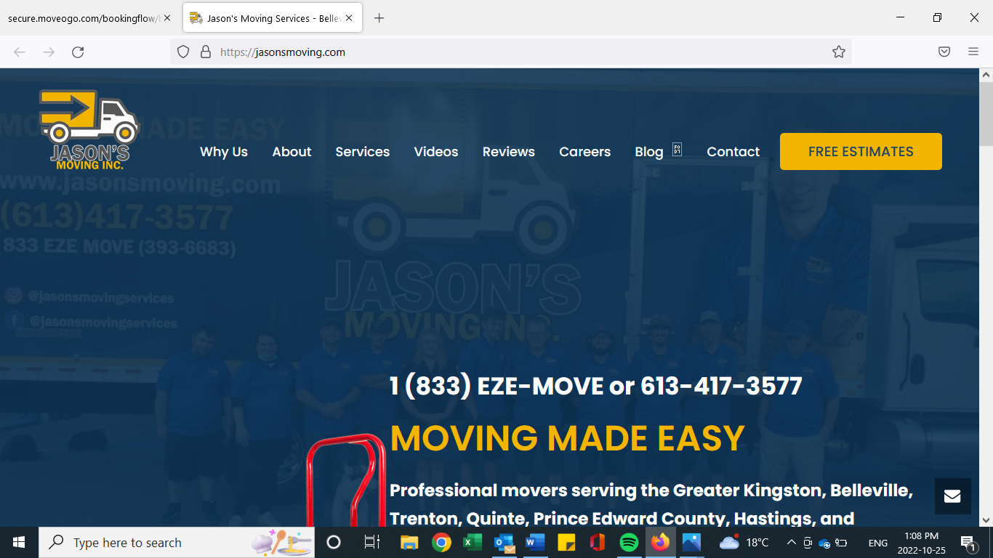

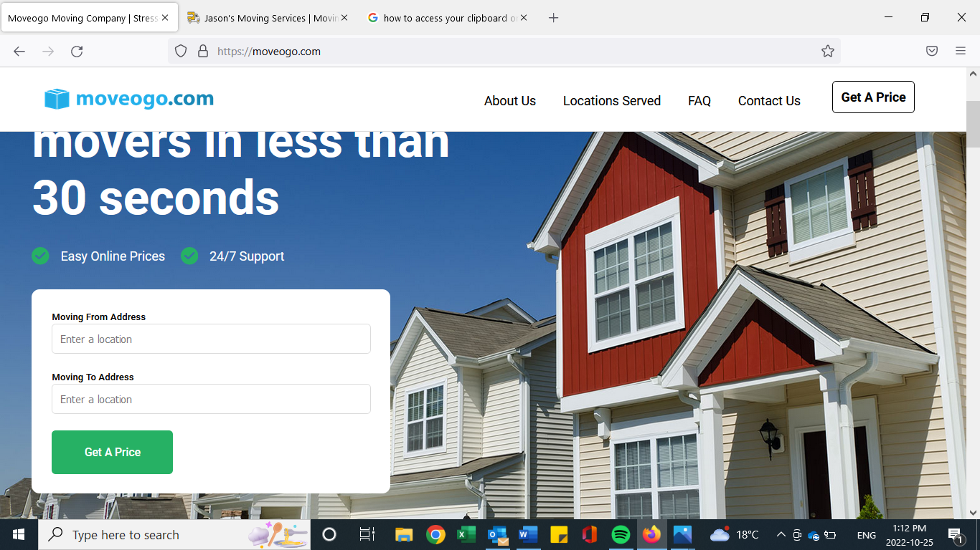

Step#2: Customer Info (Name, Address, E-Mail, etc.)

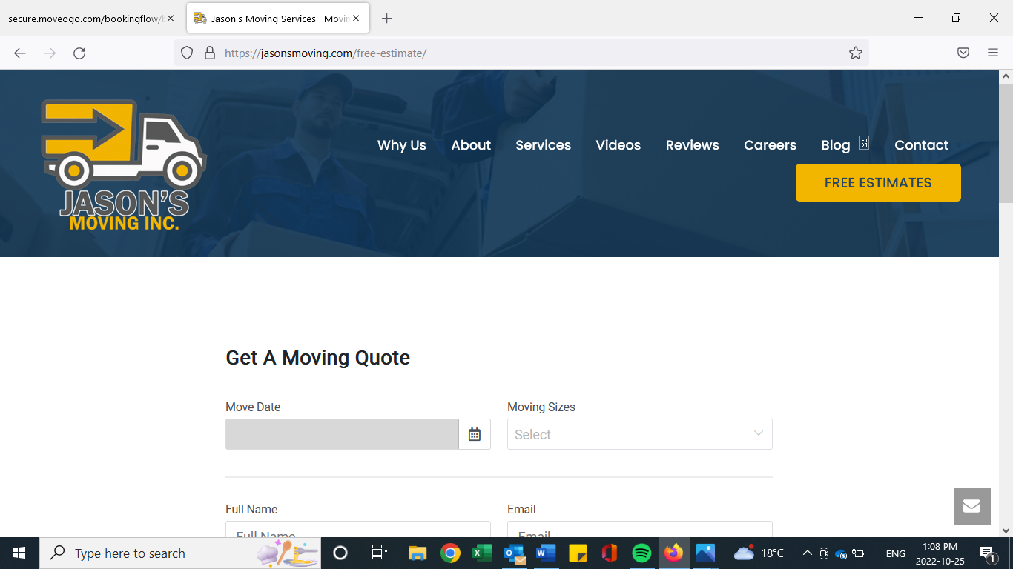

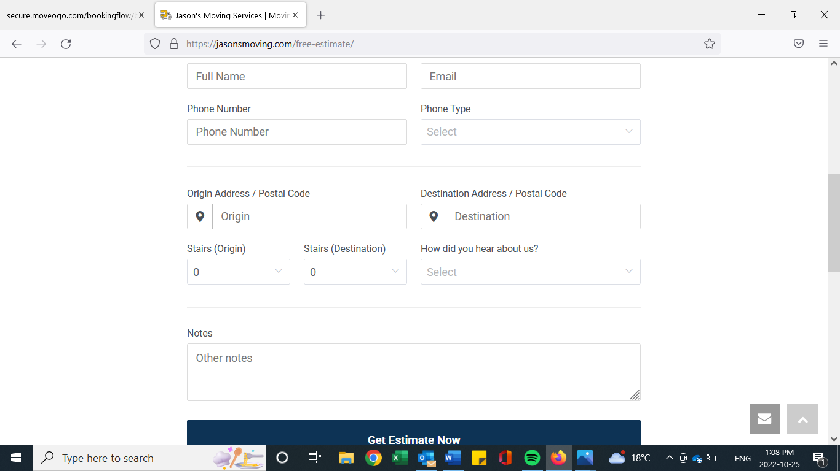

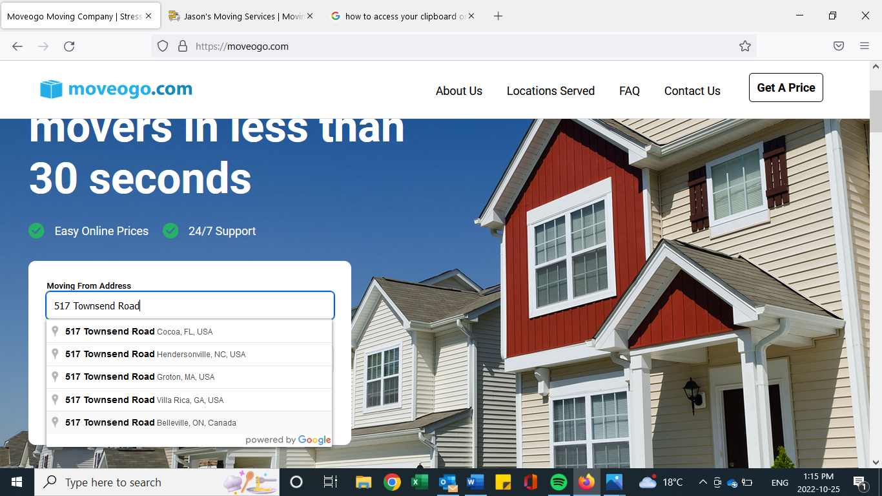

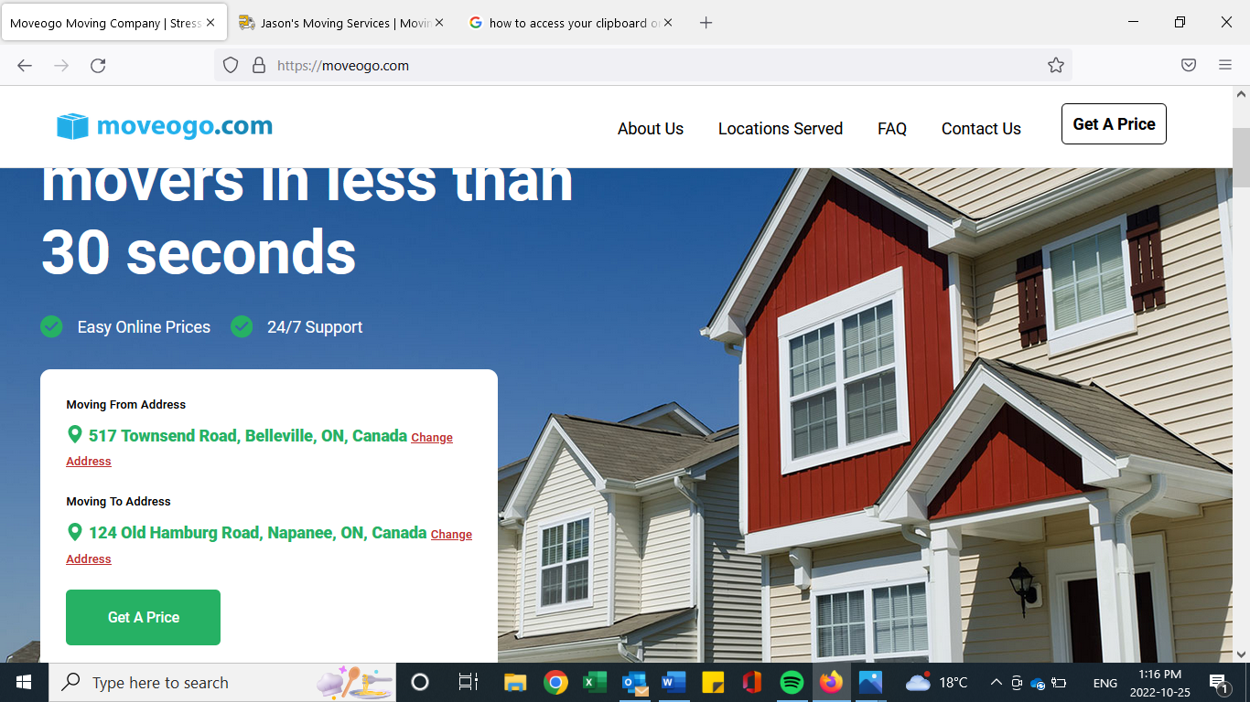

Step #3: Customer Selects the type of they are moving from and moving to (Single Family Home, Duplex, apartment etc.)

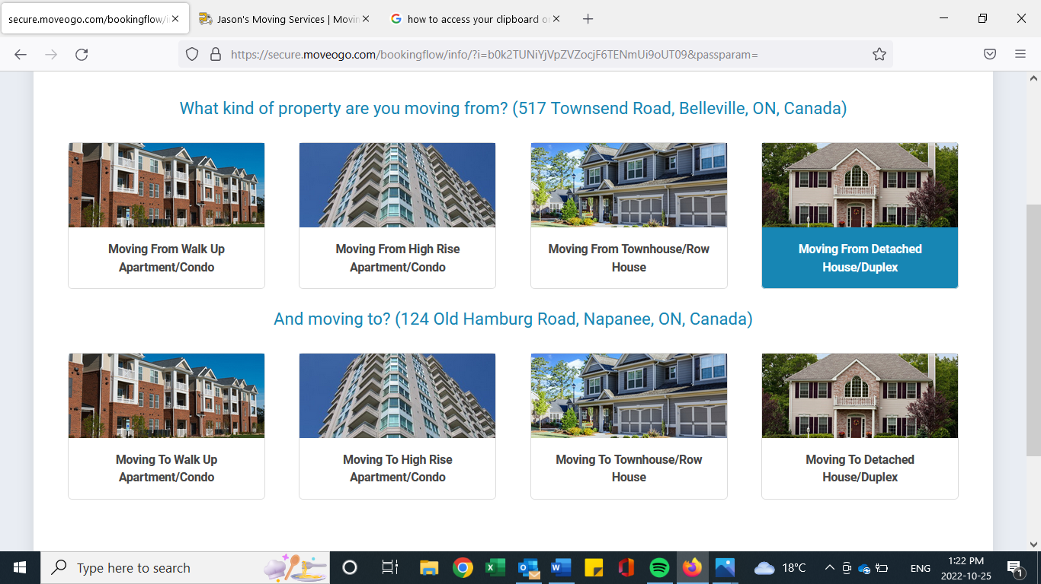

Step #4: Home Inventory (Customer inputs info about the move such as number of bedrooms, square feet of home, furniture items, etc. and the Moveogo proprietary system calculates and estimate for the consumer.

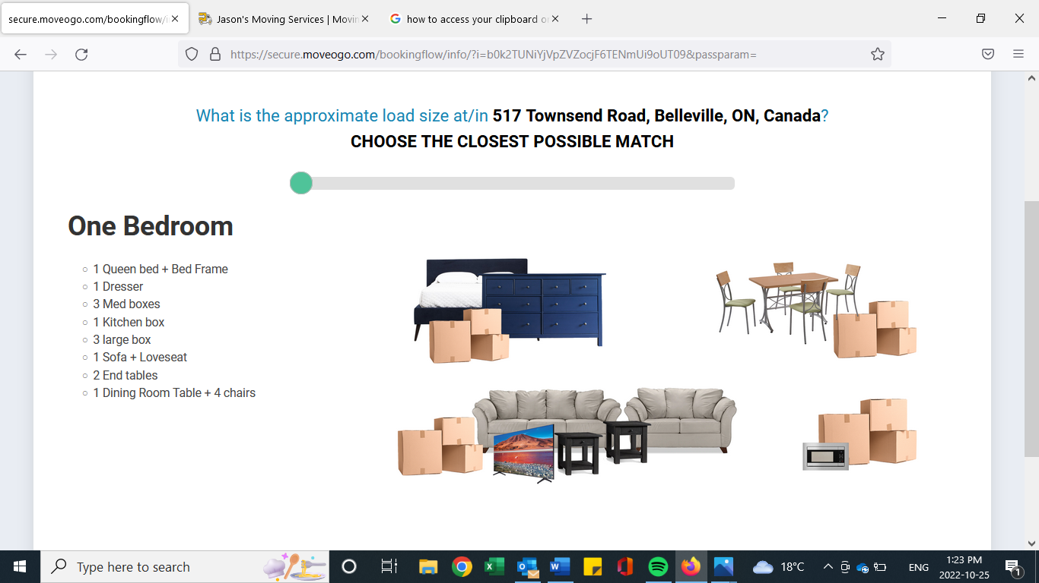

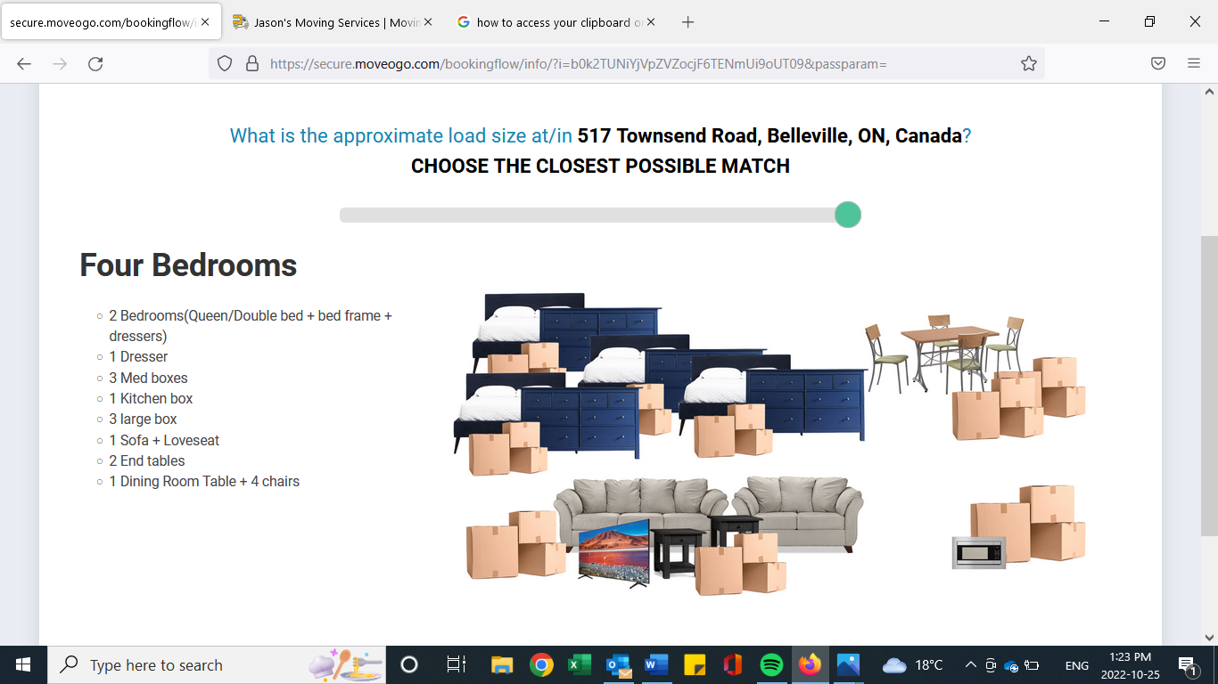

Step #5: Customer Receives an Estimate

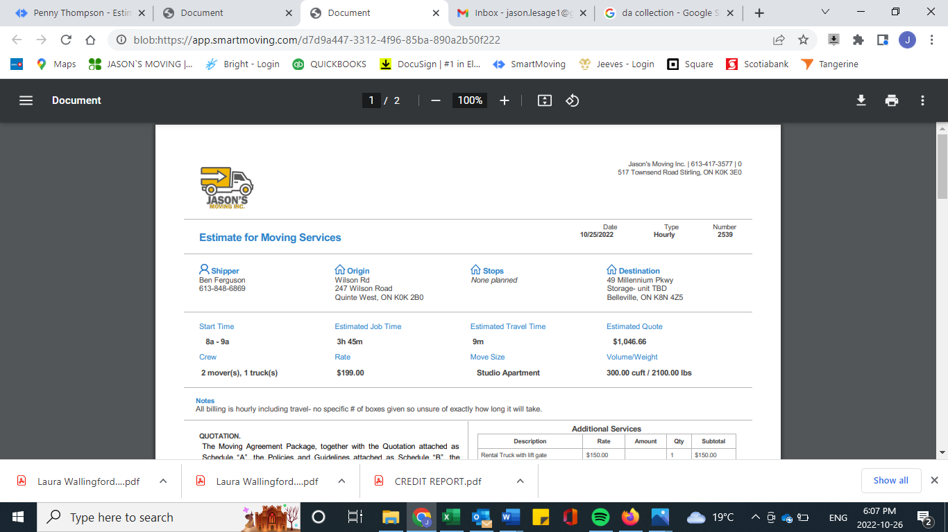

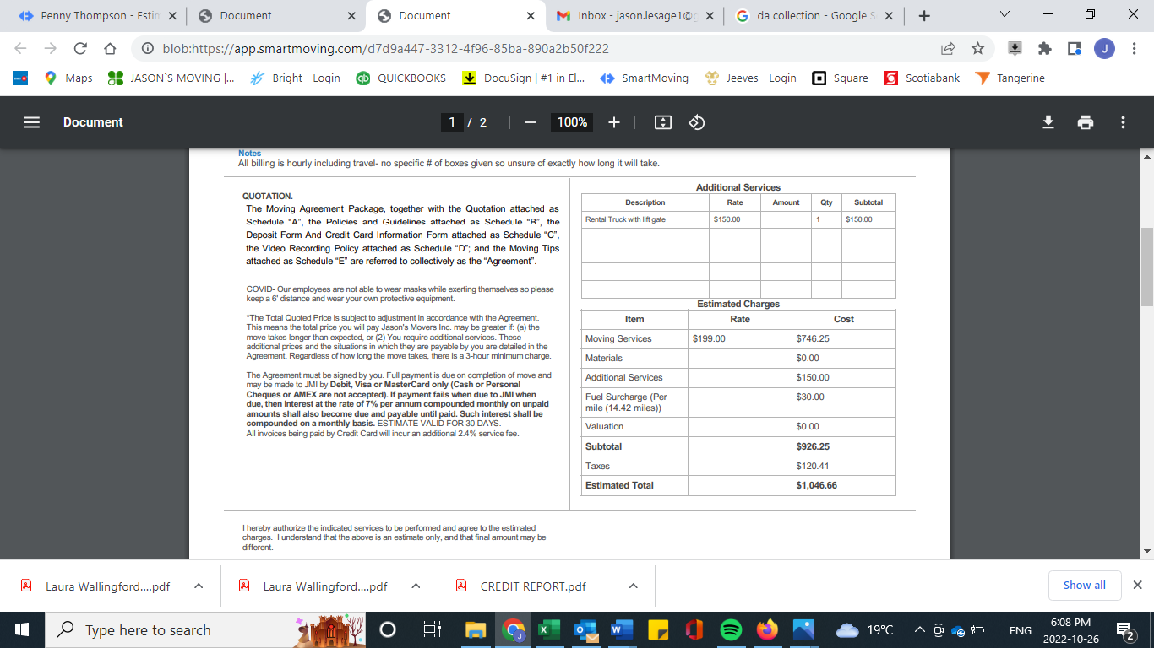

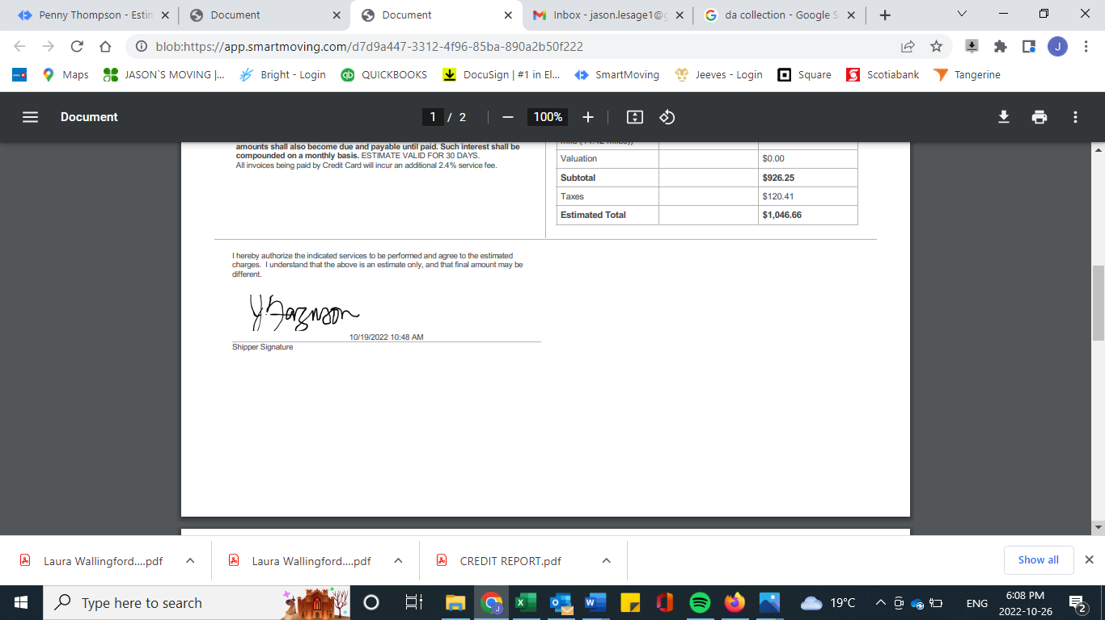

Step #6: Customer Clicks “Accept Estimate” and signs

Step #7: Customer selects a Move Date based on the Availability Calendar

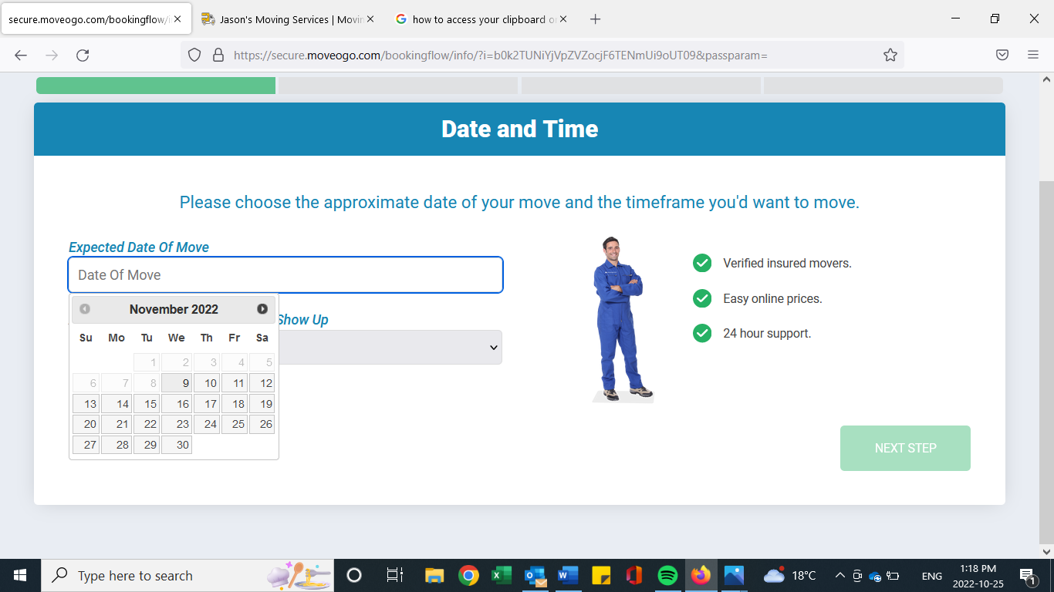

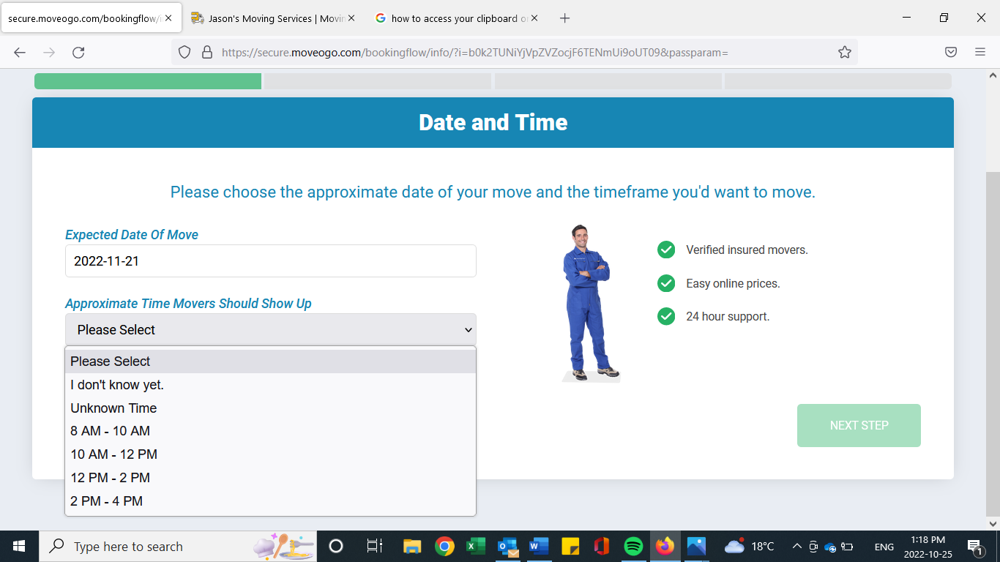

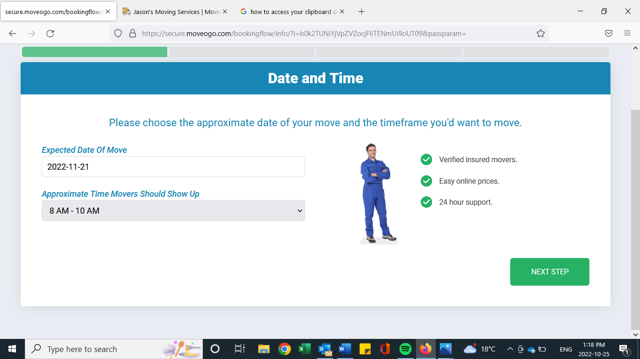

Step #8: Customer is sent a Moving Agreement/Contract to complete and sign.

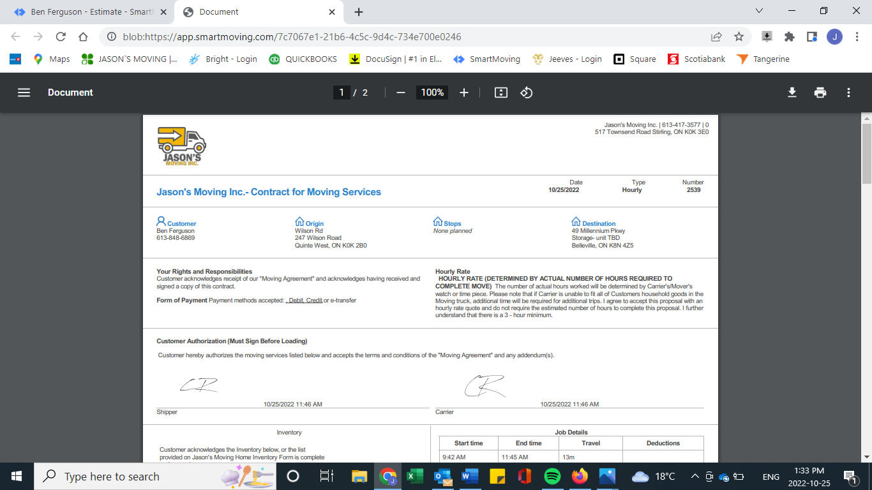

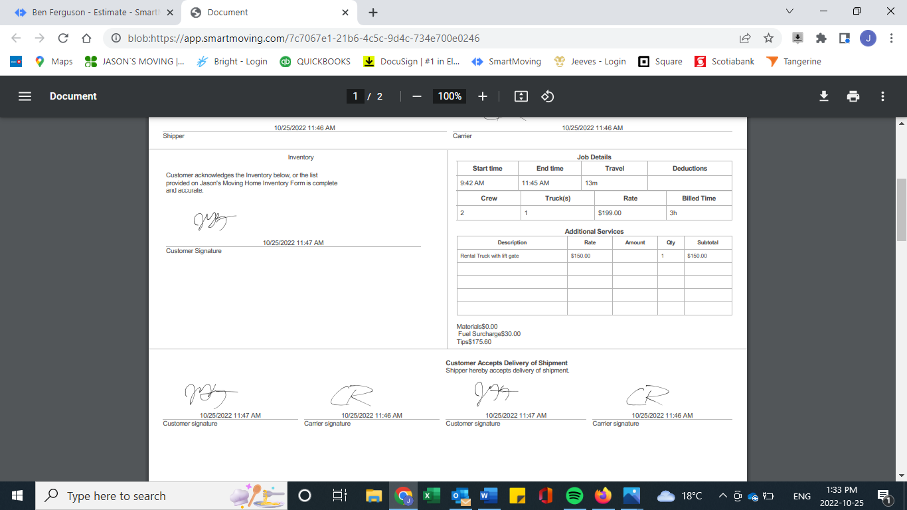

Step #9: Customer enters payment info (Credit Card/Pay-Pal) to leave a deposit and secure their move date

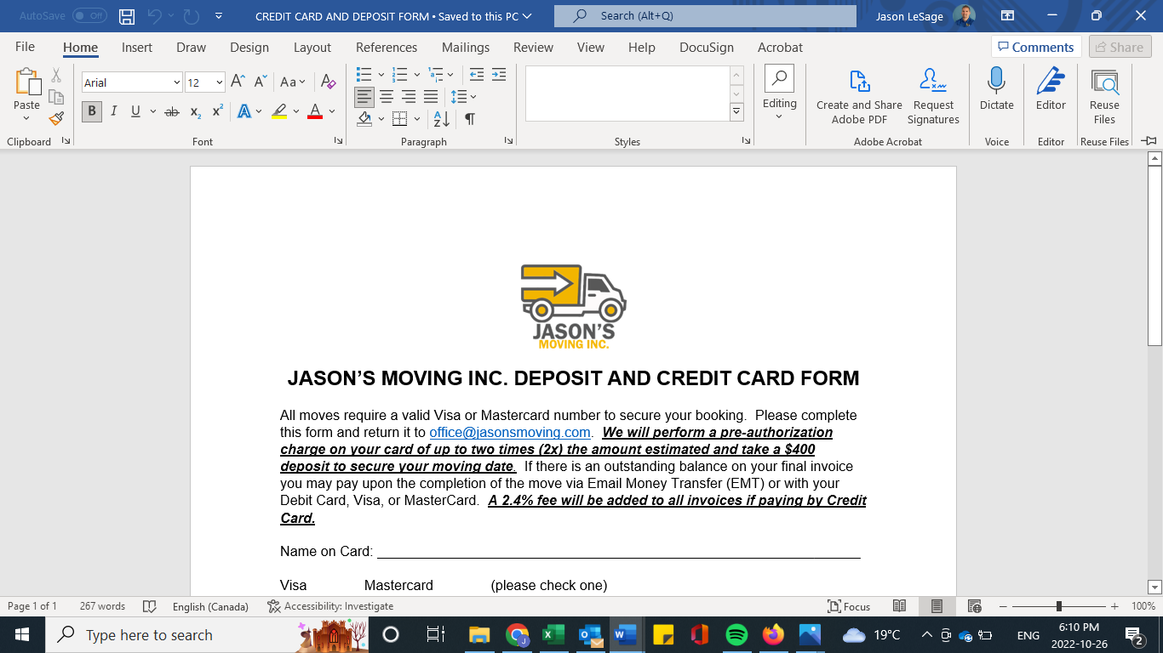

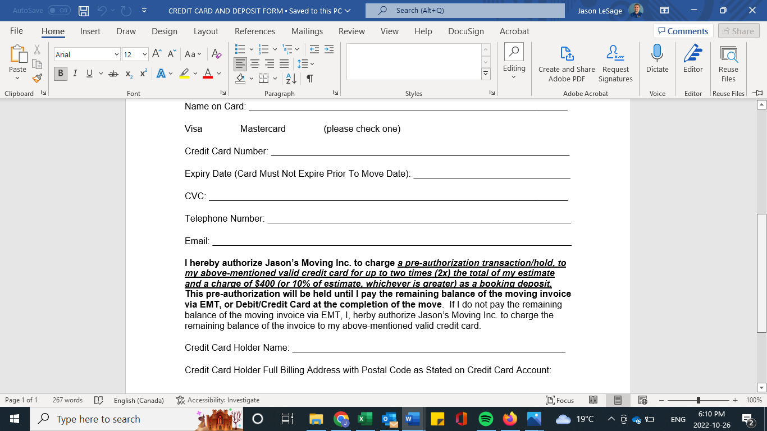

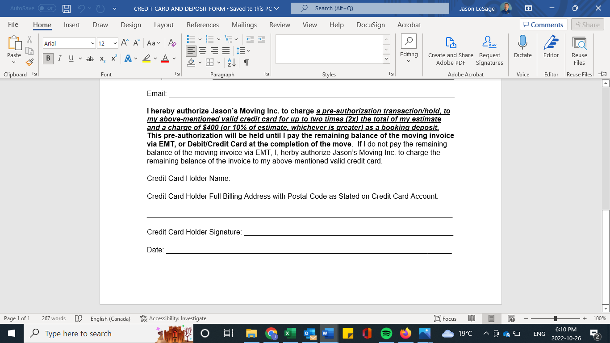

Step #10 Mass text goes out to all Moving Crew members within Jason’s Moving Inc. advising them of a move that was just booked and gives the crew members necessary info of the move such as date, size of move, moving from and moving to addresses, etc.

Step #11 Crew Members that want to work on that date click “accept” or “confirm” from their smart device

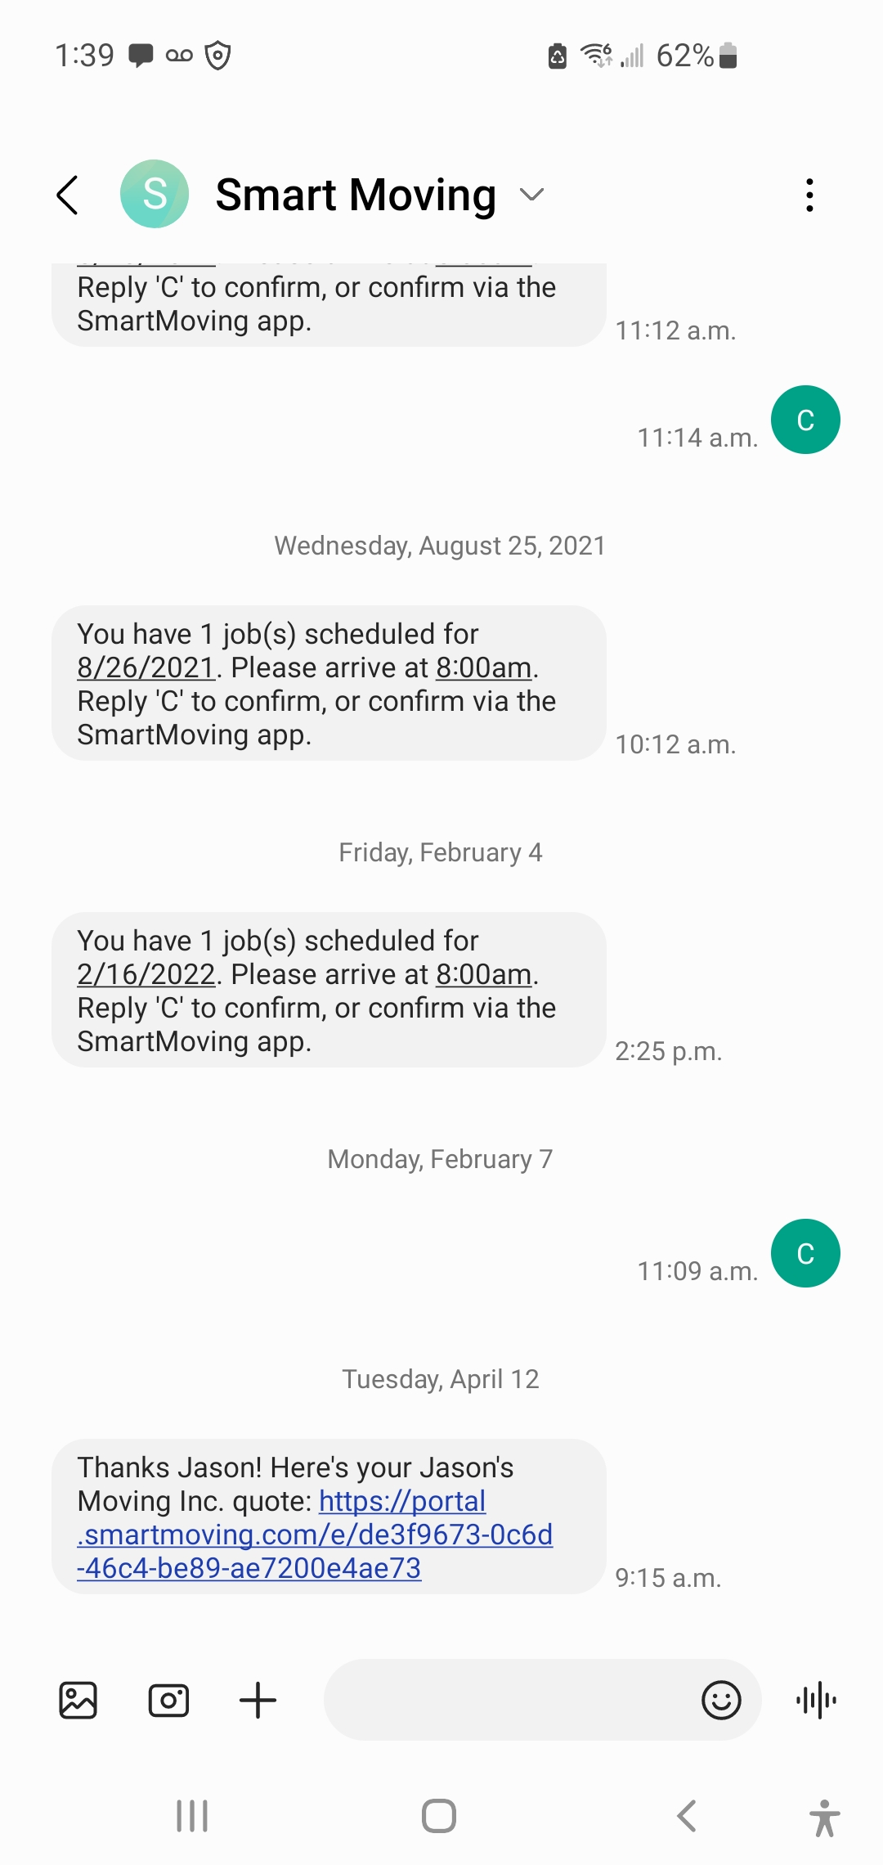

Step #12: Once all positions are filled for the job, customer receives a text and email confirming that their move has been booked with Movers #1, #2, and #3 and includes names, bio, pics, and info about each mover so that customers know who to expect at their door.

Step# 13: Customer gets friendly reminder text 48 hours prior to the move and has a link to a PDF document listing everything that should be done prior to the arrival of the movers on x date

Step# 14: On the day of the move, a crew member clicks “On Route” from their smartphone and the customer gets a text message and email that says “On Route” to advise them that the movers are on their way.

MANY OF THESE STEPS CAN INCLUDE VIDEOS TO WALK CUSTOMERS THROUGH THE PROCESS STEP BY STEP.

*** ADD A STEP FOR VIDEO UPLOAD AND PICTURE UPLOAD FROM REAL ESTATE/MLS LISTINGS TO GIVE MOVE ESTIMATORS MORE VISUALS OF THE HOME AND CONTENTS TO BE MOVED FOR AN EVEN MORE ACCURATE ESTIMATE.

THINK OF WAYS TO MARKET TO REAL ESTATE FIRMS SO THAT THEY WILL WORK MORE CLOSELY WITH US TO BRING BETTER VALUE TO THE CUSTOMER REGARDING THE ESTIMATE AND SALES PROCESS****

