University of Ottawa

GNG 1103: Engineering Design
Deliverable E – Project Plan and Cost

Presented to:
Dr. David Nox

Presented by Group 14:
Wissal Assi – 300146551
Xiyu Bo – 300188288
Jacob Nolan – 300337194
Milo Murillo – 300381208
Chiemelie Osigwe – 300325153

October 29, 2023
Table of Contents
List of figures 2
List of tables 2
I. Introduction 3
II. Design Drawings 4
III. Cost estimation: 5
IV. List of equipment: 5
V. Project Risks: 5
VI. Prototyping and Testing 7
Why are we doing these tests? 7
What is the prototype and what is the test? 7
How is the prototype used? Does it match the objectives (i.e. the Why)? 7
Determine the purpose of the test： 7
Important data: 7
When is the testing happening and how long will it take? 7
VII. Wrike 7
VIII. Conclusion 8
IX. References 8

List of figures
Figure 1:Design drawings 4

List of tables
Table 1: Cost estimation table 5

Introduction
The primary goals of this deliverable are to create a project schedule, ensuring the completion of the project prototype by the end of the semester, and to provide a project cost estimate.

Design Drawings
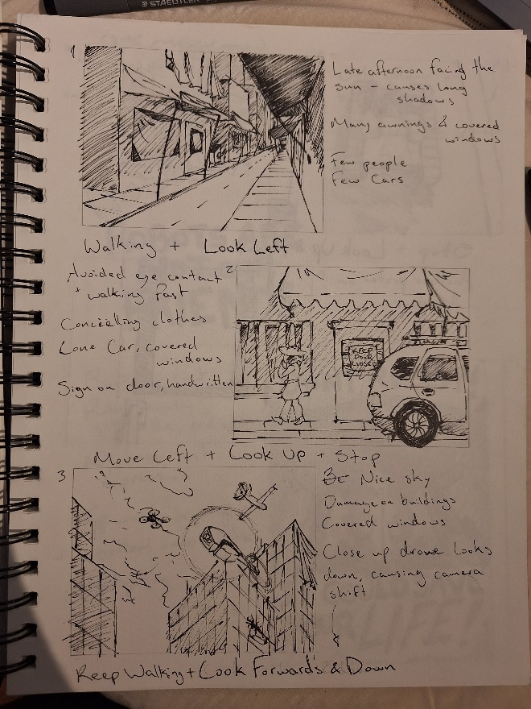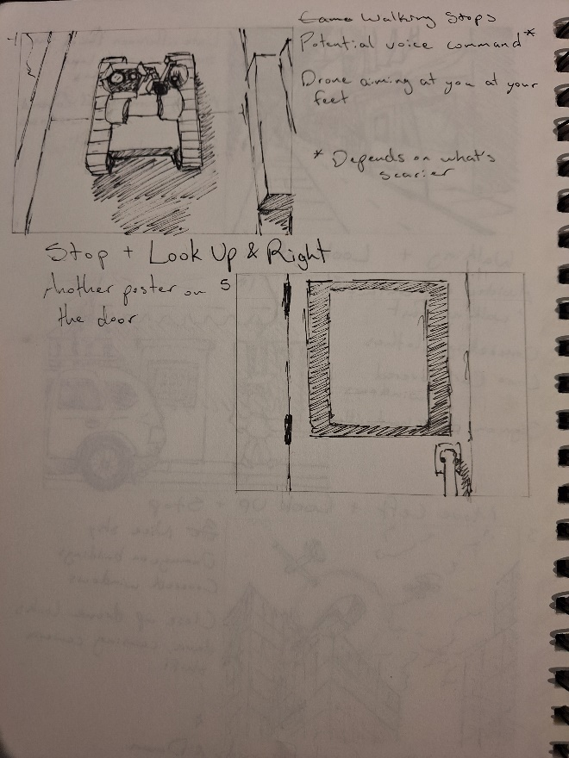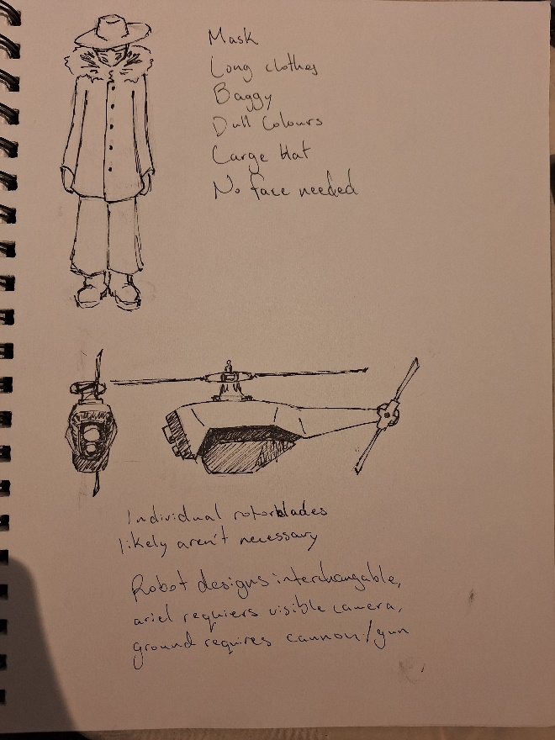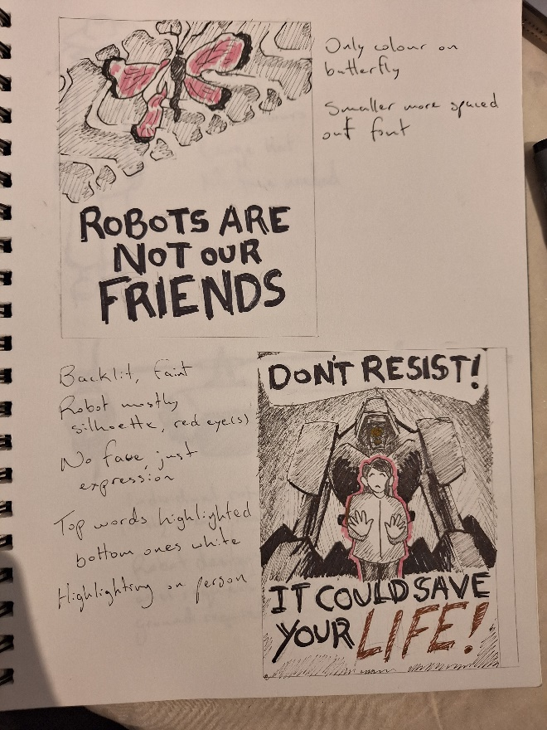
Figure 1:Design drawings

Cost estimation:
The cost estimation for our project has been summarised in the following table.
Table 1: Cost estimation table
Material | Cost ($)
Houses | 0
Shops | 0
Window covers | 0
Streets | 0
Sidewalks | 0
A person | 0
Posters | 0
Cars | 0
Sky | 0
Voice Narration | 0
Total Project Cost | 0

List of equipment:
Since our project is primarily software-based, the only materials required will be software tools such as Unity and Clip Studio Paint, along with a computer capable of handling the workload.

Project Risks:
- Lack of computer recourses will likely impact the UX negatively (FPS).
Contingency plans:
  - Switching computers (ex: using another one of our laptops/using the ones provided by the university).
  - Minimizing the number of background assets/animations
  - Changing Unity graphics quality
- Incompatibility between assets, programs, and versions of unity.
  - Isolating the assets/programs to see if they even work alone
  - Checking the error log
  - Looking for potential Unity dependencies and installing the appropriate ones (if applicable)
  - Installing different versions of Unity
  - Using other assets/programs
- Too much difficulty engineering certain concepts/too many concepts to engineer in the simulation given the time limit.
  - Weigh the importance of concepts against their difficulty, and choose concepts to discard until a reasonable time is reached

Prototyping and Testing

Why are we doing these tests?
We are doing these tests to ensure that the prototype functions properly, fits the client’s needs (solves problems + user experience), and meets specifications before the prototype may become the final product. This is done by doing prototype trials involving usage of the prototype by potential users, running of programs, assets and animations, compatibility tests, etc.

What is the prototype and what is the test?
The prototypes are camera movements and animations. Animation prototypes will employ tests to check for object collisions and ensure certain actions are triggered when expected. Camera movement tests include checking to ensure the view of the camera is at the right position and ensuring there are no obstructions. Lastly, overall prototype testing will include ensuring all other aspects run effectively together.

How is the prototype used? Does it match the objectives (i.e. the Why)?
1. The entire prototype will be presented to the audience in the form of an animation.
2. Yes, it is matching the objectives.

Determine the purpose of the test：
We want to make people feel the cruelty of war and the inhumanity of autonomous weapons through a non-bloody picture.

Important data:
- The most important data is to find people who are unfamiliar with this prototype to watch and give feedback.
- The content length of this prototype. (Content that is too long or too short will reduce the audience's attention and fail to achieve the test goal）
- Whether the level of blood and gore will make people feel uncomfortable.
- Whether the content well expresses the view that makes people agree with the inhumanity of autonomous weapons.
Finally, for the data I introduced above, it is necessary to collect them so that our prototype can better achieve our testing goals.

When is the testing happening and how long will it take?
The testing will take place from October 30^{th,} and it will last for a period of two weeks.

Wrike
https://www.wrike.com/frontend/ganttchart/index.html?snapshotId=BvDihODBWW767rx5MPI5Aa6HiKrwSQEF%7CIE2DSNZVHA2DELSTGIYA

Conclusion
Our team has presented an initial design outlining our project's expectations, along with a cost estimate and information regarding our upcoming prototype, including the testing type and duration. This deliverable serves as a significant step in initiating the video production process.

References
Obsidian Entertainment. (2010). Fallout: New vegas [PC]. Bethesda Studios
SPROUT DISTRO. (2015, November 11). COPS ARE NOT OUR FRIENDS [Tumblr post]. Retrieved from https://www.tumblr.com/sproutdistro/133000676464/cops-are-not-our-friends
Wikimedia Foundation. (2023, October 1). Black Hornet Nano. Wikipedia. https://en.wikipedia.org/wiki/Black_Hornet_Nano
Wikimedia Foundation. (2023, August 29). Miloš (unmanned ground vehicle). Wikipedia. https://en.wikipedia.org/wiki/Milo%C5%A1_(unmanned_ground_vehicle)
Kjosvold, T. (2022, August 24). UK and Norway join forces to purchase micro-drones for Ukraine worth $9 MLN. Rubryka. https://rubryka.com/en/2022/08/24/brytaniya-ta-norvegiya-ob-yednalysya-dlya-zakupivli-mikrodroniv-ukrayini-na-9-mln/
Teen Poets. (2017). “The broken butterfly.” The Dots. (n.d.). https://the-dots.com/projects/the-broken-butterfly-299074

