Deliverable Title:

Deliverable F: Prototype 1 and Customer Feedback

Group Members’ Name(s):

Youssef Yacout (300106440)
Mustafa Warsame (300116411)
Rawan Al Sayed (300107944)
Shubham Ambalia (N/A)
Jackie Zhou (300197798)

Date Deliverable Submitted:

Saturday, November 14, 2020

Subject:

GNG1103
University of Ottawa – Faculty of Engineering

Table of Contents:

Introduction: 3
Why Prototype: 4
Prototype Scenes: 6
Scene 1a: Main menu 6
Scene 1b: Settings 7
Scene 2: Language Selection 7
Scene 3: English Hazard Screen 7
Scene 4: French Hazard Screen 8
Scene 5: Tutorial 8
Testing Plan Outline: 8
A proper testing plan should include the following: 9
Client/User Feedback: 10
Conclusion: 10

Introduction:

In this deliverable, this team has created the prototype’s interface of our augmented reality system. The objective of this prototype is to ensure that we have applied the customer feedback given, and therefore develop the product and theoretically explore various methods for the development of the AR system. During the completion of the prototype many tests will be conducted on the product. This will help the design team evaluate the prototype and discern which components are usable and which need to be dramatically improved. The testing will be done at a small-scale level by going from scene to scene and making sure that every scene has no issues pertaining to coding or in the scene itself. As this is the first prototype, cosmetics and other add-ons will be brought to fruition later in the project.
A prototype is a representation of the idea of a component or an entire design. The goal of prototyping is to learn and understand more about a design idea. In addition, through gaining more understanding of the design, it is then possible to analyze the system and the subsystems and enhance our product. The objectives of the first prototype, is enhancing the interface and creating a flow diagram of all the different options for the user. Becoming familiar with C-Script coding which will cut down on the time fixing errors. Completing the interface for AR and implementing all the ideas that the team generated to make it user friendly. Implementing an English and French version for all scenes. Implementing videos at the start of the interface to educate users on the AR app.
As a group, there is still progression to learn how to use unity to represent us best in this first prototype, and to directly express our ideas. As research was carried out on the best techniques to efficiently maneuver through Unity and C-Script, multiple videos and different types of scripts will be implemented to establish a base understanding. When the first prototype of our game is built, the team will then focus on learning how to create a user-friendly interface that has all the components that have already brainstormed, and to properly translate it toward the AR through unity.

Why Prototype:

- Reduce the probability of mistakes
- Find errors in advance, fix them, and apply given feedback/suggestion
- Provide a solid plan for final prototype to present Design Day
- Get a better picture of what we are trying to create/design
- Verify that design is feasible

A prototype reflects a single component or an entire design idea. The goal of prototyping is to learn more about the design idea and to grasp it more clearly. In addition to gaining more understanding on the design, both the performance and efficiency of the system and the subsystems must be studied. These are the main aspects of a prototype that are both used to innovate, enhance, and perfect the product.
For our first prototype, we built a concrete and centered prototype. We selected a physical prototype because we are all new to Unity software and it was necessary for us to test our satisfaction with this software. We tried to find an average calculation taking into account the amount of work required by the program to assess the number of scenes, the extent of complexity and the number of components that we will realistically be able to incorporate in each scene. In addition, our choice to work with oriented scenes was such that we had a general sense of the overall setting in - scene, which would give us a rough idea of what our final designs would look like. The execution of the characteristics of the product, in particular the transformations, has allowed us to create unique uncertainty regarding our product. Later, we will draw on the initial environments (AR scene) more accurately on our future designs to get us closer to our final design target.
Our first prototype contains six scenes. First scene is the main menu, it contains options for settings, start, quit. Second scene is the language selection option, depending on the language selected either scene three (English) will open or scene four (French). Scene three/four contain a hazard warning message with a confirmation button of understanding. Upon clicking “I understand”, scene five will open, it will contain a thorough tutorial explaining the proper usage of this software. After completing the tutorial, scene 6 will open which is an empty scene for the AR. It was left empty because no structure was given at the time.
The first prototype looks like a promising one as it resembles our design philosophy and is aesthetically appealing. The prototype was tested in front of family members and their feedback was given and taken into consideration. We performed an observational simulation. Our first prototype was oriented and analytical, while the final prototype would be more detailed/comprehensive. The quality of our first prototype is high, as it reflects the scenes almost as they would be in the final, considering the limited emphasis.

Prototype Scenes:

Scene 1a: Main menu
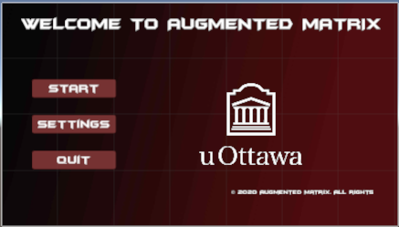

Scene 1b: Settings
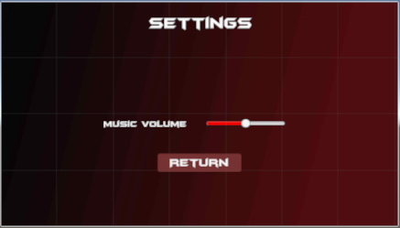

Scene 2: Language Selection
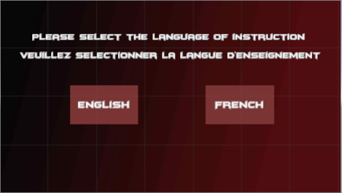

Scene 3: English Hazard Screen
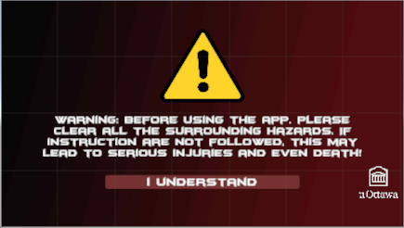

Scene 4: French Hazard Screen
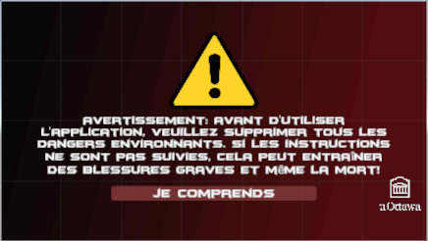

Scene 5: Tutorial
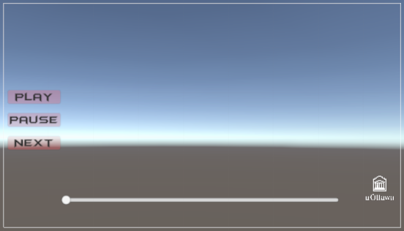

Testing Plan Outline:

Testing is a vital component of every engineering design. It helps engineers/designers to know whether their product has fulfilled its specifications effectively or if more should be done to boost the productivity of the product. Testing also guarantees that all parts are running correctly and that there are no identifiable design defects.
Some of the additional advantages of research include predicting demand, observation of different materials factors, product benchmarking (comparing performance with other products) and testing of whether the product is ready to be released. To accurately assess the performance of the product and evaluate its functionality, the design team must draw up a testing plan.

A proper testing plan should include the following:

- Define the purpose of the test
  - What is the design team attempting to analyze from the prototype?

- Choose a subsystem
  - Choose measurable attributes
- Choose a testing method
  - Simulations, physical concepts, etc.
- Perform the test
  - Measure and record the results
  - Can the results be analysed by the design team?
- Interpret the results
  - How can we improve?

The subsystem we chose for testing was the Main Menu scene. After further analysis of its functionality a defect/bug was found. The defect is as follows: after you switch back and forth from the main menu to the settings twice, the scene disappears completely. The same test was performed 5 times to gather data and we received the same results. After long hours of trying to fix this bug, we came up with a solution. Instead of unchecking the visuals for the scene, we will make separate scenes (one for the main menu and the other for the settings). This will allow us to fix the bug. A script will be written for the scene switch. This was the most noticeable flaw in this subsystem. A quick general testing was done on the overall system and everything looks fine.

Client/User Feedback:

By consulting the input of the customer and receiving suggestions of prospective customers, the design team will significantly enhance and improve the prototype. Through getting multiple opinions/feedback and advice on the prototype, the design team will decide what works, what does not work, and what needs to be changed. With close consideration of the guidance provided by others, the design team will get a new viewpoint on the AR software and how it can be strengthened.
We requested feedback from younger family members who are more technology oriented and might be potential users. They provided us with some useful suggestions can help us perfect our product. Most of the users enjoyed the way we handled this product as a game. The gamification feature made it much more fun to play, and it drew their interest. The testers pointed out that the music was too loud and recommended that we make change the intro music to a softer one. They also noted that there was not anything to play with in the game, but that was not our key focus on this prototype. Overall, the users like the quick transition from one scene to the other. Lastly, they thought it was easy to use and friendly.

Conclusion:

In conclusion, after designing and evaluating the first prototype of our AR software, we were able to decide what had to be improved to increase overall consistency and user interface, and to ensure that the learning result was grasped. The benefit of checking the prototype is that it eliminates the chances of experiencing technological difficulties with the AR and guarantees that the demands of the customer are fulfilled before the final prototype is presented. As a part of this first version, we have a stable basis of the finished product that has the key functionality required to satisfy the needs of the client and offers a framework that can be further developed and more advanced features can be integrated. In future prototypes, the scene disappearing issue will be fixed and the music will be changed to a softer one. We will act upon all the given feedback and improve our product.

