Deliverable D- Conceptual Design

Prepared for

Elsa Lange
Project Manager

Pankaj K. Rathi
Teacher Assistant

By

Akem Shergill- 300246583
Wacira Muiruri- 0300245399
Shahrayar Nur- 0300233739
Mathew Emmanuel- 300240312
Ayham Alshaikhali- 300244961

Sunday February 13th 2022

Abstract
This document contains information about our robot designed for the Halifax class destroyer ship. The document will show the functional decomposition of how the robot will work when given an order. We categorised the important functions of the robot through four subsystems. The four subsystems are Articulation, End Effector, Accessories, and Base. The document will then indicate, through a design matrix, our design process and which design was the best suitable for the robot.

Table of Contents

Deliverable D- Conceptual Design 1
Table of Contents 2
Introduction 3
There are already many robots of this kind, so to begin benchmarking we’ve looked at 2 different robots that have been created to carry out similar tasks. One is a robot “thor”, made to have 6 degrees of freedom, and can carry out similar tasks to the ones we are trying to make. The other robot was made by Nick Benoit. The purpose of his robot is to pick up items and move them somewhere else using the end effector. 3
Problem Statement 3
Problem Statement 3
Functional Decomposition 4
Subsystems 4
Subsystem 1: Articulation 4
Subsystem 2: End Effector 5
Subsystem 3: Accessories 6
Subsystem 4: Base 7
Table of Subsystem Ideas 8
Solution 8
Base 8
Accessories 10
Articulation 12
End Effector 13
Block/Tree Diagram 15
Conclusion 16
5.1. Global Concept 16
Appendix 16

Introduction
The problem given to the group is to build a robotic arm with 3 degrees of freedom. On top of creating this robotic arm, we are tasked to make sure it can carry out specific tasks such as painting, spraying down, and scanning areas.

There are already many robots of this kind, so to begin benchmarking we’ve looked at 2 different robots that have been created to carry out similar tasks. One is a robot “thor”, made to have 6 degrees of freedom, and can carry out similar tasks to the ones we are trying to make. The other robot was made by Nick Benoit. The purpose of his robot is to pick up items and move them somewhere else using the end effector.

Problem Statement

Problem Statement
To be able to refurbish and paint areas of the Halifax class destroyer ship without increasing the cost of staff by using robotics. An inverse kinematics solver that is easy to use, light-weight, cost-effective, and portable with three degrees of freedom with an end effector which is able to hold a pen, water gun, camera holder with scan, and light.

Functional Decomposition
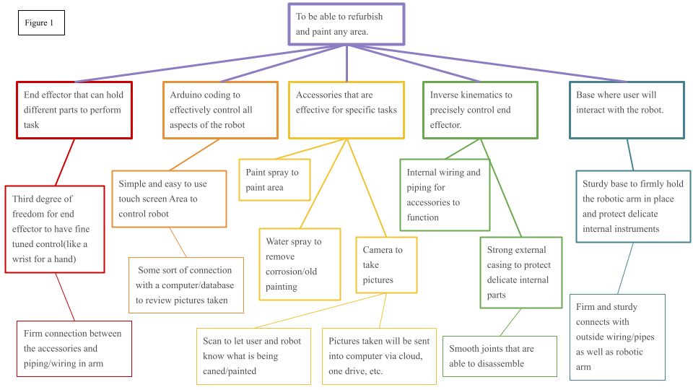
(Figure 1. Functional decomposition of the inverse kinematic robotic arm)

Subsystems

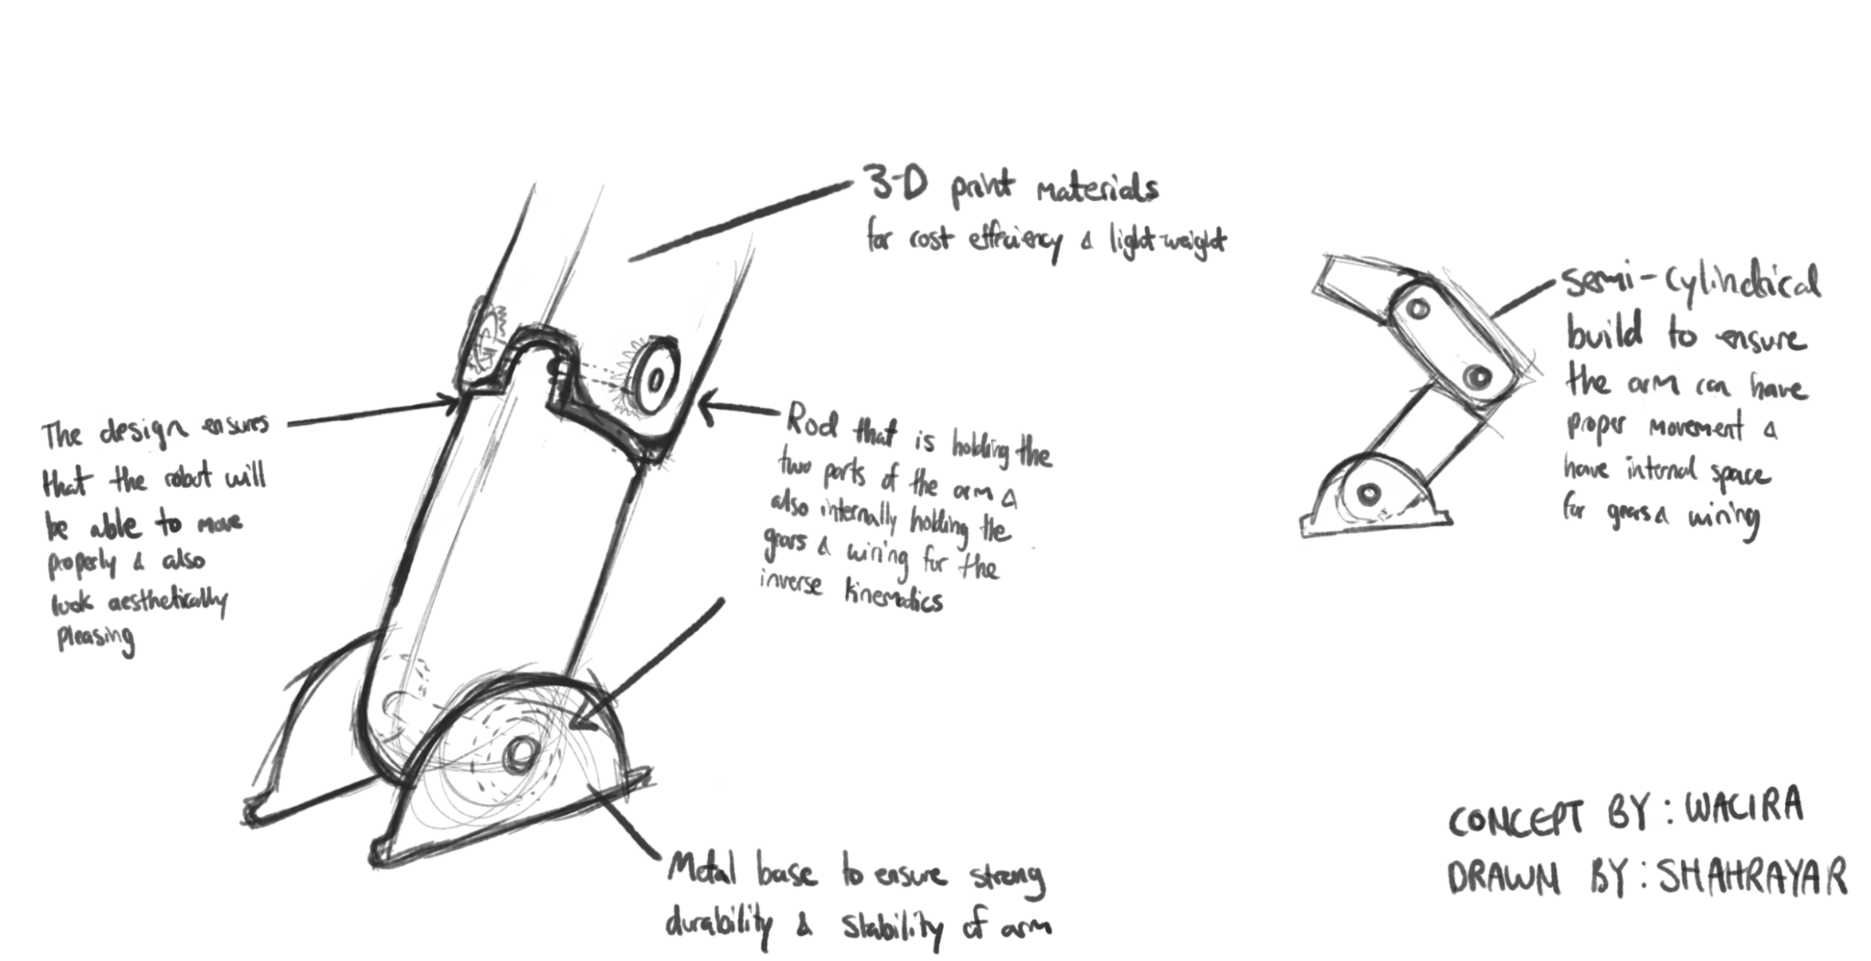
Subsystem 1: Articulation

(Figure 2. Standard example of the drawing of the articulation)

Subsystem 1 focuses on the movement at the joints of the robot. It outlines the main concern, which is to have detachable pieces for easier transport

These joints must move with ease in a 3-dimensional plane with the use of inverse kinematics. Each joint needs to be durable enough to run for 24 hours, carrying weights up to 1kg.

We’ve decided to make the joints detachable with the use of a rod to create a simple process to move the robot around into areas it may not be able to fit into if it were fully assembled.

The base consists of metal to create a durable and stable housing for the base of the arm. The arm will have a semi-cylindrical piece to ensure that the arm can move freely while still having enough space for all the wiring and gears.

Subsystem 2: End Effector
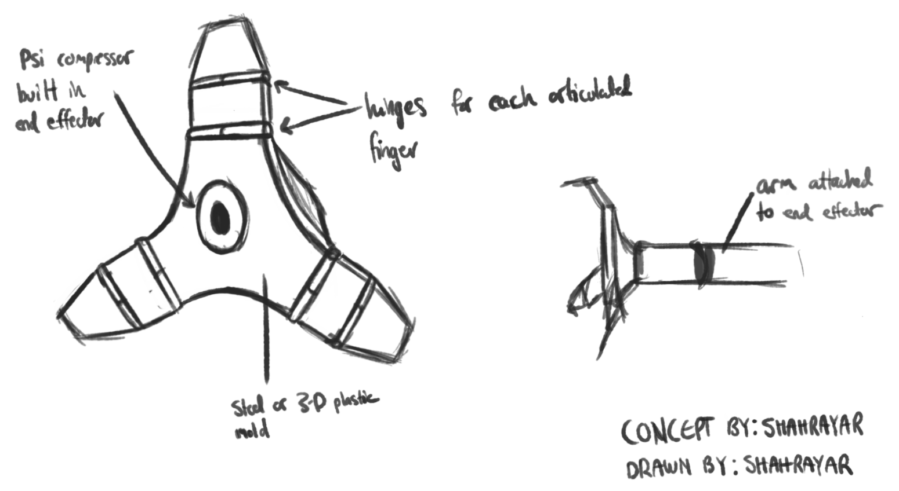
(Figure 3. Standard example of the drawing of the End Effector)

Subsystem 2 focuses on the end effector.

The end effector will be where the camera, compressor, and lights are housed. They need to be able to firmly hold objects, and be able to move in a 3-dimensional plane (as if it were a wrist).

If we were to use an airbrush we would need the end effector to have a mechanism that could press down on the trigger for the air brush as well as release the trigger.

As mentioned, within the end effector the compressor will be integrated in the middle so that it is flush with the base of the end effector.

Subsystem 3: Accessories
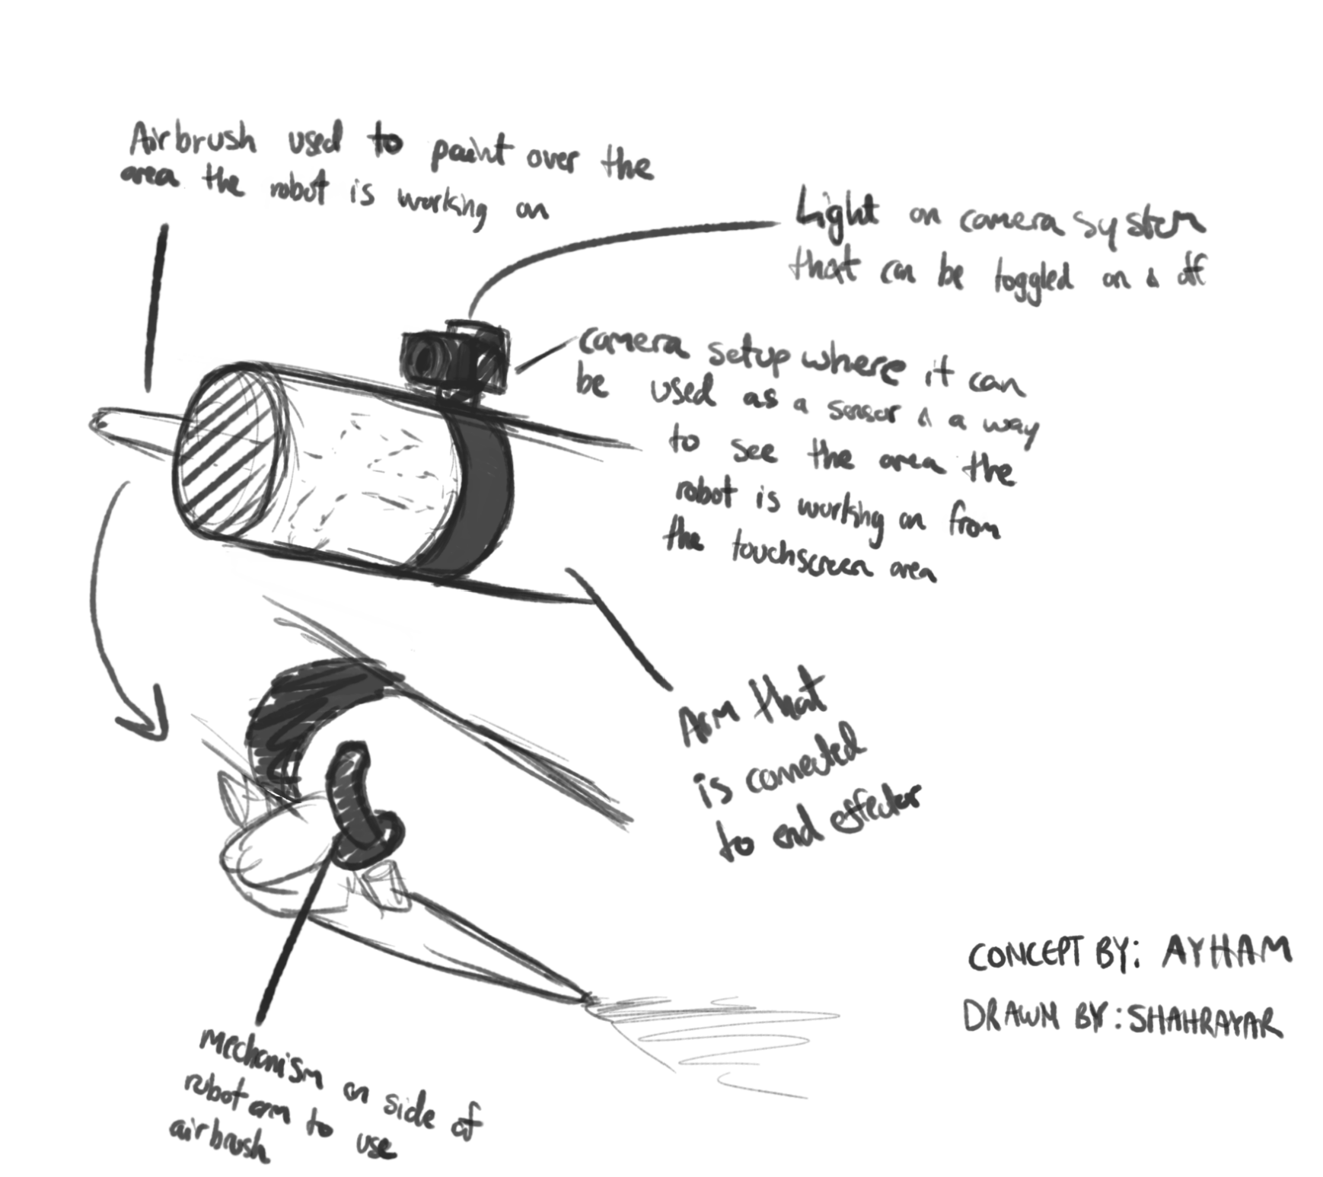
(Figure 4. Standard example of the drawing of the accessories)

Subsystem 3 has to do with our plans for the accessories on the robot. We have decided to add a camera to create an accurate scan of the area, as well as photograph the areas before work begins in case of any problems needing to be addressed with the work surface.

The next accessory we added was the light to have a constant light level while the robot scans/works. As mentioned previously we’ve also decided to have added to them arm as an external accessory rather than integrated into the end effector.

In doing so, the camera will be able to encompass the whole area and can be removed if needed.

Subsystem 4: Base
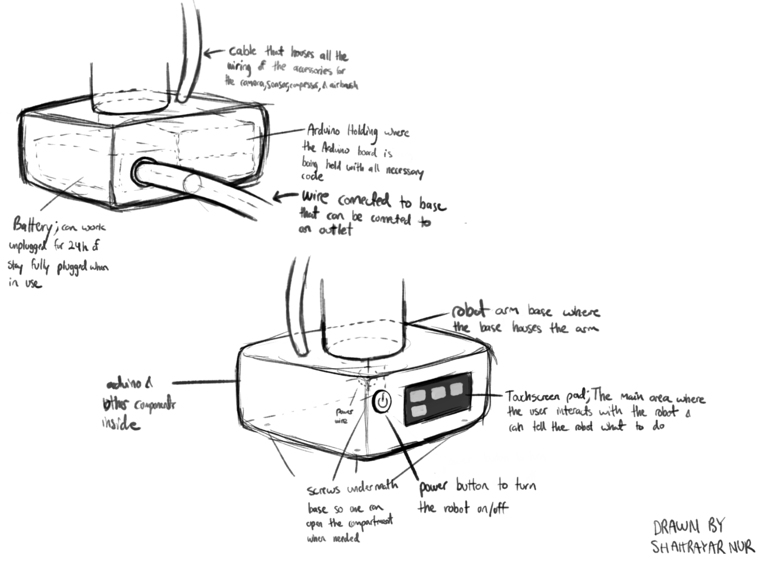
(Figure 5. Standard example of the drawing of the base )
This subsystem is the base of the robot. It will be the main area that houses all the compartments of the robot including wires, a battery, and the arduino case inside.
This will also be the area in which the user will interact with the robot. There is a touchscreen display on the side where the power button also lies. On the touchscreen display, there will be different tasks to choose from which the robot will respond to. The main buttons we are planning to have are the buttons for the water spray, airbrush, lights, and camera, which can be toggled on and off.
Multiple wires will also protrude from the base. The top cable houses all the accessory wires, including the camera, lights, and airbrush accessories. The bottom wire is connected to a battery inside the case where the robot can either work plugged in an outlet or work off of the battery it has.
The bottom of the base will have 4 screws to keep the structure intact. When necessary, the user can use a screwdriver and open up the case to either fix or tamper with the robot.

Table of Subsystem Ideas

Names | Base | Accessories | Articulation | End Effector
Akem | 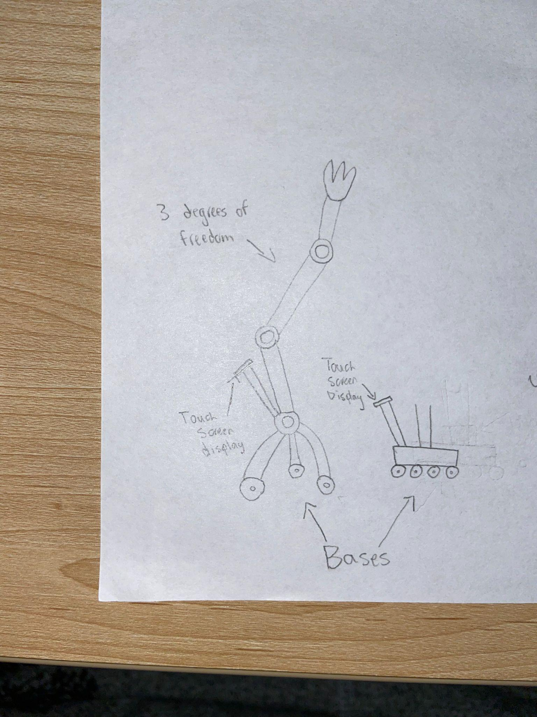 | 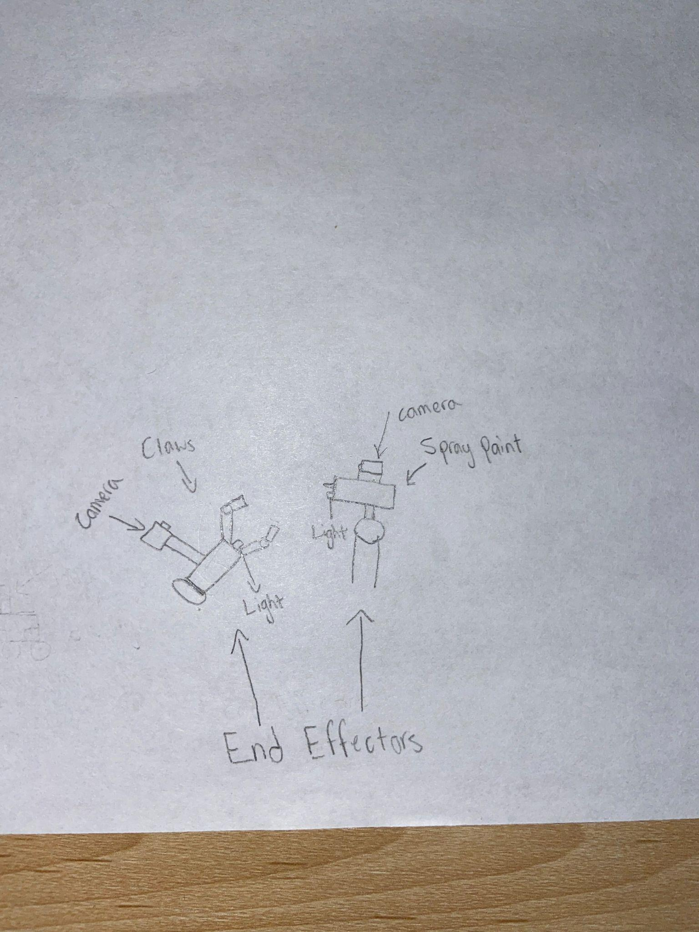
Wacira | 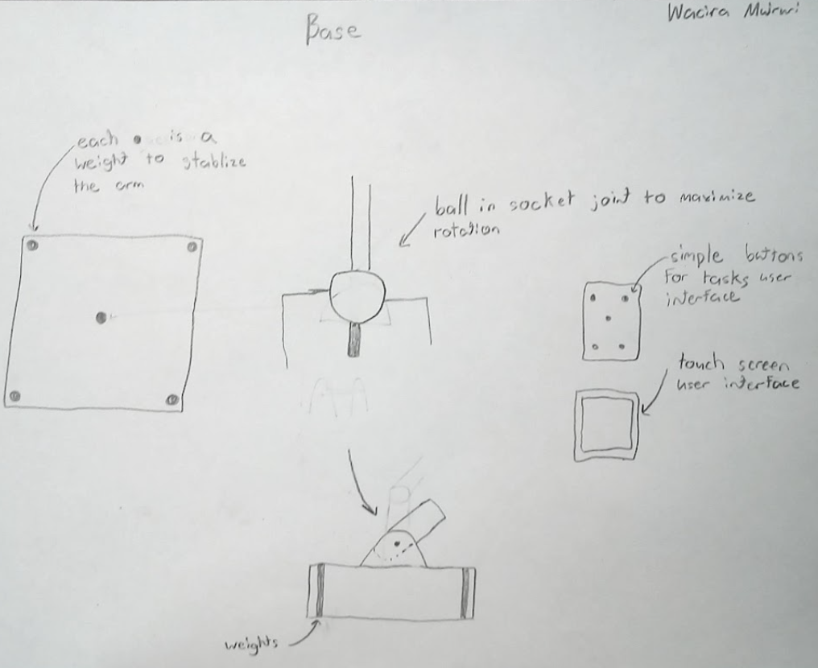 | 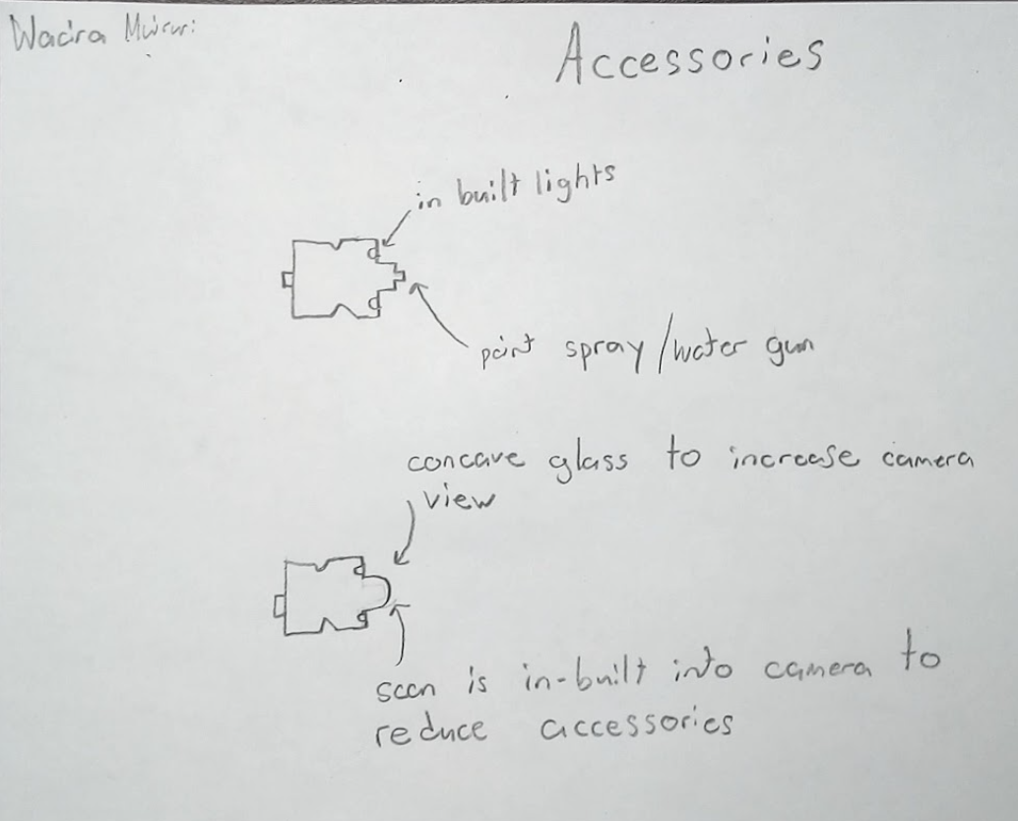 | 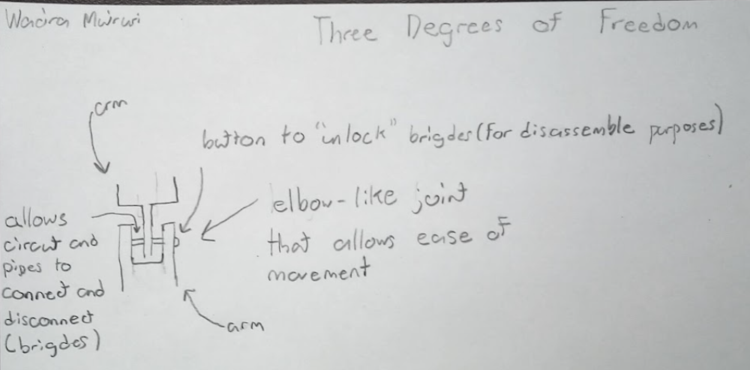 | 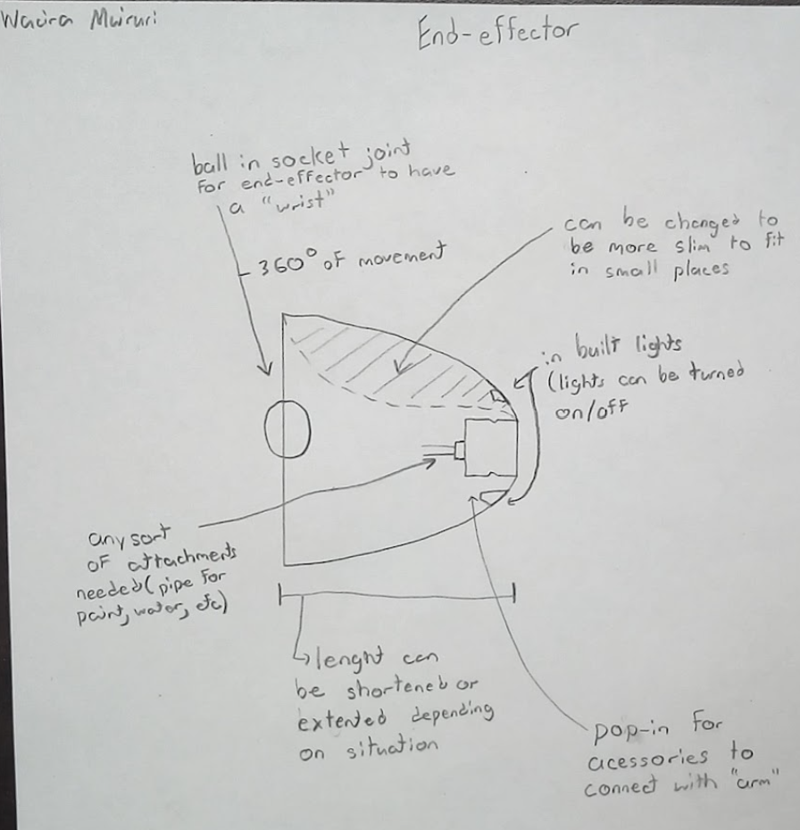
Matthew | 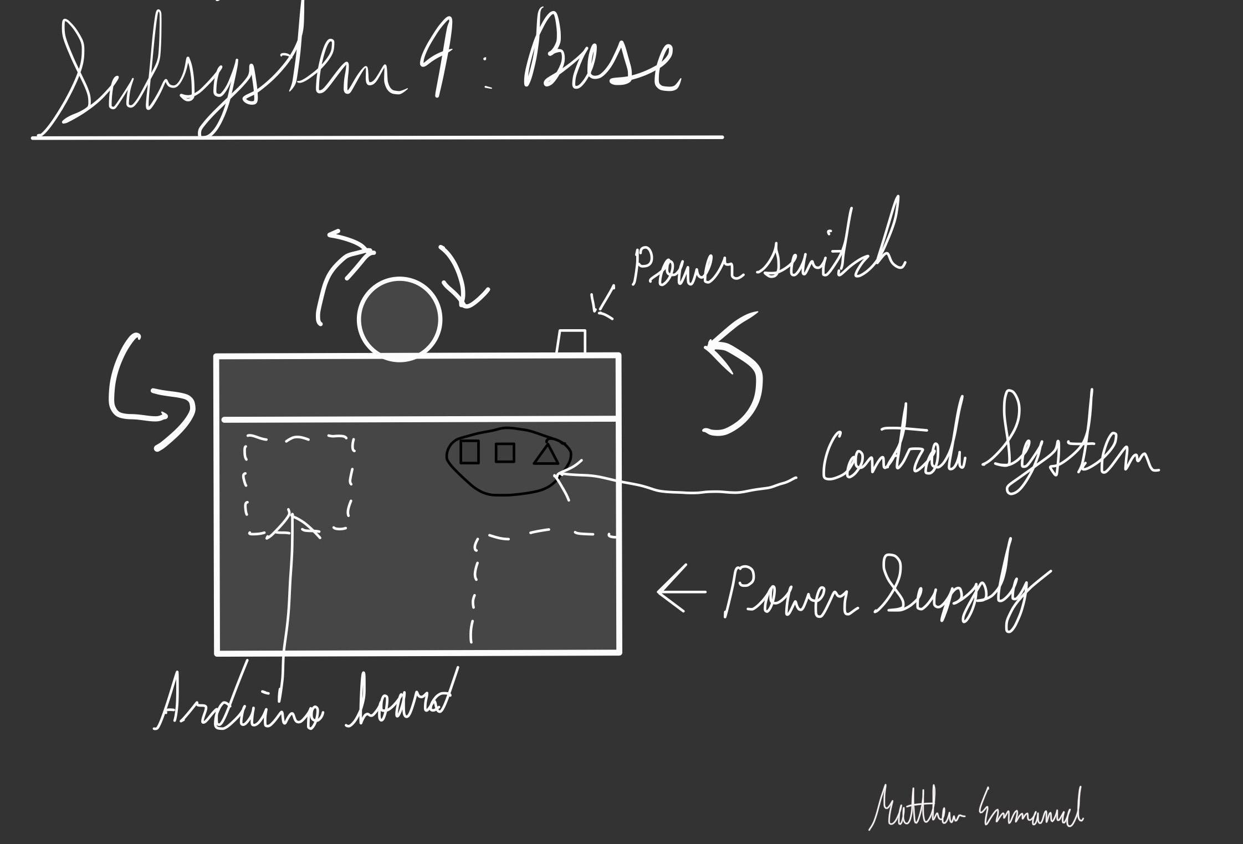 | 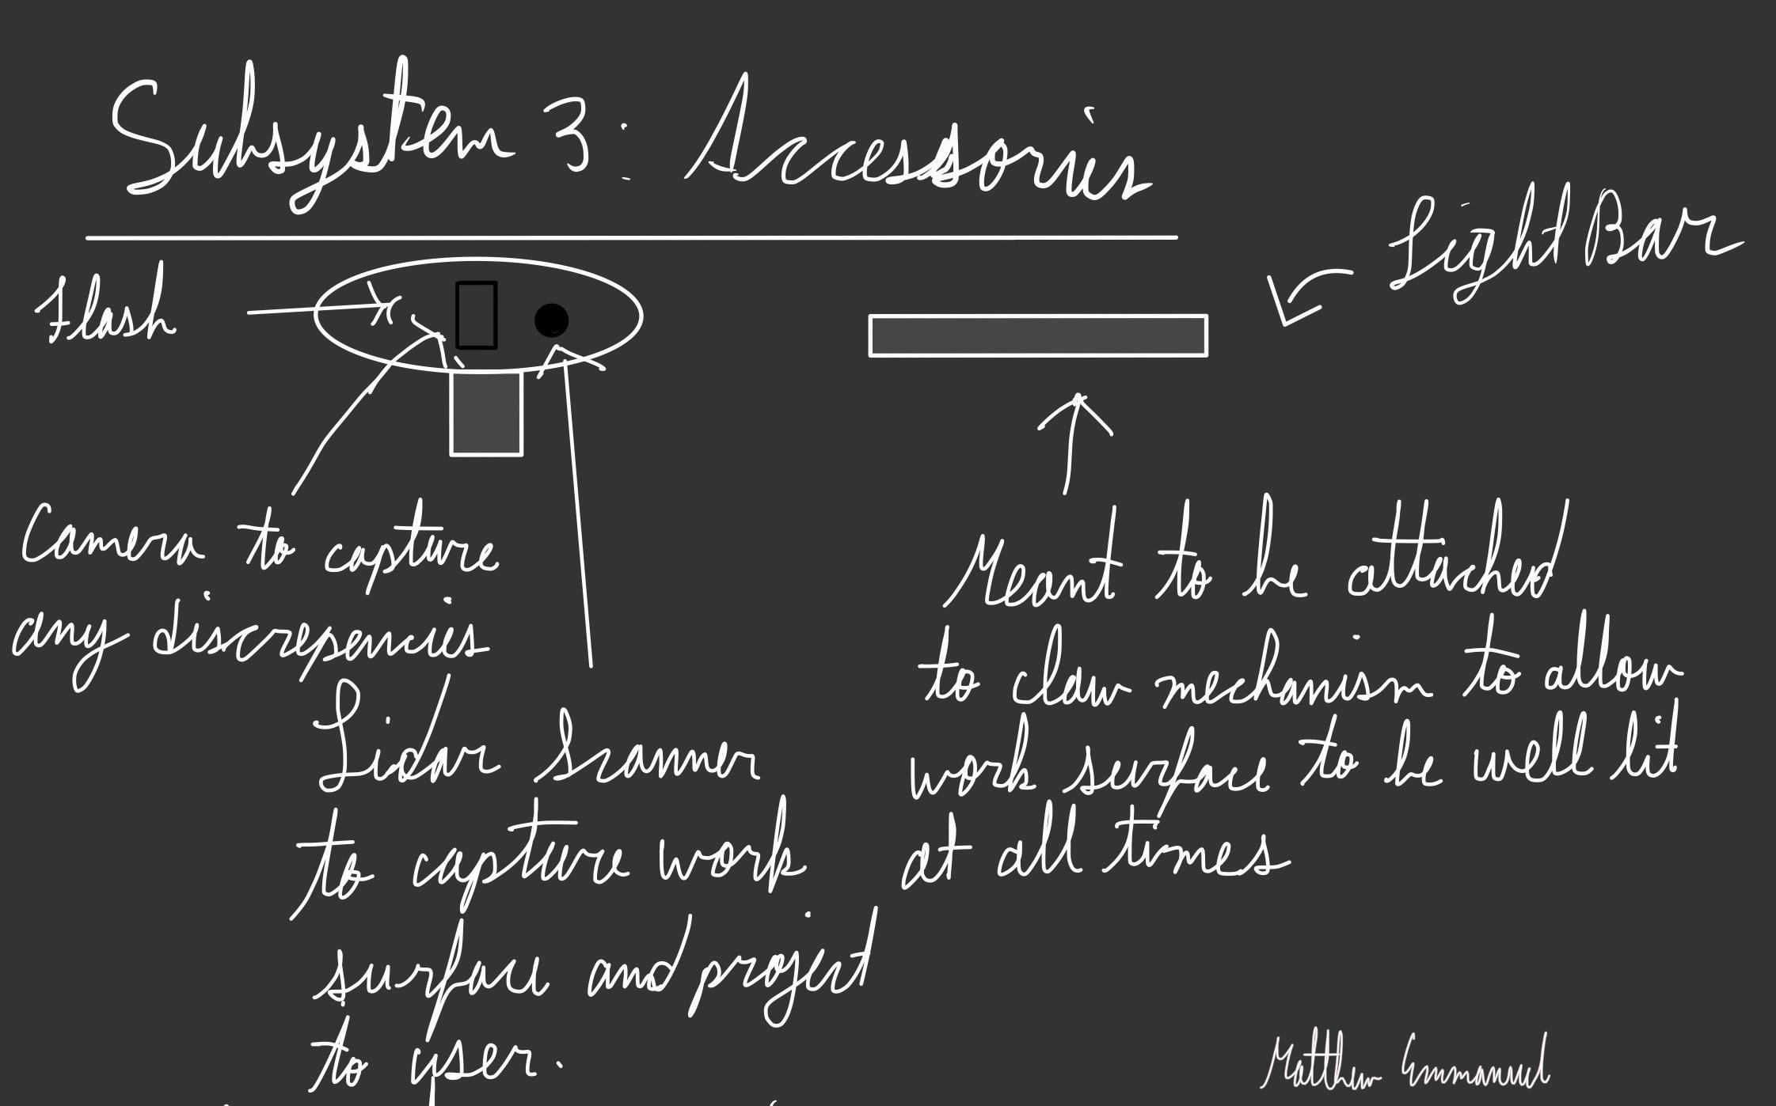 | 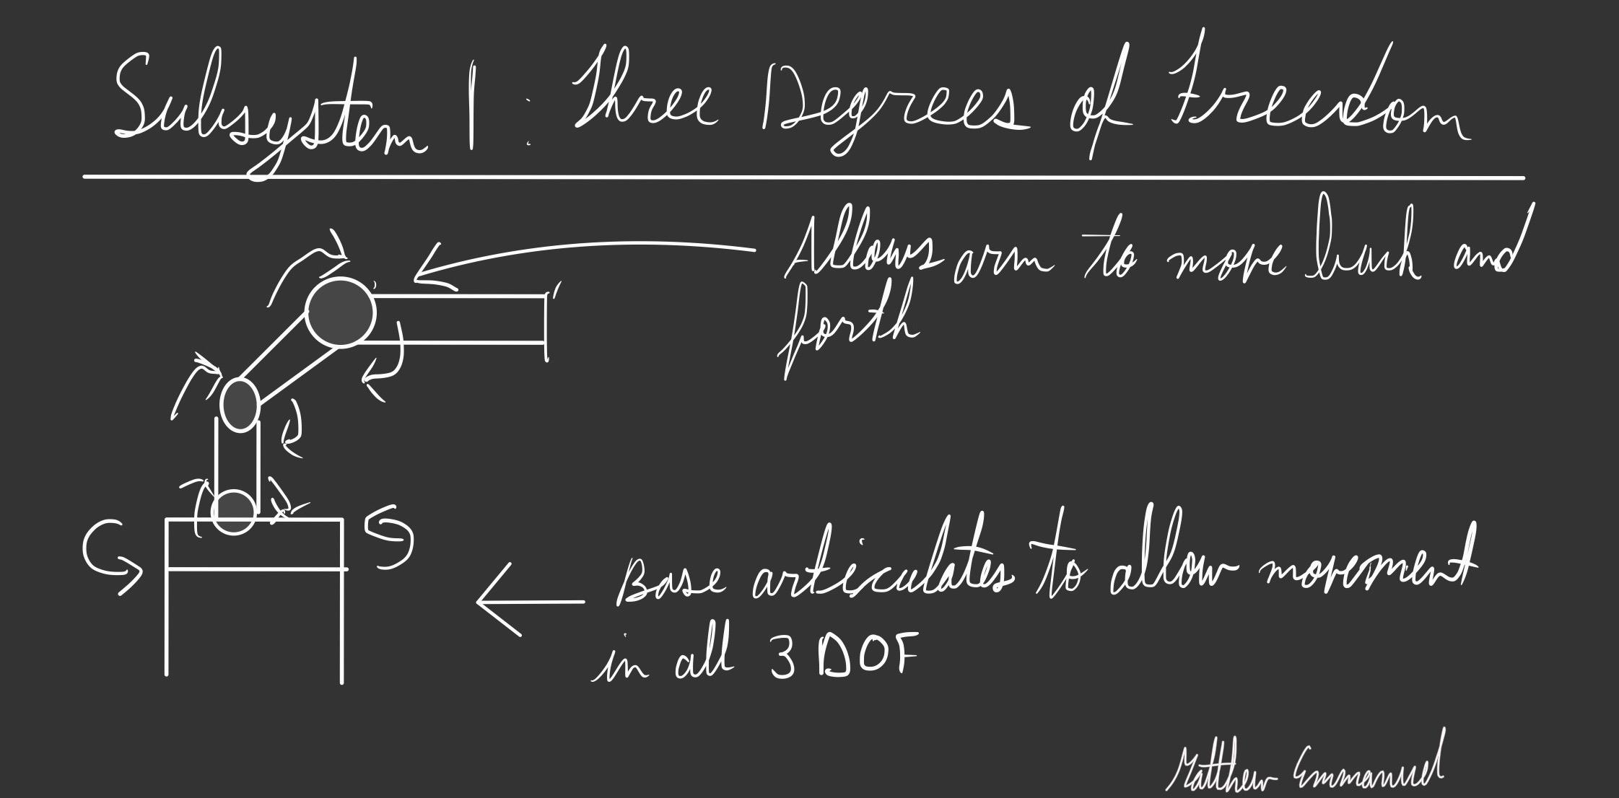 | 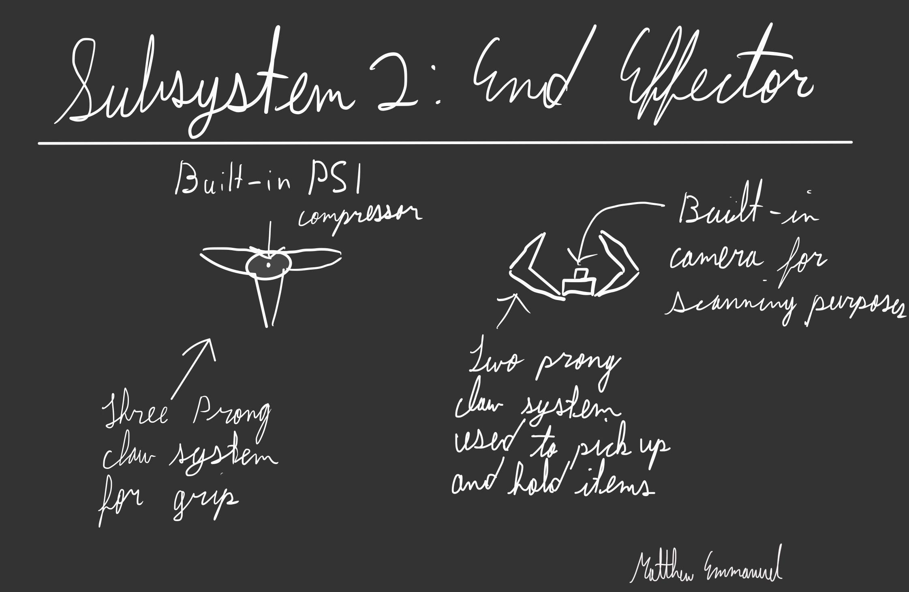
Ayham | 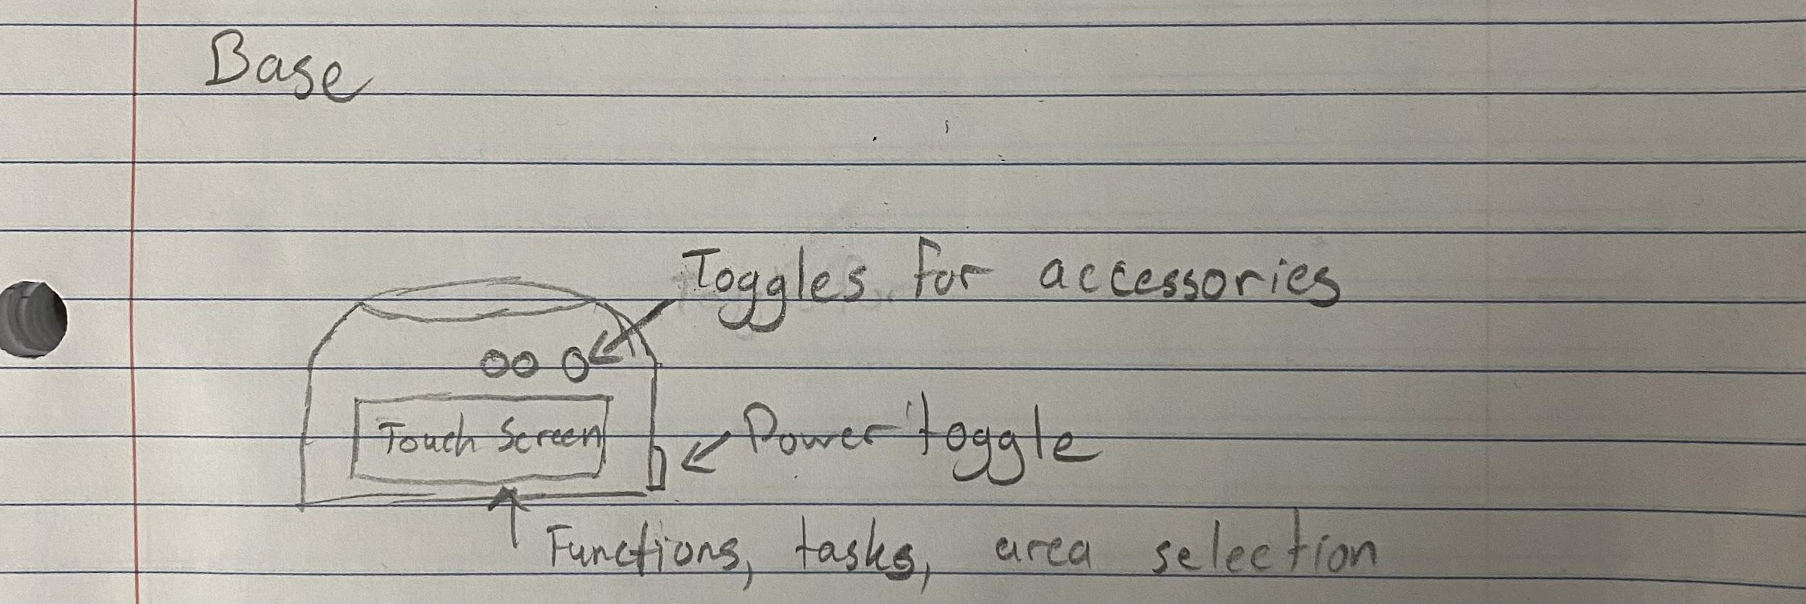 | 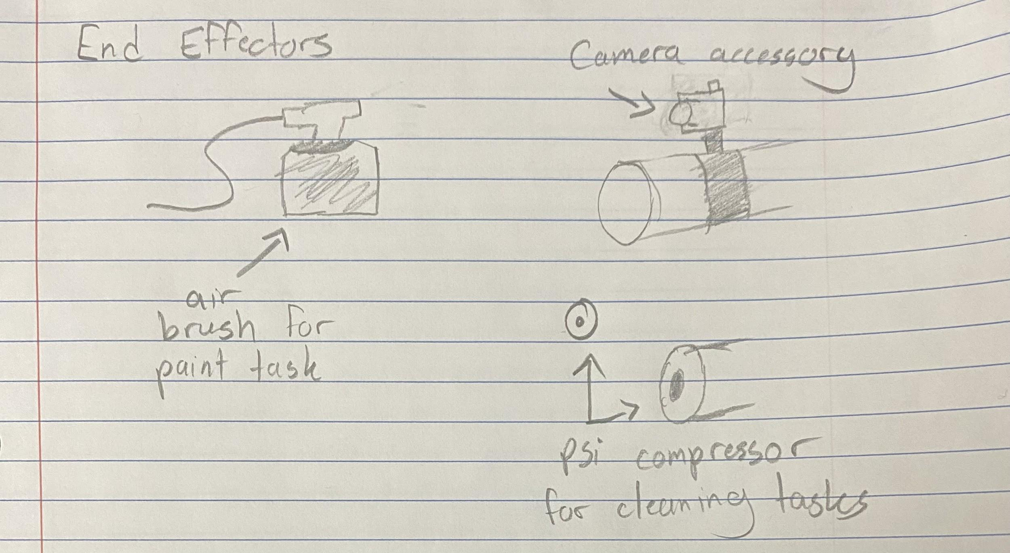 | 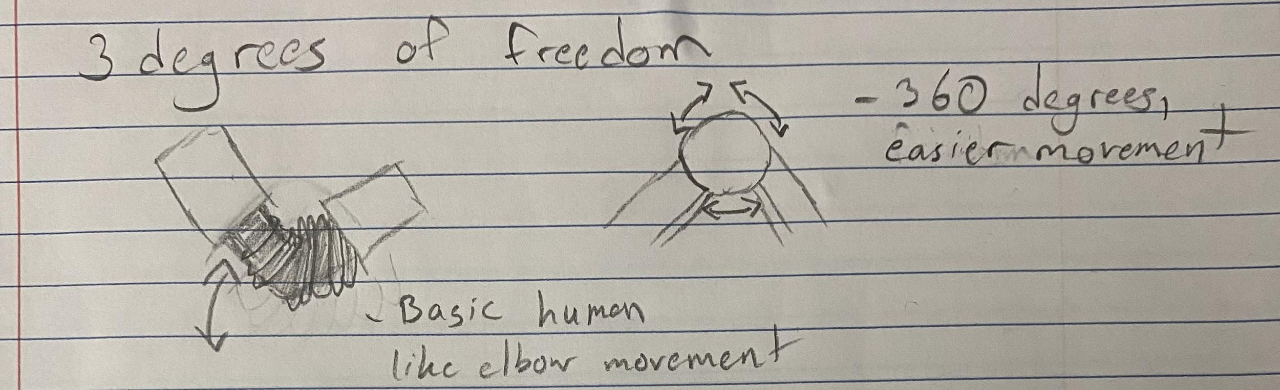
Shahrayar | 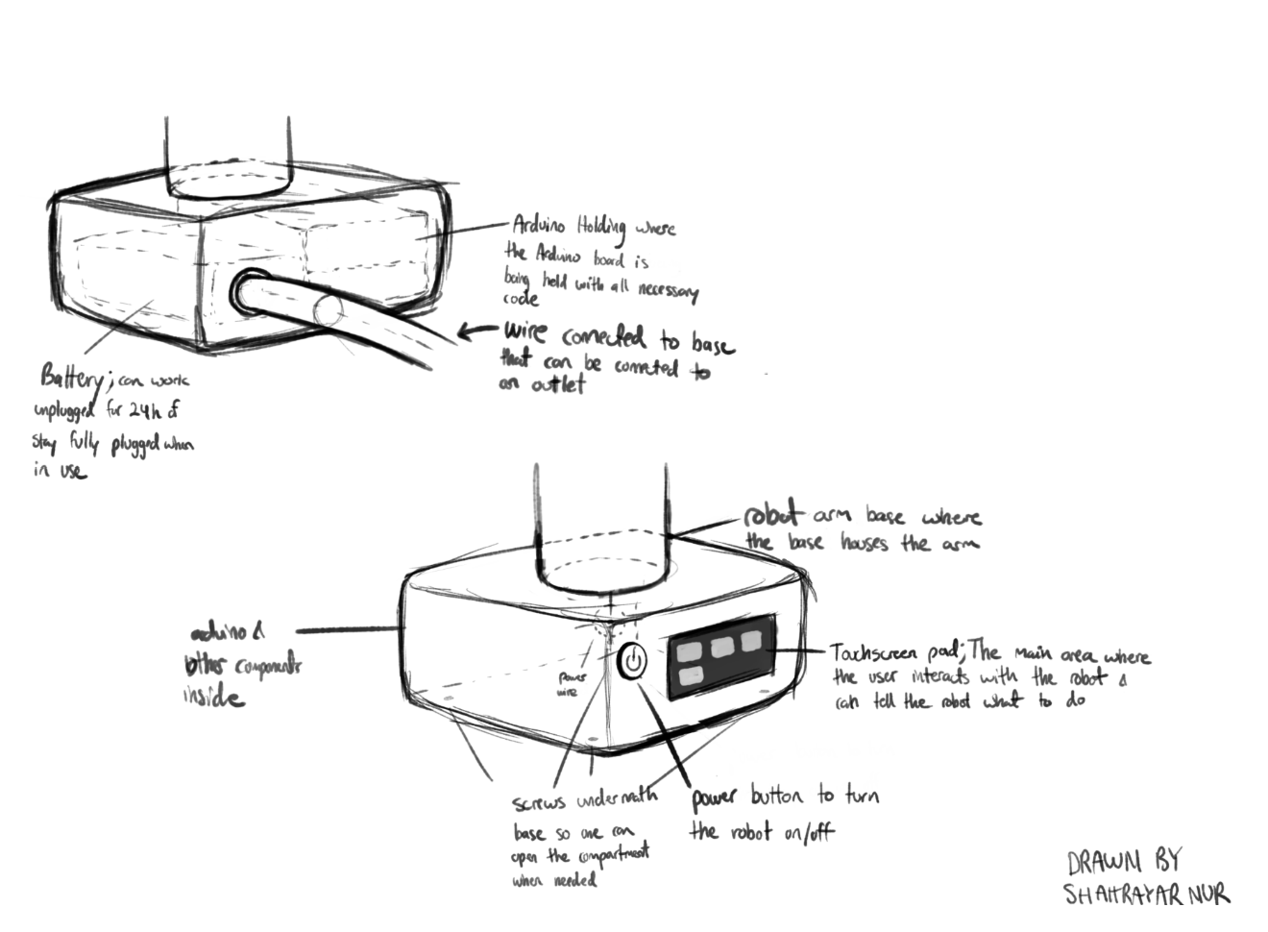 | 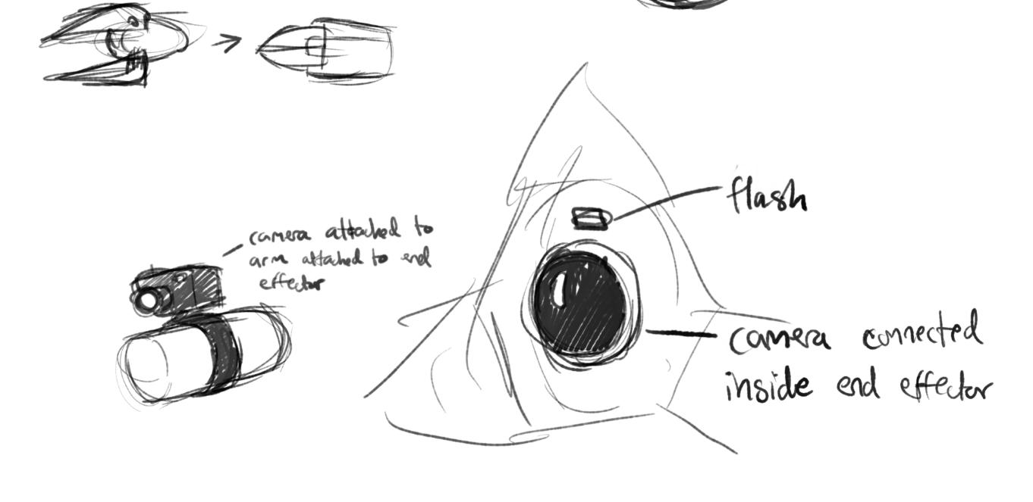 | 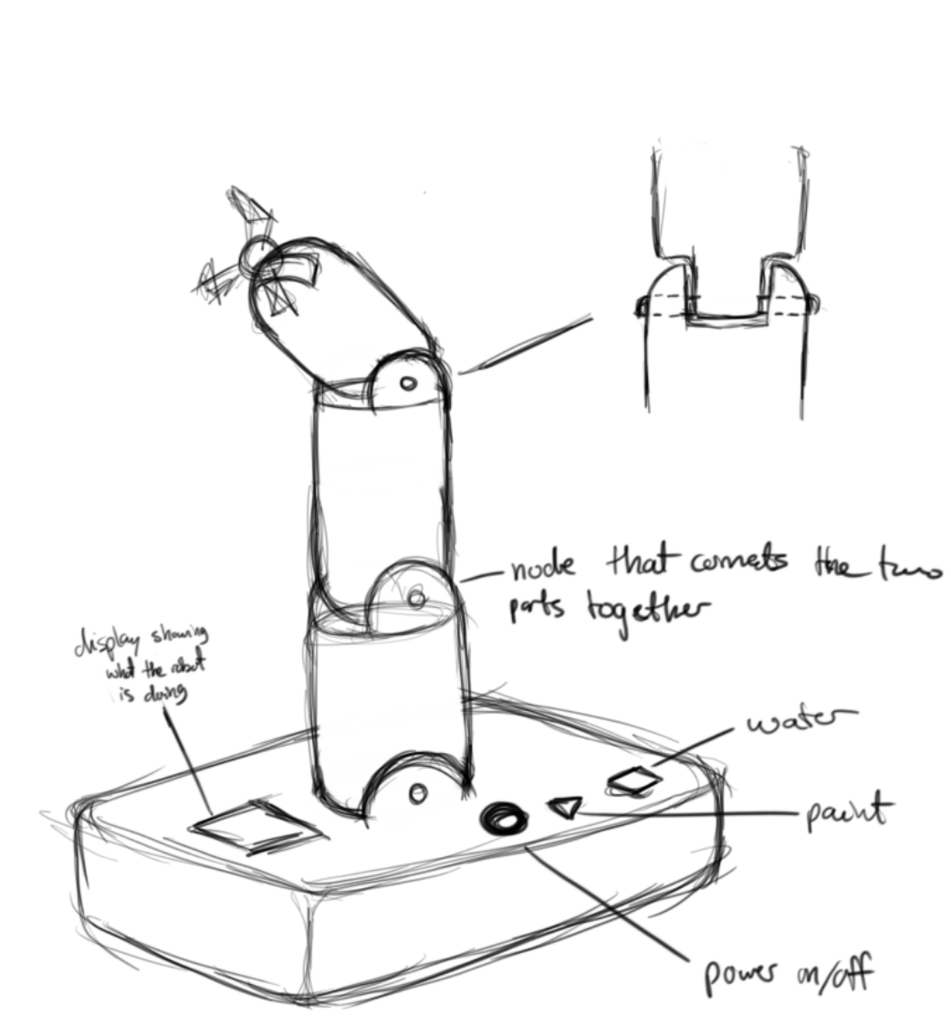 | 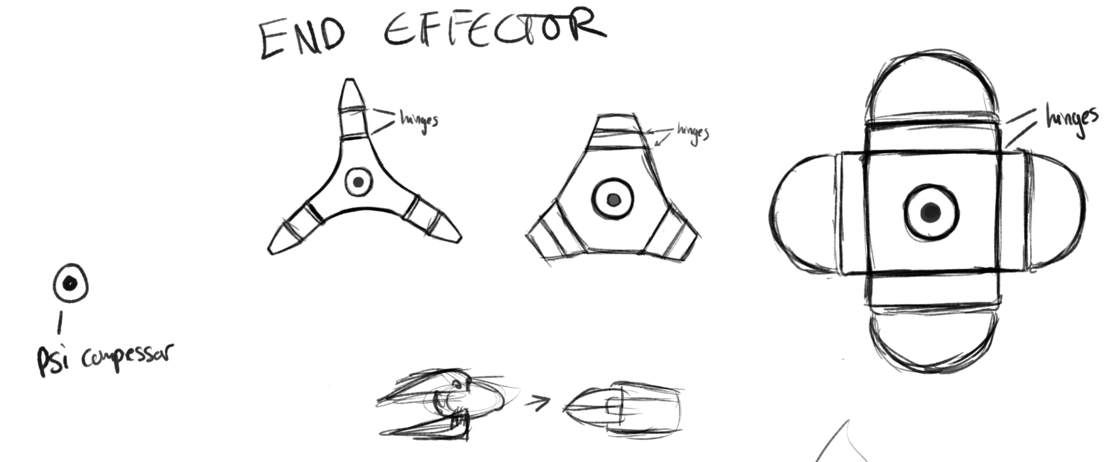

(Figure 6. Table ideas that contain all subsystems that each team member drew)

Solution

Base
    - The idea base that we chose as our first pick was Shahrayar’s drawing of the base. This is due to its user-friendly touch screen which is very important for the user to be able to use. The drawing also has a study out shell to protect the more delicate internal hardware which is also stored in the base.
(Figure 7. Shahrayar Nur’s drawing of the base)

    - The second idea that we chose for the base was Ayham’s drawing of the base due to the easy to use buttons like the power and accessories toggles for further ease of use. The Base is also made for easy transportation, being able to detach from the robotic arm.

(Figure 8. Ayham Alshaikhali’s drawing of the base)

    - For our third drawing, we decided to use Akem’s base drawing, this is because the idea of a raised touch screen interface allows more ease of usage and can be used by people who are unable to kneel, sit, bend back or squat for any reason. Also, the wheels at the bottom allow for easy movement on the floor thus, reducing the number of times you need to pick up the robotic arm

(Figure 9. Akem Shergill’s drawing of the base)

Accessories
    - The idea accessory that we chose as our first pick was Ayham’s drawing which gives a view of the end effector as an airbrush. It also shows how the accessories are going to be attached to the end effector.

(Figure 10. Ayham’s drawing of accessories)

    - The second drawing that we chose was Shahrayar’s drawing as it gives a detailed view of the locations that different accessories would be placed on the end effectors, as well as the placements of the hinges to show how the claw would move.
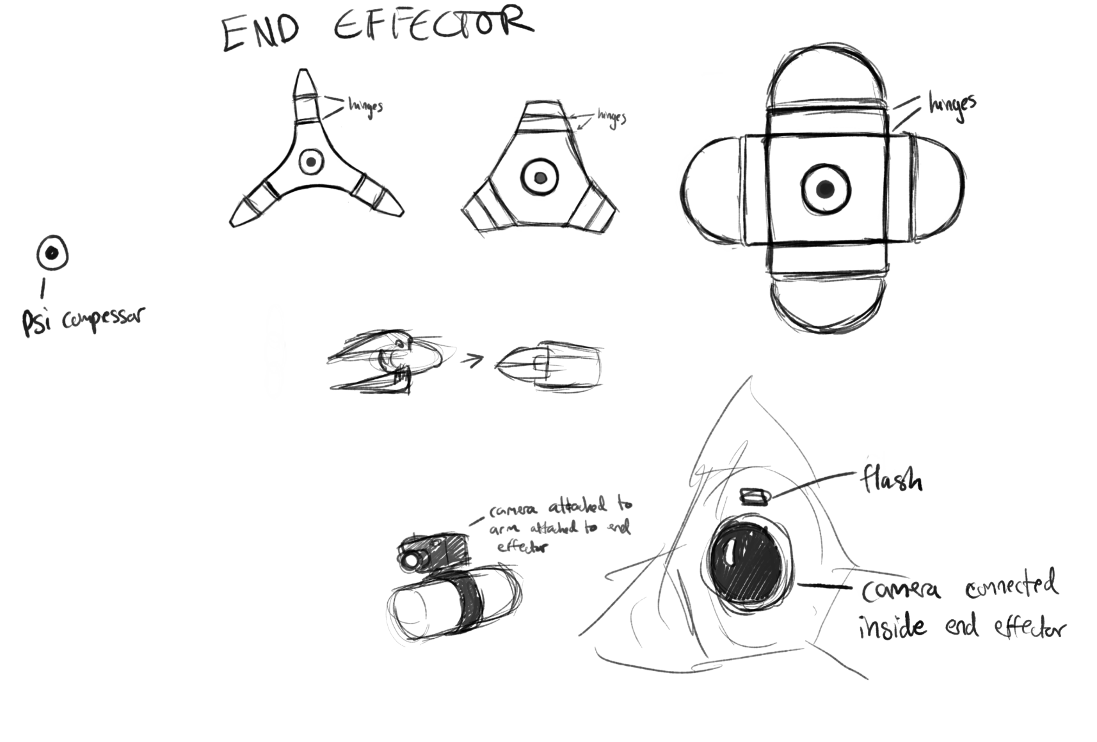
(Figure 11. Shahrayar’s drawing of accessories)
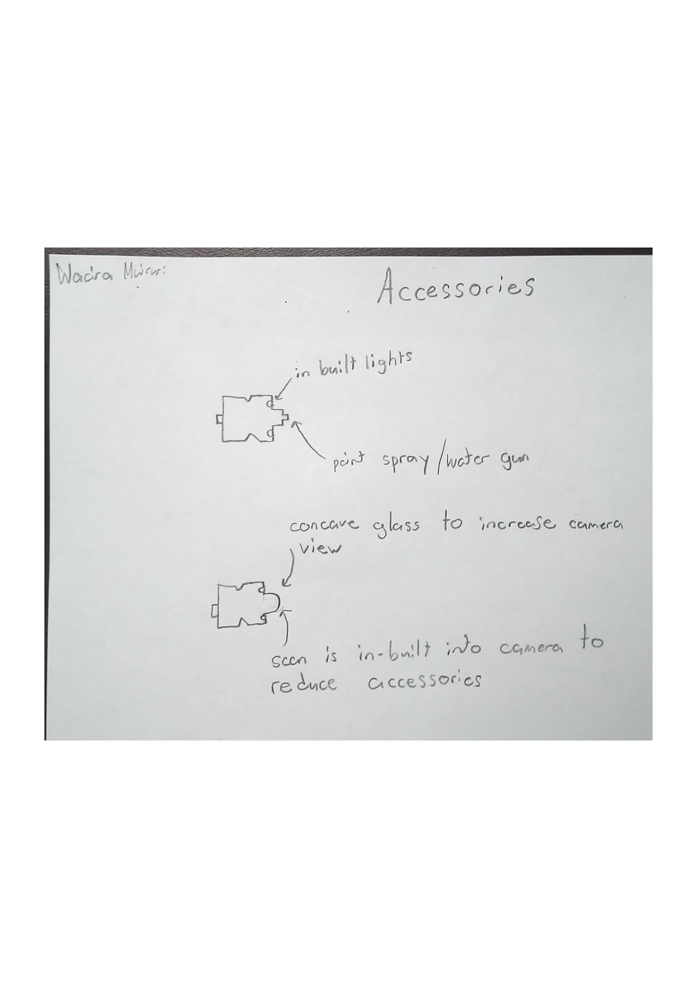
    - The third drawing that we chose is Wacira’s drawing which show the light, spray, and camera/scanner could be placed. The scanner would be built into the camera to reduce the amount of accessories, and the lights would be built into the end effector to keep a clean look.

(Figure 12. Wacira’s drawing of accessories)

Articulation
    - The first pick for the articulation is Shahrayar’s drawing. Due to the simplicity of the joints, it is very easy to assemble and disassemble the joints and makes transportation of the parts easier. The arm is very sturdy and has a very spacious interior for the more sensitive internal hardware such as gears, wires, and pipes

(Figure 13. Shahrayar’s drawing of the articulation)

    - The second drawing that was chosen was Wacira’s drawing, the elbow-like joint allows for smooth movement throughout the arm. The bridge idea with figure 14 allows for wiring and piping to easily connect in the different arms and joints. The button on the side of the joint allows for further increased rigidity at the joint which is less sturdy, it also allows for easy disassembling at the joints for easy transportation and movement.
(Figure 14. Wacira’s drawing of the articulation)

    - The third chosen drawing we chose is Matthew. The three degrees of freedom are placed in key positions and the third degree(closest to the end effector) has an additional ability to extend or retract depending on the user’s input. This allows for the end effect to reach further and cover more area when cleaning, scanning, taking photos, and painting an area. The base area for the arm has an extra degree of movement that allows the am to rotate.

(Figure 15. Matthew’s drawing of the articulation)

End Effector
    - The first design that we chose is Shahrayar’s, which describes where the hinges on the claw end effector to show how it would move. It also describes the attachments such as the psi compressor built into the claw.
(Figure 16. Shahrayar’s drawing of the end effector)

    - The second design that we chose is Mathew’s which describes the built in psi compressor in the end effector as well as the camera attached to the claw.
(Figure 17. Matthew’s drawing of the end effector)

    - The third design that we chose is Akem’s which describes the end effector as a claw and an airbrush. It also shows where each accessory will be attached to the end effector.
(Figure 18. Akem’s drawing of the end effector)

Block/Tree Diagram
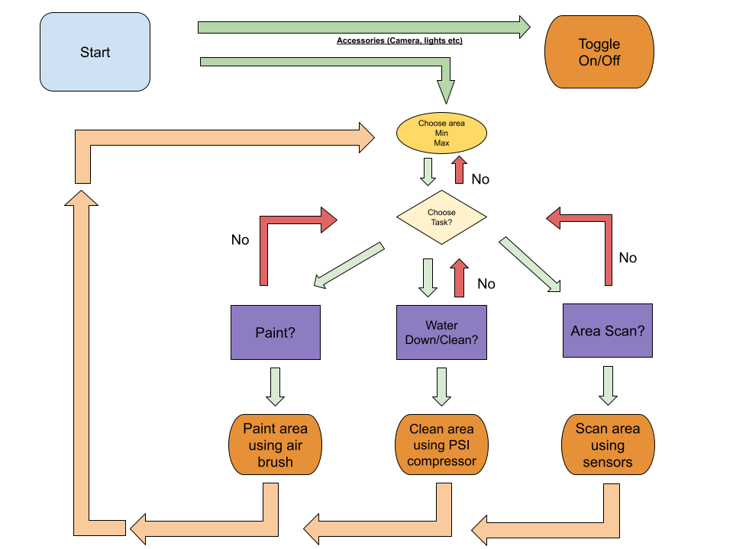
(Figure 19. Tree diagram showing a step-by-step method of operating the robotic arm)

Conclusion

5.1. Global Concept
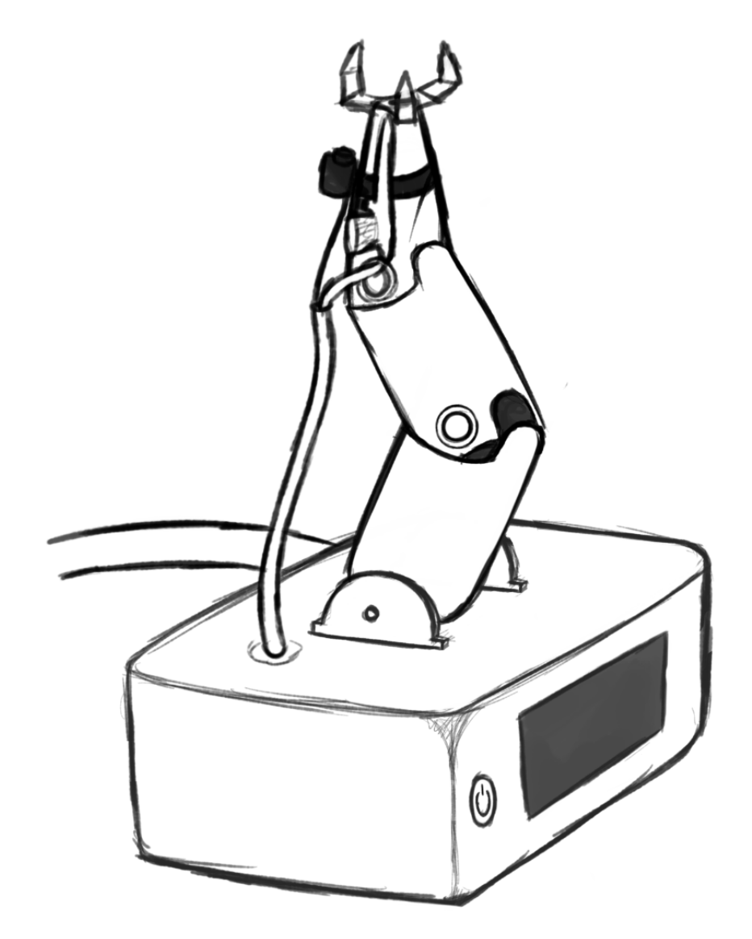
(Figure 20. Global concept drawing done by Shahrayar)
This is our global concept drawing for the inverse kinematic robotic arm. We made the base very sturdy to eliminate the chance of swaying and falling and made the outer shell tough to increase the safety of the internal hardware and software. The touchscreen and power button make the robotic arm easy to use for all users. The articulation has very simple nodes at each joint ensuring smooth joint movement as well as easy disassembling and reassembling. The arm has a study out shell and has a spacious interior for the gears, wires and piping. The end effector has a powerful claw granting stability to any accessory that is mounted as well as a firm connection for the piping to the specific accessory. Finally the accessories themselves are all either held and connected to the end effector via the claw, or like the camera and scan, mounted on the side of the arm.

This global concept is a fusion of all the ideas that were generated in the subsystem and well as the solution faze. The user would have to first connect the power and prepare the piping for the paint and the water. Using the user-friendly interface on the touch screen display, once the area size is determined the display will give you the option of using the water spray, area scan and paint. By pressing the camera option the camera will initiate a scan of the desired area and the option of taking a picture will be shown(optional). The movement of the arm is directly affected by what has been scanned as well as the area size. Next, choosing the water spray option will let the robotic arm spray water in the desired area and finally choosing the paint option will let the robot know to paint a certain area.

All in all, the global concept allows for an easy to use system to paint any desired area and the structure drawn incorporates many important standards to properly perform.

Appendix
-one accessory for both water blaster and paint spray

Wacira Muiruri
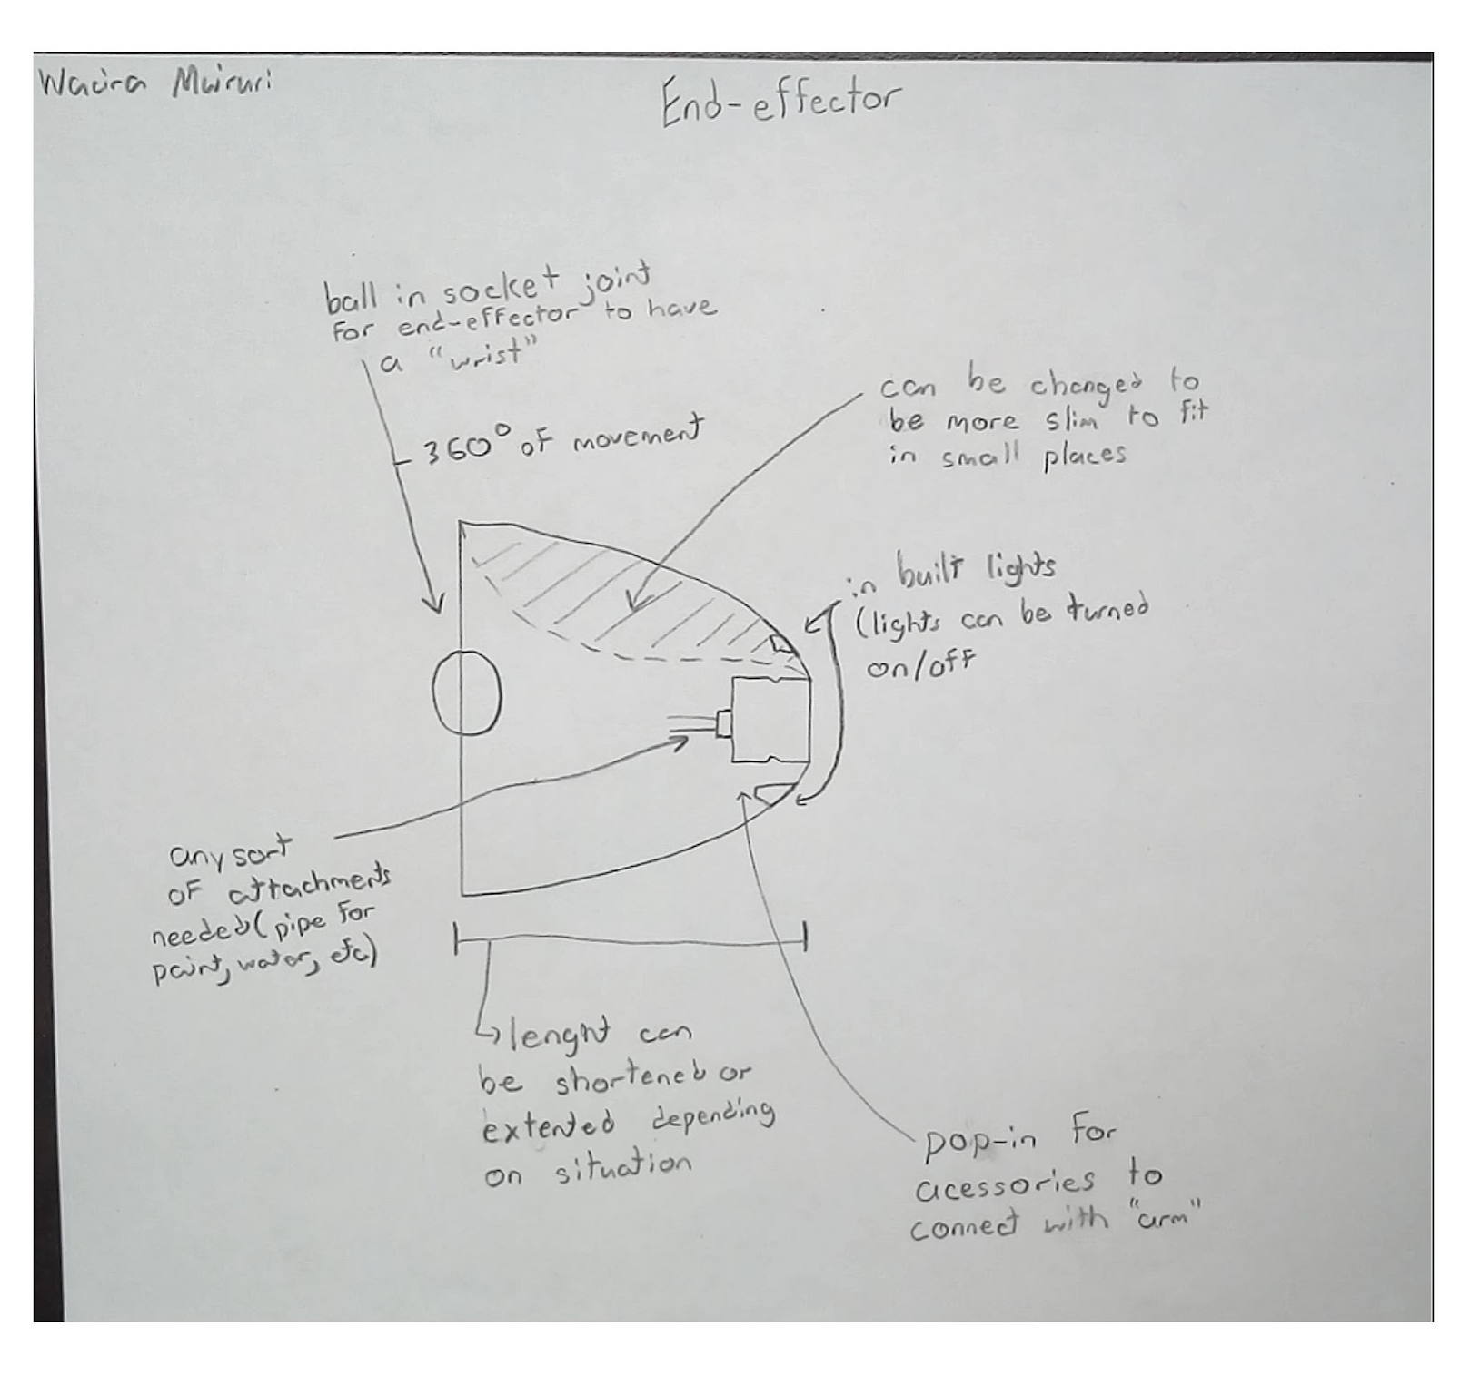
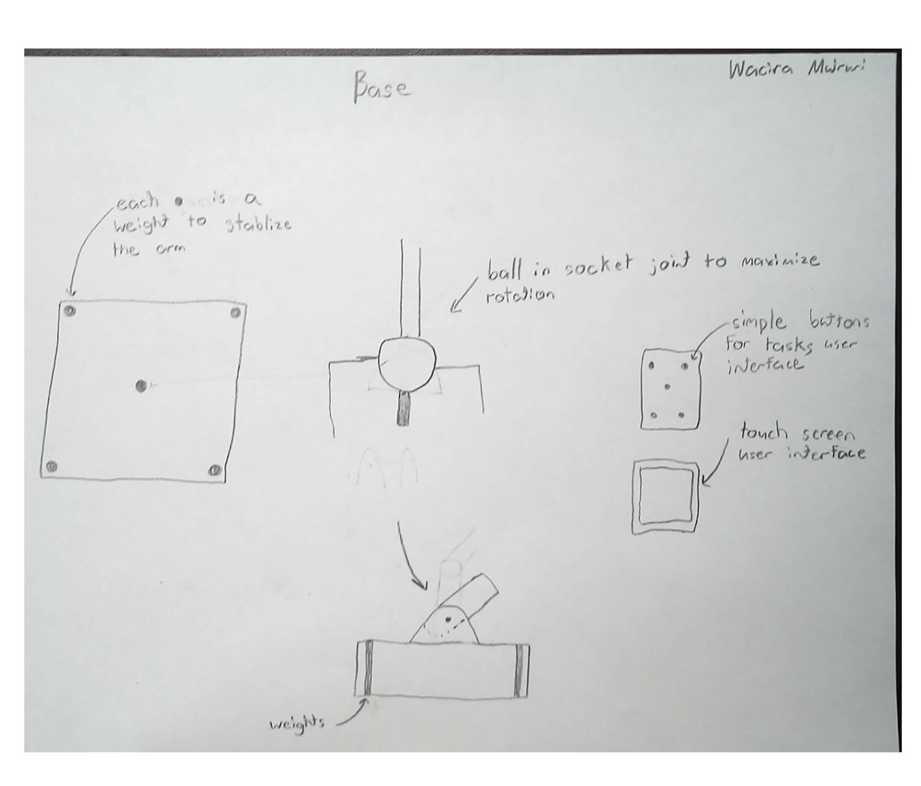

Ayham Alshaikhal
Base
Articulation
End effectors/ Accessories

Matthew Emmanuel
Base

Accessories

Articulation

End Effector

Akem Shergill
Base

Accessories/End Effector

Articulation

Shahrayar N.
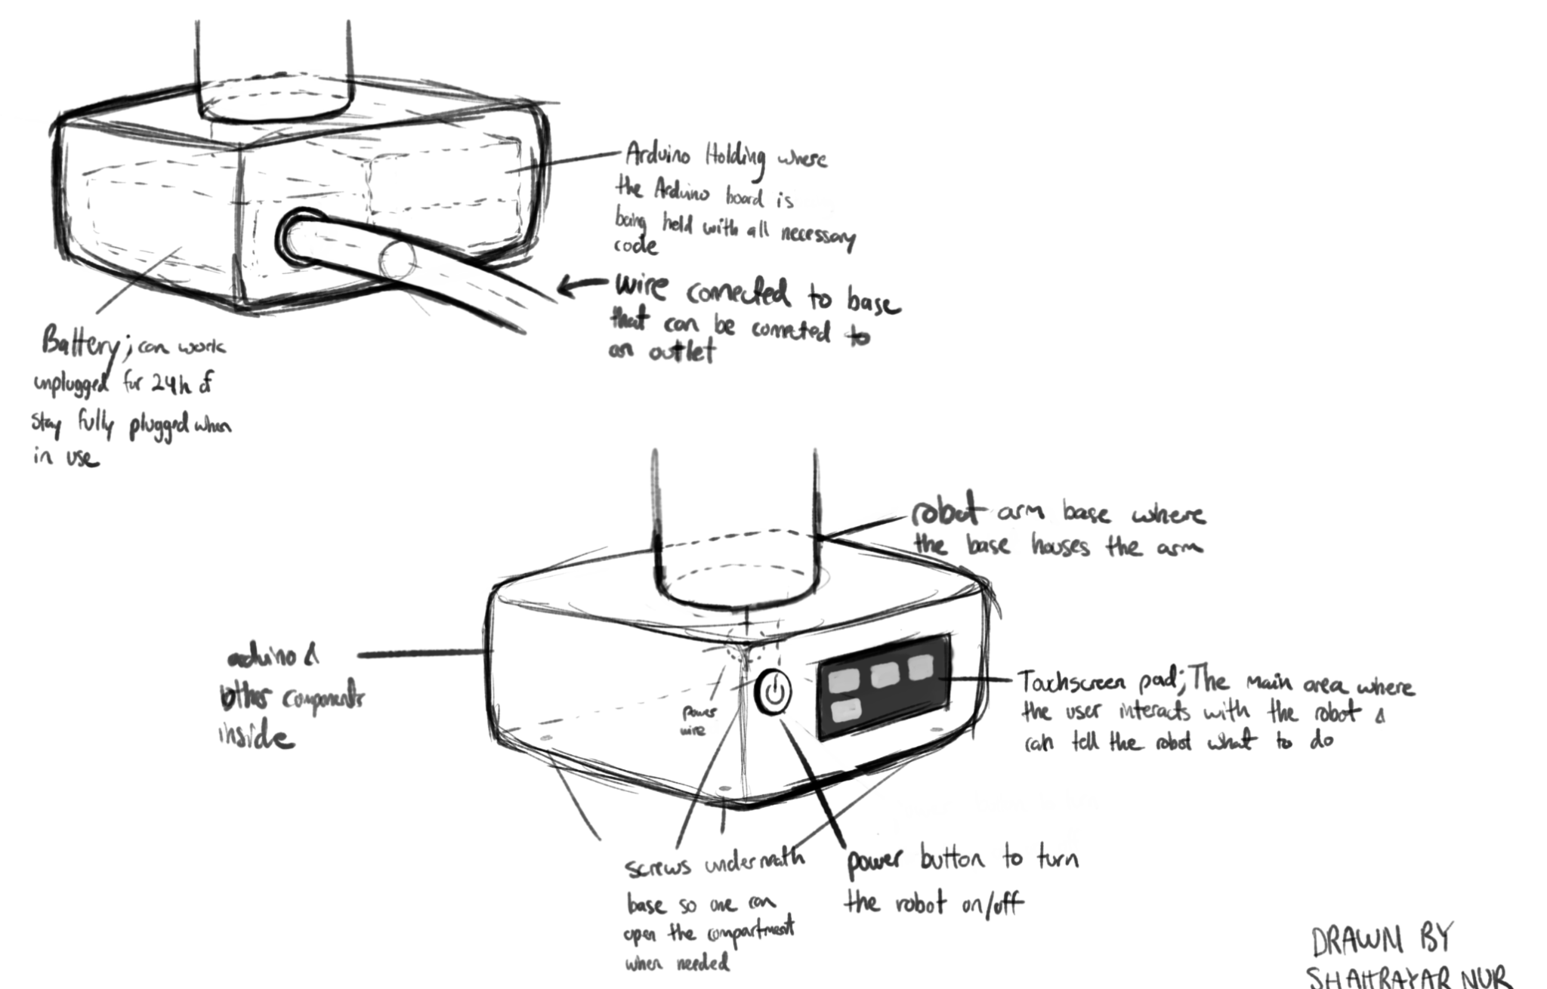
Base

Articulation
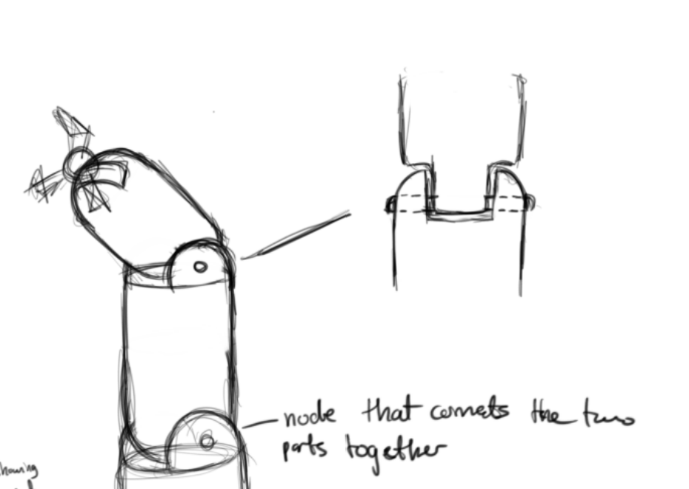

End Effector/Accessories
Functional Decomposition

Block/Tree Diagram
