Deliverable E- Project Plan and Cost

Prepared for

Elsa Lange
Project Manager

Pankaj K. Rathi
Teacher Assistant

By

Akem Shergill- 300246583
Wacira Muiruri- 0300245399
Shahrayar Nur- 0300233739
Mathew Emmanuel- 300240312
Ayham Alshaikhali- 300244961

Sunday, February 20th, 2022

Abstract
Below is a document that outlines our project plan, the risks associated with it and both our bill of materials and list of equipment. Given a budget of $50 we decided to look through our options and put together a spreadsheet outlining all the costs for the entirety of the project.

Table of Contents

Deliverable E- Project Plan and Cost 1
Table of Contents 2
Introduction 3
Updated Design 3
Materials (Prototype 1) 4
List of equipment 4
Bill Of Materials 5
Project Planning 5
Project Risks 5
Project Plan
Appendix 6

Introduction

In this deliverable, we are expected to update our wrike and create a project plan that outlines the risks associated with the construction of our end-effector and the contingencies we have to counteract any problems. On top of this, we must also provide a bill of materials(BOM) that outlines all the costs associated with constructing the end effector prototypes.

Updated Design
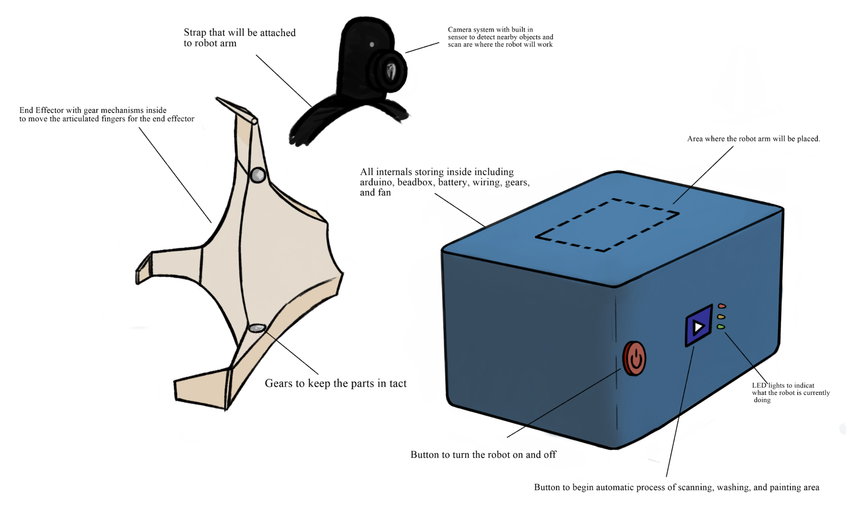
After the last client meeting, we were given feedback on specific components of our robot. Upon receiving the input, the team decided to redo the design to fit the specifications outlined by the client. Some of these changes are, the removal of the LCD screen, and since the arm is being provided to us, we have decided to focus on the end effector. With the removal of the LCD screen, we decided to add 2 buttons and 3 LEDs that correspond to the process being carried out.

Materials (Prototype 1)

List of equipment
The list of equipment below outlines both the hardware and software we will be using to design and construct prototype 1 of our end effector. We will be using these items to create a proof of concept that we can test during the lab and use to improve each prototype as we progress through the course.

Hardware | Software
Screws, Washers, and Bearings | Onshape
Metal sheets | Arduino Sketch
Adhesives
3D printer

(Table 1: List of equipment needed for Prototype 1)

Bill Of Materials

The bill of materials outlines all the costs associated with the construction of prototype 1 of the end effector and base. The budget given to us was 50 dollars so we tried to stay as efficient as possible with this budget. We focused mainly on the base and the end effector since the arm is being provided to us.
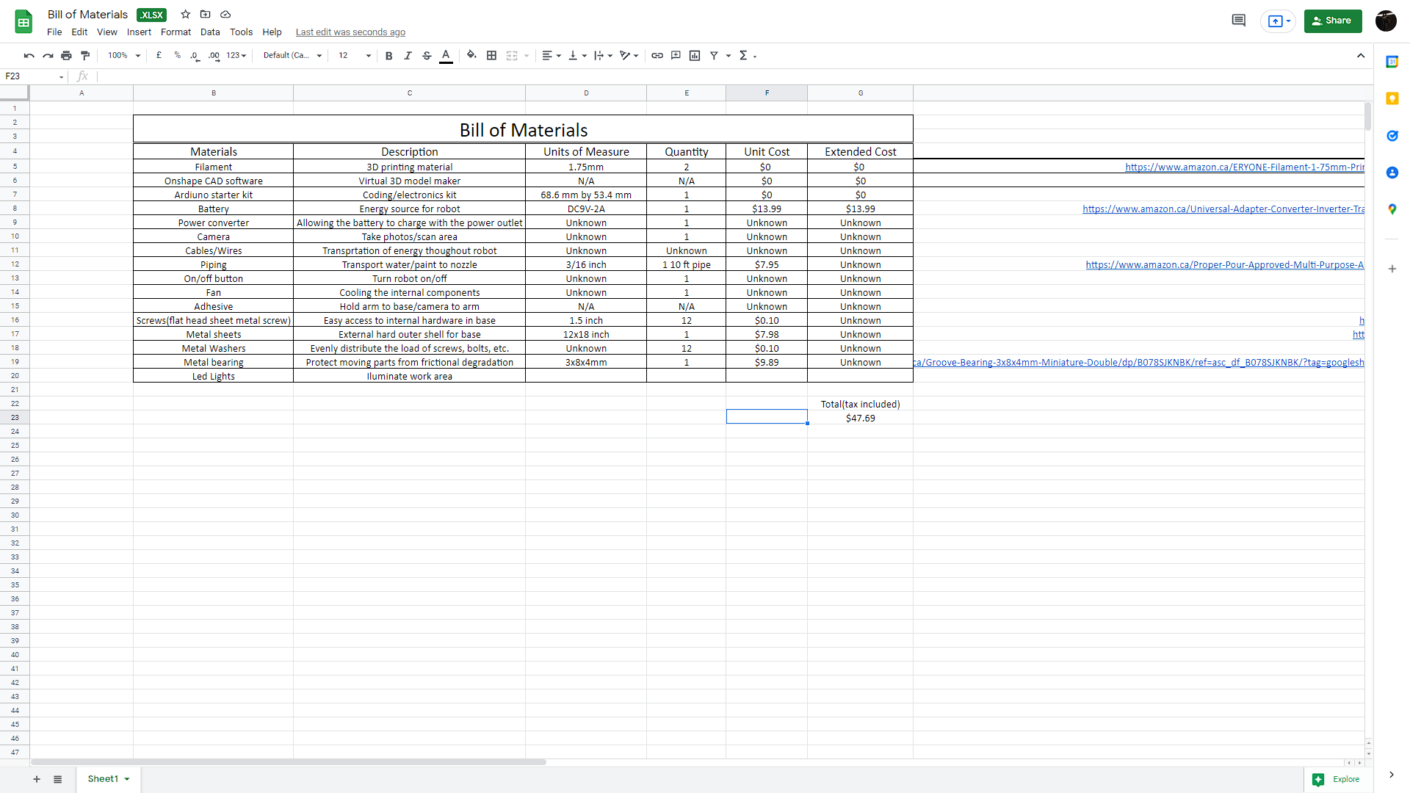
(Figure 2: The bill of materials for our project, a link will be provided to take a look as well)

Project Planning

Project Risks
This will be the first prototype, so it is possible that certain human errors can occur. Below are some risks and solutions we have to counteract these problems. It will take all of us to make sure we don’t encounter any of these problems, but if they were to arise we have thought through plans to make sure it can be fixed or be prevented from happening.

Risks | Solutions
Buttons on the robot may malfunction | We will try to fix these errors through trial and error or beforehand we coordinate how each button will work to ensure things work properly
End effector gears might not work | Trial and error to see where the problem
Messing up the inverse kinematics calculations | We can run this through a matrix solver, as well as get our work checked by our TA or any upper years who have passed the course
Making the code wrong | We can each check the work done and point out anything we think that may be wrong and get it checked
Printing out improper measurements | We will double check all the materials we have to be 100% sure what the measurements are so that when printing there will be no complications
(Table 2: Outlines the risks and solutions of the entire timeline of our project)

Project Plan

Test ID | Test Objective  (Why) | Description of Prototype used and of Basic Test Method (What) | Description of  Results to be  Recorded and  how these results will be used (How) | Estimated Test duration and planned start date (When)
1 | Testing the light and button system for the Arduino. | The first prototype’s base will be used and the best method will be to simplify turning on the robot and testing the button system to see if the arduino reacts properly. | The result should be that the proper light is activated when the right button is pressed. | Tes duration should be about 10-15 mins.  Planned start date is March 1st.
2 | Testing the code to see if it works. | This test includes the coding and will only be testing the software of the robotic arm. | If the code works well we are good to move on to the next test, but if not we would have to go back and refine it. | Test duration should not be very long as we are just looking to see if there are any errors in code.  The planned start date is march 1st.
3 | Test to see if all subsystems fit/work together. | Attach the end effector, robotic arm and base together to see if they all fit. | If all parts fit well together we are good to go, but if they do not, we would need to make refinements to the design of how they attach together. | Test duration would be about 20-30 minutes to fit all parts together.  Planned start date is march 2nd.
4 | Testing the end effector. | The end effector of prototype one will be used to test as well as the accessories and other objects to see if the end effector can. | The desired result for this test would be that the end effector would be able to pick up a variety of objects including the accessories. A firm and steady grip will also be desired and tested in this specific test. | The test duration would be around 10-15 minutes.  Planned start date is March 2nd.
5 | Testing the camera and scanner to see if it works. | The camera and sensors would be tested to ensure that they can be used. | The desired result would be that the camera and scanner works with the robot, but if it does not, we would need to search for where the issue is and what is causing it so that we can fix it. | This test should last about 30 minutes as there is a good chance that it may not work on our first try.  Planned start date is march 2nd.
6 | Testing the inverse kinematics of the robotic arm. | The robotic arm will be put through a series of tests to ensure that the inverse kinematics that were programmed are working and are very steady as well as precise movement. | The robotic arm will be able to pass this test if the programmed inverse kinematics are able to run smoothly with the hardware such as the gears, bearings, etc. and if the arm itself is steady enough to be able to paint intricate designs in the future. | This test should take about 30-40 minutes to test.  The Scheduled test date is March 3rd.
7 | Testing to see if all parts of the robot work together. | Adding each subsystem,part, component and attachment together. | We would put all parts of the robot together and see if the robot is able to work correctly. | This test may take upwards of 30 minutes as it may not work on our first try.  Planned test date to be March 3rd.

- Appendix
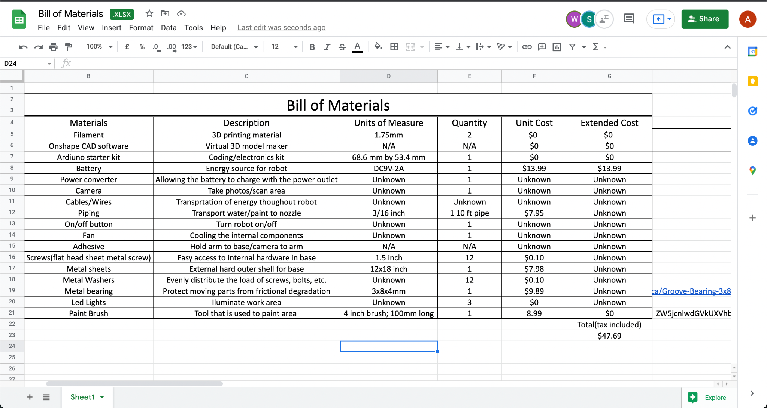
Website URLs for items in bill of materials:
-https://www.amazon.ca/ERYONE-Filament-1-75mm-Printing-Printer/dp/B07ZPT32M8/ref=sr_1_5?crid=2OJ1J0H7Y51GI&keywords=filament+PLA&qid=1644870433&sprefix=filament+pla%2Caps%2C113&sr=8-5
-https://www.onshape.com/en/
-https://store-usa.arduino.cc/products/arduino-starter-kit-multi-language?selectedStore=us
-https://www.amazon.ca/Universal-Adapter-Converter-Inverter-Transformer/dp/B08HK9ZPVL/ref=sr_1_5?crid=D5QN25TVSCU8&keywords=9v+ac+adapter&qid=1644960501&s=electronics&sprefix=9v%2Celectronics%2C76&sr=1-5
-https://www.amazon.ca/Proper-Pour-Approved-Multi-Purpose-Aquaponics/dp/B017EA5ST6/ref=sr_1_6?crid=1VXUQXAWKZKK7&keywords=plastic%2Bpipe&qid=1645316925&sprefix=plastic%2Bpipe%2Caps%2C90&sr=8-6&th=1
-https://edu-makerlab.odoo.com/shop/product/flat-head-wood-screws-75?category=3#attr=383,389
-https://www.homedepot.ca/product/paulin-12-x-18-inch-26-gauge-steel-sheet-galvanized/1000861560
-https://edu-makerlab.odoo.com/shop/product/flat-washers-74?category=3#attr=122
-https://www.amazon.ca/Groove-Bearing-3x8x4mm-Miniature-Double/dp/B078SJKNBK/ref=asc_df_B078SJKNBK/?tag=googleshopc0c-20&linkCode=df0&hvadid=459442106099&hvpos=&hvnetw=g&hvrand=5159118538115907575&hvpone=&hvptwo=&hvqmt=&hvdev=c&hvdvcmdl=&hvlocint=&hvlocphy=9000784&hvtargid=pla-1186688773153&psc=1

