GNG 1103
Design Project User and Product Manual

Accelerated Rock Erosion Test System (ARETS)

Submitted by:
AREA Engineering
AVERY TAYLOR, 300366472
RASHAD NESAR, 300372555
EMILY FACETTE, 300109170
ANNABELLE OSAZUWA 300361617

April 10th 2024
University of Ottawa

Table of Contents
Table of Contents 2
List of Figures 5
List of Tables 6
List of Acronyms and Glossary 7
1 Introduction 8
2 Overview 9
2.1 Conventions 13
2.2 Cautions & Warnings 13
3 Getting started 14
3.1 Configuration Considerations 14
3.2 User Access Considerations 14
3.3 Accessing/setting up the System 15
3.4 System Organization & Navigation 18
3.5 Exiting the System 22
4 Using the System 23
4.1 Filling The bucket 23
4.1.1 Abrasives 23
4.2 Attaching Samples to Shaft 23
4.3 Attaching the Shaft to the Chuck 23
4.4 Powering the Motor 23
4.4.1 Potentiometer 24
4.5 Running Code 24
5 Troubleshooting & Support 25
5.1 Error Messages or Behaviors 25
5.1.1 Arduino IDE 25
5.1.2 Prototype Parts 26
5.2 Maintenance 27
5.3 Support 27
6 Product Documentation 28
6.1 Bucket Selection and Setup 28
6.1.1 BOM (Bill of Materials) 28
6.1.2 Equipment list 28
6.1.3 Instructions 28
6.2 Motor Selection and Setup 29
6.2.1 BOM (Bill of Materials) 29
6.2.2 Equipment list 29
6.2.3 Instructions 30
6.3 Electronic Selection and Configuration 30
6.3.1 BOM (Bill of Materials) 30
6.3.2 Equipment list 31
6.3.3 Instructions 31
6.4 Testing & Validation 34
7 Conclusions and Recommendations for Future Work 36
8 Bibliography 38
9 APPENDICES 39
APPENDIX A: Design Files 39
APPENDIX B: Code 40

List of Figures
Figure 1: Product Front View 10
Figure 2: Baffles Attached to Bucket 11
Figure 3: Rod with Sample 11
Figure 4: Electrical Components of Device 12
Figure 5: Block Diagram of the Complete System 13
Figure 6: System Configuration 14
Figure 7: Zip Tie Configuration 16
Figure 8: Chuck Key 16
Figure 9: Signal Wire is Unplugged 16
Figure 10: Battery Plugged in 17
Figure 11: How to Run a Sketch on Arduino IDE 17
Figure 12: Motor Attachment 19
Figure 13: Hall Sensor 20
Figure 14: Speed Controller Configuration 20
Figure 15: Relay Switch 21
Figure 16: Arduino IDE Test Run 24
Figure 17: Baffles 3D print design 29
Figure 18: Motor On Lid 30
Figure 19: Hall Sensor Proximity 31
Figure 20: Tinker Cad set up for Arduino 32
Figure 21: Speed Controller Set up 32
Figure 22: Complete Electrical Set up 33
Figure 23: Arduino Board Set up 33
Figure 24: 300 RPM Test Results 35
Figure 25: 550 RPM Tests Results 35

List of Tables
Table 1. Acronyms 7
Table 2. Glossary 7
Table 3 Referenced Documents…………………………………………………………………..39

List of Acronyms and Glossary

Table 1. Acronyms
Acronym | Definition
ARETS | Accelerated Rock Erosion Test System
RPM | Rotations per minute
UPM | User and Product Manual

Table 2. Glossary
Term | Acronym | Definition
Variable Speed Motor/ Variable Frequency Drive Motor | VFD Motor | A motor designed to operate at different speeds based on the application's requirements. Unlike traditional motors that run at a fixed speed, variable speed motors can adjust their speed to match the desired output.
Baffles |  | A device (such as a plate, wall, or screen) to deflect, check, or regulate flow or passage of a fluid, light, or sound.
Potentiometer | Pot, Pot meter | A potentiometer is defined as a 3 terminal variable resistor in which the resistance is manually varied to control the flow of electric current. A potentiometer acts as an adjustable voltage divider.

Introduction

Ailsa Eyvindson from Canadian Nuclear Laboratories has requested a design for a highly accelerated erosion testing system for different materials. This document will go over the identification of the client’s needs, corresponding design criteria and how they apply to the different subsystems of the device. The user instructions for starting the apparatus, ending the experiments, a breakdown of subsystems, and possible troubleshooting errors will be explained in this document.

This User and Product Manual (UPM) provides the information necessary for engineers, geologists, environmental scientists, researchers, construction companies and mining companies to effectively use the Accelerated Rock Erosion Test System (ARETS) and for prototype documentation.

Overview
Rotating equipment is used in all sorts of industries, such as the energy sector, geologists, and of course nuclear science. These parts are exposed to very high fluid viscosities, which can cause erosion over time. We have been tasked with creating a prototype which mimics a high fluid viscosity, to test which parameters are most influential in causing erosion.
Today's climate is leading to increasing temperatures, and ultimately accelerating glacier and ice cap melting. This is increasing the water level of oceans and severity of storms; consequently, causing premature rock erosion and costal erosion. To predict the performance of material, a highly accelerated erosion testing apparatus will be constructed so users can predict the performance of a sample. The fundamental needs of the user and the client can be split up into design, function, and prototyping and testing.
DESIGN
- The prototype should be safe to use
- Affordability
- The prototype should be stable and able to accommodate with the high rotational speed
- The prototype should be durable

FUNCTION
- The prototype set up should be used to accelerate erosion testing by rotating components.
- The prototype should be flexible enough to test variety of materials, temperatures, diameter of component, fluid viscosities, abrasion, and rotational speeds.

THEORY AND TESTING
- Demonstrate your system and describe the features that accelerate the erosion with empirical proof
- The process should be repeatable
- Erosion should be visible in a week or two after testing started
- Minimal Maintenance
The needs of the client were summarized and translated a problem statement and corresponding design criteria. We will design and develop an erosion testing system which is safe, economic, durable, and stable. The system must be flexible and repeatable to accommodate different testing parameters. The goal is to create a design which will allow for a deeper understanding of how different factors affect the rate of erosion. The corresponding design criteria include a variable speed motor, an easy-to-use system, stable and secure adherence of all components, and it will be able to test a variety of different components, such as sand, salt, duration, and rotations per minute (RPM).
Our product differs from others, as we have focused on the repeatability of the tests. Our product has a variable speed motor, which will allow users to adjust the speed of the motor to a known value. This allows user to adjust different parameters of the design, while keeping other parameters constant to pinpoint which parameter has the more significant effect on erosion. Additionally, the motor chosen for this device is a drill motor, thus it can reach high speeds to simulate erosion quickly. We have chosen to add baffles in the bucket to simulate more turbulent conditions and promote mixing. Coupling the high RPM with the baffles for turbulence, we expected the sample to exhibit erosion quickly.
The following figures depict the final prototype, the electrical components of the device, as well as the placement of the baffles.
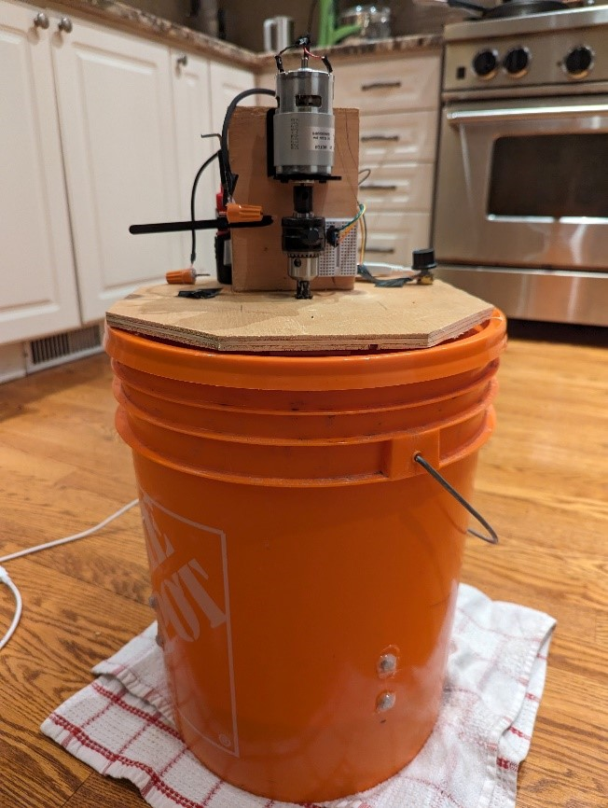
Figure 1: Product Front View
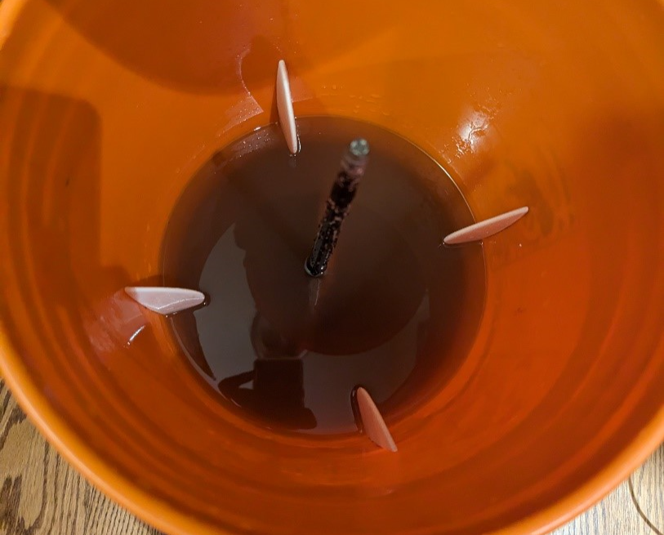
Figure 2: Baffles Attached to Bucket
Figure 3: Rod with Sample

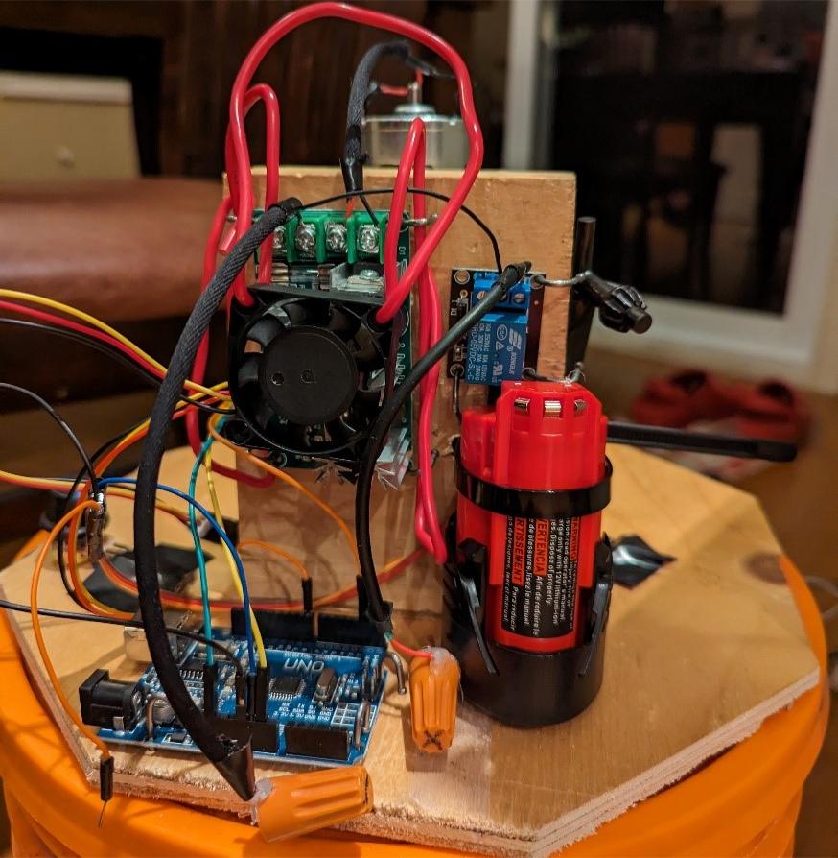
Figure 4: Electrical Components of Device
The main components are the bucket, the rod/turbine, the baffles, the motor, the speed controller the potentiometer, the hall sensor, and the battery. The baffles have been attached to the inside of the bucket with screws to promote turbulence and mixing. The chuck in the motor will attach to the rod (pictured in Figure 3 above), which has the sample attached to it. The variable speed motor works with the user adjusting the speed on the potentiometer dial, which will send a signal through the speed controller to increase or decrease the power being supplied to the motor. The hall sensor will read the magnetic field of the motor and show the corresponding value on a serial monitor.
The Home Depot bucket is used as the main container for the water and samples, and where the erosion will take place. Drilled into the sides of the bucket are 4 baffles screwed in, equally spaced inside the bucket used to increase erosion. The screws on the outside of the bucket are sealed with hot glue to ensure no water leakage. The lid of the bucket is used to ensure no water from the erosion testing comes out of the top. There is a small hole in the center of the lid for the motor shaft to go through and spin in the water. On top of the lid is a piece of plywood used to give us a flat surface for all of our electrical components to sit. A small 2X4 is drilled to the plywood, the motor will attach to this piece of wood so it can stand facing down towards the bucket. On the other side of the 2x4 is the speed controller, which the motor, power supply, and potentiometer will be plugged into. The potentiometer is taped onto the plywood. The Arduino is nailed to the plywood, it connects the hall sensor and a computer. The hall sensor is taped next to the motor to measure its speed. The battery slides in next to the 2x4 into a zip tie to ensure it doesn’t move during tests. The relay switch is next to the speed controller, the Arduino is plugged into it and the positive connection of the battery. When the motor is running, and everything is connected you can see the rpm of the motor on your computer screen, by running the code provided by Appendix II, in Arduino IDE.
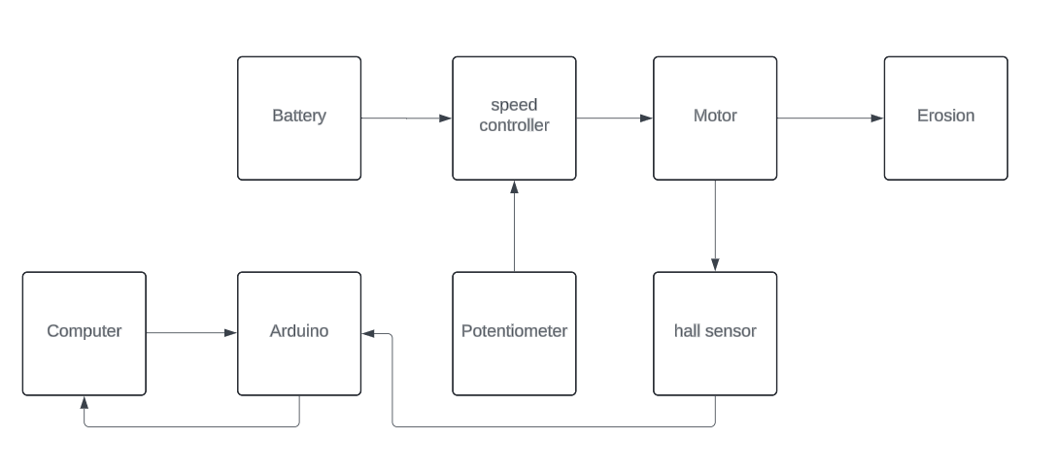
Figure 5: Block Diagram of the Complete System
The block diagram shows the 2 power supplies: the battery and the computer, as inputs, and details how they output erosion on to our sample.

Conventions
There is no command syntax on this device. The user simply needs to run a code on Arduino IDE and spin the potentiometer to their desired speed. This code can be seen in Appendix B.

2.2 Cautions & Warnings
The motor selected for the design is a drill motor, thus it has a high torque and power output. For this reason, it is crucial that users ensure the chuck is tightened to the rod with the supplied chuck key. For user safety, it is also required that users keep their fingers away from moving parts whilst the device is in operation. The battery is connected with 2 wires to the speed controller, and the wires that plug into the battery are covered with marettes. For user safety, users are only to touch those wires by the marettes to prevent any risk of shock or electrocution. Lastly, because this device deals with water and electrical components, users must be careful when dealing with water around the electrical components.

3 Getting started

This section will provide a general walkthrough of the system, as well as the sequence and flow of system components and use.

Configuration Considerations
This product is composed of a home depot bucket and lid, a sheet of plywood attached to the lid, a square piece of wood which the motor is attached to, the motor with a chuck to attach to the rod, a battery, and some electrical components to power the system. No tools are required to attach pieces, except for the chuck key which is used to tighten the rod connection. The electrical components will be monitored by Arduino IDE, which is ran on a connected laptop. The following figure shows the general configuration of the system.
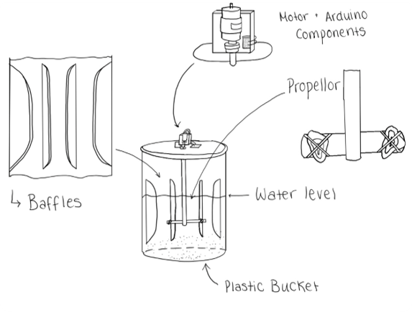
Figure 6: System Configuration

3.2 User Access Considerations
Research organizations, such as Canadian Nuclear Laboratories, these users would use our prototype for research purposes such as erosion tests, rotating component tests, and motor speed tests. Such organizations should however keep in mind the limitations of the prototype such as motor speed limitations, volume, and weight of sample.
Farmers and other professionals in agriculture might be interested in our protype to test the quality of soil before planting begins. The motor set-up can be used to accelerate the drying process. These users should protect the parts from water exposure on the farm and exposure to pests and livestock.
Government and construction companies could use our prototype for testing rock performance before construction starts. Knowing the performance of the material sample would prove to be incredibly helpful in construction projects. These users should not test too many heavy samples, as the rod is not designed for large samples.
Environmental scientists may also be interested in this design to predict the performance of coastal rocks under the effects of coastal erosion due to climate change and increased ocean water levels.

3.3 Accessing/setting up the System
The RPM measurement system is run by Arduino. The Arduino IDE can be downloaded from here: https://www.arduino.cc/en/Main/Software (Windows), http://www.wch-ic.com/downloads/CH341SER_ZIP.html (MAC).
To use Arduino application,
  - Connect the Arduino board to an open USB port on the computer with the USB cable. The Arduino board LEDs should light up, as power is drawn through the USB connection.
  - Launch the Arduino IDE Software, and pick ‘Arduino Uno’ from the dropdown menu in Tools→Board→Arduino AVR Boards. Back in the ‘Tools’ tab, select ‘Port’ and choose the serial port that the Arduino is connected to
  - Open a new sketch and paste the provided code. Select the arrow icon
  - Open the serial monitor by selecting Toolsà Serial Monitor.
To run the physical system, the following steps need to be taken:
  - Remove lid from bucket and fill up bucket with desired amount of water (half way up the baffles) and pre weighed additives.
  - Attach the rock sample to the end of the rod with 3 zip ties. 2 around the sample and 1 around the sample and the shaft of the rod.

Figure 7: Zip Tie Configuration
  - Attach the rod to the chuck. Use the chuck key to tighten attachments.
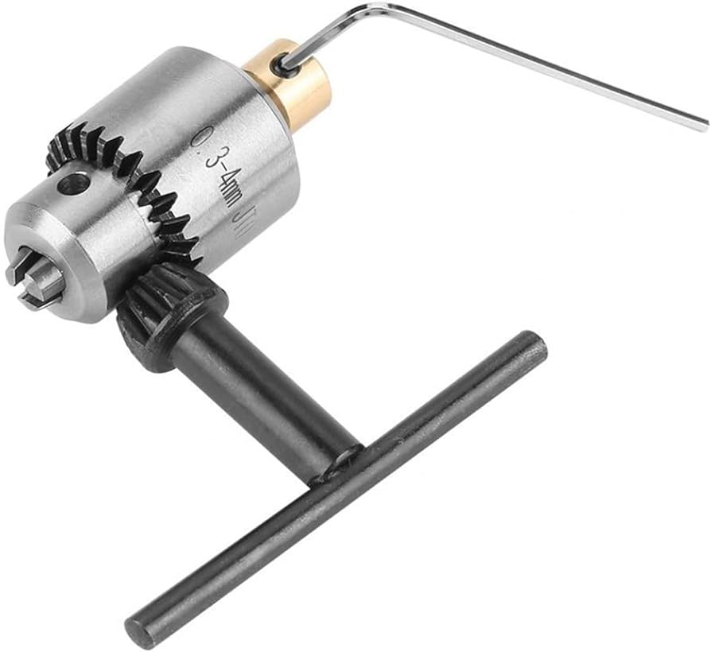
Figure 88: Chuck Key
  - Attach the lid to the bucket securely. It should click into place and be flush.
  - Make sure the signal (orange wire) is unplugged from the Arduino
Figure 99: Signal Wire is Unplugged

  - Make sure the potentiometer is all the way down (twisted counter clockwise left)

  - Attach the red wire to the '+' terminal on the battery *make sure to only attach/touch one wire at a time for safety*

  - Attach the black wire to the '-' terminal on the battery *make sure to only attach/touch one wire at a time for safety*
Figure 1010: Battery Plugged in
  - Plug in ardunio and up upload sketch from Appendix B
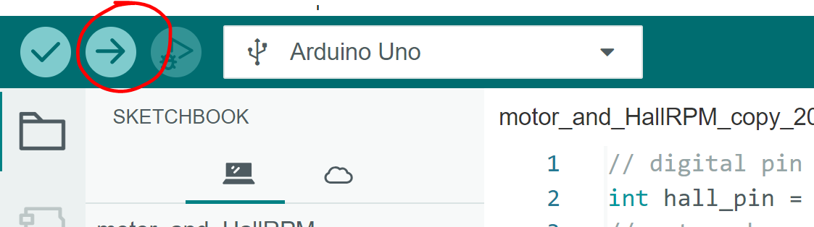
Figure 1111: How to Run a Sketch on Arduino IDE
  - Plug in relay signal wire (orange) into the 5V on the Arduino board

  - Slowly increase power with potentiometer

  - Open serial monitor on Arduino IDE to view speed

  - Adjust speed as desired.

3.4 System Organization & Navigation
The main components, as broken down in Section 3.1, include:
  - A home depot bucket and lid
  - A sheet of plywood attached to the lid
  - A square piece of wood which the motor is attached to
  - The motor
  - A chuck to attach to the rod
  - A battery
  - Some electrical components
    - Hall sensor
    - Speed Control
    - Potentiometer
    - Battery
    - Relay Switch
3.4.1 Bucket and Lid Connection
The selected bucket for the system was a Home Depot bucket and a lid. A sheet of plywood was cut to size and drilled to the lid of the Home Depot bucket. Coupling the Home Depot bucket lid with the plywood will allow for a secure and strong connection to the lid. A hole was drilled through the center of both the lid and the octagonal piece of plywood to allow the turbine to go through.
3.4.2 Motor Attachment and rod
To fasten the motor to the lid securely, the 4 in x 3-inch motor stand was attached with 3 screws to a small section of plywood. The motor was attached with four screws, as seen in the following figure.
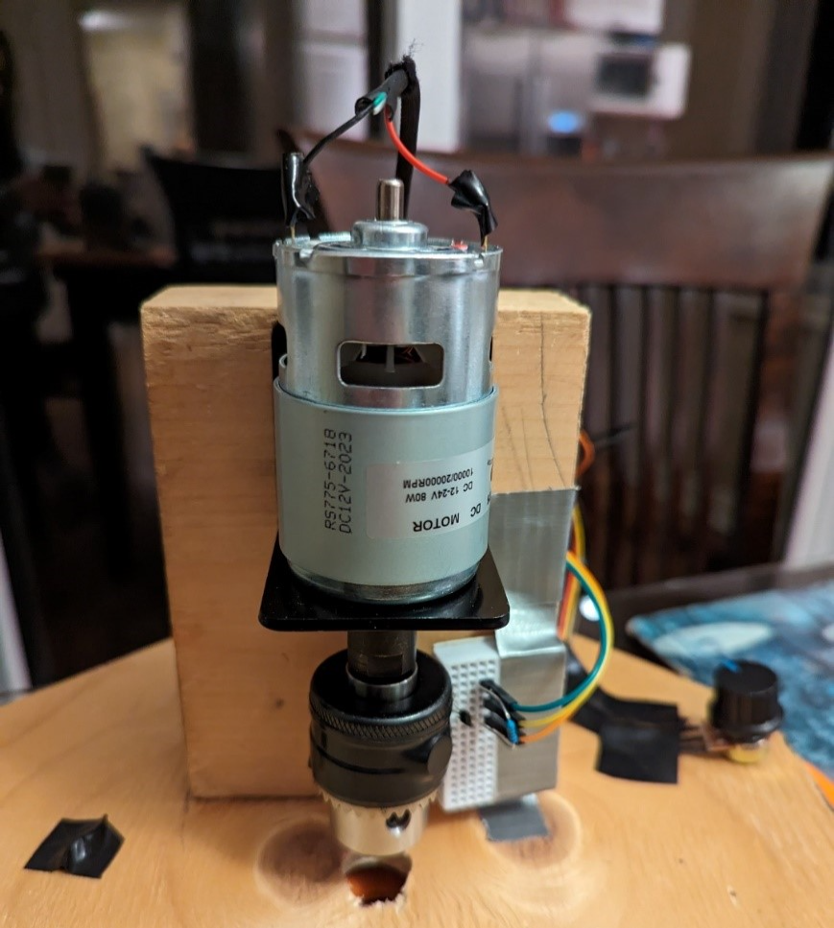
Figure 1212: Motor Attachment
The rod is attached by going through the hole into the lid and connecting to the chuck on the motor. The chuck is tightened with the chuck key to ensure a tight connection.
3.4.3 Electrical Components
3.4.3.1 Hall sensor
The hall sensor was positioned so that it was close to the motor, as seen in the following figure. A magnet was taped to the motor so that the hall sensor could measure the magnetic field correctly. The hall sensor wires are attached to the Arduino. The results will be displayed on the Arduino IDE software through the use of code.
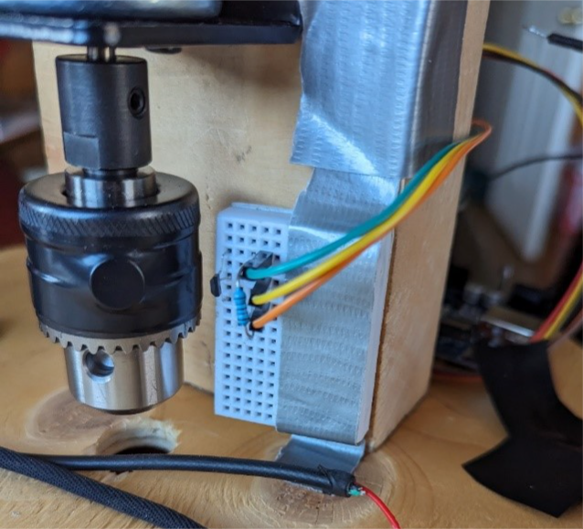
Figure 1313: Hall Sensor
3.4.3.2 Speed Controller, Potentiometer and Battery
The positive and negative wires from the battery were attached to the corresponding terminals on the relay, and likewise for the motor to the speed controller. The following figures show the specific layout for the speed controller.
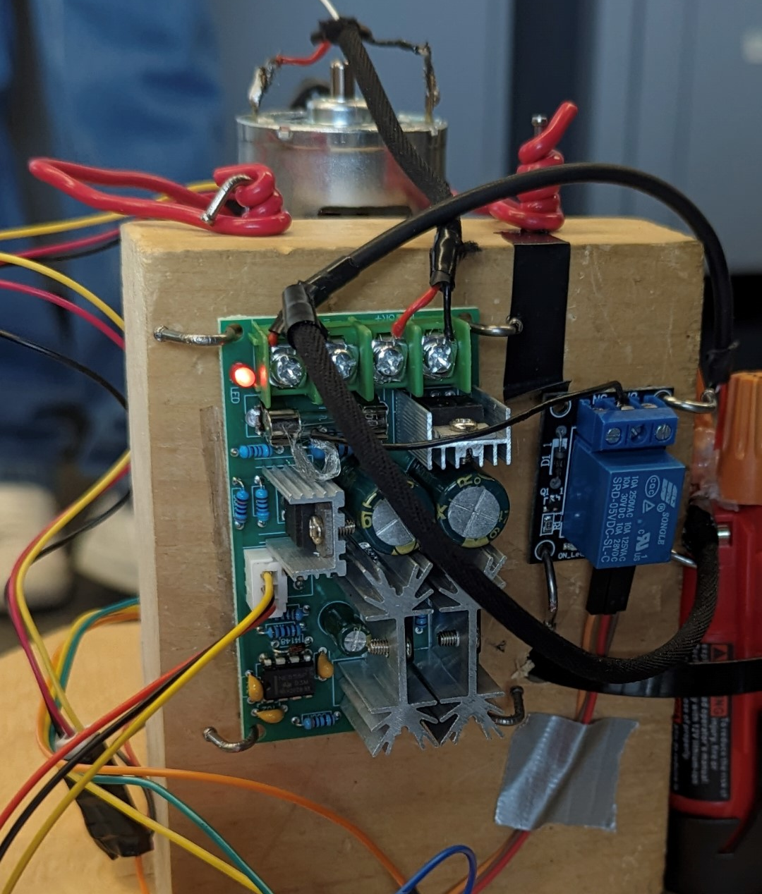
Figure 1414: Speed Controller Configuration
The potentiometer is used to adjust the speed of the motor. This is connected to the speed controller as seen in the figure above (yellow, black, and red wires). The user controls the speed by adjusting the knob.
3.4.3.3 Relay
The relay switch acts as a medium between the battery and the speed controller. The positive power terminal of the speed controller is connected to the relay, and the negative power terminal of the speed controller is connected directly to the negative power terminal on the battery. The relay switch can be seen below.
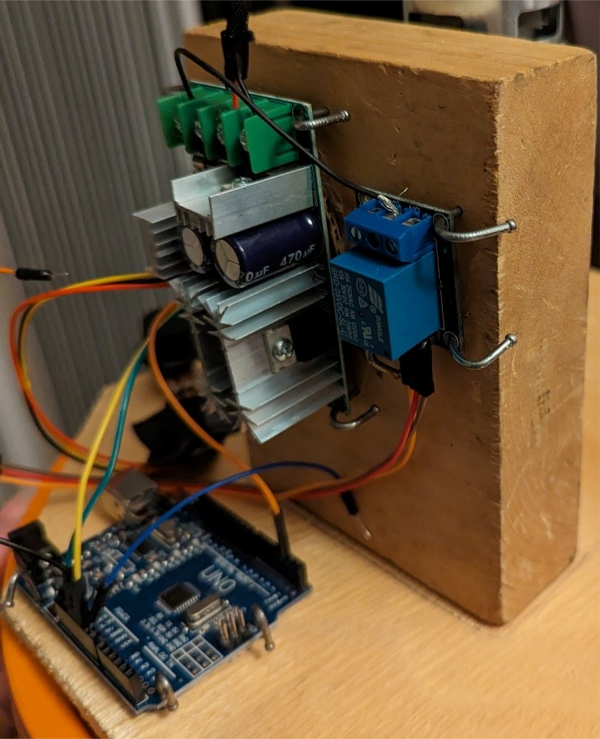
Figure 1515: Relay Switch
3.4.3.4 Arduino
There are 3 Arduino cables that are connected from the relay to the Arduino. These will be attached to the ground, 5V and power ports of the Arduino. When the orange wire in the 5V port is unplugged, the power supply is stopped. Likewise, when it is plugged into the Arduino, the power is supplied. There are three wires from the hall sensor which are connected to the Arduino. The Arduino will be used to measure the speed of the hall sensor on the Arduino IDE system using a code.

Exiting the System
To turn off the system, the following steps should be taken.
  - Slowly decrease the potentiometer counterclockwise to OFF
  - Unplug the relay switch wire (orange) form the 5V port
  - Unplug the ‘+’ wire from the battery
  - Unplug the ‘-’ wire from the battery
  - Remove Lid
  - Disconnect rod from chuck by unscrewing with your fingers.
  - Dispose of water

Using the System
The following sub-sections provide detailed, step-by-step instructions on how to use the various functions or features of the ARETS.

4.1 Filling The bucket
No erosion will take place if the bucket is empty. To fill the bucket, open the lid of the bucket and fill it with water the water line reaches about halfway up the baffles.

Abrasives
Part of our testing parameters was using different abrasives (salt, gravel & sand or both) with our water to see the differences in erosion rate. If you are doing a test with an abrasive, measure how much of the abrasive you add before you add it. This ensure your results are repeatable and accurate.

Attaching Samples to Shaft
This step is needed to make sure the samples are able to rotate uniformly through the water. Hold the sample against the metal bar attached to the shaft. Use 2 zip ties to tie the sample to the metal bar, and another to tie the sample to the shaft, while going through the previous loop you made.

Attaching the Shaft to the Chuck
The shaft must be firmly attached to the motor chuck, if it is not the shaft may come lose during tests. Rotate the chuck counterclockwise to widen the hole in the chuck. Once it is wide enough, put the end of the shaft into the chuck and tighten it by turning it clockwise. After tightening it by hand use the chuck key to tighten it further. Do this by inserting the geared end into the hole on the chuck and turn right to tighten (refer to Figure 8: Chuck Key).

Powering the Motor
Powering the motor will allow the samples attached to the shaft in water to be spun, causing erosion. To power the motor, plug the wire marked with a + into the end of the battery marked with a +, and do the same with the – wire and – port on the battery. Then plug the loose orange wire into the 5v port in the Arduino.

Potentiometer
Use the potentiometer to increase or decrease the voltage going to the motor. At the start the potentiometer will be all the way to the right, giving the motor no power. Turn the dial clockwise to increase voltage. Turn the potentiometer slowly.

Running Code
The code shows the rotational speed of the motor in real time. Plug the Arduino into a laptop/computer with Arduino IDE installed, and copy and paste the code from Appendix B to Arduino IDE. Click “select board” and then “Arduino Uno” from the Arduino IDE software. Then click the check mark to verify the code, and then the up arrow to run the code. Everything can be found in the top left corner as shown in Figure 16.
Figure 16: Arduino IDE Test Run

Troubleshooting & Support
This section will highlight all procedures to be followed in case of error or malfunction with the system.

Error Messages or Behaviors

Arduino IDE
Once the Arduino has been attached to a laptop and the code has been prepared, there may be several errors shown on the Arduino IDE serial monitor. These errors could consist of;
  - Invalid Serial Port/Serial Port Not Found: In the case of this error there are several possible issues. This could mean a variety of things from a different USB cable is needed, the wrong COM port was chosen, or the board purchased could be defective.
To fix this issue ensure the correct COM port has been selected. To check, make sure when the wire is plugged in and unplugged from the Arduino that the COM port disappears and reappears. If this issue continues to reappear, restart the Arduino IDE software and attempt to change the wire.
  - Programmer Not Responding: This error may appear when attempting to upload the sketch, this means there is a possible circuit error that is interfering with the uploading process.
To troubleshoot this error, ensure the right board and port have been chosen and both are connected properly. Additionally verify your program is updated properly, and that the board is not resting on any conductive materials.
  - Compilation Error: This error simply means there is a syntax error somewhere within the code.
This error could possibly be from a missing semicolon, incorrect spelling, missing brackets, or invalid functions. Simply go over the code and double check for any of these errors.
  - Timeout Error: This error typically is a result of the Arduino board and IDE not being able to communicate within a specific amount of time. This typically is not due to user error but however a malfunction with the equipment or incorrect selection of settings.
To troubleshoot this issue, attempt switching out the USB cable and insuring there is a stable connection between the two. This error may also be cause by incorrect baud settings which is set within the code itself. If none of these solutions fix the error, it may be an issue with the board itself.

Prototype Parts
While the prototype does not have an extensive list of parts there are some issues you may run into while beginning the testing process.
  - Dead Batteries: In the case that your motor begins slowing down and comes to a complete stop this is likely due to the batteries not having enough power.
The simple fix for this issue is simply to plug in the battery for approximately an hour or two, the system should run smoothly again afterwards.
  - Relay: The relay essentially acts as a medium between the battery and the speed controller, but if not stable will cause issues. When the relay is not stable, there will be s repeated clicking noise and the motor will not be able to run at its full capacity without turning on and off.
If this issue is experienced it is simply a matter of stabilizing the relay itself. Ensure the relay is attached on all four corners tightly with nails. If no nails are available, then tape will work in the meantime as long as the relay is stable. It is also advisable to ensure the connection with the cables Ii secure.
  - Chuck: Through testing, the chuck is likely to become slightly loose due to the testing in highly viscous fluids for long periods of time. In the case that the chuck becomes too loose the rod will become completely disconnected in the middle of testing. There is the possibility if the chuck is not fastened on the motor properly as well, that it may fly off causing hazards.
To avoid these hazards or interruptions during testing, before each test tighten the chuck properly with its key. Additionally fasten the chuck on the motor properly as well using an Allen key
  - Leaking Baffles: The baffles are attached to the outside of the bucket using nails and hot glue, there is the possibility through testing that water may leak through these nails.
In the case of leakage, secure the outside of the bucket with waterproofing materials such as tape or additional hot glue.

Maintenance
To avoid failure, regular maintenance should be performed on the prototype. This will include few actions such as;
  - Regularly charging the batteries and maintaining them so there are no issues when having to begin testing.
  - After each test performed/every few tests, the water should be changed out. Having several additives in the water such as gravel, sand and salt, it is important to continue changing out the water to avoid rust, smells, and build up around the inside of the prototype.
  - In addition to changing out the water, the inside of the prototype should be cleaned regularly as well to avoid build up.

Support
Arduino Help Center: Online Support
https://support.arduino.cc/hc/en-us

If any issues are found with the Arduino IDE or physical Arduino itself there are guides to follow through this website, and frequently asked questions with answers. If that is not able to help, there is a ‘Contact Us’ option available where they are able to reach out personally if a name, email, and situation is left.

CHANCS Motor Support: Online Support
https://chancsmotor.com/contact/
With the CHANCS Mini electric Motor if any issues are experienced, there is the option for ‘Contact Us’ where if a name, email, and message is left describing your issues, there will be a support service that is be able to respond quickly to help troubleshoot the issues.

Product Documentation

Bucket Selection and Setup

BOM (Bill of Materials)
- The main components of the bucket se up are a home depot bucket and lid, as well as ply wood.

- The Home Depot Orange Logo Bucket, $3.47, https://www.homedepot.ca/product/the-home-depot-8l-orange-home-depot-logo-bucket/1000784938?eid=PS_GOOGLE_D00_Corporate_GGL_Shopping_PLA_All-Products_All%20Products__PRODUCT_GROUP_pla-298555526333&gad_source=1&gclid=Cj0KCQiA5rGuBhCnARIsAN11vgTqV0GebkP_QkRNYY9TOl4vdvrl20UBwTslLch64TK44cOek6Zb_N8aAtkXEALw_wcB&gclsrc=aw.ds
- Shale, $0.00,
- Alexandria Moulding White Melamine Handy Panel Plywood, $5.51, Alexandria Moulding 1/8-inch x 24-inch x 24-inch White Melamine Handy Panel | The Home Depot Canada

Equipment list
The following equipment was required to build this subsystem. Th
  - Drill
  - Impact Driver
  - Saw
  - Measuring Tape
  - Screws
  - Hot Glue
  - Screw Driver

6.1.3 Instructions
The plywood was measured to be approximately the same size as the home depot bucket lid. The wood was cut into an octagonal shape, which was attached to the lid of the home depot bucket with 4 screws. The home depot bucket was chosen as it was the least expensive option, and provided stability. It was decided that stainless steal would be too expensive for the budget. A 4 x 3 x 2 inch piece of wood was screwed to the lid with 3 screws. The motor would later be attached to this for a secure base. A hole was drilled in the lid to allow the rod to go through the top of the apparatus. The baffles, pictured below, were screwed to the inside of the bucket to promote aeration and maintaining the sediments in solution.
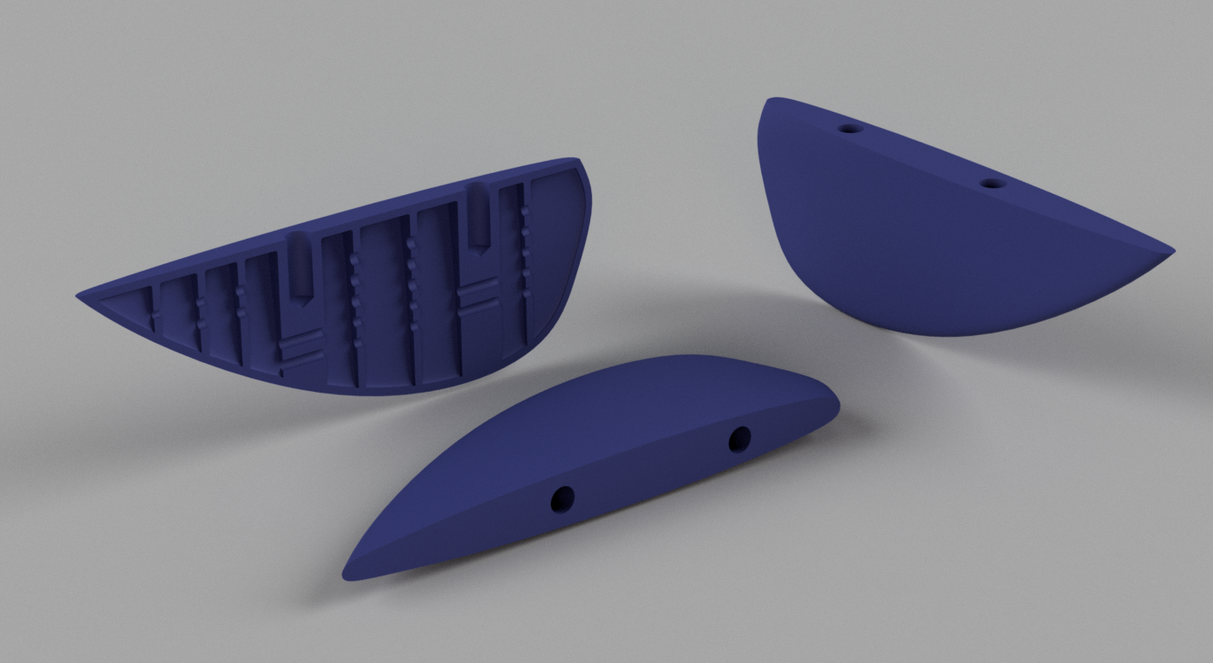
Figure 17: Baffles 3D print design
The material in which the baffles should be produced was discussed heavily amongst team members. We considered laser cutting, however we thought the water would disintegrate them. We also considered using metal, however we had no idea how to mount them to the bucket. Alas, the 3D print was the best option, as it allowed us to screw them in. Once they were screwed in, they were coated with hot glue on the outside to prevent leaking.

Motor Selection and Setup

BOM (Bill of Materials)
The main components include the motor (with chuck and mount) and the metal rod.
- Steelworks Weldable Steel Rod, $4.99, Steelworks Weldable Steel Rod, For Increased Strength, Assorted Sizes | Canadian Tire
- CHANCS Mini Electric Motor with Drill Chuck and PWM DC Motor Speed Controller, $42.90, CHANCS Mini Electric Motor 775 DC 12V/24V with Drill Chuck and PWM DC Motor Speed Controller : Amazon.ca: Tools & Home Improvement

Equipment list
The following equipment was required to build this subsystem. T
  - Drill
  - Measuring Tape
  - Screws
  - Screw Driver

6.2.3 Instructions
As mentioned above, a hole was drilled in the lid to allow the rod to go through the top of the apparatus. The motor was attached to the 3x4x2 inch motor stand and lined up to the hole in the center of the bucket lid. It was important to center the hole so that the rod was in equilibrium in the bucket. We considered other motors; however the high torque and RPM of a drill motor would allow us to have the required power to perform our tests and see erosion. The following figure depicts the motor on the lid.
Figure 18: Motor On Lid

Electronic Selection and Configuration

BOM (Bill of Materials)
The electrical components included the Arduino board, the cables, the battery, the marrettes, the relay, the hall sensor, and the little Arduino fan.
- ELEGOO UNO R3 Board with USB Cable for Arduino, $15.99, https://makerstore.ca/shop/ols/products/arduino-uno-r3-clone
- Wires Kit for Arduino, $1.00, Jumper Cables (pack of 10) (makerstore.ca)
- Battery, $20.00, Bdreer 2 Pack 3000mAh 12V Lithium Ion Replacement Battery Compatible with Milwaukee M12 Battery 48-11-2401 48-11-2402 48-11-2411 48-11-2420 12-Volt Cordless Tools : Amazon.ca: Tools & Home Improvement
- Marrettes, $0.28, 2299503-1 TE Connectivity AMP Connectors | Connectors, Interconnects | DigiKey
- Relay Power Switch, $2.75, Huayao 5PCS 5V One Channel Relay Module Board Shield for PIC AVR DSP ARM for Arduino Relay : Amazon.ca: Electronics
- Hall Sensor for Arduino. $0.88, Current Hall Sensor, Hall Effect Sensors Metal&Plastic -65~150 Celsius Degree Made Hall Effect Applied to Equipment for Electronic Toys, Small Household Appliances : Amazon.ca: Industrial & Scientific
- Little Fan, $3.20, Cooling Fan for 3D printer, ASHATA DC 5V 3D Cooling Fan, 8500RPM 4CFM High-speed Mini Cooling Fan 3D Printer Parts (5 Packs) : Amazon.ca: Electronics

Equipment list
The following equipment was required to build the system:
  - Nails
  - Hammer
  - Screw driver
  - Wire stripper
  - Electrical tape
  - Solder Gun
  - Hot glue

6.2.3 Instructions
The electrical components were attached to the back of the motor stand piece of wood. This includes the Arduino and PWM DC Motor Speed Controller. The potentiometer was attached to the speed controller and secured with tape to the board. The hall sensor to measure RPM was attached very close to the motor, as shown below. A magnet was also taped to the motor so that the magnetic field could accurately be measured.
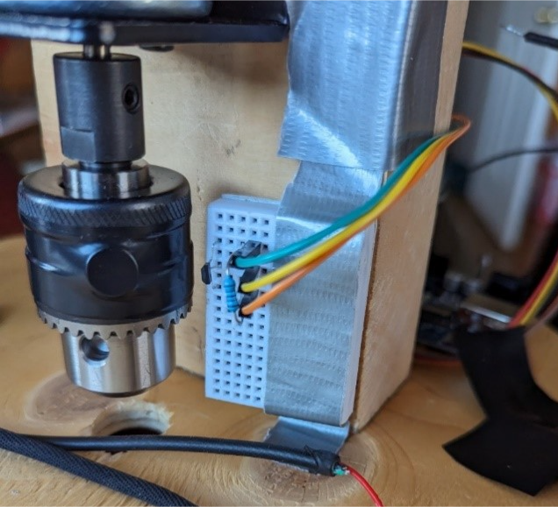
Figure 19: Hall Sensor Proximity
The Tinker CAD simulation was followed for the hall sensor and Arduino setup, as shown in the following figure.
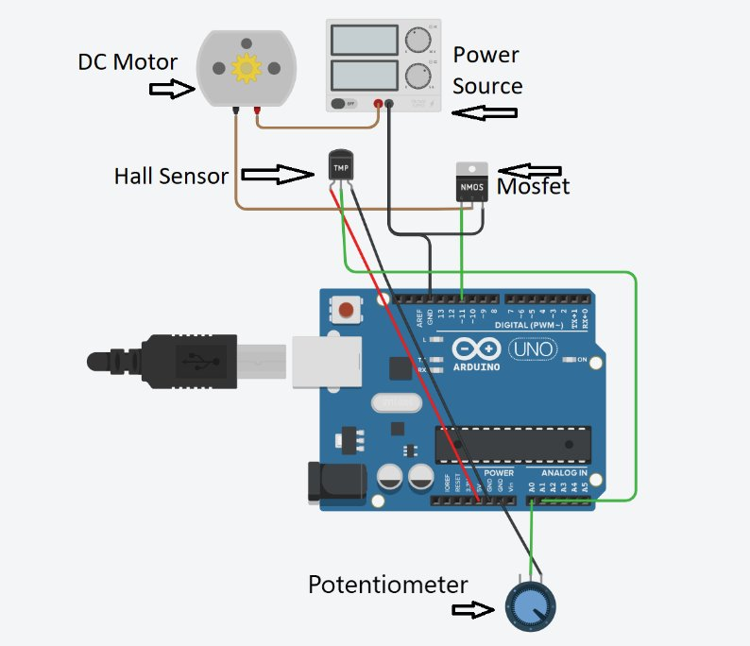
Figure 20: Tinker Cad set up for Arduino
The relay was secured to the back of the board, which was connected to the power terminal of the speed controller and directly to the battery's negative terminal. The relay was also connected to the Arduino to control power input for safety switch. The safety switch (orange wire in the 5V port) stops the power supply. Connect the power positive terminal of the battery to the other cable from the relay switch. The wires from the motor were attached to the speed controller directly. The following figure depicts where to plug in the wires on the speed controller.
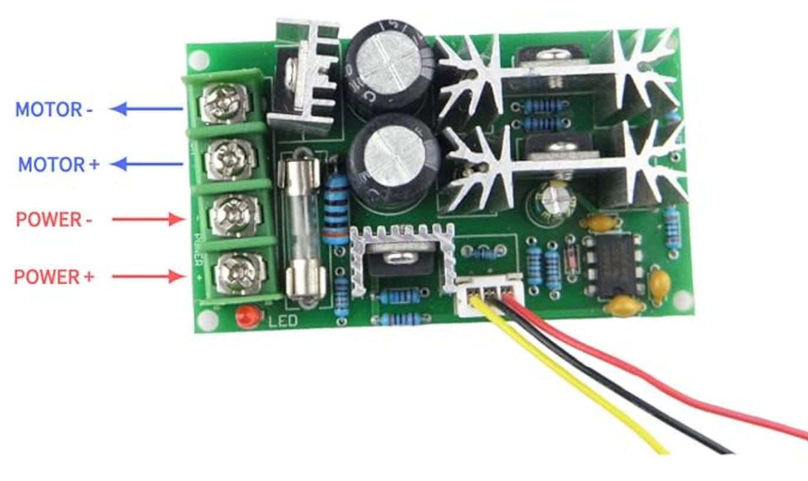
Figure 21: Speed Controller Set up
The following figure shows the complete set up, as well as the Arduino board set up .
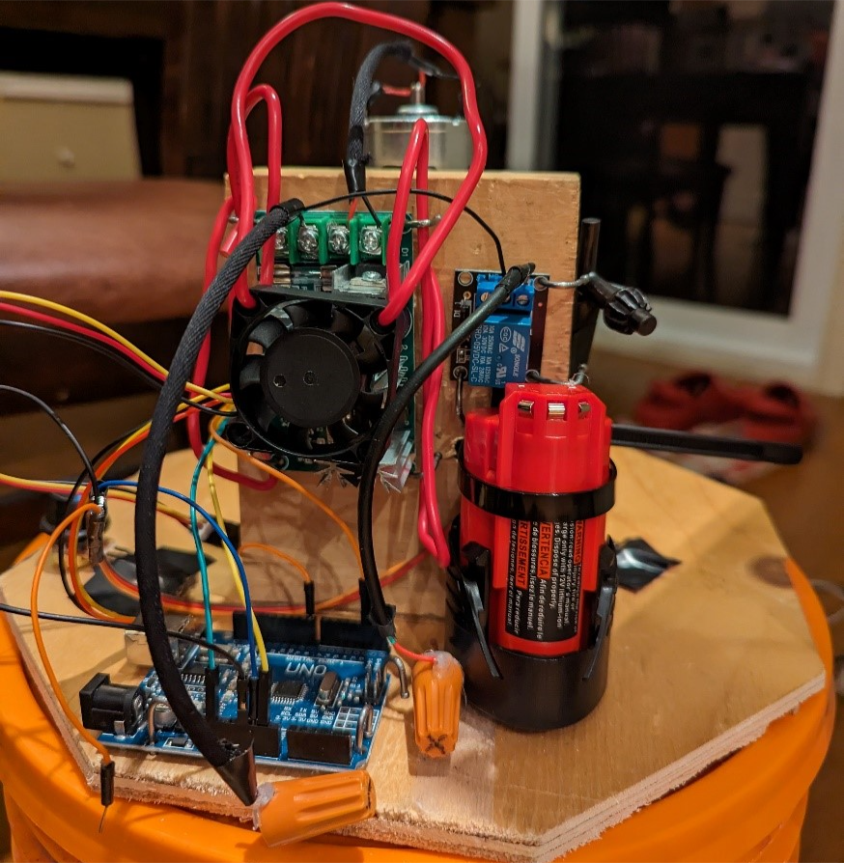
Figure 22: Complete Electrical Set up
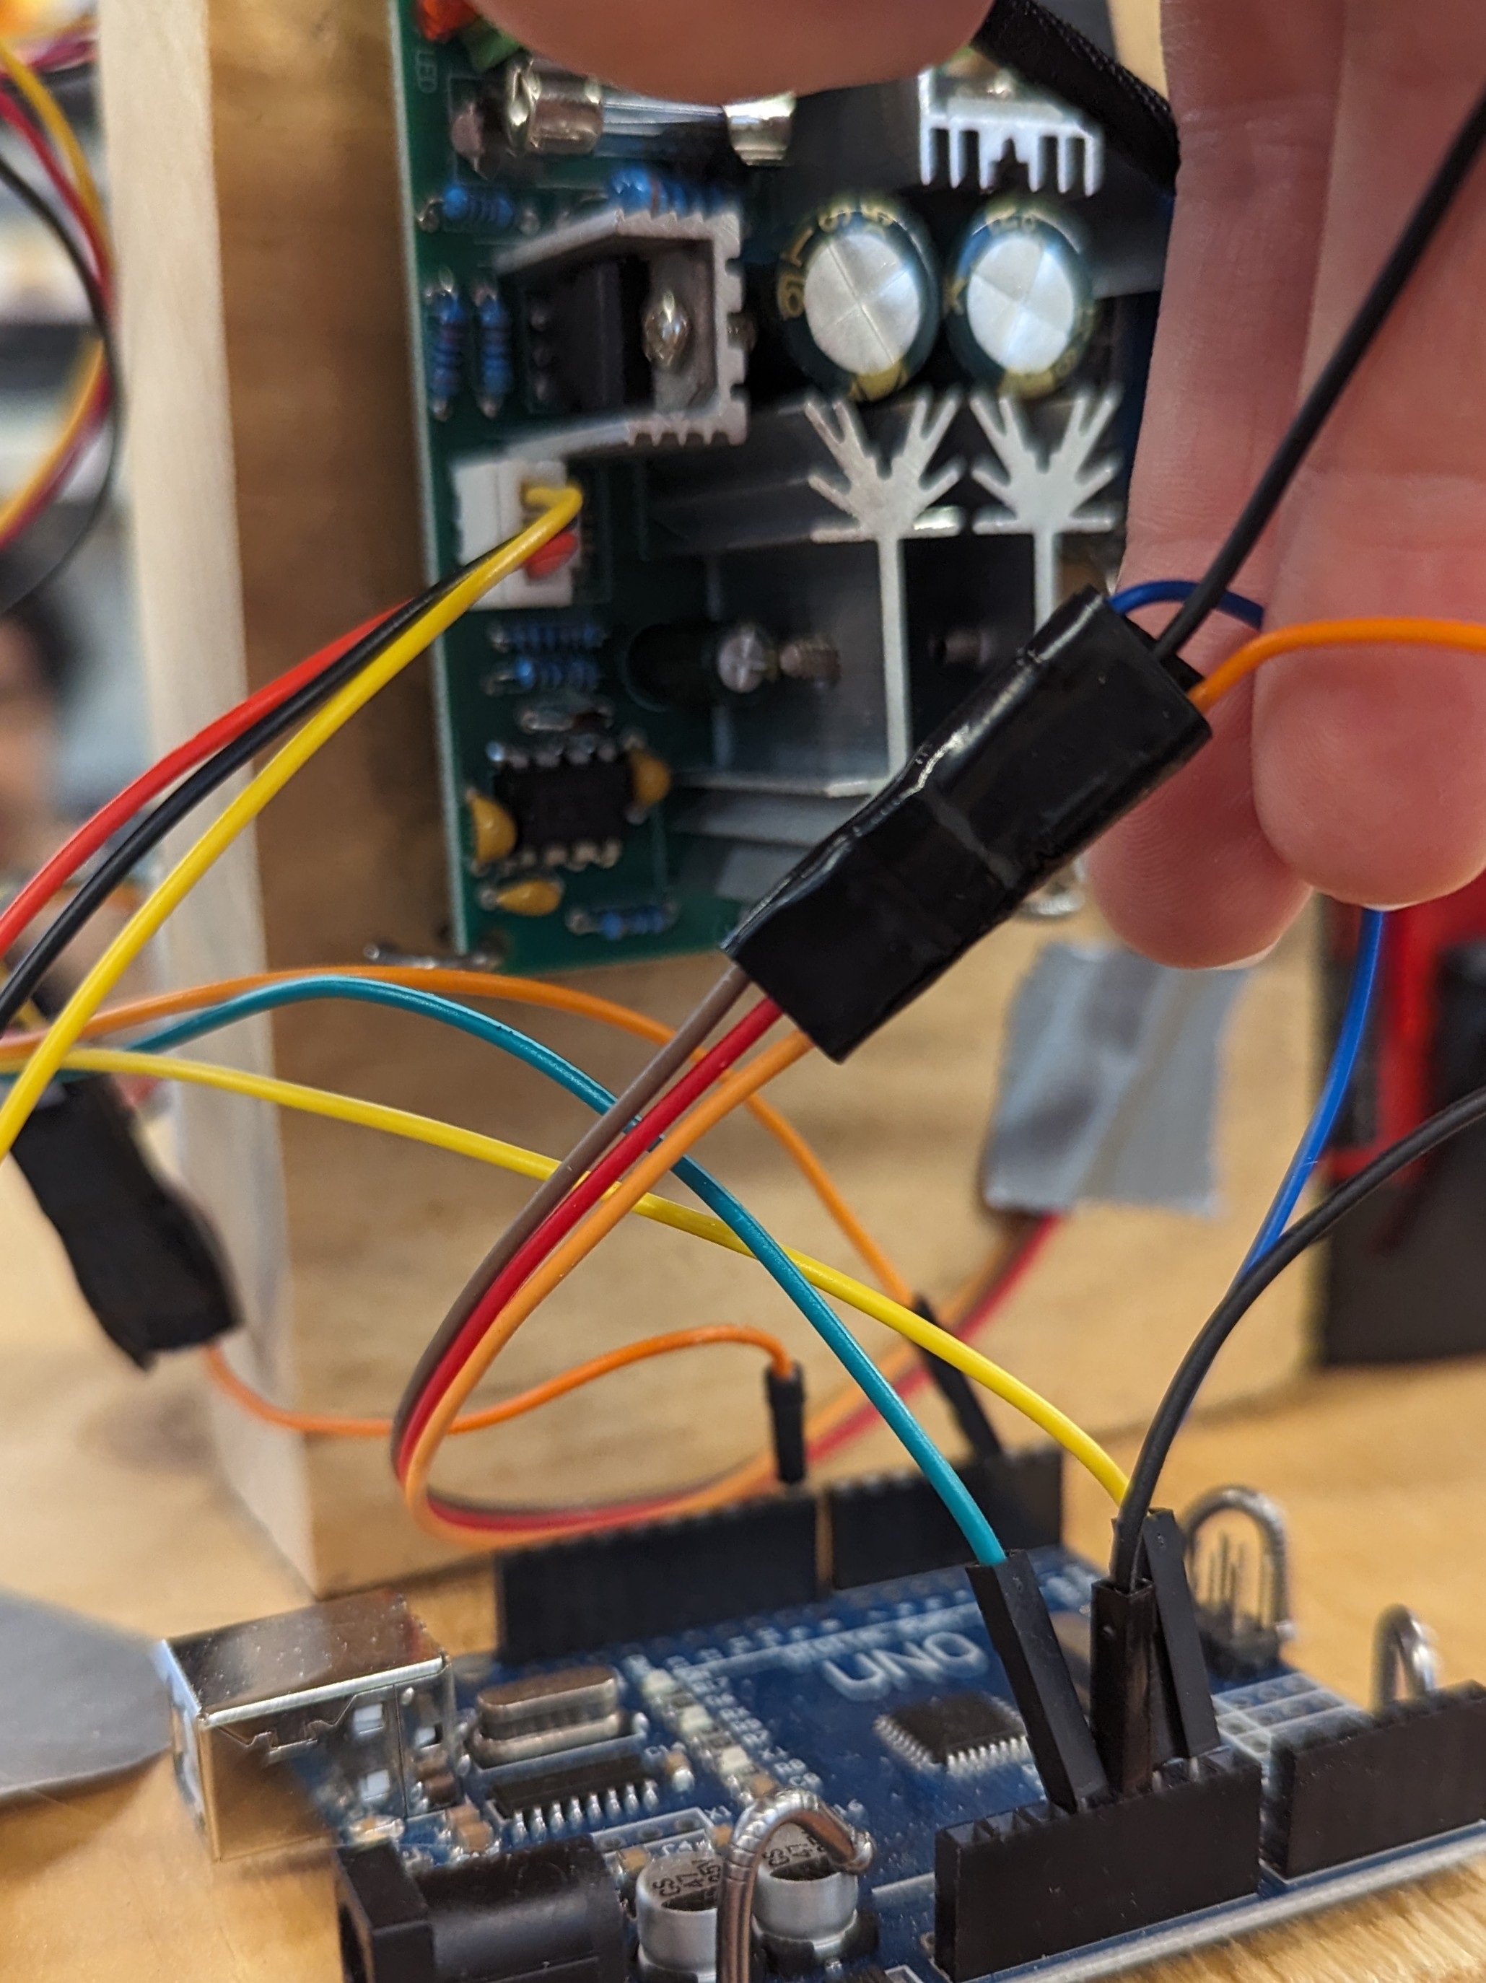
Figure 23: Arduino Board Set up
It must be noted that marrettes were hot glued to the end of the battery wires to prevent electrocution, and so they could be easily plugged in/removed.

6.4 Testing & Validation

Blank Test:
For this test only water was used to erode the rock sample. Significant erosion was seen although no abrasives were added to the water. We carried out two tests, one at 300 rpm and the other at 550 rpm. At 300 rpm, the initial mass was 12 g and the final mass was 20g. At 500 rpm, the initial mass was 8g and the final mass was 4g.

Salt Test
For this test we introduced 300g of salt as an abrasive, but the salt didn’t work as well as we expected. We also carried out two tests, one at 300 rpm and the other at 550 rpm. At 300 rpm, the rock sample's initial mass was 10g and the final was 9g. At 550 rpm, the initial mass was 15g and the final mass was 14 g.

Sand Test
Significant erosion was seen with 300g of sand/gravel as the abrasive. Two tests were done with sand, at speeds of 300 and 550 RPM. There is certain error in this test because larger particle size may settle out of suspension. In the first test the average RPM was 300. The initial mass of the rock was 20 g, the final mass was 18 g. In the second test the average speed was 550 RPM, the initial mass was 16g, the final mass was 12 g.

Salt and Sand Test
Using a mixture of both salt and sand, we ran two tests at varying speeds of 300 and 550 RPM. With these tests we identified effects of erosion, ranging from an initial mass of 15g to final mass of 12g using 300 RPM, and an initial mass of 12g with a final mass of 9g using 550 RPM. Though the effects of erosion were evident using these abrasives, there was not a large noticeable change using the two abrasives combined compared to them separately. Having the salt or sand on its own displayed approximately the same results. This could be due to the fact that different rock specimens have different specifications and properties, leading to different results.

Test Conclusions
Through the performance of eight tests under different parameters, several conclusions and inconsistencies can be drawn. It was observed that an increase in rotational speed does not universally increase the rate of erosion, and only did when using sand alone or no abrasive at all, as seen in the following figure.

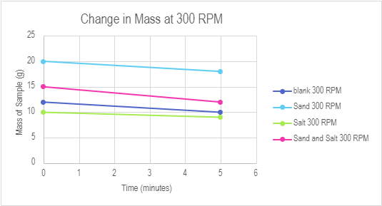
Figure 24: 300 RPM Test Results

Through analytical testing, it was concluded that salt was the weakest abrasive, even showing less erosion than when there is no abrasive at all. Notably, at 550 rpm no added abrasive showed the most erosion, possibly because shale is very brittle, thus the sample broke apart in the water or the samples had different or weaker properties. The following figure shows the trends from the 500 RPM tests.
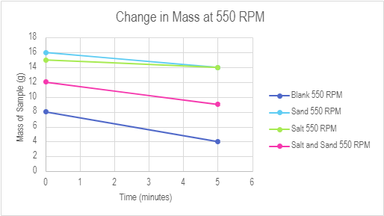
Figure 25: 550 RPM Tests Results

The most erosion was measured at 550 RPM when sand was the abrasive, showing even more than when using sand and salt together. These results show salt has the least effect on erosion, and won’t be useful as an abrasive. Future experiments should consider testing abrasiveness over extended durations, incorporating sand, gravel, and conducting blank tests for comprehensive analysis.

Some important things to remember when using the project for testing include that because the baffles were 3D printed and drilled to the inside of the bucket and have a high tendency to allow leaking of the water inside. When water was added to the bucket, there was slight leaking from the holes, as it was not waterproof. To solve this, the butts of the screws were covered with hot glue on the outside of the bucket to create a seal. When the test was run again, there were no signs of leaking.

The battery should also be fully charged before testing commences. The battery was able to successfully support the motor for several tests. Once going through about six tests, we ran into issues of the motor slowing down or stopping completely because the battery died. To help with this issue, we have a second battery on the side being charged while the other is going through testing, so we can switch them out once one begins to die to decrease any time waiting for them to be charged.

Also, the stability of the device starts to become a problem at higher rpm. When testing at 500+ rpm the motor starts to shake the bucket. The shaking causes a lot of noise and would affect the rate of erosion of the materials. A weight needed to be added to the top of the bucket to decrease the shaking.

Conclusions and Recommendations for Future Work

Through the course of this semester, we have completed a great deal of benchmarking and rigorous testing to develop and refine an accelerated rock erosion testing system that proved to be successful. Using several components such as a Home Depot bucket, a CHANCS DC motor, Arduino, and numerous other Arduino and electric components, this final prototype received up to 5g of erosion in only five minutes using sand and gravel as abrasives at 550 RPM.
Throughout testing we have learned the valuable lessons of not only coding, material selection and creating the prototypes themselves, but specifically the importance of agility and adapting through the design process. Given our time constraints, it was especially important to be able to allow rapid iteration and adapt to any changed requirements or unforeseen challenges.
Looking ahead for future work there are several steps that could be taken to further refine and develop this prototype, that with a few more months could have been implemented or for future groups. These steps could include a more developed system for collecting data regarding how much erosion is observed. With a kitchen scale being used for data collection and the sample being tied to the rod there was room for potential user error. With more time this system could be further refined to decrease the risk of error and increase precision. Additionally, conducting more tests for a longer period would test the overall durability of the system and give users a deeper insight into the long-term effects of erosion using the system, potential long-term effects of degradation on the system itself, and give users a chance to gather more comprehensive data using various conditions. With more time these avenues could be further explored to refine and develop the prototype and increase productivity.
Due to lack of time, there were a few additions we chose to abandon that could have further accelerated the effects or erosion, such as adding heating elements inside the apparatus. With time constraints and with a decreased budget, we were not able to perform tests to decide whether the addition of a heating element would overall be beneficial.
In conclusion, by further refining these elements listed above and given there was more time with an extended budget, this prototype successfully displayed effects of erosion through several months of testing fitting the criteria for an accelerated rock erosion testing system.

Bibliography

Hall Sensor Code was based on MakersPortal: Arduino Tachmoter:
Hrisko, J. (2022, November 16). Arduino Tachometer - Using a Hall Effect Sensor (A3144) to Measure Rotations from a Fan — Maker Portal. Maker Portal. https://makersportal.com/blog/2018/10/3/arduino-tachometer-using-a-hall-effect-sensor-to-measure-rotations-from-a-fan
Definition of Baffles: baffle. (2024). In Merriam-Webster Dictionary. https://www.merriam-webster.com/dictionary/baffle
Definition of Potentiometer: Electrical4U. (2020, October 28). Potentiometer: definition, types, and working principle. Electrical4U. https://www.electrical4u.com/potentiometer/
Definition of Variable Speed Motor:
MaLiang. (2023, July 19). Variable Speed Electric Motor: The Ultimate guide. PINYI MOTOR. https://electricalmotor.net/blogs/blogs/variable-speed-electric-motor-the-ultimate-guide

APPENDICES

APPENDIX A: Design Files
AREA Accelerated Rock Erosion Testing System - MakerRepo Page

Table A.1. Referenced Documents
Document Name | Document Location and/or URL | Issuance Date
Deliverable A | MakerRepo project files | 01/21/2024
Deliverable B | MakerRepo project files | 01/27/2024
Deliverable C | MakerRepo project files | 02/04/2024
Deliverable D | MakerRepo project files | 02/11/2024
Deliverable E | MakerRepo project files | 02/25/2024
Deliverable F | MakerRepo project files | 03/03/2024
Deliverable G | MakerRepo project files | 03/10/2024
Deliverable H | MakerRepo project files | 03/24/2024
Deliverable I | MakerRepo project files | 04/04/2024
Deliverable J | MakerRepo project files | 03/15/2024
March 22 Tests | MakerRepo project files | 03/22/2024
March 22 Results | MakerRepo project files | 03/22/2024

APPENDIX B: Code

// digital pin 2 is the hall pin
const int hall_pin = 2;

// set number of hall trips for RPM reading (higher improves accuracy)
const float hall_thresh =50.0;

void setup() {
// initialize serial communication at 115200 bits per second:
Serial.begin(115200);

// make the hall pin an input:
pinMode(hall_pin, INPUT);
}

void loop() {
// preallocate values for tach
float hall_count = 1.0;
unsigned long start_time = micros();
bool on_state = false;

// counting number of times the hall sensor is tripped
// but without double counting during the same trip
while (true) {
if (digitalRead(hall_pin) == LOW) {
if (!on_state) {
on_state = true;
hall_count += 1.0;
}
} else {
on_state = false;
}

if (hall_count >= hall_thresh) {
break;
}
}

// print information about Time and RPM
unsigned long end_time = micros();
float time_passed = ((end_time - start_time) / 1000000.0);

Serial.print("Time Passed: ");
Serial.print(time_passed);
Serial.println("s");

float rpm_val = (hall_count / time_passed) * 60.0;
Serial.print(rpm_val);
Serial.println(" RPM");

delay(1); // delay in between reads for stability
}

