Design Criteria and Target Specifications
By Yalin Tuo, Verina Tawadros, Bobby Lachambre, and Kris Keon
Introduction
This document will define functional and non-functional requirements for the desired, modular heated sidewalk mat product. In this document, different aspects of the product are inspected and then connected to already existing products to benchmarks minimum or desired metrics. The purpose of these identifications is so that we can develop design goals which can be fulfilled by the final solution.
The document will also cover how the client meeting had an impact on the development of the design criteria and specifications. The purpose of this is to contextualize the design process and how the client needs are being worked on and considered. Gaps in knowledge and necessary future research and consideration will also be discussed, while going over effective strategies to bridge these connections.
The five key areas that we need to benchmark needs for are cost, shape/size, damage/water resistance, safety, and operating conditions. These five will be covered throughout each section of the document.

Water resistance
There are two ways to use geothermal system to apply in heated sidewalks: heat pipes and directly using geothermal hot water. Heat pipes can be used with normal ground temperature. However, they may not be as efficient as directly using geothermal hot water, because the circulation will absorb energy from the heating process. The installation cost of heat pipe is around $35/ft², and for geothermal system it is around $20/ft² which include the well and pumping system.

For the heat pipe, it is important to make sure all joints are sealed and that the pipes are protected to prevent corrosion. The lower end of the pipe is the evaporator while the upper portion serves as the condenser. When the evaporator is warmer than the condenser, a portion of the liquid vaporizes and moves into the condenser where its potential heat of vaporization is released upon condensing. The vapor automatically rises, and the condensate lowers due to gravity. This forms a circulatory system.

Benchmarking
 | Heat Pipes | Geothermal Hot Water
Material | Steel pipe | Polyethylene tubing
Cost | $35/ft2 | $20/ft2
Time to use | 2 years | Yearly repaired
snow melting rates | 1/4 and 1/2 inches per hour (in –6℃) | 3-inches per hour (in -23℃)
Largest Problem | Liquid locks
Additional cost | Expensive excavation | Low repair fee

 | Importance weight | Heat pipes Score | Geothermal hot water Score
Cost | 3 | 1 | 2
safety | 5 | 4 | 5
Operating condition | 4 | 2 | 3
Total |  | 7 | 10

Reference
https://www.osti.gov/etdeweb/servlets/purl/895225

Materials
The needed materials are mats and cables that can be installed over asphalt, or concrete during any typical sidewalk installation.
The material in which you embed the cable will play an important role as the conductor, distributing heat to ensure that the cable does not burn out.
Snow-melting cable is the most affordable option at $8-$16 per square foot. The cable emits up to 50 watts per square foot, depending on how it’s spaced. It’s available in four voltages for a variety of project types, at 120, 208, 240 and 277 VAC. However, installation is more labor intensive.
Heated Snow-Melting Walkway Mat (standard):
This mat will melt snow at a rate of 2" (5 cm) per hour, accounting for even the heaviest storms. The water from the melted snow evaporates right off the mat.

No installation required, just lay them down and plug them in and these mats are designed to be left out all winter.

The following is criteria for an existing product:
MATERIAL | Mats | Cable
Cost | $ 139.95 USD. | $8-$16 per square foot
Size | 20" x 60" | Minimum cable coverage is 2” and the Maximum coverage is 4”.
Snow melting rates. | 2" (5 cm) per hour | Maximum temperatures of 464°F.
Installations conditions | No installation required. | Installation required.
Electricity | Amps: 2.5 | Up to 50 watts per square foot

References

https://heattrak.com/products/residential-heated-walkway-mat
https://www.warmup.ca/snow-melting-systems/heated-sidewalks

Power Supply
The two possible sources of power that are available, as described by the client at the first meeting, both come from the buildings nearby to each sidewalk. All building on the university campus are equipped with sufficient energy to power the sidewalk mats, and they are also equipped to provide sufficient hot water.
Here, we come across a major issue with benchmarking the power supply. As it exists today, very little information exists about products that match our project description that are also powered by hot water. The existing heated sidewalk products that utilize this are pipes that are encased in concrete, which is explicitly not what is wanted for this project. The closest existing product to a modular mat that get heat from hot water is heated mattress pads from South Korea. In order to consider more seriously hot water as a source of heat, more research will need to be conducted in order to scale incompatible products down to what we are looking for. If such a comparison cannot be made, then our team may need to conduct our own tests in order to check feasibility.
As it stands now, a product that plugs into the university electrical supply is the most likely to succeed. There are many existing products that use electricity to heat a mat. The three existing products that will be looked at here are from Canada Mats, HOTflake, and HeatTrak.

Product | Canada Mats | HOTflake | HeatTrak
Voltage (V) | 120 or 240 | 120 | 120
Current (Amps) | 3.4 or 1.7 | 15 | 2.5
Source | GFCI Power unit | GFCI Power unit | GFCI Power unit
Temperature | 7-10 ◦C | 4-7 ◦C | 22 ◦C above ambient temperature
With this comparison, it seems that the HOTflake power unit is the best for our project’s intended purpose and identified needs.
References
https://www.costco.ca/wcsstore/CostcoCABCCatalogAssetStore/Attachment/364970EN.pdf
https://heattrak.com/products/heated-walkway-mat-30-x-60
https://canadamats.ca/products/snow-melting-heated-mats

Wrike
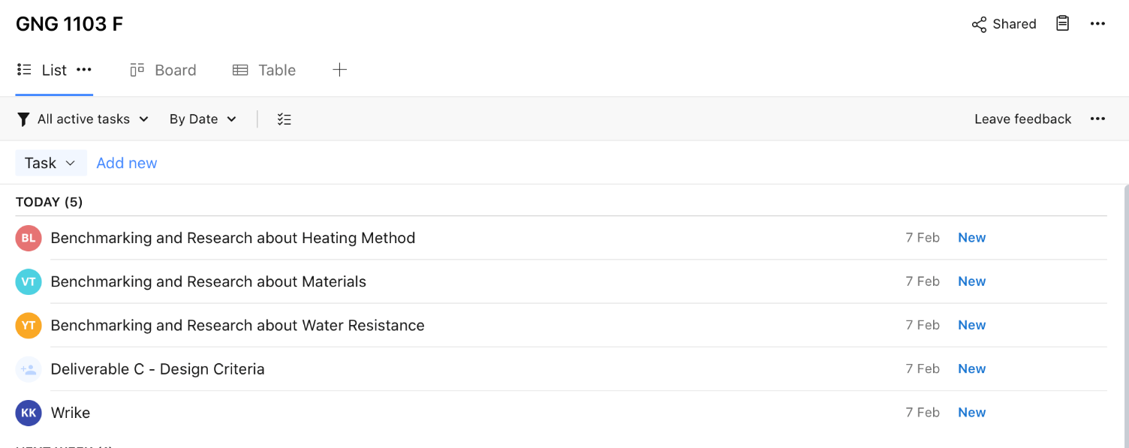
(See our page on Wrike for a more complete view of our project plan.)

Conclusion
Our identified needs from Project Deliverable B remain accurate now. Each of the five main needs (cost, shape/size, damage resistance, safety, and operating conditions) have been addressed in this document. The benchmarking sections have taken the data made available by the retailers of the existing products and have been categorized and compared to fit the existing needs we are to meet. The first client meeting was very important for contextualizing the project and allow us to narrow the scope of our design. From this meeting, we were able to identify the possible solutions that the university has the infrastructure to support. A very good example of this is with the power supply section.
The major subjects that require more research are components that existing products are lacking, or do not outright disclose. Many of the modular sidewalk products viewed do not disclose the materials used to walk on top of or have in contact with the ground. Most give vague descriptions but are unspecific as they use proprietary materials that they have developed. In order to gather more information on this, our team must conduct our own tests to discover what the optimal material for traction and practicality are. The same can be said for the hot water heat supply that is used in other products, but not modular heated sidewalk mats.
In this document, we have taken our needs that were outlined in Deliverable B and used them to categorize data available from existing products in order to benchmark the possibilities for our product. This came in the form of both a direct comparison of existing products, contrasting different possible components, and viewing minimum requirements that are standard for the industry. In gathering this data, we are now better prepared to continue to develop our product.

