GNG1103 Deliverable G
  - Prototype II and Customer Feedback
  - Team 1.2
Yasen Akir, Leo Dionne, Jiacheng Zhou, Yahia Fawzy
March 13, 2022

Table of Contents
1 Introduction 3
2 Third Client Meeting Feedback Outline 3
3 Prototype II Documentation 4
3.1 Analysis of Critical components: 4
3.1.1 The Collisions Code 4
3.1.2 Visualizing the Empathetic Device 4
4 Prototype III Outline 4
4.1 Objective 4
4.2 Stopping Criteria 5
4.3 Fidelity 5
5 Conclusion 5
6 Wrike Snapshot 5
7 Appendix 6
7.1 Appendix I: The Collisions Code 6

Figure 1: A Screenshot of the Collisions Code 6

Introduction
At the start of this project, we used the initial client meeting to determine their needs, interpreted them in technical terms and ranked these interpreted needs in importance from 1 to 5. We then used the most important requirements to form our problem statement for this project. This allowed us to come up with design criteria that includes functional and non-functional requirements, as well as constraints. These design criteria helped us identify target specifications for our requirements and we assigned metrics and methods to measure their effectiveness. After identifying our target specifications and our important requirements, we were then able to benchmark our ideas to existing products in the market that relate to our future product and compare our design criteria. We used our design criteria to determine the three subsystems that can allow us to tie together all our concepts into a final conceptual design: the Virtual Environment, the Interaction component, and the Storyline component that will allow us to promote empathy. Moreover, we developed a detailed design, a Bill off Materials, a list of equipment, and we identified project risks and how to counteract them. In the first prototype, we used the feedback we received following the second client meeting to improve the empathy aspect of our project by developing a storyline and looking for constant feedback. This allowed us to build our environment around a more empathetic component that conveys emotion and the struggles of people with physical disabilities. In the second prototype will focus on developing our storyline component further, coming up with a visualization of scenes, as well as coming up with code for collisions with objects in the virtual environment. We will also be outlining our test plan for prototype III.

Third Client Meeting Feedback Outline
- Virtual environment is at a good point
  - Identify where the barriers are in the environment
    - Where we want to integrate the storyline
- Storyline is taking shape
  - Add more detail to make it make more sense
  - Identify our main part/scene and changing scenes
- Make sure we can visualize the ideas we have for the storyline
- Explore ways to integrate the storyline into the virtual environment
  - How do we maximize promoting empathy while doing this?

Prototype II Documentation

Analysis of Critical components:

The Collisions Code
This code uses built in Unity box and capsule colliders to allow the user to physically hit objects. This code, used in tandem with these colliders, allows the user to hit object. It can be found in the first appendix. This code is critical because it allows the environment to contain and use the empathetic device.

Visualizing the Empathetic Device
The following are the messages that people with physical disabilities may perceive when trying to navigate life as a student on campus:
- "There are no ramps to assist people in wheelchairs around the building, therefore you cannot access this building."
- "You must take a detour to the opposite side of the building because there are no ramps at the main entrance, you will be 10 minutes late to your class."
- (After going to the other side to the building) "You may now enter the building."
- "The door is too heavy and does not have an automatic door button, ask for help from a passerby."
(Gets rejected a couple of times to create embarrassment)
- "I've been attending school on campus for the past 7 months and they still have not installed any ramps or automatic doors in this building. Hopefully they can improve soon."
The theme here is repetition and lack of improvement which can be frustrating and cause unnecessary embarrassment in such situations. The user in this experience will be prompted to feel the same way when navigating the virtual environment. This will evoke a feeling of empathy towards people who experience this in their daily lives.

Prototype III Outline

Objective
Our objective for this prototype is to finally bring all the pieces we have been working on together into one singular experience. We want to finish the story with its details and start integrating it into the environment. We want to implement the codes we have been working on for the collisions, respawn points, and implementing elements of the story in the environment. We want to be able to see all the different aspects of our project work together.

Stopping Criteria
Our stopping criteria for this prototype is to have an experience that has all the elements we have been working on work in unison together to deliver the experience of a visibly disabled person. We want the prototype to make the user feel empathy for our character. We will have people test run this prototype and get their feedback on how they feel about the experience overall, and more importantly if they feel empathetic for the character and their situation.

Fidelity
We will use the feedback received from the test runs to improve elements of the story and environment based on the comments of our test runners. We will also probably be making our own improvements as we see fit on things where we think we can do better. In all probability, 70%-80% of this prototype will probably be present in our final installment.

Conclusion
In conclusion, this week we were able to outline the feedback we got from the third client meeting, our two minute pitch. With this feedback, we were able to reassess our progress and better organize our next steps. We realized that instead of separating the empathetic device and the graphic aspect of unity, it was best to put them together and keep the virtual space and code as its basic blocks. Through this, our aim for the final product is for it to show the users the day to day of a physically limited person. With this in mind, we made an outline for our next prototype.

Wrike Snapshot
https://www.wrike.com/frontend/ganttchart/index.html?snapshotId=pP1Q4y353y8FJH5QjxWBZdBII1VNI1Q5%7CIE2DSNZVHA2DELSTGIYA

Appendix

Appendix I: The Collisions Code
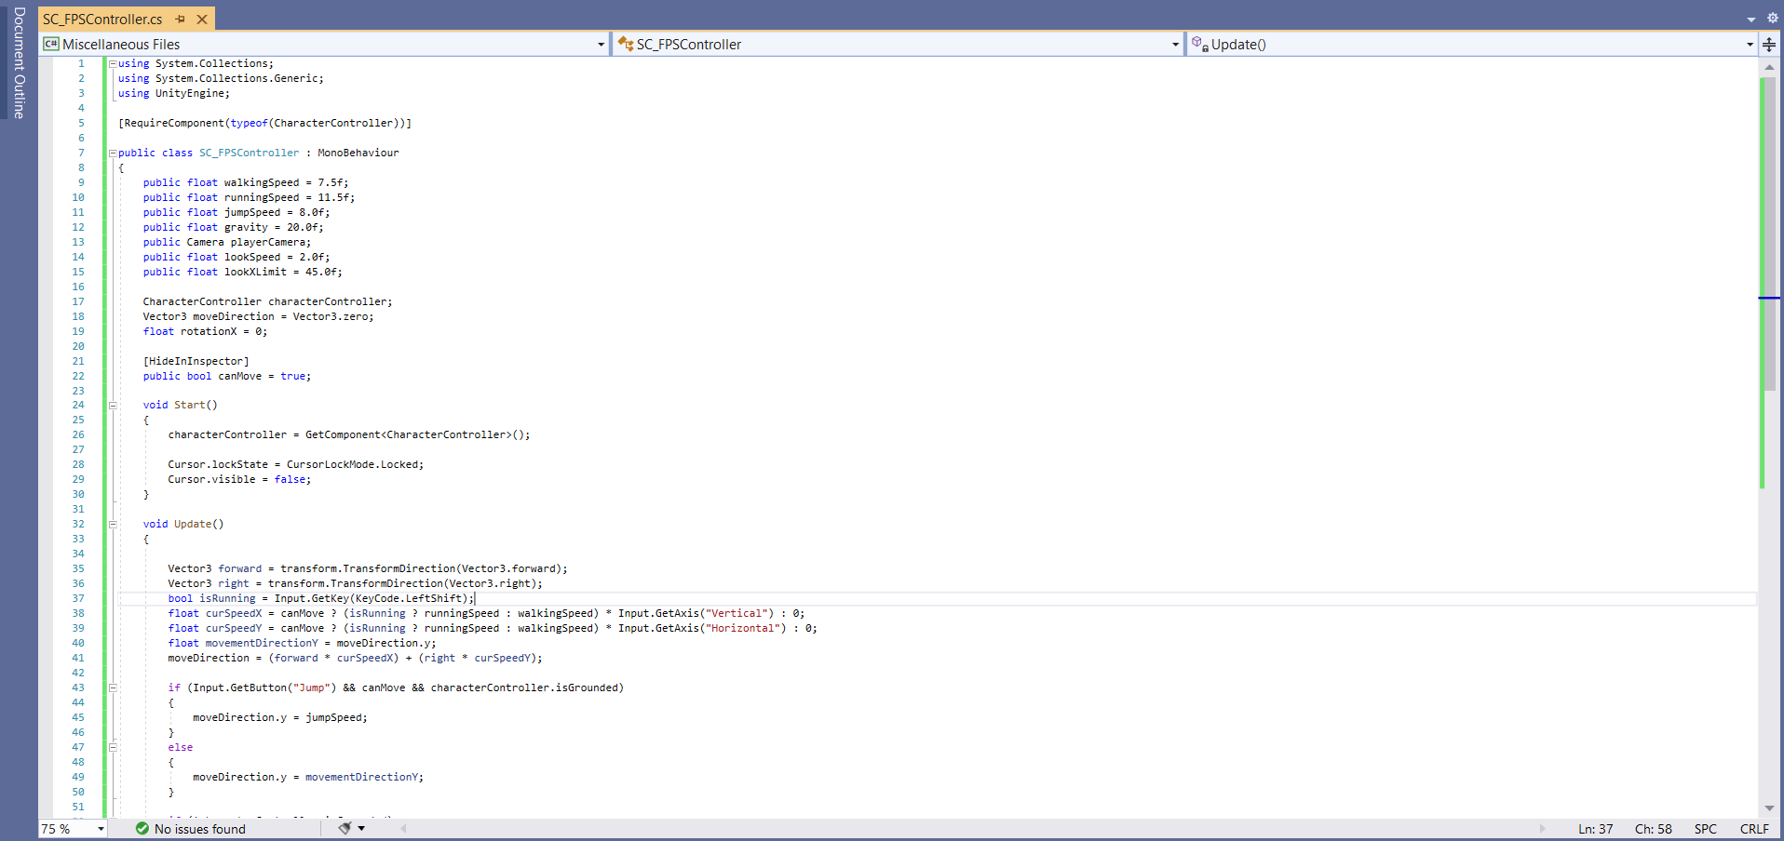
Figure 1: A Screenshot of the Collisions Code

