Deliverable F- Prototype I and Customer Feedback

Prepared for

Elsa Lange
Project Manager

Pankaj K. Rathi
Teacher Assistant

By

Akem Shergill- 300246583
Wacira Muiruri- 0300245399
Shahrayar Nur- 0300233739
Mathew Emmanuel- 300240312
Ayham Alshaikhali- 300244961

Sunday, February 27th, 2022

Abstract
Below is a technical document that outlines prototype 1 of our robot and our project plan for prototype 2. There will be a simple analysis of our prototype included and changes made with the feedback given by the customer and aims to answer all questions and concerns the customer may have with the prototype.

Introduction
In this deliverable, we have shown our proof of concept for prototype I of the inverse kinematics robot and received feedback. Given this feedback, we plan to begin the project plan for prototype II and consider the feedback we received. We must also provide a simple analysis.

Simple Analysis
  - First, we will take a look at the base of the robot since that was the first proof of concept we developed. It started with an LCD screen for ease of use. Still, upon showing the customer and receiving feedback, we decided to scrap the idea and use a button system instead since it may be easier for the user during operation. We plan to use steel for the base part that the arm would connect to minimize the number of repairs needed over extensive use.
  - Next, While looking at the actual arm of the robot, we had many ideas about the shape, size, materials and even the joints. Due to some changes in the overall project for the inverse kinematics robotic arm, the detailed designs for the arm are already given and the parts that need to be 3D printed will be printed. This robotic arm also comes with its own writing and Arduino coding, making it perfectly functional by itself, although we will be making some necessary changes to the wiring and software to suit our client’s needs.
  - Finally, the end effector unlike the previous two will not have any major changes to its design from before. The end effector will be having three large claws allowing it to easily grab and firmly hold any object. The triangular shape end effector creates more space to hold the gears needed to make the small hinge joints for the ends of the end effector to hold objects(like figures).

Prototype test plan
  - For our first test, we tested the light and button system for the Arduino. This first step is to check and make sure that the Arduino is working as well as the light system that will be crucial for the user to easily interact with the robotic arm.
  - The second test that we conducted was the testing of all the coding via the computer, to make sure that the software is smooth and is up to standard so that the hardware is able to smoothly perform.
  - The third test is to properly fit all the subsystems together, including the delicate internal hardware like wires, gears, bearing, etc. This fitting allows us to confirm that all the pieces fit and any piece that needs to be reprinted and readjusted.
  - The fourth test conducted was to test the end effector during our lab session. Once connected to the arm provided we will test to ensure that the end effector works up to standard.
  - The fifth test conducted was to ensure that the camera we chose would work effectively in terms of photographing and scanning the area we choose. If the camera is able to scan a work environment and project it correctly to the robot then we can move forward, otherwise, we will look for other alternatives.

  - The sixth test that was conducted was testing the actual inverse kinematics of the robotic arm. One of the important details that the client specified was that the robotic arm needed to use inverse kinematics. This test is to make sure that the whole arm is able to smoothly move each joint individually and together.
  - The final test conducted is to make sure every component of our robot works well together. In this test, we performed exactly how we would present to the client on our third client meet. We tested by the simple movement of the arm to test the base and user interaction area and the end effector’s handling ability. This test is assuming that the robotic arm is the final product.

Feedback
  - From our first client meeting, we were able to ask a variety of questions to our client and vice versa, and the information that we retrieved allowed us to make various changes that are more in line with our user. Firstly, we removed the touch screen idea due to the fact the robotic arm will have to work in small, oxygen-poor areas and people might not be very near to the arm but still will need to operate it to a certain extent. So, our solution was to scrap the touch screen idea and went with a more simple approach which involved a button and light system. The system would allow the user to preset the robotic arm before hoisting it into any unreachable spaces. We are also going to add more safety features to the robotic arm within the source code as well as the mechanism itself. The end effector has gone through some tweaking due to our project manager’s feedback about the hand-like end effector. The new end-effector will be much like how a drill holds a drill bit, making the end effector as a whole more slim, smaller, and less pieces to be 3-D printed.

Updated target specification
- After our meeting with our PM Elsa Lange, our next target that we will be focusing on during the phases for Prototype II will be safety. We will be looking at safety while testing the following prototype, functions such as emergency stop, human interference, and testing of the sensors. Before doing this however, we will be making sure to test our code first, ensuring that the code functions in conjunction with the robot arm as a whole.

Updated detailed design

End Effector
    - Due to the client’s dislike of the hand-like end effector, we decided to remake the end effector into a drill-like structure, where the different drill bits can easily be put into the drill. This allows for the end effector to be smaller and more compact allowing for more movability in any environment. This also reduces the amount of 3-D pieces that need to be printed, thus reducing printing time and plastic.
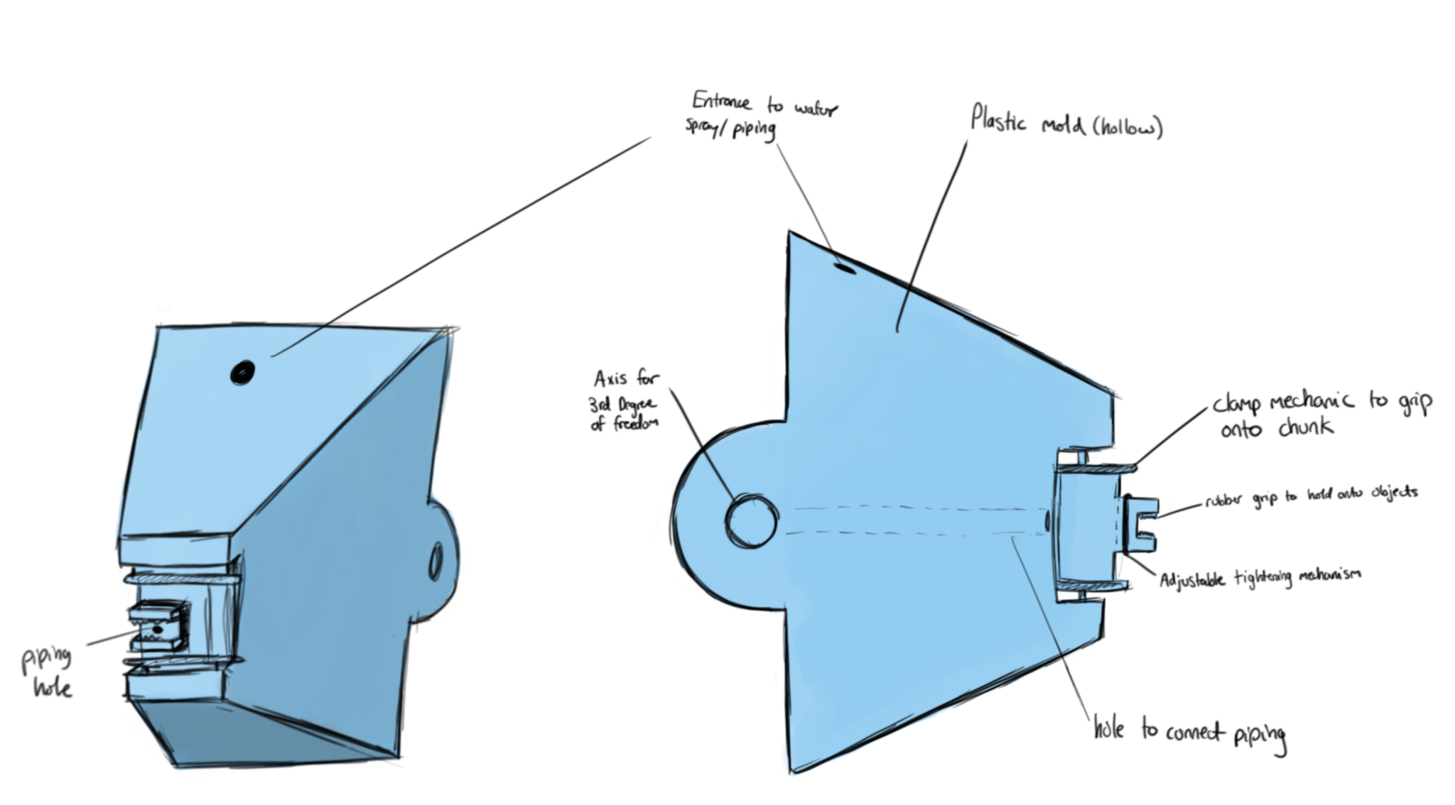
(Figure 1: The updated end effector)

Base
    - The client was not very interested with the idea of having the touch screen on the base due to rendering the robotic arm useless in small or oxygen poor places where people cannot enter. Thus, we made a more simple button and light system that can be pre-programmed before being housed into an area.
(Figure 2: The updated base)

Updated BOM
(Figure 3: The updated bill of materials for our project, all website links will be provided)

Project lab for Prototype 2

Risks and Solutions

Human Error on calculations for Inverse Kinematics | We can run this through a matrix solver, as well as get our work checked by our TA or any upper years who have experience in the field of calculations
Errors during preliminary Coding | Debugging the code as well as making sure it functions on its own. There will be use of open source codes found through websites such as GitHub to mitigate any future errors
Printing out improper measurements | Each piece will go through solo and group screening to make sure that the measurements are correct. The solo screening will make sure that there are no defects with the 3-D pieces. The group screening will test if the groups are able to smoothly connect with each other.

Project Test Plan

Test ID | Test Objective  (Why) | Description of Prototype used and of Basic Test Method (What) | Description of  Results to be  Recorded and  how these results will be used (How) | Estimated Test duration and planned start date (When)
1 | Testing the light and button system for the Arduino. | The first prototype’s base will be used and the best method will be to simplify turning on the robot and testing the button system to see if the arduino reacts properly. | The result should be that the proper light is activated when the right button is pressed. | Test duration should be about 10-15 mins.  Planned start date is March 8th.
2 | Testing the code to see if it works. | This test includes the coding and will only be testing the software of the robotic arm. | If the code works well we are good to move on to the next test, but if not we would have to go back and refine it. | Test duration should not be very long as we are just looking to see if there are any errors in code.  The planned start date is March 8th.
3 | Test to see if all subsystems fit/work together. | Attach the end effector, robotic arm and base together to see if they all fit. | If all parts fit well together we are good to go, but if they do not, we would need to make refinements to the design of how they attach together. | Test duration would be about 20-30 minutes to fit all parts together.  Planned start date is March 10th.
4 | Testing the end effector. | The end effector of prototype one will be used to test as well as the accessories and other objects to see if the end effector can. | The desired result for this test would be that the end effector would be able to pick up a variety of objects including the accessories. A firm and steady grip will also be desired and tested in this specific test. | The test duration would be around 10-15 minutes.  Planned start date is March 10th.
5 | Testing the camera and scanner to see if it works. | The camera and sensors would be tested to ensure that they can be used. | The desired result would be that the camera and scanner works with the robot, but if it does not, we would need to search for where the issue is and what is causing it so that we can fix it. | This test should last about 30 minutes as there is a good chance that it may not work on our first try.  Planned start date is March 10th.
6 | Testing the inverse kinematics of the robotic arm. | The robotic arm will be put through a series of tests to ensure that the inverse kinematics that were programmed are working and are very steady as well as precise movement. | The robotic arm will be able to pass this test if the programmed inverse kinematics are able to run smoothly with the hardware such as the gears, bearings, etc. and if the arm itself is steady enough to be able to paint intricate designs in the future. | This test should take about 30-40 minutes to test.  The Scheduled test date is March 10th.
7 | Testing to see if all parts of the robot work together. | Adding each subsystem,part, component and attachment together. | We would put all parts of the robot together and see if the robot is able to work correctly. | This test may take upwards of 30 minutes as it may not work on our first try.  Planned test date to be March 10th.

Appendix
End effector: https://cad.onshape.com/documents/64b559d181167fb6bbf9523f/w/db85bd6c72569264de684ec5/e/f9f238a80aa6c593ef60053b?renderMode=0&uiState=62256dfd9a48cf69e4efa301

BOM Updated Link:
https://docs.google.com/spreadsheets/d/1wq36ni8hpT2WktvP7z3EDxPM8IhdatdBUw7ytzWgmE8/edit?usp=sharing

Website URLs for items in bill of materials:
-https://www.amazon.ca/ERYONE-Filament-1-75mm-Printing-Printer/dp/B07ZPT32M8/ref=sr_1_5?crid=2OJ1J0H7Y51GI&keywords=filament+PLA&qid=1644870433&sprefix=filament+pla%2Caps%2C113&sr=8-5
-https://www.onshape.com/en/
-https://store-usa.arduino.cc/products/arduino-starter-kit-multi-language?selectedStore=us
-https://www.amazon.ca/Universal-Adapter-Converter-Inverter-Transformer/dp/B08HK9ZPVL/ref=sr_1_5?crid=D5QN25TVSCU8&keywords=9v+ac+adapter&qid=1644960501&s=electronics&sprefix=9v%2Celectronics%2C76&sr=1-5
-https://www.amazon.ca/Proper-Pour-Approved-Multi-Purpose-Aquaponics/dp/B017EA5ST6/ref=sr_1_6?crid=1VXUQXAWKZKK7&keywords=plastic%2Bpipe&qid=1645316925&sprefix=plastic%2Bpipe%2Caps%2C90&sr=8-6&th=1
-https://edu-makerlab.odoo.com/shop/product/flat-head-wood-screws-75?category=3#attr=383,389
-https://www.homedepot.ca/product/paulin-12-x-18-inch-26-gauge-steel-sheet-galvanized/1000861560
-https://edu-makerlab.odoo.com/shop/product/flat-washers-74?category=3#attr=122
-https://www.amazon.ca/Groove-Bearing-3x8x4mm-Miniature-Double/dp/B078SJKNBK/ref=asc_df_B078SJKNBK/?tag=googleshopc0c-20&linkCode=df0&hvadid=459442106099&hvpos=&hvnetw=g&hvrand=5159118538115907575&hvpone=&hvptwo=&hvqmt=&hvdev=c&hvdvcmdl=&hvlocint=&hvlocphy=9000784&hvtargid=pla-1186688773153&psc=1

