GNG2101 Project Deliverable F:
Prototype II

Submitted by:
[Team Z24]

Hans Rao Ladkoo
Yunsu Lee
Sylvain Quach
Evan Tomietto

June 18, 2022

University of Ottawa

Abstract

This deliverable will focus on our second prototype in our design process to the Seat Belt Guide problem presented by our client Clinton. A project progress was presented to our client and was used to gather feedback to change and improve our prototype. Based on this feedback, a second prototype was created looking to further fit the client’s needs for the Seat Belt Guide problem. Testing was also done on this prototype as well as comparing it to the target specifications developed in Project Deliverable B.

Table of Contents
Abstract…………………………………………………………………………………………………….. i
Table of Contents…………………………………………………………………………………………... ii
List of Tables……………………………………………………………………………………………… iii
List of Figures……………………………………………………………………………………………... iv
1: Introduction……………………………………………………………………………………………… 5
2.1 Client Feedback……………………………………………………………………………………. 5
2.2 Updated Concept…………………………………………………………………………………... 5
3: Prototype II……………………………………………………………………………………………… 7
3.1 Assumptions……………………………………………………………………………………….. 7
3.2 Development……………………………………………………………………………………….. 7
3.3 Testing……………………………………………………………………………………………. 10
4: Conclusion……………………………………………………………………………………………... 17
References.………………………………………………………………………………………………... 18
Wrike Updates…………………………………………………………………………………………….. 19

List of Tables
Table 1: Prototyping and Testing Plan……………………………………………...……..8

List of Figures

Figure 1:Conceptual design #4……..……………………………………………………..6
Figure 2: Second Benchmarked Product…………………………………………………..7
Figure 3: Seat Belt Buckle ………………………………………………………………..7
Figure 4-1: Seat belt Buckle Booster 3D Design-1.………………………………………9
Figure 4-2: Seat belt Buckle Booster 3D Design-2.………………………………………9
Figure 4-3: Seat belt Buckle Booster 3D Design-3.………………………………………9
Figure 5-1. Seat Belt Guide 3D Design-1………………………………………………..10
Figure 5-2. Seat Belt Guide 3D Design-2………………………………………………..10
Figure 5-3. Seat Belt Guide 3D Design-3………………………………………………..10
Figure 6-1. Installation of the Second Prototype-Guide 1...……………………………..11
Figure 6-2. Installation of the Second Prototype-Guide 2...……………………………..12
Figure 7-1. Installation of the Second Prototype-Booster 1...……………….…………..13
Figure 7-2. Installation of the Second Prototype-Booste1...……………………………..14
Figure 8-1. Second Prototype Testing 1…………………...……………………………..15
Figure 8-2. Second Prototype Testing 2…………………...……………………………..16
Figure 8-3. Second Prototype Testing 3…………………...……………………………..17

1: Introduction
To come up with a design for a seconds prototype, many factors were taken into consideration. All ideas would come from client feedback received during client meets. This includes a hole at the end of the handle with a strap attached at the end of the handle for an easier reach. With that information, an updated concept was created which focuses on reaching and grabbing the male part of the seat belt and moving it independently to the female counterpart. The creation of the second prototype should feature a 3D CAD version of the first prototype by developing it in 3D CAD software: Fusion360 and 3D printing it. Prototype 2 was in such a way to match the needs of the client as much as possible. Testing of the prototype is also included.

2: Third Client Meeting Overview

2.1 Client Feedback

During the third client meeting with Clinton, the team presented the Seat Belt Guide’s problem statement, existing products used for benchmarking, revised conceptual designs, second prototype and bill of material. During the previous meeting, the client wanted a solid handle for his daughter to reach, grab, and guide the male part of the seat belt to its female counterpart, and the team revised the conceptual design and generated the second prototype. He checked the 3D-printed prototype and said he liked a hole at the end of the handle; a strap will be attached at the end of the handle for an easier reach.

2.2 Updated Concept
The new design is developed based on the Conceptual Design #4 (Figure 1), the Second Benchmarked Product (Figure 2), and the seat belt buckle booster (Figure 3). From the first prototype testing, the team realized that a seat belt buckle should always stay upright for an easier reach and clasp. The buckle booster was an excellent choice for the client’s needs and we revised the design. For further development of the second prototype, the client previously outlined that the product should focus on reaching and grabbing the male part of the seat belt and moving it independently to the female counterpart. He also mentioned how the concept should be changed to have a rigid handle and to potentially have a quick release feature; both of these characteristics would allow his daughter to firmly hold the handle at different angles to pivot/reposition the male part of the seat belt if needed.

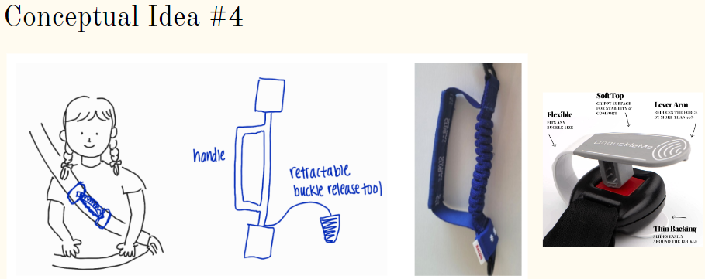
Figure 1. Concept #4

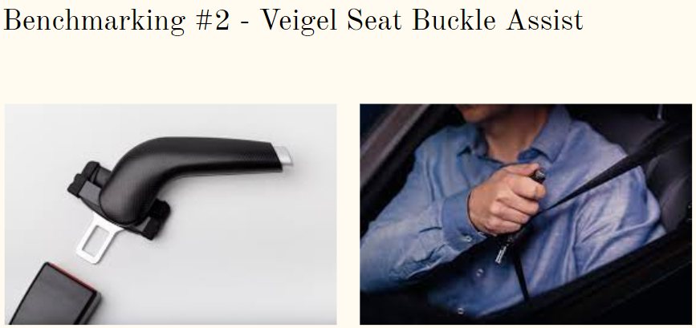
Figure 2. Second Benchmarked Product (Veigel, 2020)

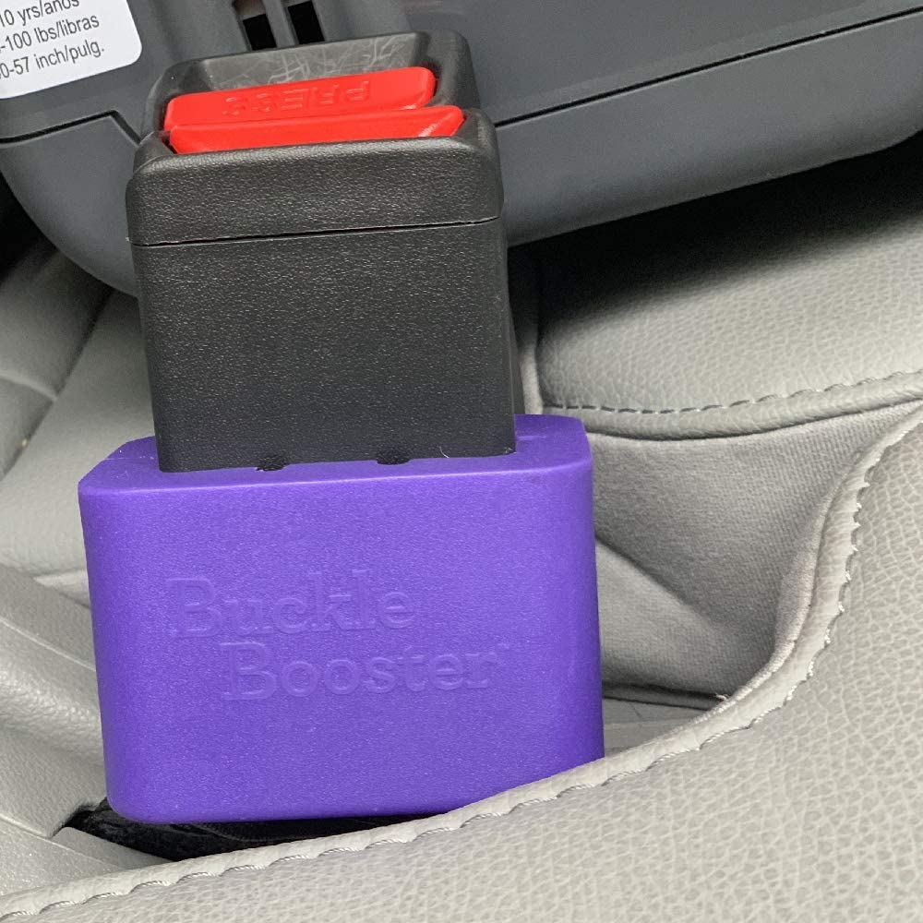
Figure 3. Seat Belt Buckle Booster (HR Auto Parts, 2019)

3: Prototype II

3.1 Assumptions

After having a second client meeting and gathering feedback from proposed ideas, assumptions were made to improve upon the existing idea selected by the client followed by a first prototype development. The second prototype should feature a 3D CAD version of the first prototype by developing it in 3D CAD software: Fusion360 and 3D printing it. Special attention should be devoted to designing a strong and thick handle and ensure that it relates to the client’s needs in terms of a strong grip. The team placed special emphasis on developing design criteria for the handle, that it how it should look like, how sturdy it should be, it’s size and dimensions to be implemented on Fusion360 and whether it is in continuous alignment with the client’s needs and adheres to received feedback from previous client meetings, during team meetings.

3.2 Development

Prototype 2 was once again developed in such a way to match the needs of the client as much as possible, with an emphasis on the grip aspect where the focus was on the rigid handle leading the male part to the female part. Securing the female part was less of the priority. Prototype 2 is basically a replica of prototype 1 but with special attention placed on the rigid handle and was developed in CAD software: Fusion360. The purpose of this prototype was to develop a 3D cad version of prototype 1, ensure that it is aligned with the client’s needs based on feedback obtained from Client meeting 2 and also develop testing parameters to assess whether the prototype is functioning as expected in reality. Future prototypes will consist of a continuous refinement of prototype 2 based on generated client feedback, especially the inclusion of a quick release function option to allow quick prompt removal from the latch plate, which was one of the main feedback received from the client in Client Meeting 3.

Table 1. Prototyping and Testing Plan
 | Objective | Type | Fidelity Level | Fidelity Factor | How to Build | When to Build | How to Test | When to Test
Prototype 1 | Demonstrate the overall product concept and set dimensions | Physical | Low | Visual | Cardboard  Tape  Stapler Disposable mask  highlighter | May 27 | Qualitative, quantitative and Visual | May 28
Prototype II | Improvement of the first prototype, 3D printing | Physical | Medium | Visual, Functional | 3D printer | June 18 | Qualitative, quantitative and Visual | June 18

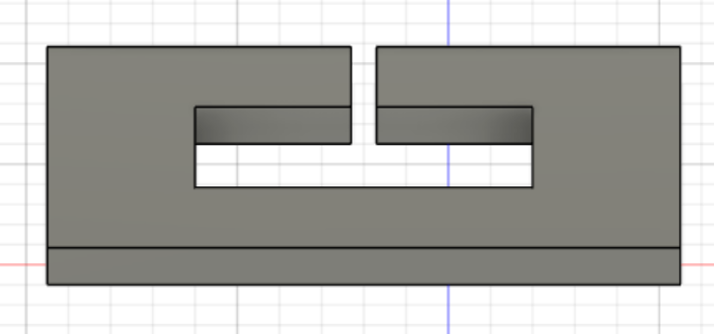
Figure 4-1: Seat belt Buckle Booster 3D Design 1

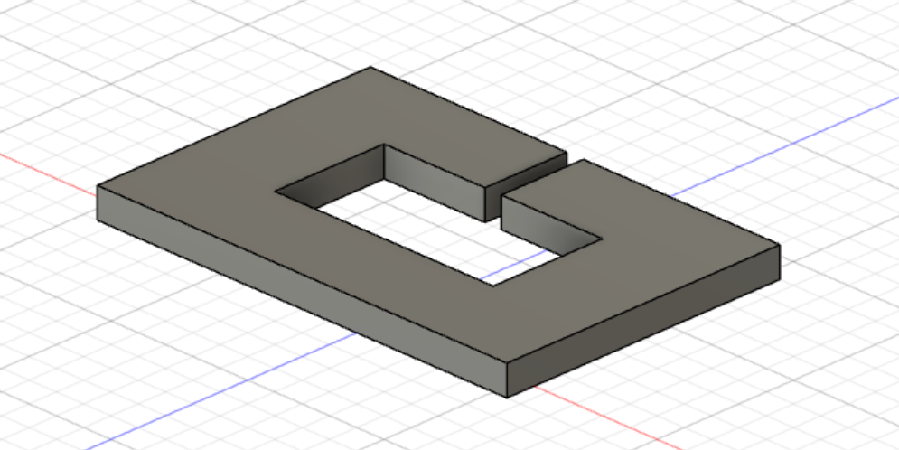

Figure 4-2. Seat belt Buckle Booster 3D Design 2

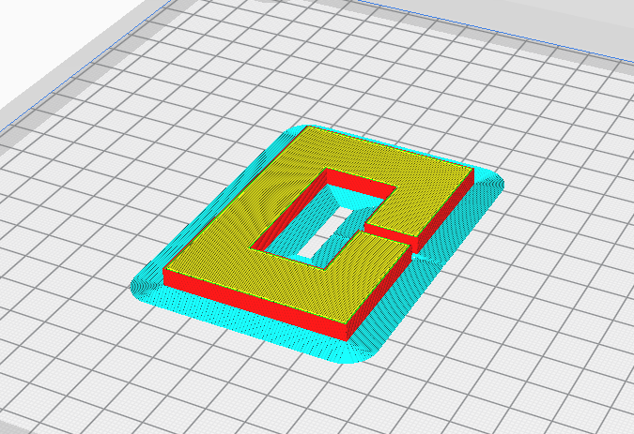
Figure 4-3. Seat belt Buckle Booster 3D Design 3

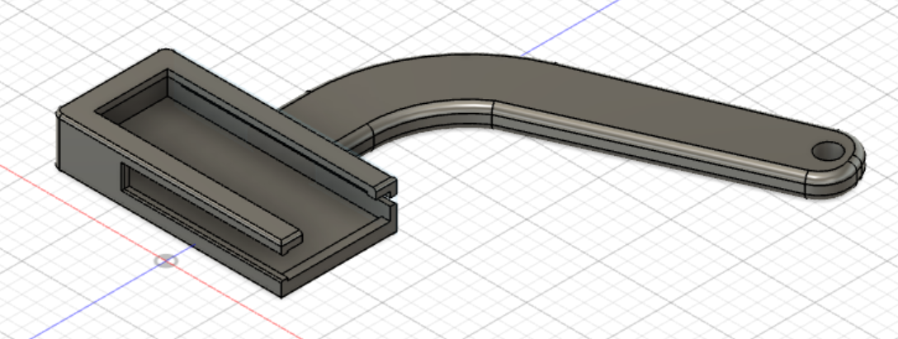
Figure 5-1. Seat Belt Guide 3D Design-1

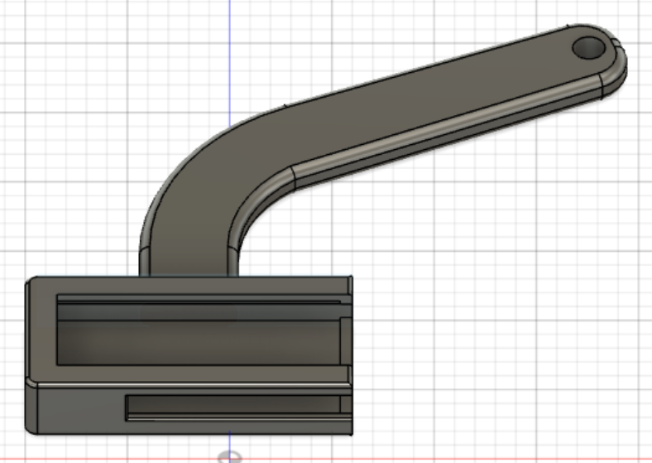
Figure 5-2. Seat Belt Guide 3D Design-2

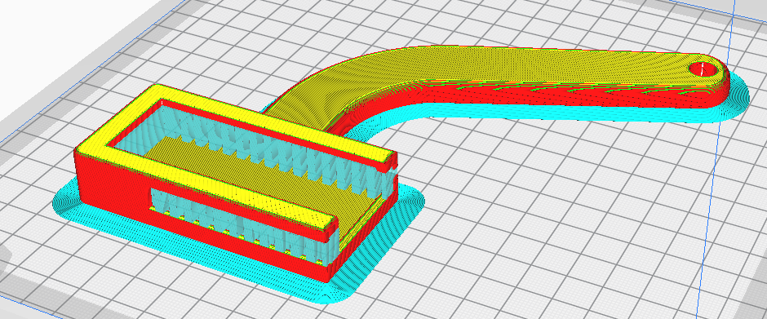
Figure 5-3. Seat Belt Guide 3D Design-

3.3 Testing

After prototype 2 was subjected to established testing parameters, observations were made on the prototype’s performance and the following could be concluded: The handle was a bit too thin and weak, hence does not conform to the strong and sturdy grip requirement from the client. The handle was also too small for the latch plate meaning that the handle would need to be redimensioned. The buckle booster was perfect but the slit was too small so it was hard to get the webbing through. Hence the dimensions of the slit would also need to be reestablished.

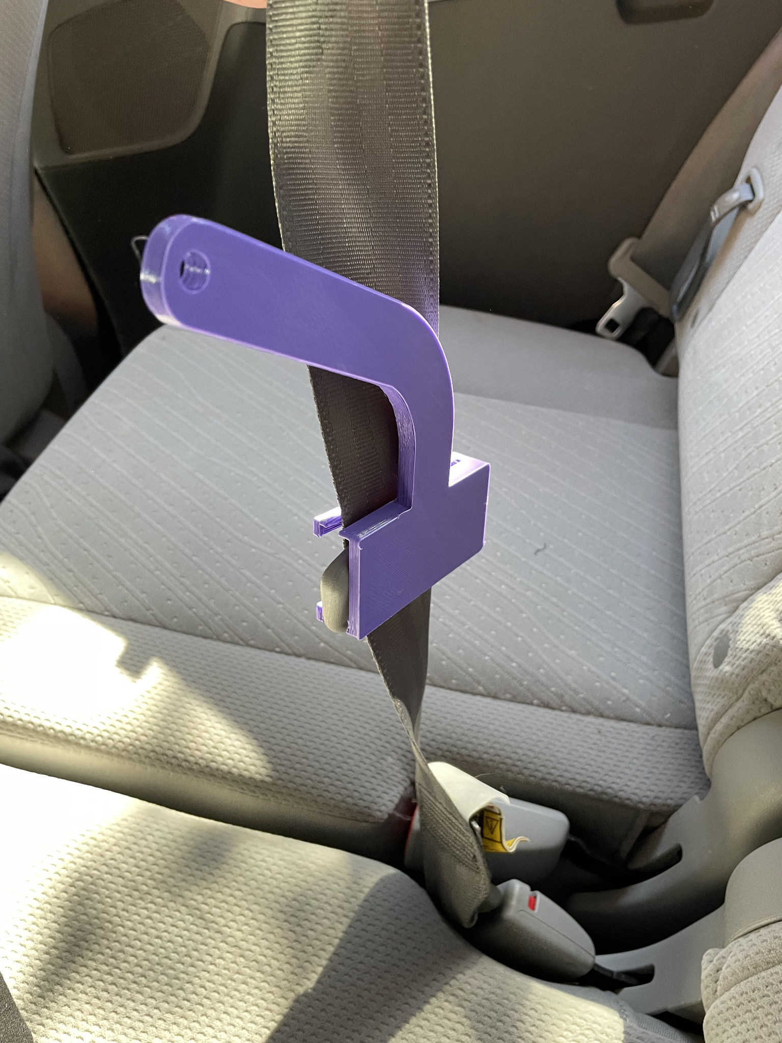

Figure 6-1. Installation of the Second Prototype-Guide 1
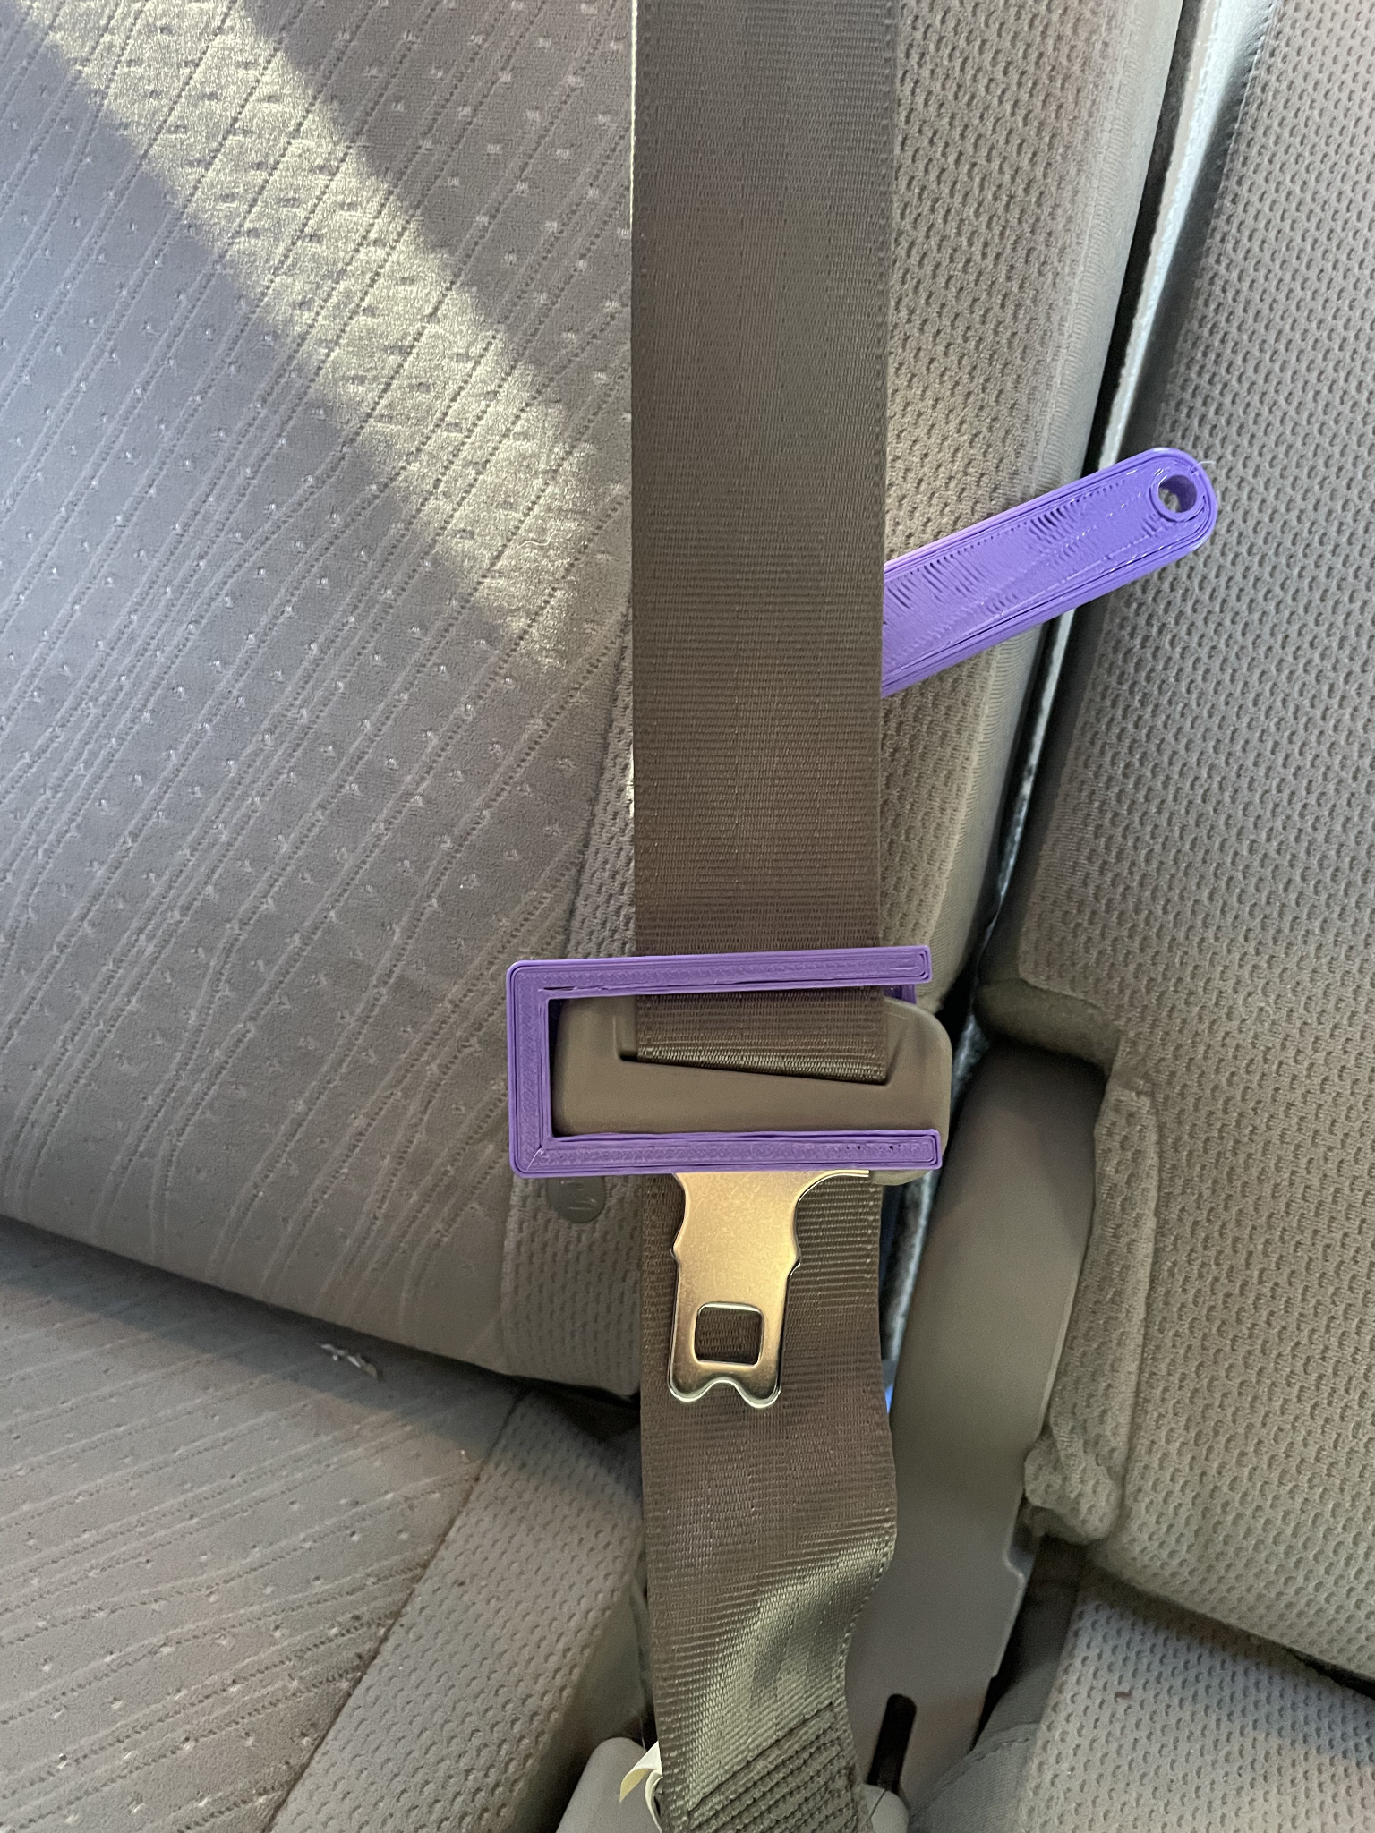
Figure 6-2. Installation of the Second Prototype-Guide 2

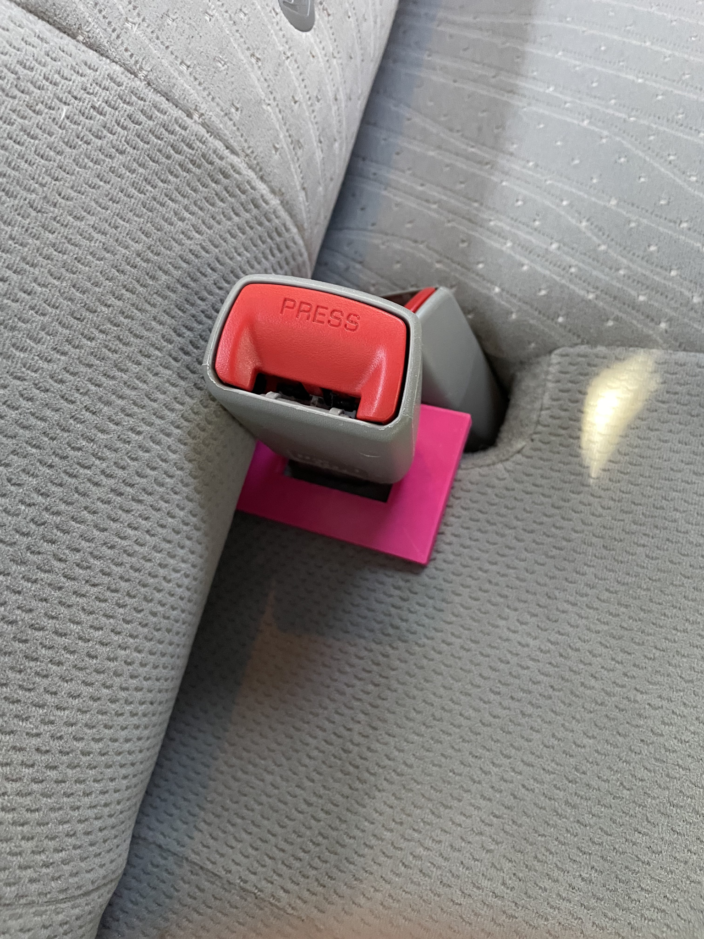
Figure 7-1. Installation of the Second Prototype-Booster 1
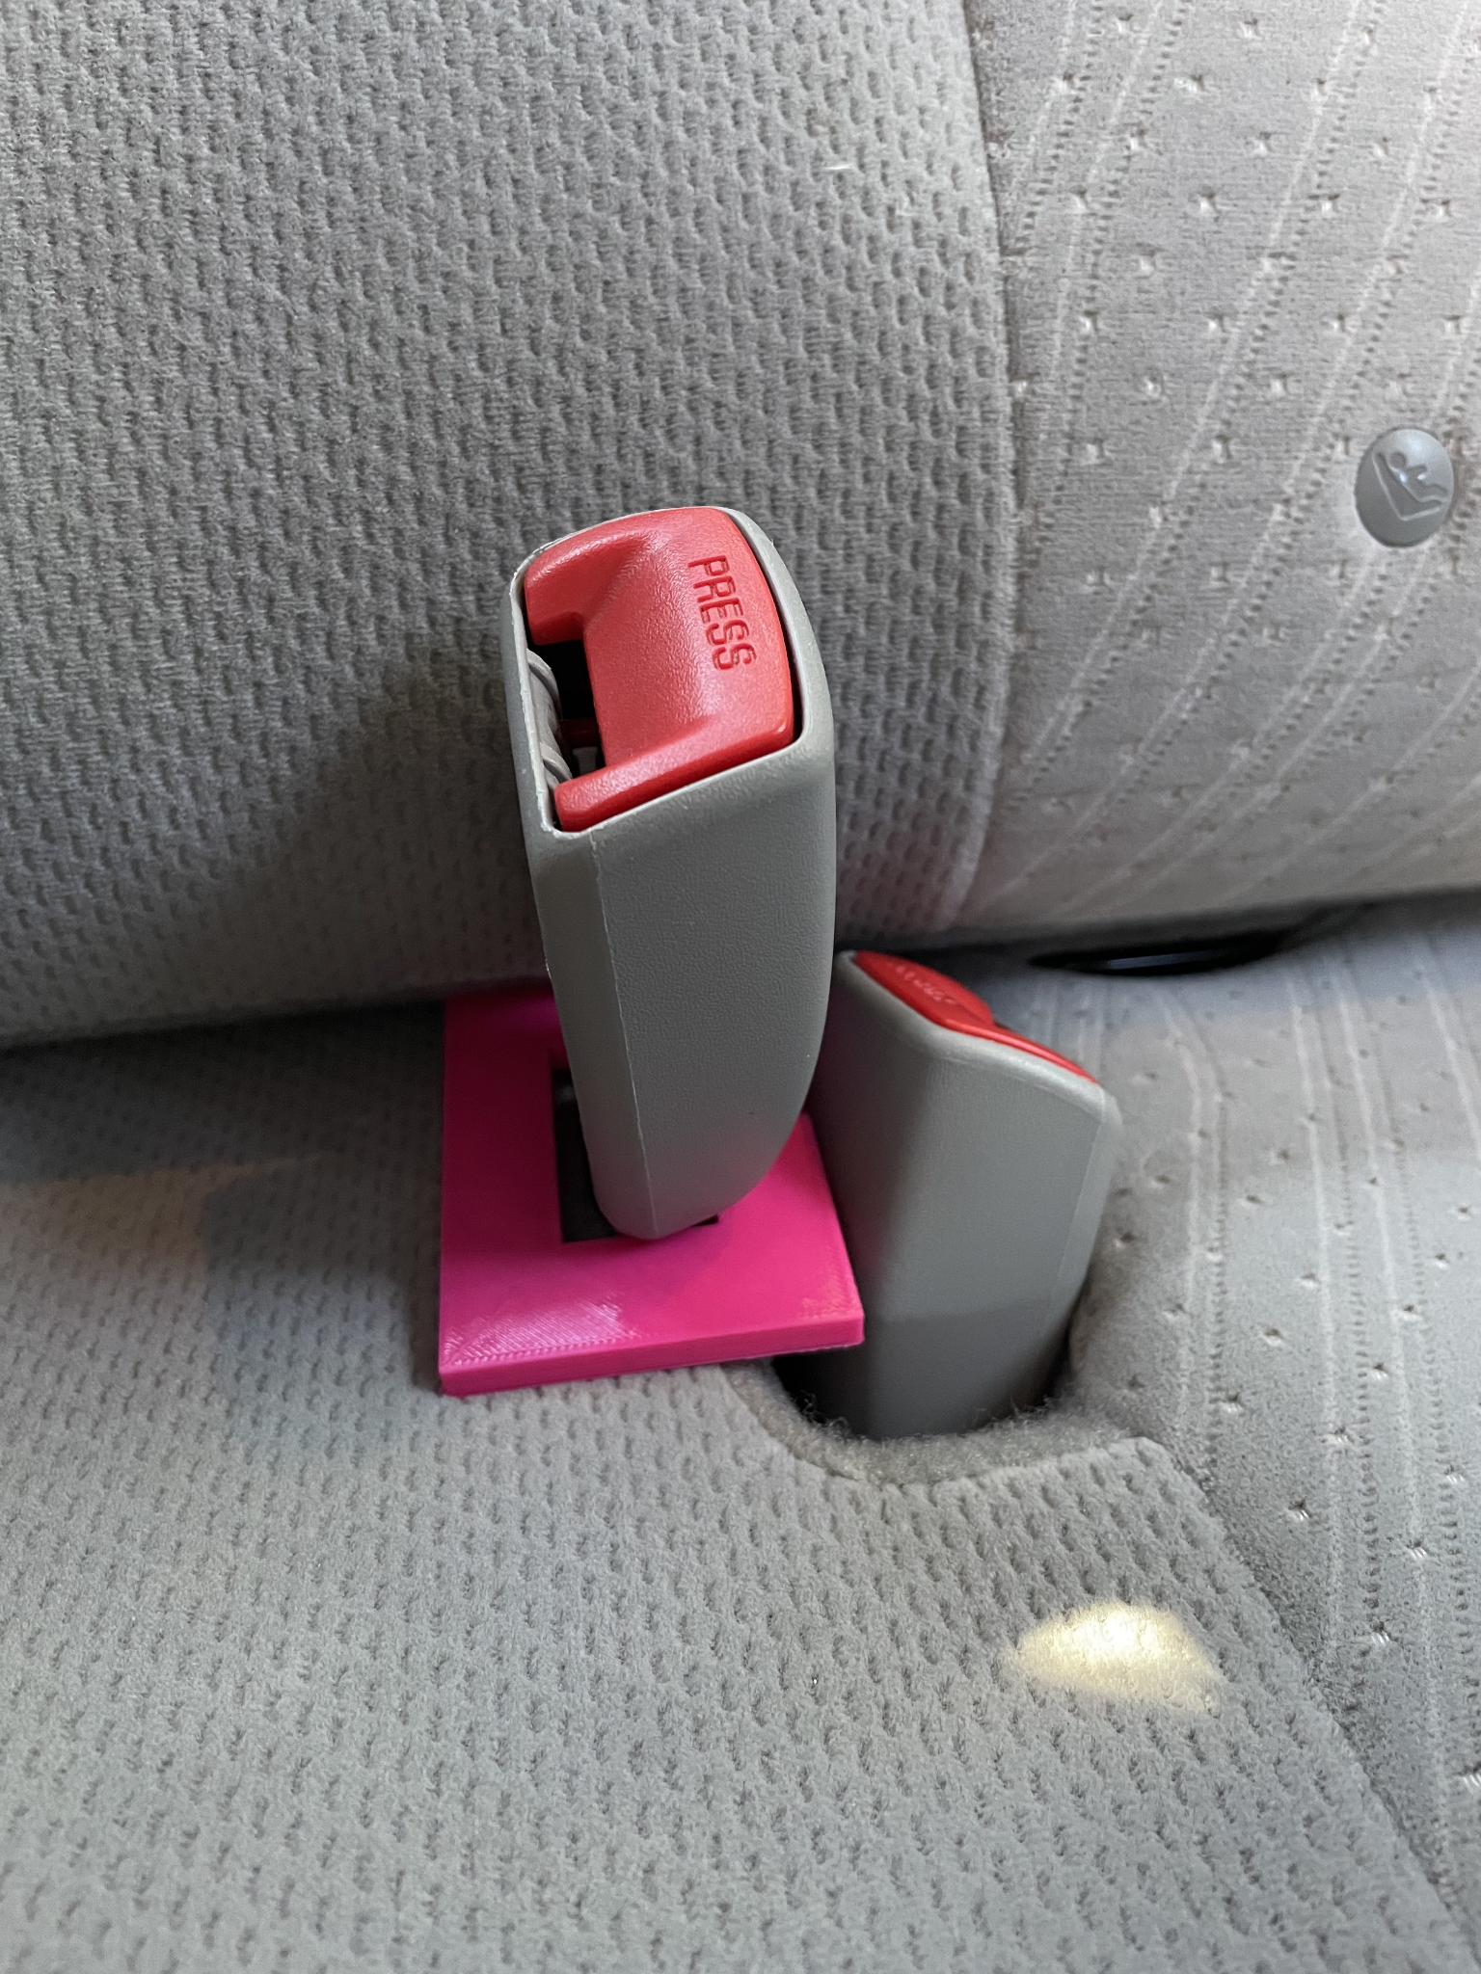
Figure 7-2. Installation of the Second Prototype-Booster 2

Figure 8-1. Second Prototype Testing-1

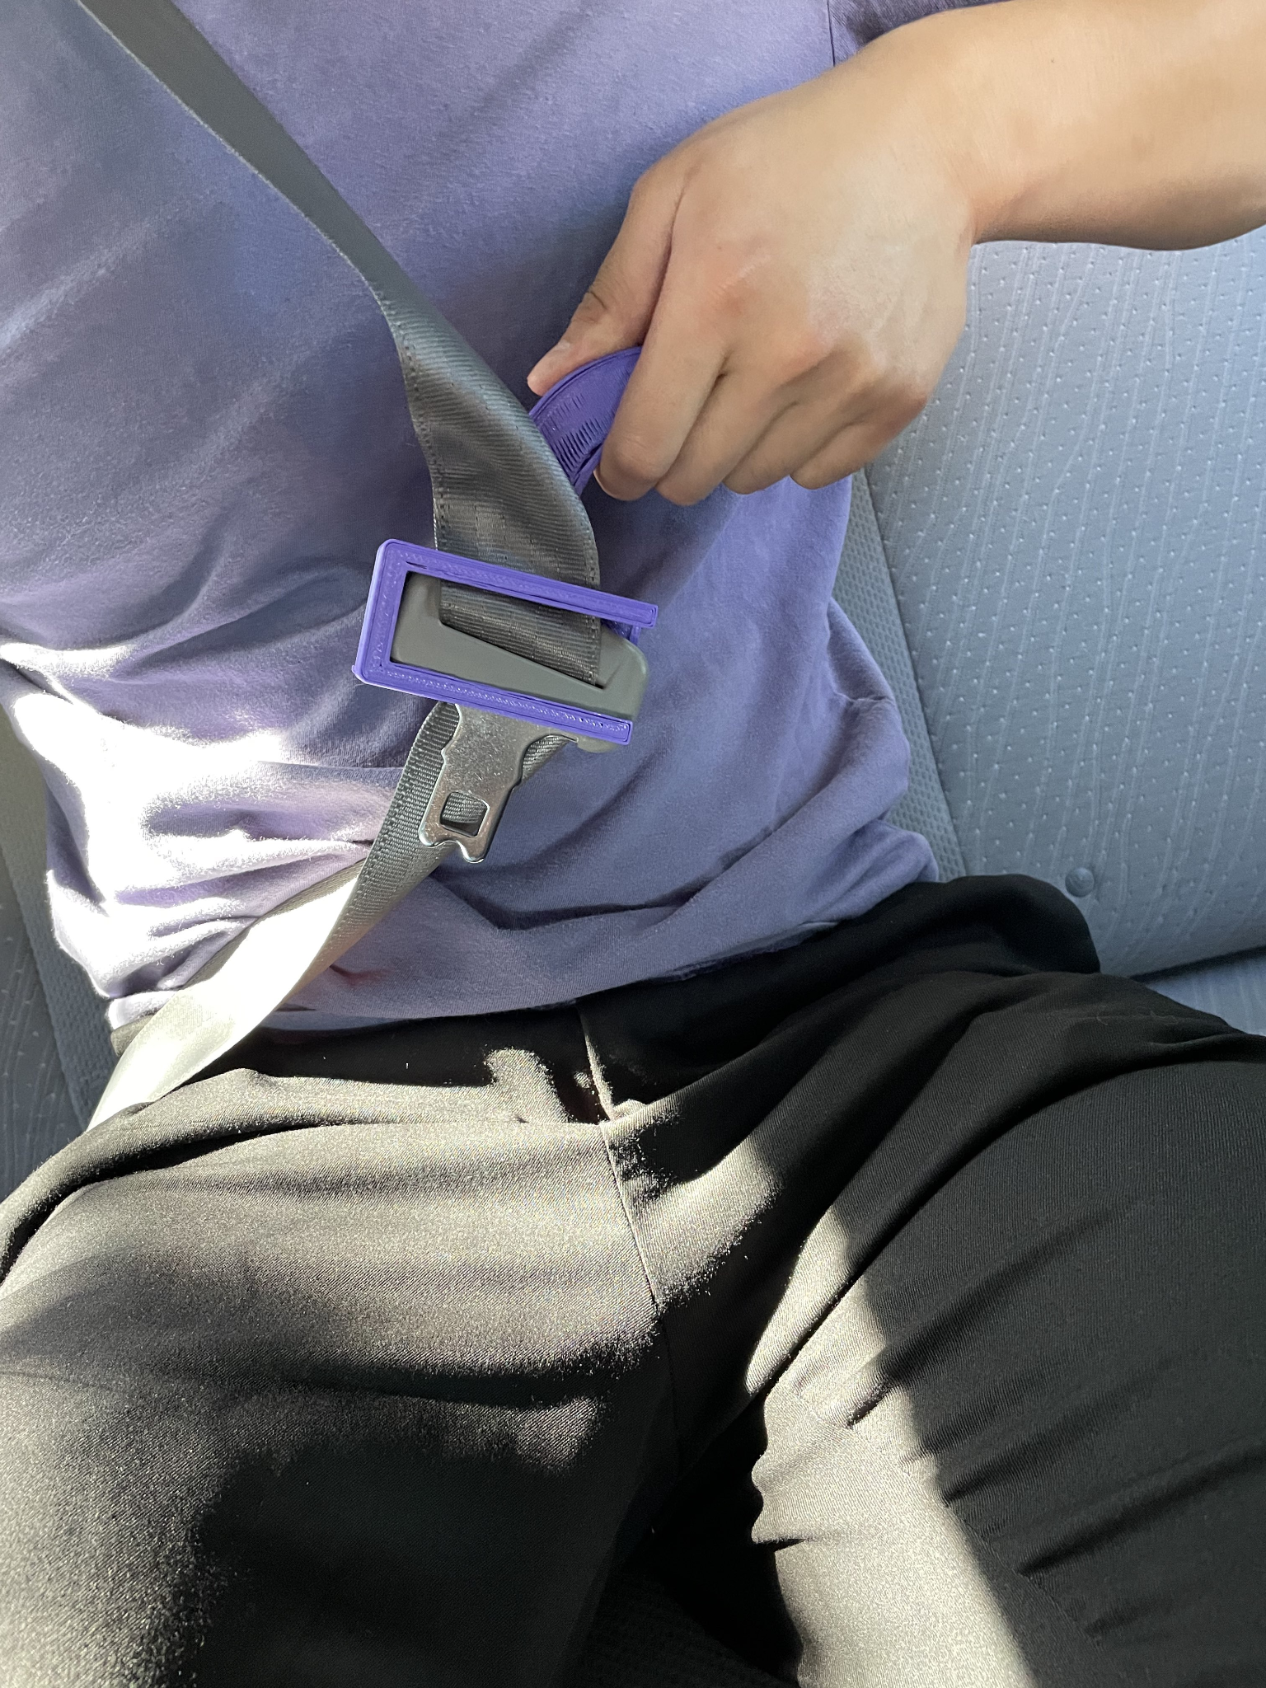
Figure 8-2. Second Prototype Testing-2

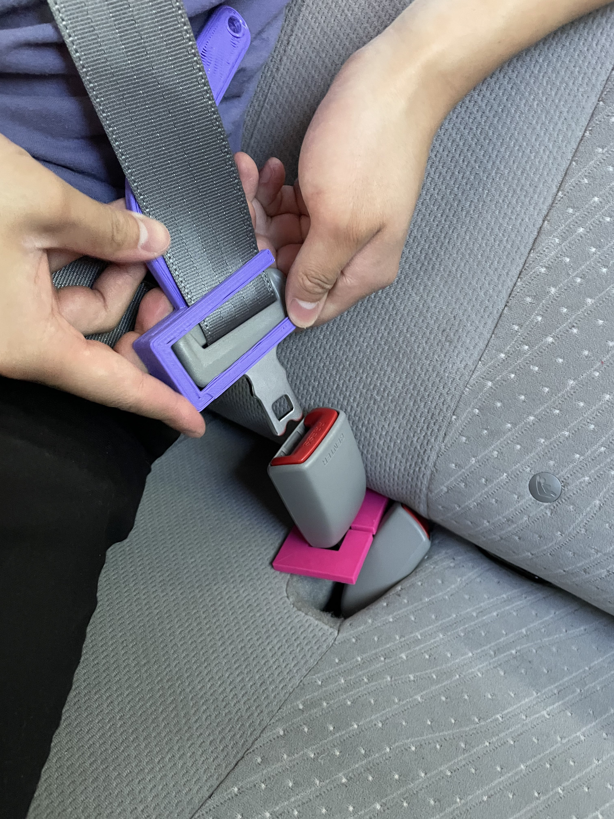
Figure 8-3. Second Prototype Testing-3

4: Conclusion
In conclusion, this project deliverable encompases the group’s second prototype and its benefits. It includes the feedback provided by the client, an updated concept based on that feedback, the assumptions used to create the second prototype, the development process of the second prototype and finally, the testing of the second prototype.

References

HR Auto Parts. “Seat Belt Buckle Booster.” Amazon, 2019, https://www.amazon.ca/Seat-Belt-Buckle-Booster-Receptacle/dp/B07PRKBL73/ref=sr_1_2_sspa?crid=1OQM7PNBE30AR&keywords=seatbelt%2Bbooster&qid=1655653461&sprefix=seatbelt%2Bboost%2Caps%2C272&sr=8-2-spons&smid=A34LWHIP1XDWV&spLa=ZW5jcnlwdGVkUXVhbGlmaWVyPUExQ0lR.
Veigel. “JIMMY – Seat Buckle Assist.” Veigel, 2020, https://www.veigel-automotive.de/en/ergomotive/jimmy-seat-buckle-assist/.

Wrike Updates
https://www.wrike.com/frontend/ganttchart/index.html?snapshotId=Tq65HllyTCocHks0zmaEHFw0Gv892h37%7CIE2DSNZVHA2DELSTGIYA

