User and Product Manual Instructions
This document is a template of a user and product manual. The client may wish to make improvements on the prototype or need to fix it if something goes wrong or another group of students may work to make a more rugged prototype. The document needs to be clear for someone else who is not an engineer to use, maintain or reproduce the project. Include as many images and diagrams as possible for a better understanding. Keep it plain, simple, visual and logical.
In general, if you are not sure exactly what to include, imagine that this document was the only thing that you had. Imagine also that your job was to add a new feature or recreate the project that is described in your document. What would you need to know?
Only include details relating to your final prototype.

Template conventions:
- Remove all red text, it is only there to guide you
- Remove this page (instructions)
- Replace all instances of <xxx> with the appropriate information for your group, for example you could replace <System Name (Acronym)> by The Amazing Product (TAP)
- Save this document as ‘User and Product Manual_group number’ instead of Deliverable X so that others know what it represents when they see it in MakeRepo

GNG<1103/2101>
Design Project User and Product Manual

<TITLE>

Submitted by:
Maanashan Rudranantha, 300318691

<Gong (Victor) Feng, 300176400>

<Lemuel Douglas, 300286474>

< George Osariemen Omoregie, 300325739>

<Jasem Alenezi, 300230705>

<10-04-2024>
University of Ottawa

Table of Contents
Table of Contents ii
List of Figures iv
List of Tables v
List of Acronyms and Glossary vi
1 Introduction 1
2 Overview 2
2.1 Conventions 2
2.2 Cautions & Warnings 2
3 Getting started 3
3.1 Set-up Considerations 3
3.2 User Access Considerations 3
3.3 Accessing the System 3
3.4 System Organization & Navigation 3
3.5 Exiting the System 3
4 Using the System 4
4.1 <Given Function/Feature> 4
4.1.1 <Given Sub-Function/Sub-Feature> 4
5 Troubleshooting & Support 5
5.1 Error Messages or Behaviors 5
5.2 Special Considerations 5
5.3 Maintenance 5
5.4 Support 5
6 Product Documentation 6
6.1 <Subsystem 1 of prototype> 6
6.1.1 BOM (Bill of Materials) 6
6.1.2 Equipment list 6
6.1.3 Instructions 6
6.2 Testing & Validation 7
7 Conclusions and Recommendations for Future Work 8
8 Bibliography 9
APPENDICES 10
APPENDIX I: Design Files 10
APPENDIX II: Other Appendices 11

List of Figures
Insert your list of figures here (right-click to update this field).

List of Tables
Table 1. Acronyms vii
Table 2. Glossary vii
Table 3. Referenced Documents 10

List of Acronyms and Glossary
Provide a list of acronyms and associated literal translations used within the document. List the acronyms in alphabetical order using a tabular format as depicted below.

Table 1. Acronyms
Acronym | Definition

Provide clear and concise definitions for terms used in this document that may be unfamiliar to readers of the document. Terms are to be listed in alphabetical order.

Table 2. Glossary
Term | Acronym | Definition

Introduction

In today’s world, the design and development of assistive technologies play a crucial role in improving the quality of life for individuals with disabilities. This document serves as a comprehensive User and Product Manual for Pants Assistance Device, a revolutionary solution designed to empower children with limited mobility to independently manage one of their most fundamental daily tasks: using the restroom.

Context and Assumptions:
This device is developed with the understanding of the challenges faced by children with conditions such as arthrogryposis, affecting their hand strength and mobility. Assumptions underlying this work include the need for a safe, user-friendly device that promotes independence and dignity while addressing specific mobility limitations.

Document Structure Overview:
This document is structured into several sections, each addressing different aspects of the Devices:

- Introduction
- System Overview
- User Manual
- Trouble Shooting and Support
- Product Documentation
- Conclusion and Recommendations for future work
Purpose and Scope:
The purpose of this document is to provide comprehensive guidance for users and caregivers on the setup, operation, maintenance, trouble shooting, support and product documents of the device. It aims to ensure that users can effectively utilize the device to enhance their independence and quality of life.

Intended Audience:
The intended audience for this document includes:
- Children with limited mobility and their caregivers
- Healthcare professionals and therapists
- Engineers and developers involved in assistive technology
- Support personnel responsible for system maintenance and assistance
Security/Safety and Privacy Considerations:
The safety and privacy of users are paramount considerations in the design and use of the device. Measures have been implemented to ensure the device’s safety during operation, including rounded edges, soft touch points, and secure clamping mechanisms. Additionally, privacy considerations are addressed by providing guidance on proper device use.

This document aims to provide comprehensive support and guidance for users and stakeholders involved in the deployment and operation of the device, ultimately contributing to the enhancement of independence and well-being for children with limited mobility.

Overview
The problem we're focusing on is individuals with limited mobility, specifically children with conditions like arthrogryposis, to perform daily tasks independently. One critical aspect of daily life that can be challenging for these individuals is using the restroom independently, a task that many of us take for granted. The importance of this problem cannot be overstated as it directly impacts the user's dignity, independence, and quality of life. Children, in particular, face significant challenges in this aspect, as most assistive devices are not designed with their specific needs, sizes, or strengths in mind.
The fundamental needs of the user include:
- Ease of Use: The device must be operable with limited hand strength and flexibility, typical of someone with arthrogryposis.
- Safety: It must be safe to use, with no sharp edges or components that could harm the user or damage clothing.
- Adaptability: The device should be adjustable to accommodate different sizes and be usable with various types of clothing.
- Independence: Enabling the user to perform the task without assistance from others is a primary goal, enhancing their self-reliance.
What differentiates our product from others is its design, focusing on children with limited hand mobility. It incorporates a releasable clamp mechanism that's easy to operate, adjustable features for growth and comfort, and materials chosen for durability and safety in a bathroom environment. Moreover, the use of lightweight, water-resistant materials and a design devoid of sharp edges sets our device apart, ensuring safety and usability in potentially wet conditions.
Our final prototype features several key aspects:
Releasable Clamp Mechanism: Designed for easy operation, these clamps securely hold onto the clothing without damaging it, allowing for pulling up or down with minimal effort.
Adjustable Frame: The frame is made of lightweight PEX, tailored to the user's height and can be adjusted as the child grows.
Soft Touch Points: Areas of the device that come into contact with the user are soft to prevent discomfort or injury.
The architecture of our system is primarily mechanical, with a robust yet lightweight metal frame for structural support and durability. It includes a set of ergonomic handles equipped with triggers to control the clamps. The user accesses the device's functionality through these triggers, designed to be easily operated with limited hand strength. The system does not rely on complex electronics, making it durable and easy to maintain. Special conditions taken into account include its use in a wet bathroom environment, leading to the selection of water-resistant materials.

Getting started
- First put the device around your waist, with the handles at the front of your body
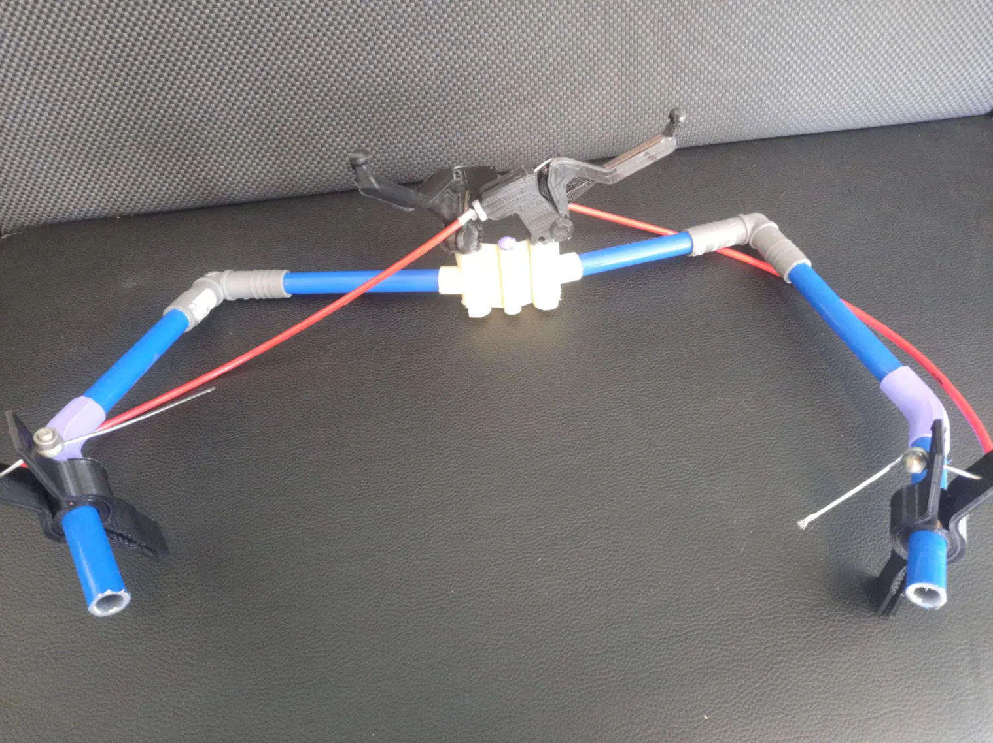
Figure 1:
- Adjust the arms so that the clamps can reach the back of your pants
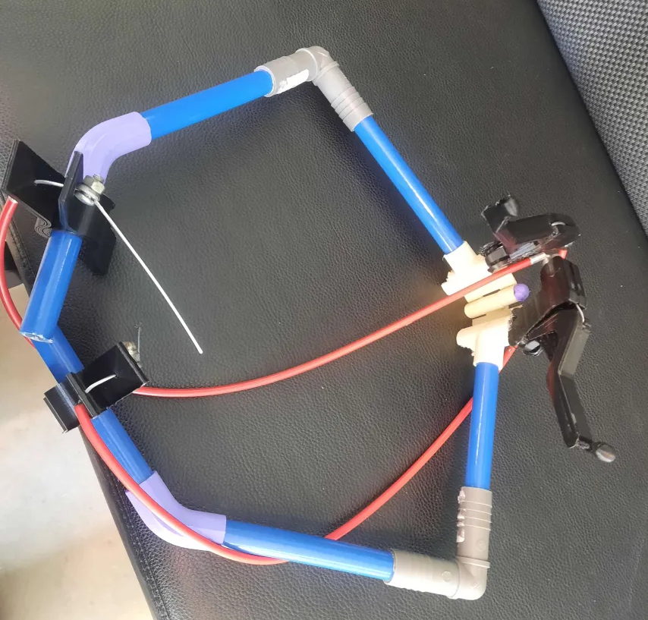
Figure 2:
- Then press down on the triggers to open the clamps at the back of the device
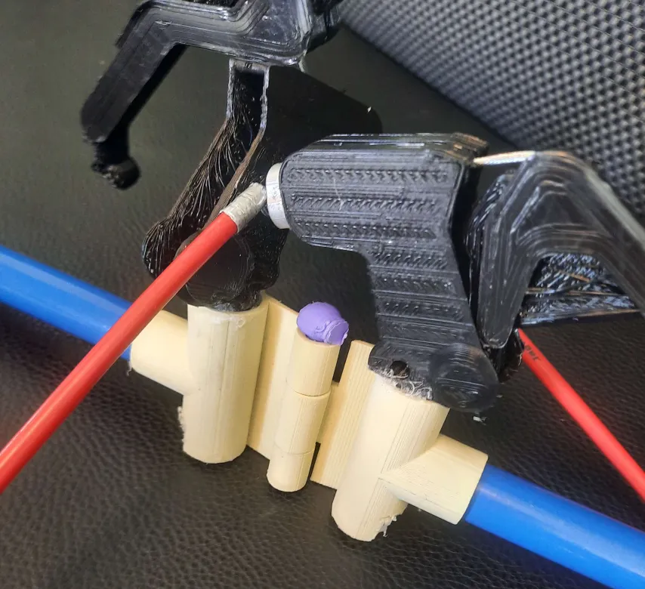
Figure 3:
- Next move the device so that it can clamp onto your pants and let go of the triggers
- Next move then device down so that it pulls your pants down
- After you are done, you can pull your pants back up with the device
- Hold down the triggers again to unclamp the device from your pants
- Get out of the device and take the pin out of the hinge to put the device away

  - Configuration Considerations
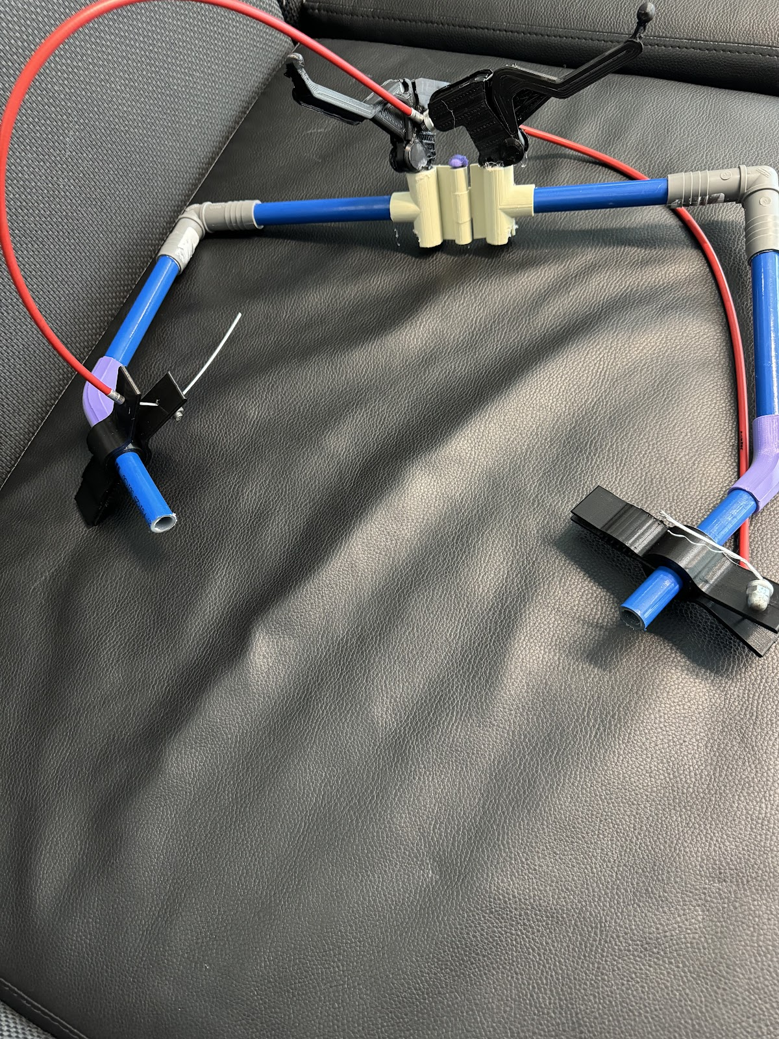
Clamps
Hinge
Triggers
Frame
Figure 4:
Triggers: Used to open and close the clamps
Hinge: Keeps the 2 arms together, also helps with moving the arms to provide a more snug fit when using the device
Clamps: Clasps onto the user’s pants
Frame: Rectangular hula-hoop shape to wrap around the user’s waist

User Access Considerations
The prototype that our group developed was made specifically for the user. Since the device was specifically made for specifically for one person, there are not many groups that can use this device. Other groups that could use the device can include other people living with arthrogryposis, or people who have shoulder mobility and strength issues.

Accessing/setting up the System
There are no special procedures for setting up the system, the device is always set up and is not needed to be taken apart. For the best use of the device, you first need to adjust the frame of the device to wrap around your hips, ensuring that the clamps reach the back of your pants properly. You also need to move the device up and down afterwards to ensure that the clamps can clamp onto your clothes properly and as a result the clamps are able to hold onto your clothes properly.
  - System Organization & Navigation

  - Main Component
    - The main component of the system is the assistive device itself, designed to aid individuals with limited mobility in using the restroom independently.
    - The device consists of several key components, including the frame, clamps, triggers, and hinge, which work together to facilitate its functionality.
2. Frame
    - The frame serves as the primary structural supports for the device, providing stability and anchoring points for other components.
    - It is designed in a rectangular hula-hoop shape to wrap around the user’s waist comfortably.
    - The frame is adjustable to accommodate different user sizes, ensuring a proper fit.
3. Clamps
    - The clamps are located at the back of the device and are responsible for securely holding onto the user’s clothing.
    - They feature a releasable clamp mechanism designed for easy operation, controlled by the triggers located at the front of the device.
    - The clamps are adjustable to accommodate various clothing materials and thickness.
4. Triggers
    - The triggers are ergonomic handles located at the front of the device, used to control the opening and clothing of the clamps.
    - They are designed to be easy to press, requiring minimal hand strength and dexterity to operate effectively.
    - The triggers are linked to the clamps through a mechanical linkage system, allowing for synchronized movement.
5. Hinge
    - The hinge is a pivotal component that connects the two arms of the device together.
    - It allows for movement and adjustment to provide a snag fit around the user’s waist.
    - The hinge is designed to be durable and relable, with smooth articulation to facilitate comfortable use.
6. Connections to Main Features
    - Each component of the system is linked together through mechanical connections, such as hinges, screws, or fasteners.
    - These connections are designed to be secure and reliable, ensuring
    - That the device functions smoothly and effectively during use.
Clear instructions and visual aids may be provided to guide users in assembling and disassembling the device, if necessary.

Exiting the System
  - Releasing Clamps
    - Begin by holding down the triggers located at the front of the device to release the clamps securely holding onto the user’s clothing.
    - Ensure that the clamps are fully disengaged before proceeding to the next step.
2. Removing Device
    - Once the clamps are released, carefully remove the device from around the user’s waist.
    - Holde onto the device securely to prevent it from accidentally falling or causing damage.
3. Folding
    - Fold the device to reduce its size and facilitate storage
4. Storing the System
    - Once the device is properly folded, store it in a designated location for safekeeping.
    - Choose a clean, dry area free from moisture or extreme temperatures to prevent damage to the device over time.
    - Ensure that the storage area is easily accessible for future use, but out of reach of children or pets to avoid accidents.

Using the System
User Manual for Automated Pants Assistance Device
4.1 Picking Up the Device
Input
- Approach the device.
- Grasp the main frame under the triggers.
Output
- Device ready to be maneuvered.
4.2 Positioning the Device Around the Waist
Input
- Hold the device against the waist.
- Ensure the opening of the device aligns with the waist area.
Output
- The device should be positioned horizontally around the waist, ready for further adjustments.
4.3 Adjusting the Clamps
Input
- Use the mainframe under the trigger mechanism to control the location of the clamps.
- Use the adjustment controls to position the clamps.
Output
- The clamps move to a position where they can easily attach to the clothing.
4.4 Attaching the Clamps to the Pants
Input
- Press the trigger to open the clamp.
- Place the open clamp onto the waistband of the pants.
Output
- The clamps securely hold the waistband of the pants.
4.5 Pulling Down the Pants
Input
- Using the mainframe as a handle, pull down to lower the pants.
Output
- The pants are lowered to the desired position.

<Given Function/Feature>
This device is designed to aid children with arthrogryposis and similar conditions affecting hand strength and mobility in using the restroom independently. It focuses on safety, ease of use, and adaptability, ensuring that the dignity and independence of the user are upheld.
Feature 1: Releasable Clamp Mechanism
Description:
The releasable clamp mechanism is a central feature designed to facilitate the independent pulling up and down of pants with minimal effort. The clamps are operated via triggers located on the handles that users can press using limited hand strength.
Functionality:
- Secure Grip: The clamps provide a firm grip on the clothing without causing damage, using soft-lined jaws that contour to the fabric.
- Easy Release: With a simple press of the trigger, the clamps open allowing the clothing to be released or secured effortlessly.
- Minimal Force Required: The design of the trigger mechanism ensures that very little force is needed to operate the clamps, suitable for users with very limited hand mobility.
Safety Features:
- Soft Jaws: The clamp jaws are padded to prevent any injury to the user or damage to the clothing.
- Rounded Edges: All parts of the clamps that might come into contact with the user have rounded edges to enhance safety.
Figure 1: Releasable Clamp Mechanism
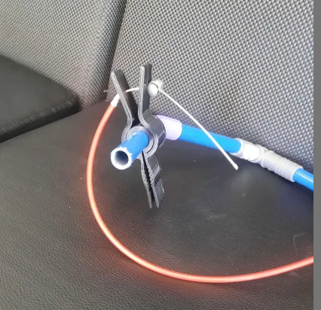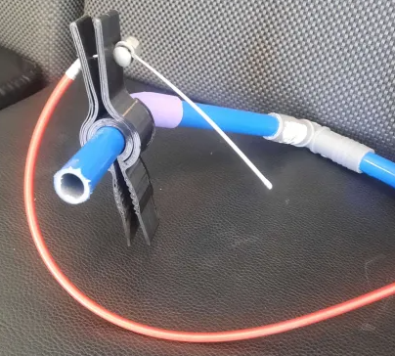
Figure 5: Figure 6:
Feature 2: Adjustable Frame
Description:
The frame of the device is constructed from lightweight PVC, designed to be both sturdy and adjustable. It can be modified to fit the child’s height and accommodate growth.
Functionality:
- Height Adjustment: The frame can be easily adjusted to various heights, ensuring it can grow with the child.
- Stable Base: Despite its lightweight design, the PEX frame provides a stable base, preventing tipping during use.
Safety Features:
- Smooth Surfaces: The entire frame is finished with smooth surfaces and rounded corners to eliminate the risk of scratches or other injuries.
- Water-resistant: PEX is naturally water-resistant, making it ideal for use in wet environments like bathrooms.
Figure 2: Adjustable Frame
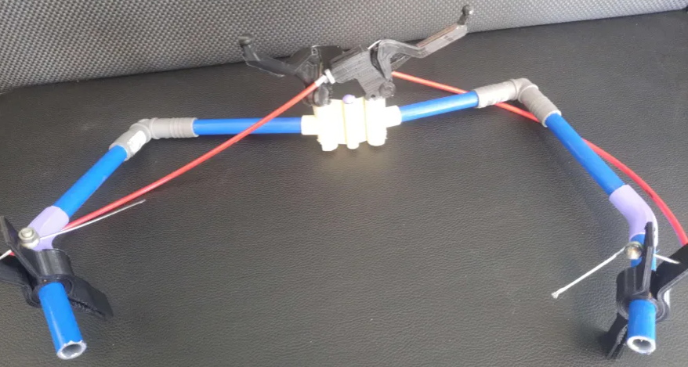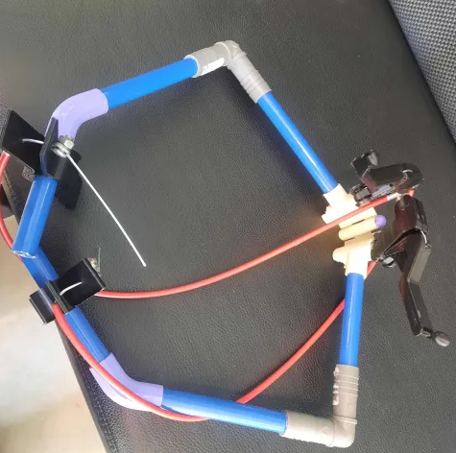
Figure 7: Figure 8:
This device is thoughtfully designed to address the needs of children with limited mobility by providing a mechanism that is safe, easy to use, and adaptable. The inclusion of features such as the releasable clamp mechanism, adjustable frame, and soft touch points ensure that the device not only supports the child's independence but also promotes safety and comfort. The mechanical simplicity of the design also minimizes maintenance issues and ensures long-term durability in a bathroom environment.

Troubleshooting & Support
These troubleshooting and support guidelines, users can effectively address any issue or concerns with the device and ensure its continued functionality and reliability. If you have any further questions or need additional assistance, please let us know

Error Messages or Behaviors
  - Clamp Failure
    - Error Message/Behavior: Difficulty in opening or closing the lamps, clamps not securely holding onto clothing.
    - Likely Cause(s): Accumulation of debris or clothing fibers, misalignment of clamp mechanism.
    - Possible Corrective Actions:
      - Clean the clamp mechanism with a soft brush or cloth to remove any debris.
      - Check for proper alignment of the clamp mechanism and replace it if necessary.
- 2. Frame instability
    - Error Message/Behavior: Device tipping or instability during use.
    - Likely Cause(s) Uneven surface, improper adjustment of frame height.
    - Possible Corrective Actions:

      - Ensure that the device is placed on a flat and stable surface.

Adjust the frame height to ensure proper stability and balance.

Special Considerations
In case of any persistent issues or concerns with the device’s functionality, users are encouraged to seek assistance from a qualified caregiver or healthcare professional.
  - Avoid excessive force when operating the device, as it may lead to damage or malfunction.

Maintenance
1. Regular Cleaning
  - Periodically clean the clamp mechanism and frame surfaces with a mild detergent and water solution to remove dirt and debris.
  - Ensure all components are thoroughly dried after cleaning to prevent corrosion.
2. Inspection
  - Conduct regular visual inspections of the device for any signs of wear, damage, or loose components.
  - Pay particular attention to the condition of the clamp mechanism and frame joints.

Support
- For emergency assistance or system support, user can contact our m by jalen010@uottawa.ca
- For security incident handling, users should immediately report any suspected security breaches or incidents to our team for prompt investigation and resolution.

Product Documentation
We started preparing for our final prototype by purchasing tools we thought we needed. We started with purchasing bicycle brake triggers with cables attached to them. However, upon receiving the purchase, further inspection revealed to us that what we were trying to achieve would be too heavy for our client’s daughter and it also proved too complex for us to build upon within the timeframe we were given. We decided to 3D print the bicycle brake triggers and clamps as this proved to be easier to build up on and it was also lighter than the bicycle brake triggers, we had bought. The design for the objects we 3D printed are displayed below.
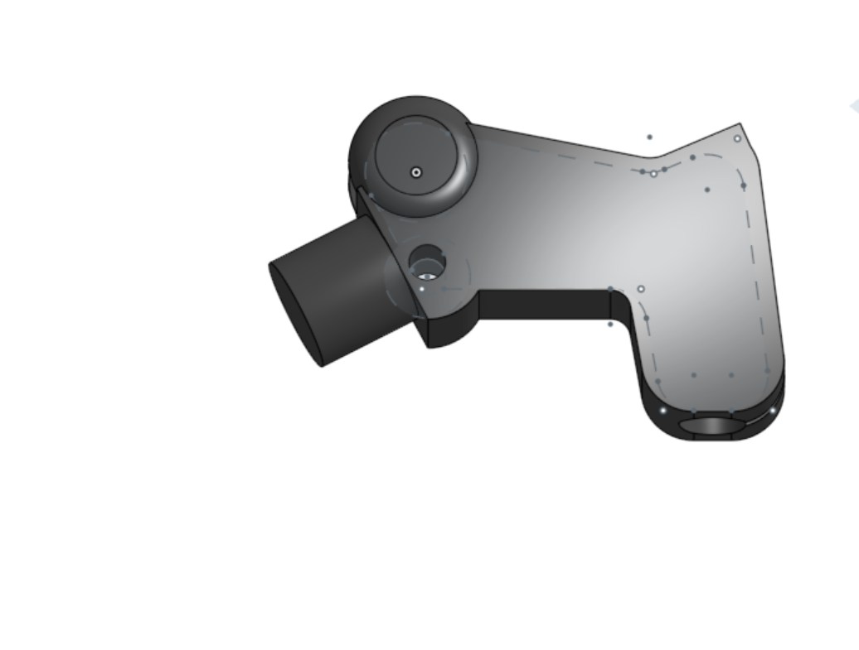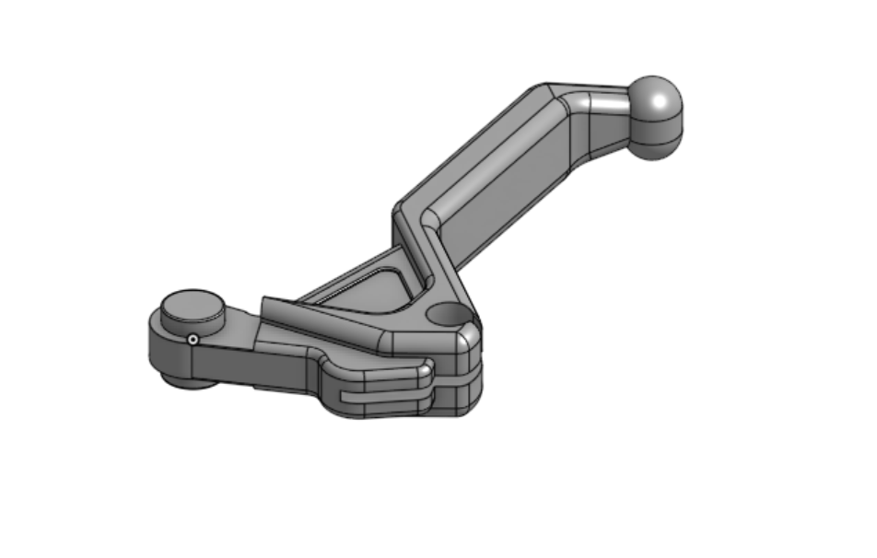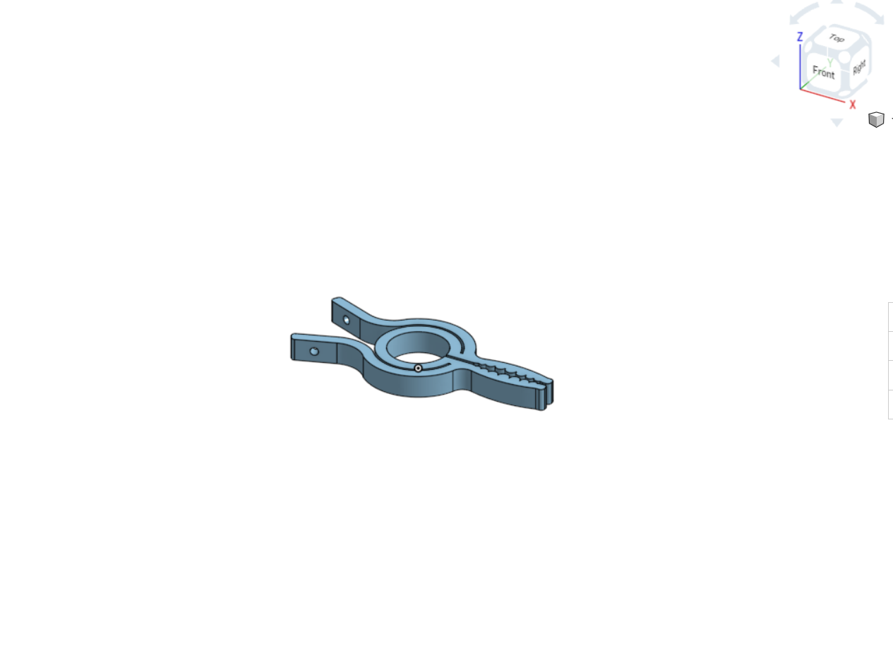Figure 9-12: Images of Onshape design of 3D-printed bicycle brake trigger and Clamp
Once 3D printed, we could use a cable we got from the University of Ottawa to connect the clamp to the bicycle brake trigger. We then tested this system and it worked ideally. With this we had a basis of functionality to build on. We then decided to build the frame.
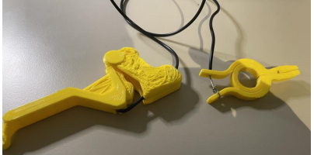
Figure 13: Trigger, clamp and Cable together as a system
After consulting personnel from Brunsfield at the University of Ottawa, we decided to scrap our initial idea of a circular frame and aim for a more rectangular shape for our frame. A rectangular frame that consisted of 2 90-degree connectors, 2 45-degree connectors and a hinge. The body of the frame is made of a PEX pipe a half-inch diameter purchased from Home Depot cut into different sizes using the body measurements of a team Member.

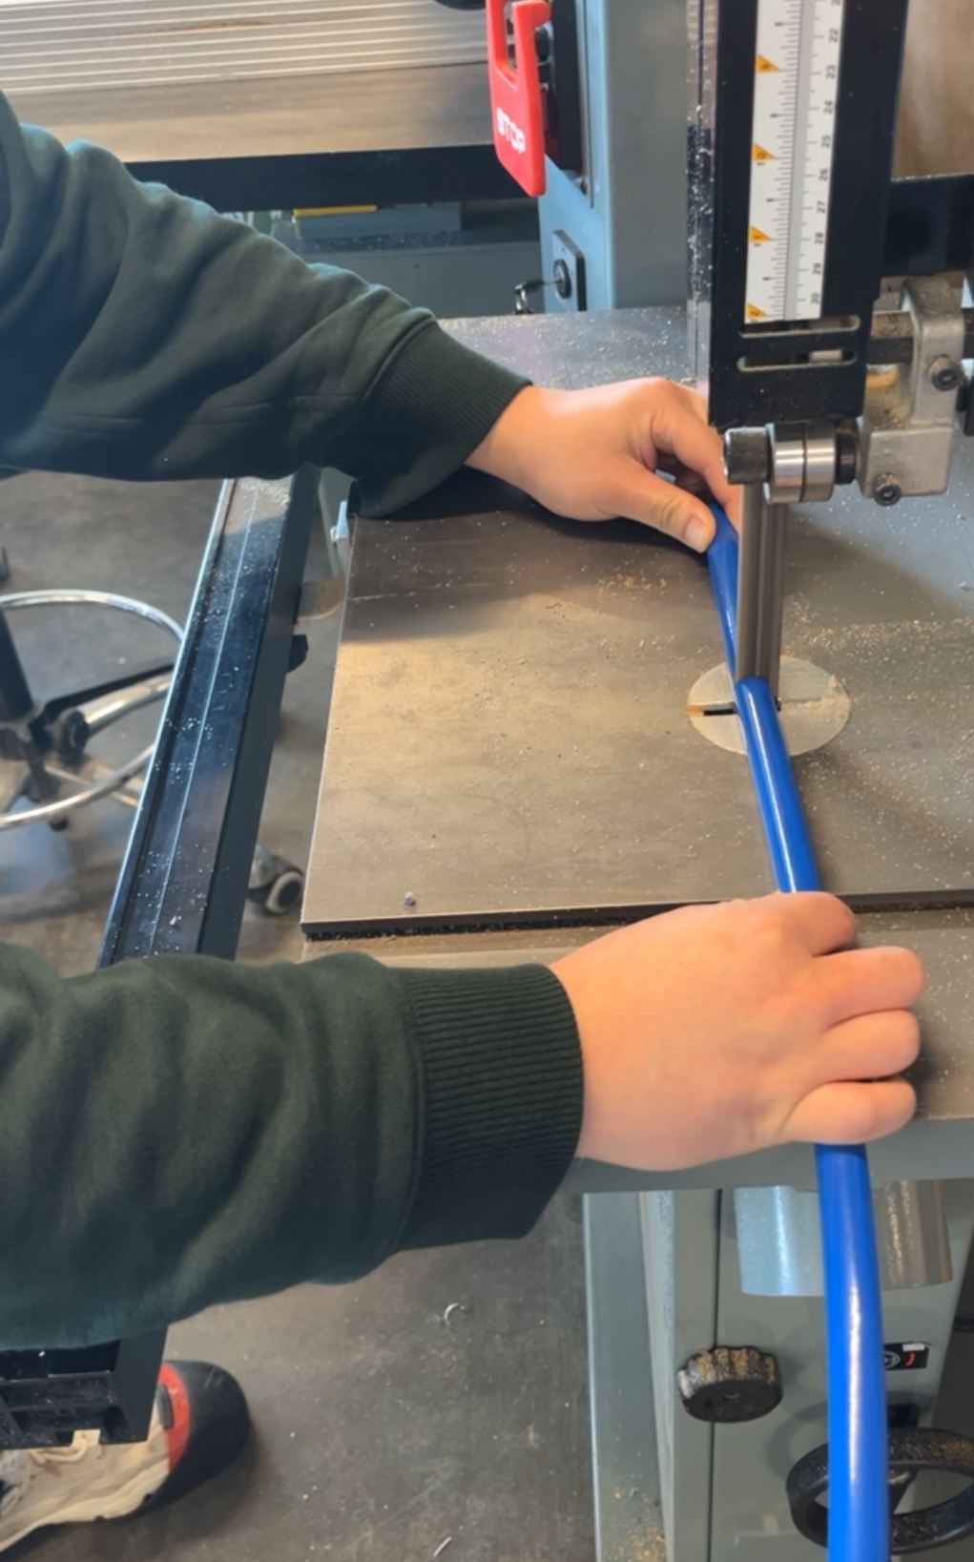
Figure 14: Process of cutting PEX pipe at Brunsfield
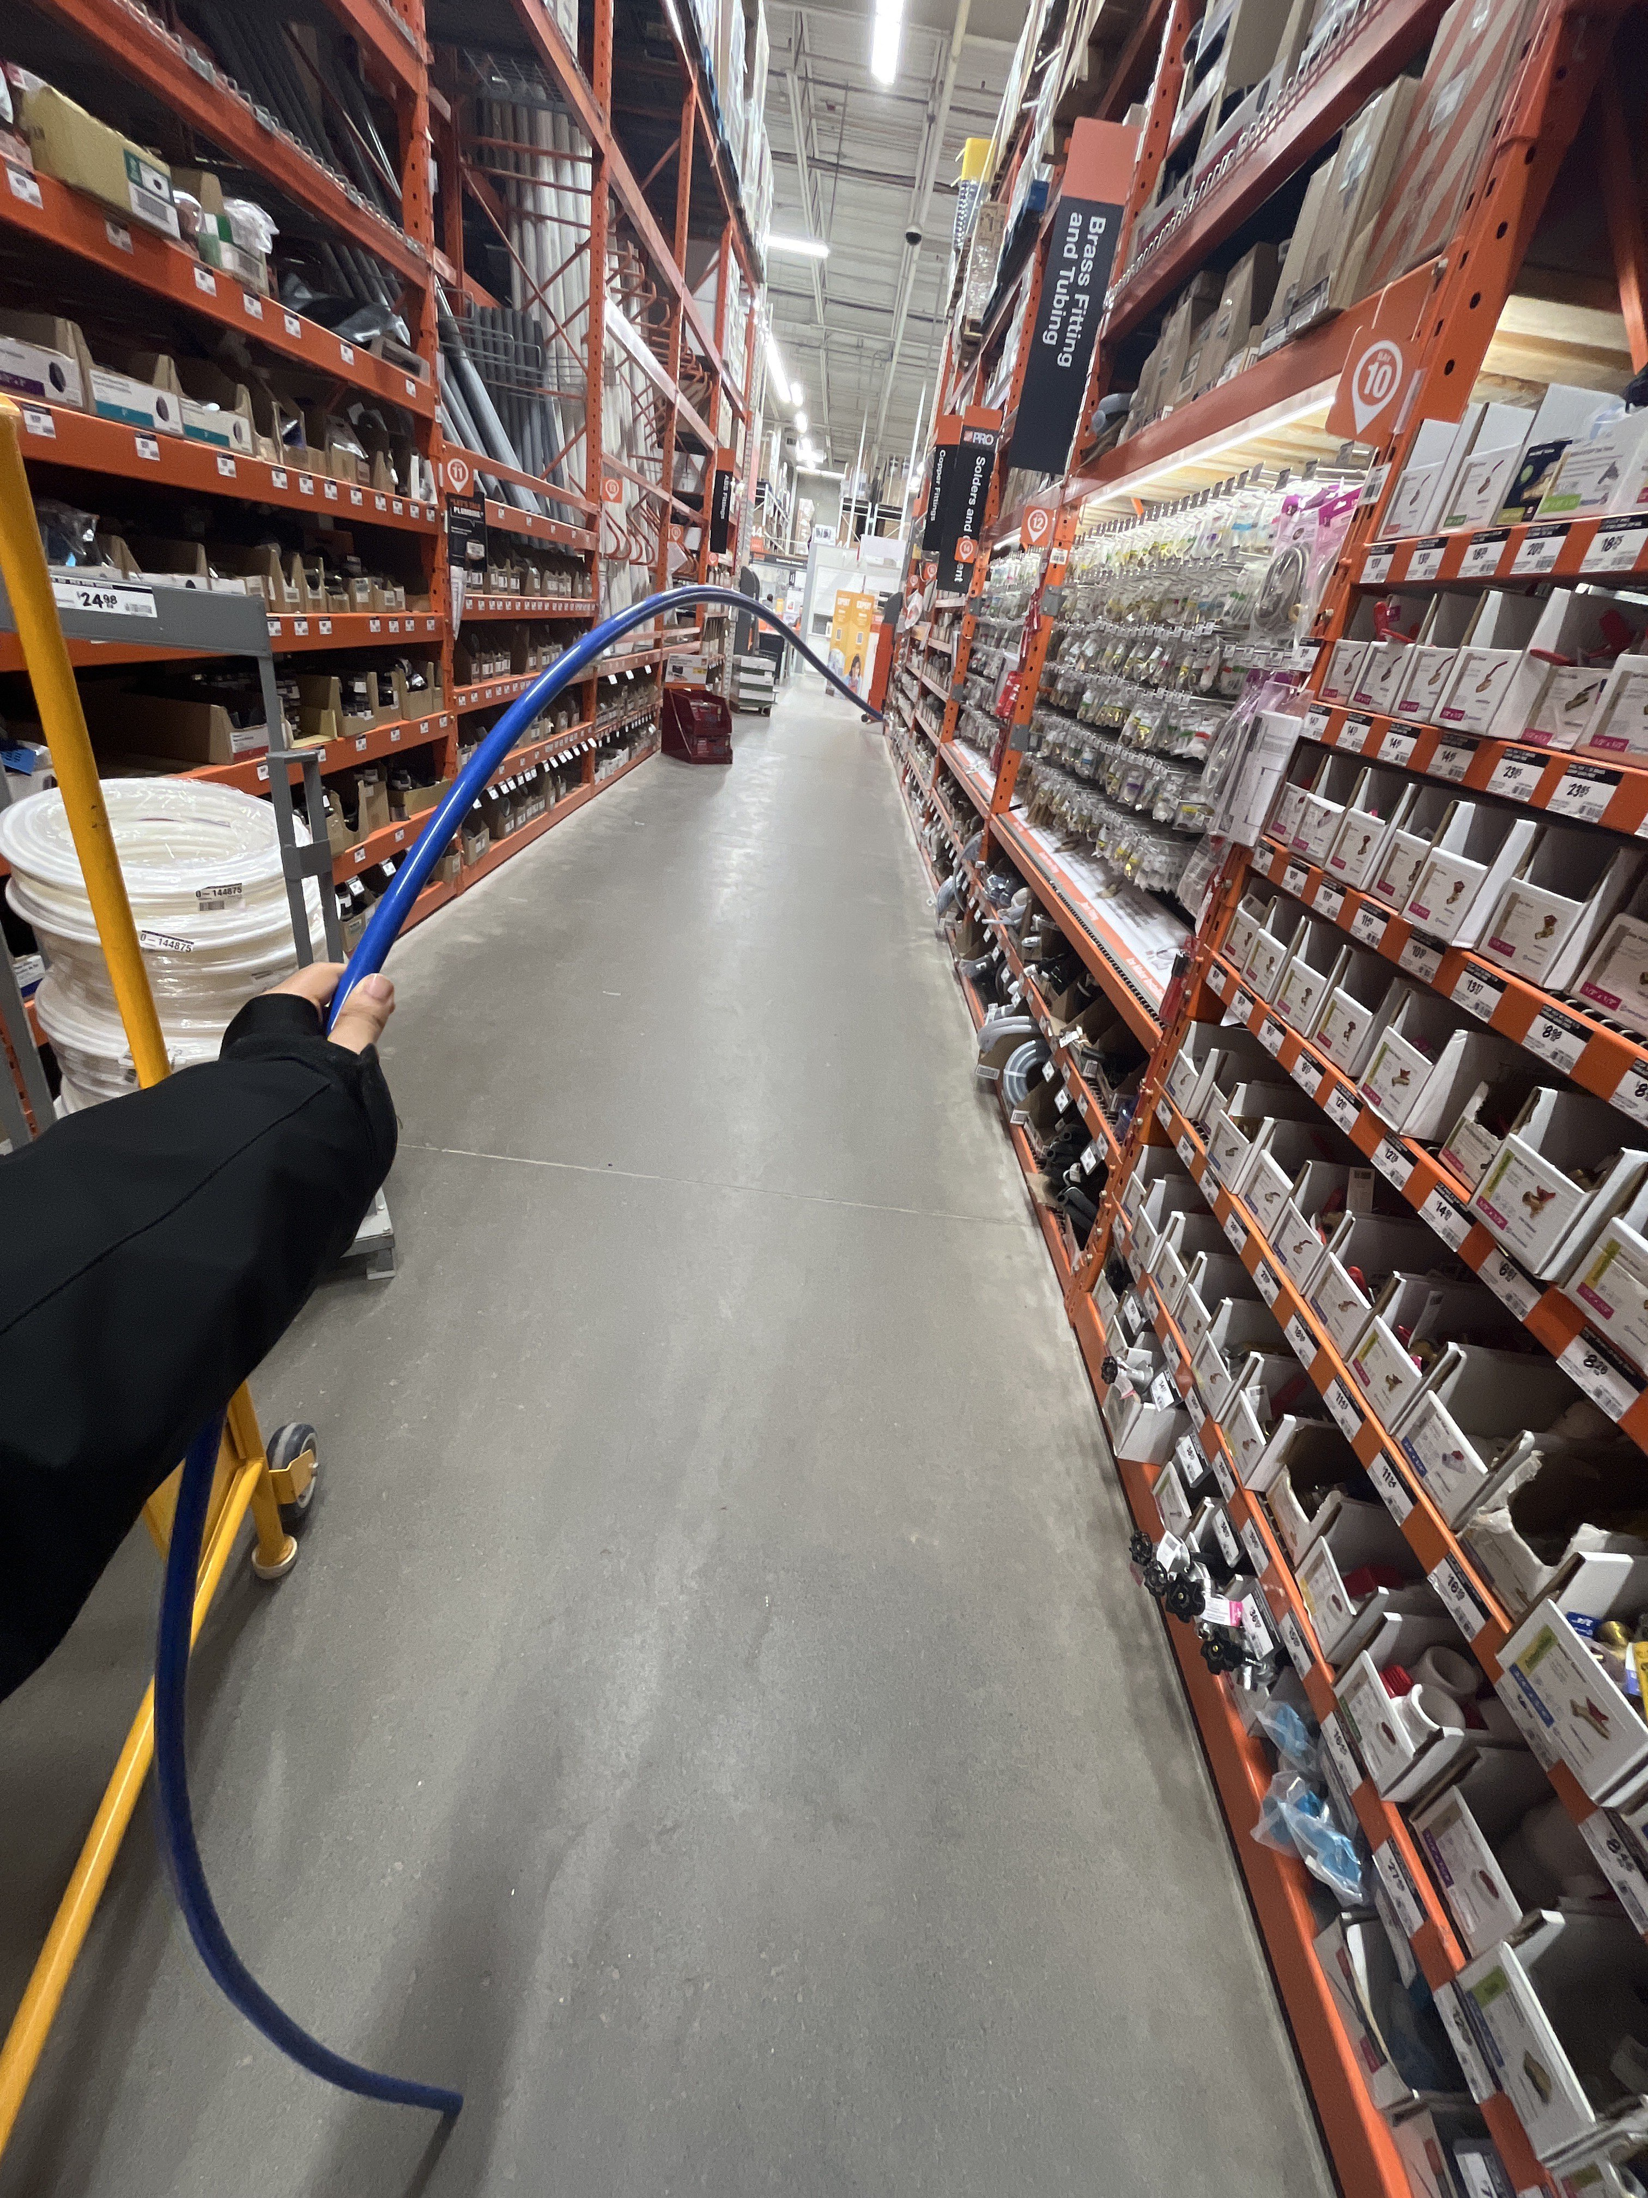
Figure 15: PEX pipe from Home Depot
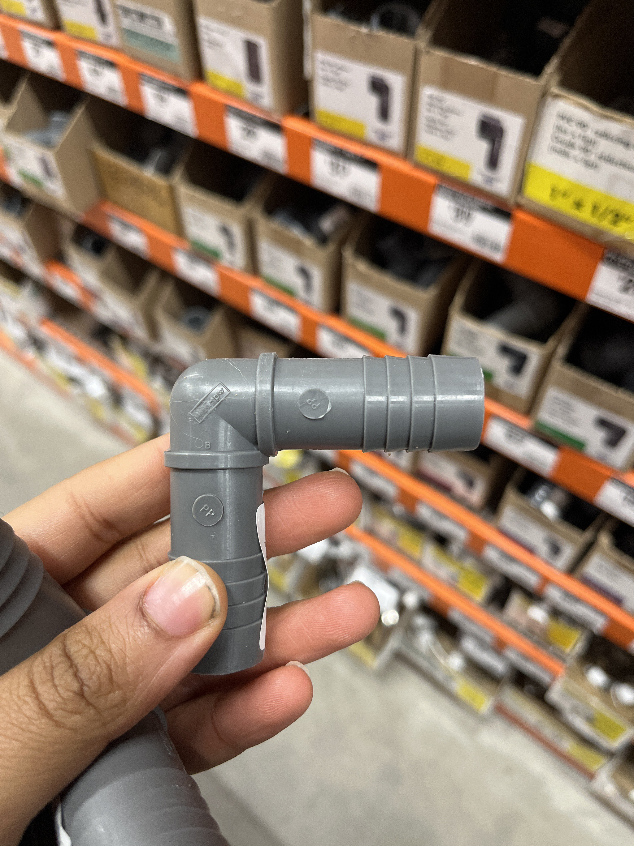
Figure 16: 90-degree connector
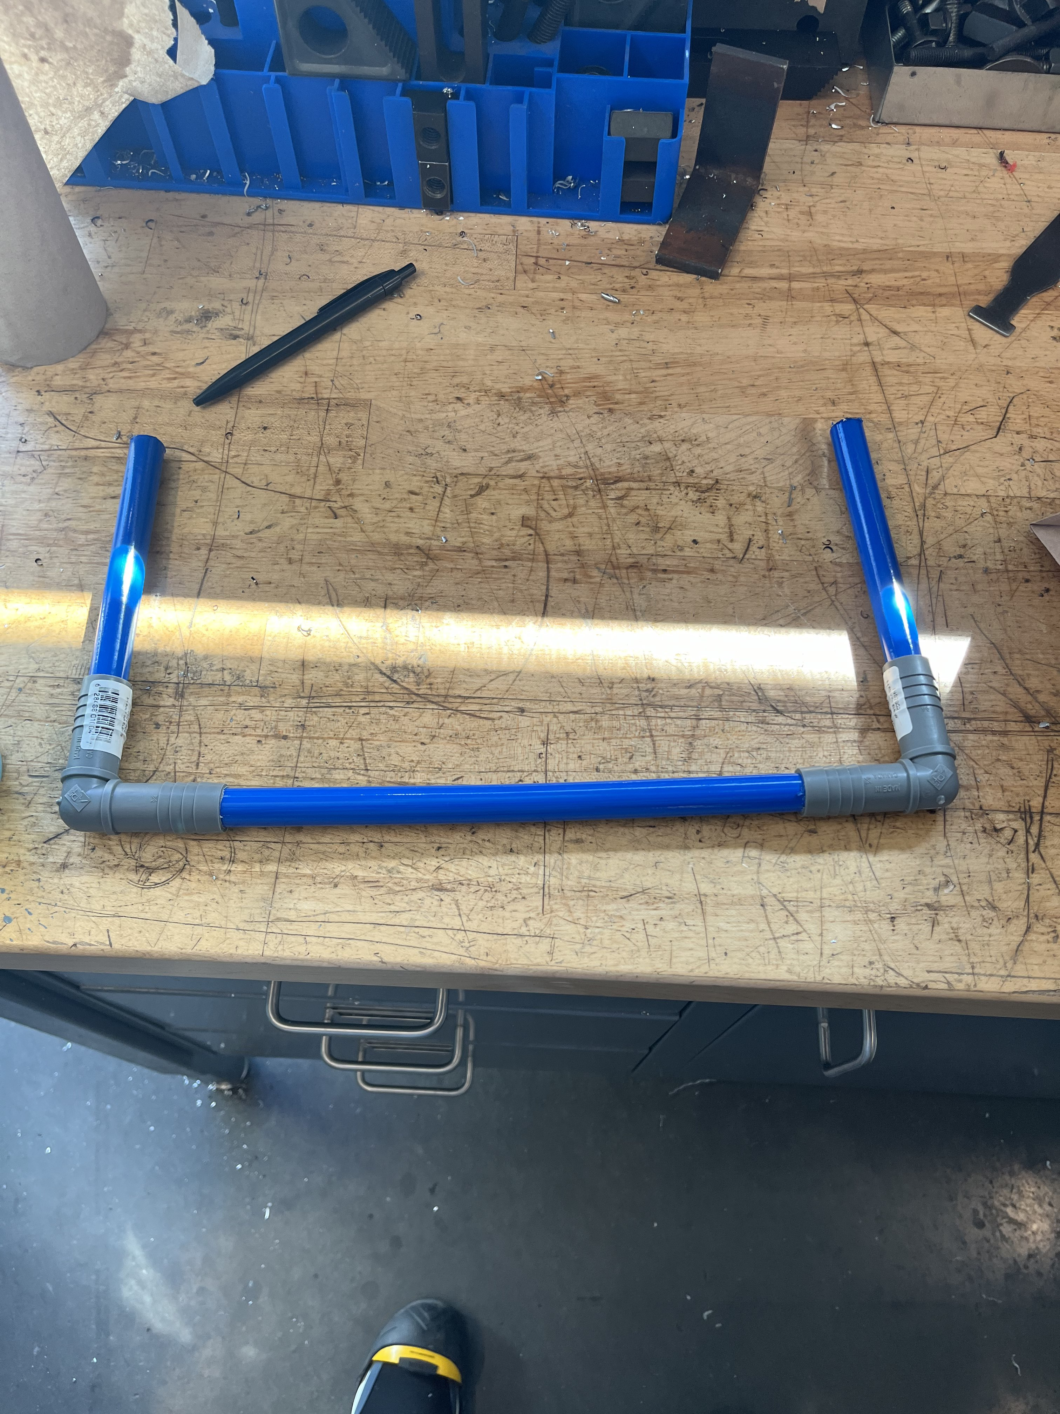
Figure 17: PEX pipe fitted with 90-degree connector.
The 90-degree connectors gotten from Home Depot were a bit too narrow to fit the PEX pipe in, so we used a drill bit to widen the inner diameter of the connector and make it able to house the PEX pipe. We couldn’t get an ideal hinge and 45-degree connector from Home Depot so we 3D printed them.
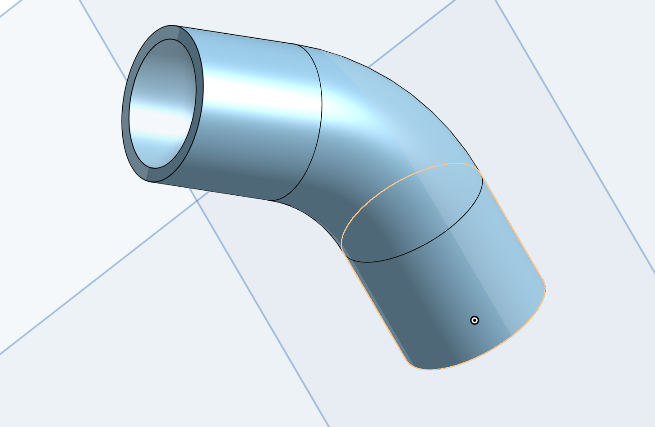
Figure 18: Onshape Design for 45-degree connector
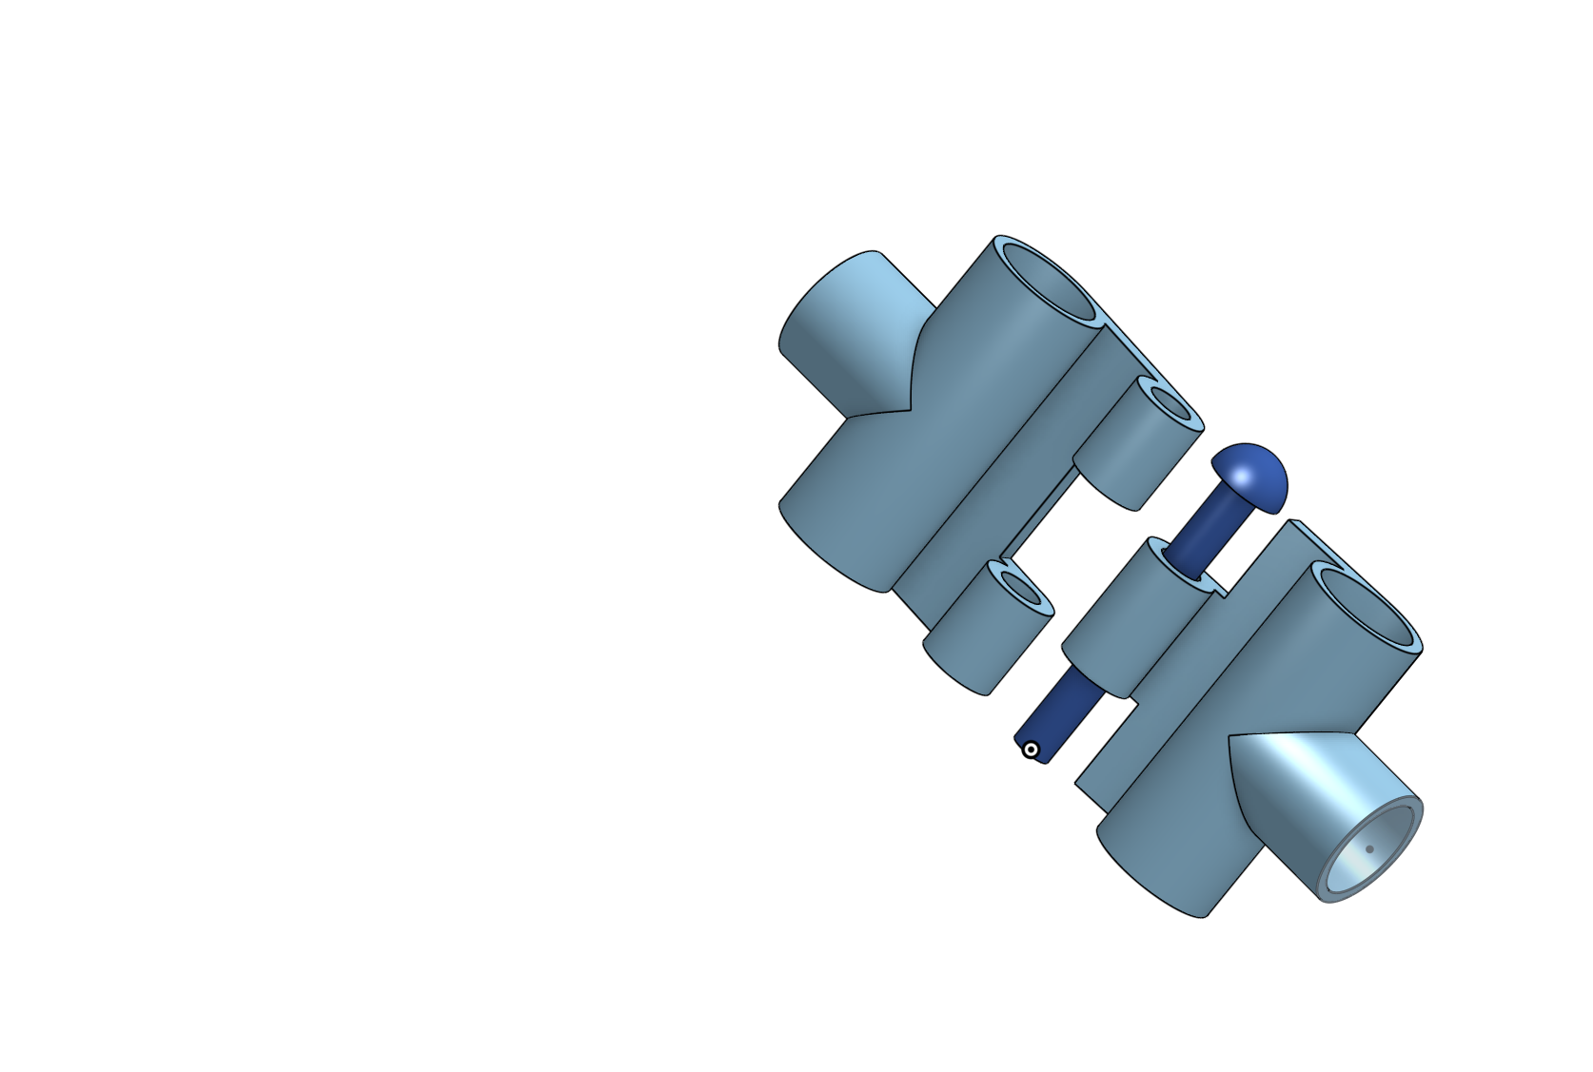
Figure 19: Onshape design for hinge
Once the hinge and 45-degree connector had been 3D printed we put the frame together.
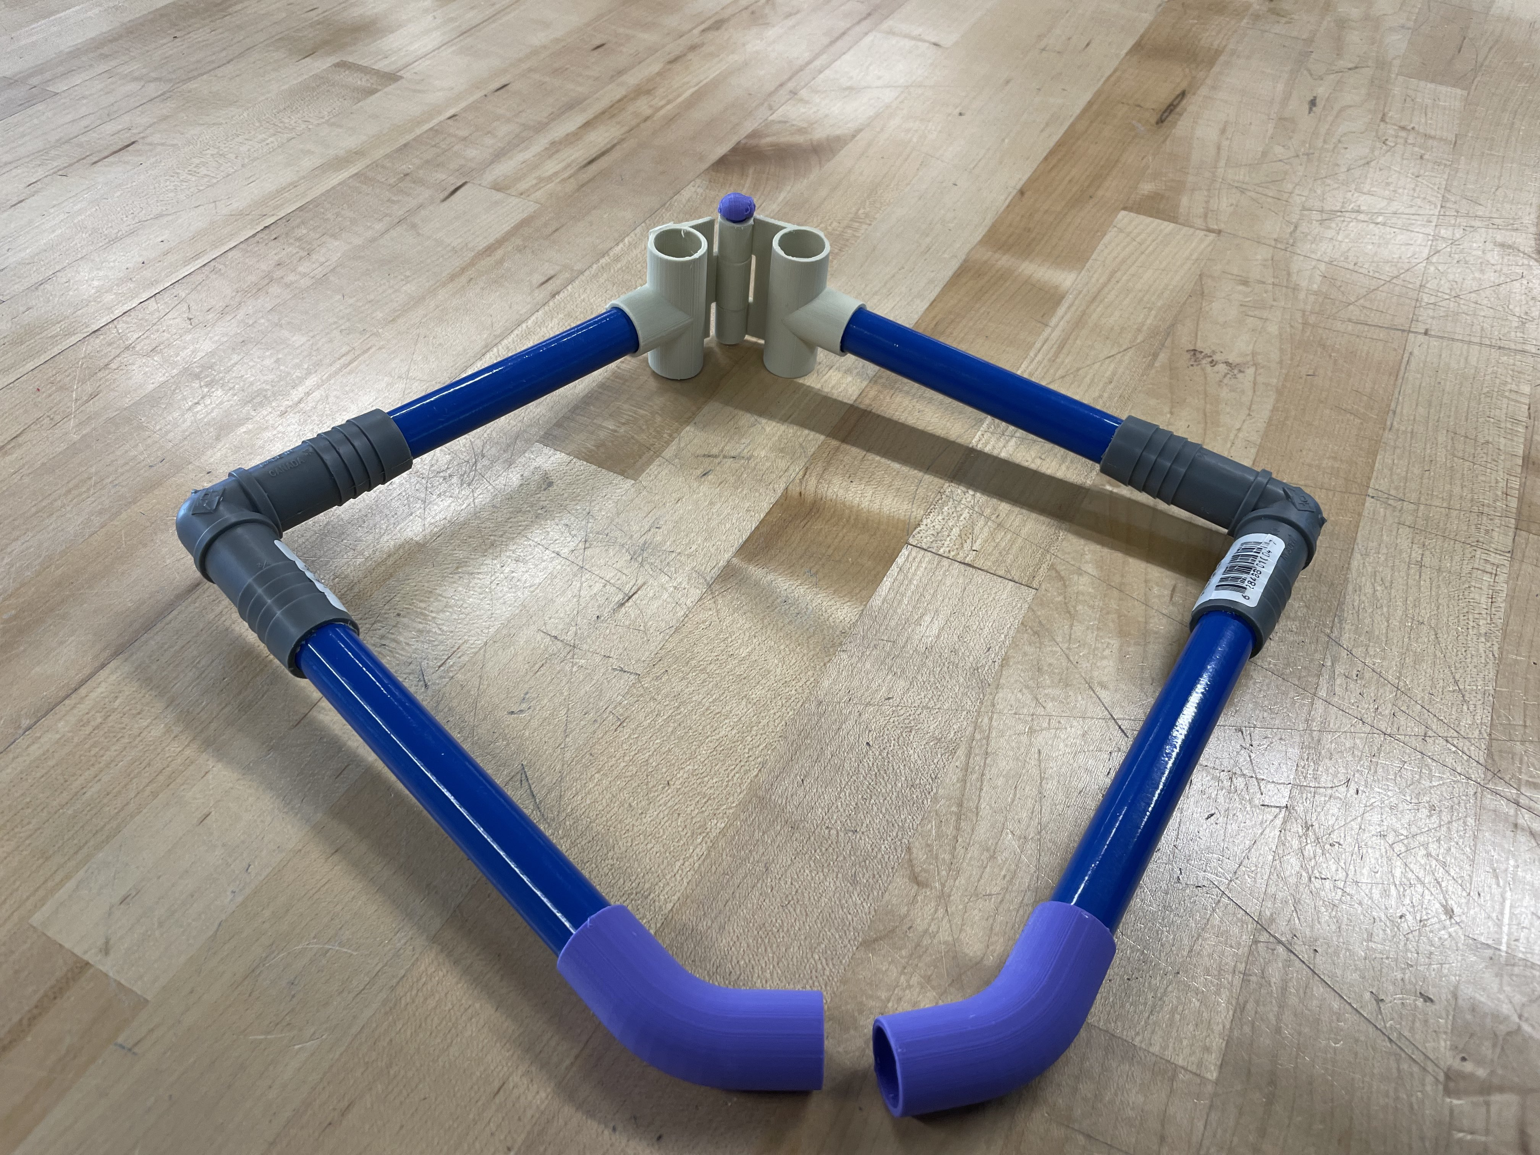
Figure 20: All parts of the frame put together.
Now we turned our attention back to our clamps and triggers. We faced two major issues: the first one was how we were going to attach the clamps and the triggers to the frame and how to optimise the functionality of the system. To optimise the functionality of the system we made use of stoppers attached to the end of the clamp and the trigger enabling them to work better. We also got an insulating material to cover the cable that connected the triggers and the clamps.
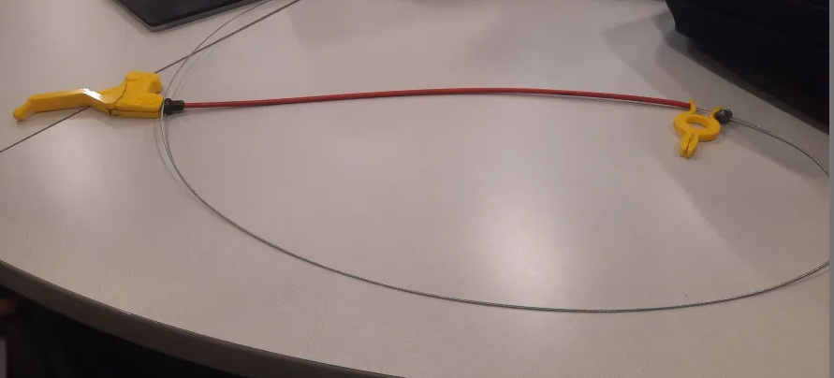
Figure 21: Trigger, clamp, stopper, cables and cable cover making a system.

The next issue was attaching this system to the frame. Thankfully, the clamp we had designed already had a hole where we could fit our PEX pipe through, we just needed to adjust the size of the hole on Onshape. Our hinge was designed with the idea of being able to fit redesigned triggers in the holes at the top of the hinge. So, we redesigned the triggers and we were able to attach them to the frame through the hinge.
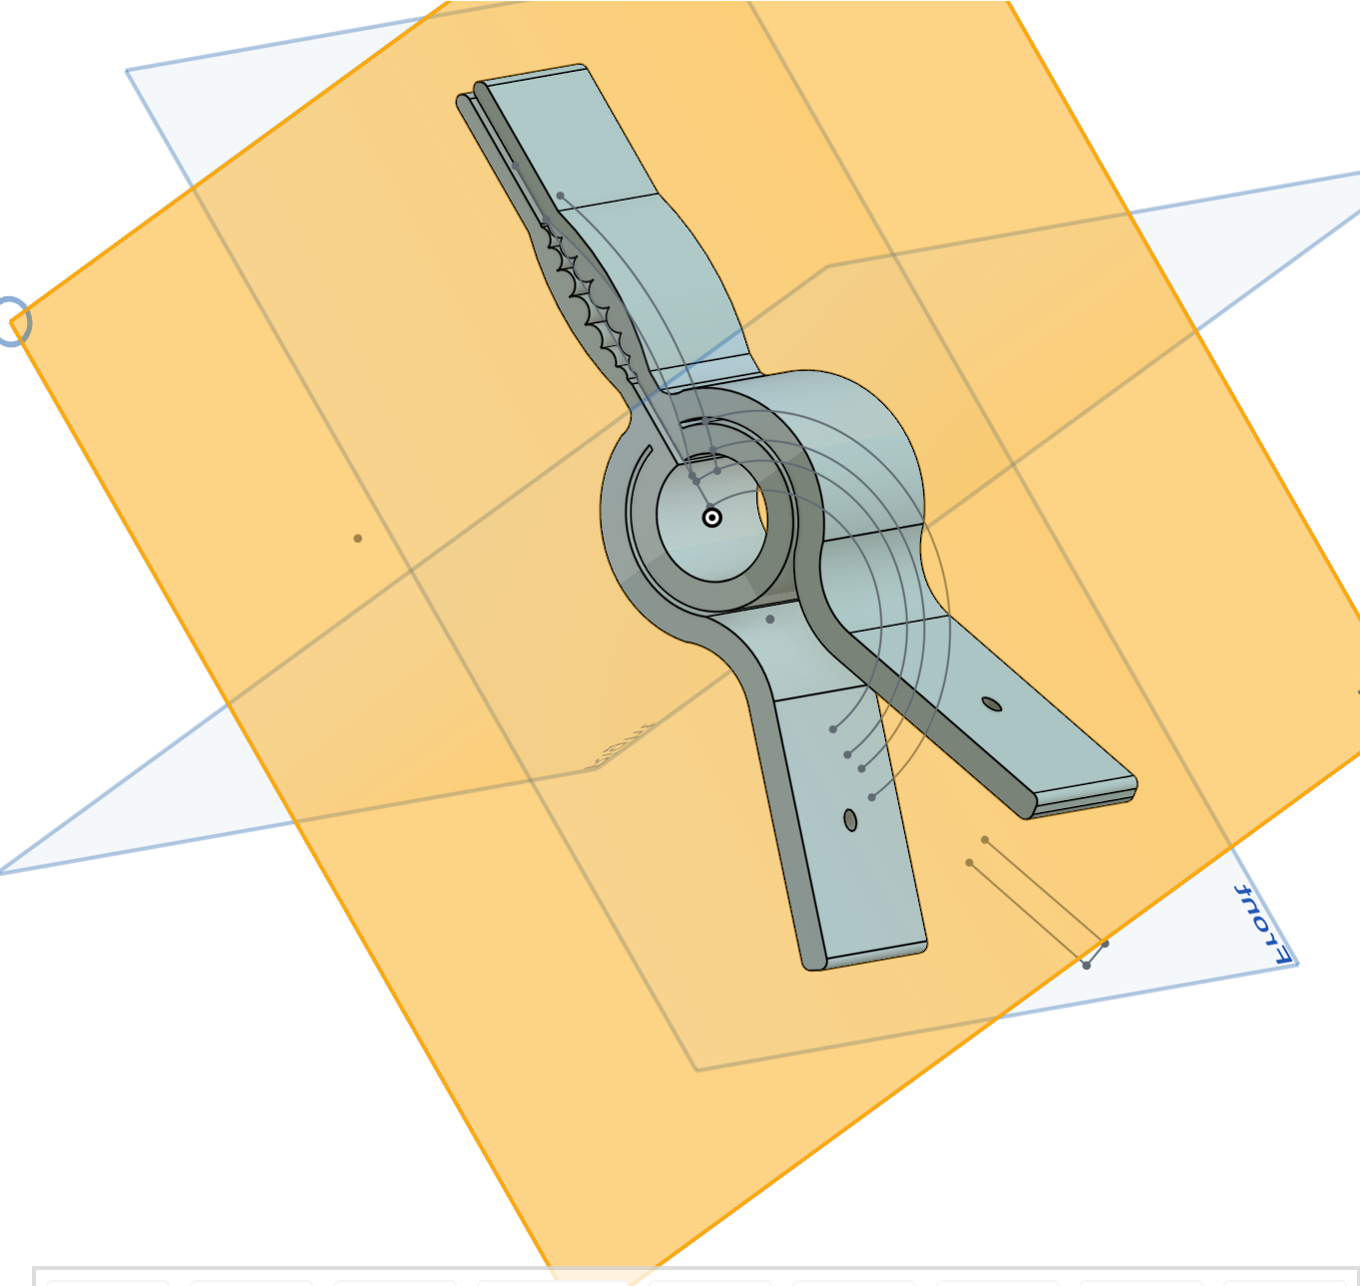
Figure 22: Redesigned Clamp.
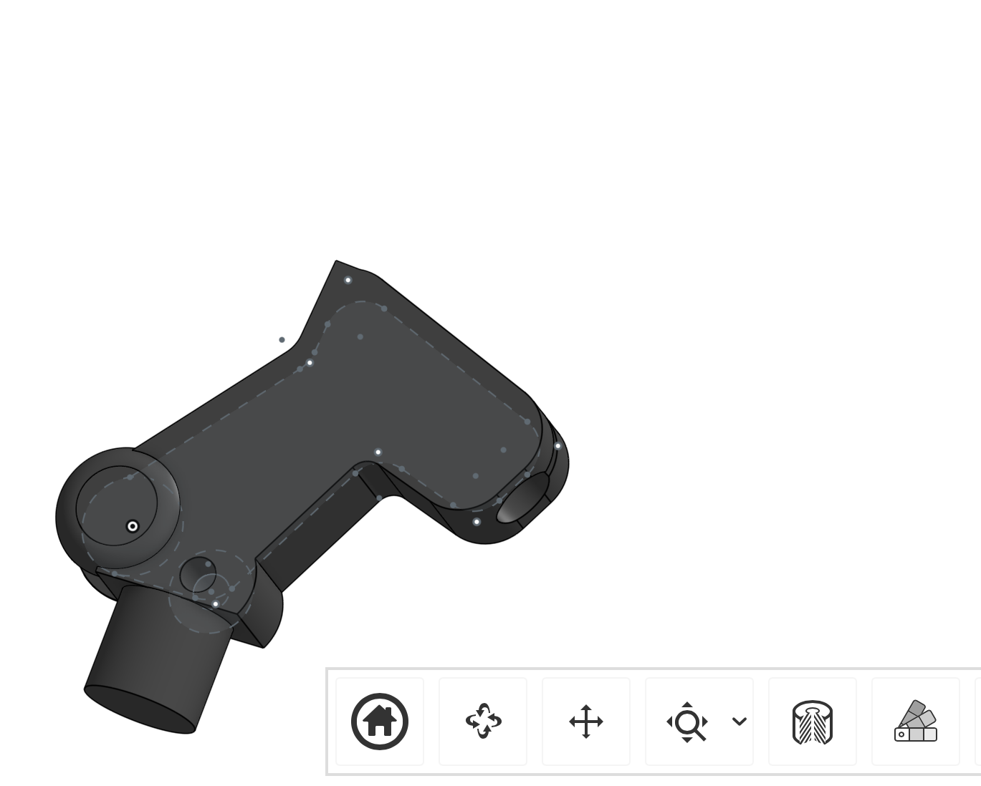
Figure 23: Redesigned part of the trigger
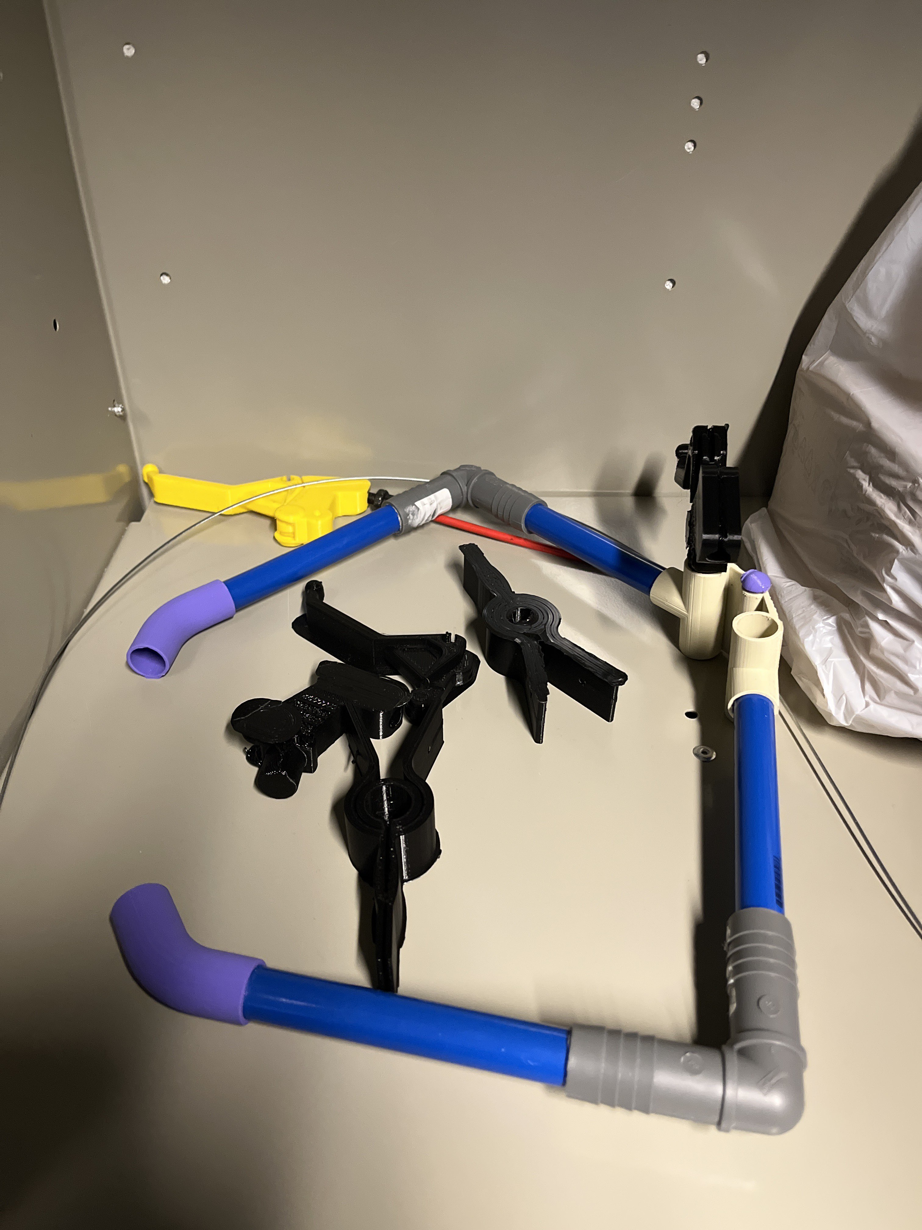
Figure 24: All parts of the final prototype
After all this all we were left with was putting everything together to make the final prototype.
Figure 16: All subsystems put together.

Clamp and Trigger Subsystem
The first subsystem includes cables, bicycle brake triggers, screws acting as stoppers, a hose acting as cable covering and clamps.

BOM (Bill of Materials)(Lemuel)
Item # | Description | Quantity | Unit Cost (CAD) | Extended Cost (CAD) (For students) | Extended Cost (CAD) (For Non-students) | Visual Representation
1 | 3-D printing (clamps and triggers) | 4 | 0 | 0 | 110
2 | Cables | 2 | $4.95 | $9.90 | $9.90
3 | Screw | 2 | $2.50 | $5.00 | $5.00
4 | Hose | 2 | 0 | 0 | N/A

Equipment list
- 3D printer
- Spanner
- Wire cutter

Instructions(Lemuel)
First design the clamp and triggers on Onshape using the diagrams below.
Figure 17: Images of Onshape design of 3D-printed bicycle brake trigger and Clamp
Then 3D-print the designs. The prints may have extra filling on them so make sure to chip them away. The designs are made with holes for the cables. Insert the cables through these holes to connect the clamps to the triggers. Before this though, make sure to fit the cable through the hose. Once the clamps and triggers have been connected, add the stoppers to the end of the trigger and to the uninsulated end of the cable just beyond the clamp. Using a spanner, tighten the stopper on to the cable.
Figure 18: Trigger, clamp, stopper, cables and cable cover making a system.

Testing & Validation
The test for the first subsystem was straightforward as we were only testing the functionality of this subsystem. We were looking to see if the triggers would trigger the clamps to open like we expected. By pulling on the lever of the trigger we were able to get the clamp to open.
The second test we carried out was when we had assembled all the subsystems together to get the final prototype. This test was to see if the first subsystem would still be functional when attached to the frame we built. Once we were able to fit the triggers on the frame and attach the clamps to the frame as well, we pulled the triggers to see if the clamps would still open and they still worked. However once opened, they don’t fully close.

Conclusions and Recommendations for Future Work
LESSONS LEARNED
- Have a clear idea on how ideas work practically and find ways to test them before purchasing materials.
- There might be easier ways to execute an idea than initially envisioned, make sure to always look for them.

For now, I think this is the most practical prototype that can be implemented in the time given. To improve this prototype more care with measurements and dimensions is required as that is what made our clamp unable to function optimally.
If we had more time, we would put more care into the dimensions of our prototype as it was carelessness with dimensions that inhibited the functionality of our final prototype. We had to abandon making our device adjustable due to lack of time available.

Bibliography

Insert your list of references here.

APPENDICES

APPENDIX I: Design Files
https://makerepo.com/Jasem/1965.grip-and-go
Table 3. Referenced Documents
Document Name | Document Location and/or URL | Issuance Date

APPENDIX II: Other Appendices
You can include other critical and important work here. Maybe they are not important in the structure of this document but need to be included.

