Objective:
Devise a test plan and develop your third prototype. Get customer feedback on your prototype.
Instructions:
Teams will outline a prototyping test plan based on the template provided in “Lecture 11 – Prototyping Test Plan” and develop a prototype which will be used to achieve the objectives your team has set out in this plan (i.e. you need to answer the “why”, “what” and “when” of prototyping). Typical objectives include communicating and getting feedback for ideas, verifying feasibility, analysing critical subsystems or system integration or reducing risk and uncertainty. You must also define a stopping criteria which will allow you to end the test once you are satisfied that you have achieved your testing objectives. Be very clear about what you are trying to measure and define an acceptable fidelity based on the objectives of your prototype. See https://wiki.makerepo.com/wiki/Design_for_manufacturing.
Since this will be your team’s third prototype, your justifications and reasoning for this prototype should include a short explanation of your results from your previous prototypes and how this third prototype continues the development of your solution. This third prototype should be a fully functional version of your solution (i.e. a comprehensive prototype). Keeping in mind the total course budget of $100, get creative in order to improve your results. It does NOT need to be the version you would actually sell. Finally, you must gather feedback and comments on your ideas and prototype from potential clients/users that you have sought out and identified on your own and/or your actual client.
Carefully document your prototyping test plan and results (including detailed images of your prototype), as well as the feedback and comments you have gathered. Again, it is strongly recommended that you start early. You may have two weeks to complete this prototype, but keep in mind that this prototype should be comprehensive and will require a significant amount of time to complete.
Also submit trello board a usual

Project Deliverable H: Prototype III
GNG 1103 – Engineering Design

Group A13:

Maurice Hartlieb - 300105453
Jean Gaster - 300072874
Bradley Cole - 300172151
Mathieu Lagacé-O’Connor - 300184437

Faculty of Engineering
University of Ottawa

Our Previous Prototypes
Prototype 1: In this prototype a baseline layout was developed. This version had no functionality whatsoever, and was only for aesthetic purposes. This prototype, however, allowed us to visualize what had to be completed in the coming weeks, and how we could divide the work amongst each other. To decide on a theme, each group member made a draft with pen and paper, and these were combined into a virtual draft.
Prototype 2: Prototype two was mainly focused on basic functionality (buttons). Each team member created a version of their designated section, and attempted to learn how to link individual pages with buttons. Once this was accomplished, each member’s java and XML scripts were combined in one document. The next goal was to code further functionality into the interface (search bar, live map, sign-in, drone communication, ect…).
How Has Our Prototype Improved?
Prototype 3: Over the last two weeks we have advanced our prototype to a new level of functionality. Our goal for the third deliverable was to have an interface that was user interactable and can save user input. We have reached this goal and still plan on working towards even greater functionality leading up to design day.
How Will We Test Our Latest Prototype?
Our plan for testing prototype three is to use a focus group (made up of mainly our individual families and friends) to test the functionality and reliability of our app. We want to see if our design can withstand rapid use without crashing and/or stuttering. From this we hope to gain an idea of what needs to be coded differently. We have found that simplistic code design is usually the most effective and reliable, and that most times crashes are a result of over complex code. A metric that would be reliable in this testing is crash percentage. The idea behind this would be to repeatedly do a task in the app, and find how many times the app malfunctions. Areas with higher malfunctions rates will then be looked at and changed if possible.

Test ID | Test Objective  (Why) | Description of Prototype used and of Basic Test Method  (What) | Description of Results to be Recorded and how these results will be used (How) | Estimated Test duration and planned start date  (When)
1 | Is the interface easy to navigate? | The physical app was given to the test subject, and they were asked to navigate through the app. | The user found that the initial pages were difficult to operate, however was less confusing when the color coded buttons were used. | Was started at the end of prototype 2. Results were taken into consideration when corrections were made.
2 | Testing the individual buttons to make sure that they work since this is vital to the functionality of the app. | This is a focused test of the buttons that is performed by every member of the team individually on every button in the app. | Each team member will keep a list of the buttons that do not yet function and report to the team which buttons were causing issues | Dependencies: ever button needs to be coded properly. The test should take no more than a half hour and will start as early as possible (once all buttons are coded)
3 | Testing how well the save choices option works. | The user was asked to enter what they wanted into the app and save it. | The selection save feature was easy for the user to operate, however the user could not find the search button at first. | This was done just before prototype three was submitted.
4 | Testing reliability of app, (whether or not it crashed when something was done). | The same task of entering an item into the saved options was done repetitively. | The app would “stutter” or crash about 1 out of ten times the task was done. | This was carried out prior to prototype three.
5 | Testing the overall design | The app initially had 2 set designs and to determine which design was better we surveyed members of our family and would expect to expand and survey individuals in a more rural setting. | The overall surveyed population preferred white design mainly because the logo stood out and the app was “eye-catching”. We used colour white as it represents cleanliness (jamZ promotes contactless delivery during this pandemic) | This was done a little before prototype 1 and ended around the start of prototype 2.This is when the team finalized overall concept and design.
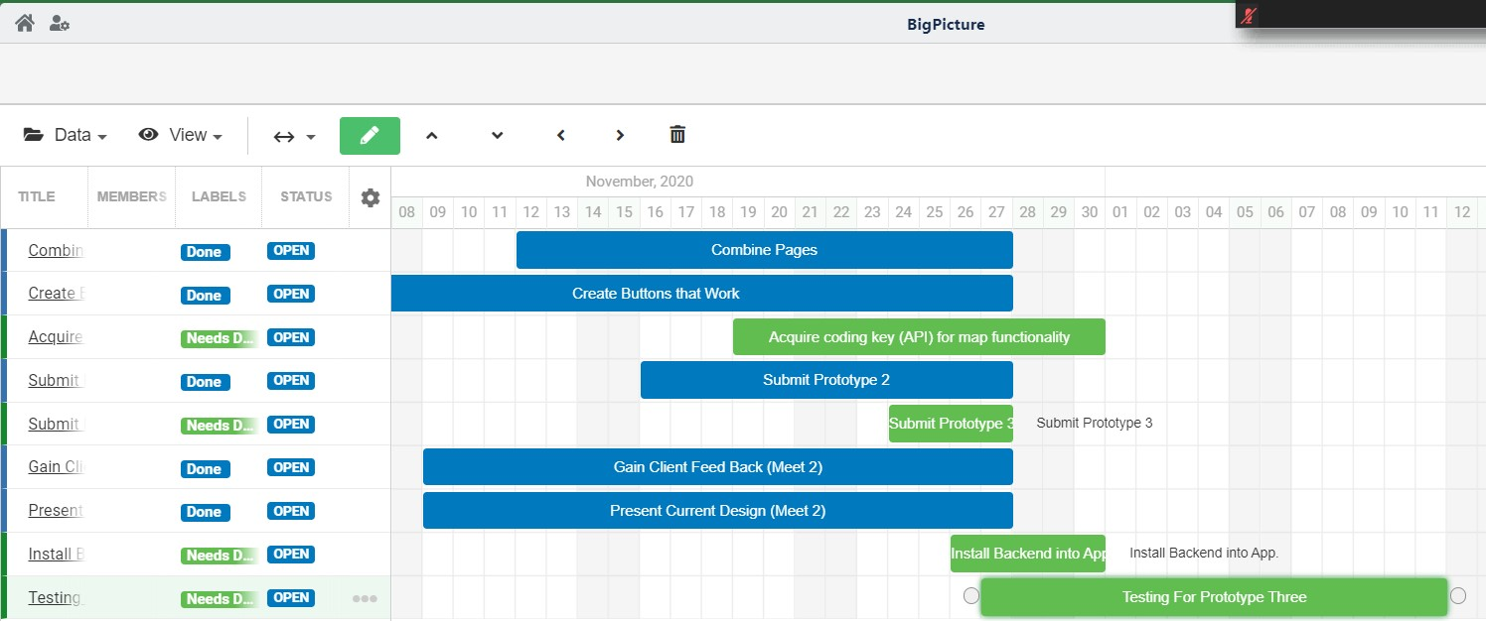

App changes:
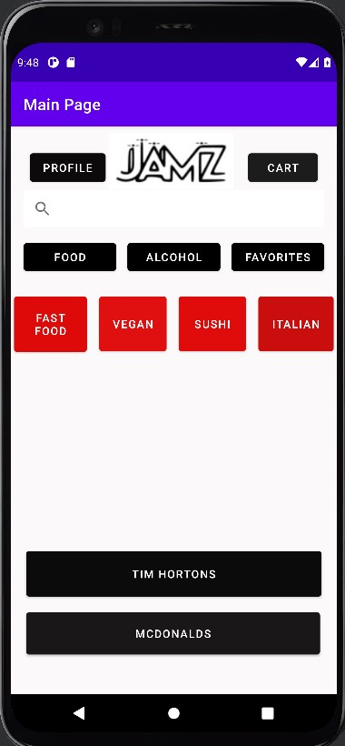
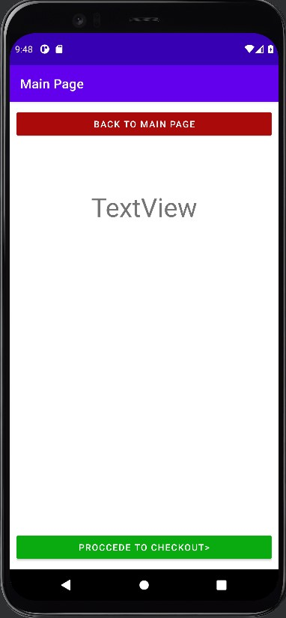
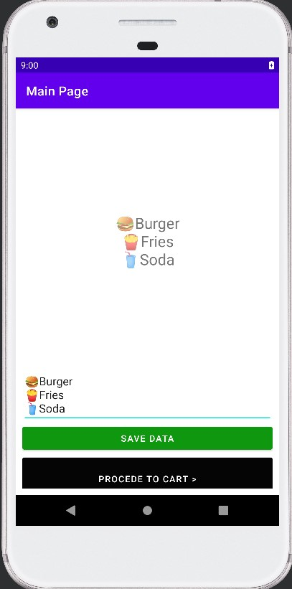
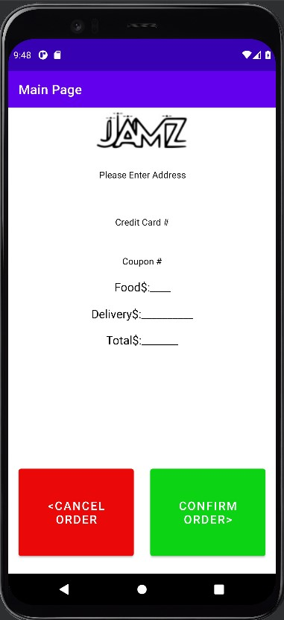
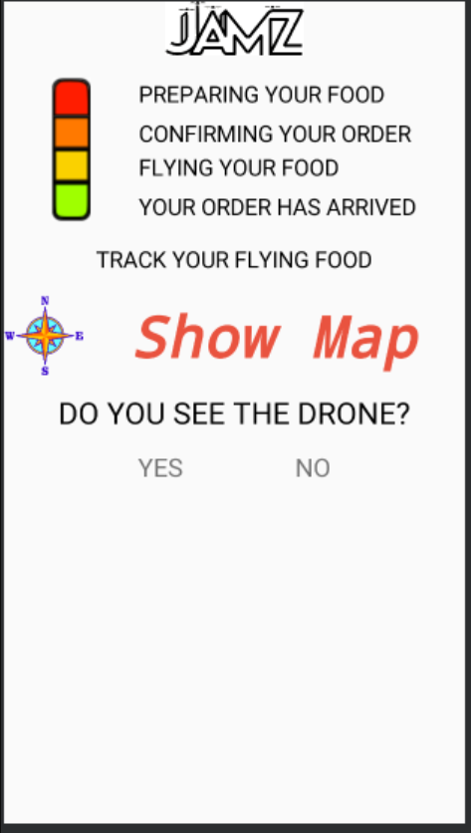

The “Track Your Order” page has lost the previous map icon and instead we have added the “Show Map” button with a compass. Now this button will lead customers to the map that shows the location of the drone. This map will be incorporated from google maps. This map will show the location of the drone, its predicted delivery time and the route it takes. This will allow customers to know exactly where their package is located throughout the entire delivery process.We had difficulty showing how the map would look in the final product, as android studio would just open up a blank Google Maps instance. Overall the page continues to follow the theme and the “Show Map” sign in pink draws attention to the customers.

