Project Schedule and Cost
Brooke Joyce, Hassan Ahmed, Ancelin Avenido, Jacky Zhu, Christopher Webster
February 20th, 2022

Table of Contents
1 Design Drawing 4
1.1 Picture 1: Detailed Design Drawing 4
2 BOM 5
2.1 Table 1: 5
3 List of Equipment 7
3.1 Table 2: List of Equipment 7
4 Significant Project Risks 9
4.1 Table 3: Risks 9
5 Prototyping Test Plan 10
5.1 Table 4: Plan 10
6 Wrike Snapshot Link 11

Design Drawing

Picture 1: Detailed Design Drawing
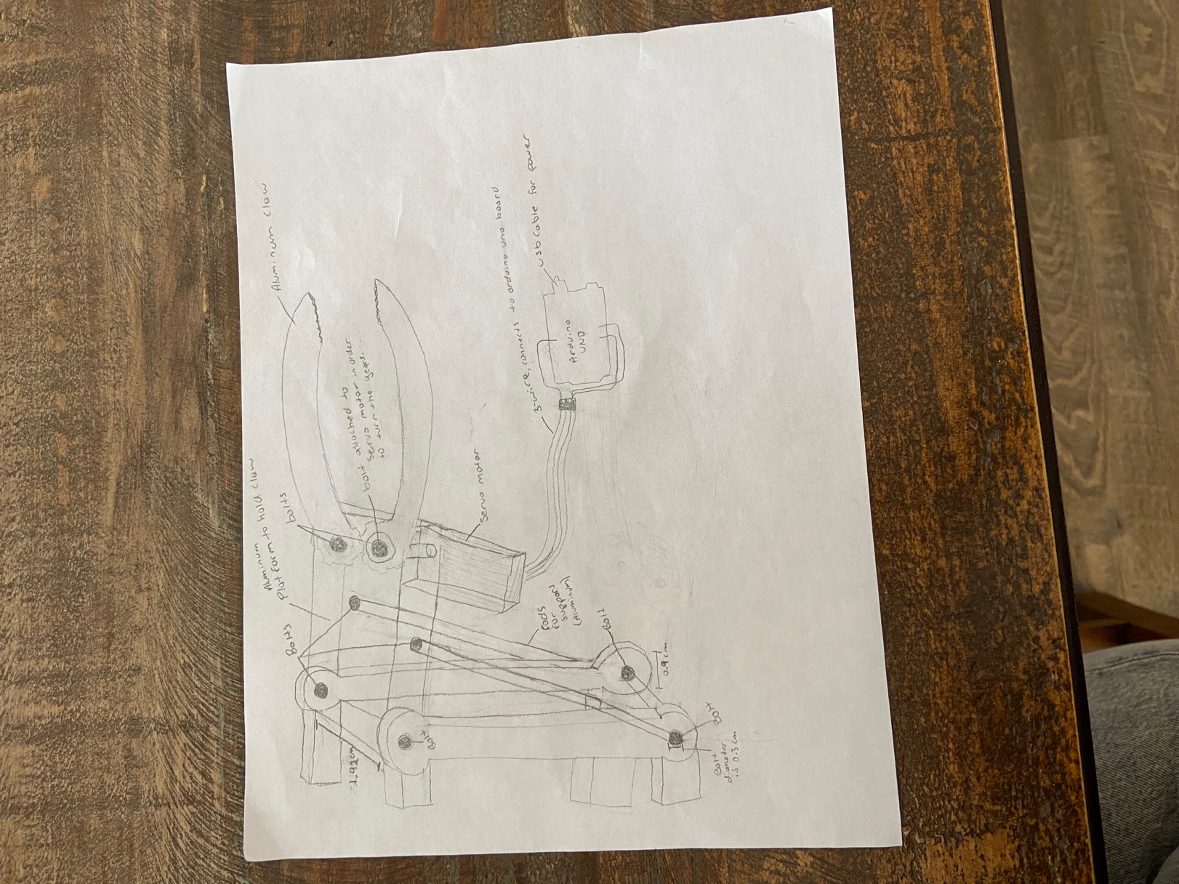

BOM

Table 1:
Item Name | Description | Unit of Meaure | Quantity | Unit Cost ($) | Extended Cost | Link
Aluminum Platform | To hold the claws, (1.92x3.70)cm, Volume 7.104cm^3 | cm^3 | 1 | 0.0634 | N/A | https://makerstore.ca/
Aluminum Rods | To support the end-effector platform, Length=3.8 cm and Diam= 0.3 cm (BUT ONLY IF THE CLAW IS HEAVY ENOUGH TO NEED IT, TAs can judge this) | cm^3 | 2 | 0.0096 | N/A | https://makerstore.ca/
Aluminum gear claws | To hold a camera, based on calculation the Total volume is 8.131cm^3, id we can only order in blocks, get a 10cmx2cm block | cm^3 | 2 | 0.357 | N/A | https://makerstore.ca/
Servo motor with wires and horn | To control the claws | N/A | 1 | 22.99 | N/A | https://www.amazon.ca/ZOSKAY-Waterproof-DS3218-Digital-Control/dp/B07Q3YF2NB/ref=sr_1_31?crid=J3BD4KIN29KV&keywords=servo+horn&qid=1645389606&sprefix=servo+horn+%2Caps%2C153&sr=8-31
Bolt | To bolt down the end-effector, nominal diameter=0.3cm (FIND BOLTS WITH WASHERS INCLUDED, IF NT THEN DON'T GET THEM) | cm | 8 | 0 | N/A | https://www.homehardware.ca/en/10-pack-6-32-x-1-12-zinc-plated-round-head-machine-screws-with-nuts/p/2125649?page=category%20page#ccode=17298
Arduino Board (Including USB Cable) | To control position precisely | N/A | 1 | 27.99 | N/A | https://www.amazon.ca/ARDUINO-A000066-Uno-DIP-1-5/dp/B008GRTSV6/ref=asc_df_B008GRTSV6/?tag=googleshopc0c-20&linkCode=df0&hvadid=292998575882&hvpos=&hvnetw=g&hvrand=6283618637980886509&hvpone=&hvptwo=&hvqmt=&hvdev=c&hvdvcmdl=&hvlocint=&hvlocphy=9000668&hvtargid=pla-457497319401&psc=1
Washers | To keep scres from loosening, can fit a hole of 3cm nominal diameter | cm | 8 | 2.99 | N/A | https://www.homehardware.ca/en/10-pack-6-32-x-1-12-zinc-plated-round-head-machine-screws-with-nuts/p/2125649?page=category%20page#ccode=17298
Small rubber bands | For grips on end of claws | N/A | 1 | 0.99 | N/A | https://www.walmart.ca/en/ip/Annie-Rubber-Bands-Black-3149-Black/PRD0SAFYJO3ICUG
Screw driver | To screw in the bolts | N/A | 1 | 0 | N/A | Brooke has one
Laser Cutter | To laser cut the flat platform and claws | N/A | 1 | 0 | N/A | https://engineering.uottawa.ca/ceed/design-spaces/makerspace
 |  |  | Total Cost(no taxes) | 55.39
 |  |  | Total cost(Taxes) | 62.5907

List of Equipment

Table 2: List of Equipment
List of Equipment
Item Name | Description | Type | Prototype | Source
Aluminum Platform | Base of end effector | Material | 3 | https://makerstore.ca/
Aluminum Rods | Hold and support the end effector | Material | 3 | https://makerstore.ca/
Aluminum gear claws | To hold the camera (or other items) | Material | 3 | https://makerstore.ca/
Servo motor with wires | Control the movement of the claws | Software/motor | 3 | https://www.robotshop.com/ca /en/9g-micro-servo-motor-4-8v .html
Servo Horn | To control the gear from the servo motor | Equipment | 3 | https://www.amazon.ca/Servo- Teeth-Futaba-TowerPro-Acces sory/dp/B07DPGWCRR
Bolts | To hold together the end effector with the arm | Material | 3 | https://www.homehardware.ca /en/10-pack-6-32-x-1-12-zinc- plated-round-head-machine-s crews-with-nuts/p/2125649?p age=category%20page#ccod e=17298
Arduino Board | To control position precisely | Software | 3 | https://www.arduino.cc/en/mai n/products
USB for power | To power motors and board | Power Supply | 3 | https://www.amazon.ca/UGRE EN-Printer-Computer-Scanner -Brother/dp/B00P0FO1P0/ref= sr_1_5?crid=2D7HFRQCYIVS 8&keywords=usb%2Bb&qid=1 645335196&sprefix=usb%2Bb %2Caps%2C64&sr=8-5&th=1
Washers | To prevent bolts from loosening | Material | 3 | https://www.homehardware.ca /en/10-pack-6-32-x-1-12-zinc- plated-round-head-machine-s crews-with-nuts/p/2125649?p age=category%20page#ccod e=17298
Small rubber bands | Grips for end of claw | Material | 3 | https://www.walmart.ca/en/ip/ Annie-Rubber-Bands-Black-3 149-Black/PRD0SAFYJO3IC UG
Screw driver | To tighten the bolts | Equipment | 3 | https://www.homedepot.ca/pro duct/dewalt-ratcheting-screwd river-with-removable-bar-and- 12-bits/1000708398
Laser Cutter | To laser cut platform and claws | Equipment | 3 | https://engineering.uottawa.ca /ceed/design-spaces/makersp ace
Cardboard | For the platform, claws, and trusses on arm | Material | 1 | Household Supply
Hot Glue | To hold parts together and mimic a servo horn | Material | 1 | Household Supply
Paper clip | To mimic a servo motor | Material | 1 | Household Supply
String | To help hold in the end-effector | Material | 1 | Household Supply
Tape | To hold together the platform | Material | 1 | Household Supply
Pin | To hold in the claw | Material | 1 | Household Supply

Significant Project Risks
- The parts get broken during the process of laser cutting.
- The time of finishing the project might take longer than we expected (switch the tasks between each team member, cut off some unnecessary part of project plan).
- The prototype might get broken when moving it around. (Prepare some extra parts for the prototype).
- The money that spent on the project might go over the budget. (Replace some unnecessary part of the prototype with cheaper materials).
- The plan might get misunderstood by some team members. (Hold scheduling meeting with team regularly to make sure that each team member understands their work that they must done).
- The prototype might not work as intended. (Look at the other machine that are similar to our project, take inspiration from it.) [ask Ta, professor, and other team (if we can) for ideas].
- Materials that are required for the prototype are lost. (Purchase extra).

Table 3: Risks

Risk | Likelihood that this will happen | Level of Impact that the risk will cause | Plans to mitigate the risk
The parts got broken during the process of laser cutting or 3D printing | Medium | Medium  (The process of making the prototype is delayed) | Double check the process of laser cutting and 3D printing. Make sure that we know how to do these processes correctly and safely.
The time of finishing the project might take longer than we expected | Medium | Medium  (We might not be able to finish the project on time) | switch the tasks between each team member, cut off some unnecessary part of project plan.
The prototype might get broken when moving it around. | Medium | High  (It will delay the process of testing the prototype and fixing it takes time) | Prepare some extra parts for the prototype.
The money that spent on the project might went over the budget. | Low | Medium | Replace some unnecessary part of the prototype with cheaper materials
The project plan might get misunderstood by some team member. Members didn’t know what they need to do. | Medium | High  (Delay the process of making the prototype and affect the quality of the prototype.) | Hold scheduling meeting with team regularly to make sure that each team member understands their work that they must done.
The prototype might not work as intended. | Low | High  (The prototype might not get approved and it will affect the grade of this project.) | (Look at the other machine that are similar to our project, take inspiration from them.) [ask Ta, professor, and other team (if we can) for ideas].
Materials that are required for the prototype are lost. | Low | Low | Purchase extra.
Some team members might get sick so they will no longer be able to finish the task that are assign to them | Medium | Medium | The rest of the team can split up the task and finish it together.

Prototyping Test Plan

Table 4: Plan
Test ID | Test Objective  (Why) | Description of Prototype used and of Basic Test Method  (What) | Description of Results to be Recorded and how these results will be used (How) | Estimated Test duration and planned start date  (When)
1 | Testing the overall movement of the end effector connected to the arm to avoid error in the arm’s overall function | Comprehensive prototype using a physical model | Record the arm’s overall functionality, stop when we are able to hold a camera. | This prototype is leaned more towards the end of the testing stage after all the subsystems are infused together  - Approximately a week or so before design day
2 | Testing the basic function and grip of the camera to decrease the chances of damaging the object held up by the arm (the end effector’s ability to hold the camera stable in place) | Focused prototype using a physical and/or analytical model  - Analytical  - Through the online software CAD Onshape, a visual of the model can be made  Cost: $0  - Physical  Materials include:  - using 3-D printing and laser cutting, the components can be made  - Go-pro  Cost: $62.5907 | -Record the dimensions (length, width and height of each component made and used)  - Compare initial, researched measurements with finalized ones  -Record physical observations of the quality to ensure no damage is done to the camera.  -Stop when the end-effector is able to pick up and hold the camera without scratching or dropping it. | 1-2 weeks before design day
3 | Testing the controllability of the code of the end effector (this will determine the opening and closing movement) | Focused prototype using a physical and/or analytical model  Materials include:  - Arduino uno  - USB port  Cost: $62.5907 | -Making notes on if the claw can open and close, how well it can open and close, and if it can hold the camera.  -Stop when the camera can be moved around without dropping. | 1-2 weeks before design day.

Wrike Snapshot Link
https://www.wrike.com/frontend/ganttchart/index.html?snapshotId=aSs9gTBP69Kl2mluF5EC6GIXjcI8fl9R%7CIE2DSNZVHA2DELSTGIYA

