GNG2101
Design Project Progress Update

<E3.4>

Submitted by:
Maanashan Rudranantha, 300318691
<Gong (Victor) Feng, 300176400>
<Lemuel Douglas, 300286474>
< George Osariemen Omoregie, 300325739>
<Jasem Alenezi, 300230705>

<Date>
University of Ottawa

Table of Contents
Project Deliverable Report Instructions i
Table of Contents ii
List of Figures iv
List of Tables v
List of Acronyms and Glossary vi
1 Introduction 1
2 Business Model Canvas and DFX 2
2.1 Business model and sustainability report 2
2.2 Design for X 2
3 Problem Definition, Concept Development, and Project Plan 3
3.1 Problem definition 3
3.2 Concept development 3
3.3 Project plan 3
4 Detailed Design and BOM 4
4.1 Detailed design 4
4.2 BOM 4
4.3 Project plan update 4
5 Prototype 1, Project Progress Presentation, Peer Feedback and Team Dynamics 5
5.1 Prototype 1 5
5.2 Project Progress Presentation 5
5.3 Project plan update 5
6 Design Constraints and Prototype 2 6
6.1 Design constraints 6
6.2 Prototype 2 6
6.3 Project plan update 6
7 Other Considerations 7
7.1 Economics report 7
7.2 Intellectual property report 7
7.3 Project plan update 7
8 Design Day Pitch and Final Prototype Evaluation 8
9 Video and User Manual 9
9.1 Video pitch 9
9.2 User manual 9
10 Conclusions 10
11 Bibliography 11

List of Figures
Insert your list of figures here (right-click to update this field).
List of Tables
Table 1. Acronyms vi
Table 2. Glossary vi

List of Acronyms and Glossary
Provide a list of acronyms and associated literal translations used within the document. List the acronyms in alphabetical order using a tabular format as depicted below.

Table 1. Acronyms
Acronym | Definition

Provide clear and concise definitions for terms used in this document that may be unfamiliar to readers of the document. Terms are to be listed in alphabetical order.

Table 2. Glossary
Term | Acronym | Definition

Introduction
Our design is meant to aid a seven-year-old girl in pulling up and pulling down her pants when she goes to use the restroom. The design must feature a releasable clamp mechanism capable of securely holding onto clothing. This requires careful consideration of the mechanism's design to ensure it can be easily operated by the user, given their limited hand strength and flexibility.

Some of the assumptions we made include:
- assuming the weight and size of the design (i.e. making sure it is not too heavy for the user)
- assuming the clamps we get can be squeezed into pants and grip onto the user’s pants.
- assuming the clamps grip does not harm the user’s clothing.
To test the weight and size of our design we will use the user’s measurements to calculate the volume of our design and multiply that by the density of the material we are using (which is PLA, which has a density of 1.25 g/cm³).

To test the grip of the clamp we can get an average grip strength/force of the specific clamp we are interested in and use that to calculate if it generates the force required to help our client pull up or pull down her pants. We will try the clamp that we choose on clothing that we do not use anymore to determine if it could harm the user’s clothing.
This document presents our prototypes, how we intend to present each prototype and project plan updates. We also discuss and record the improvements on our design and the decision we made for our next prototype and final product. We expect this report can serve as a comprehensive guide for designers and engineers tackling similar challenges in creating assistive devices for individuals with limited mobility. Our objectives encompass not only the successful development of a functional and ergonomic solution but also the enhancement of the user’s independence and dignity. By addressing the specific needs of our seven-year-old user, we aim to alleviate any discomfort or frustration associated with using the restroom independently.

Prototype 1, Project Progress Presentation, Peer Feedback and Team Dynamics

Prototype 1
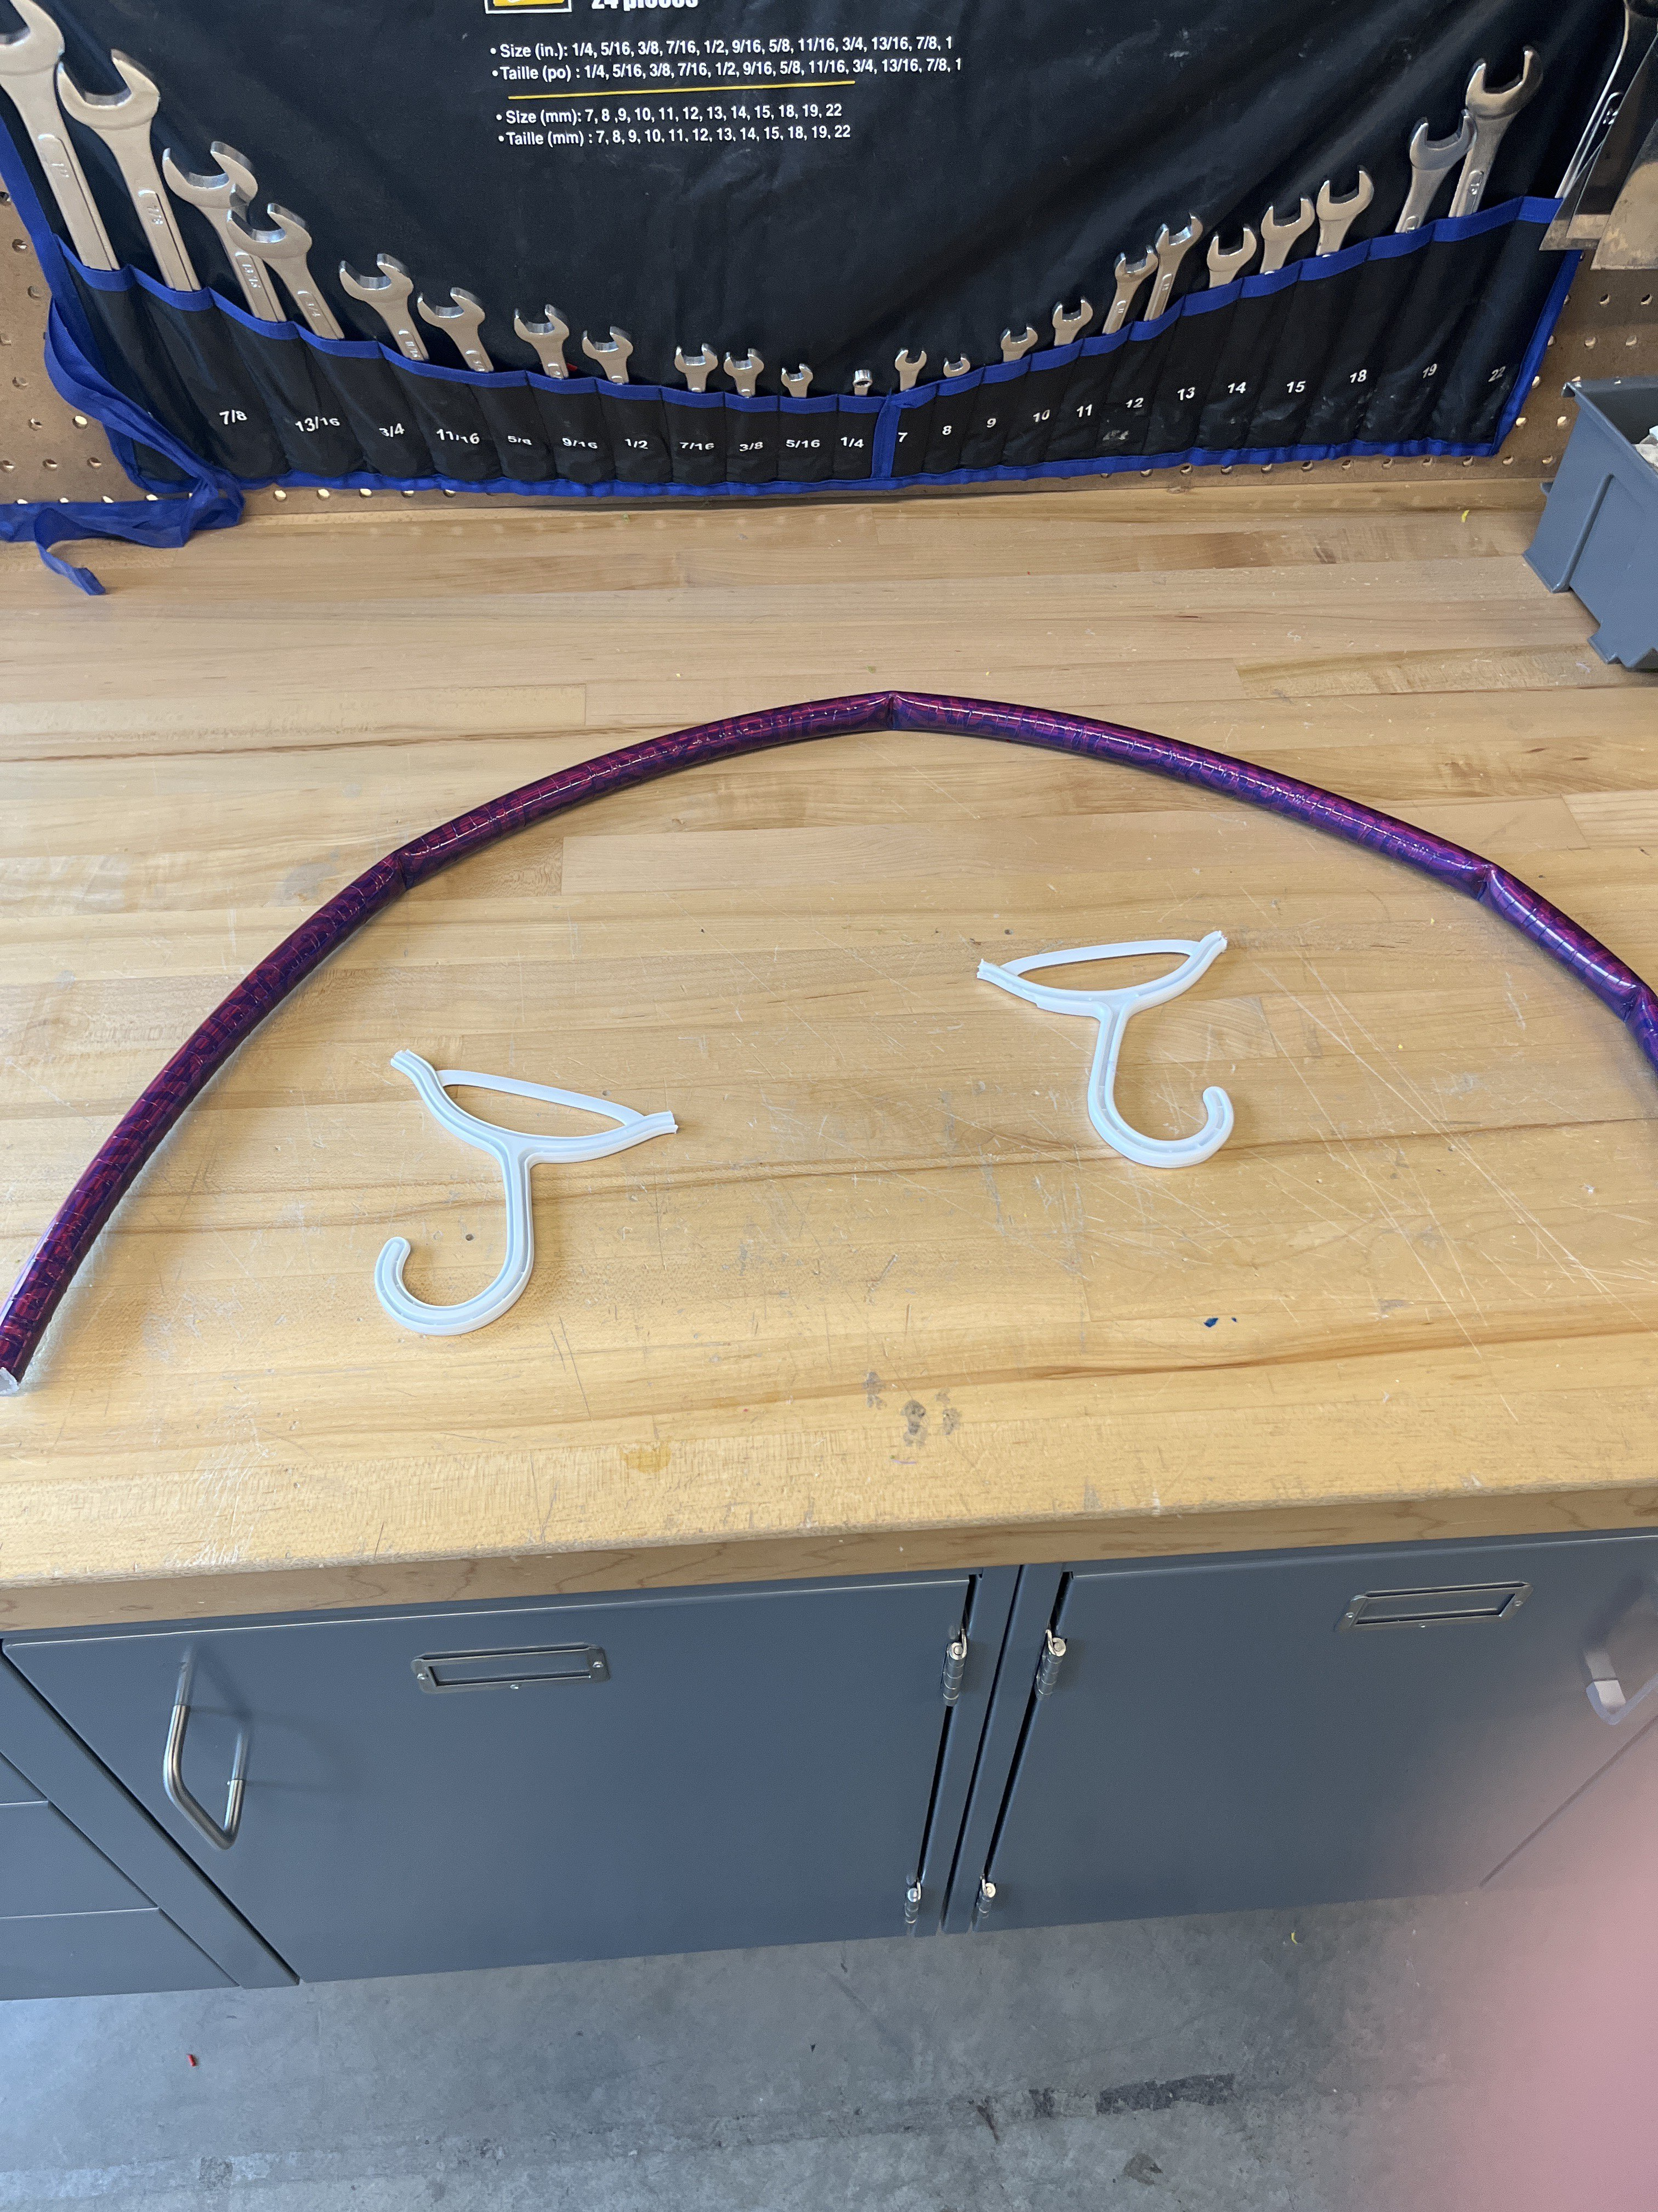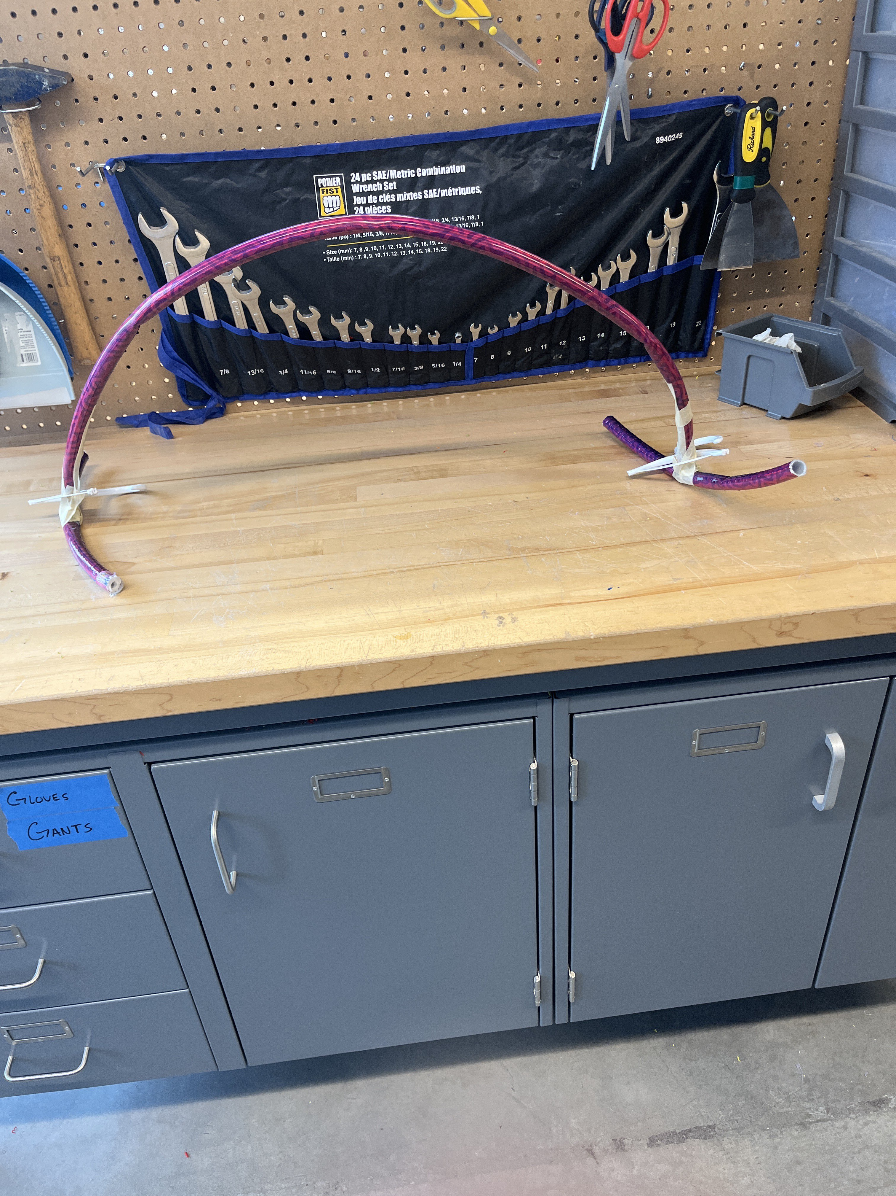

Our prototype aims to give us a brief overview of our design, and the main purpose of this prototype is to validate the subsystem of the clamps. We want to ensure the clamp can be squeezed inside the pants, the position that we should attach the clamps in the frame so that the user can use the clamps to pull up and down the pants.
Since the clamps in our prototype were broken when we implemented testing, I use the coat hanger to demonstrate the testing procedures.
Test the clamp can easily be squeezed into the pants:
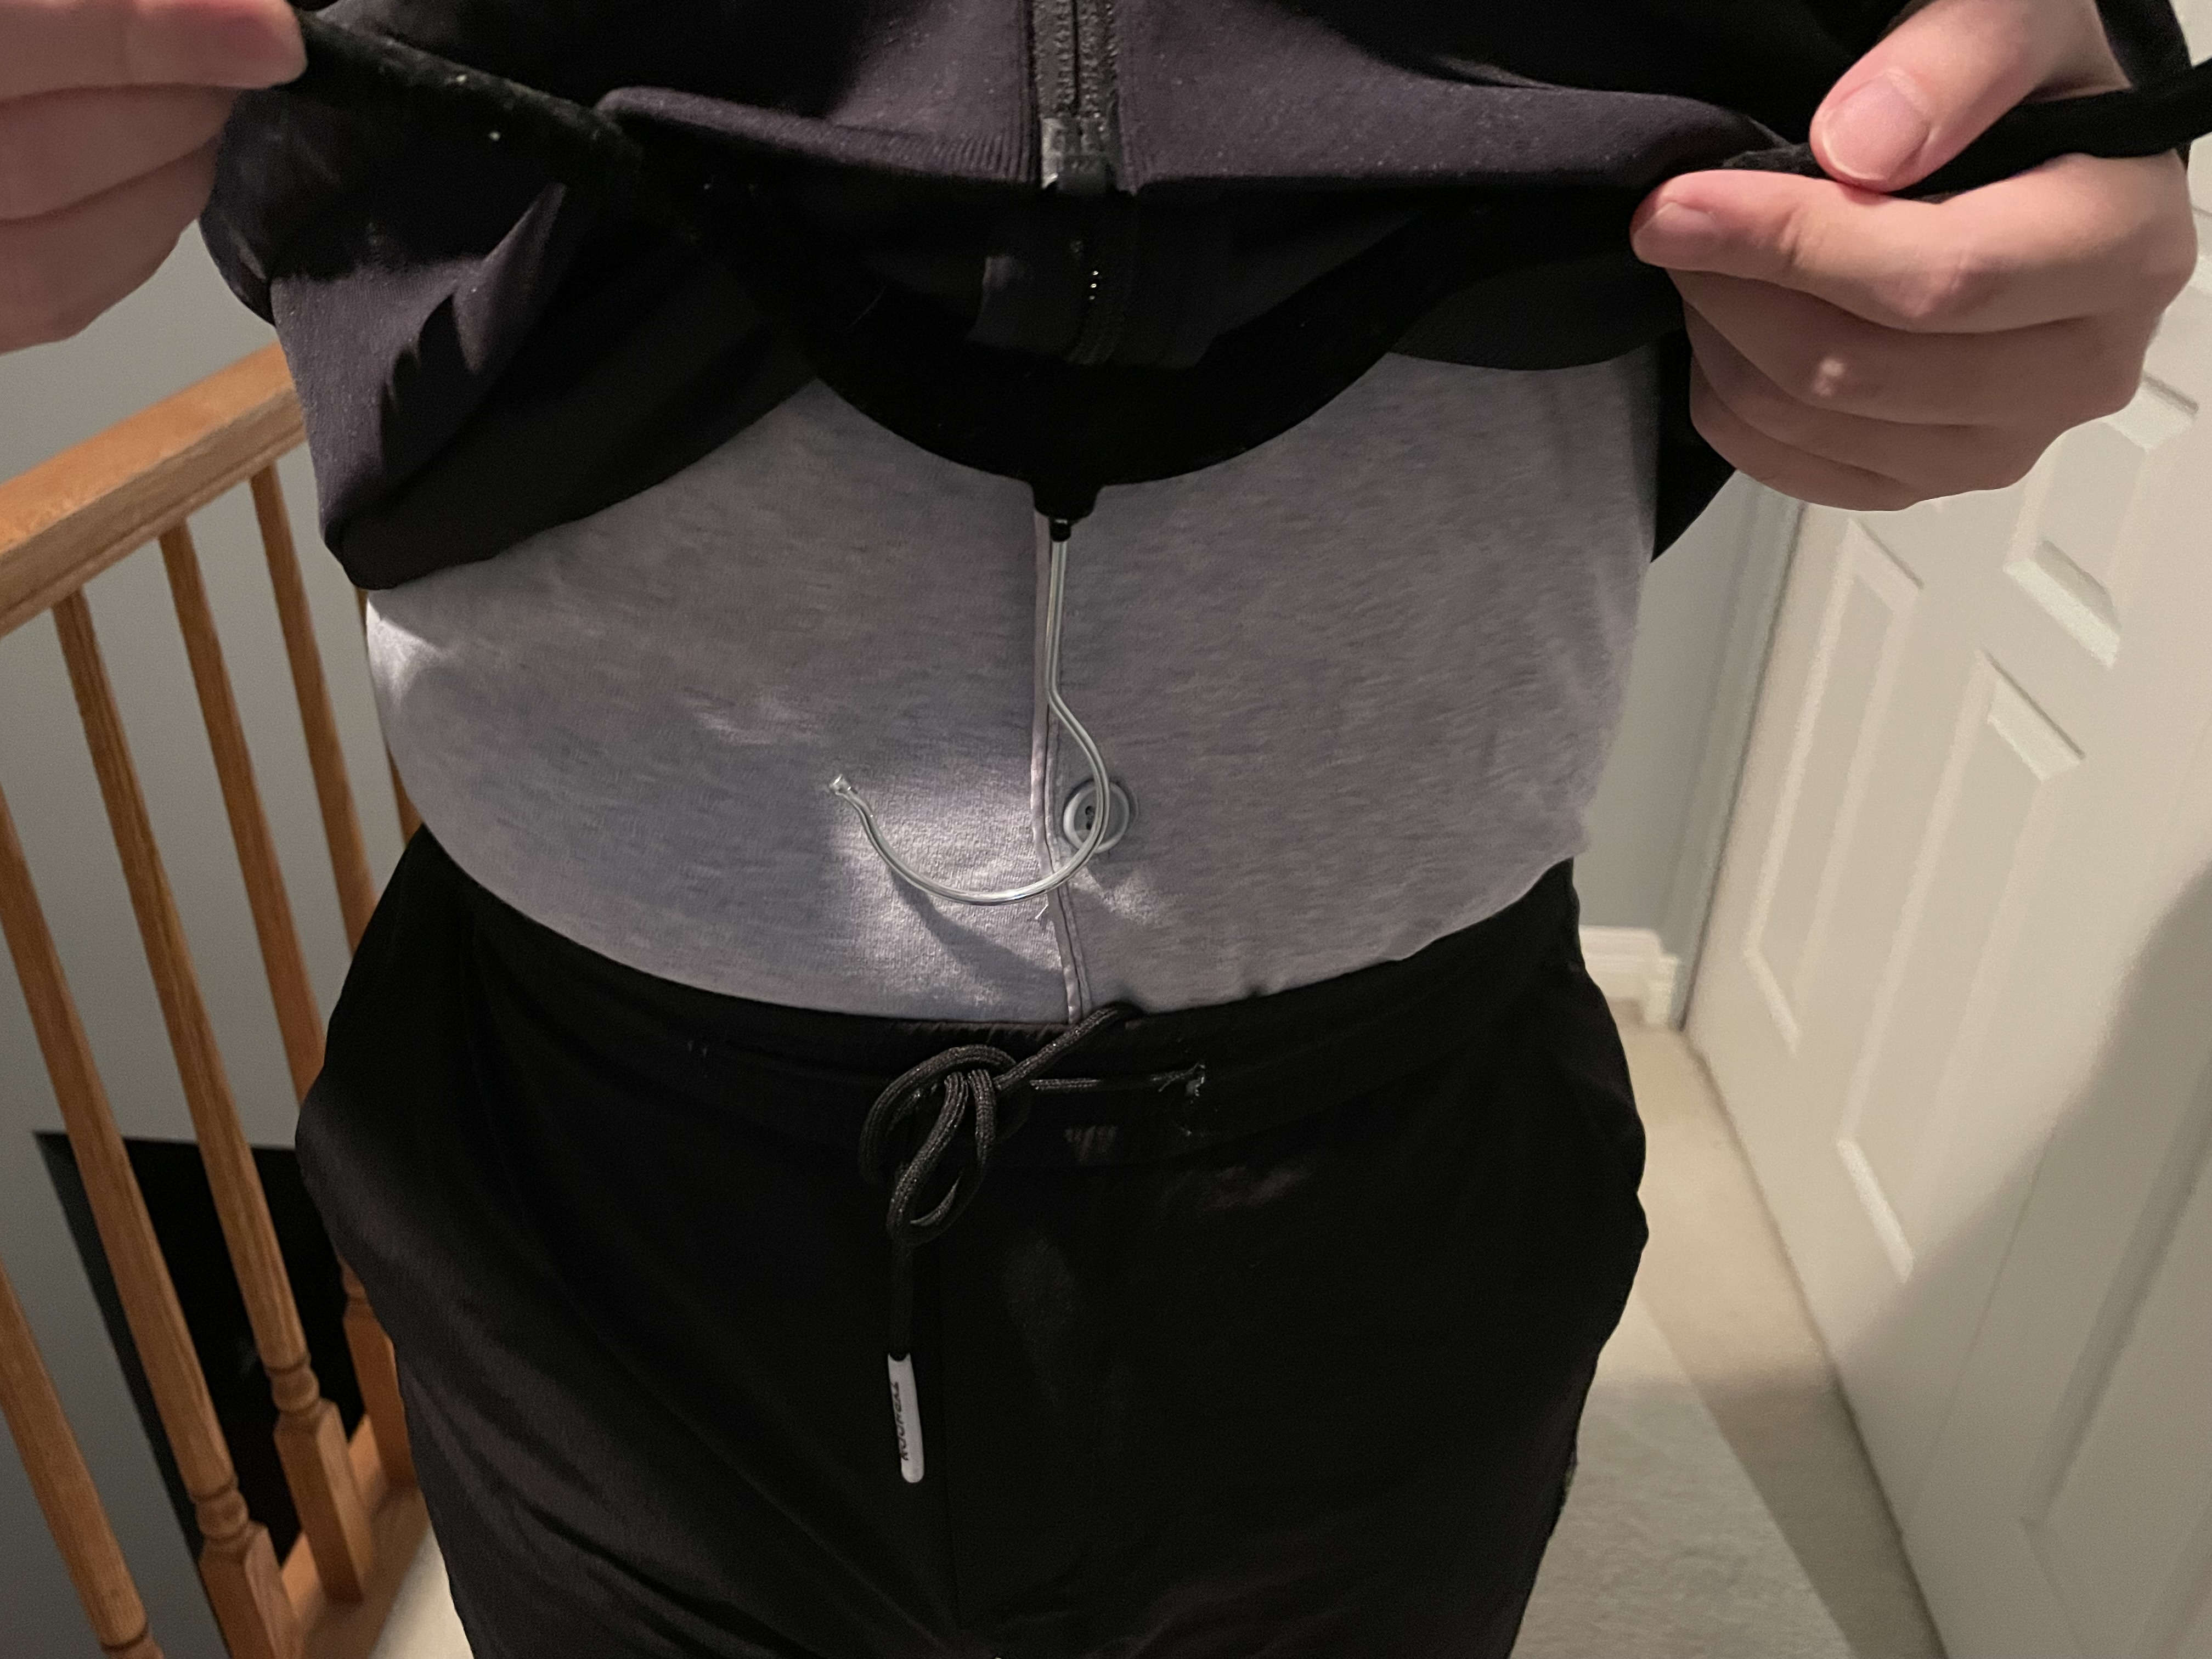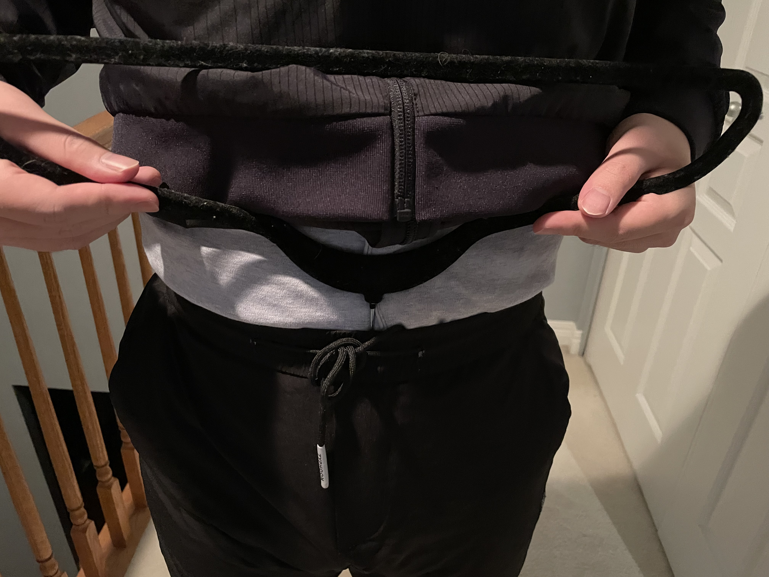

Test the best position to attach the clamps:
If the clamps are attached to the side, I feel it is not easy to pull up and down pants.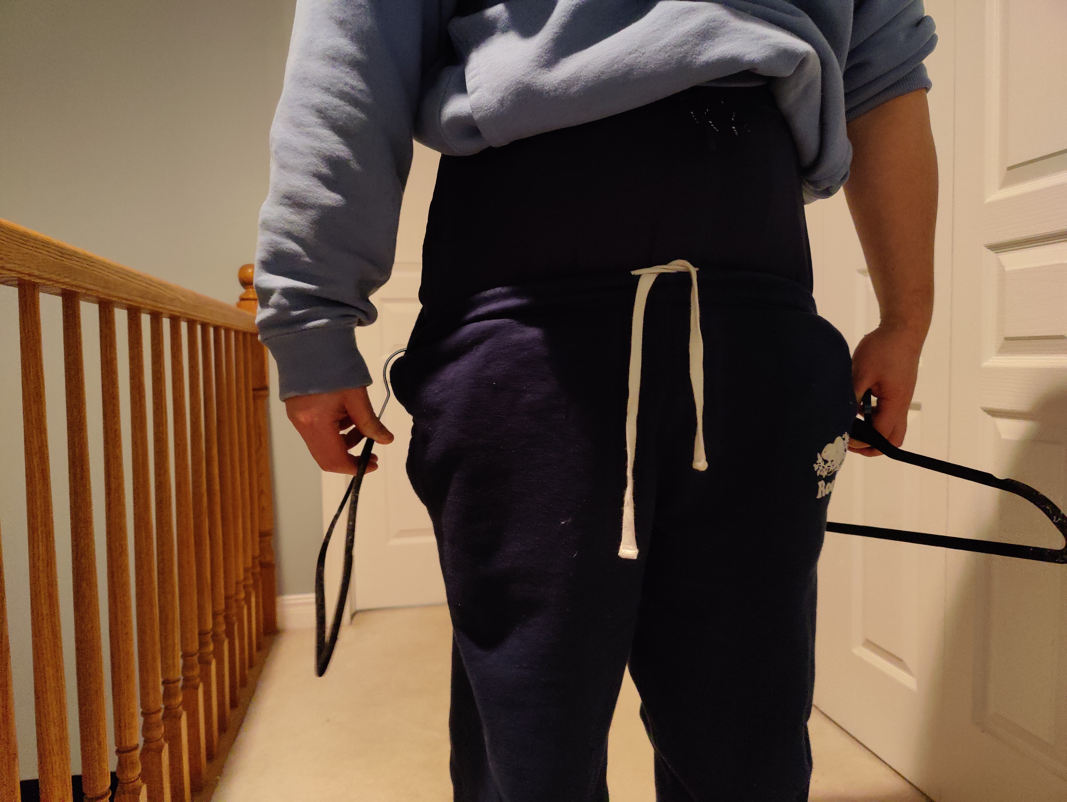

If the clamps are attached to the back, the procedure of pulling down and up pants are much easier, the user need to bend over a bit.
.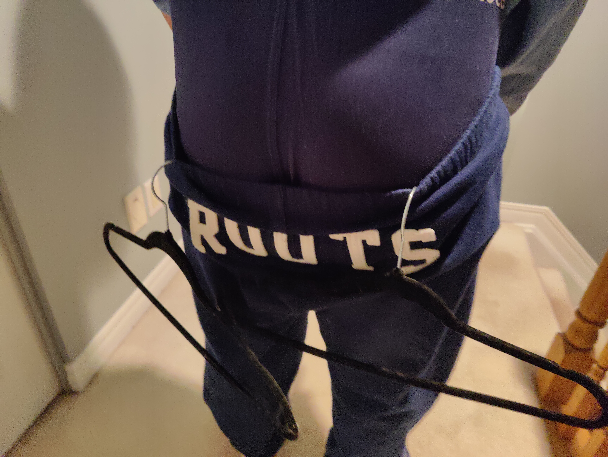

Target Specifications | Test Result
Functionality: Squeezing into pants | Yes
Functionality: Pulling down and up pants | Yes
Weight: 3lb | Yes (weight < 10 lb.)
Size (Height) | Yes
Size (width) | Yes
Clamp strength | No, clamps were broken in our prototype.
Safety | Yes, prototype did not harm closing.

Project Progress Presentation
Link to Presentation

Project plan update

Design Constraints and Prototype 2
Client feedback
The client stated that he’s fine with the idea that we will design the device all sizes, the usage of PVC in the frame, and the mechanism of the clamps. However, the client reminded us to use rubber or any other material so that the clothes will not be harmed of the clamps. We also proposed our next prototype, which is to design a hinge to connect the main frame, so that the user can adjust the positions of the clamps. The TA help us managing the client expectations by saying that “The project will be passed on to other team of students in the summer if our team did not fulfill his needs”. In general, the client liked our idea and look forward for the future prototypes.

Design constraints
To develop our second prototype, we've carefully considered three non-functional design constraints: Safety, Usability, and Cost.

Safety:
Ensuring safety with independence is our top priority, especially given the unique challenges posed by our user medical condition (arthrogryposis) and the bathroom environment. We've prioritized water-resistant design and materials to address potential water exposure hazards. Also, avoiding sharp edges, ensuring the clamps do not harm the user’s skin, and confirming that the clamp's material do not damage the clothing fabric or annoy the user in any way.

Usability:

We've implemented a user-friendly design with clear, intuitive controls that are easy for the user to operate. That is by ensuring she can easily operate the clamps. This involves the physical effort required to hold and release the clamps, the triggers accessibility, and the general mechanism.
Cost:

Considering our uncertainty about whether our prototype will meet the client's requirements, we've been mindful of costs. As such, we've opted to design parts and 3D print them, which is a cost-effective manufacturing method, particularly suitable for prototypes or low-volume production.

Regarding our approach for the second prototype, we had two options:

1. Purchase bicycle brakes and clamps from Amazon.
2. Design triggers and clamps using OnShape, then produce them using a 3D printer and assemble them.

After thorough discussion among team members, we decided to pursue the second option of designing and 3D printing the parts; however, we decided to buy PVC pipe from Home Depot to assemble our main frame, since it would take lots of time to 3D print the main frame, time cost is also a cost. Buying a PVC pipe costs less than 10 dollars and we only need to cut them to suitable length that we need.

Safety Concerns:

The bicycle brakes available on Amazon are relatively heavy and contain iron components that may rust easily when exposed to the bathroom environment. This poses potential safety risks to the user. So, we 3D printed the triggers and tested them, the results were good so far. In the coming weeks we are planning to increase the infill density of the triggers and give it to the client and user for feedback.

Usability Concerns:

Bicycle brakes come with two triggers—one for braking and another for adjusting speed gears. This complexity may confuse our user, and the design cannot be easily customized to meet the client's specific requirements. Conversely, 3D printing allows for customization and adaptability, crucial for accommodating the client's needs related to arthrogryposis. The 3D printed triggers make it easy for the user to hold and release the clamps with low physical power. Moreover, we are designing the adjustable parts Without sharp edges and with comfortable holders for the clamps. We Will ask the client to give us the. Detailed measurements for the user.
Cost Considerations:

While purchasing bicycle brakes and clamps from Amazon would cost around $40, 3D printing offers a cost-effective solution, especially for students, as it is free for students and suitable for prototyping or low-volume production. However, PVC pipe is totally affordable, compared to the time cost of 3D printing, purchasing PVC pipe is a good choice for our prototyping.

Design changed according to the constraints:

Original Trigger:
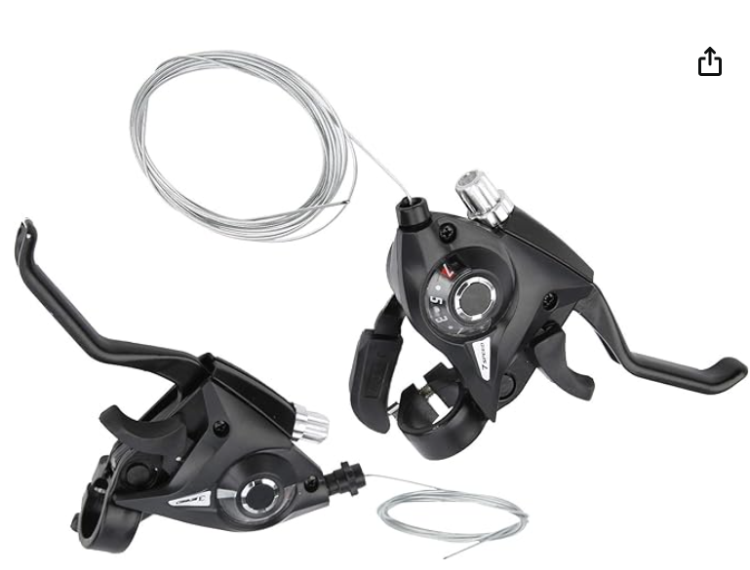
New Trigger:
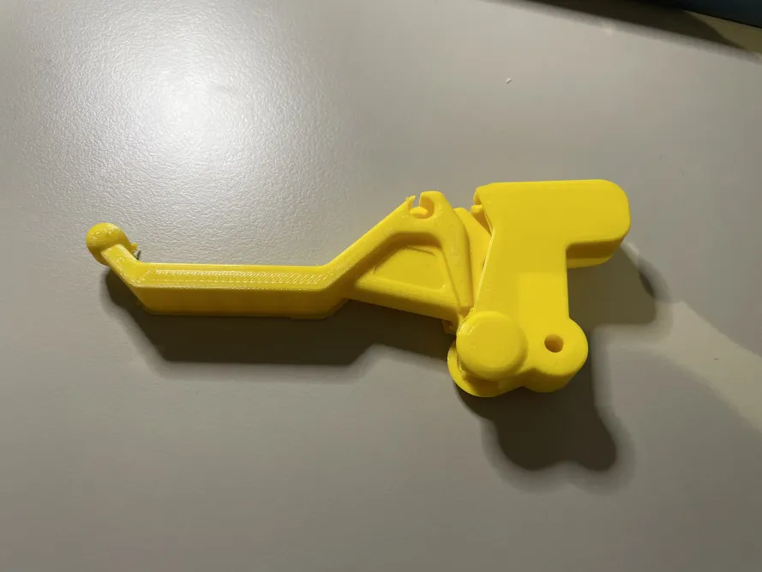Original clamps:
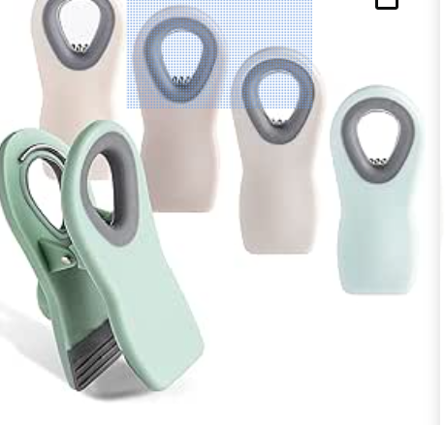

New clamps:
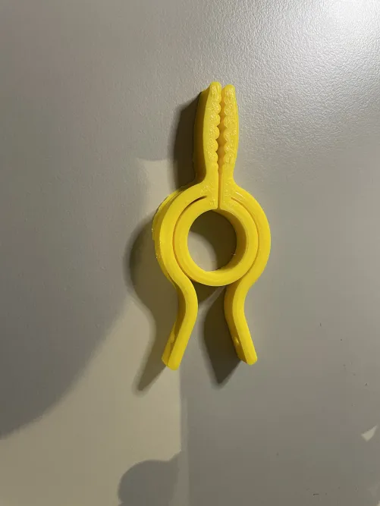
Old frame and adjustable parts:
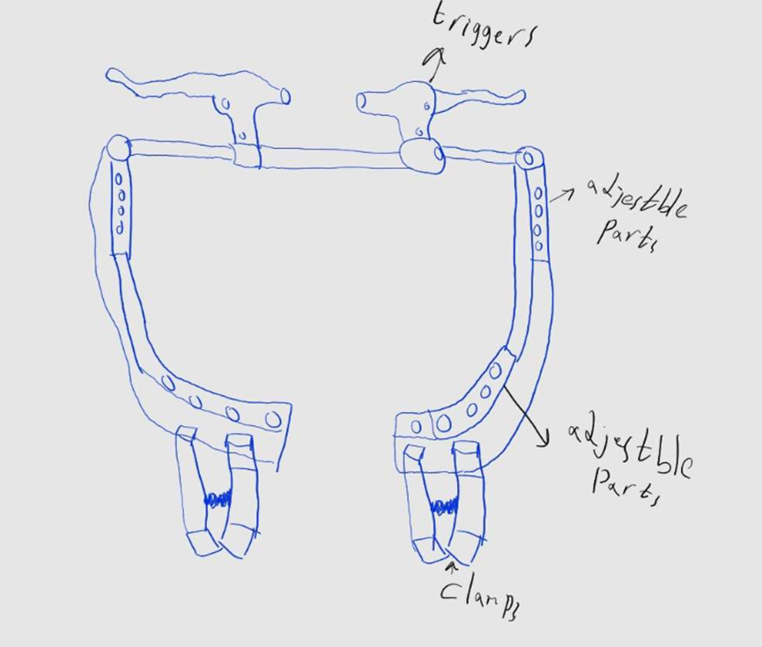

New frame and adjustable parts:
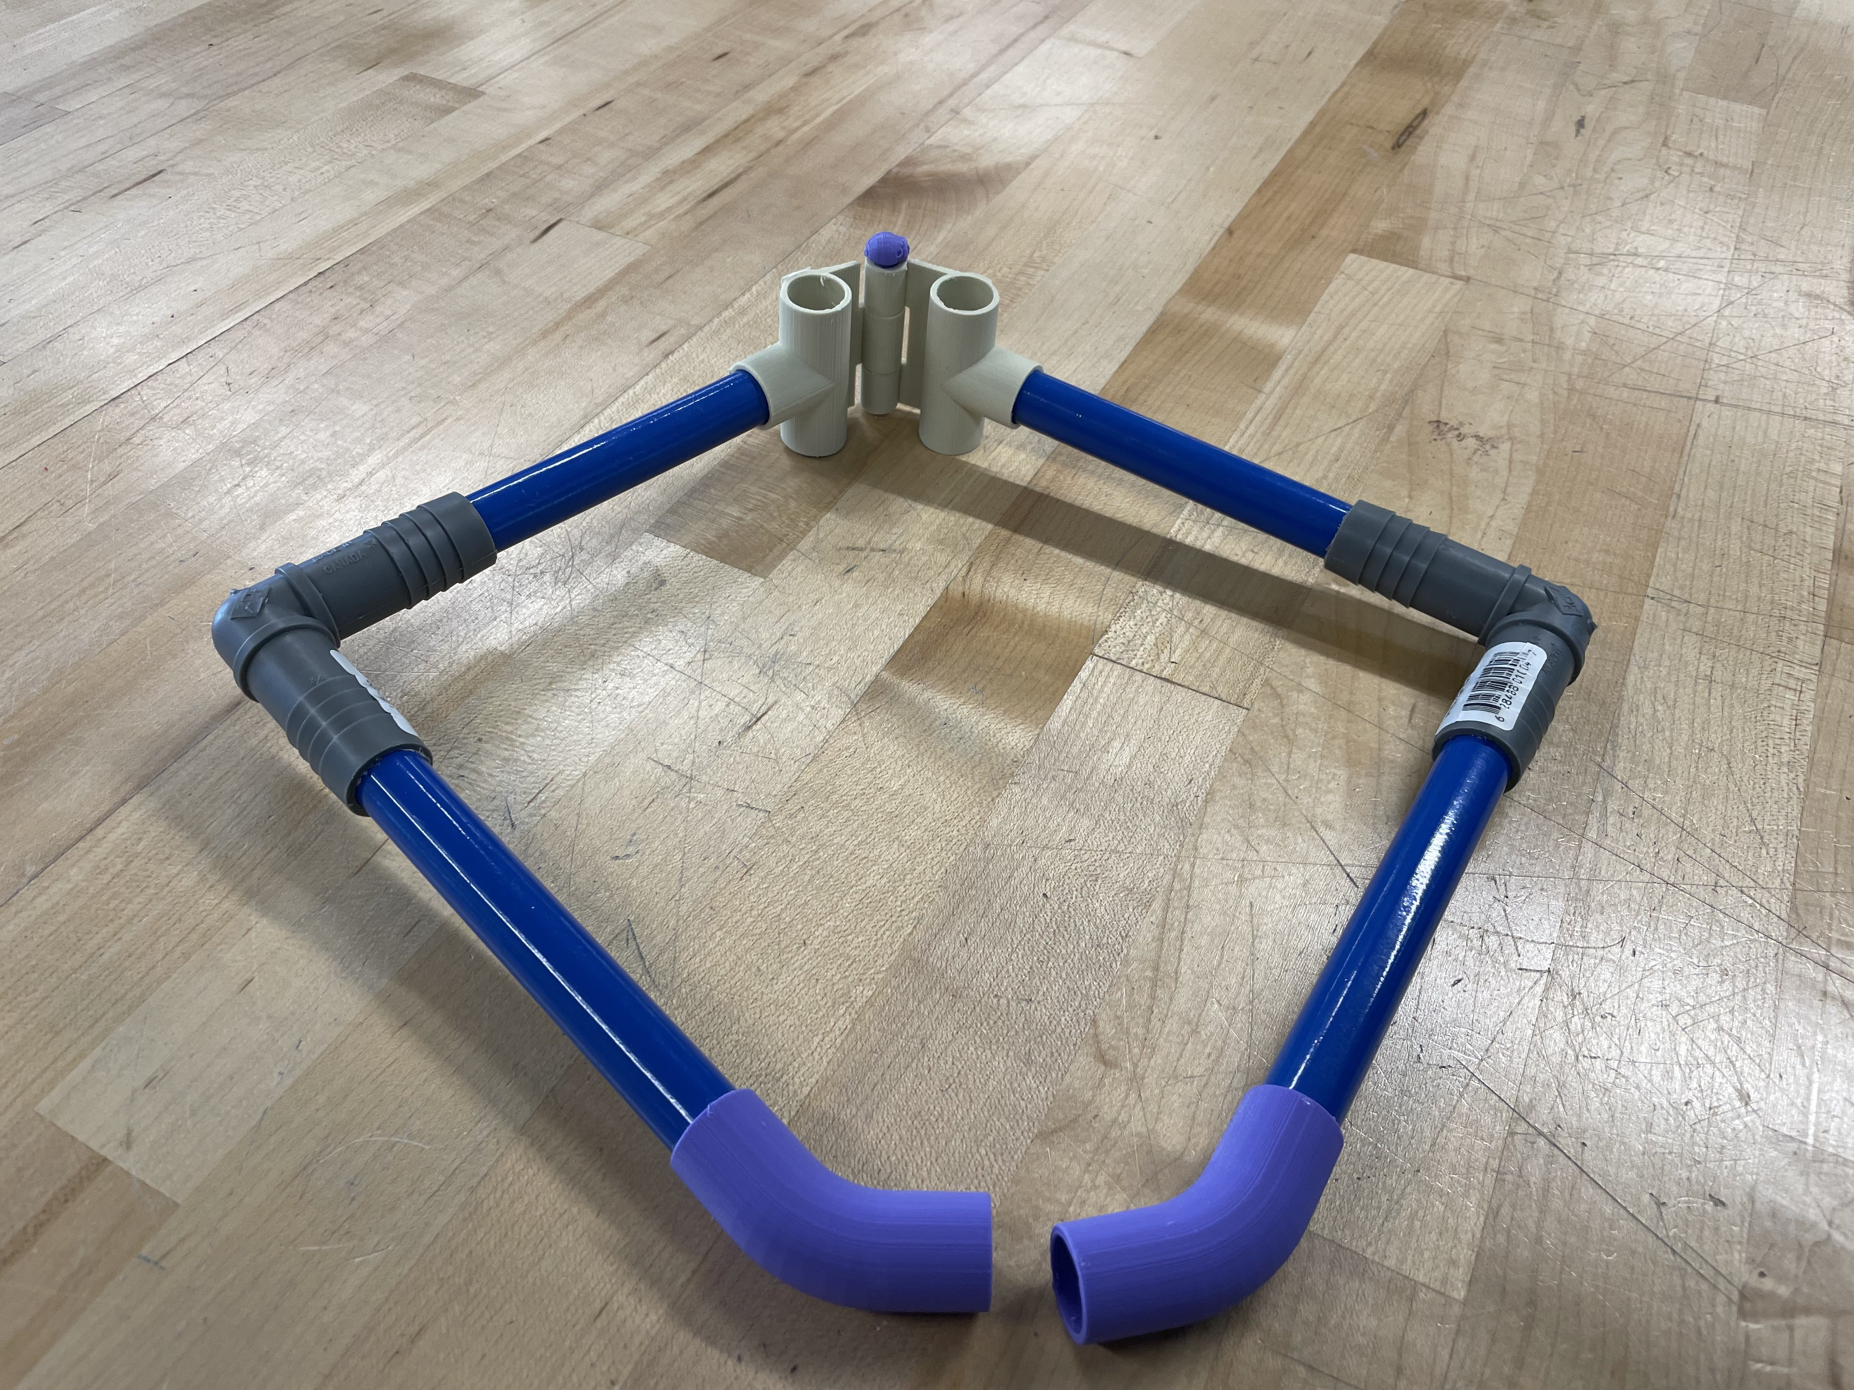

Summary of Testing Results for Prototype 2

We bought bicycle brake levers as our original plan was to use them as the triggers for our prototype. However, we faced the issue of getting a suitable/compatible clamp that would work with the levers. We also got a pair of bicycles Triggers from one of our group members, however, the bicycle triggers are a bit heavy, and it consists of mental components, which may be rusted since our product must be used in bathroom. So, we ended up 3D printing our triggers and clamps. Although the first clamp we printed was unable to connect suitably to our 3D-printed triggers, the second clamp works well with our triggers. However, the second clamp will not be able to fit in the user’s pants the same way the first one does due to the design of the clamp. The thing that we should improve in future designs is the clamp mechanism. It should be more comfortable and easier to use. Also, we should start designing printing the adjustable part as soon as we get the measurements from the find Client.

Critical Assumptions made

Assumption #1: The device is portable. This relates to our mobility DFX as the portability of a device determines how mobile the device is i.e. whether the user can carry the device around.

Assumption #3: We assumed that our device is waterproof and will not cause any harm to the user as they use it in the restroom. This relates to the safety DFX as the device being waterproof ensures that the device is safe to use while in the restroom.

Assumption #4 We assumed that the strength of the clamps will not get weaker after certain period. This relates to the durability DFX as this plays a major role in device should work.

Development of Second Prototype

For our second set of prototypes, we decided to go with 3D printing our clamps and triggers. For the designs we found them online on the Onshape library and adjusted them to fit our requirements. We printed out 2 different clamps to see which clamp would work best and printed out our triggers to test and see if the clamp and trigger system would work. After 3D printing, we connected the triggers and clamps with a cable and tested them. The clamps open when pressing the triggers and they close when you let go of the triggers. We found that the rounder clamp worked better so chose that as our clamp for our prototype.

The second set of prototypes:
- Adjustment in the design of the clamps with a new infill density.
- The start of the design of the adjustable parts. In addition, deciding which material we should use in them.
- Combining all substance into one design.
1. Clamps Design Adjustment Prototype
To test the effectiveness of clamps with a new infill density and an adjustment in the design. That will affect their strength, flexibility, and durability without damaging cloths.
- Run tests to measure the clamps' grip strength on various fabric types and their resilience to repeated use.
2. Adjustable Parts Design Prototype
To finalize the design of adjustable parts that can adapt to different user sizes and preferences, ensuring comfort and effectiveness. Choosing materials based on strength with light wight and user comfort.
- Test the adjustability range, ease of modification by users, and durability of adjustment mechanisms. Also, ask the clint for testing and feed back
3. Integrated Prototype Development
Combine the improved clamps and adjustable parts into a single, cohesive prototype that reflects the final product's design intent. Ensure that all parts work together, maintaining the device's overall functionality.
- Test the integrated prototype for overall functionality, including the ease of use, effectiveness, and user comfort.

Images of the second Prototype
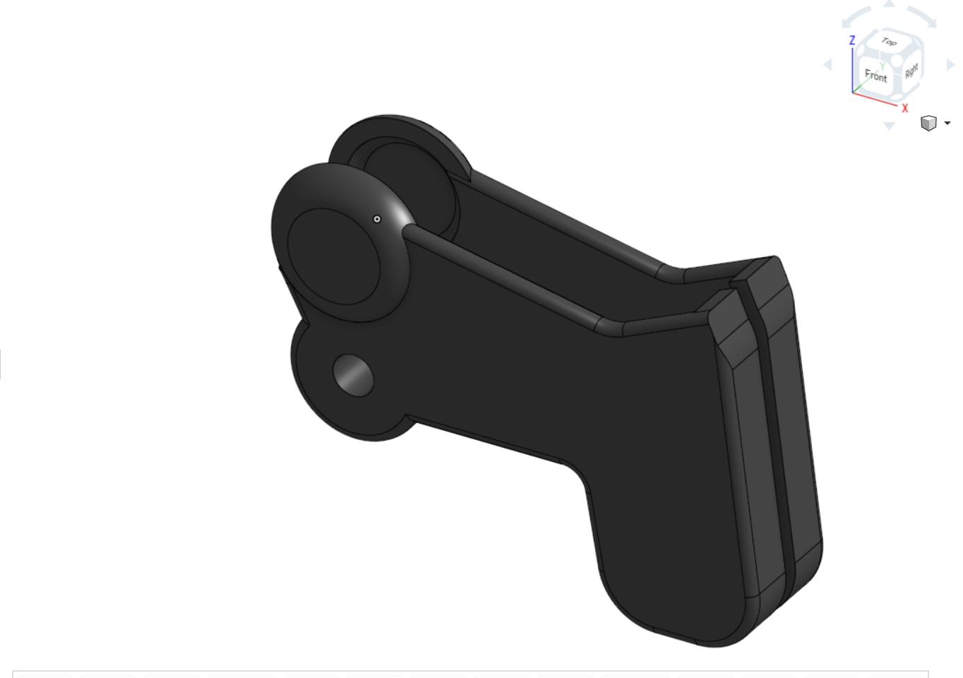
Figure 1. Trigger Holder on Onshape

Figure 2. Trigger on Onshape

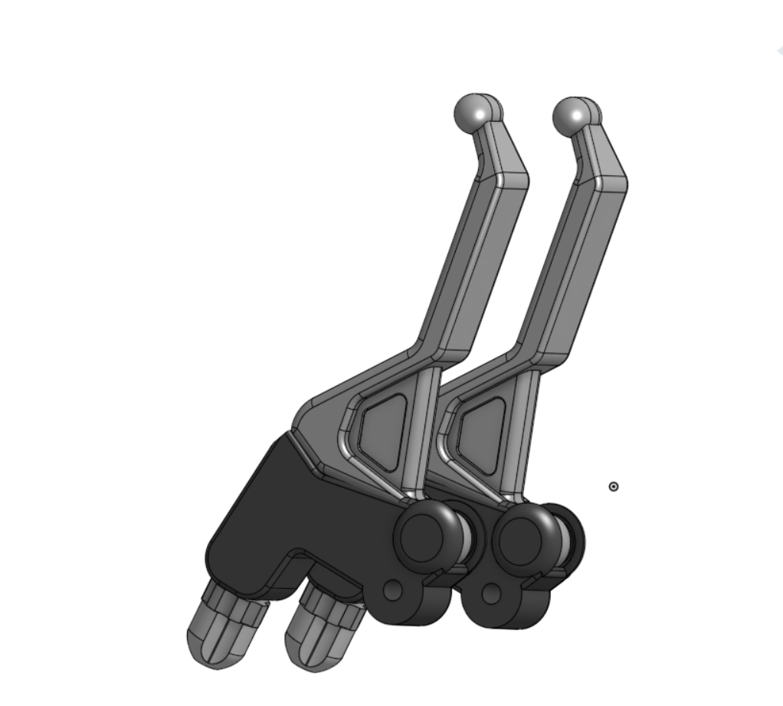
Figure 3. Assembly of trigger holder and trigger

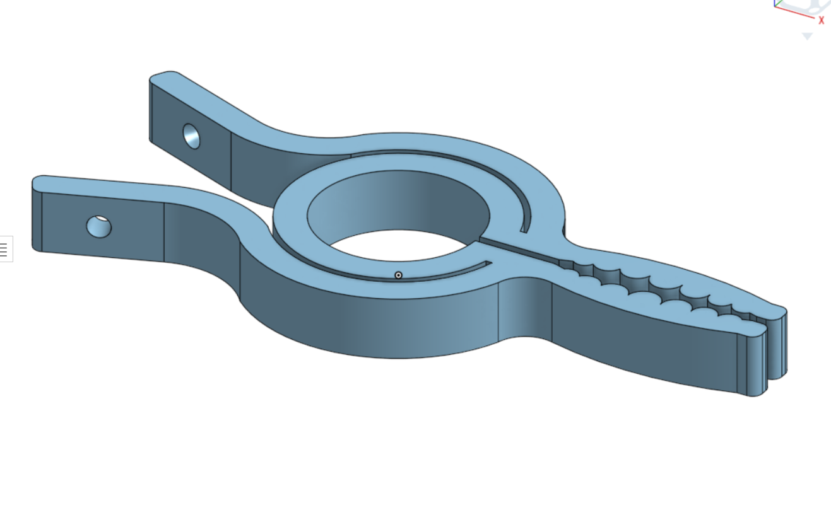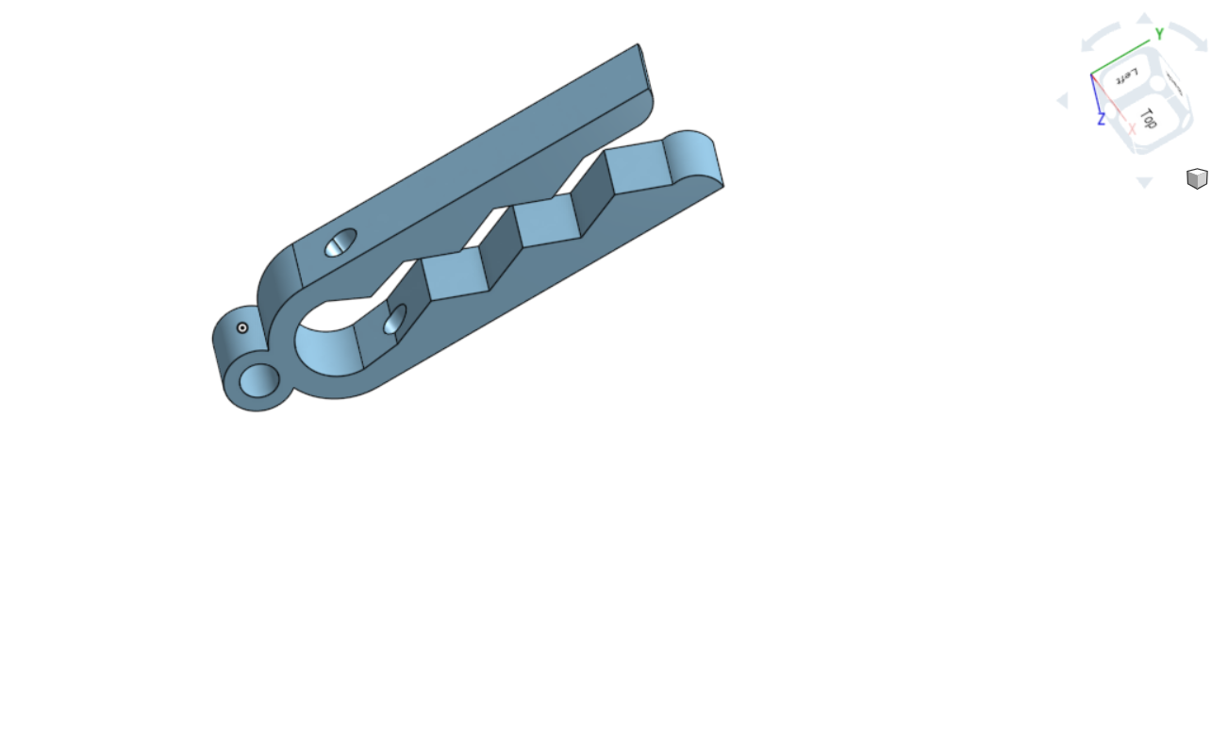
Figure 4. Clamps on Onshape
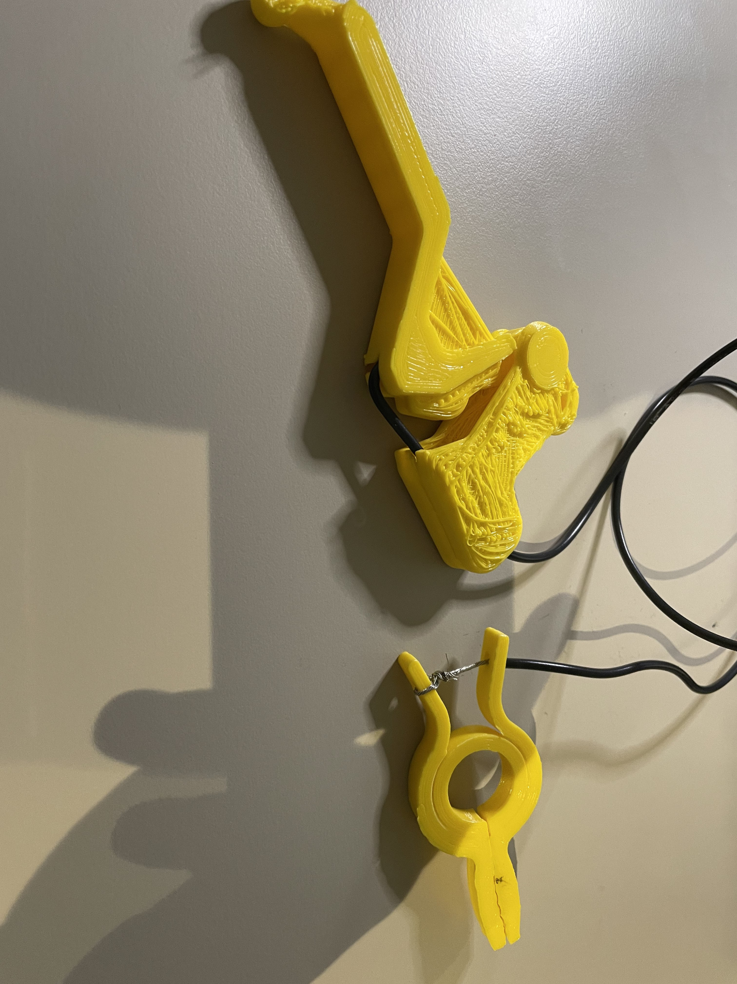
Figure 5. Picture of 3D-printed trigger and clamp connected using a cable.

Our prototype enables us to test the compatibility of a trigger and a clamp by applying tension in the cable between the clamp and the triggers. We want to see if the clamps will open when we press the trigger to determine how functional they are. This will help us as this is a key area of our final prototype.

Expected and actual results

 | Metric ID Number | Design Specification | Unit | Verification method | Ideal Value | Tested Value
Functional Requirements | 1 | Clamp | N/A | Test | Yes | Yes
 | 2 | Triggers | N/A | Test | Yes | Yes
Non-functional Requirements | 3 | Aesthetics | N/A | Analysis | Rabbits, stickers, purple | Not tested
 | 4 | Material | N/A | Analysis/Test | Carbon fiber | PLA
 | 5 | Safety | N/A | Test | No sharp parts, harmless clamps | No sharp parts, harmless clamps
 | 6 | Product Life | years | Estimate | >=20 | Not tested
Constraints | 7 | Weight | lbs | Analysis | =<5 | Not tested
 | 8 | Size (Height) | in | Analysis | =<12 | Not tested
 | 9 | Size (Width) | in | Analysis | =<7 | Not tested
 | 10 | Waterproof | N/A | Test | Yes | Not tested
 | 11 | Cost | $ (CAD) | Estimate | =<50 | =<50 (so far)

For the client meeting 3
We intend on presenting our two prototypes with much more focus being put on the second prototype. We expect to get reviews from our client on each prototype and our progress so far in this project. We hope the client will be able to provide us with information to consider that will help us make this project better. The link to the presentation is shared below. Would like to know the measurements that the user is most comfortable with our design. Also, we would like to know how the client thinks of our prototypes so far and what adjustment can improve the design.

Presentation link

Project plan update
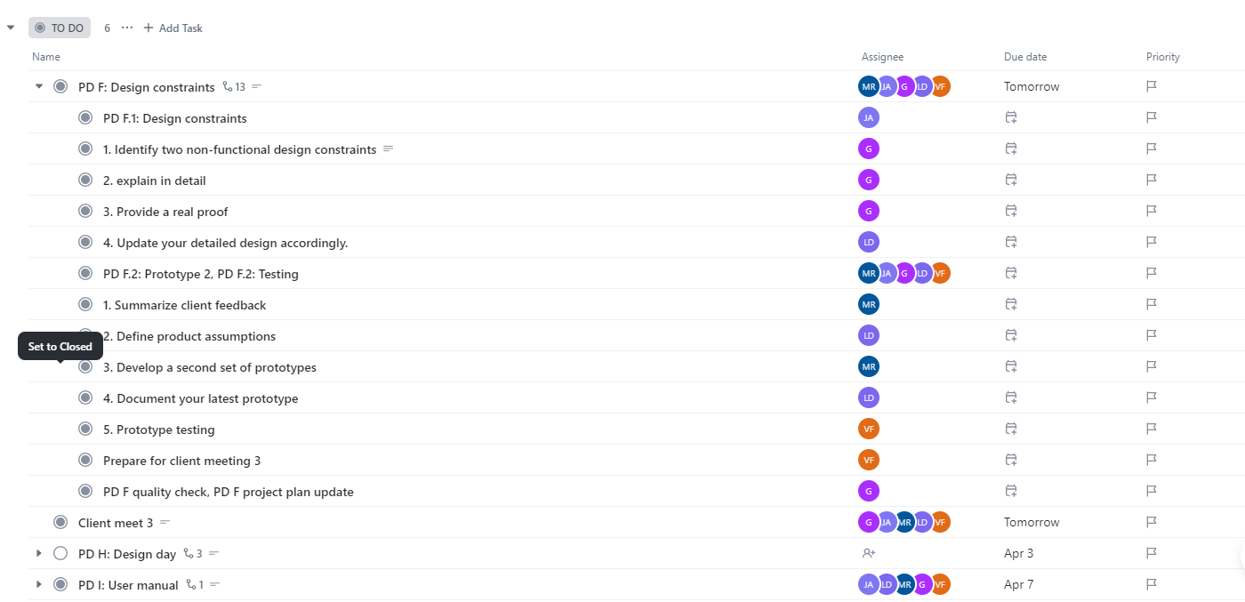For PD F
- We had two meetings one on Saturday on the other on Sunday. On Saturday we will write the document and plan for Sunday. On Sunday we will test our prototypes and document them, and plan for new ones.
For the client meeting 3
- we will prepare a quick presentation, and the prototypes that we have tested. Also we will ask for feedback from the client. Potentially we will ask the client to take the prototype with him and tested himself.
For PD G
- We are planning to continue testing and coming up with Prototypes.
- We have our regular Saturday meeting. In which we would write the document, and if we need more time we will use. every he available spite in our schedules to finish PD G.
- We don't know yet who will be available at that day. However, we are sure that at least someone be there.
- We will update the sub-tasks accordingly in Clickup to match our availability and events in life
-Out of strategies to actively preform our plan is to utilize every lab session, TBD class, weekend if we needed. However, some of us will have midterms, assignments, or any other life problems. So, we must be flexible and do whatever we can when we can.

Conclusions
To conclude, our rigorous testing of triggers and clamps, tailored precisely to our client's needs and preferences, has provided invaluable insights into the functionality and usability of our design. Additionally, we have meticulously selected materials and hinge mechanisms for our main frame, prioritizing durability and comfort.

Moving forward, our focus shifts towards the integration of all subsystems, a crucial step in ensuring seamless operation and ergonomic performance. This entails designing join sections that facilitate the harmonious assembly of components, optimizing the overall functionality and reliability of the device. With each milestone achieved, we are one step closer to realizing our vision of a practical, user-friendly solution that enhances the quality of life for our client.

As we embark on the final stages of development, collaboration and innovation remain at the forefront of our approach. By leveraging collective expertise and remaining responsive to user feedback, we are poised to refine our design further and ultimately deliver a product that exceeds expectations. Through perseverance and dedication, we are committed to making a meaningful difference in the lives of individuals with limited mobility, empowering them to navigate daily tasks with confidence and independence.

Economics report

Describe and justify all assumptions that you have made in developing your economics report. The assumptions must be factual based on a preliminary market research that you conduct in order to determine the amount of demand in your target market, the expected % of the market that you would own, and the unit price of your product based on a sound pricing strategy.

Important note: we expect you to make many assumptions here. However, each assumption should be identified and justified using information you gathered from various sources. Provide references when using this information.

Assumption and Justification:
- To produce devices, an injection moulding machine must be bought, the price for smaller machine may cost $100000. Our device is relatively simple, I would say, a small machine is enough. Therefore, we need $100000 investment to start production.
Cost of injection Moulding machine:
https://plastiwin.com/buy-used-plastic-processing-equipment/used-plastic-injection-molding-machines/
- Market Demand: There is a market demand for people who need to use the bathroom independently but can't because of trouble reaching their backs or low strength. That includes Alderley people and people with paralysis. Canada has around 8.0 million people with disabilities, and the percentage is increasing, we assume 10% of them having limited arm mobility and low strength. There are still 800000 people requiring our device.
- Material cost: The material cost including PLA, PVC pipe and rubber padding and metal cables from our BOM is around $35. Considering discount of large amount purchase, I would say the material cost should be around $15.
- Rent: as a startup, renting a warehouse for us to produce our products should be enough, the warehouse around 2500 square feet would cost around $5000.
- other utilities: according to website - How to Estimate Utility Costs for a Small Business, the cost would be $2.14 per square feet, therefore, the cost of 2500 square feet would be $5350.
- Depreciation: assume the machine can be used for 10 years, the depreciation cost is initial cost / useful life = $100000 / 10 = $10000.
- Pricing strategy: Considering the benchmarking and material cost, operating costs, I would say the price of our device should be $50.

Include a list of variable/fixed, direct/indirect, and material/labour/overhead costs associated with your business, based on the manufacturing and sale of your product. Make sure that you distinguish between price and cost and realize that prototyping and higher-volume manufacturing costs will probably be different.
Expanding on each point within the cost categorization provides a detailed understanding of the financial aspects of manufacturing and selling your product. This detailed view is crucial for budgeting, pricing strategy, and financial planning.
Variable Costs
Material Costs:
- PLA for components such as the adjustable parts and the clamps.
- PVC pipes for the device framework.
- rubber padding for grips and comfort.
- Metal cables for the mechanism.
Direct Labor Costs:
Design of the devices.
Assembly and quality checking of each finished unit.

Shipping Costs:
The expenses associated with delivering the final product to customers, including packaging. These costs are variable, as they depend on the number of units sold and the shipping distance.
Fixed Costs
- Rent: The monthly or yearly cost of leasing a space for manufacturing, assembly, and office work. This cost remains constant regardless of the volume of the production, adding to overall fixed expenses.
- Utilities: Fixed monthly bills for electricity, water, and internet services required to operate the manufacturing space and offices. These costs are in general constant; however, it can vary slightly based on usage, nevertheless not directly with production volume.
- Salaries: Wages paid to full-time staff who are not involved in the direct manufacturing process, such as administrative employees, management, and marketing personnel. These costs are fixed in the short term, though they may increase as the company grows.

Direct Costs
- Material Costs and Direct Labor Costs fall under this category, as they are essential for the creation of each unit and vary directly with the number of units produced.
Indirect Costs
- Rent, Utilities, Salaries, and Marketing and Advertising expenses are necessary for the operation of the business but do not fluctuate directly with the number of units produced.
Material/Labor/Overhead Costs
- Material Costs: The material cost including PLA, PVC pipe and rubber padding and metal cables from our BOM is around $35. Considering discount of large amount purchase, I would say the material cost should be around $15.
- Labor Costs: we might need 5 staff, 2 for manufacture, one for administration, one for marketing and one for design and customer service. We give $20 per hour, so the labor costs would be $320 per day for manufacturing staff.
- Overhead Costs: rent + utilities + salaries for non-manufacturing staff + equipment depreciation + marketing = $5000 +$5350 + $9000 + $10000 + $10000 = $39350

 | Material | Labour | Expense
Direct | - PLA for components such as the adjustable parts and the clamps.  - PVC pipes for the device framework.  - rubber padding for grips and comfort.  - Metal cables for the mechanism. | - Design of the devices.  - Assembly and quality checking of each finished unit.
Indirect |  | - Salaries | - Marketing Campaigns  - Utilities  - Rent  - Depreciation of machine
Fixed |  | - Salaries | - Marketing Campaigns  - Rent  - Utilities
Variable | - PLA for components such as the adjustable parts and the clamps.  - PVC pipes for the device framework.  - rubber padding for grips and comfort.  - Metal cables for the mechanism. | - Design of the devices.  - Assembly and quality checking of each finished unit. | - Depreciation of machine

2. Develop a 3-year income statement, which includes sales revenue and costs of units sold for each year, gross profit, operating expenses and operating income (no need to include interest and taxes).

Year 1 Projections
- Sales Revenue: $100000, we sold 2000 devices in the first year.
- Cost of Units Sold: The variable cost per unit is $20, leading to a total variable cost of $40000 for units. This cost encompasses all direct costs associated with manufacturing each unit, including materials, direct labor, and any variable overheads directly tied to production volume.
- Gross Profit: Calculated as Sales Revenue minus Cost of Units Sold, amounting to
- $100000 - $40000 = $60,000. This figure represents the profit before accounting for fixed operating expenses and indicates the effectiveness of the pricing strategy and cost control in the production process.
- Operating Expenses: Fixed costs total $39350, covering rent, utilities, salaries for administrative staff, and other costs not varying with production volume. These expenses are necessary to maintain the business's operational capabilities.
- Operating Income: The net result after subtracting Operating Expenses from Gross Profit, yielding $60000 - $39350 = $20650. This positive operating income in the first year is a promising sign, indicating that the business can cover its variable and fixed costs, with profit remaining.

Year 2 Projections
- Sales Revenue: $250000, we sold 5000 devices.
- Cost of Units Sold: $100000.
- Gross Profit: $250000 - $100000 = $150000
- Operating Expenses: $39350
- Operating Income: $150000 - $39350 = $110650
Year 3 Projections
- Sales Revenue: $300000, we sold 6000 devices
- Cost of Units Sold: $120000
- Gross Profit: $300000 - $120000 = $180000
- Operating Expenses: $39350
- Operating Income: $180000 - $39350 = $140650

Based on the project requirements, the following assumptions were made. Since most of the materials needed to complete this project were procured in-house, the cost of production was $15. Considering the directed labor, the cost should be $20.

Using a NPV analysis, determine the break-even point (i.e. number of units that must be sold for your business to become profitable). Note: It is highly unlikely that your operating income will be positive in the first year because of fixed costs. Therefore, you must use a NPV analysis to compare costs and profits over multiple years based on present value. Draw two cash flow diagrams of the expenses and incomes for the next three years. Calculate the NPV value of each expense/income and determine the differences and then the break-event point.

To determine the break-even point using a Net Present Value (NPV) analysis, we will calculate the present value of both expenses and incomes over the next three years and then find the point at which the incomes greater than expense.
Assume discount rate of 10% for the NPV calculation
.
Now
Year1
Year2
Year3
Income
expense
-$1000000
-$39350
-$39350
-$39350
$20650
$110650
$140650
Expenses:
Year 1 PV = $39350 / (1+0.1) = $35773
Year 2 PV = $39350 / (1+0.1) ^ 2 = $32521
Year 3 PV = $39350 / (1+0.1) ^ 3 = $29564
Initial investment = $100000
Total NPV for expense = $35773 + $32521 + $29564 + $100000 = $197858
Income:
Year 1 PV = $20650 / (1+0.1) = $18773
Year 2 PV = $110650 / (1+0.1) ^ 2 = $91446
Year 3 PV = $140650 / (1+0.1) ^ 3 = $105672
Total NPV for income = $215891

The NPV income per unit = total NPV income / number of sells = $215891 / 13000 = $16.6
Let's denote the number of units sold as N.
$16.6 * N >= total NPV expense = $197858.
N >= 11920.
Therefore, after selling 11920 devices, the business becomes profitable.

Intellectual property report
Patents
- The devices utilize a new mechanism method for assisting with dressing with a disability. For example, the way triggers activate clamps in a way that helps with dressing with a disability. Also, it improves upon existing dressing aids in terms of efficiency, ease of use, safety, or other metrics, these improvements. Therefore, obtaining a patent for the unique mechanisms of our device gives us exclusive rights to use and commercialize these inventions. This means no one can make, use, or sell our inventions without our permission. That provide us with competitive advantage, making it difficult for competitors to offer similar products that use the same mechanisms, thereby protecting our market share. However, obtaining a patent requires a detailed information about our invention. This ensures that while get exclusive rights, the knowledge is shared for future innovation. Moreover, the patent application process can be time-consuming and costly. In addition, it’s territorial, meaning we have to have patent protection in every country we plan to sell our product in which add to the complexity and cost.
Copyrights
- We have created original 3D design digital models for the functioning of our device. Moreover, we have written instruction manuals and descriptions of the invention. Copyright protects our original 3D design digital models and written materials. This prevents others from stealing our work . Also, it can also provide a licensing agreement, allowing to permit others to use our designs or written works under specified conditions. However, we are required to prove our ownership and the originality of our work and we cannot prevent others from creating devices that achieve the same function but through different designs.

Trademarks
- The companies name “Nkechi”.
- The company’s slogan “Grip and Go”
- The company’s logo
- Protecting the name “Nkechi,” the slogan “Grip and Go,” and the company’s logo as trademarks helps in building a strong brand identity that give us customer loyalty and brand recognition, and offer legal action if others used our trademark in a way that could confuse consumers or dilute. However, we are required to prove our ownership and the originality of our trademark and we cannot prevent others from creating name, slogan, logo that are smaller to us. Also, we have to trademark protection in every country we plan to sell our product in.

In summary, our project intersects with these areas of intellectual property due to its innovative functional elements (patent), original authorship in the form of digital design and documentation (copyright), and it’s name, logo, and slogan (Trademark). Protecting these aspects can provide us with exclusive rights, prevent others from exploiting our work without permission, and potentially offer a competitive edge in the market.
http://cipo.gc.ca/http://www.freepatentsonline.com/http://patft.uspto.gov/https://patents.google.com/

Project plan update
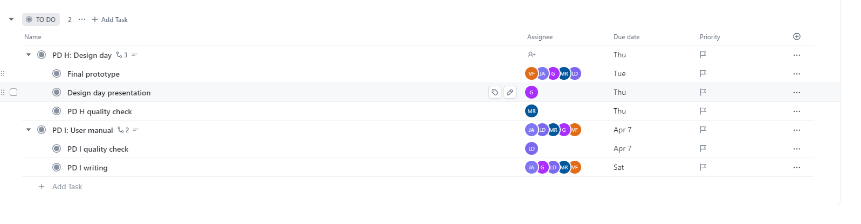
For design day
- we don't know yet who will be available at that day. However, we are sure that at least someone be there.

- We will update the sub-tasks accordingly in Clickup to match our availability and events in life
-Out of strategies to actively preform our plan is to utilize every lab session, TBD class, weekend if we needed. However, some of us will have assignments or any other life problems. So, we must be flexible and do whatever we can when we can.

Video and User Manual

Video pitch
https://youtu.be/qll3ZzRiq64
.

Conclusions
1. Understanding User Needs
- Empathy and Insight: Engaging directly with the client and potential users provided profound insights into the specific challenges faced by individuals with limited mobility. This emphasized the need for a design that not only meets functional requirements but also enhances the user's dignity and independence.
- Iterative Feedback: User feedback was crucial in iterating design elements to better meet user needs, particularly in terms of usability and comfort.
2. Design Complexity and Simplification
- Mechanical Design: Initially underestimated the complexity of designing a simple, yet functional clamp mechanism that a child could operate. This required several redesigns to simplify the use while ensuring durability and effectiveness.
- Material Selection: Choosing the right materials (PLA for 3D printing, PVC for the frame) was key in balancing cost, functionality, and user safety. The ongoing evaluations helped refine these choices to improve the final product.
3. Prototyping and Testing
- Rapid Prototyping: Utilizing 3D printing enabled quick turnarounds on prototypes but also presented challenges such as material limitations and mechanical integrity under stress.
- Testing Under Real Conditions: Simulated use-case scenarios were essential for understanding how the device would perform in real-world conditions, particularly in a bathroom environment which highlighted the need for water-resistant materials.
4. Project Management
- Agile Development: Adopting an agile project management style helped accommodate the evolving nature of the project requirements and team availability.
- Time Management: Balancing this project with academic responsibilities taught us valuable lessons in time allocation and priority setting.
5. Collaboration and Communication
- Team Dynamics: Effective communication and clear distribution of tasks within the team were crucial for smooth progression and timely completions of project phases.
- Stakeholder Engagement: Regular updates and meetings with the client and academic advisors ensured the project remained aligned with the user’s needs and compliance requirements.
Conclusion
This project provided us with a comprehensive learning experience from conceptualization to prototype development, testing, and refinement. It underscored the importance of user-centered design, agile project management, and the effective use of technology in creating innovative solutions. Moving forward, the project team must address the outstanding issues related to durability, manufacturing scalability, regulatory compliance, and intellectual property management to successfully bring the product to market and ensure it can make a positive impact on its intended users.

Bibliography

Insert your list of references here.

chat GPT logo

