Deliverable D
Project Plan, BOM, and Feasibility Study

Vin Kumar 7289971
Shantal Maharaj 300013673
Reethi Paul 300030366
Sachi Sant 300018860
Jasmine Silver 300028214
GNG 2101 – Section Z01: Group 2
Emmanuel Bouendeu
June 6th, 2018
Tasks
 |  | Task | Duration for completion | Who is responsible | Task dependencies
Prototype 1 | 1 | Plan design of prototype  - Sketch static model and label materials used in prototype 1 at each part | 3 days | everyone
 | 2 | Get materials for prototype 1 | 1 day | everyone | 1
 | 3 | Make prototype 1 | 3 days | Jasmine | 1,2
 | 4 | Modify any design flaws if needed to improve user friendliness | 2 days | Shantal, Vin | 1,2,3
Prototype 2 | 5 | Analyze coding requirements | 3 days | Vin | 9
 | 6 | - Create coding for rotation and touch sensor  - Plan electrics | 1 day | Vin, Reethi | 5
 | 7 | Design prototype body  - Sketch casing design | 2 days | Sachi
 | 8 | Design toothbrush head and neck  - Create sketches from each point of view and label materials used | 1 day | Jasmine
 | 9 | Get materials for prototype | 2 days | Shantal, Jasmine | 7,8
 | 10 | Build each part and put prototype together | 1 day | everyone | 5,6,9
 | 11 | Improve physical design and positioning of parts within prototype | 1 day | Reethi, Sachi | 10
 | 12 | Test prototype and evaluate user friendliness, make note of needed adjustments | 1 day | Shantal, Sachi | 11
 | 13 | Make any required adjustments and improvements | 0.5 day | Everyone | 12
 | 14 | Retest prototype and do any further adjustments if needed | 0.5 day | everyone | 13

Milestones to achieve
- Create prototype 1
- Research electrics and coding of electric toothbrushes
- Create coding and integrate with electrics
- Adjust design to accomodate for computing and electric requirements
- Create first model of prototype 2
- Test functioning of coding and electrics
- Improve coding functions
- Create final model of prototype 2

Gantt Diagram
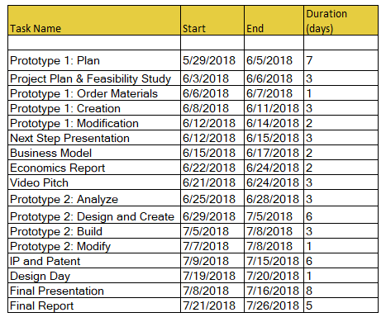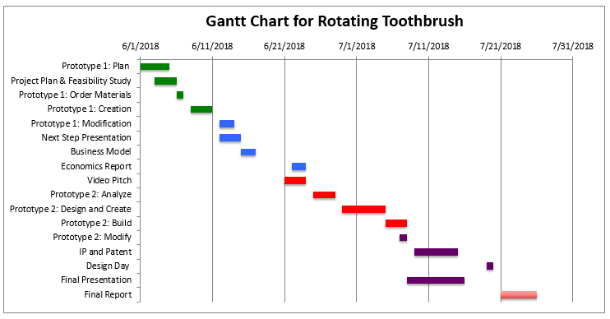

Burndown Chart from Trello

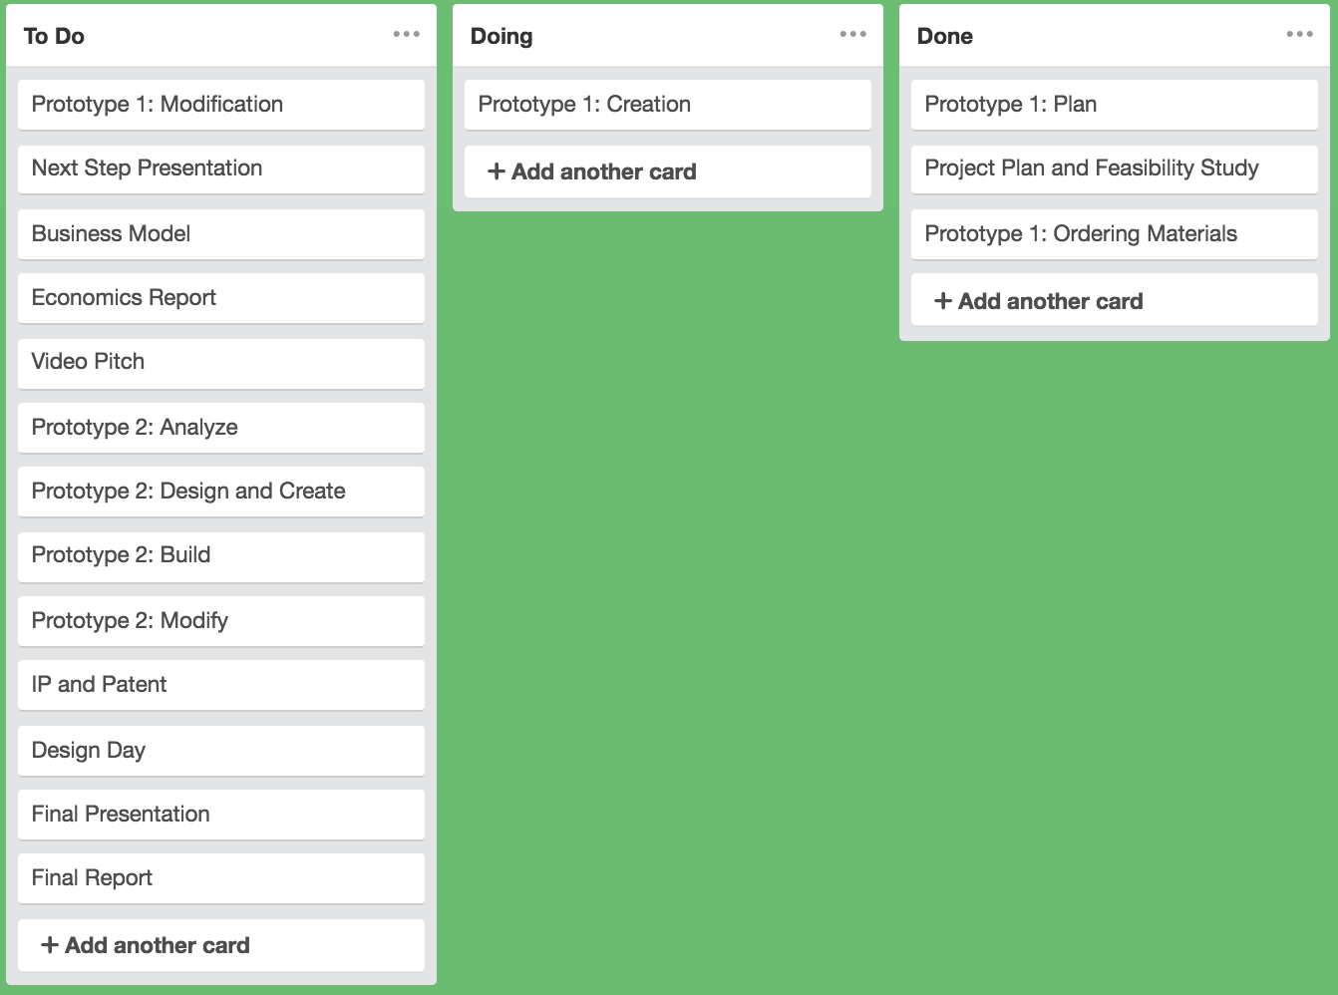

Bill of Materials
 | Part Name | Supplier | Cost per Unit | Quantity | Total
1 | 9V Battery | https://www.makerstore.ca/products/9v-battery | $1 | 1 | $1
2 | Double-Sided Prototype PCB | https://www.amazon.com/Double-side-Prototype-Universal-Printed-Circuit/dp/B0147YM3DG | $0.99-6.99 | 1 | $0.99-6.99
3 | 9V battery clip | https://www.makerstore.ca | $0.84 | 1 | $0.84
4 | OSEPP Touch Sensor Module | https://www.active123.com/TOUCH01-OSEPP-Touch-Sensor-Module-Prodview.html | $7.95 | 3 | $23.85
6 | 1k potentiometer | https://www.makerstore.ca/products/c052 | $1.26 | 1 | $1.26
8 | Electric Toothbrush | https://www.amazon.ca/gp/product/B01BV0EZY4/ref=ox_sc_act_title_1?smid=A3DWYIK6Y9EEQB&psc=1 | $29.96 | 1 | $29.96
9 | Brushless DC Motor | https://www.digikey.com/product-detail/en/dfrobot/FIT0441/1738-1157-ND/6588579 | $20.50 | 1 | $20.50

 | Part Name | Justification
1 | Pro Micro | The Pro Micro is the microcontroller circuit that will control the whole rotation of the toothbrush and all of the modifications that will be added to it.
2 | Double-Sided Prototype PCB | The prototyping PCB will be where add/solder our circuitry of our designs and modifications in our final product.
3 | Stepper Motor (ULN2003) | The Stepper motor is the part that will actually be used to add rotation in our design and is needed.
4 | ULN2003 Driver Board | Are the controller to energize the phases in a timely sequenze to make the motor turn.
5 | Rotary Slip Ring | We will use the rotary slip ring as a design choice in order to avoid the tangling of wires in the future when the toothbrush rotates giving the design ability allocate all power to a single source.
5 | 100μF Capacitor | To add decoupling capacitor to protect the driver board from voltage spikes.
6 | Flexible Shaft Bits | Our patient has trouble using her wrists past her waist, using these shaft bits she will be able to use the brush more effectively and is a requirement of the product.
7 | Electric Toothbrush | The electric toothbrush we will buy is the toothbrush is the one we will modify to allow for these rotations.
8 | Touch Sensitive Button | Our patient does not have the necessary strength to push a physical button, to circumvent this we will use a touch sensitive button.

Risk and Uncertainties
With this project there comes with it a high risk and many unknowns about the future of the product going forward. This is because the nature of the project deals with the product going into the patient's mouth safely and comfortably, this in itself comes with a projected risk.

Risks
- The main risk with the project is that the rotation of the servo will not work as expected. It will either be too powerful, or to weak and not be in the right position for the patient to be actually be viable for her to use.
- The touch sensitive button will not be responsive to our patient and it will become unusable to her be herself
- The toothbrush is uncomfortable and she decides not to use it going forward

Uncertainties
- It is uncertain how the patient will take to the product as she has never tried something like this before, it is new and bold and could possibly go completely wrong as it has in past groups

