University of Ottawa
GNG 1103: Engineering Design

Deliverable H- Prototype III and Customer Feedback
March 24th, 2023
Group F-12
Avery Taylor (300366472)
Emily Facette (300109170)
Rashad Nesar (300372555)
Annabelle Osazuwa (300361617)

Abstract
This report shows the process of developing and testing Prototype III. The prototype consists of a turbine-motor setup for erosion testing, electrical components such as the Arduino, Hall sensor, Potentiometer, various wires connecting said components, and baffles to enhance water flow. Key components and modifications were included such as the addition of the relay switch for a safer power control method, placement of electrical components behind protective barriers, and completion and implementation of the hall sensor code to measure the RPM. Results indicate a successful solution of the leakage issues and improved turbulence for erosion testing. The tests showed that sand and gravel proved to be the most useful additives, and salt was the least effective additive. Discrepancies may have arised due to the brittleness of shale, different properties of shale, and measurement error. Feedback from a contractor, and recent engineering graduates from uOttawa and Carleton suggest future works to increase user experience and safety, as well as potential use beyond academic research. The report concludes with an updated Bill of Materials and recommendations for future iterations.

Table of Contents
Contents
Abstract 2
Table of Contents 3
List of Figures 4
Introduction 5
Prototype Plan 5
Changes, Justification, and goals 5
Analysis 5
Results 10
Leaking Test 10
Cooling Methods 10
Code Function 10
Battery 10
Stability test 11
Blank Test 11
Salt Test 11
Sand Test 11
Salt and Sand Test 11
Test Conclusions 12
Feedback 13
Updated BOM 14
Conclusions and Recommendations 14

List of Figures
Figure 1: Relay Switch 6
Figure 2: Hall Sensor 6
Figure 3: Motor 7
Figure 4: Electrical Components Configuration with fan and battery 8
Figure 5: Baffles 9
Figure 6: Entire Configuration 9
Figure 7: 300 RPM Tests Results 12
Figure 8: 550 RPM Tests Results 12

Introduction
Using the feedback from client meetings and presentations, we have completed the final prototype assembly, including feasible code and different testing environments. Utilizing this prototype, we have conducted several tests varying speed, abrasives, and shale masses to accelerate the effects of erosion. Our report provides a detailed analysis of each subsystem's performance during testing, along with any necessary adjustments and results. These tests involved speeds of 300RPM and 550RPM, with abrasives ranging from nothing to sand, salt, and a mixture of both.

Prototype Plan

Changes, Justification, and goals
The final prototype combines the physical turbine configuration from prototype 1 and the focused physical Arduino and motor setup from prototype 1 and 2, respectively. Since the last deliverable, we have decided to take the advice of the potential users we interviewed. We have placed the electrical components behind a piece of wood for added safety and protection from water. We have placed the ends of the wires attached to the battery to marettes to eliminate any possibility of electrocution. We have also decided to input a relay (switch) to control the supply of power to the system. In this prototype, the jug set up will be configured according to our sketch in deliverable E, and the code will be developed to run the circuit and measure the RPM by the hall sensor. Once the apparatus is set up, multiple tests will be performed with different parameters to measure the erosion of the rock.

Analysis
Our first step was the implementation of the relay switch. This will act as a medium between the motor and the speed controller. The positive power terminal of the speed controller is connected to the relay, and the negative power terminal of the speed controller is connected directly to the negative power terminal on the battery. The power positive terminal on the battery is connected to the other cable from the relay. There are 3 Arduino cables connected from the relay to the Arduino. These will be attached to the ground, 5V and power ports of the Arduino. When the orange wire in the 5V port is unplugged, the power supply is stopped. Likewise, when it is plugged into the Arduino, the power is supplied. The relay switch can be seen below.
Figure 1: Relay Switch
Our next focus was using the code to measure the output from the hall sensor. We started by defining the Arduino pins. Using a loop with an “if else” statement, we were able to measure the number of times the magnet passed the hall sensor, which consequently will measure the RPM. As recommended by Josiah Bigras in Deliverable F, the hall sensor was placed directly next to the motor, which can be seen below.
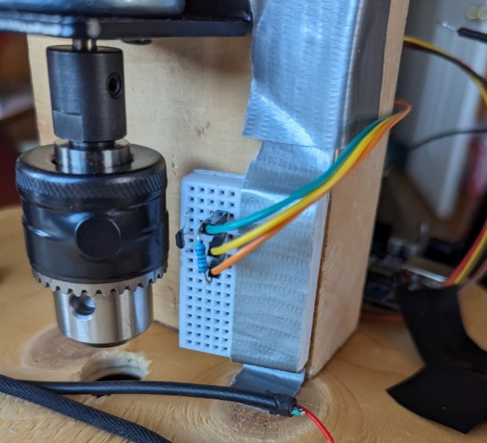
Figure 2: Hall Sensor
The motor was re-configured so that it was going into the bucket, as pictured below. To fasten the motor to the lid securely, the 4 in x 3 in motor stand was attached with 3 screws to a small section of plywood. The sheet of plywood was cut and drilled to the lid of the Home Depot bucket. Coupling the Home Depot bucket lid with the plywood will allow for a secure and strong connection to the lid. A hole was drilled through the center of both the lid and the octagonal piece of plywood to allow the turbine to go through. The motor exhibited heat during preliminary testing, thus a little Arduino fan has been attached to cool the components.
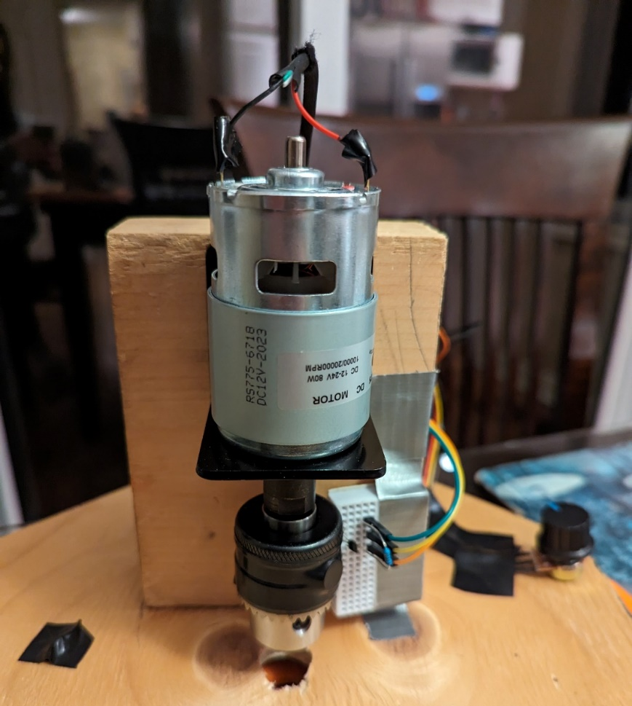
Figure 3: Motor
The electrical components were attached to the motor's back side, seen in the following figure. This figure includes the battery, the fan, and the newly added marrettes on the wires to be connected to the battery.

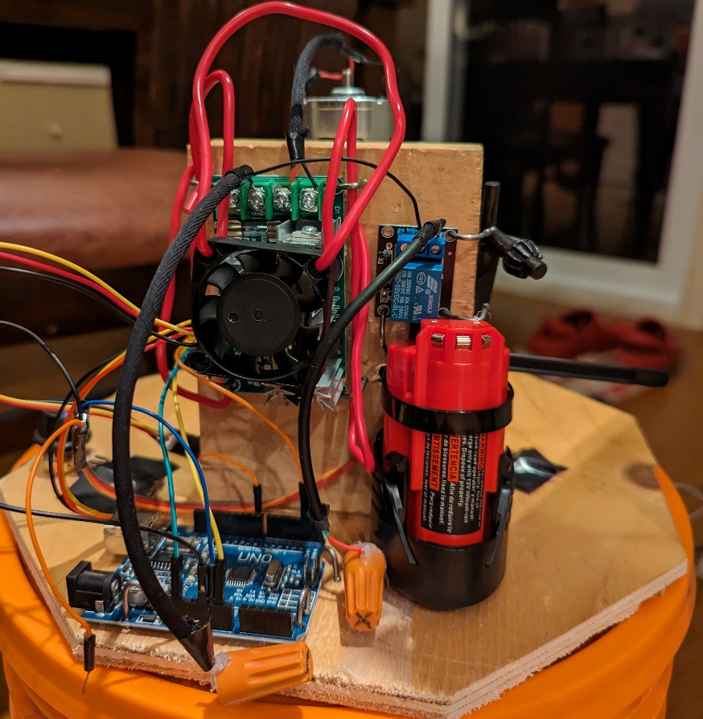
Figure 4: Electrical Components Configuration with fan and battery
The rod used in Deliverable F will be used, however it has been shortened and screwed together. Four baffles were 3D- printed to be attached to the inside of the bucket, as seen below. Throughout the eight tests that will be conducted, the performance of the baffles will be measured to ensure that they are performing adequately. They will be watched to see if they wobble or fall off.

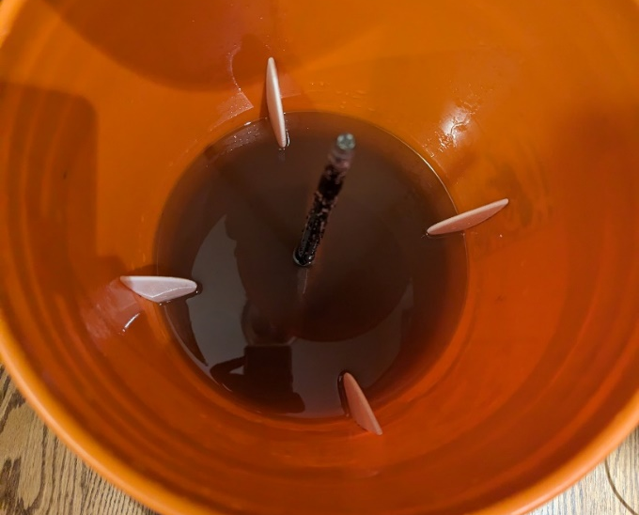
Figure 5: Baffles
The overall configuration of the system can be seen in the following figure.
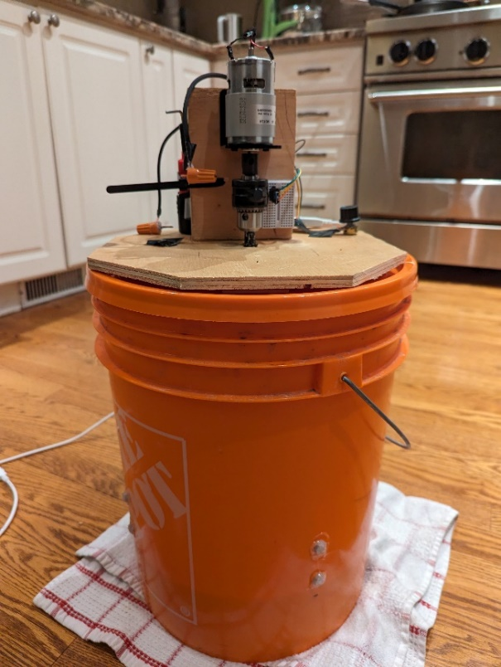
Figure 6: Entire Configuration
8 tests will be performed to test for signs of erosion.
- No additives, 300 and 550 RPM
- Salt, 300 and 550 RPM
- Sand, 300 and 550 RPM
- Salt and Sand, 300 and 550 RPM

Results

Leaking Test
The baffles were 3D printed and drilled to the inside of the bucket. When water was added to the bucket, there was slight leaking from the holes, as it was not waterproof. To solve this, the butts of the screws were covered with hot glue on the outside of the bucket to create a seal. When the test was run again, there were no signs of leaking. The flow with the baffles was much more turbulent than without. The baffles allowed for the water to get kicked up and the condition was more aggressive on the rock sample.

Cooling Methods
The complete set up ran at a high rotational speed for a few minutes and the components got quite warm. For this reason, we implemented a tiny Arduino fan to cool the speed controller.

Code Function
The developed code was able to measure the rotational speed of the motor. The rotational speed would be displayed along with the time interval since the last reading on the Adruino IDE application. The hall sensor would read the magnetic field between it and the motor, while taking the time between intervals. The code was configured so that the hall sensor would count 100 times the motor made a full rotation and divide it by the time it took. At 300 RPM, for example, the speed would only be shown every 20 seconds (0.333 mins) . This makes it hard to adjust the speed exactly as feedback isn’t displayed as often. It was possible to change the 100 intervals to a smaller value, such as 50, but this means the speed may not be as much of an average as it is currently.

Battery
The battery was able to successfully support the motor for several tests. Once going through about six tests, we ran into issues of the motor slowing down or stopping completely. We traced this issue back to the battery running out and needing to be charged before continuing. To help with this issue we have implemented a second battery on the side being charged while the other is going through testing, this means we are able to switch them out once one begins to die to decrease any time spent waiting for them to be charged.

Stability test
The stability of the device starts to become a problem at higher rpm. When testing at 500+ rpm the motor starts to shake the bucket. The shaking causes a lot of noise, and would effect the rate of erosion of the materials. A weight needed to be added to the top of the bucket to decrease the shaking. More weight should be added to the bottom, or on the top of the bucket, to increase stability in future tests.

Blank Test
For this test only water was used to erode the rock sample. Significant erosion was seen although no abrasives were added to the water. We carried out two tests, one at 300 rpm and the other at 550 rpm. At 300 rpm, the initial mass was 12 g and the final mass was 20g. At 500 rpm, the initial mass was 8g and the final mass was 4g.

Salt Test
For this test we introduced 300g of salt as an abrasive, but the salt didn’t work as well as we expected. We also carried out two tests, one at 300 rpm and the other at 550 rpm. At 300 rpm, the rock sample's initial mass was 10g and the final was 9g. At 550 rpm, the initial mass was 15g and the final mass was 14 g.

Sand Test
Significant erosion was seen with 300g of sand/gravel as the abrasive. Two tests were done with sand, at speeds of 300 and 550 RPM. There is certain error in this test because larger particle size may settle out of suspension. In the first test the average RPM was 300. The initial mass of the rock was 20 g, the final mass was 18 g. In the second test the average speed was 550 RPM, the initial mass was 16g, the final mass was 12 g.

Salt and Sand Test
Using a mixture of both salt and sand, we ran two tests at varying speeds of 300 and 550 RPM. With these tests we identified effects of erosion, ranging from an initial mass of 15g to final mass of 12g using 300 RPM, and an initial mass of 12g with a final mass of 9g using 550 RPM. Though the effects of erosion were evident using these abrasives, there was not a large noticeable change using the two abrasives combined compared to them separately. Having the salt or sand on its own displayed approximately the same results. This could be due to the fact that different rock specimens have different specifications and properties, leading to different results.

Test Conclusions
Through the performance of eight tests under different parameters, several conclusions and inconsistencies can be drawn. It was observed that an increase in rotational speed does not universally increase the rate of erosion, and only did when using sand alone or no abrasive at all, as seen in the following figure.
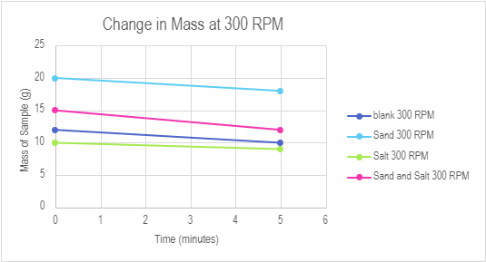
Figure 7: 300 RPM Tests Results

Through analytical testing, it was concluded that salt was the weakest abrasive, even showing less erosion than when there is no abrasive at all. Notably, at 550 rpm no added abrasive showed the most erosion, possibly because shale is very brittle, thus the sample broke apart in the water or the samples had different or weaker properties. The following figure shows the trends from the 500 RPM tests.
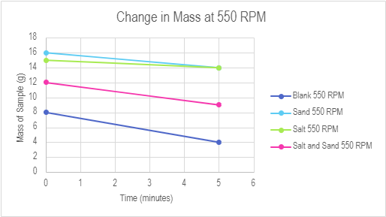
Figure 8: 550 RPM Tests Results
The most erosion was measured at 550 RPM when sand was the abrasive, showing even more than when using sand and salt together. These results show salt has the least effect on erosion, and won’t be useful as an abrasive. Future experiments should consider testing abrasiveness over extended durations, incorporating sand, gravel, and conducting blank tests for comprehensive analysis.

Feedback
Roger Bourdeau, Owner of Rogers Personal Touch Contracting Services, reviewed the design and was impressed by the functionality, stability, and the variety of components on the device. He often mixes concrete for work and was intrigued by the possibility of using the device as an electric, hands-free, automated concrete mixing device. He emphasized how much he appreciated the covered lid for ease of use and cleanliness; however, he wondered if there was a better way, in a higher fidelity model, to make the lid easier to remove, as the plywood makes it stiff. He also appreciated that the motor had varying speeds, so that the user could choose their desired speed.
Zachary Georgitsos, a recent graduate from Civil Engineering at the University of Ottawa was impressed by the overall design. His primary concern was regarding the robustness of the device. He was worried that in transit the small wires may become unplugged and need to be fixed by the user. In future higher fidelity models, we would suggest soldering wires or fastening the Arduino and other circuitry in a carrying case.
Eric Tran, Graduate from Carleton University Mechanical Engineering. He thought our focus on repeatability was well executed through the variable speeds of the motor, and the hall sensor precisely measuring the speed. The results of the shale tests were shared, including the time intervals and how the samples were measured before and after with a kitchen scale to see erosion. He thought 5 minutes may be too short for erosion to occur, and recommended we switch to a wired power adapter for longer future tests because it would decrease the likely hood of tests being inconsistent because of power. He thought we should use a higher quality scale as erosion may occur by fractions of a gram that we would not be able to detect because the scale used only reads to the nearest gram.
Clay Poole, P.ENG Electrical Practice Lead, reviewed the electrical components of the final prototype impressed with the set up's overall simplicity and the addition of the relay switch. His main concerns consisted if the exposed components and suggested creating a cover for the parts to protect them from any outside elements. He mentioned the addition of heat as well shrink on the wires to not only help with aesthetic purposes and cleaning it up, but as well to protect the wires themselves.

Updated BOM
Since the last Deliverable, we have included a relay switch, a little Arduino fan, and marrettes. This is reflected in the attached BOM.

Conclusions and Recommendations
The final prototype incorporates all the elements of all previous prototypes and our initial designs presented to the client. To enhance safety, a relay switch was added to ensure the circuit is not continuously running. Attached is a spreadsheet of all the test results, including graphs of the shale samples’ mases over time. It was concluded that salt was the least effective abrasive, and the sand and gravel additives were the most. Suggestions from potential users recommended using a more permanent power source, increasing user experience by making the lid easier to remove, increasing robustness of the prototype, and placing the electronical components in casing for long term stability.

