Prototype 3 and Customer Feedback
Brooke Joyce, Hassan Ahmed, Ancelin Avenido, Jacky Zhu
March 27th, 2022

Table of Contents
Prototype 3 4
Picture 1: Prototype 3 4
Prototyping Test Plan 6
Feedback and Comments 7
Wrike Snapshot Link 8

Prototype 3

Picture 1: Prototype 3
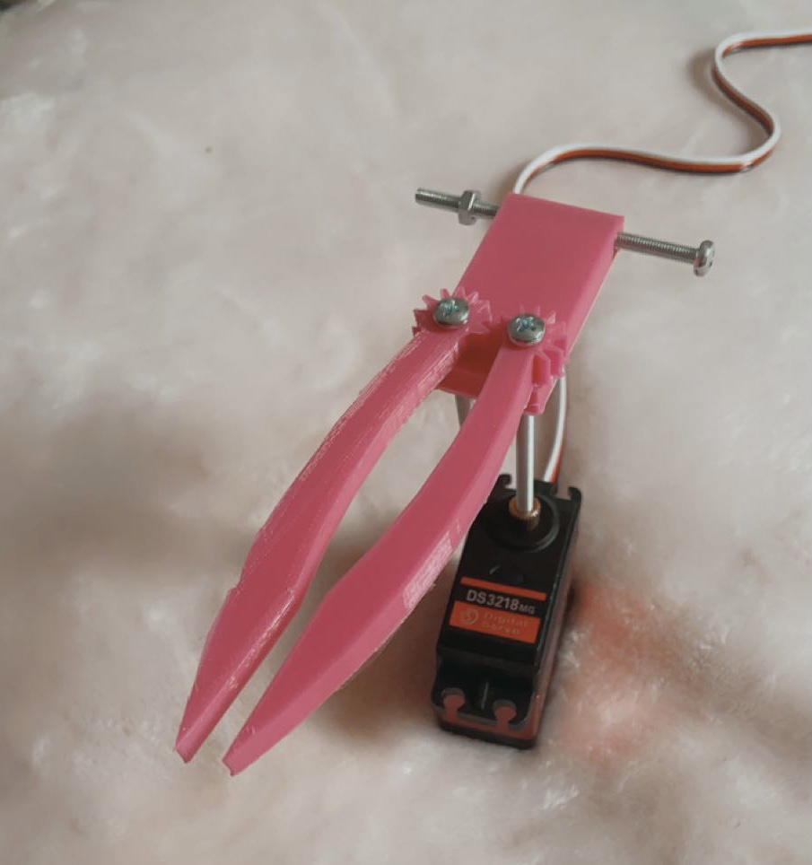

Prototype 3 tested the functionality of the end-effector with the servo motor and arm itself. We ran into an issue of it printing out too small which led us to change dimensions through sizing up so the screws could fit. Why do we want this? We need to have a functioning 3D-Printed end-effector for design day and there’s no better way to test if it works than actually printing it. Now that we have a functioning end-effector, we can test our code and inverse kinematics. By running the code through the Arduino-board we were able to see if the arm and end-effector moved properly. This was done about a week before design day so we could use the last lab to make corrections in case the arm or end-effector didn’t move properly when we were testing it.
Once we 3D printed our prototype, we had to analyze the prototype to make sure it met our requirements. We started with analyzing if the claw can fit the camera in between it. With the increased length in the claws, the claws were able to comfortably fit the camera in between. We then made sure that the claw was fastened securely to the platform by making sure the bolts were the correct size and tight enough so the claw will not become loose overtime. We tested the functionality of the prototype by checking if the servo motor works with the gear and that the gears turned without any problems. After testing that the prototype could function, we added items for it to hold. This resulted in us learning that the claws will not hold a lot of weight due to the 3D printing material since it is very lightweight. Another issue that we observed was that many items would slip through the claws grip. This was because the claws were too slippery to securely hold items. Our temporary solution was to add double sided tape to the claws in order to create some friction between the items and the claws. To combat this issue permanently, we have decided to add rubber sleeves to the claws in order to prevent the items from slipping in between the claws. Finally, we observed that the 3D printed prototype was smaller in size compared to the 3D model that was created on a CAD software. This is due to the 3D printing material shrinking right after it has been printed. To combat this issue, we plan on printing our final product a little bit larger to combat shrinkage we experienced previously.

Prototyping Test Plan

Test ID | Test Objective  (Why) | Description of Prototype used and of Basic Test Method  (What) | Description of Results to be Recorded and how these results will be used (How) | Estimated Test duration and planned start date  (When)
1 | Testing the overall movement of the end effector connected to the arm by implementing the code to avoid any errors in the arm’s overall movement and function  Possibly a better way:  - Using an online software such as CAD to implement the code and test the movement  - An online software would be cheaper and possibly reduce the risk of errors in the final prototype  However,  - Due to time constraints, making an online analytical model may take too long to complete  - For a comprehensive model, implementing all the physical components together to assess the overall design seems more of a practical solution | Comprehensive prototype using a physical model  Materials:  - 3-D printed end effector made from the Maker Lab from our previous prototype  - Researched code possibly from GitHub or another online source to implement with the Arduino hardware  - Computer keyboard  Cost: $50.98  Tasks/Process:  - Taking our previous prototype that was 3-D printed in the Maker Lab and connecting it with the servo motor and wires to a computer, we can implement the overall function the arm using the code we researched previously | Record:  - any errors found in the tested code  - any uncertain functions of the arm that may lead to the risk of breaking the end effector or the design of the overall arm itself | Planned Start Date:  - Approximately 4-5 days before design day (March 31^{st,} 2022)  - Will take approximately a day or two to complete depending on the errors needed to be observed and reviewed  Dependencies:  - The code must be completed for the end effector to function  - The previous prototype must be successful for this test to be executed properly  - The connection between the computer and the end effector must be stable

Feedback and Comments

Parents’ feedback about the end effector: the claw could be a bit shorter and have a bigger area on the side where it grabs the go-pro, this could make the claw grab the go pro easier. Make the claw more like an in-car phone holder. Also, the addition of rubber could make the go pro harder to fall off.
Friends’ feedback: we could add more color and drawing (logo) on the arm and the end effector, make it look more memorable, also easy for the team to identify the robotic arm.

Wrike Snapshot Link
https://www.wrike.com/frontend/ganttchart/index.html?snapshotId=La0v6Ktkvb0HnDTZitV9i4U78wUN4zfm%7CIE2DSNZVHA2DELSTGIYA

