Prototype 2 and Customer Feedback
Brooke Joyce, Hassan Ahmed, Ancelin Avenido, Jacky Zhu, Christopher Webster
March 13th, 2022

Table of Contents
1. Feedback from Client 4
1.1. Results from your previous prototype 4
2. Prototype 2 5
2.1. CAD Model 5
2.2. Feedback from potential users 6
3. Prototyping Test Plan 7
4. Wrike Snapshot Link 10

Feedback from Client
We received feedback from our client for our first prototype. After showing how our end effector looks as a prototype, we received feedback about our claws being too small to hold items. This feedback helps us design a new end effector that is larger than the previous one. This larger claw helps us assure that it can hold all items we put between it without worrying about the item not fitting.

Results from your previous prototype
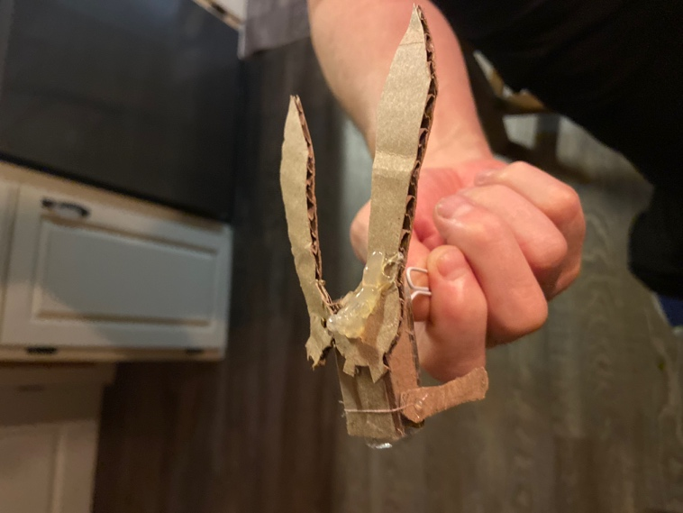

The first prototype helped us to know how the servo motor works with the gear to rotate the claw for our device (two claws that are attached with gear, one of them is linked with servo motor, the servo motor will help the gear to rotate with each other in order to open and close the claw) It will also let us know how to build the structure to support the claw and its base.

Prototype 2 will let us know how well the claw can hold the object, can the arm move with it? How does the inverse and forward kinematic work on the arm? do we need to adjust the size of the claw or even the size of the entire end effector before we actually start to build the end effector.

During the making of the second prototype, we also get to know what kind of parts we should make in order to build the end effector, and what other parts (screw, bolts, etc..) do we need to purchase from stores.

Prototype 2
Link for forward kinematics to test the inverse kinematics: https://www.desmos.com/calculator/51thh79vcx

CAD Model
This second prototype continues the development of our solution because we can test the functionality of the end-effector, and its dimensions. This prototype also allows us to ensure the gears shape and dimensions will work accordingly.

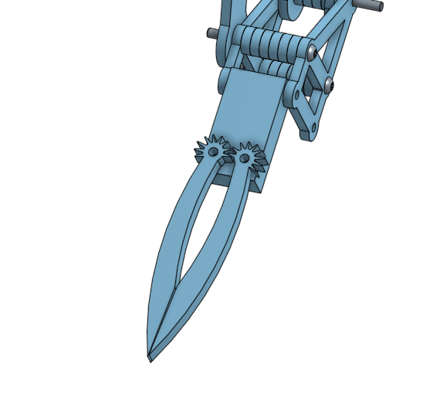
Feedback from potential users
Some feedback and ideas that we have gathered from other clients is feedback for the arm safety issues and easy user interface. The client wants to make sure the arm can be safely turned off if it ever goes out of control or malfunctions. To combat such needs, we can create a kill switch either on the robotic arm itself or a button on the user interface that can be pressed on the computer controlling the arm. This kill switch can instantly cut power to the arm if it ever goes out of control, preventing any further damages to the arm itself or its surroundings. The client also would like the arm to be easy to control. This means having a user-friendly software that controls the arm. This is important as having a clear user interface can remove confusion when controlling the arm which can help prevent any mistakes caused by confusion.

Prototyping Test Plan

Test ID | Test Objective  (Why) | Description of Prototype used and of Basic Test Method  (What) | Description of Results to be Recorded and how these results will be used (How) | Estimated Test duration and planned start date  (When)
1 | Testing the physical components of the end effector to avoid the risk of damaging the most critical part of the arm which is the end effector itself by observing its overall design through its basic movement, function, and dimensions in a physical setting | Focused prototype on the most critical component of the arm – the end effector  Based on an experimental to test its overall design (physical model)  Materials:  - Experimental model made with 3-D printed materials instead of aluminum for the claws of the end effector for a more practical use and a less expensive investment  - Small rubber bands around the claw to increase its grip  - An aluminum platform that acts as the base of the end effector itself  - Aluminum rods and bolts to hold, support and connect the end effector  - Go-pro (if available)  Cost: $1.06 ($1.20 with tax)  - excluding the cost of 3-D printing and the Go-pro  Main member responsible:  - Brooke (available in-person to print and assemble the parts) | Rough Process/tasks:  - Using the 3-D printing software available in the Maker lab, print the claws of the end effector  - Attached the platform and the claws together using the aluminum rods and bolts available to connect the components  - Increase the grip of the end effector by adding the rubber bands around each claw  - If available, placed the go-pro in between the claws to ensure stability  - Record the dimensions of each component used to build the prototype to ensure its usability for the product  - Observe and record any functioning problems with the connected components of the end effector and review with the other team members of any issues (such as the stress in grip, or the restrictions in movement) | Dependent on:  - the success of the analytical simulated model planned and performed after the last deliverable  - the materials available in the lab and the team budget  Planned start date:  - approximately 1-2 weeks before Design Day (or around Monday, March 14th during lab hours)  Activities  - Development and testing (1 day)  - Reviews (1 day)  - Adjustments (approximately 1-2 days)
2 | Testing the implemented code with the pre-built physical end effector from the last other prototype test to ensure its usability in control and movement of the claws | Focused prototype on the function of code and the controllability the end effector  Based on an experimental model to test the precision of its function with the end effector  Materials required:  - Arduino board to connected to control the end effector  - Servo motor with wires to control the movement of the claws  - A USB port to power the motors and the end effector  - The physical prototype of the end effector design from the pervious test  Cost: $50.98 ($57.61 with tax)  Main member(s) responsible:  - Chris (in charge of the end effector’s software)  - Brooke (in charge of assembling the code and arm) | Rough Process/tasks:  - Connect the wires of the servo motor to the claws of the end effector  - Using the Arduino board as an interface, control the positioning of the end effector  - Use the USB port to connect and power the overall system  - Record any issues (such as restrictions in controllability and/or movement) with implementing the control system to the physical end effector and review with the other team members to make improvements to the product | Dependent on:  - the success of the previous prototype test which involved physically making the components of the end effector ensuring its use, stability and confirming it won’t be damaged for the final product  - Note: if the materials required to control the code aren’t available in the lab to connect to the, then Chris at home can attempt to perform the experiment with his available software materials to test the code or the team will decide an alternative method to test the function of the code with the end effector  - the success of the written code with the implemented solution to the inverse kinematics problem  Planned start date:  - approximately 1-2 weeks before Design Day (or around March the week March 14th)  Activities  - Development and testing (1 day)  - Reviews (1 day)  - Adjustments (approximately 1-2 days)

Wrike Snapshot Link
https://www.wrike.com/frontend/ganttchart/index.html?snapshotId=bmSPoZNXYLcKJ912bQI1MfRu1t2IN7ZH%7CIE2DSNZVHA2DELSTGIYA

