Prototype 1 and Customer
Brooke Joyce, Hassan Ahmed, Ancelin Avenido, Jacky Zhu, Christopher Webster
March 6th, 2022

Table of Contents
1. Feedback from Client 4
2. Prototype 1 4
Pictures of Prototype 1 4
Video of Prototype 1 (Click to watch) 9
1. Feedback from potential users 10
3. Analysis of Critical Components 10
4. Prototyping Test Plan 10
1. Prototype 1 10
2. Prototype 2 11
5. Wrike Snapshot Link 13

Feedback from Client
From the last client meeting, the client asked us about the inverse kinematic, the purpose of our design and our task plan. From his feedback, our group figured out what code we’re using for solving the inverse kinematic problem. Before the meeting, we thought we had to build the entire arm, after the receiving the feedback, our group figured out what we need to do for the project, we are going to build an end-effector that can hold a camera. The client’s feedback helped us to set our goal and start the design stage. With our goal set, we will be able to decide who will do the coding part, who will do the design part and who will build the prototype.

Prototype 1

Pictures of Prototype 1

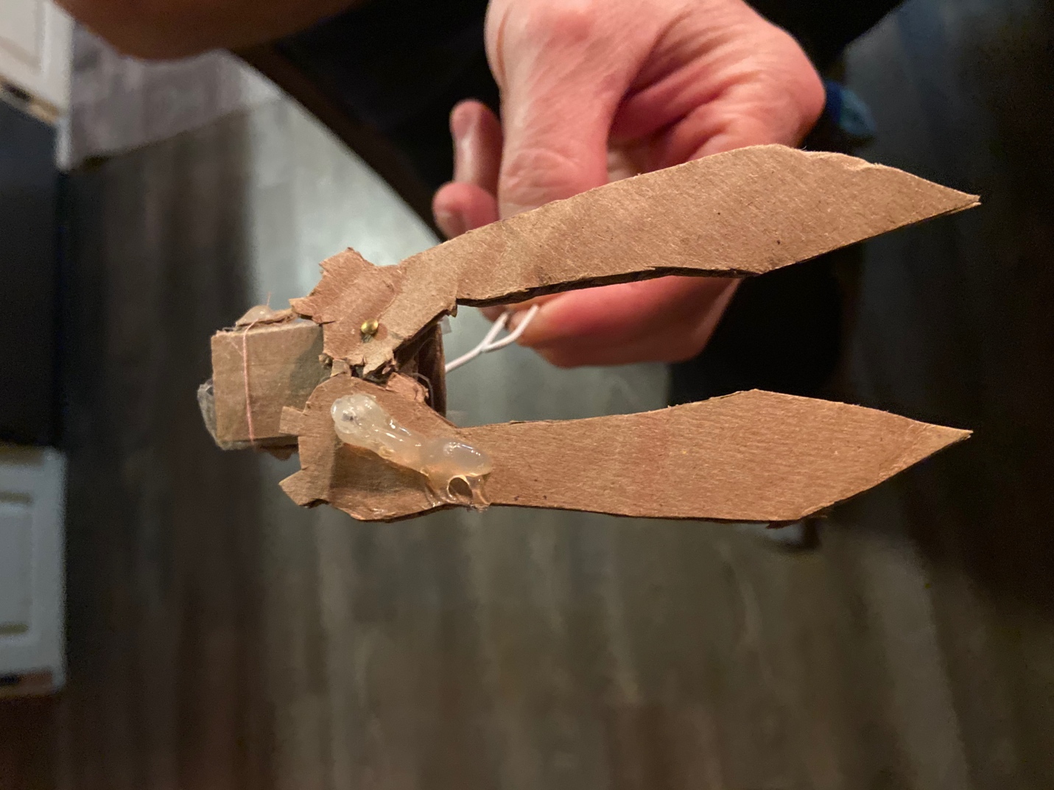
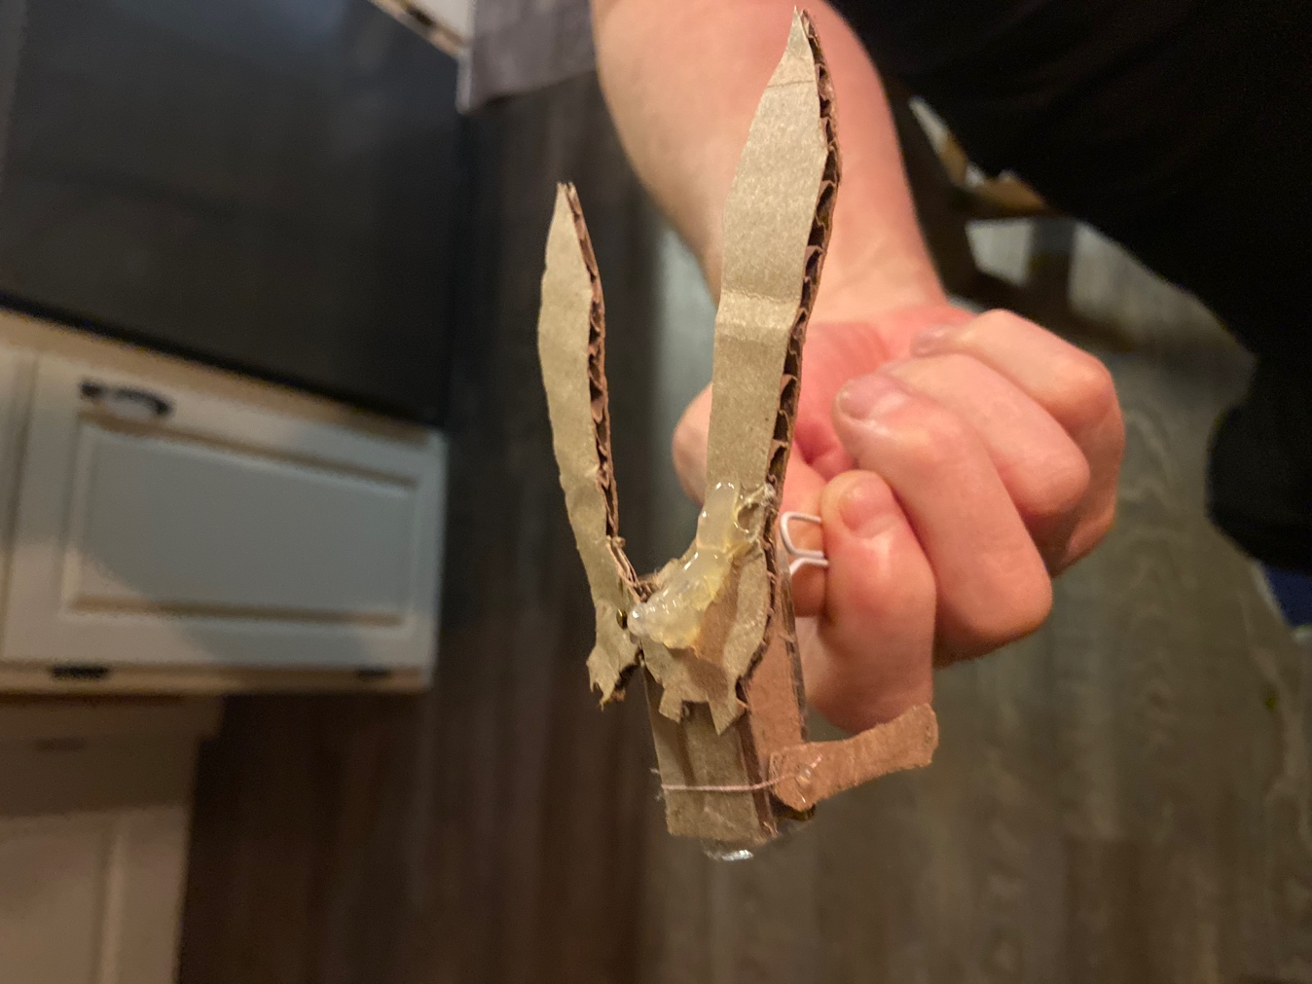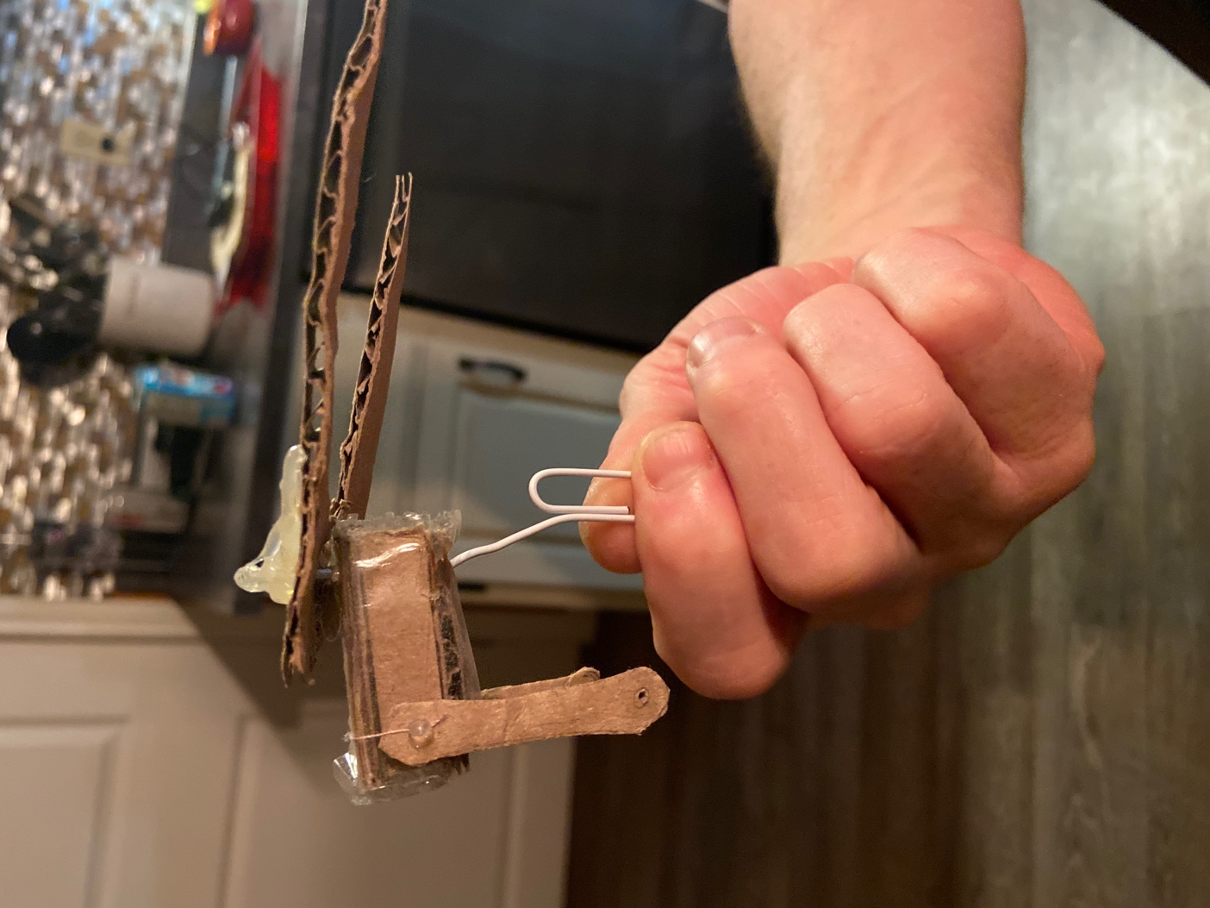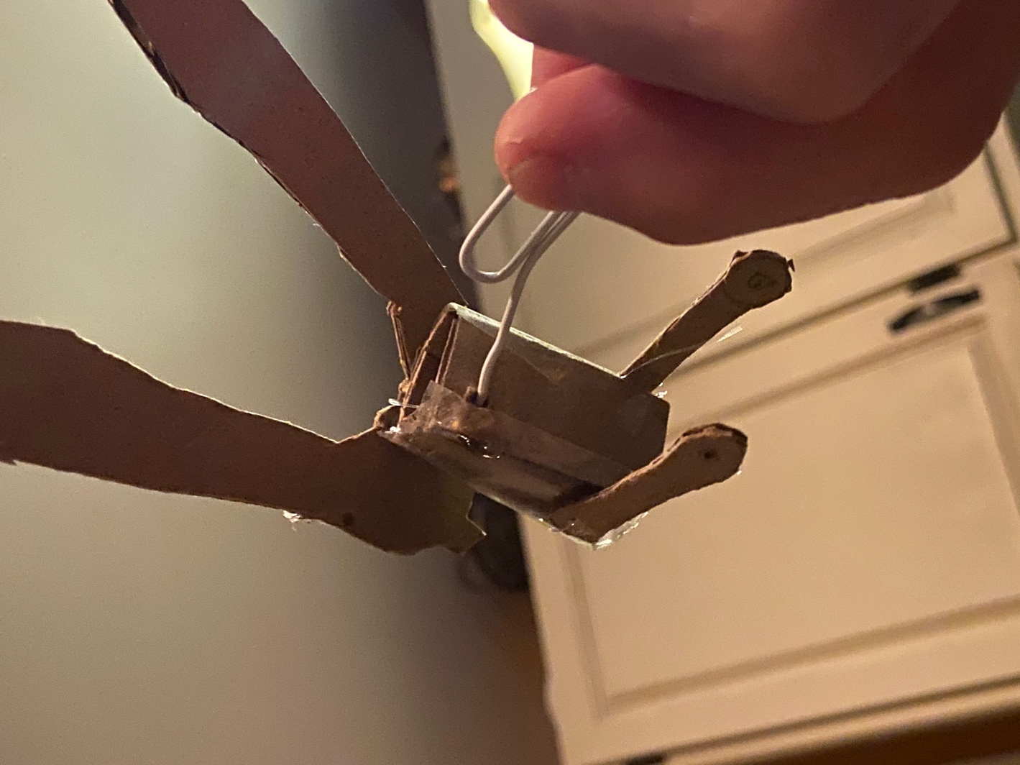

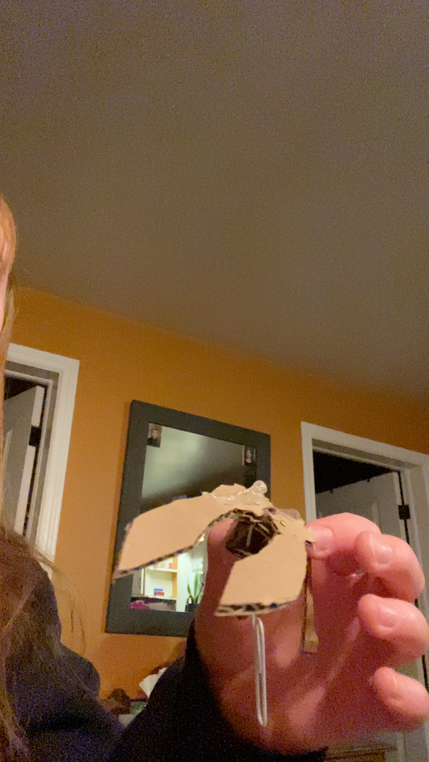
Video of Prototype 1 (Click to watch)

The paper clip represents the servo motor turning the servo horn (which is represented by the hot glue on top of the gear) which will activate the gear movement to open and close the claws.

Feedback from potential users

I talked to an electrician and they said the Arduino keyboard would be very useful and making sure the end-effector can come off of the arm would help with repairs.

A quality assurance specialist that focuses on efficiency within processes I talked to informed me that the rod is not necessary in our design since it uses extra material we do not need.

Analysis of Critical Components
Servo Motor: Will act as a rotary motor that allows precise control of the speed at which the claws will open and close at. Servo Motors can connect to Arduino boards to control their movements very precisely.
Aluminum: Aluminum will be very useful as it is a strong and very lightweight metal. It is also resistant to corrosion in case we get any water onto the metal and it is more affordable compared to other metals.
Arduino board: Arduino boards are able to read inputs such as a code and turn it into an output. It is used to control the claws with precise movements. Arduino boards are affordable and easy to use as they are open source.

Prototyping Test Plan

Prototype 1
Test ID | Test Objective  (Why) | Description of Prototype used and of Basic Test Method  (What) | Description of Results to be Recorded and how these results will be used (How) | Estimated Test duration and planned start date  (When)
1 | Testing the overall movement of the end effector connected to the arm to avoid error in the arm’s overall function | Comprehensive prototype using a physical model | Record the arm’s overall functionality, stop when we are able to hold a camera. | 3-4 weeks before design day
2 | Testing the basic function and grip of the camera to decrease the chances of damaging the object held up by the arm (the end effector’s ability to hold the camera stable in place) | Focused prototype using a physical and/or analytical model  - Analytical  - Through the online software CAD Onshape, a visual of the model can be made  Cost: $0  - Physical  Materials include:  Cardboard  Hot Glue  Paper clip  String  Tape  Pin | -Record the dimensions (length, width and height of each component made and used)  - Compare initial, researched measurements with finalized ones  -Record physical observations of the quality to ensure no damage is done to the camera.  -Stop when the end-effector is able to pick up the camera(ensure the claws are wide enough). | 1-2 weeks before design day

Prototype 2

Test ID | Test Objective  (Why) | Description of Prototype used and of Basic Test Method  (What) | Description of Results to be Recorded and how these results will be used (How) | Estimated Test duration and planned start date  (When)
1 | Testing the overall movement of the end effector connected to the arm to decrease the risk of errors found in the system of the robotic arm and testing the | A comprehensive prototype using a physical model  Process:  Implement the code in the Arduino system and connect the end effector to the pre-built robotic arm to move and test its ability to open and hold a camera  - Use an Arduino keyboard to control the arm’s movement  Materials Required:  Aluminum Platform  Aluminum Rods  Aluminum gear claws  Servo motor with wires  Servo Horn  Bolts  Arduino Board  USB for power  Washers  3-d printer  Screw-driver  Laser Cutter  Cost: $31 | -Record the movement of the arm with and without the GoPro held to compare its stability with and without the camera to avoid risks in damaging the final product  -Record the minimum and maximum weight the end effector could carry/withstand to ensure it can hold a camera of appropriate size | 1-2 weeks before Design Day
2 | Testing the code implemented in the system to avoid the chances of error found in the coordinates integrated by inverse kinematic calculations which can affect the end effector’s overall ability to open and close | A focused prototype using a physical/analytical model  Process:  - Through an online Arduino software, the code can be implemented and tested automatically  Materials Required:  C++ Code and same as above  Cost: use same prototype as step 1 | -Record the trial and error of each presented version of code to ensure success in the arm’s movement and functionality  -Record possible errors found in calculations of the inverse kinematics | 1-2 weeks before Design Day
3 | Testing the basic function and grip of the camera to decrease the chances of damaging the object held up by the arm (the end effector’s ability to hold the camera stable in place) | Focused prototype using a physical and/or analytical model  - Analytical  - Through the online software CAD Onshape, a visual of the model can be made  Cost: $0  - Physical  Materials include:  - using 3-D printing and laser cutting, the components can be made  - Go-pro  Aluminum Platform  Aluminum Rods  Aluminum gear claws  Servo motor with wires  Servo Horn  Bolts  Arduino Board  USB for power  Washers  3-d printer  Screw-driver  Laser Cutter  Cost: use same prototype as step 1 | -Record the dimensions (length, width and height of each component made and used)  - Compare initial, researched measurements with finalized ones  -Record physical observations of the quality to ensure no damage is done to the camera.  -Stop when the end-effector is able to pick up and hold the camera without scratching or dropping it. | 1-2 weeks before design day

Wrike Snapshot Link
https://www.wrike.com/frontend/ganttchart/index.html?snapshotId=gHcMd7EehXm8yMgxlYIYAEfws6I4KObu%7CIE2DSNZVHA2DELSTGIYA

