Deliverable E: Project Plan and Cost Estimate

Group 18: Calum Avon, Ashley Larocque, Poula Rezkalla

Abstract

The purpose of this deliverable is to develop a project plan in order to execute our final conceptual design based on the previous deliverables. A project schedule was created to outline all major and minor tasks that need to be completed throughout the development process. Additionally, a risk and contingency plan has been developed to mitigate the critical risks that are reasonably likely. Finally, an exhaustive list of all the materials being used was developed to determine the estimated total cost of the system.

Table of Contents
Table of Contents 3
Design Overview 4
Parts of the system: 4
Design Drawing: 5
Bill of Materials 6
Risk and Contingency 7
Schedule 7
Equipment List 8
Equipment Required for Building the Prototype 8
Equipment Required for Testing the Prototype 8
Prototyping Test Plan 9
Procedure: 9
Stopping criteria: 9
Objective: 9
Conclusion 10

Design Overview
The final design was determined to be a combination of the conceptual designs from deliverable D. The design is to have a multitude of sensors, including an accelerometer, a motion detector, a carbon monoxide sensor, and a temperature sensor. These sensors will determine if there is an occupant inside of the parked vehicle and if the conditions inside are becoming dangerous. It will also include an app that will send persistent notifications to the owner’s cell phone in the event that an occupant is detected with dangerous conditions in the vehicle. The system will have multiple fastening options, including: under the front seat, under a rear headrest, on the ceiling. These options will create the most flexibility for the owner and ensure that the product is as universal as possible.

Parts of the system:
- Arduino Board
- Accelerometer
- Temperature sensor (TMP36)
- Motion sensor (HC-SR501)
- Carbon monoxide sensor (MQ-7)
- ESP32 BLE
- Speaker
- Phone application
- GSM module

Design Drawings:

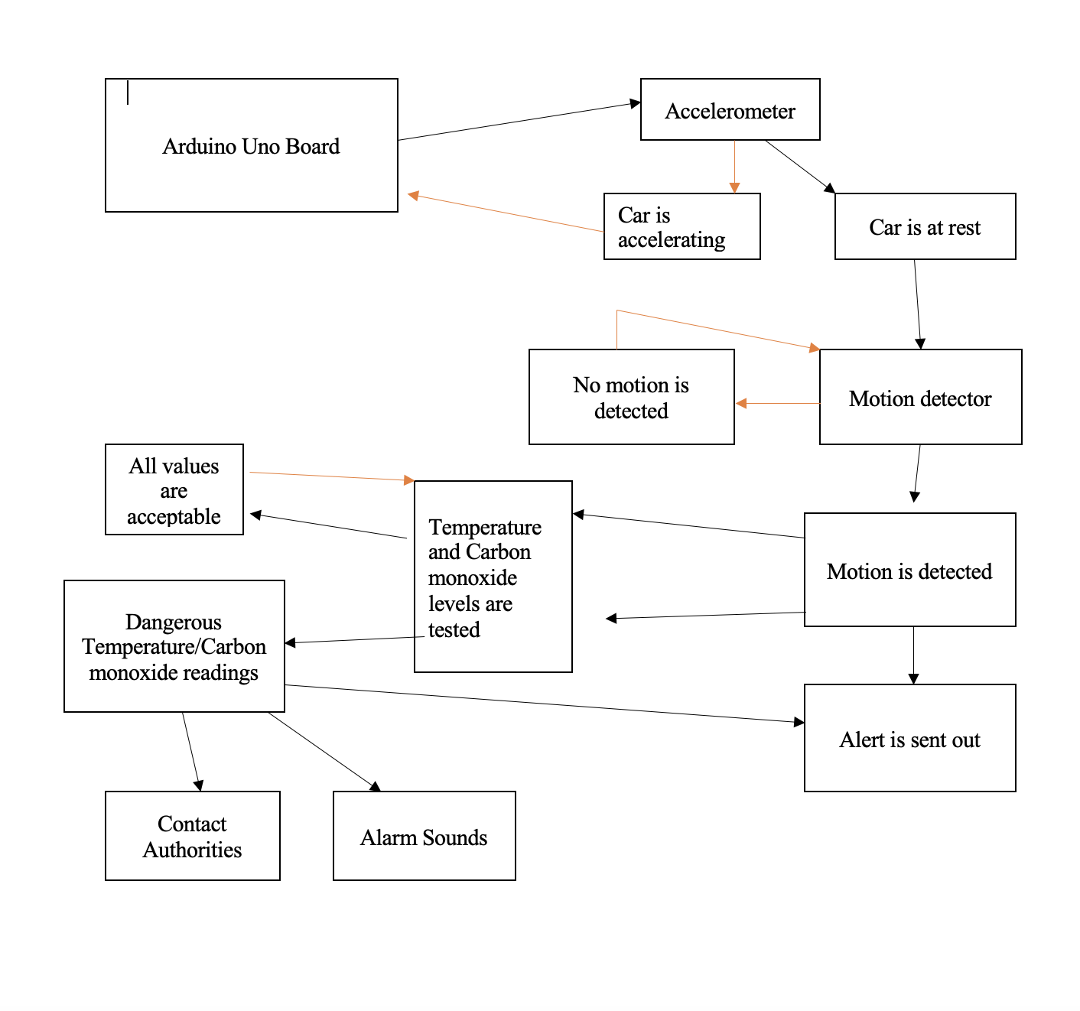
Figure 1: Path of Action

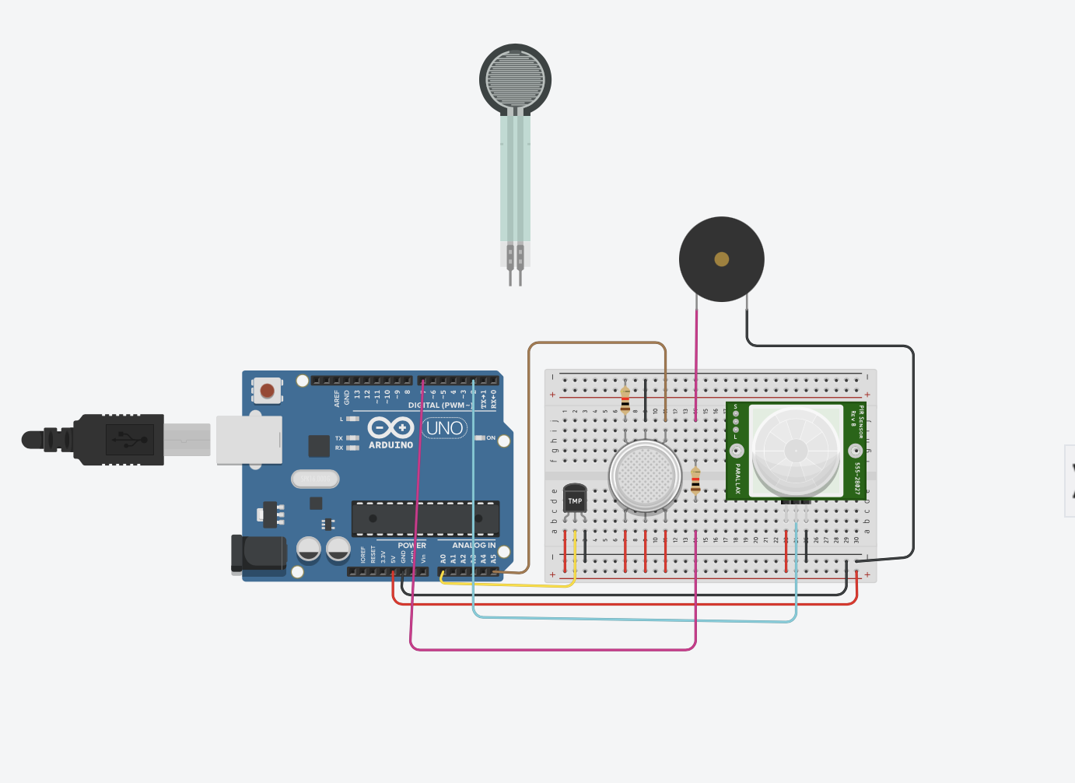

Figure 2: Circuit Diagram

Bill of Materials
Item no. | Item name | Purpose | Cost $ | Purchase Link
1 | Motion Sensor (HC-SR501) | Detects motion of an occupant within 7 metres | 1.11 | [1]
2 | Arduino Uno | Connected to all the sensors | 17.00 | [2]
3 | Carbon monoxide gas sensor (MQ-7) | Monitor carbon monoxide concentration in the vehicle  Between 10 and 50 ppm | 1.66 | [3]
4 | Accelerometer (Cytron ADXL335) | Detects acceleration to activate the system | 4.95 | [4]
5 | Temperature Sensor (TMP-36) | Monitors the temperature in the vehicle | 1.92 | [5]
6 | Resistor 10k ohm | Required to build the circuit with Arduino and the MQ-7 | 0.65 | [6]
7 | ESP32 BLE | Connects the Arduino board via Bluetooth to the driver’s device | 16.90 | [7]
8 | Jumper cables | Building circuits | 9.99 | [8]
9 | Breadboard | Building circuits | 10.00 | [9]
10 | Miniature 8Ω loudspeaker | Create the alarm sound when the conditions in the vehicle are not safe for an occupant | 9.26 | [10]
11 | Capacitors | Building the circuit with the speaker and the Arduino | 2.01 | [11]
12 | Resistors (15kΩ, 27kΩ, 470kΩ ) | Building the circuit with the speaker and the Arduino | 0.65 | [12]
13 | Transistor (2N2222) | Building the circuit with the speaker and the Arduino | 3.71 | [13]
14 | Programmable unijunction transistor (2N6027) | Building the circuit with the speaker and the Arduino | 1.99 | [14]
15 | Pololu Carrier for MQ Gas Sensors | Building the circuit with the MQ-7 gas sensor and the Arduino | 0.95 | [15]
16 | GSM Module | Allows the Arduino board to connect to the internet, send and receive SMS, and make voice calls | 26.19 | [16]

Total Estimated Cost = $84.05
Total Estimated Cost with tax = $94.97

Risk and Contingency
Potential Risk | Response | Contingency Plan | Trigger | Who is Responsible
Equipment Malfunctioning | Mitigate: Choose a reliable vendor | Order a replacement | Prototype does not pass tests | Ashley
User backlash | Mitigate: Provide a demonstration | Review customer feedback and consider making modifications to the system. | Client meeting | Ashley  Calum  Poula
Materials’ availability | Mitigate: Work on other components until the materials arrive | Find possible alternatives and place orders | Lack of supplies | Ashley
Labour Shortages | Mitigate: have a group meeting to reassess our timeline and discuss the remaining tasks | Work together to get the urgent task finished | Poor time management | Ashley  Calum  Poula

Schedule

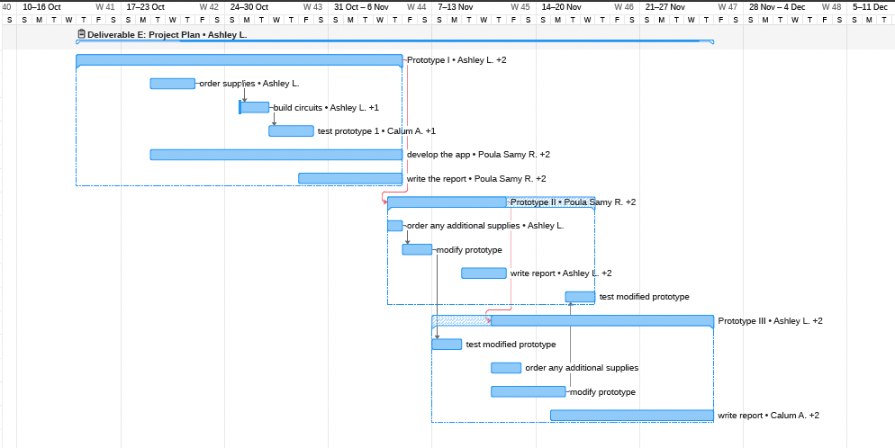Figure 3: Project Timeline - Ghant Chart

Equipment List

Equipment Required for Building the Prototype
- Thunkable (Software for app creation)
Thunkable will be the primary software used for creating the app, UI
and images will be created with it in addition to photoshop.
- Soldering Iron and Solder
Will be used to modify the connections and lengthen portions of wires if needed.
- Wiring
Will be used to connect required parts, and lengthen required wires if necessary.
- Fastening Material (Tape, Zipties,)
- Arduino IDE
The Arduino IDE will be used to set up code for the Arduino, it will outline steps to be followed in specific situations, and will tell the Arduino what sensors must be monitored and what to do at specific values.

Equipment Required for Testing the Prototype

- Enclosed sealed space (Parked car)
This space will be used to simulate a parked car, the prototype will be placed inside of the car where numerous tests will be conducted to determine its effectiveness. The cars will be used to test the motion sensor, heat sensor, CO sensor, as well as all communication systems on the prototype.
- Heat source (Hairdryer)
This will be used to simulate raising temperatures inside of the car, a hairdryer or equivalent heat source will be pointed at the temperature sensor to determine if it is functioning as intended. A hairdryer will replicate a car heating up naturally and will make testing for temperature more feasible.
- CO source (Human)
A human will be used to test the CO sensor by breathing on it. This will
determine if the sensor is strong enough and if the system successfully follows the determined process if CO is detected in the car. A CO₂ canister can also be used.
- 12V battery
Initially a 12V battery will be used to power the prototype, making it a completely stand-alone system. Eventually, a connection will be made to the car’s power system through multiple options that can be selected by the user.

Prototyping Test Plan

Procedure:
The tests will commence by attempting to install the prototype in a vehicle. This will ensure that the system will be easy to install and will validify our installation techniques. Next, the sensors will be tested. This will be done by attempting to activate them using various methods, including a source of heat, a source of CO and moving. Once it is confirmed that these sensors are creating an accurate and reliable reading, the communication subsystem will be tested. To do this we will recreate the required parameters that would cause the system to send a signal out to the app.

Stopping criteria:
Once it is determined that all sensors, communication systems and the code is functioning as initially intended, and within an acceptable error, the testing will be completed. If any of these criteria are not met adjustments will be made until they are.

Objective:
The object of the prototype is to ensure the feasibility of the system, analyze critical subsystems, and get feedback on our initial design.

Conclusion

We have outlined a clear prototyping stage and cost estimate. This will make testing and building the prototype much more straightforward and avoid any possible confusion and lack of testing. A clear schedule has been created to outline when each step will be completed to ensure that the process stays on track. The potential risks and their associated contingency plan have been outlined to minimize the effect such risks could have on the completion of the project.

Prototyping will be done using several tools to mimic realistic conditions that would cause readings in all sensors and thus activate other subsystems. Only once it is determined that each sensor and subsystem works within a specified uncertainty, and functions reliable, will the tests be concluded. These tests will ensure that the prototype as a whole is feasible, will allow us to analyze critical subsystems and get feedback on our original design.

