GNG 2101
Introduction to Product Development and Management for Engineers and Computer Scientists

Project Deliverable H: Economics Report and 1 Minute Video Pitch

Lab Section: A02, Wednesday, Lab Group A7

Student Number |  | Name
300077504 |  | Prisha Shetty
300122381 |  | Liam Kennedy
300062079 |  | Jeta Thavarasah
300117908  300132765 |  | Joshua Coutinho  Liam Fagan
Date Submitted:November 19th , 2020
Professor: Dr. Hanan Anis
PM: Cooper Lawrence
TA: Jaya Kandimalla

Faculty of Engineering
2020

Introduction

The following deliverable outlines the income statement for our device. It goes into detail about the variable, fixed, direct, and indirect costs of our business based on the manufacturing and sale of our product. This deliverable also contains the three year income statement plan for our product, which includes ; sales revenue and costs of units sold for each year, gross profit, operating expenses and operating income. Additionally we have also included an NPV analysis to determine the break even point in our report.

Assumptions
For the following data in the deliverable it is important to know the following assumptions which the calculations are based on. In Canada there are approximately 226,000 blind people, of 3.8 million people with disabilities 5.8% were legally blind as reported by the survey linked below. Of the 226,000 blind we planned to sell to 1.5% in the first year, another 3% in the second and an additional 3.5% in the third. For the rent calculations the data was collected from edmonton commercial which is referenced below. The Edmonton commercial reports an average of $2-3 per square foot of factory space and another $9-20 each square foot for rent. The salary/wages are estimated from the average wage of a Honda employee in Canada which is between $29,000 for an entry level worker and $54,000 for an experienced worker. We preferred the experienced workers for our factory because they may need a multitude of different skills to function thus $50,000 became the average wage of the employees. As for our marketing spotify will play an add for $0.015 per listener and we would like approximately 5,000,000 adds to play thus reaching a total of $75,000 and we would like to invest $50,000 in to radio stations which cost $200-2000 to play and add for 30 seconds 20 times throughout the week. We made the assumption that we would need $100,000 dollars worth of machine investments into the company initially such as forklifts($20,000-45,000), milling machines($2,000-5,000), drill presses($1,000-5,000), 3D printers($100-10,000), conveyors($100/sqft), Injection moulding machines($10,000-100,000) all of which would add up to an estimated $100,000. The cost of materials is initially 48.44 for one unit and we estimate that only 1/10 people will buy a warranty leading to our calculations. The manufacturing costs are calculated based on the value of the machines and how many units they produce so at 3390 units and $100,000 the manufacturing cost is $29.5 each unit ($100,000/3,390).

Costs | Fixed | Variable | Direct ($) | Indirect ($)
Cost of Materials |  | x | 48.44 per unit
Salaries | x |  | 200,000
Rental Space | x |  |  | 80,000
Marketing |  | x |  | 175,000
Depreciation |  | x | ($10,000)@10%
Loans | x |  | 112,000
Utilities | x |  | 12,000
Price | Fixed | Variable | Direct ($) | Indirect ($)
Individual Product | x |  | $140 per unit
Warranties | x |  | $15
Bulk Product |  | x | 45 per unit
Manufacturing costs |  | x | $29.5 per unit

Revenue: | 2020 | 2021 | 2022
Product income | (3,390*$140)= $474,600 | (6,644*$140)= $930,160 | (7,519*$140)= $1,052,660
Warranties | (3,390/10)=452  339*$15=$5,085 | (6,644/10)=664  664*$15=$9,960 | (7,519/10)=752  752*$15=$11,280
Sales Revenue | $479,685 | $940,120 | $1,063,940
Cost of Goods Sold
Production Materials | $48.44*3,390= $164,211 | $(40-$8.44)*6,644= $265,760 | ($30-$18.44)*7,519= $225,570
Manufacturing costs | $0 | ($8.44/2)*6,644= $56,075 | ($18.44/3)*7,519=  $138,650
Gross Profit(Sales revenue - cost of goods) | $479,685-$164,211= $315,474 | $940,120-$265,760-$$56,075= $618,285 | $1,063,940-$225,570-$138,650= $699,720
Operating Expenses:
Marketing | Spotify $75,000+  Radio $50,000=  $125,000 | $125,000+  $50,000=  $175,000 | $175,000+  $50,000=  $225,000
Utilities | $3/sqft * 4000 sqft= $12,000 | $3/sqft * 4000 sqft= $12,000 | $3/sqft * 4000 sqft= $12,000
Salary | 4*$50,000=$200,000 | 4*$50,000=$200,000 | 5*$50,000=$250,000
Depreciation | $100,000 at 10% =$10,000 | $90,000 at 10% =$9,000 | $81,000 at 10% =$8,100
Rent | $20/sqft per year *4000=80,000 | $20/sqft per year *4000=80,000 | $20/sqft per year *4000=80,000
Operating Income(Gross profit-operating expenses): | $ -111,526 | $142,285 | $121,620
Net Income:(*No tax or interest) | $ -111,526 | $142,285 | $124,620

Cash Flow Analysis:

Year 2020
 | Cash In ($CAD) | Cash out ($CAD)
Product Income | 474,600
Warranties | 5,085
Production Materials |  | 164,211
Manufacturing cost |  | 0
Marketing |  | 125,000
Utilities |  | 12,000
Salaries |  | 200,000
Depreciation |  | 10,000
Rent |  | 80,000
Total Cash in | 479,685
Total Cash out |  | 591 211

Net Cash Flow: 479 685 - 591 211 = $-111 526

Year 2021
 | Cash In ($CAD) | Cash out ($CAD)
Product Income | 930,160
Warranties | 9,960
Production Materials |  | 265,760
Manufacturing cost |  | 56,075
Marketing |  | 175,000
Utilities |  | 12,000
Salaries |  | 200,000
Depreciation |  | 9,000
Rent |  | 80,000
Total Cash in | 940,120
Total Cash out |  | 797 835
Net Cash Flow: $142 285

Year 2022
 | Cash In ($CAD) | Cash out ($CAD)
Product Income | 1,052,660
Warranties | 11,280
Production Materials |  | 225,570
Manufacturing cost |  | 138,650
Marketing |  | 225,000
Utilities |  | 12,000
Salaries |  | 250,000
Depreciation |  | 8,100
Rent |  | 80,000
Total Cash in | 1,063,940
Total Cash out |  | 939,320
Net Cash flow: $124 620
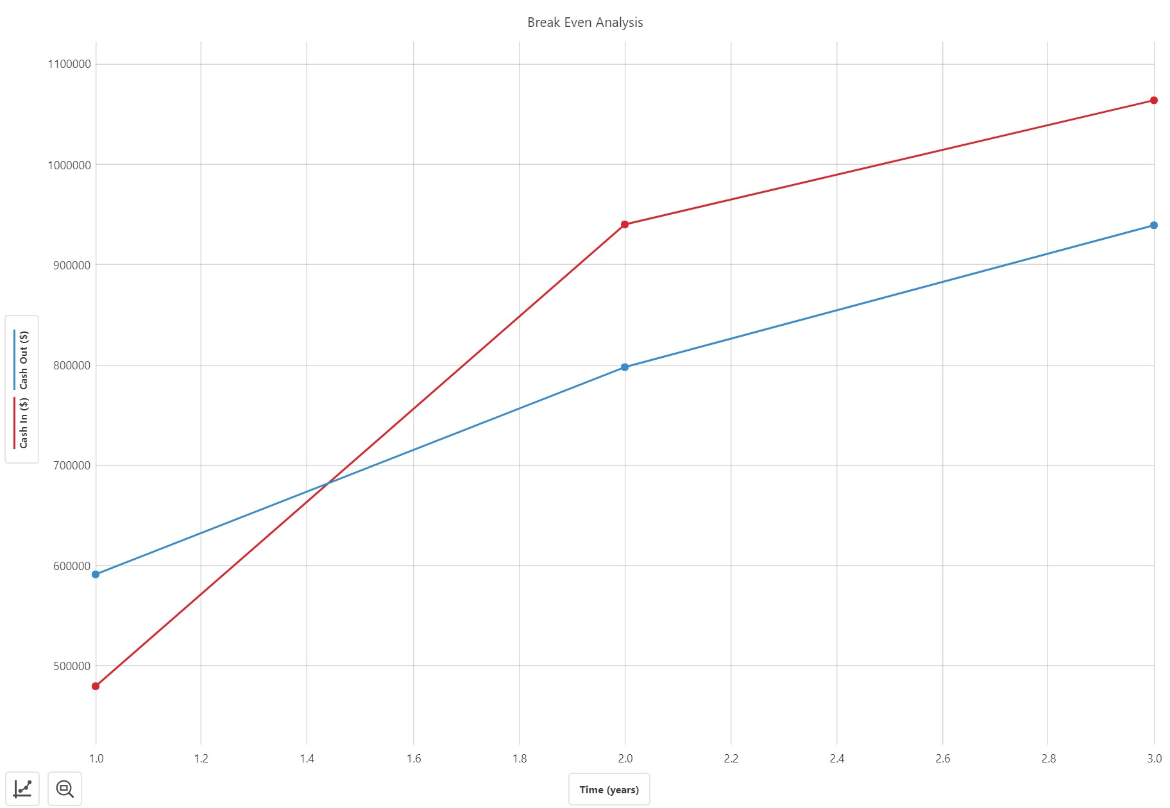

https://www.edmontoncommercial.com/utility-costs-warehouse-space-edmonton/

https://www150.statcan.gc.ca/n1/daily-quotidien/160229/dq160229c-eng.htm

https://youtu.be/mwqh5IjcBbU

https://makerepo.com/joshh05027/gng-2101-/edit

