Project Deliverable # L: Final Design Report
Introduction to Product Development and Management for Engineers GNG 2101

Faculty of Engineering University of Ottawa

Group B4
Names-Student IDs
Aya Al-shawabkeh-300036357
Marjan Riazi-5885367
Michael Zhang-0300004984
Codrin Gherghel-7818418
Hassan Abdi-5698480

Table of Contents Page #’s

- Abstract ……………………………………………….…...3
- Introduction ………………………………...…………….....4
- Design Process .…………………………………………....4
- Empathize …………………………………….………..5
- Define ……………………………….……...6
- Ideate …………..………………………………7-9
- Prototype ……………………………….10
- Feasibility Study …..………………………………………..11
- Conclusion ……………………………………………….12

List of Tables/Figures
Page 4 – Figure 1.0: this figure is used to outline our design process
Page 6 – Figure 2.0: this is the wheelchair that Molly was equipped with
Page 8 – Figure 3.0: This is a sketch of an initial concept
Page 9 – Figure 3.1: another sketch of a different concept
Page 10 – Figure 4.0: This is the BOM that was used to determine cost

Abstract (Codrin)
Accessibility issues affect 13.7% of Canadians (3.8 million) and it seems as if society puts them to the side more and more as time goes on. Of those Canadians, mobility and dexterity affect 7.2% and 3.5% respectively. This leaves a lot of Canadians at the hands of mercy wherein they may not be able to perform a multitude of tasks. The students in GNG2101 were assigned projects to help alleviate some of the stresses that these disabled adults deal with. Group B4 was introduced to a very lively and outgoing client named Molly. Molly is confined to a wheelchair and bed 24/7 and she has a very hard time dealing with anything that requires hand movements, more specifically wrist rotation. She has severe arthritis and carpal tunnel and cannot clasp objects. Luckily for us, we were able to help in at least one area. Of the many things that a nurse may help her with, brushing her teeth is something she would like to do independently as she hadn’t in 15 years.
Consideration of the design process was very important throughout this project. Seeing as Molly was very open about speaking to us, we chose to listen to her needs and wants; and so we incorporated an empathetic Design Thinking process. The key to this process was constantly checking in with our client for feedback. We started by gaining some knowledge from Molly in our first meeting. Here we learned what our design constraints would include and we set out to research and brainstorm any and all ideas. During our second meeting, we learned that Molly was skeptical of any ‘automated’ tools due to past traumatic experiences and Bocar also alerted us to the possible regulatory bumps we might hit. We re-assured them of our design and continued ahead with the project. During the third meeting, Molly was very excited to see the first prototype and our worries were subdued. We continued down our empathetic design process and began prototyping our mouth guard concept.
After our first prototype, we were able to see where there needed to be changes. We fixed any issues and made our final prototype. I believe it was extremely successful and with a few more weeks of work, Group 4B will have a market-ready product that we will patent.
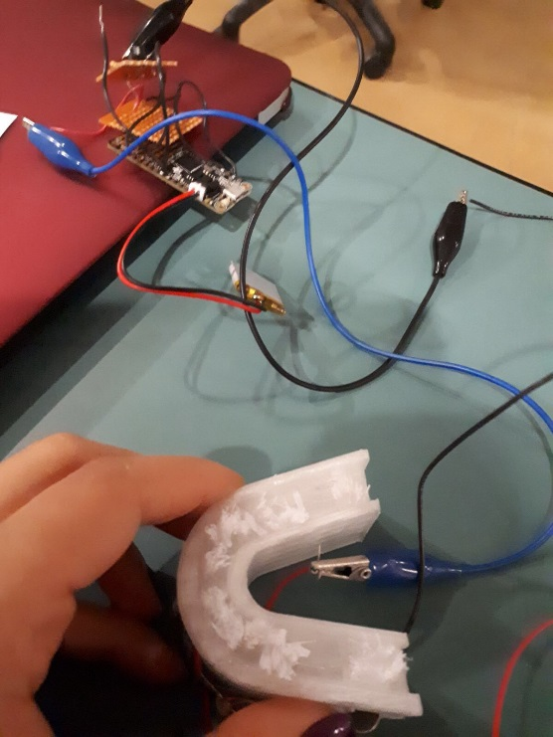
Introduction (Codrin)
The main scope of this project was focused around accessibility. It is a very pressing issue, especially among the growing elderly population in Canada (Statistics Canada, 2016 Census of population), that has not been taken seriously for far too long. Our client, Molly, is among these statistics except she also has the added hindrance of a disability. Because of severe arthritis and carpal tunnel, Molly has been very limited in what tasks she can fulfill independently, amongst which is brushing her teeth. Group 4B was tasked with figuring out a way to allow for our client to perform this simple task by herself.
When we first went to visit Molly, we became a lot more visually aware of her limitations. She is an older woman who is confined to a wheelchair and her bed at the hospital. After speaking to her we soon learned that she had not brushed her teeth by herself in 15 years. Unfortunately, this brought us to the realization that there are many people out in the world that cannot perform this simple task, so we set out to improve their lives and give them at least some sense of independence. Through producing such a device we can help not only patients in need, but we can also alleviate some of the daily tasks that every nurse must do.
Using the concepts we have been taught in GNG2101 and the newly learned machining skills, our team set out to create something that has not been thought of before. After scouring the internet, we were unable to find any sort of accessibility focused oral hygienic products. The closest someone had come up with was a handle that would allow for brushing without the need for your hand to clasp a handle. Due to Molly’s unique disabilities, this was not going to be enough. Our product is an all-in-one toothbrush that brushes every inch of your teeth hands-free. We focused our efforts around the mouth-guard concept which incorporated a hockey-styled mouth guard with bristles in it. We believe that this was the most effective idea that we had because it would technically take seconds for your teeth to be brushed completely. We set forward with this idea, keeping a modular design in mind throughout the entire process so that extra peripherals can be attached as needed.
Design Process (Codrin)
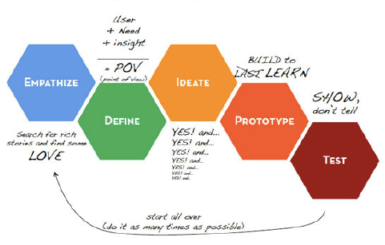
The sensitivity of this project led us to use the most client-focused design strategy: Empathetic Design Thinking. We were extremely interested in Molly’s needs and wants as this was a project built around her. We followed the ‘Design Thinking’ process as linearly and chronologically as possible because we felt that this would help with prioritization, given our time constraints.

Figure 1.0
Empathize (Codrin)
This component of our project was a key-factor in determining the general direction that our group would take. As empathetic design processes go, we decided to have Molly as involved as possible with our decision making. She was our client and we were there to fulfill her wants and needs. Along the way, we ran into some trouble with this approach as Molly was skeptical of our design due to past experiences gone-wrong. Taking this into consideration, we decided to stay committed and eventually showed her a product that she was ecstatic about.
Our client is a female adult in a wheelchair with limited hand movements. She cannot brush her teeth on her own as she requires a nurse. She prefers facial movements over hand movements in assisting with the brushing and she also requests an electric toothbrush. When she tries to brush her teeth on her own, she cannot go beyond the surface because of limited wrist movement. Due to the muscle degeneration in her hands, she is limited to using only her left hand. It was very clear to see that Molly is very technologically advanced as she is seated in a high-tech wheelchair and has multiple peripherals (iPad, computer, mouth tubes, etc.) that are charged each night by the nurse so that Molly can have continuous use of these things.
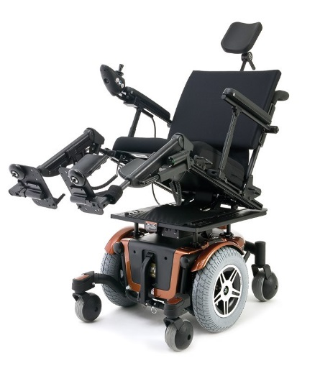
Figure 2.0: here we can see an example of what our client’s wheelchair looks like. There are some differences in reality, but this is a clear depiction of the kind of room we had to work with. Molly must sit in this chair for the majority of her day.
Despite Molly’s impairments, she is practically independent, however, she requires a nurse for three things: brushing her teeth, assisted feeding and charging her wheelchair accessories. She spends most of her time in the wheelchair and enjoys moving around the hospital. Unfortunately, Molly’s doctor recommends that she spend at least 14 hours in bed each day, leaving her minimal free time on her wheelchair. As our team set out to bring Molly some freedom, we learned a few things:
- Accessibility is scarcely prioritized within the toothbrush industry
- There are many people with disabilities such as Molly’s
- Brushing your teeth is a very key hygienic role that can potentially reduce your risk from heart attack or stroke. (Appropriate citations will be found in bibliography)
- Poor gum health has been linked to an increase of developing dementia by 30%-40%

Define (Codrin)
Our problem statement is best defined using the five W’s and one H:
- (Who): Our client Molly is an adult female confined to a wheelchair due to limited hand and leg movement. She wishes to brush her teeth independent of help from a nurse.
- (What): If we do not fulfill our promise to Molly, she will be left feeling helpless. It is also possible that she may face future problems in life if she does not receive proper oral hygienic care. The problems can be as serious as increased chance of developing Dementia and increased chances of heart attacks and strokes.
- (Where): Our client is located at St.Vincent’s Hospital where she is being cared for by Bocar and respective nurses assigned to her. It is also important to note that Molly is not the only one facing these issues of impaired hand movement. Through the completion of our project, we can help thousands of people who face the same issues
- (When): As outlined in our syllabus, the final prototype was due on November 29th, but ultimately this issue needs to be resolved as soon as possible.
- (Why): Molly has not brushed her teeth by herself in 15 years. If our project is successful we can bring back her independence, as well as free up some stress from hospital nurses all around the world.
- (How): We set out to design a hands-free toothbrush that is efficient, comfortable and modular. We incorporated the use of a mouth guard and outfitted it with bristles and vibrating motors that would ultrasonically brush away at tar and other dental deposits.
To best describe our priorities, we wanted to design a device that needs limited user input and takes into account any and all needs for modular additions. Through analyzing our client’s comments, we noticed that she was not fully engaged with the entire project as a whole. She explained to us that the reason behind this was past projects that have left her skeptical.
During the second client meeting, we were also made aware of the many regulations regarding testing. We kept this in mind and planned to speak to several dentists. Unfortunately, we were unable to find any specific regulations for St. Vincents, but we found a list of optimum assurances that medical device safety entails:
- It is important to keep in mind that absolute safety cannot be guaranteed
- Risk management must be outlined
- Effectiveness/performance is a key element
- Device life span must be considered
- Shared responsibility among stakeholders of the respective hospital
Keeping all of the above in mind, we set forward onto the next stage, and remembered our client’s comments:
“I just want a device that will be easy to use, will clean my teeth,
and will bring back my independence” – Molly

Ideate (Aya)
To address Molly’s inability to rotate or move her wrists, we came up with multiple solutions to allow her to brush her own teeth with no further assistance from the nurses. As we have mentioned in the introduction and background information about our client, Molly cannot move her wrists but she is technologically advanced with the “Sip and Puff” technique that allows her to turn on the TV or the lights when she blows onto a peripheral, which is attached onto her wheelchair. We have collected those information about Molly from the information given to us in the instructions about the toothbrush project and during our first client meeting with Molly and Bocar. When Bocar met with us, he had no expectations for the electric toothbrush based on previous attempts with other invasive projects, so he expected us to simply attach a bendable peripheral to Molly’s electric toothbrush and attempt to make the toothbrush reach the bottom teeth. We come up with these solutions using the methods that have been provided in the course, such as brainstorming and using SCAMPER to try and to add and modify toothbrushes found in the current market.

1. Solution 1: Peripheral with an Electric Toothbrush

The client does not prefer holding the toothbrush for a long period of time nor moving her hands, she prefers facial movements for activities that require her labour. That is why the “Sip and Puff” technique inspired us to come up with a corrugated material will act as a long straw for the client to enable her to brush her teeth by rotating her head towards the electric toothbrush on the support peripheral. Molly expressed from the beginning her detest towards normal toothbrushes and the fact the she only wants an electric toothbrush. As we have mentioned, we could have attached an electric toothbrush to the peripheral and added a simple button to press with protective toothbrush cover since she spends most her time on her wheelchair around the hospital and we want to attach the toothbrush to the wheelchair. The benefit of this design is that she will be able to reach below the surface of her front row of teeth and does not need to hold the heavy electric toothbrush for a long time. She can brush her teeth on her wheelchair or on her bed because of the support. However, the design contains a few design drawbacks. First of all, the electric toothbrush is too heavy for the straw material and it is difficult to work with plastic and it would be inconvenient for us to try and attach the plastic toothbrush hard material to the corrugated (straw-like) support. Glue would be a very inefficient way to stick them together since with time it will easily come off. Furthermore, we would not address the most pressing issue, she will require a nurse or a volunteer to set it up for her in the morning and de-attach it at night. Another disadvantage of this design is the amount of time and effort Molly would have to invest in brushing her teeth using this device. For example, Molly would have to spend a long time rotating her head from left to right to allow the toothbrush into her mouth, which in her case would be a very strenuous exercise.

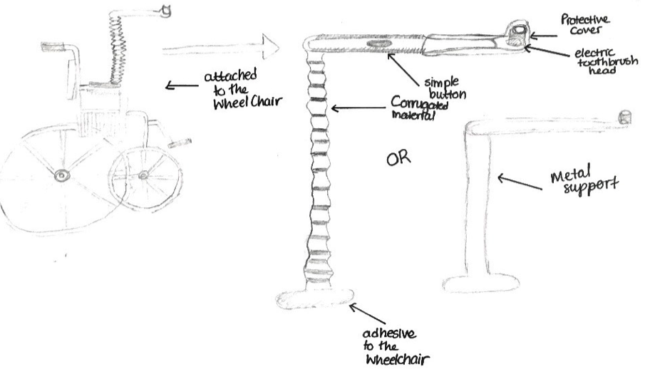
Figure 3.0

Solution 2: Rotating Toothbrush Extension

This design contains an extension attached to an electric toothbrush that rotates inside her mouth to reach top and bottom and beyond the surface teeth without the client moving her arms to brush her teeth. This design will include features that will allow Molly to brush her teeth without assistance. The first main feature is what it is made from the electric toothbrush must be of a light one to enable the client to hold the brush for a long period of time, and we will only install a simple button to turn on or turn off the brush. Moreover, it must include a support to hold the toothbrush to allow Molly to move her face closer to the brush without holding it in future cases where she would not be able to hold the toothbrush. The drawbacks of this design is that it is difficult to make the electric toothbrush of a light material because it needs a lot of heavy electric parts to work and even if we find the light material, it could be too difficult for her to hold for a long period of time. This design will also include movement restrictions, for Molly to brush her teeth she must only brush her teeth in one place because the toothbrush will have too many parts for it to be portable. Furthermore, for the brushes to rotate, we must include motors with specific coding that will require skills passed our basic coding skills.

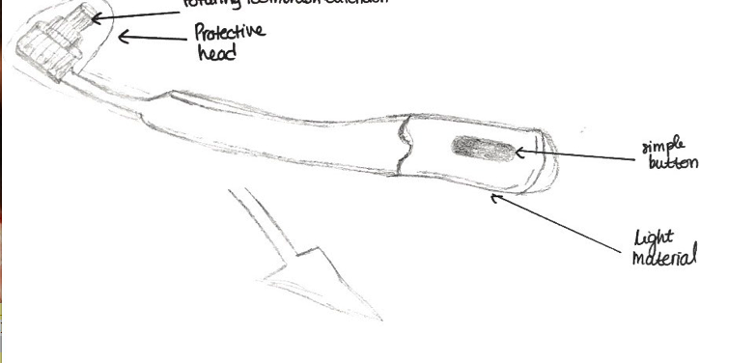
Figure 3.1

Solution 3: Piston rotating electric toothbrush head

This last solution consists of the normal toothbrush with a piston that thrusts slowly into Molly’s mouth to brush the bottom and front of her teeth, rotating in between. It would consists of the normal everyday toothbrush attached to a piston head with a metal support handle to be able to withstand the weight of the piston. This design did not work for many reasons. To begin with, Molly in her requirements specified for an electric toothbrush and if we replace the normal everyday toothbrush with the electric one, it could injury because the the entire toothbrush is rotating and the brushes on it are vibrating in an opposite motion. If the right force is applied, it would harm Molly’s gums. Furthermore, Molly expressed her disdain to too many moving objects due to past experiences with other projects.

Solution 4: The vibrating Mouth guard

The vibrating mouthguard was our final solution and based on a comparative analysis between our solutions we choose to move forward with it. The vibrating mouth guard would include two hockey inspired mouthguards

Prototype (Aya)
Before beginning work on our prototypes, we had to write down a BOM that accurately reflected the components that we would use. Luckily, most of the research we had done led us to properly gauge the types of materials needed. Everything that had to do with the construction of the prototypes was purchased through the makerspace lab, or we 3D printed it ourselves.

Bill of Materials

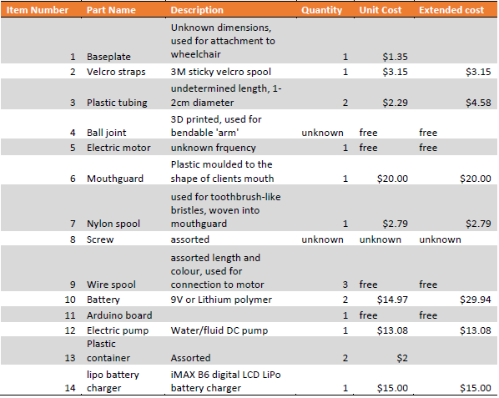
Figure 4.0

Prototype 1…

Consists of two 3D printed hockey mouthguards connected with a 3D printed joint that were created using Solidworks and Tinkercad. Furthermore, the brushes were everyday brushes heads glued on the surface of the mouthguard. The prototype was only for visual reasons to showcase our mouthguard idea to Bocar and Molly during our client meeting. There were many advantages and disadvantages of this Mouth guard model, first of all we allowed Molly to picture how our model would look, with us explaining to her the position of the wires and what kind of motors we will implement. This enabled us to understand even how refine our product for the next phase of prototypes using Molly’s feedback on the size of the mouthguard and what type of motors she would like us to use. Furthermore, we created a list of modifications to implement on Prototype 2 using the feedbacks given to us by Molly’s feedback. The list consisted of us discarding the idea of sensors to vibrating motors,

Prototype 2…

Was more functional with higher fidelity than the first prototype in both function and design, the aim of this prototype was to see how it would function as a toothbrush in cleaning teeth with the vibration of the brushes caused by the power of the motors. This prototype consisted of a more refined design of the mouthguard in Solidworks, with a smaller size and less bulkiness of the joint, it also consisted of slits to directly place the motors inside. Another feature that was important in the mouthguard is the canal we designed to hide the wires of the motors in so that no wires would be visible to the naked eye. Moreover, the design was improved by having standalone bristles that were extracted from toothbrushes using hot glue gun and scissors and directly attaching the brushes onto the surface of the mouthguard. This prototype was functional because we attached unbalanced vibrating motors to it in a switch circuit so that Molly could turn on and off the mouth guard with a press of a button. The motors were coded using the Adafruit program using C language syntax and language to allow the motors to directly vibrate under the brushes to allow the brushes to absorb the vibrations and brush.

Testing (Codrin)
The testing stage in our project was unfortunately cut short due to scheduling issues. In the future, we hope to further develop our design and eventually test a TRUE proof-of-concept. The primary idea’s we have learned to focus on rely on comfortability, efficiency and aesthetic.
The final prototype used was a good example of our concept and it was received very well.
Uncertainties and risk

As with any accessibility projects, the uncertainties rely greatly on safety standards and unique/niche capabilities. Our mouthguard design incorporates a never-before-seen concept that utilizes one single large brushing surface to target every tooth at once. A large uncertainty in our project is testing the capabilities of the motor we will utilize and if, when attached to the mouthguard, it will properly clean each tooth. Once this concept is tested, we will have a better understanding of the proficiency of the motor and mouthguard, and we will be able to gauge whether or not this idea is still possible.
Another uncertainty would be the support used to hold the apparatus up to Molly’s mouth. Since we have not done any testing as of now, we are unsure of the flexibility and strength of the ball-joint arm. Once again, future testing will shed light on this component and we can further develop the arm if it is needed.
We believe that the risks associated with this product are not high. It is not a very costly device, therefore we will not lose any money if it doesn’t work. Also, more importantly, the product will need to go through rigorous testing before we even approach the hospital to ask for approval. Once the testing is done to our standards, it is up to the hospital to approve the use of this apparatus on our client. We would assume that the hospital will not approve a defective product, and if Molly has the chance to test our device for herself, she will be in no danger.

Feasibility Study (Codrin)
Before concluding the contents of this report, a careful analysis of the five TELOS factors will either confirm or deny the feasibility of our project concept. A project must meet at least some requirements for it to be considered reasonable, logical and profitable. To summarize the five telos factors,
- A project must be realistically possible to create within the means of the group
- The project must be economically viable
- The project must meet legal requirements of the area that it is intended to be distributed/sold
- The project must serve a purpose, that is, it must fix a problem that was proposed by a client
- The project cannot take too long to complete, otherwise it may become arbitrary in the ecosystem that it is meant to be used in
For our mouth-guard toothbrush concept we have assessed and discussed the TELOS factors in great depth to determine if we should continue on with this concept. These are the conclusions we came to:
- Technical – Although we are currently students and do not have any real technical background, the components of our toothbrush concept are not overly difficult to piece together, and most of the parts needed were bought rather than created by us. It is also a considerable advantage that we had 5 people with different skill sets that can simultaneously work on several aspects of the project.
- Economic – Given the small scale of this project, it can be deemed economically viable. The components required for the project are not very technologically advanced and can all be acquired within the $100 allowance. Since we also had accessibility to the maker-space lab, we were able to 3D print any other components that were needed, such as the links used to create the arm that holds the mouth guard.
- Legal – Legal issues can arise with our concept as it is an invasive tooth cleaning method that needs to be reviewed by professionals in the field. We planned to speak to several dentists to assure that our project is legally feasible, and to also gauge the interest in our concept. Aside from safety issues, this apparatus is a very new and innovative concept that is not available in any local/global market. There are many electric toothbrushes with patents, however, our design is very unique in comparison. Through our research and development, we have found a slightly similar concept, but it does not work in the same way as ours does, and it is not specialized for disabled people.
- Organizational – As per our visit to St. Vincent hospital, the people in charge have told us that there may be safety and health regulations that may keep us from testing our prototype on our client. It is possible to get around this by speaking to professionals within the field and having them stand by our concept and we can also speak to hospital administration. Moreover, we have researched general health and safety regulations regarding sanitary apparatus’ and will construct our project around these constraints.
- Scheduling – Given the lack of prototype testing and resources, there were many scheduling issues that arose. To avoid these problems, we needed to prioritize certain aspects of our project to make sure that it was a safe and functional apparatus that can be delivered on time. This was done by cutting down on the complexity of the design and focusing on core features.
Conclusion (Codrin)
Our task was to create an accessibility project around a client. We focused our entire design around the following problem statement:
To design and create a tooth brushing apparatus that will bring
ease of use, reliability and efficiency to anybody (especially Molly)
facing a disability; to ultimately make them a little more independent.

GNG2101 taught us all the necessary skills needed to successfully complete this project. We learned:
- Time management and prioritizing is the key to success
- Working around constraints gives a project purpose and keeps the end-goal in clear sight
- Technical skills such as 3D printing and soldering
- Arduino coding
- Group work helps break down the load
- Market analysis will help with future plans to sell and create a business
Although our Mouth guard toothbrush was not refined enough to be ready-for-market, we believe that it was successful given all the circumstances surrounding our group. Unfortunately, we were unable to have Molly test the prototype, but we will work to eventually bring our client what she asked for. We were behind schedule for the majority of the design process, but near the end the group came together and successfully put together a functioning proof of concept.
Design day was very surprising for Aya and I (Codrin) because the overall response from professors and people alike was extremely positive. We were given lots of feedback on possible improvements and the necessary steps to take it to market. Outlined below is a list of future work:
- Continue to work on a prototype that is safe, comfortable and appealing
- Have a proof of concept by thoroughly testing the final prototype
- Speak to dentists/doctors and note any comments/concerns
- Patent the design if feedback is positive
- Either crowd-fund or find a willing toothbrush manufacturer to mass-produce
- Begin advertising
Ultimately we believe that we were very successful. We hit many ‘snags’ in the road but eventually had a working product that gained mass amounts of positive feedback. If there was anything we would change, it would revolve around time management. Given an extra week or two we believe that the toothbrush would have won first place at the Design Day fair, and we would have been on our way to placing this toothbrush in the hands of every hospital and anybody that wishes to brush their teeth with ease. The lessons learned throughout GNG2101 will stay with us as we go forward on our new path and we hope to continue on developing this great product.
Bibliography
The majority of our sources were found using Google and included things such as safety regulations Arduino coding practices. The rest was taught to us by our great Project Managers, David and Moe.
Stastics on the studies around dementia and heart attack and stroke were found here:
http://www.coventgardendental.com/8-reasons-brushing-teeth-twice-day/

Statistics on the composition of the population of disabled people in Canada were found here:
http://www.statcan.gc.ca/pub/89-654-x/89-654-x2015001-eng.htm#a2

Regulatory practices in the medical field were found here:
http://www.who.int/medical_devices/publications/en/MD_Regulations.pdf

