Project Deliverable G - Prototype II and Customer Feedback
Team A07
November 13th, 2022

Abstract:
The objective of this document is to showcase the fabrication of our second prototype, to receive customer feedback to improve it, and to present a new test plan for our third prototype

Introduction 3
I. Client Feedback 3
II. Prototype, Documentation and Results 4
Test objective
Prototype Description
Testing 6
III. Analytical, numerical or experimental model
IV. User Feedback and Comments 6
V. Review and Update 7
A. Bill of Materials + Equipment List 7
VI. Prototyping Test Plan for Prototype II 8
Conclusion 9

Introduction
Our team has been tasked with designing a hydroponic system to clean algae that 1) is automated and time efficient, 2) has an easy user interface, 3) cleans all areas of the board including contours, and 4) fits in the designated area. In this document, we showcase our second Prototype by putting it to the test with an elaborated test plan and by providing a simple but efficient analysis of its critical component(s). Although compared to the last Prototype, this one serves as a specific analysis of one of the subsystems, which is the box/frame. On the other hand, this document also serves as an update regarding the BOM and the target specifications, a gathering of feedback received from users and a preparation of a test plan for the next Prototype (III).
As a pretext, the results of Prototype I showed us that the whole cleaning process was very feasible, automated or not. It covered all the board (except the left and right sides), cleaned the holes, and exceeded time expectations. For this prototype, as mentioned above, we’ll concentrate specifically on the box that will hold both the frame and the brushes, as we illustrate how the board will be inserted and taken out, how the door will be held in place when cleaning the board, and what will happen to the excess water.
It has to be noted that the box we came up with (this critical subsystem) will be the exact one we’ll use for prototype III, with of course all of the cleaning products and others that we’ll have to work on.

Client Feedback
In this section, we consider the feedback of our client received at our meeting on November 8th, 2022, to improve upon our design and solution.

First, the time allocated for presenting and receiving feedback regarding Prototype I was very limited. On that note, what has been mentioned by the clients that day was specific and short, which reflects the following summary.

About the first prototype, the clients really seemed to entertain our concept. They did not actually point out something to modify (about the theoretical part) which makes us believe that we’re on the right track. The only thing the clients mentioned was that trying to make the top brushes (the one cleaning the holes of the raft) rotate while also going in and out the holes might be a challenge. Consequently, we’ll still try to make it work as this could be to our advantage, but if we can’t manage we’ll just stick with the penetration of the holes.

Prototype II, Documentation and Results

Test Objective:
The goal for this prototype is to test the capacity of the box to hold the frame inside of it. Specifically, we’re going to check out the time it takes to put it inside of it, its feasibility, the hinges holding the door, and the drainage system (for once the cleaning process is done).

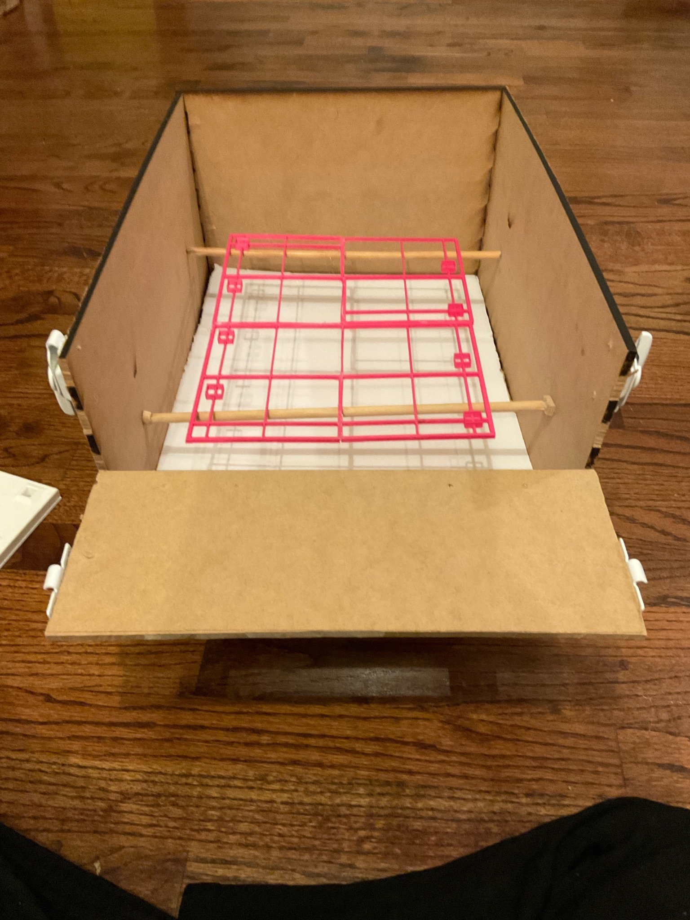

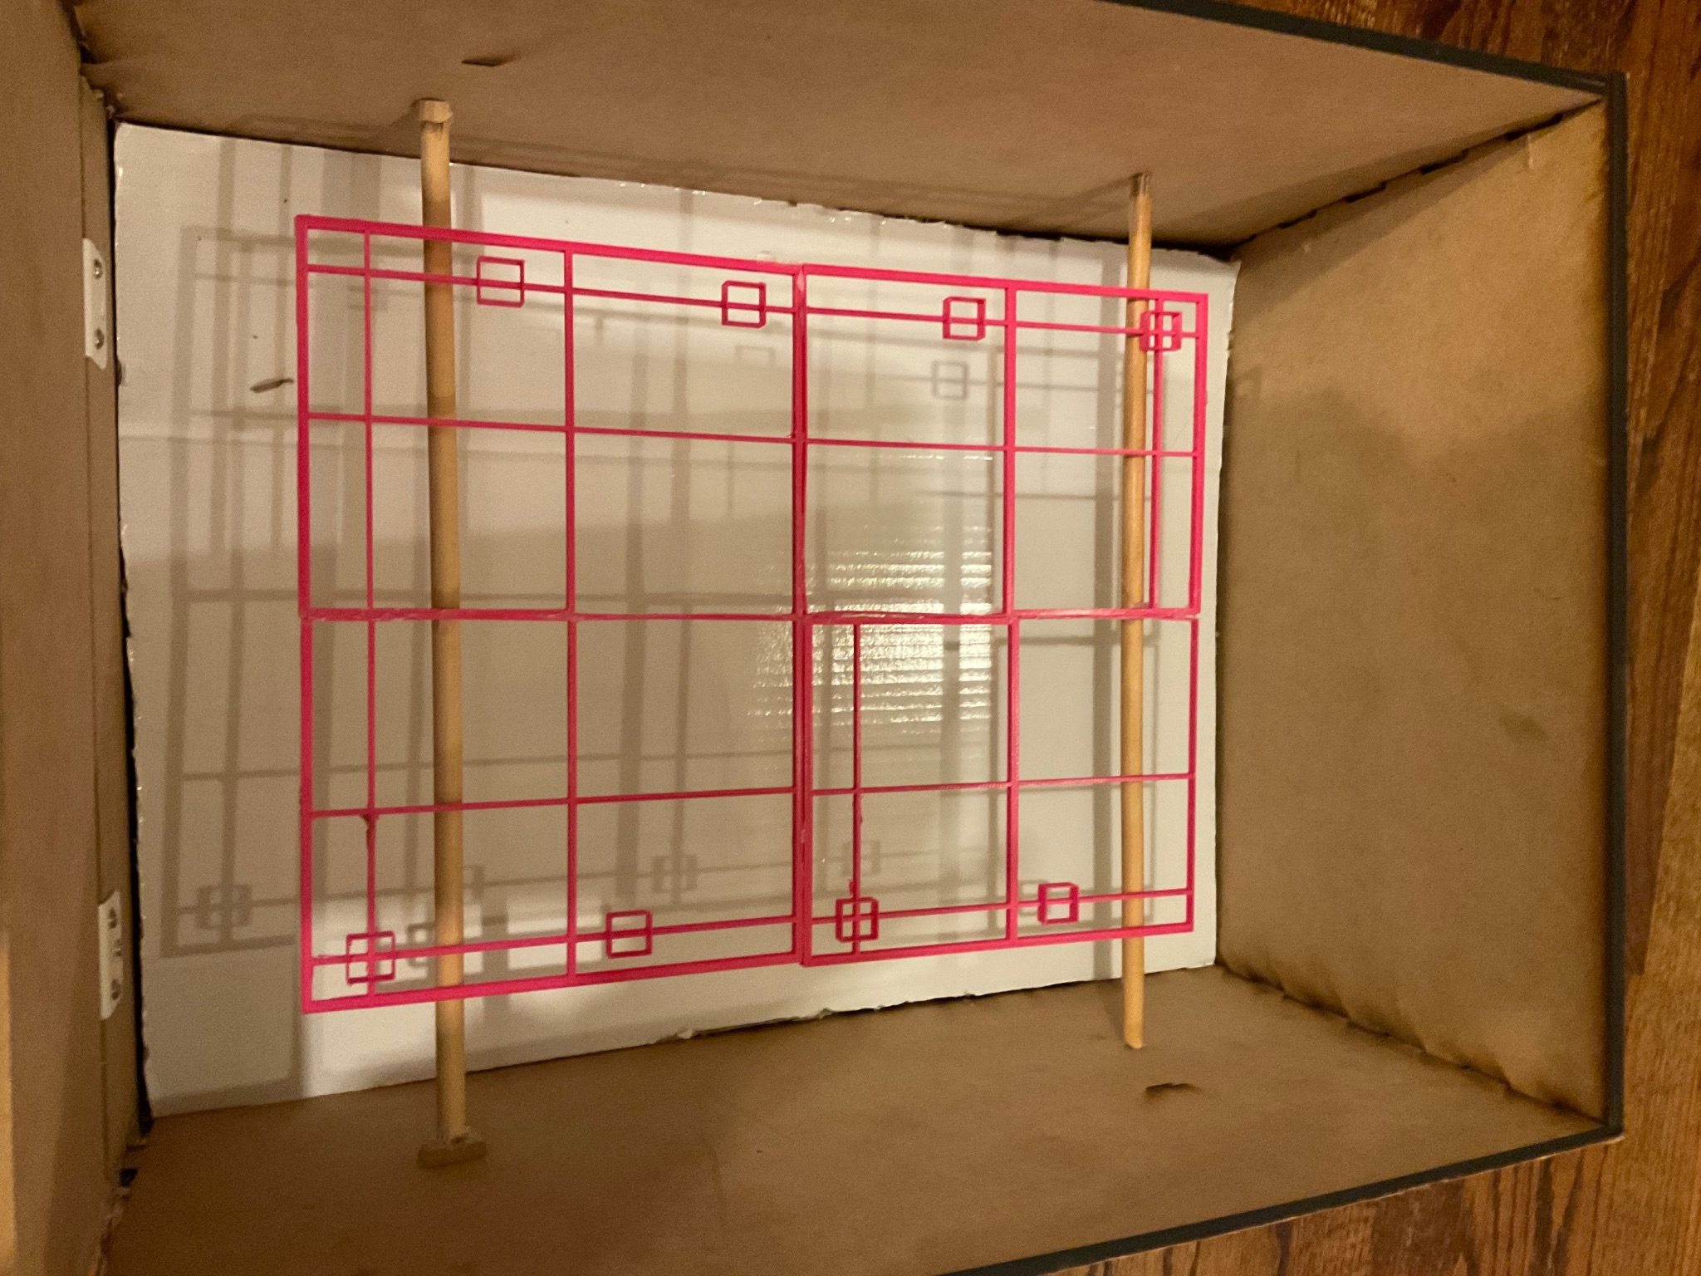
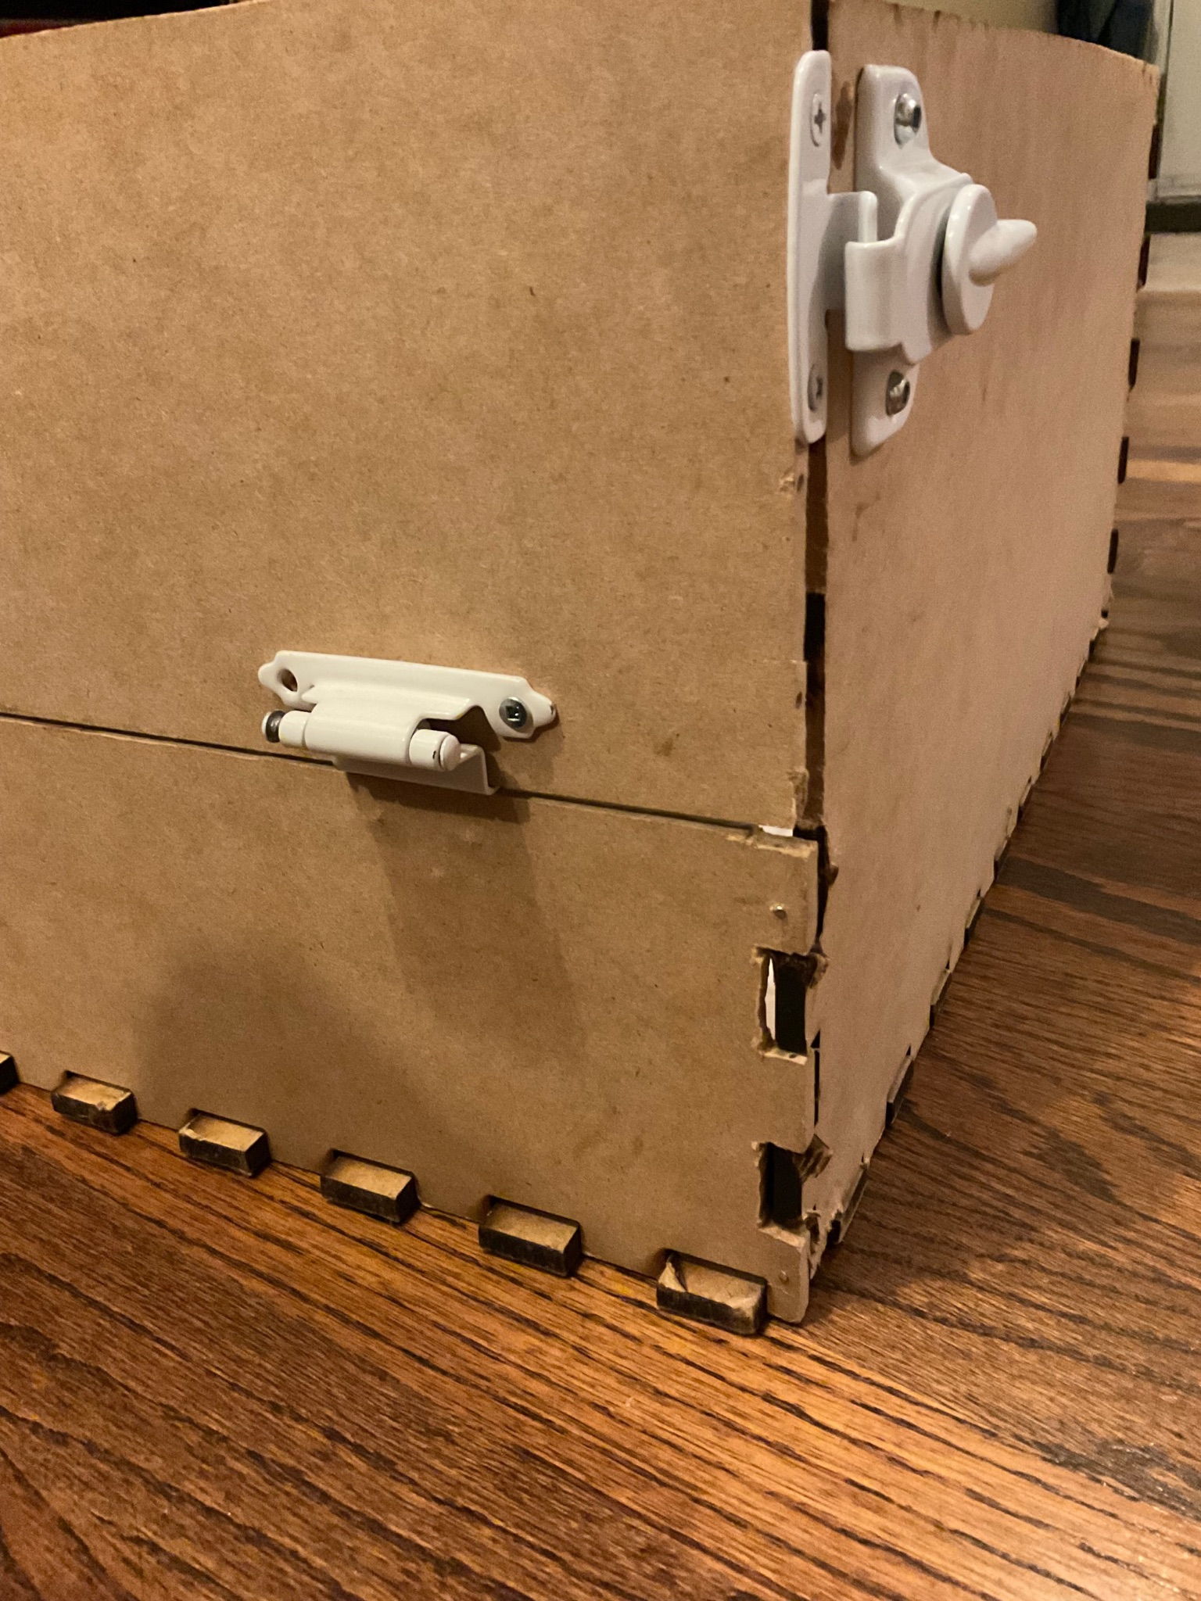
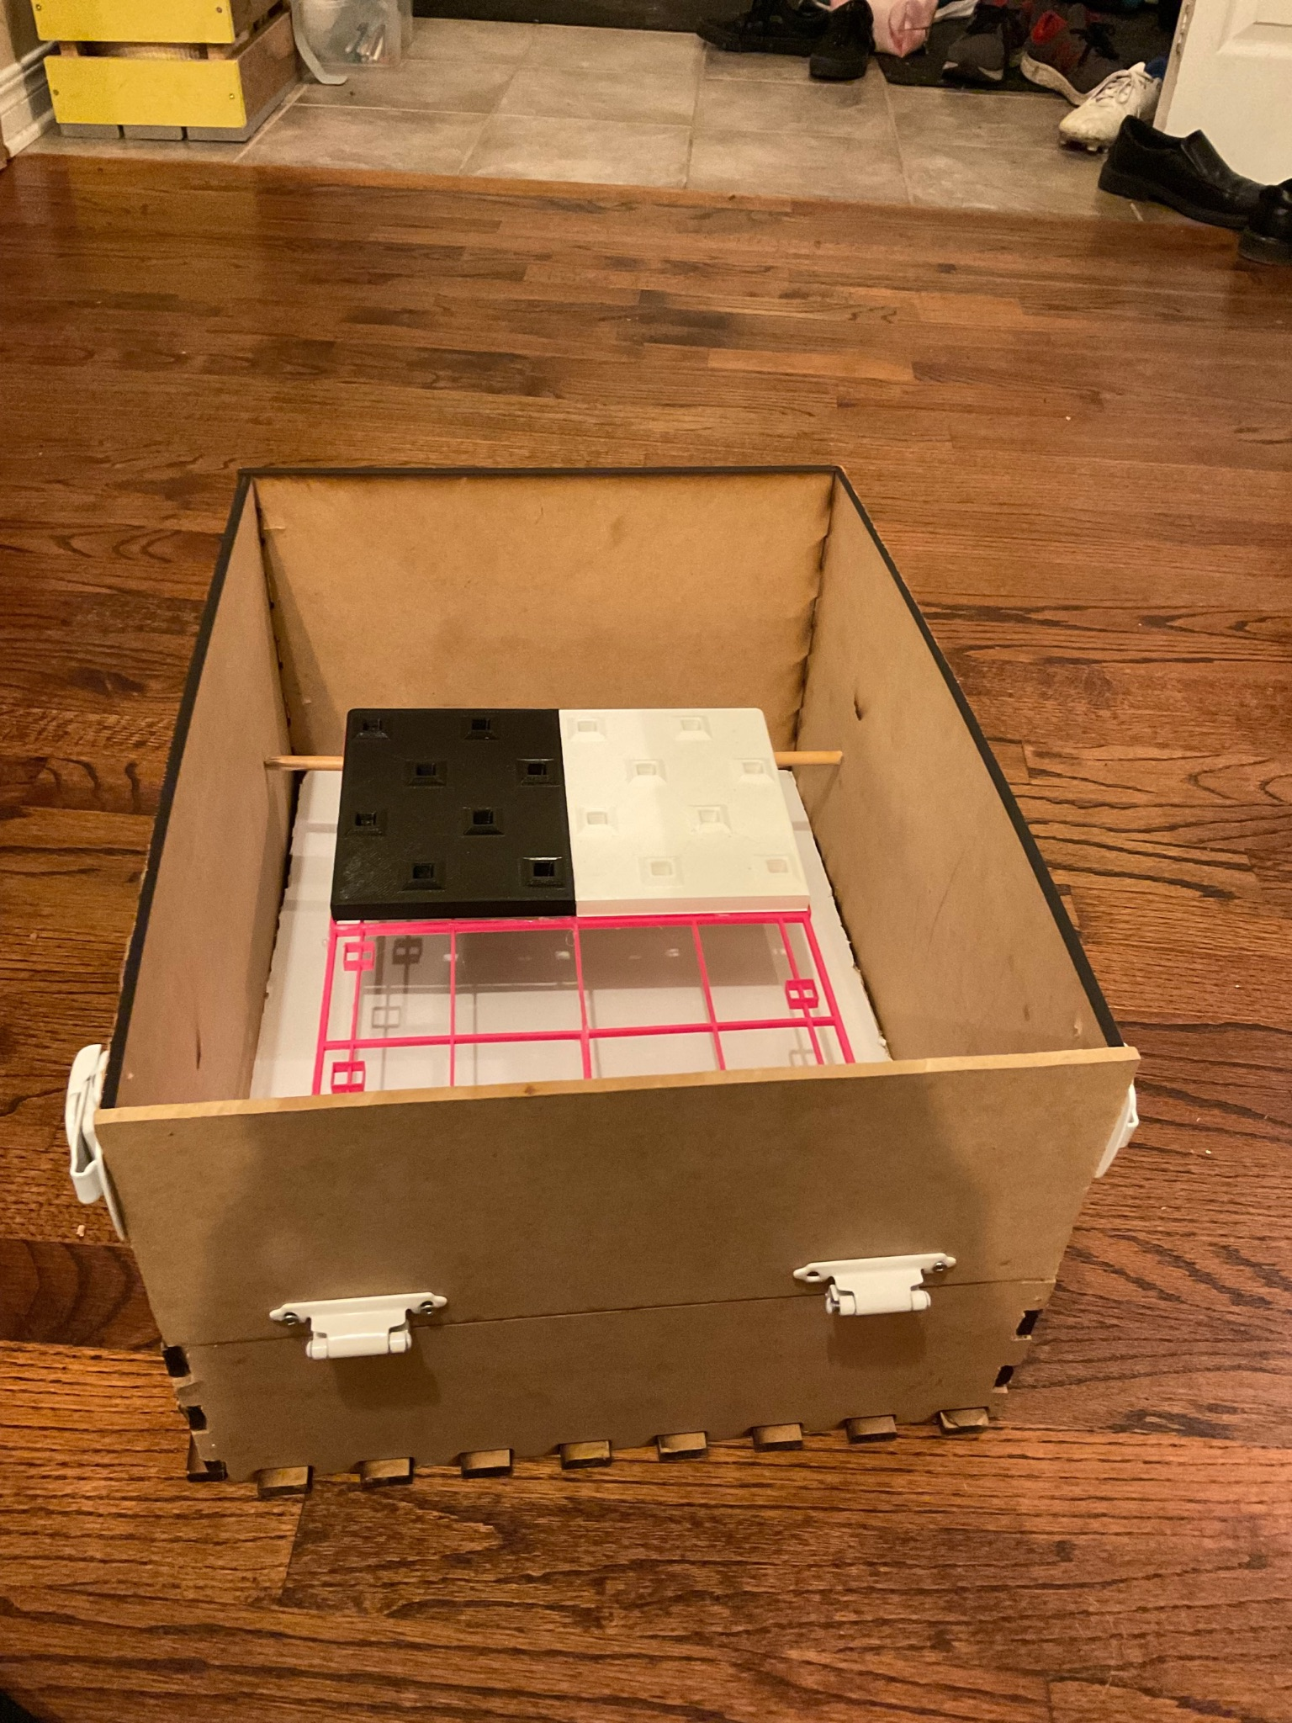

Prototype Description:
The box is composed of 5 MDF Wooden Planks: the bottom (dimensions: 20x15 in.), the larger walls (dimensions: 20x10 in. each) and the smallest walls (dimensions: 15x10 in. each). Each of these has been laser-cut in the Makerspace using the Laser Cutter in order to create “Lego” type dents on the borders which will make these last fix themselves into one another. The result of this is a sturdy base/construction for the cleaning process.
One of the smallest walls, which will be the one to open and close depending on whether you want to insert the board or not, is held by 2 latches that have been glued to the sides: when you open the latches, the wall (door) can be removed/opened to insert or remove the board, and the same applies to repositioning the wall at its place.
On another note, the raft is represented by 4 (we included only 2 for the purpose of this showcase) 3D printed versions of this last (dimensions: 14x9.3 in. together) collated to one another, and once inserted is placed on 4 3D printed versions of a grid (same dimensions as the 3D rafts).
Finally, a paved wooden plank has been added to the bottom part of the box so that the water during the cleaning process doesn’t go out and doesn’t get messy (goes to the far end of the box as demonstrated in the video with the marble), in order to easily throw it out after usage.

Testing:

Test Objective | Test Procedure | Test Description | Results Wanted | Results Yielded
Check to see if the “Lego” frame properly aligns the board | Numerically determine whether the frame will align with the board, and physically test this. | Physical/analytical, medium fidelity. | Dimensions of frame should be less than or equal to dimensions of the board.​​ | The dimensions of the box is 10x15x20 in., with the interlocking “lego” dents being distanced by 1 in. from each other.  As predicted mathematically, the walls of the box fit correctly into each other (the “lego” dents), and the hinges correctly hold the door/wall in place (regardless of its usage).
Test how easy it is to put the board into the box (frame) | Multiple physical models to represent methods of putting the board in the box (from above, in a slit in the side, etc.) | Estimate time spent to put it in to determine the model. | No predetermined range.  Fits perfectly inside the box, without trouble. | The board (dimensions: 14x9.3 in.) fit perfectly inside the box (on top of the grid).  It takes around 5 seconds to insert the board and to place it on top of the grid.
Table 1: Table Documenting the Testing of Prototype I

Analytical, numerical or experimental model

For this section, we came up with an experimental/analytical animation which illustrates in detail the functioning of the whole concept, and specifically the use of this box/frame which will for this prototype contain the raft, the grid that will hold it, and the various brushes.

In order to view the animation, check out the video submitted with this document.

User Feedback and Comments
Feedback from general users
[ Unfortunately, we did not manage to receive feedback from users regarding this Prototype.]

Review and Update

Bill of Materials + List of Equipment

The materials and equipment with their respective descriptions and others that are in red represent the updated list. The materials in bold are the ones we already bought, meaning that we’ll come to the next lab session with their receipts.

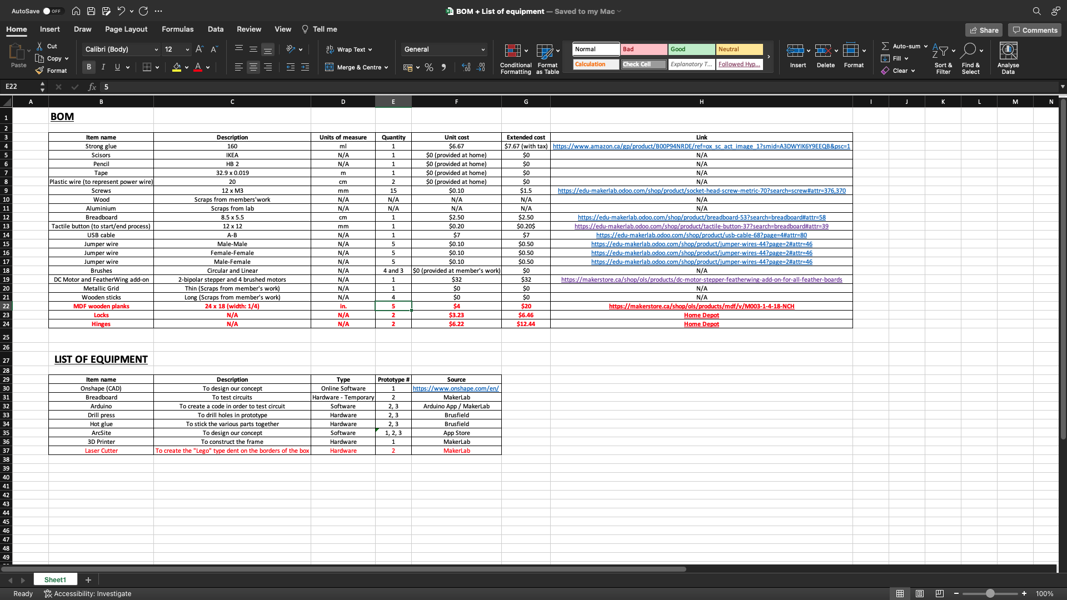

Prototyping Test Plan for Prototype III

Table 3: Test Plan Ideas for Prototype III

Test ID | Test Objective (Why) | Description of  Prototype used and of  Basic Test Method  (What) | Description of  Results to be  Recorded and  how these results  will be used  (How) | Estimated Test  duration and  planned start  date  (When)
1 | Determine a method to spin each brush of the cleaning subsystem at a fast enough speed to clean the board. | Physical model with higher fidelity (important test) of brushes hooked up to dc motors | Record the speed of each brush to find the average speed of all brushes. Also note any brushes that do not spin. This will help us determine type of brushes, motors and axles needed | Testing these brushes may take a long amount of time as the brushes need to spin for a long time to measure cleaning performance
2 | Figure out if there are any compatibility issues between the three subsystems | Physical models of the cleaning (lower fidelity), holes and frame subsystems that are wired up to a controller to allow movement. | Results of the prototype include any collision between subsystems and the lengths of subsystems that are too big for the frame. | Once subsystems are assembled testing for compatibility won’t take long
3 | Test for the amount of water that can drain from the box | Using the medium fidelity physical model from prototype 2 combined with a testing device containing water. | Measure an amount of water in liters and add it to the prototype. Then measure the amount of water that leaves the prototype to record the amount of water drained. | Since it will only require a slight modification to the model from prototype 2 little time will be spent testing this.
4 | Test for percentage of the board cleaned (related to brush speed and coverage) | Analytical model with high fidelity. Calculations for how much algae will remain after a given time of the brushes running. | Results will be the percentage of the board cleaned of algae. Used to determine the performance of the entire project | Will take a while to take into account all parts of the prototype in the calculations. All forces must be accounted for.

Conclusion
To summarize, the Prototype we came up with qualitatively translates the specific frame/box subsystem: this last is sturdy enough for any cleaning related work, fits an 18 by 12 inch raft (while being on a grid), and the hinges attached to the sides of the box successfully hold the door/wall in place when closing it.
On that note, these 2 Prototypes gave us the opportunity to see that the whole concept is very feasible: we verified that it was possible to clean most of the board with brushes that go all around this last, that the raft could be positioned on top of a grid, that the box is sturdy enough for a project of that caliber, that we have a working mechanism for the insertion of the board (thanks to the hinges that can hold or detach the door/wall) and that during the cleaning process water will be preserved for easy-to-use displacement.

