Project Deliverable F - Prototype I and Customer Feedback
Team A07
November 6th, 2022

Abstract:
The objective of this document is to showcase the fabrication of our first prototype, to present a new test plan for our second prototype and to receive customer feedback to improve your prototype.

Introduction 3
I. Client Feedback 3
II. Prototype, Documentation and Results 4
III. Simple Analysis 5
A. Subsystem 1: Cleaning of frame 5
B. Subsystem 2: Frame 5
C. Subsystem 3: Cleaning of holes 6
IV. User Feedback and Comments 6
V. Review and Update 7
A. Bill of Materials 7
VI. Prototyping Test Plan for Prototype II 8
Conclusion 9

Introduction
Our team has been tasked with designing a hydroponic system to clean algae that 1) is automated and time efficient, 2) has an easy user interface, 3) cleans all areas of the board including contours, and 4) fits in the designated area. In this document, we showcase our first prototype by putting it to the test with an elaborated test plan and by providing a simple but efficient analysis of its critical components. On the other hand, this document also serves as an update regarding the BOM and the target specifications, a gathering of feedback received from users and a preparation of a test plan for the next prototype.

Client Feedback
In this section, we consider the feedback of our client received at our meeting on October 26th, 2022, to improve upon our design and solution.

First, the most important feedback given by the client during the second meeting was to replace the drying subsystem. In fact, the client mentioned that he and the users didn’t care much for the drying of the frame, but that a subsystem regarding the cleaning of the holes had much greater value. Also, the client brought up the fact that the frame was to be 42 inches above the ground.
On that note, we amended these last during Deliverable E, by coming up with a specific concept and sketch to illustrate the whole idea and by including the height between the frame and the floor inside of our final product representation. This has been done in order to provide (as much as possible) the client with correct answers to their needs.
On the other hand, the client gave us more information about less important but valuable notions to keep in mind. For example, he mentioned that the level of noise that the machine was to produce wasn’t a problem, that the product should get the client it’s money back (initial investment) in about a year, that a backup mechanism was something to include if possible (already thought of during earlier Deliverables) and that the whole concept will have to work using a 120V motor circuit.

Prototype, Documentation and Results

Test Objective:

The main objective of the prototype is to determine how well the movement of our conceived subsystem for cleaning works. This is the objective we are looking to reach as we are unsure if the subsystem can achieve this (reducing risk) and to communicate how the subsystem will work to our clients and each other. To complete our objective we will be looking to test for if the subsystem covers the entire area, measuring the area covered if some is missed, and timing how long it takes the subsystem to cover all the area it can.

Prototype Description:

We are using a physical focused prototype consisting of a model of the cleaning subsystem concept.

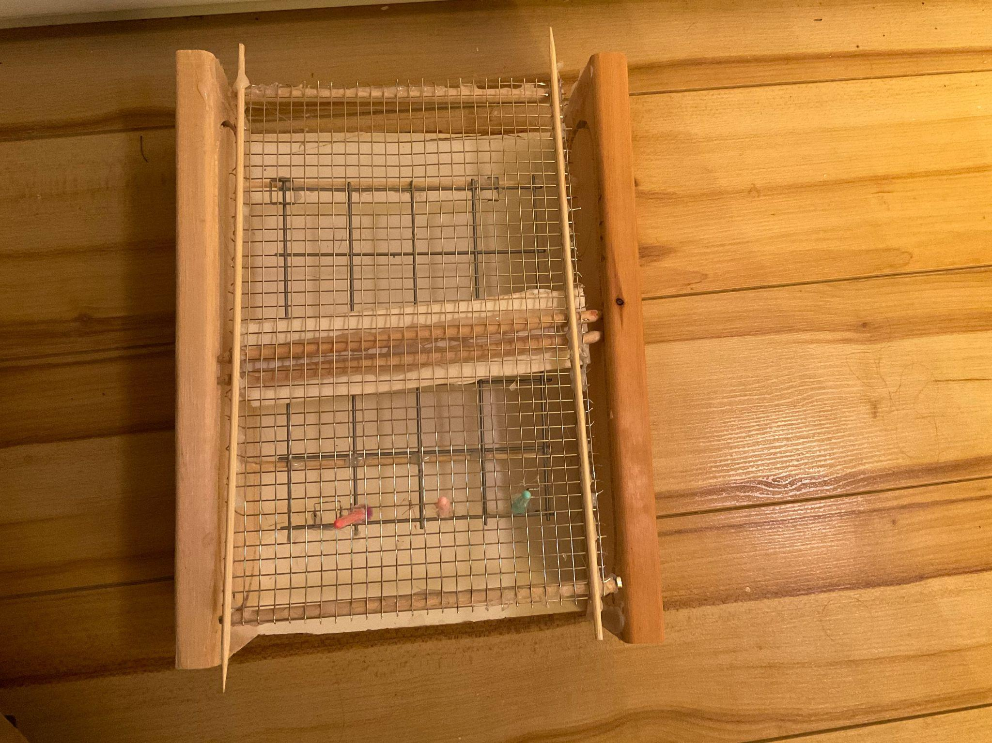
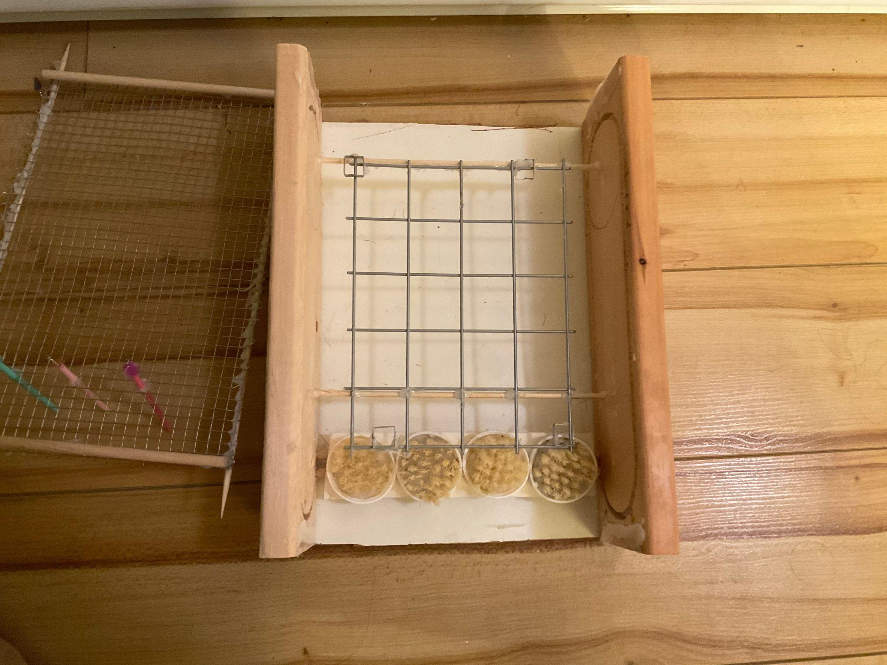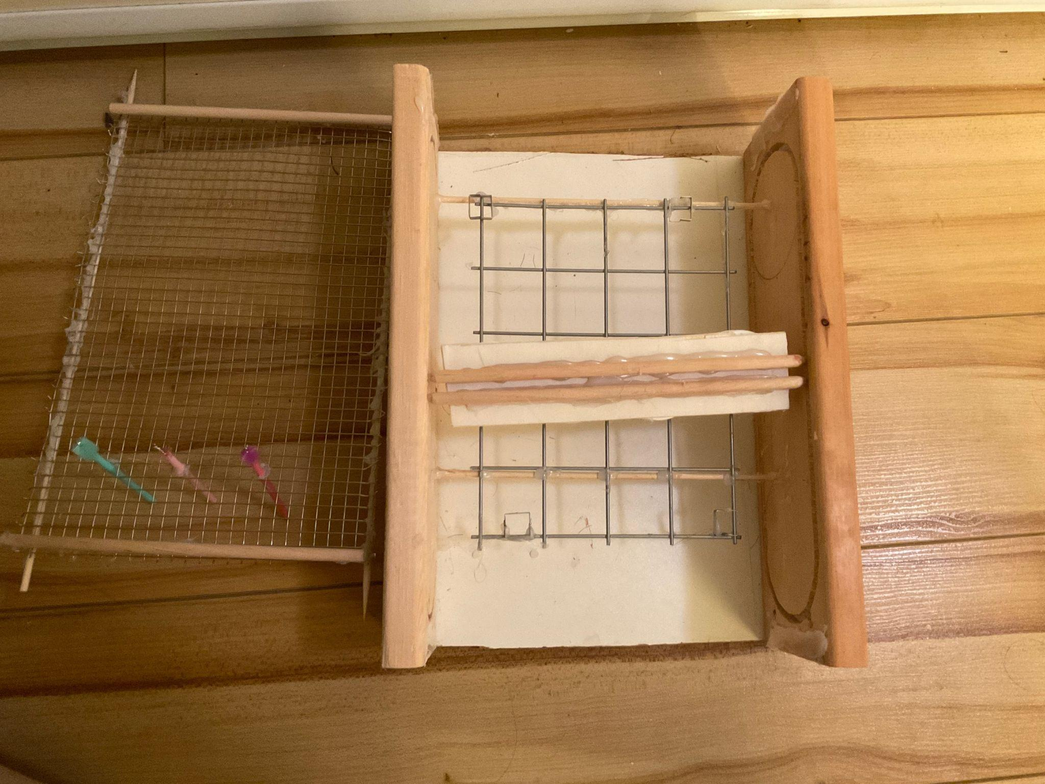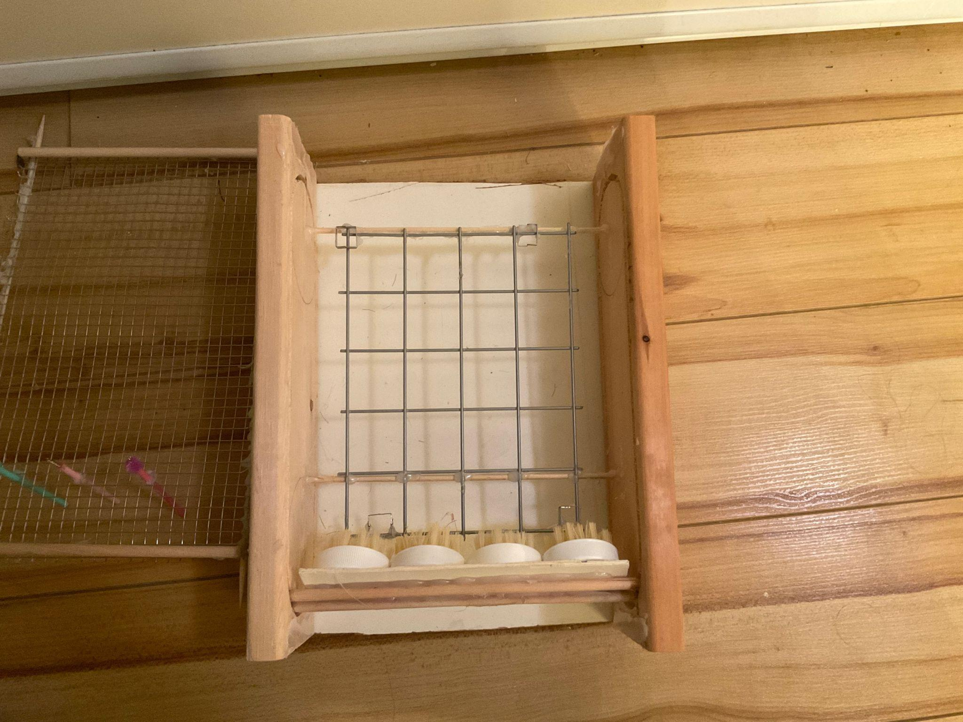
Figure 1-4. Prototype I composed of scrubbing brushes, wire, and a wood frame at every layer.

Test Procedure:

- Once the prototype is built, set up a camera to record a video of the movement of the model.
- Start recording the video and move the brushes at a constant speed.
- Once the brushes have returned to where they have started, stop the recording to get the total time spent moving the brushes
- Afterwards you may move the brushes at any pace and note down any areas missed by the brushes.
- Now measure the size of the areas missed and subtract it from the total area of the board to get the area covered by the subsystem
- Repeat any steps as necessary to record averages of data.

Results Wanted:

Covers entire area of board: Yes
Area covered: entire board
Cleans the holes: Yes
Time: less than 6 hours.

Results Received:

Covers entire area of board: Almost
Area covered: everything except the left and right borders of the frame
Cleans the holes: Yes
Time: 15 seconds (prototype not real machine)

Simple Analysis

In this section, we analyze the components of a hydroponic grower designed by our team,
using knowledge of engineering mechanics and Calculus I.

Subsystem 1: Cleaning the board
On a smaller scale that appropriates the prototype (watch the submitted video), the 3D
printed version of the frame has a 6.5x4.0 in. dimensions and is being held by
2 wooden sticks attached to the two biggest walls of the wooden box representing the
movement/positioning (only 2 walls have been represented in order to have a better idea on
how the whole concept works).

Subsystem 2: Frame
About this open box, each of the walls have dimensions of 5.5x3.2 in. and the definition of an oval shaped hole has been perforated around the zone on the walls covered by the 3D printed frame to represent the trajectory that the brushes will follow. These main brushes are attached to a cardboard piece, itself glued to 2 wooden sticks that penetrate the oval shaped hole and are able to go all around the board and clean it.

Subsystem 3: Cleaning of the holes
Regarding the cleaning of the holes of the frame, a metallic grid is being used with small brushes attached to plastic sticks inside of them (3 are enough to depict the idea) that will go in and out the holes.

On that note, there’s no automation yet as this is the 1st and basic concept, but this will be integrated in the next deliverables.

User Feedback and Comments
Feedback from general users

Jeanine Welton - Small scale hydroponic grower:
“This is definitely a huge step up from using a scrub brush, one thing to consider is that the mechanism you are using to fit the raft in place may not work for other kinds of hydroponic rafts and will only work for this specific company. If that is not a problem, then go for it. Something I really like is the use of multiple brushes, ensuring that each part of the raft is hit because any amount of algae left on the raft will speed up the process of the algae covering the board.”

Zachary Briant - Hydroponic expect and Aquaponic expert at Aquatopia water garden conservatory:
“It is very important that water and water pressure is included in your machine. Without it, the algae will never be removed no matter how hard you scrub. Personally, I also add a dilute Hydrogen Peroxide to the water to further help remove mold and algae. I like the use of the spinning round brushes in combination with the back and forth motion of the brushes , that will also help ensure that any algae is removed.”

Nolan Gabriel - Dishwasher at Aquatopia wedding catering service:
“I really like your design and I think it will wash the boards really well. If you use enough water and pressure wash the board as well, you might not even need to have the brushes that go in and out of the holes as the water could take care of that for you.”

Review and Update

Bill of Materials
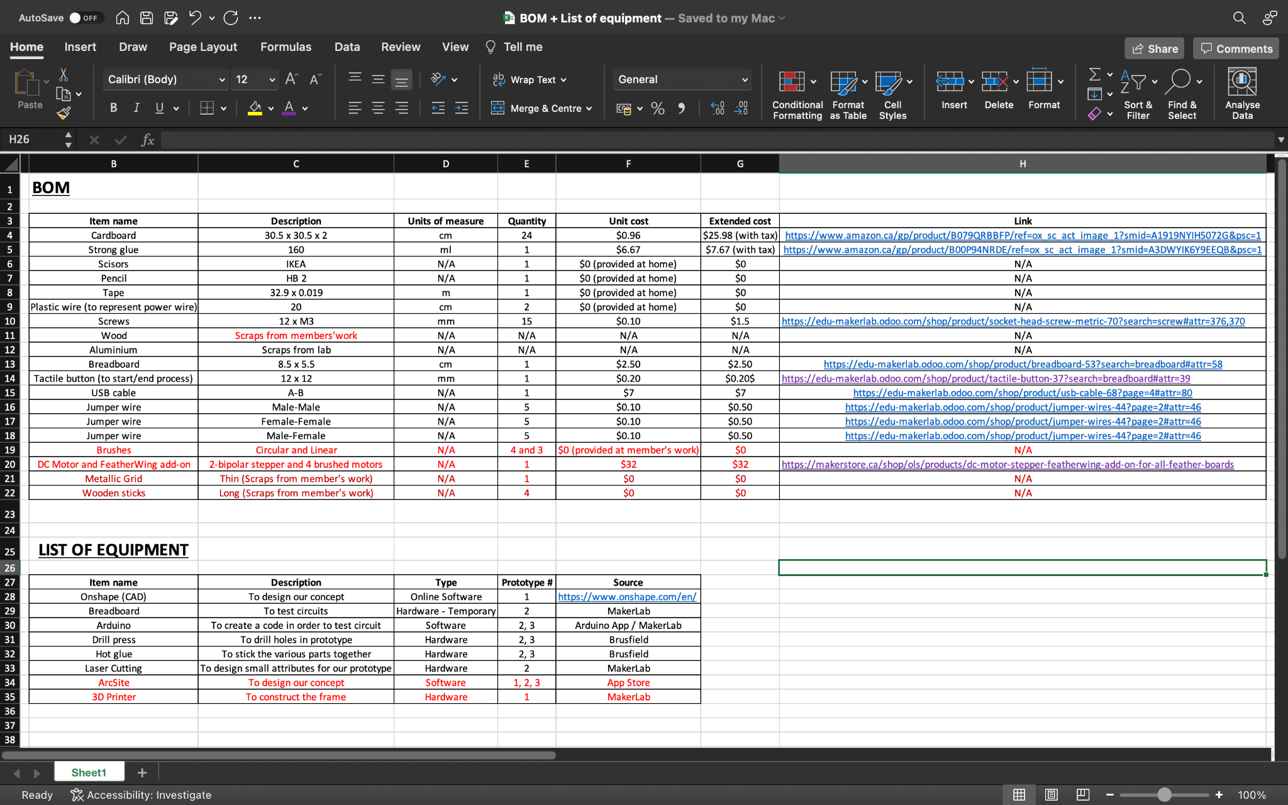
The materials and equipment with their respective descriptions and others that are in red represent the updated list.

Prototyping Test Plan for Prototype II

Table 3: Test Plan Ideas for Prototype II

Test ID | Test Objective (Why) | Description of  Prototype used and of  Basic Test Method  (What) | Description of  Results to be  Recorded and  how these results  will be used  (How) | Estimated Test  duration and  planned start  date  (When)
1 | Check to see if the “Lego” frame properly aligns the board | A physical model will be created. | A way to test the angle of the board in respect to the box (box and board should be parallel) | Very short test, once the prototype is built
2 | Test how easy it is to put the board into the box of the machine | Multiple physical models to represent methods of putting the board in the box (from above, in a slit in the side, etc.) | Calculate force to move the board into the box and time spent to put it in. Used to determine the best method. | May take a decent amount of time to design basic board entering methods and to build them.

Conclusion

To summarize, the prototype we came up with qualitatively translates the whole concept of our cleaning device: the frame will go inside of a box, brushes will go all around the board while following a specific trajectory and smaller brushes attached to a metallic grid will go in and out the holes of the board.

On that note, the prototype gave us the opportunity to see that the concept is very feasible: this first out of three prototypes was able to clean most of the board in an efficient 15 seconds. Nonetheless, for the next prototypes, we will manage to present a project that will fully cover the area and that will be automated for the most part, while upgrading the whole body to a more heavy-duty one.

Appendix

Detailed Design Concepts for Subsystems from Project Deliverable E

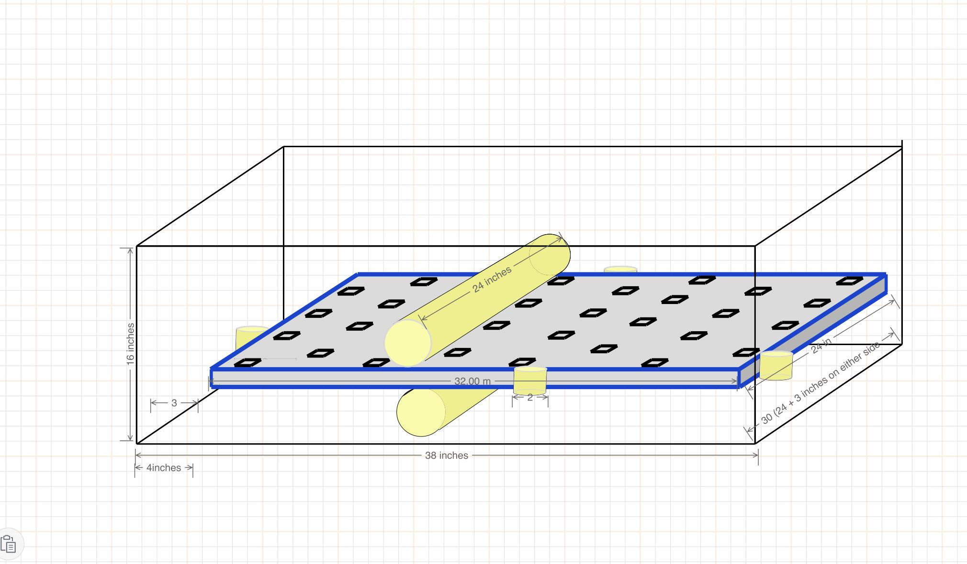
Figure 1. This image depicts our first subsystem which consists of six cylindrical brushes meant to clean the outer surface area of the board. These brushes will be made out of an outer layer of toothbrush-like bristles in order to scrub off the algae. They will spin rapidly in a circle and move across the surface multiple times in order to ensure cleanliness.

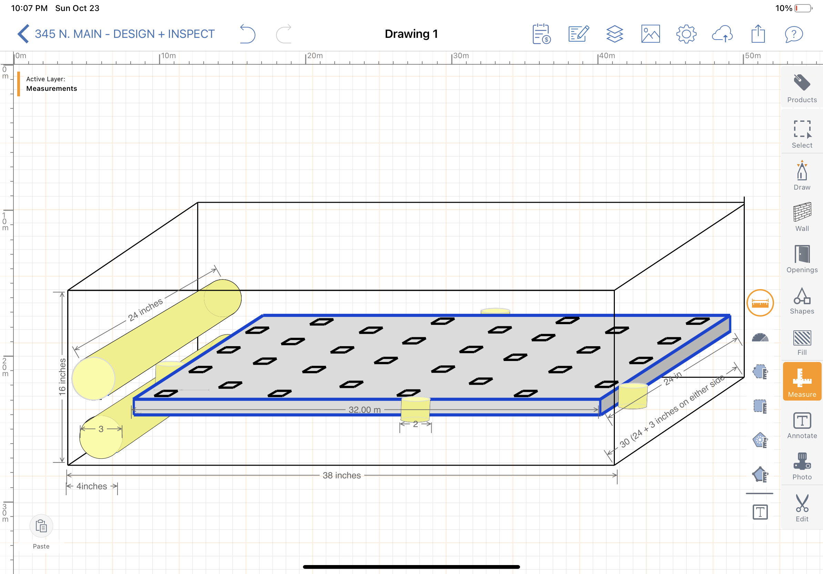
Figure 2. Brushes are out of the way with room for Subsystem two - inner hole brushes

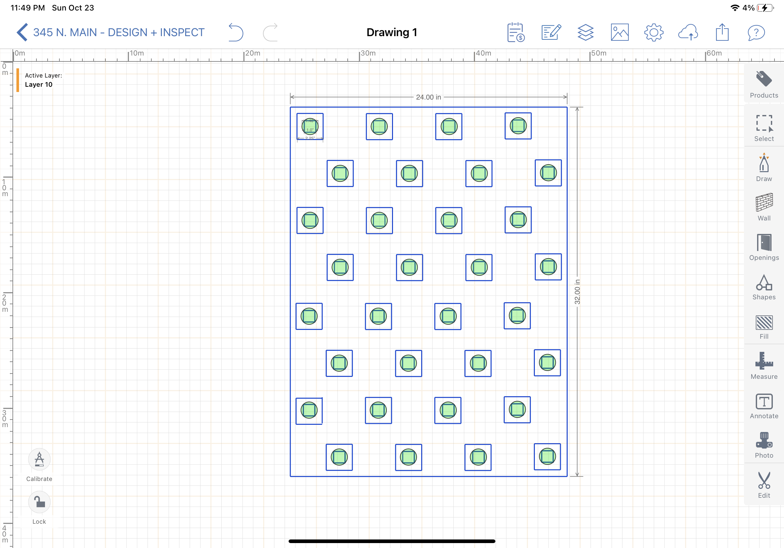
Fig 3. Accurate depiction of raft, holes, and area brushes will cover. The outer squares are the raised portion of the holes and the inner square is the actual hole in the raft. The green circles portray the area of the brushes in comparison with the square.

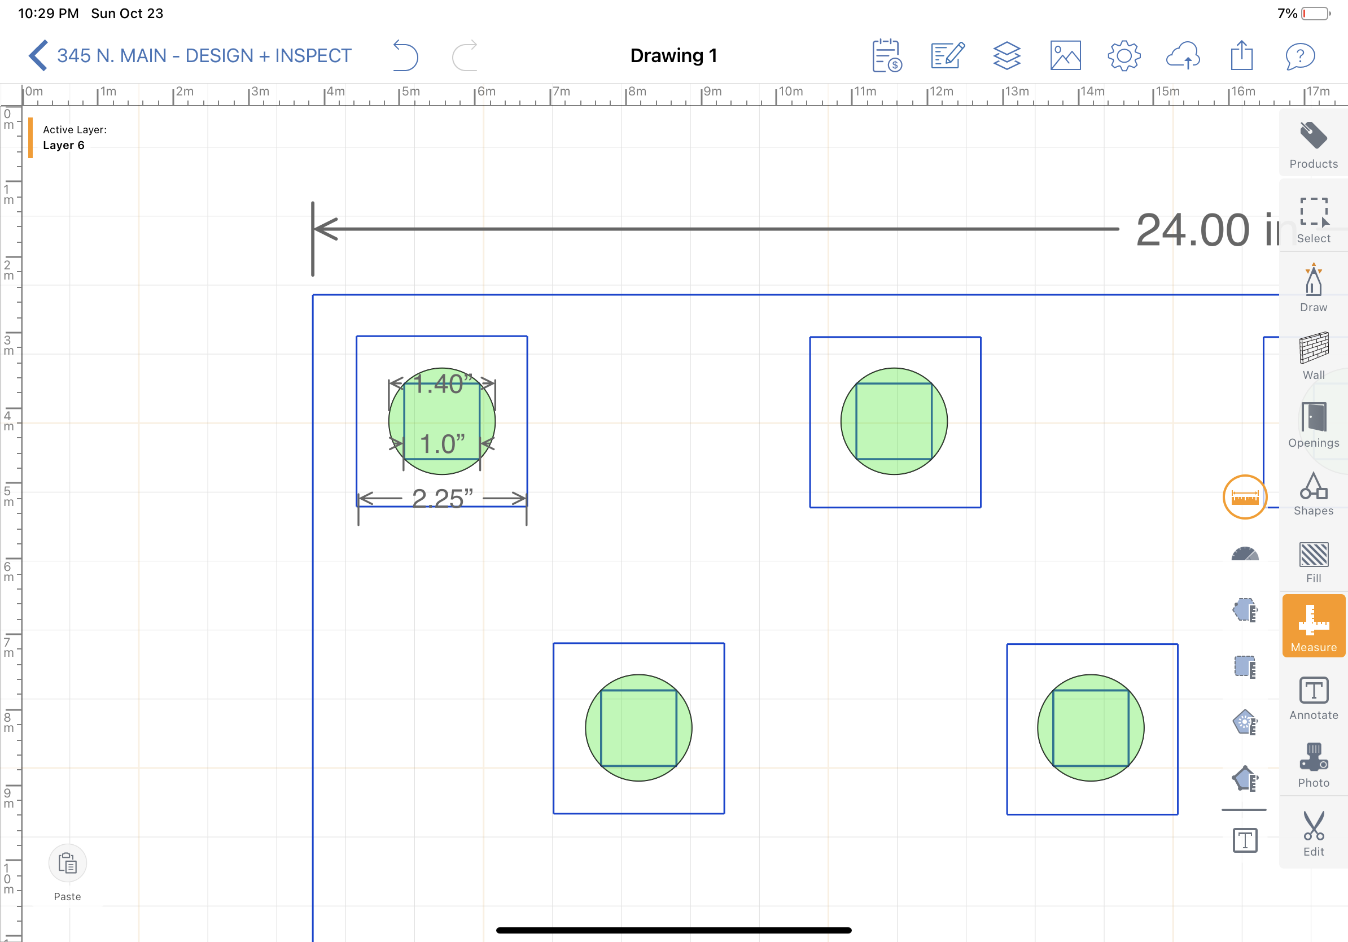
Fig 4. Close up version of holes.

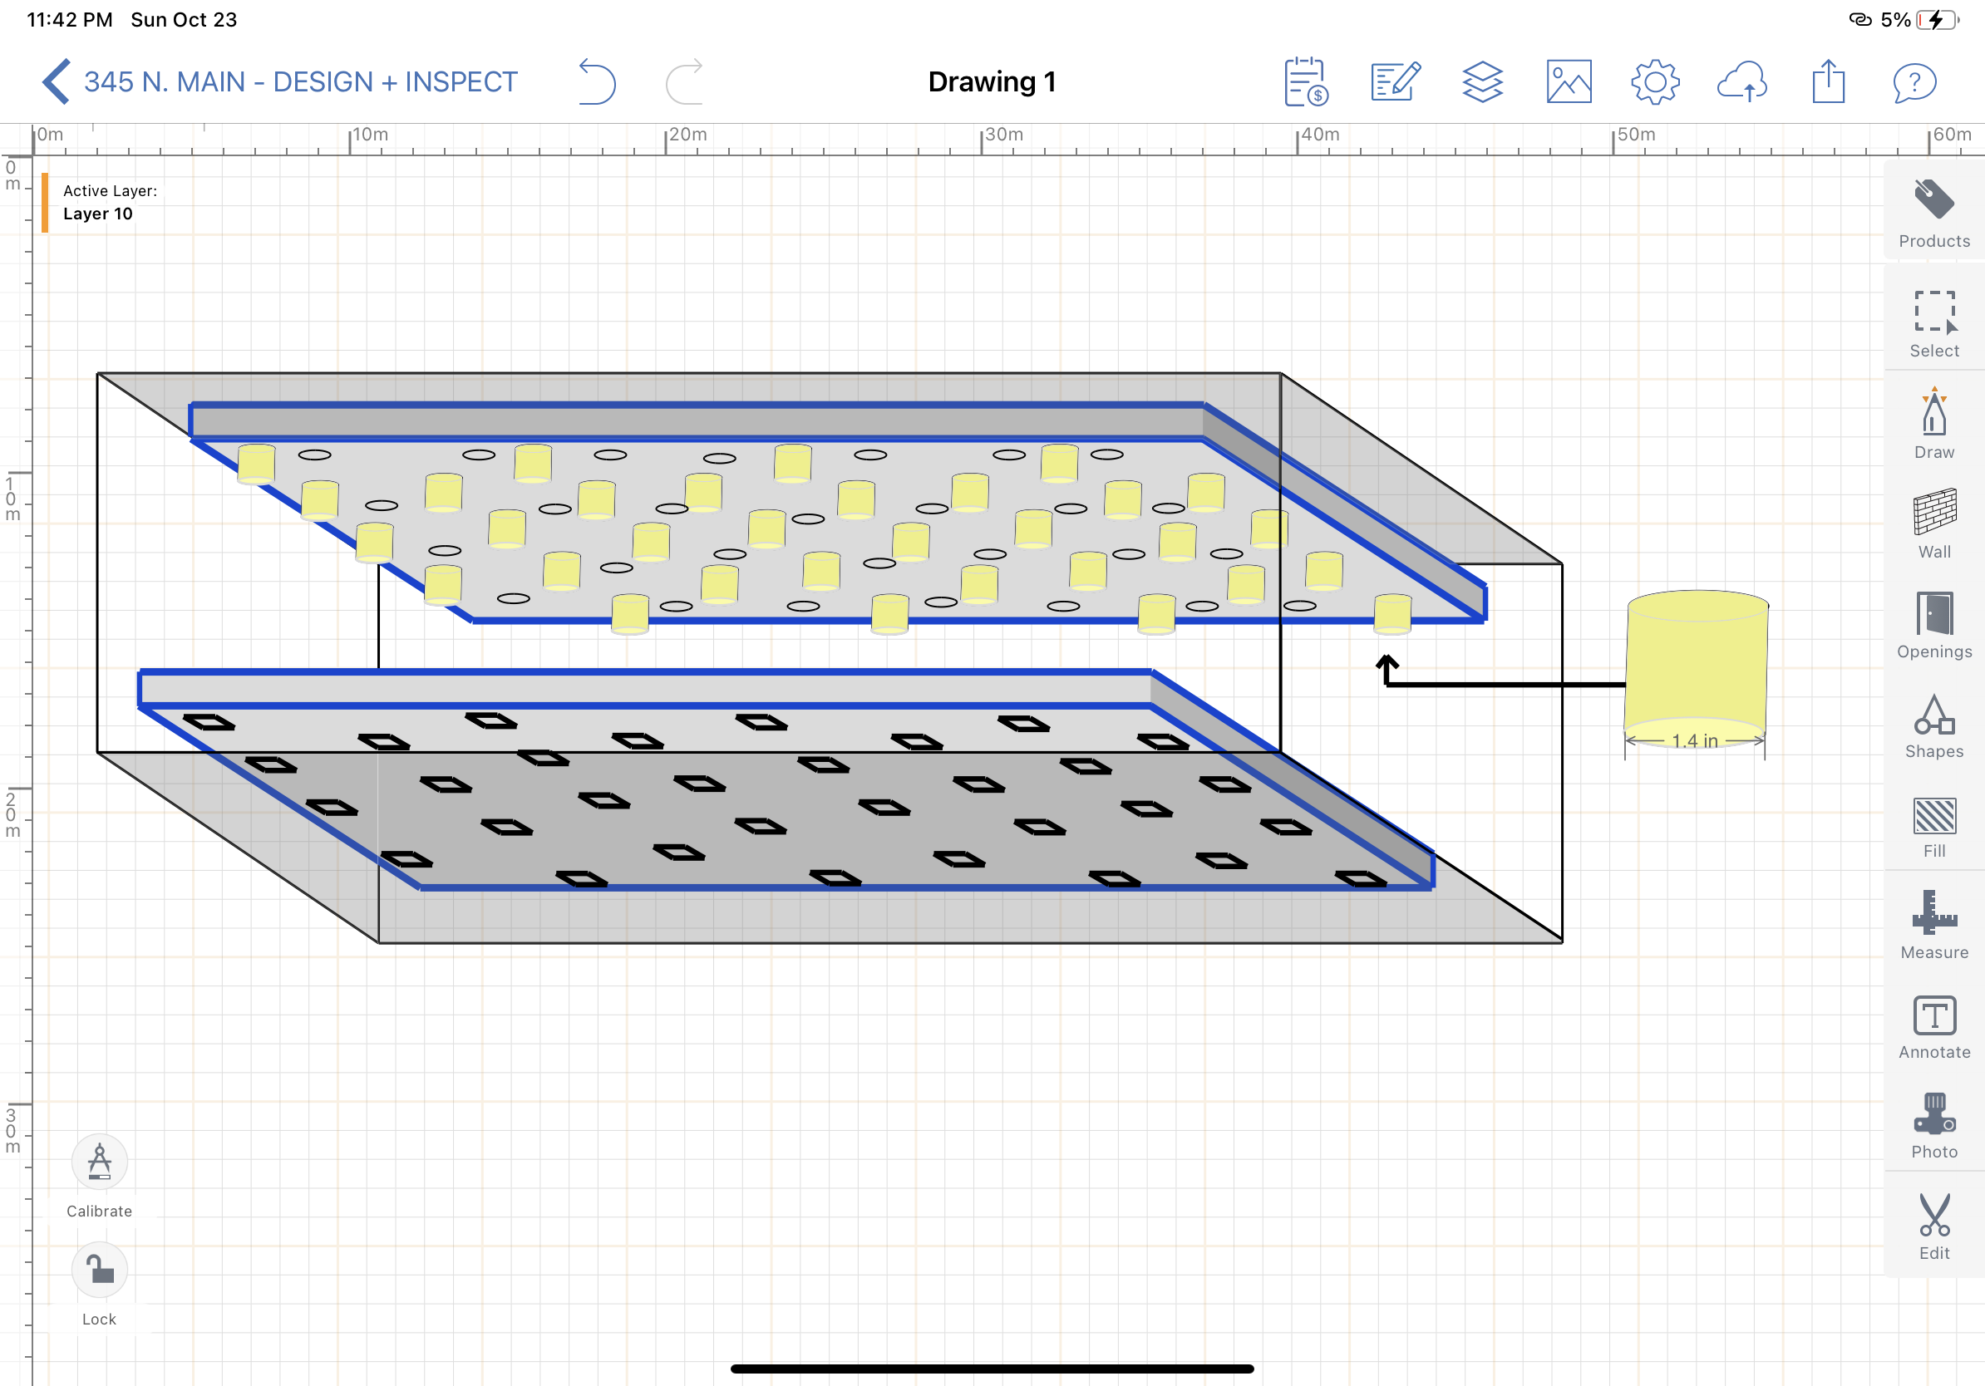
Figure 5. These brushes, in yellow, made of the same material as the brushes for subsystem 1, are pliable and can be squished into the squares while spinning, ensuring that the whole hole gets cleaned.

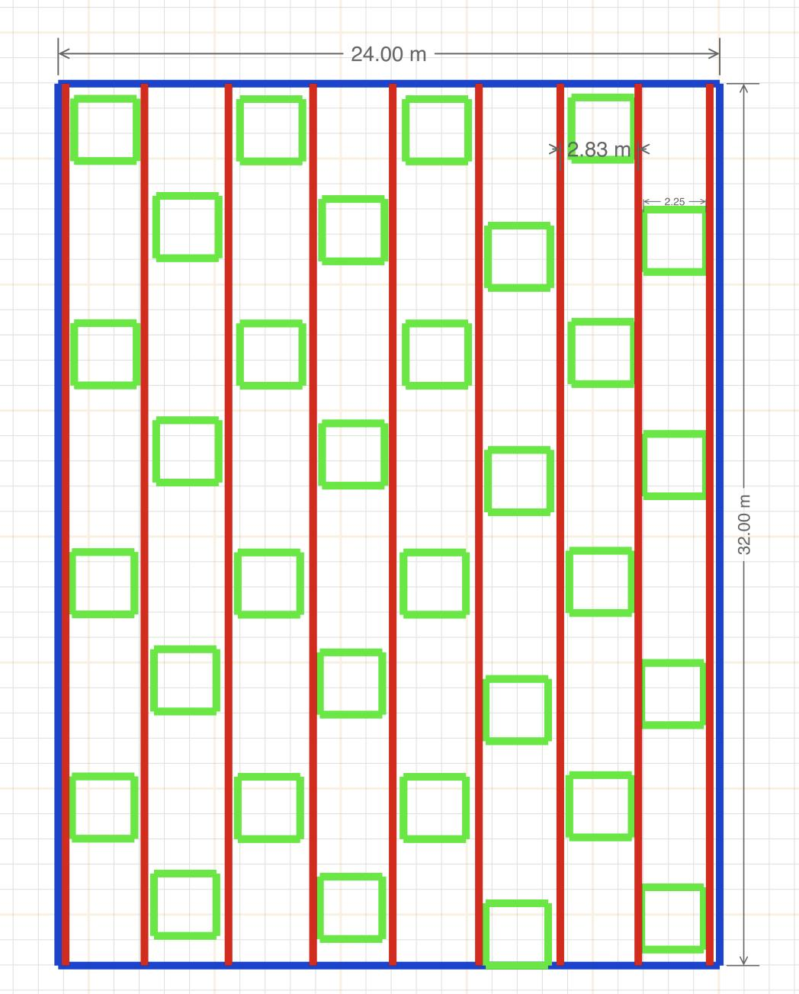
Figure 6. This is a depiction of our placement method for the raft. The raft will sit on a metal grid (see fig 7 for details) with raised squares that will fit inside of the 0.25 inch indent in the bottom of the boards (See Fig 8) in order to get it in exactly the right position for the hole brushes to fit into the board.

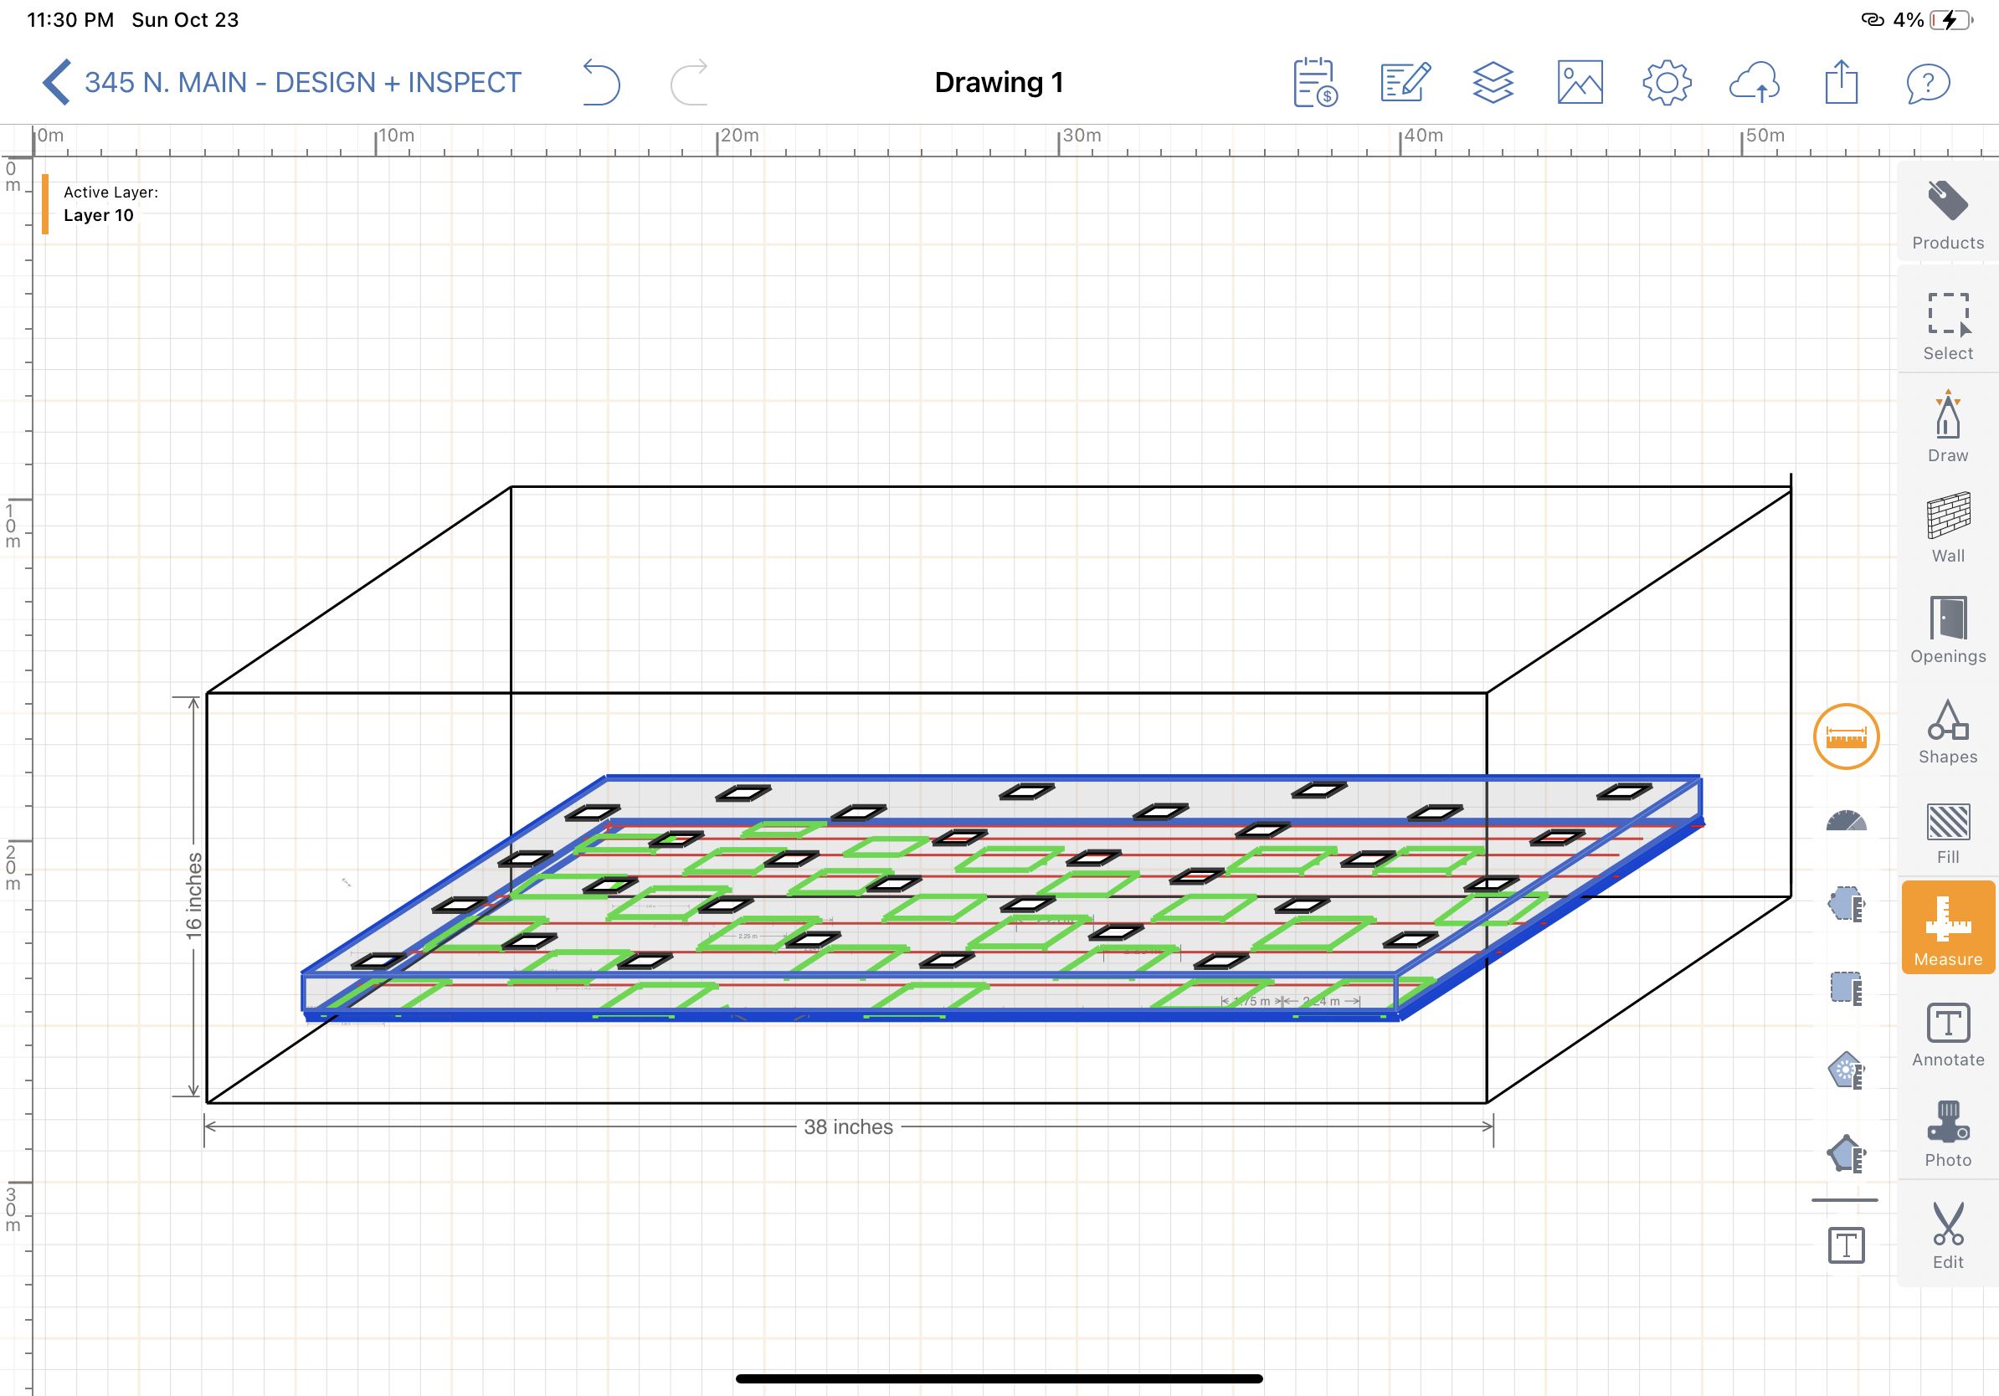
Figure 7. Visual depiction of tray under board

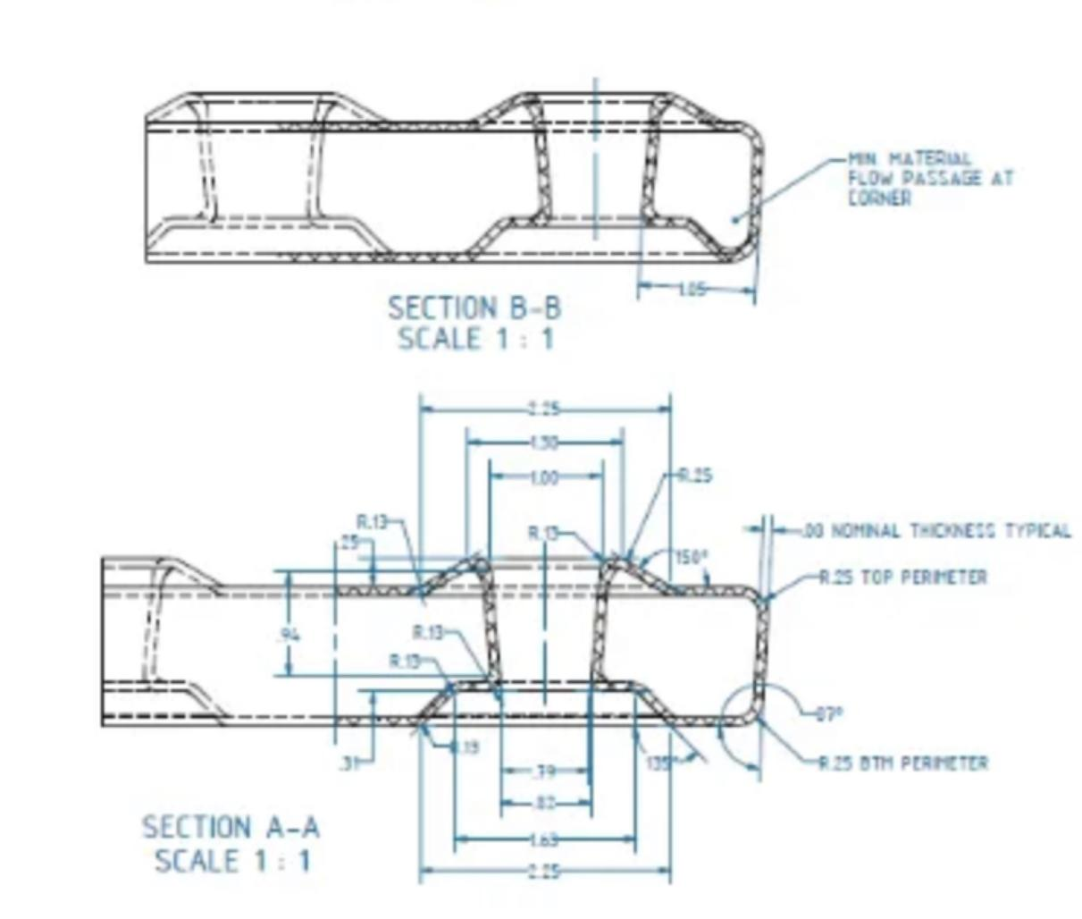
Figure 8. The indent in the boards

