GNG 2101
Introduction to Product Development and Management for Engineers and Computer Scientists

Project Deliverable F: Business Model

Lab Section: A02, Wednesday, Lab Group A7

Student Number |  | Name
300077504 |  | Prisha Shetty
300122381 |  | Liam Kennedy
300062079 |  | Jeta Thavarasah
300117908  300132765 |  | Joshua Coutinho  Liam Fagan
Date Submitted: October 22nd , 2020
Professor: Dr. Hanan Anis
PM: Cooper Lawrence
TA: Jaya Kandimalla

Faculty of Engineering
2020

INTRODUCTION
In the midst of Covid-19 our client Kim Kilpatrick is looking for a device that will help her find and press automatic buttons with the need for her or other visually impaired people to touch unsanitized buttons/surfaces. The following document compiles a hypothetical business model for such a product that will meet the clients needs. The reasoning behind this business model is justified and applied to the supposed solution in the following report. Additionally the document contains a business model canvas and explains our necessary assumptions for the feasibility of the product.

IDENTIFYING BUSINESS MODEL

After discussing the different possible business model types that would best suit our product, we decided the brick and mortar business model is best fitted for our group. We settled on the brick and mortar model because we provide an in person experience (if covid permitted) where we would cater our product to the user’s specific needs as well as an online experience where the customer can view our product and give feedback on how to improve it. We have been meeting with our client online using zoom (would be in-person but that is not possible) where we have been sharing ideas back and forth of how to make our product as efficient and useful as possible. Our client has been very impressed with our improvements and progress to our product and we have taken any suggestions they have into serious consideration when proceeding with each step of developing our device. Our client’s feedback is so important because this product will be specifically catered towards their needs so we can assist them in making their everyday life easier.

ASSUMPTIONS

Our business model will include the product being sold either in person or online. On that note, one of the core assumptions we have made based on the business model canvas is that the clients that we are assuming to attract with this product, are the blind and more generally anyone with disabilities. However, this product is not only limited to these groups of people but can ultimately be used by any user. Another core assumption we will be making is that if the product were to be purchased face to face, it is easy for the customer to ask for assistance on how to use the product from retail employees. Adding on, if the product were to be purchased online, our product can be marketed internationally or nationally, therefore expanding our business as well.

Business Model Canvas

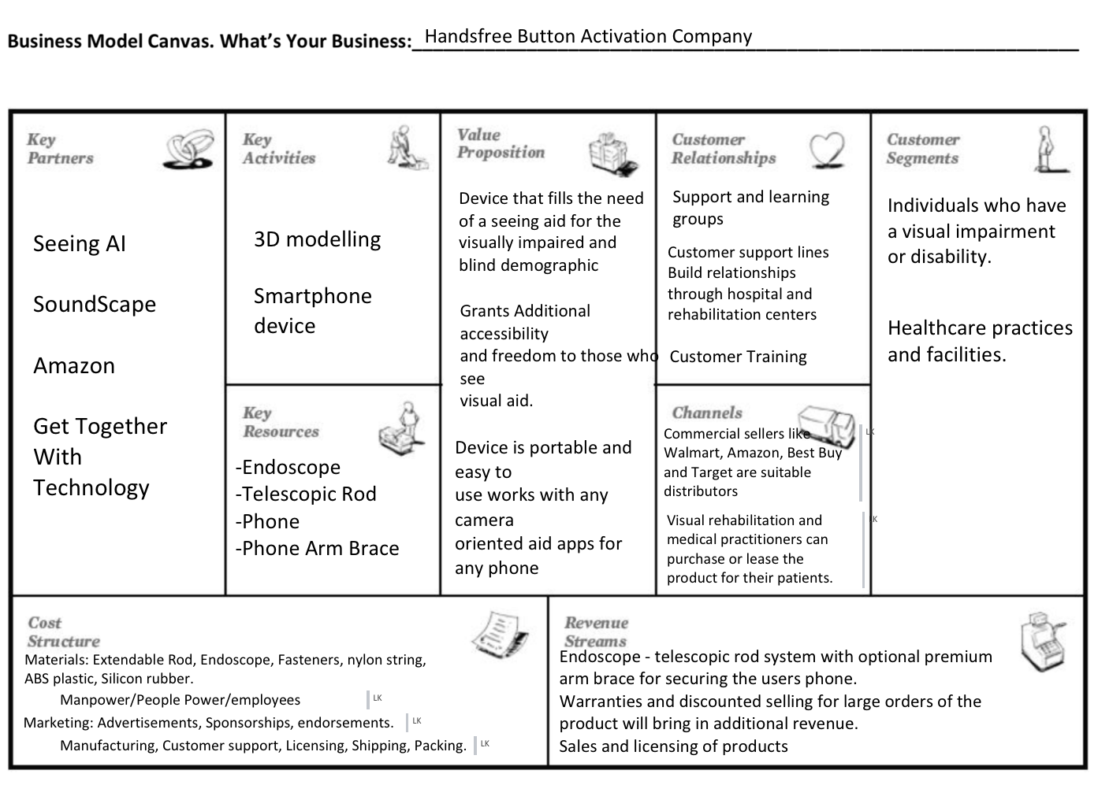

Conclusions
From our business model analysis we can conclude that though there may have been other business models that we could have used as a basis for our canvas, but a brick and mortar method is the simplest and most efficient approach given the circumstances. The Brick and mortar method is advantageous because of how easily we can distribute our design solution through generic sellers and specialized facilities at the same time. The business model canvas explored the resources, revenue streams, customer segments and cost structure considering the economic, social and cultural values pertaining to our design prototype. Being able to sell in greater numbers to generic sellers will allow us to sell at lower prices and distribute to more sellers than with a more niche marketing canvas.

Microsoft Project Plan
