Project Deliverable E: Project Plan and Cost Estimate
Team A07
October 23rd, 2022

Abstract:
The object of this document is to plan the steps necessary to complete all three project prototypes by developing a scheduled outline starting from now until the end of the semester. Each prototype will be based on the estimation of the costs and the components found in the Bill of Materials and List of Equipment in this document. Updated information from Deliverable D is included in the first section.

Table of Contents
I. Design Concept with Amendment 2
II. Bill of Materials (BOM) 3
III. Project Equipment 4
IV. Project Risks and Contingencies 5
V. Prototyping Test Plan 6

Introduction

This document includes an amendment to our work regarding deliverable D that revises one of our three subsystems to better meet the clients needs. After the amendment is a detailed design of the project using Onshape followed by a bill of materials that outlines what is needed to build and test prototypes of our project. A table of project equipment is provided to show the necessary physical and online tools being used for prototyping. Finally, this document contains a table outlining the potential risks working on this project including backup plans and a prototyping test plan.

Design Concept with Amendment

Amendment of Original Design
During the client meeting, it was mentioned that the drying system wasn’t of importance, and that a subsystem regarding the specific cleaning of the holes inside of the frame might be to their liking. On that note, the following is a description of this concept and its representative sketch.

Holes Cleaner

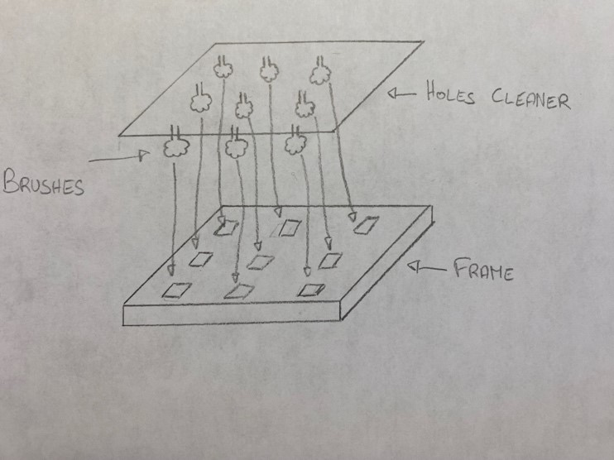
Figure II.A. Holes Cleaner. This concept consists in cleaning the holes inside of the board by using an automated frame (same size of the board) located above this last that goes down until its rotating brushes (fixed to it) are inside the holes. They then start rotating in order to clean them.

Our three solutions for the hydroponic systems are summarized below (reviewed version), in order of preference:

Solution 1:
● Cleaning subsystem: Water hose and motor brushes
● Drying subsystem: Holes cleaner
● Frame/Movement subsystem: Basic box

Solution 2:
● Cleaning subsystem: Rotating brushes
● Drying subsystem: Holes cleaner
● Frame/Movement subsystem: Conveyer belt

Solution 3 (Randomly Generated):
● Cleaning subsystem: Steam cleaning
● Drying subsystem: Holes cleaner
● Frame/Movement subsystem: Rotating platform

Detailed design drawing that summarizes our chosen concept/solution:

Figure II.B.

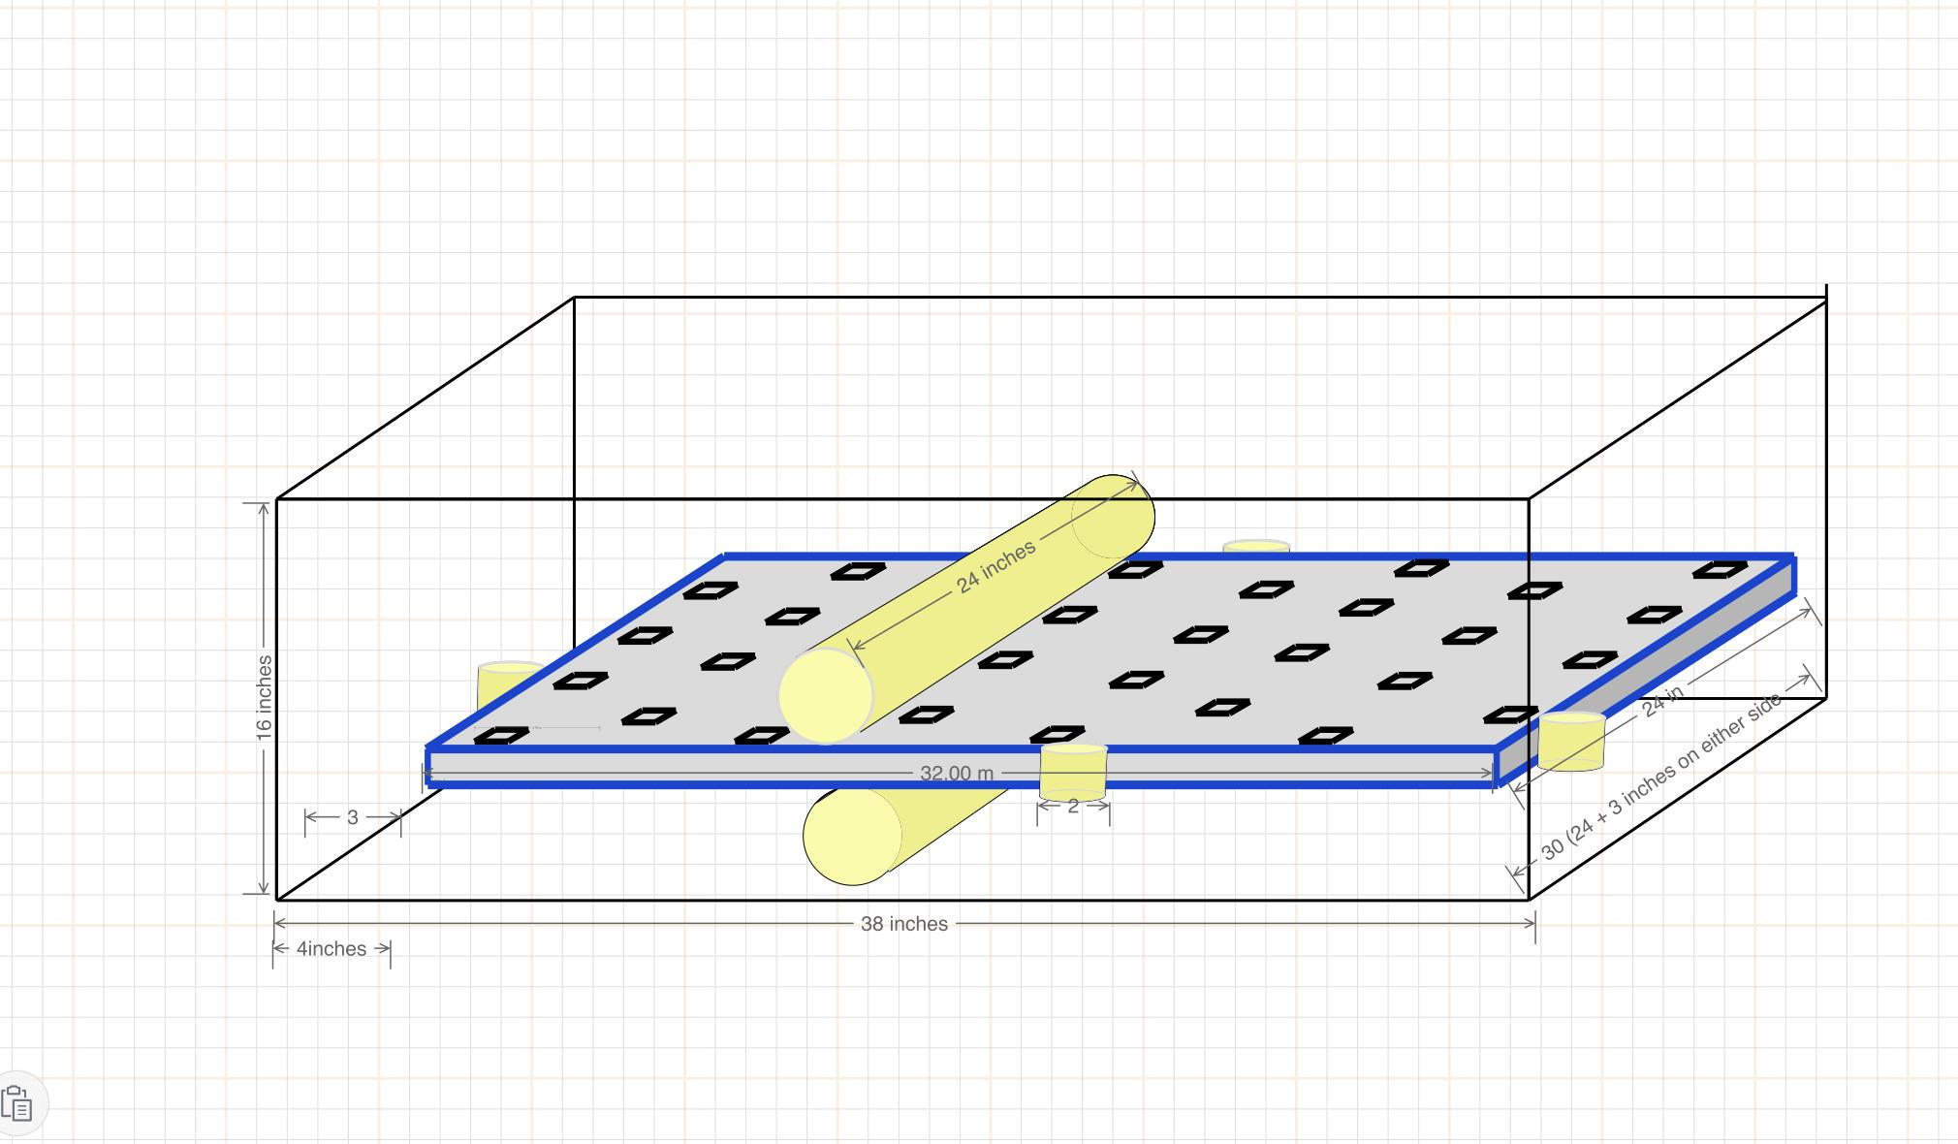
Fig 1. This image depicts our first subsystem which consists of six cylindrical brushes meant to clean the outer surface area of the board. These brushes will be made out of an outer layer of toothbrush-like bristles in order to scrub off the algae. They will spin rapidly in a circle and move across the surface multiple times in order to ensure cleanliness.

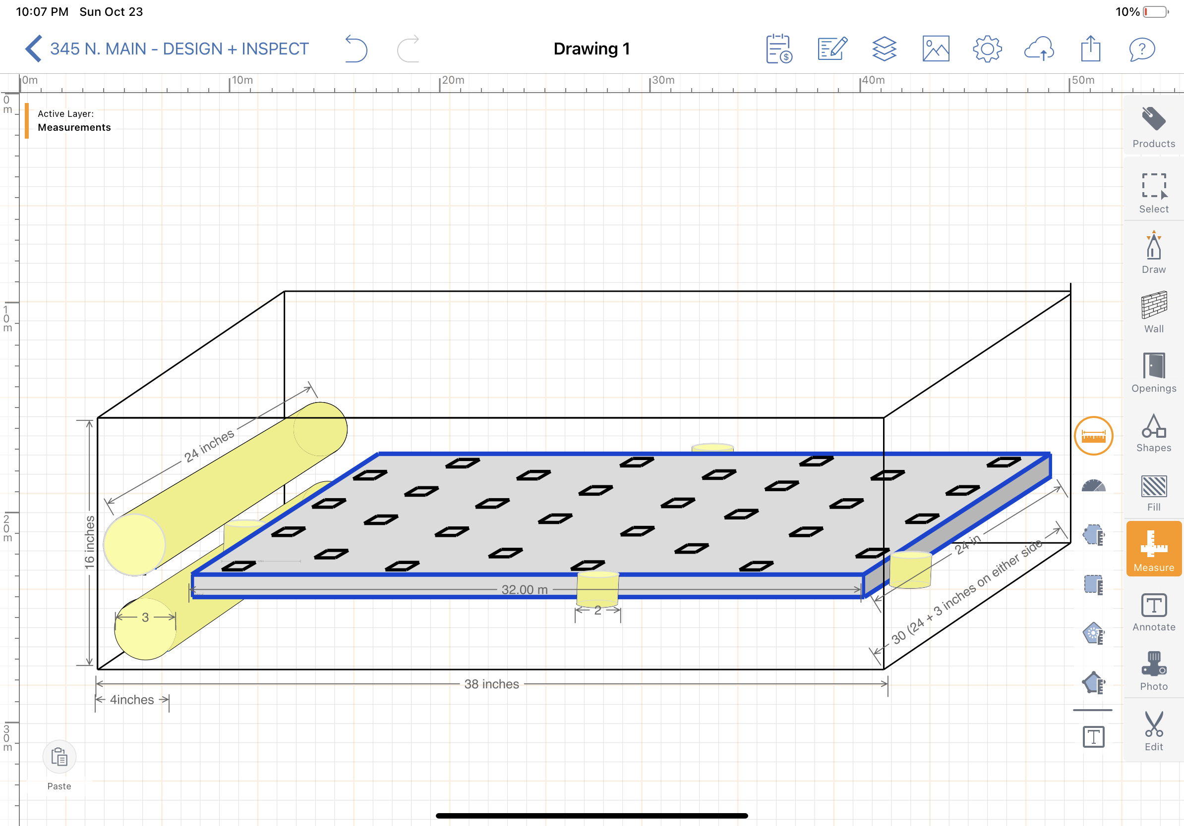
Fig 2. Brushes are out of the way with room for Subsystem two - inner hole brushes

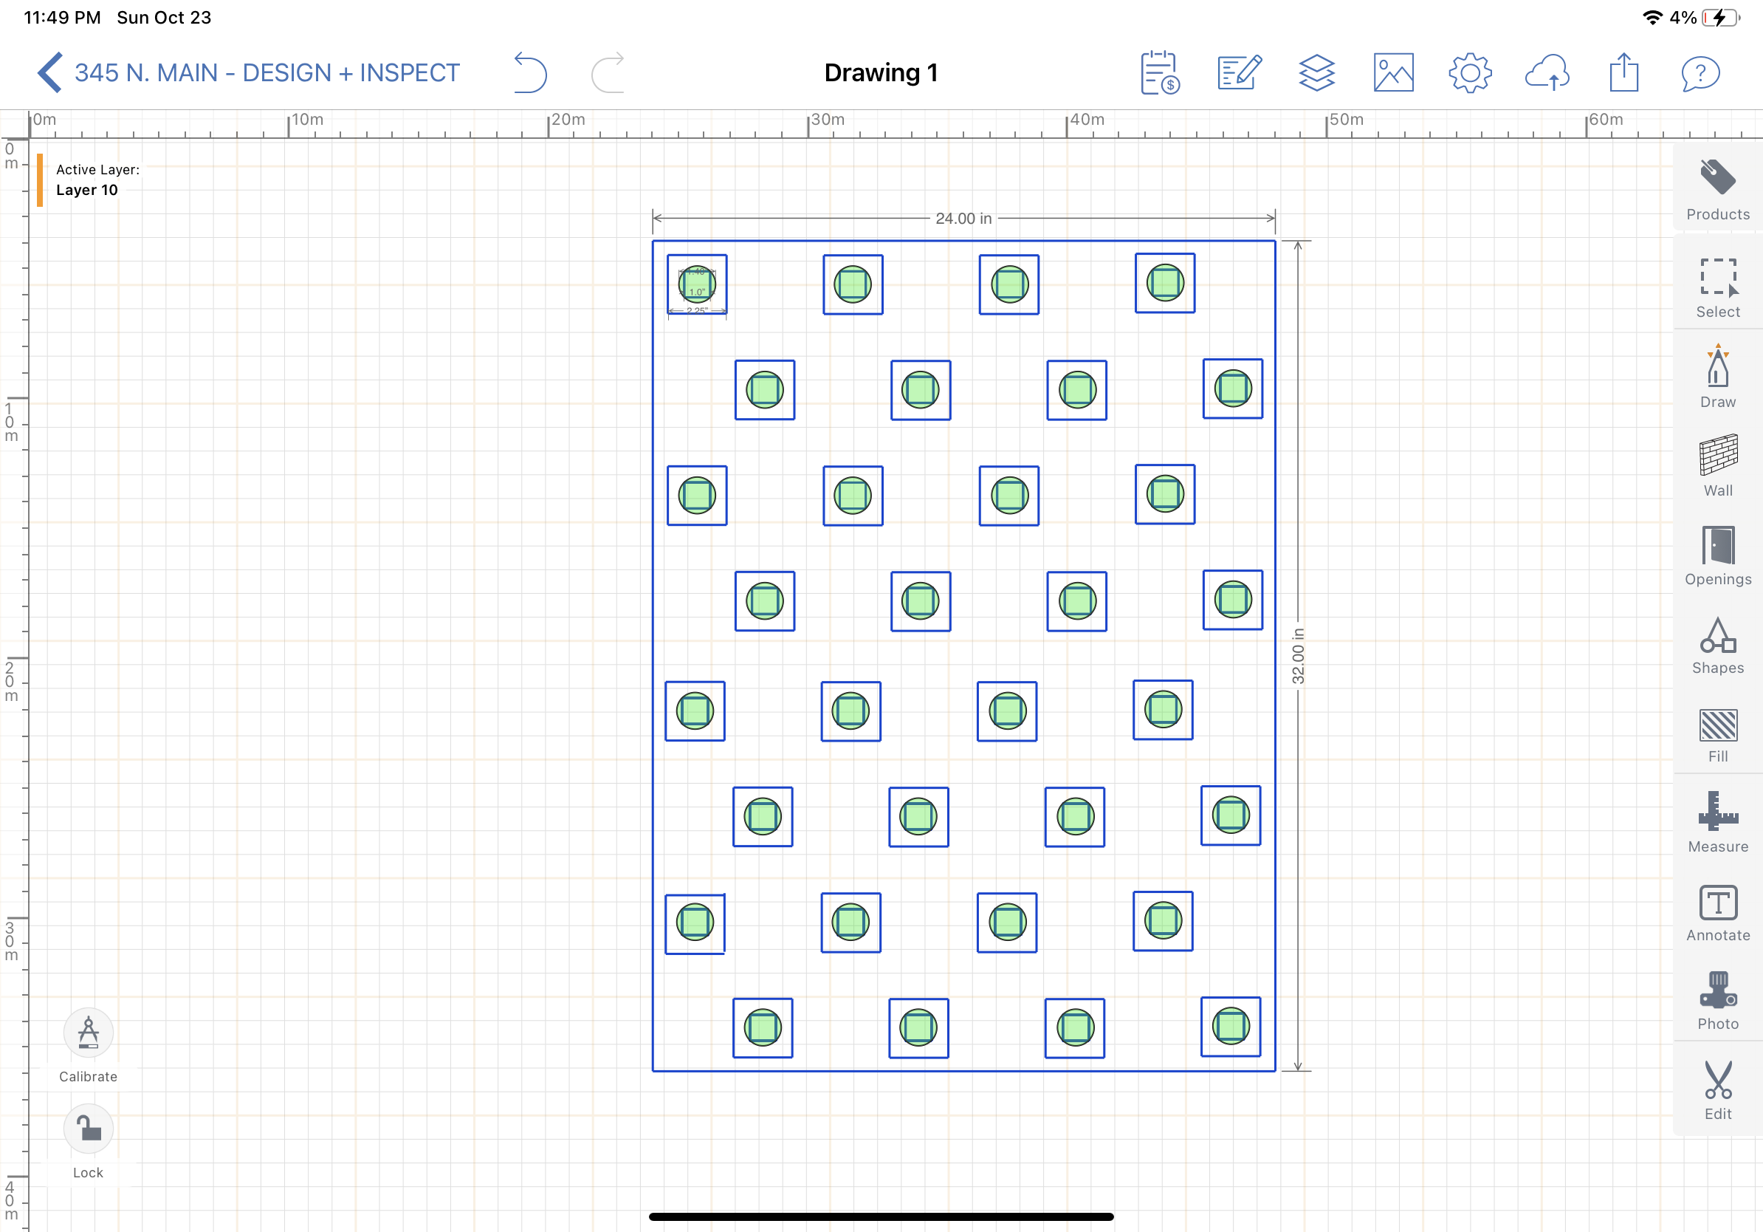
Fig 3. Accurate depiction of raft, holes, and area brushes will cover. The outer squares are the raised portion of the holes and the inner square is the actual hole in the raft. The green circles portray the area of the brushes in comparison with the square.

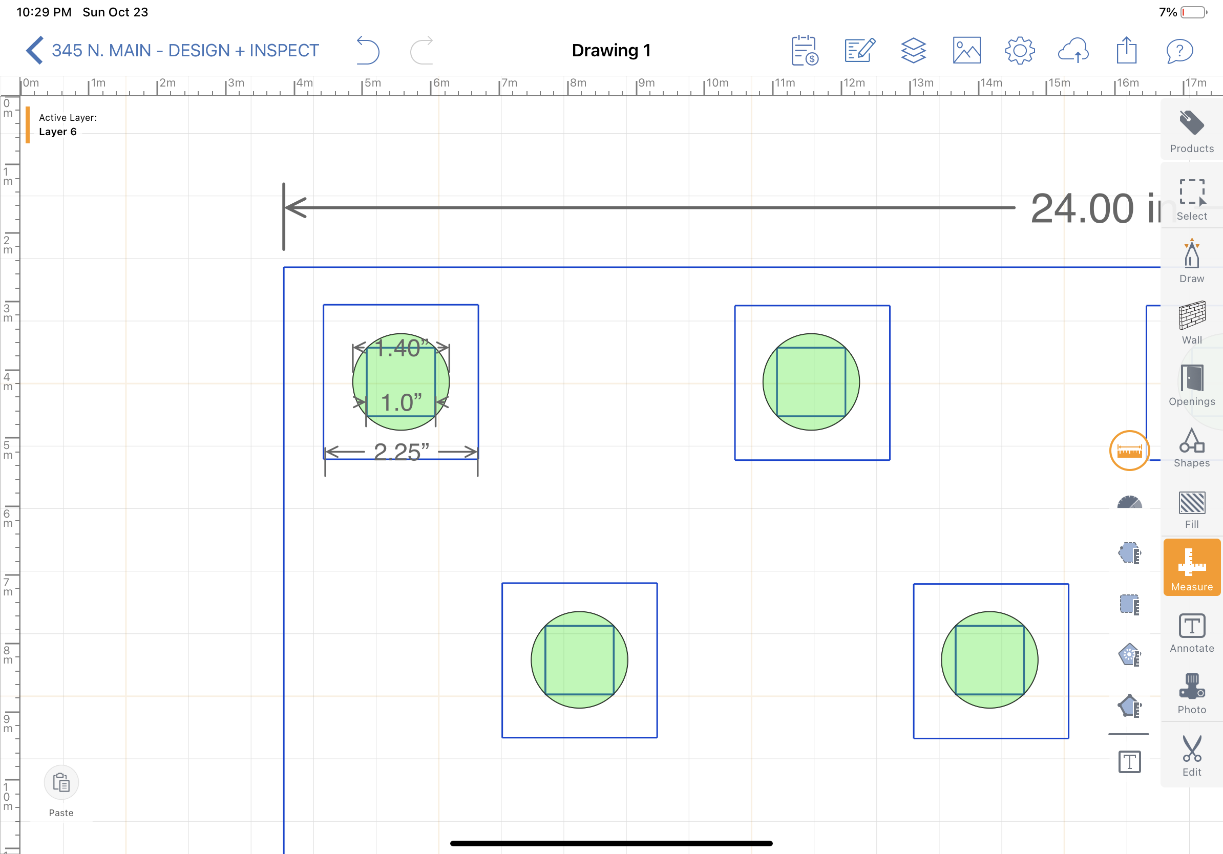
Fig 4. Close up version of holes.

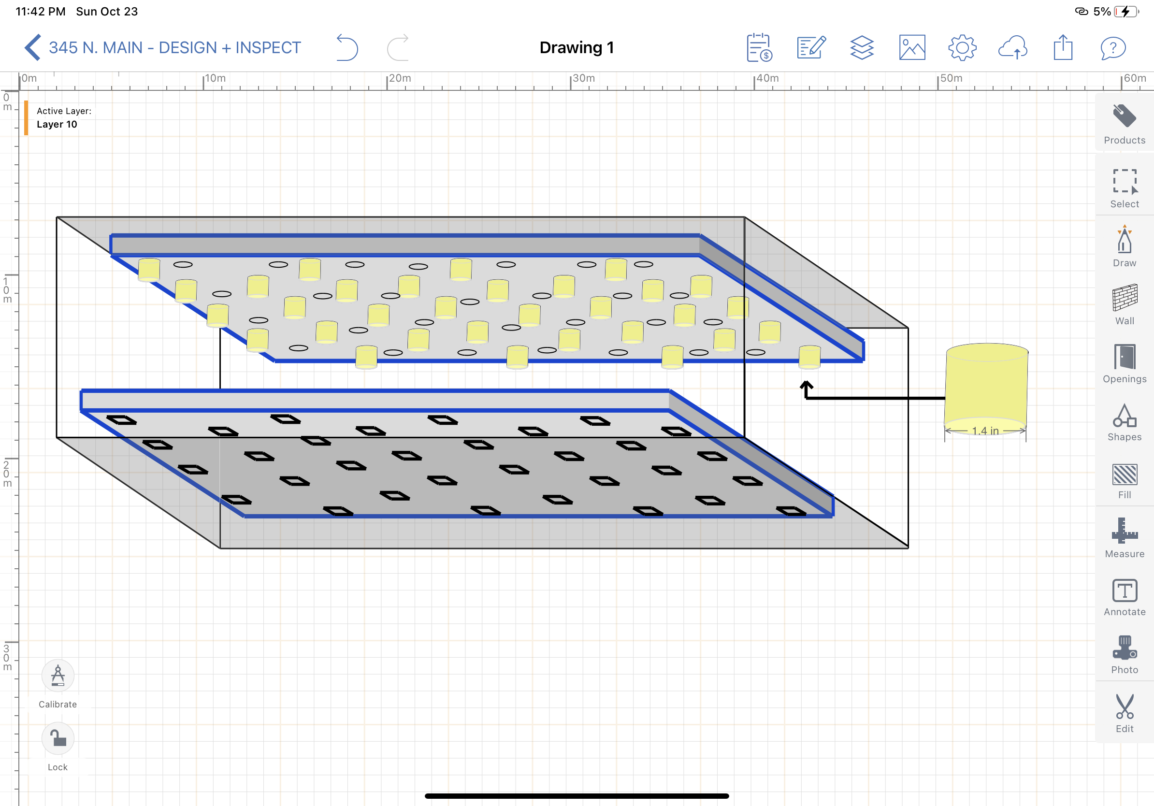
Fig 5. These brushes, in yellow, made of the same material as the brushes for subsystem 1, are pliable and can be squished into the squares while spinning, ensuring that the whole hole gets cleaned.

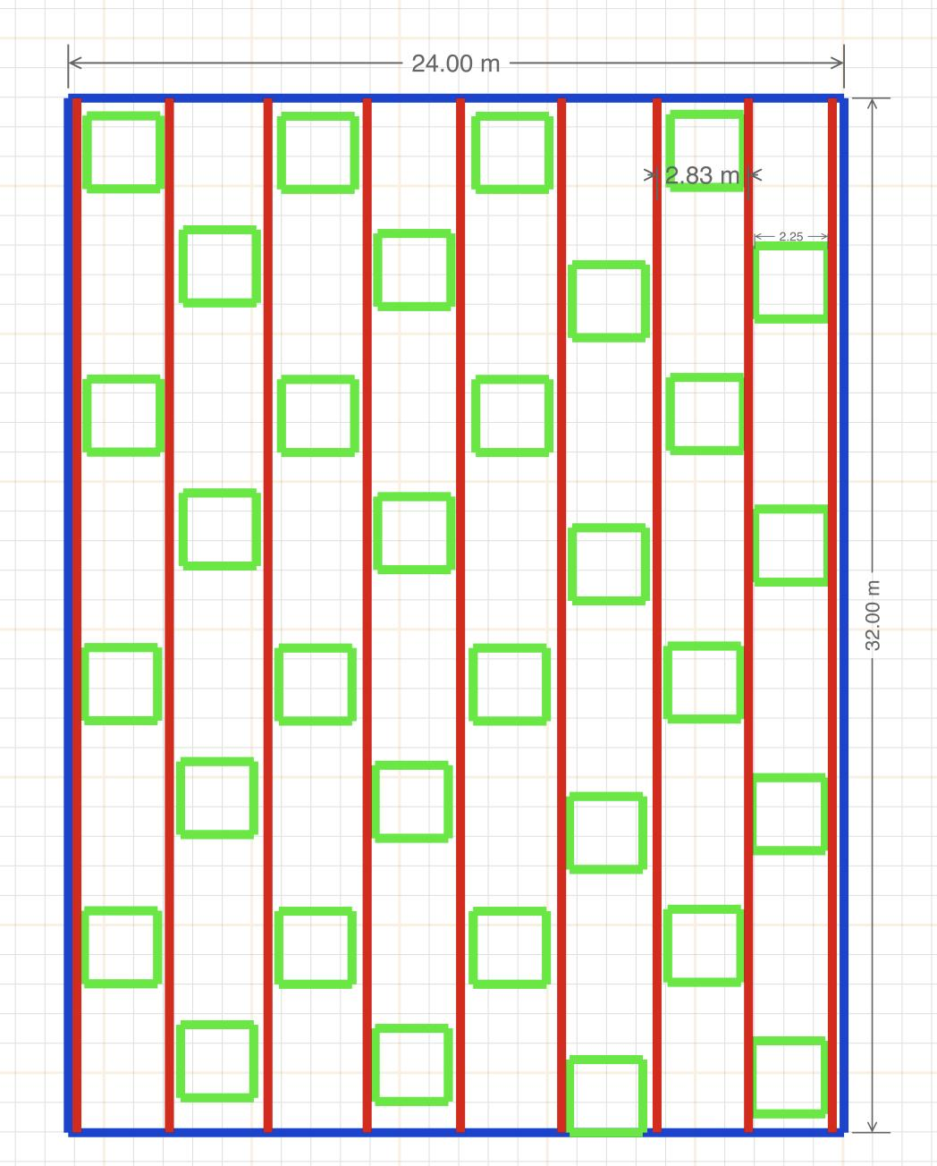
Fig 6. This is a depiction of our placement method for the raft. The raft will sit on a metal grid (see fig 7 for details) with raised squares that will fit inside of the 0.25 inch indent in the bottom of the boards (See Fig 8) in order to get it in exactly the right position for the hole brushes to fit into the board.

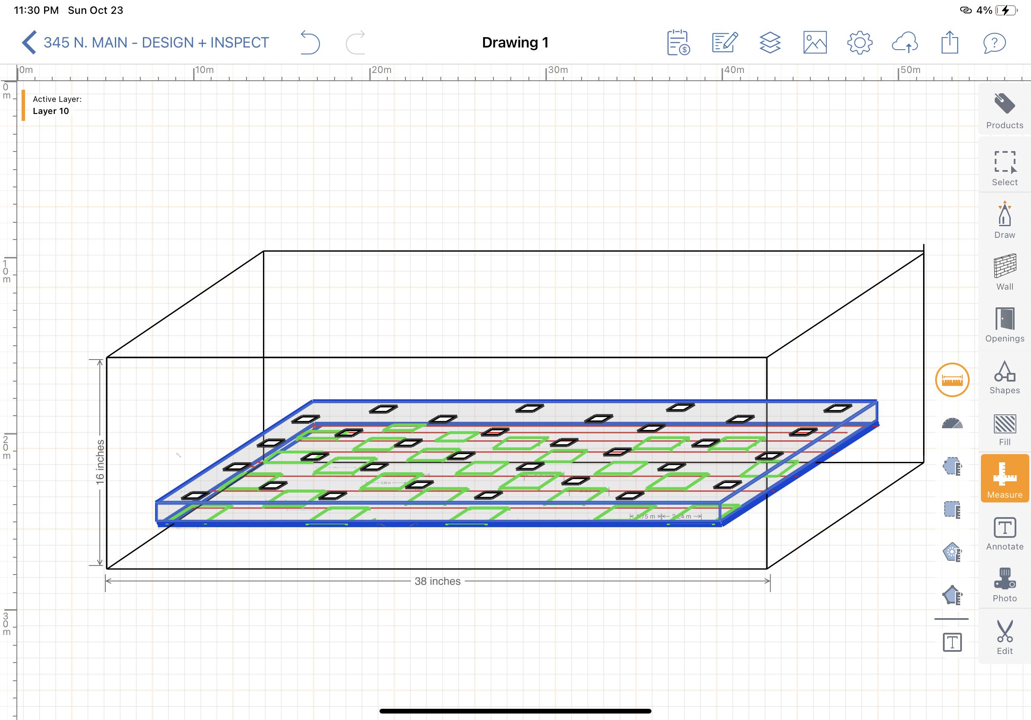
Fig 7. Visual depiction of tray under board

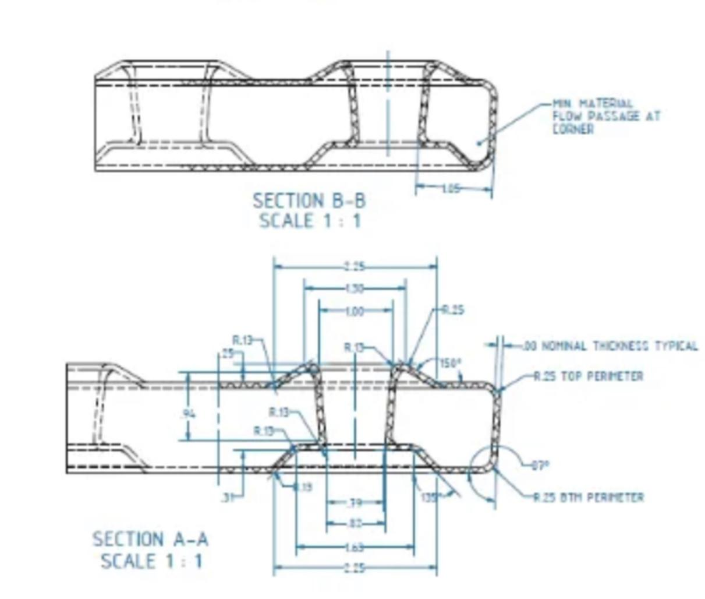
Fig 8. The indent in the boards

Bill of Materials (BOM)

Here is our table detailing the cost and method of acquisition for each material in our project.

Table 1: List of a Bill of Materials

Item name | Description | Units of measure | Quantity | Unit cost | Extended cost | Link
Cardboard | 30.5 x 30.5 x 2 | cm | 24 | $0.96 | $25.98 (with tax) | https://www.amazon.ca/gp/product/B079QRBBFP/ref=ox_sc_act_image_1?smid=A1919NYIH5072G&psc=1
Strong glue | 160 | ml | 1 | $6.67 | $7.67 (with tax) | https://www.amazon.ca/gp/product/B00P94NRDE/ref=ox_sc_act_image_1?smid=A3DWYIK6Y9EEQB&psc=1
Scissors | IKEA | N/A | 1 | $0 (provided at home) | $0 | N/A
Pencil | HB 2 | N/A | 1 | $0 (provided at home) | $0 | N/A
Tape | 32.9 x 0.019 | m | 1 | $0 (provided at home) | $0 | N/A
Plastic wire (to represent power wire) | 20 | cm | 2 | $0 (provided at home) | $0 | N/A
Screws | 12 x M3 | mm | 15 | $0.10 | $1.5 | https://edu-makerlab.odoo.com/shop/product/socket-head-screw-metric-70?search=screw#attr=376,370
Wood | Scraps from lab | N/A | N/A | N/A | N/A | N/A
Aluminum | Scraps from lab | N/A | N/A | N/A | N/A | N/A
Breadboard | 8.5 x 5.5 | cm | 1 | $2.50 | $2.50 | https://edu-makerlab.odoo.com/shop/product/breadboard-53?search=breadboard#attr=58
Tactile button (to start/end process) | 12 x 12 | mm | 1 | $0.20 | $0.20$ | https://edu-makerlab.odoo.com/shop/product/tactile-button-37?search=breadboard#attr=39
USB cable | A-B | N/A | 1 | $7 | $7 | https://edu-makerlab.odoo.com/shop/product/usb-cable-68?page=4#attr=80
Jumper wire | Male-Male | N/A | 5 | $0.10 | $0.50 | https://edu-makerlab.odoo.com/shop/product/jumper-wires-44?page=2#attr=46
Jumper wire | Female-Female | N/A | 5 | $0.10 | $0.50 | https://edu-makerlab.odoo.com/shop/product/jumper-wires-44?page=2#attr=46
Jumper wire | Male-Female | N/A | 5 | $0.10 | $0.50 | https://edu-makerlab.odoo.com/shop/product/jumper-wires-44?page=2#attr=46

Project Equipment
This table below details the equipment necessary to build the product using the materials listed above.

Table 2: List of Equipment

Item name | Description | Type | Prototype # | Source
Onshape (CAD) | To design our concept | Online Software | 1 | https://www.onshape.com/en/
Breadboard | To test circuits | Hardware - Temporary material | 2 | MakerLab
Arduino | To create a code in order to test circuit | Software | 2, 3 | Arduino App / MakerLab
Drill press | To drill holes in prototype | Hardware | 2, 3 | Brusfield
Hot glue | To stick the various parts together | Hardware | 2, 3 | Brusfield
Laser Cutting | To design small attributes for our prototype | Hardware | 2 | MakerLab

Project Risks and Contingencies
As many things can go wrong with the design and completion of prototypes and their testing, this table lists the potential risks that can occur, and contains backup/contingency plans to reduce the impact of these issues or prevent them all together.

Table 3: List of Risks and Contingencies

Risk | Severity | Likelihood | Mitigation/Contingency
Internet Outage | Moderate | Low | If the outage affects only one person, the team will work on a public network, if collective (due to a power outage), work on as much as possible without internet and communicate over text
Uncalibrated Brushes | High | Medium | If the brushes are off center this could damage the material of the board so Servo motors must be used.
Procrastination | High | Moderate | Assign tasks to each team member well in advance with breathing room and have each member strive to communicate with the team
Shortage of Material (s) | High | Low | If it is due to cost, consider sharing with other groups, or using donated equipment or household items as well as cheaper substitutes.
Difficulty with Software | High | Moderate-High | Ask for help from TA or project manager with software. Ask other groups for help and consider using online resources.
Material Breakage | High | Moderate | Try to fix it if possible and look for alternative materials. Alert the professor and TA right away.

Prototyping Test Plan

Table 4: Test Plan for Prototype Including Dates

Test ID | Test Objective (Why) | Description of  Prototype used and of  Basic Test Method  (What) | Description of  Results to be  Recorded and  how these results  will be used  (How) | Estimated Test  duration and  planned start  date  (When)
1 | Determine whether the motor brushes part of the cleaning subsystem is time efficient. | Low Fidelity/Physical  Using a stopwatch, record the time (in seconds) it takes to clean all the holes in the board. | This will be divided by the average time it takes to clean one of the client’s current boards to measure time efficiency. | Start October 31st, finish by November 3rd.  Estimated time: 45 minutes
2 | Determine whether the cleaning system as a whole is time efficient. | Low Fidelity/Physical  Using a stopwatch, record the time (in seconds) it takes to clean all the holes in the board and wash off any remaining debris. | This will be divided by the average time it takes to clean one of the client’s current boards to measure time efficiency. | Start October 31st, finish by November 3rd.  Estimated time: 45 minutes
3 | Determine whether the frame meets the size constraints of the client. | Medium Fidelity/Analytical  Measure the length and width of the frame using a tape measure. | Compare the measured space and width to the storage area and usage area defined by the client and test it in CAD. | Start October 31st, finish by November 3rd.  Estimated time: 70 minutes
4 | Determine whether the cleaning system meets the power requirements of the client. | Low fidelity/Physical  Measure the input voltage required for the motor brushes. | Compare the input voltage to the client’s requirement to ensure it is under the maximum. | Start October 31st, finish by November 4th.  Estimated time: 45 minutes
5 | Determine to what extent the frame subsystem is fail-safe. | Low Fidelity/Analytical  Determine through the use of physics/mechanics, the loading capacity of the frame (basic box). Use manufacturer provided information to determine the extent to which material is waterproof. | Test the loading capacity of the frame by placing items with distributed weights within the loading capacity on the frame. | Start by October 31st, finish by November 4th.  Estimated time: 45 minutes for calculations, 30 minutes for physical testing

Conclusion

The drying subsystem has been changed into a subsystem focused on the “holes” in any board being cleaned by the project. Each step of the pre-prototyping process is outlined including costs for materials and how the materials will come together to create the project is seen in the design drawing. Additionally, any risks that may arise are included in the “Project Risks and Contingencies” table and the plans for how the project will be prototyped using a variety of tests can be found in the table for our test plans.

