Project Deliverable D: Conceptual Design
Team A07
October 16, 2022

Abstract
The object of this document is the development, analysis, and evaluation of a set of conceptual designs for an easy-to-use product that promotes less time-consuming automation and user friendliness, ensures visual cleanliness while maintaining proper safety measurements for the plants. These designs are based on the previous user benchmarking and technical benchmarking and a list of prioritized design criteria.
Table of contents:

Introduction 2
I. Subsystems 2
II. Solutions 3
II.I. Solution 1 3
II.II. Solution 2 5
II.III. Solution 3 7
III. Concept Evaluation and Analysis 8
Conclusions and Recommendations 10
Appendix 11

Introduction
Our team has been tasked with designing a hydroponic system to clean algae that 1) is automated and time efficient, 2) has an easy user interface, 3) cleans all areas of the board including contours, and 4) fits in the designated area. In this document, we develop, analyze, and evaluate three solutions composed of conceptual designs made of three subsystems.

I. Subsystems
The subsystems of our Hydroponic Machine are as follows:

- Cleaning: This means ensuring that the board is visually clean before its next use and is probably the most important function that the machine has to accomplish. From water hoses to snails, this subsystem concentrates on the part of the machine that will have to make the board spotless.
- Drying: After the cleaning process, the board cannot be used by another user while it’s wet. That’s where the machine comes in once again: a specific part of this last portion requires drying off the board.
- Frame/Movement: This subsystem accounts for the positioning of the whole system. Specifically, it answers the following question: what is the transition from the cleaning process to the drying one?

Table 1: Subsystem Task Assignment(s) to Individual Team Members of A07
Subsystem | Mendelson |  | Jad |  | Laila |  | Chantal
1. Cleaning | Water hose and motor brushes | Submerged in moving water | Water Pressure |  | Rotating brushes | Snails | Steam cleaning | Scraper
2. Drying | Sun dry |  | Air dry | Heat | Sponge | Wipe | Vacuum dry | Chemical powder
3. Frame | Conveyer belt |  | Basic box |  | Roomba |  | Rotating platform | Rotisserie

II. Solutions
Our three solutions for the hydroponic systems are summarized below:
Solution 1:
- Cleaning subsystem: Water hose and motor brushes
- Drying subsystem: Air dry
- Frame/Movement subsystem: Basic box

Solution 2:
- Cleaning subsystem: Rotating brushes
- Drying subsystem: Vacuum dry
- Frame/Movement subsystem: Conveyer belt

Solution 3 (Randomly Generated):
- Cleaning subsystem: Steam cleaning
- Drying subsystem: Air dry
- Frame/Movement subsystem: Rotating platform

II.I. Solution 1
Cleaning Subsystem:
- Water Hose and Motor Brushes

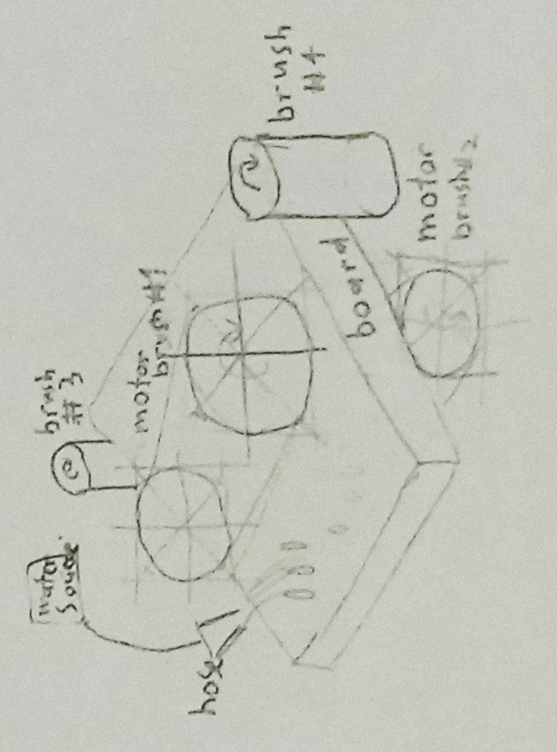
Figure 1.1. The Water Hose and Motor Brushes concept uses multiple motorized brushes to clean each edge of the board with a hose to provide water to aid in the cleaning process. Each brush can move back and forth along with the hose to fully clean all surfaces.

Drying Subsystem:

- Air Dry

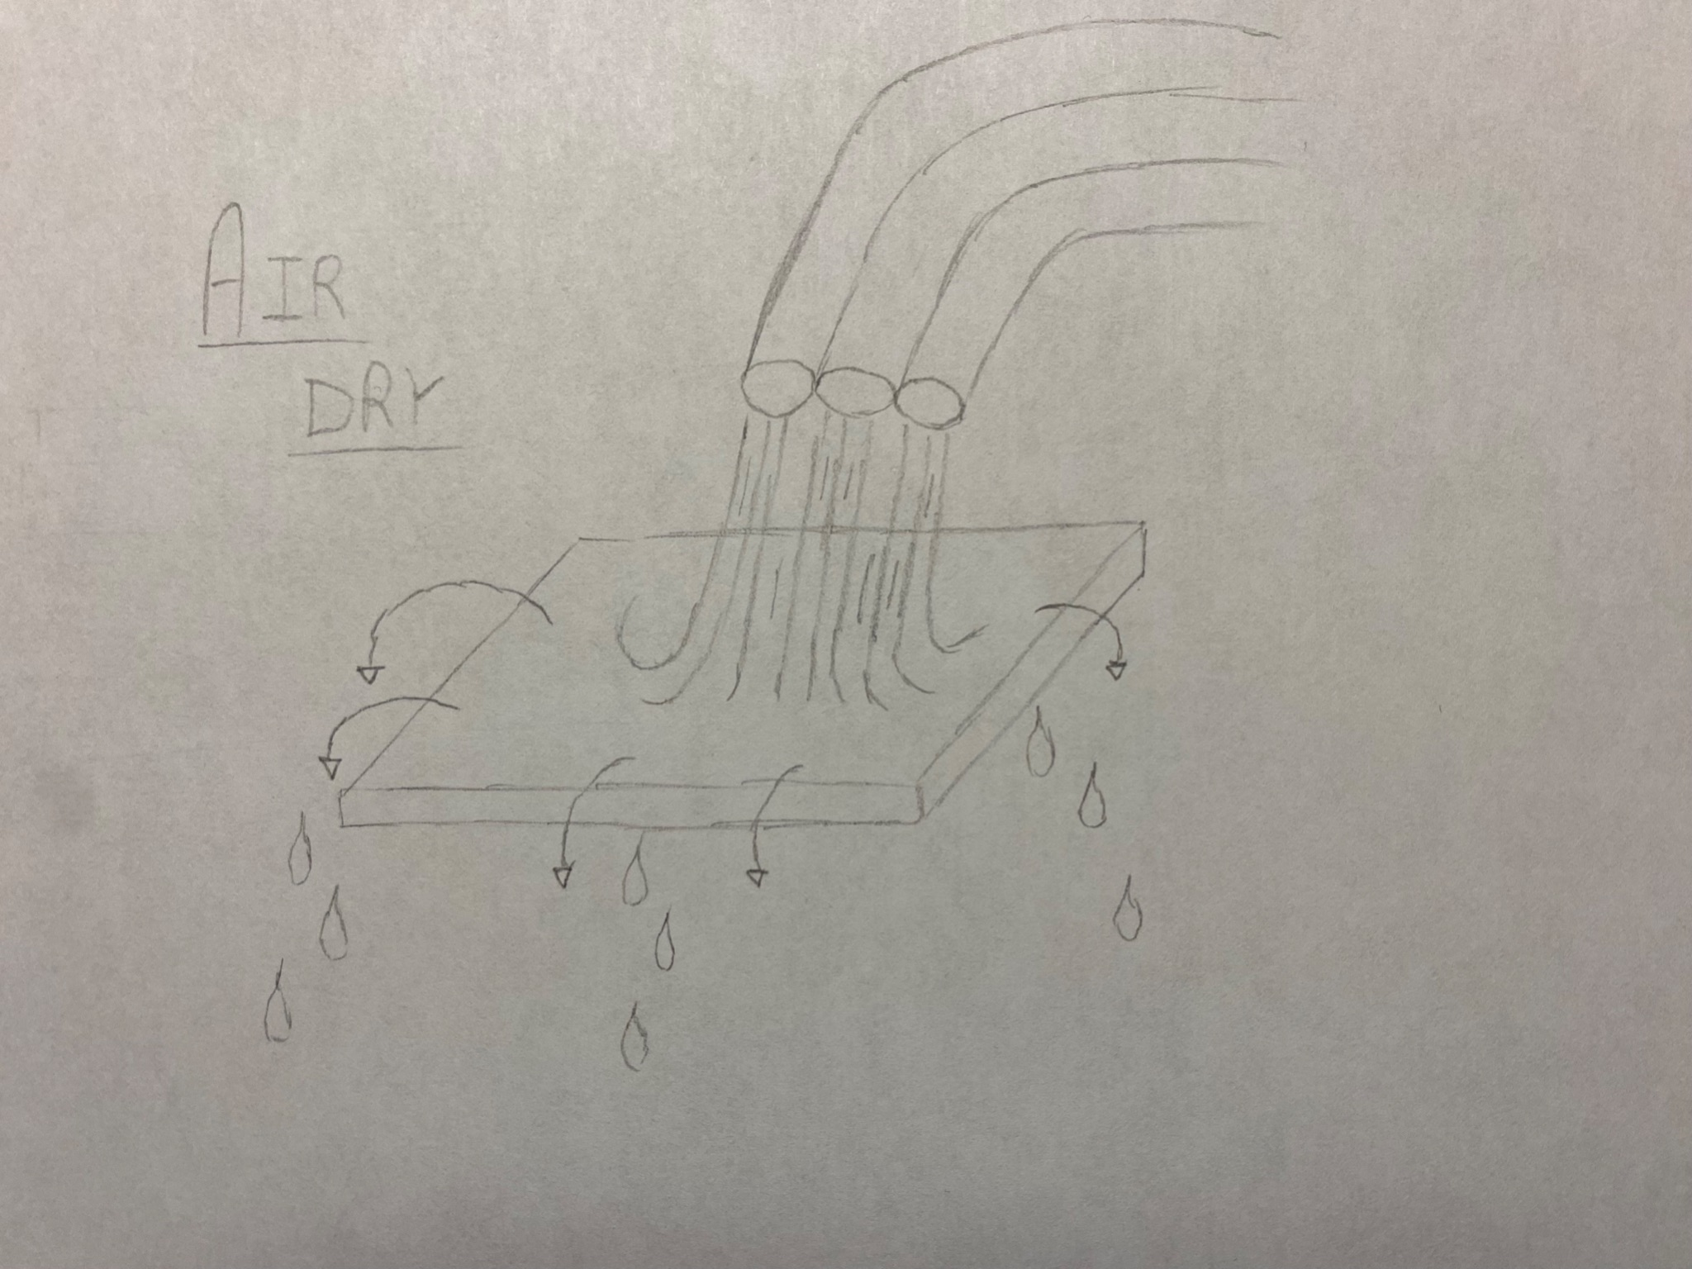
Figure 1.2. The Air Drying concept is designed for the machine to be able to dry the board (after having cleaned it) through airflow. It creates a current/breeze by blowing on it using some tubes that would be located above the board. This system pushes the water outside of the board and dries any water remaining which assures 100% dryness.

Frame/Movement Subsystem:

- Basic Box

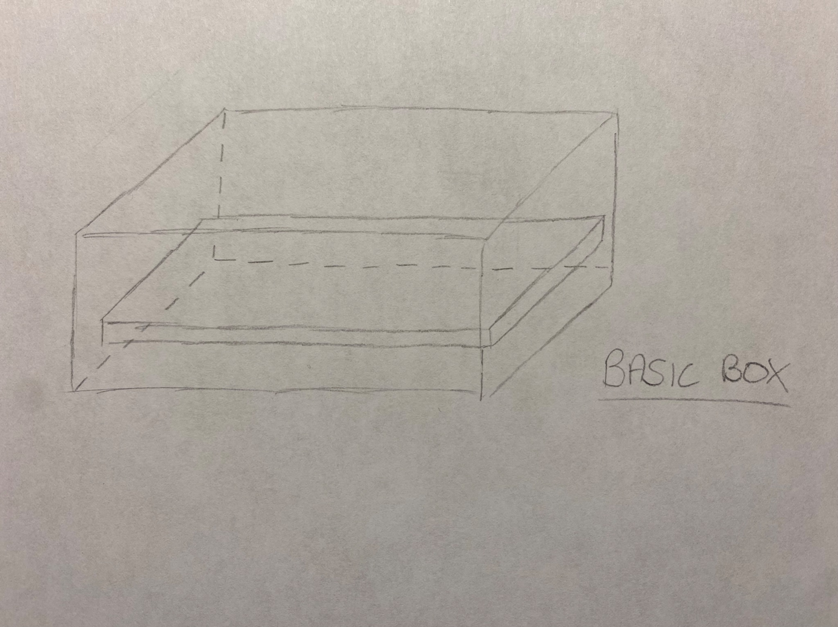
Figure 1.3. Basic Box Frame. To clean and dry it, the board will automatically (after the user finishes the whole algae growth process) be placed inside a metal or plastic box. All the water/products used to clean the board will be collected inside that box (after falling from the borders of the board) which will prevent mess and will provide an easy way to throw out these last.

II.II. Solution 2
Cleaning Subsystem:
- Rotating Brushes
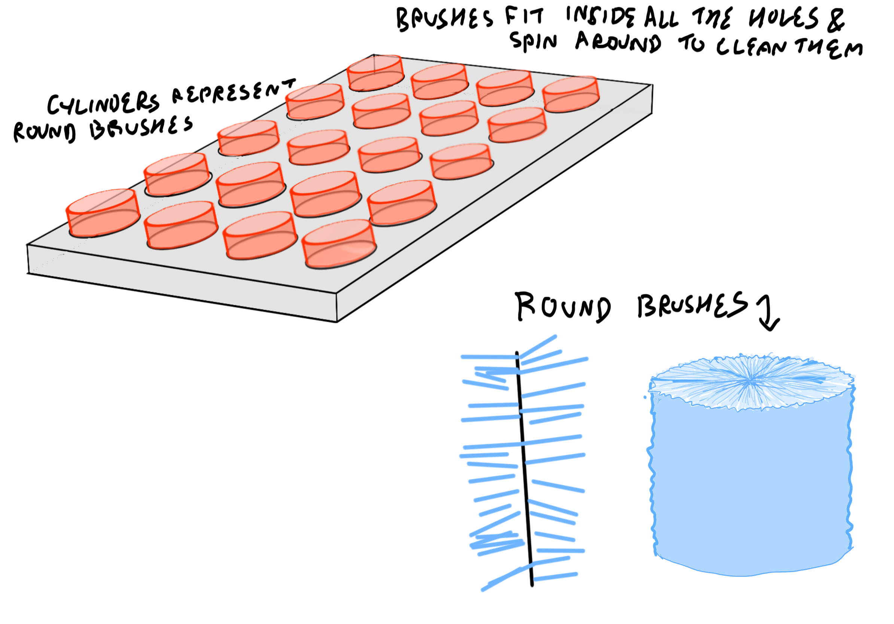
Figure 2.1. In the Rotating Brush concept, wet cylindrical brushes fit through the holes on the board and spin rapidly to remove the algae inside the holes. This is beneficial because the brushes are able to clean the areas that would be hard to reach for a typical cleaning system. The drawbacks of this cleaning system are that the brushes don’t reach the outer surfaces. This concept would have to be used in combination with another cleaning function.

Drying Subsystem:
- Vacuum Dry
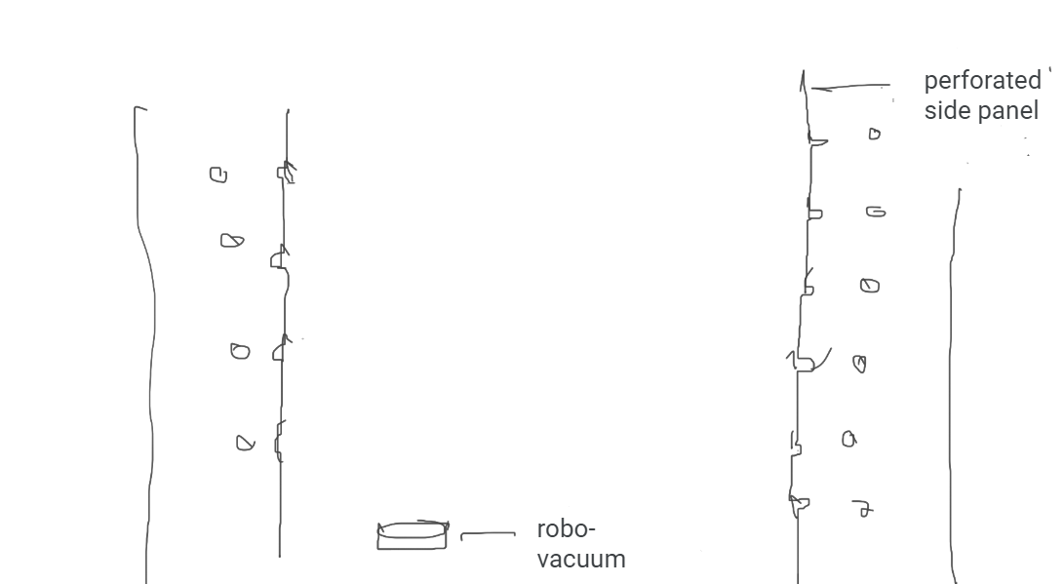
Figure 2.2. The Vacuum Dry concept uses a battery operated portable vacuum as well as cylindrical pumps within the side panels to collect algae and leftover debris.
Frame/Movement Subsystem:
- Conveyer Belt

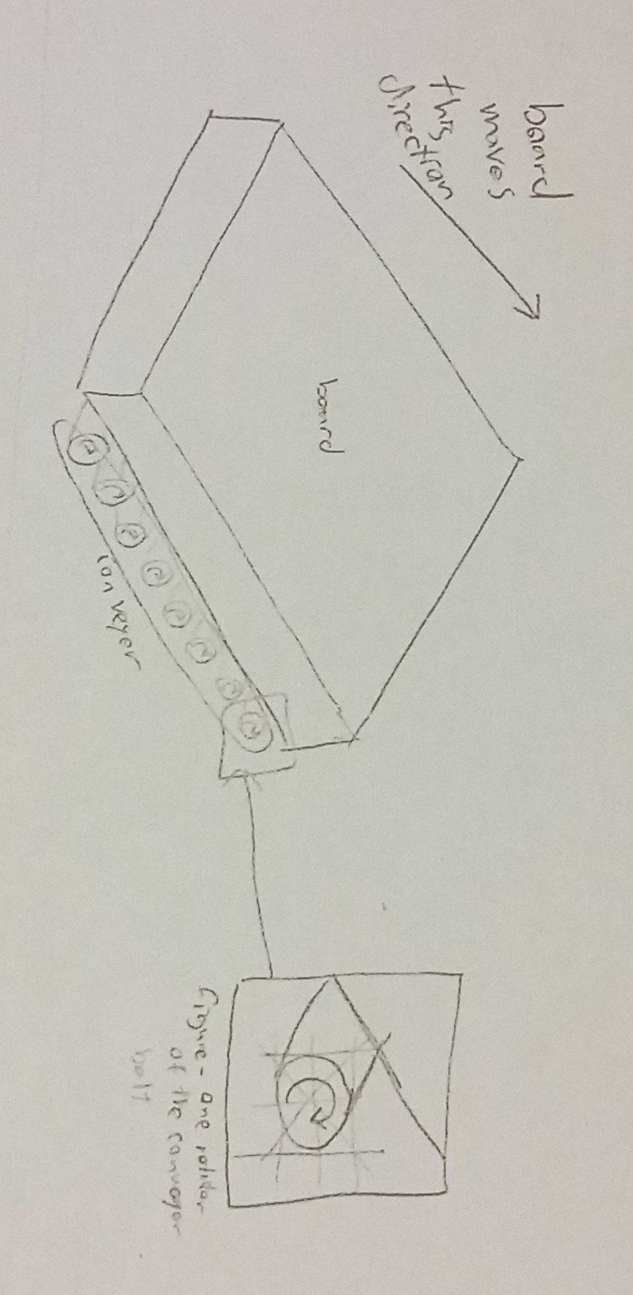
Figure 2.3. The Conveyor Belt concept uses 2 or more small motors around a belt to physically move the board from one side of the machine to another. This allows for the cleaning process to start at one end of a board and as the board moves the area being cleaned will change. There should also be some sort of area to place the boards at the start of the conveyor belt and to receive them once they reach the end of the board.

II.III. Solution 3
Cleaning Subsystem:
- Steam Cleaner and Squeegee
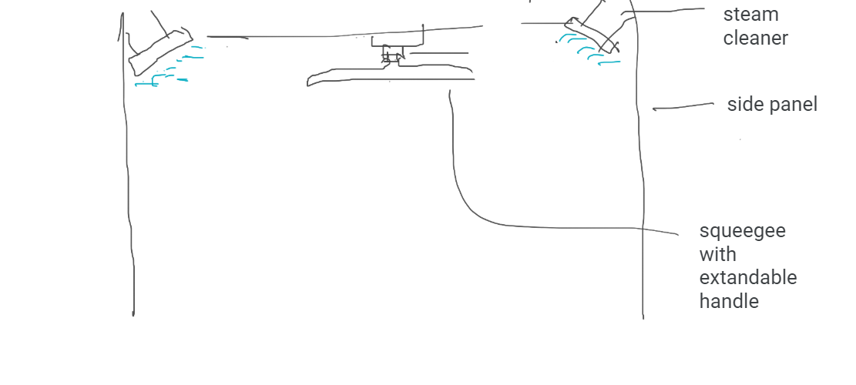
Figure 3.1. The Steam Cleaning and Squeegee concept is made of two tubes attached to the top left and right corners of a frame (respectively). Steam is released periodically from each tube. The steam is then wiped by a squeegee cleaner attached to the horizontal center of the top portion of the (rectangular or square) frame.

Drying Subsystem:
- Air Dry
As seen in Figure 1.2, the Air Drying concept is designed for the machine to be able to dry the board (after having cleaned it) through airflow. It creates a current/breeze by blowing on it using some tubes that would be located above the board. This system pushes the water outside of the board and dries any water remaining which assures 100% dryness.
Frame/Movement Subsystem:
- Rotating Platform
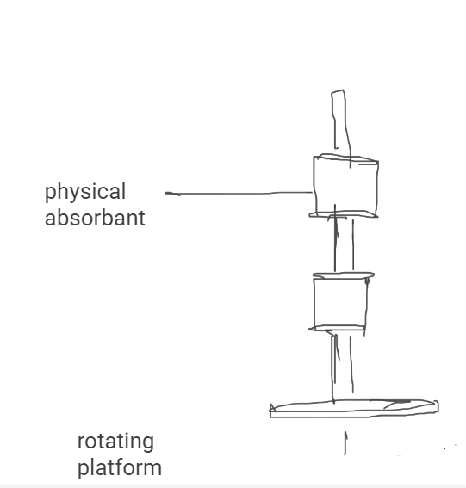
Figure 3.3. In this concept, the Rotating Platform rotates an horizontal plate with a vertical axle 360 degrees. On the axle, two physical absorbents made of a reusable material such as cotton are attached, similar to a lint roller. The platform is powered by an AC motor with a battery.

III. Concept Evaluation and Analysis
Below is a selection matrix composed of the prioritized design criteria in Project Deliverable B. This matrix is used to evaluate the performance of our three solutions against the functional and nonfunctional requirements to define the best global concept for a Hydroponic machine.
Table 2: Selection Matrix of Design Criteria for Hydroponic System

Design Criteria | Solution #1 | Solution #2 | Solution #3
Functional requirements
- Visually clean | 5 | 4 | 3
- Automated | 5 | 5 | 5
- Time to complete clean | 4 | 4 | 3
- Area of clean | ⁴ | 3 | 5
- Cleaning shape (2d, 3d) | 4 | 3 | 5
- Chemicals used | 5 (no chemicals used) | 5 (no chemicals used) | 5 (no chemicals used)
- Fail-safe (in case something wrong happens) | 1 (N/A) | 1 (N/A) | 1 (N/A)
- Dries after/during clean. | 4 | 3 | 4
Constraints
- Size | ⁵ | 3 | 2
- Power requirements | 4 | 2 | 2
- Change in pH of cleaned object. | 5 (no chemicals used) | 5 (no chemicals used) | 5 (no chemicals used)
- Backup plan for blackouts. | 2.5 | 1 (N/A) | 1 (N/A)
- Use of consumables | 4 | ⁵ | 4
Non-functional requirements
- Easy to use | ⁵ | 4 | 4
- Product life | 3 | 2 | 2
- Requires a specialist to repair | 3 | 3 | 2
- Cost | 4 | 3 | 1
Total Score (/85) | 67.5 | 56 | 54

Conclusions and Recommendations
After analyzing the selection matrix, we elected solution 1 (Section II.I) as our best global concept. One reason solution 1 was chosen was because it had a basic non-moving frame which allowed this solution to be the most compact and least power demanding. Another reason solution 1 was chosen was due to its cleaning subsystem being able to clean the most thoroughly in a time efficient manner. Finally, solution 1 has the least amount of moving parts which is reflected in its cost efficiency and ease of repair.

Solution 2 (Section II.II) had the benefit of using no water or steam unlike solution 1 and 3 but wasn’t chosen as it required a conveyor belt that made the solution larger and increased power usage.

Solution 3 (Section II.III) had the most thorough cleaning process of the three solutions but struggled due to the cleaning process being slower and the rotating platform increasing the size and power usage similar to solution 2’s conveyor belt.

Appendix

- Sketches and Designs for Alternate Concepts Not Included in the Solutions

A.1) Cleaning

- Submerged In Moving Water

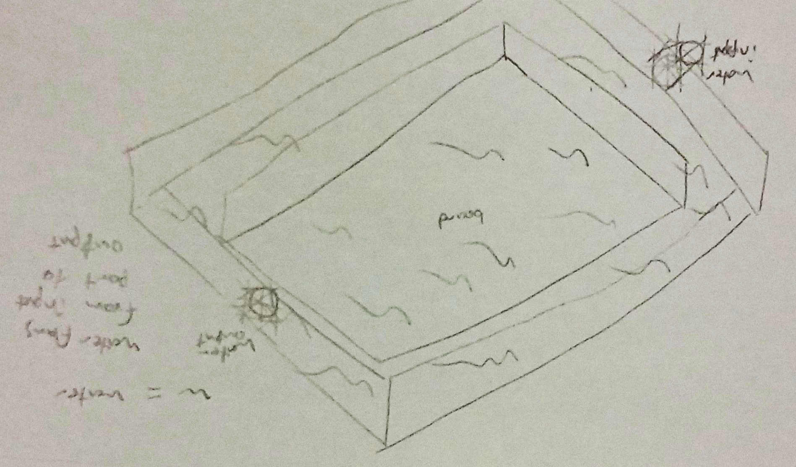
Figure A.1.1. Submerged in Moving Water. This concept has the frame of the board in a container of water with water flowing in from an input valve on one side to the output valve. As water flows quickly from one side of the container to the other this will remove the algae that builds up as the water pushes past the board. This process may take awhile as only the movement of water is involved in the cleaning process.

- Water Pressure
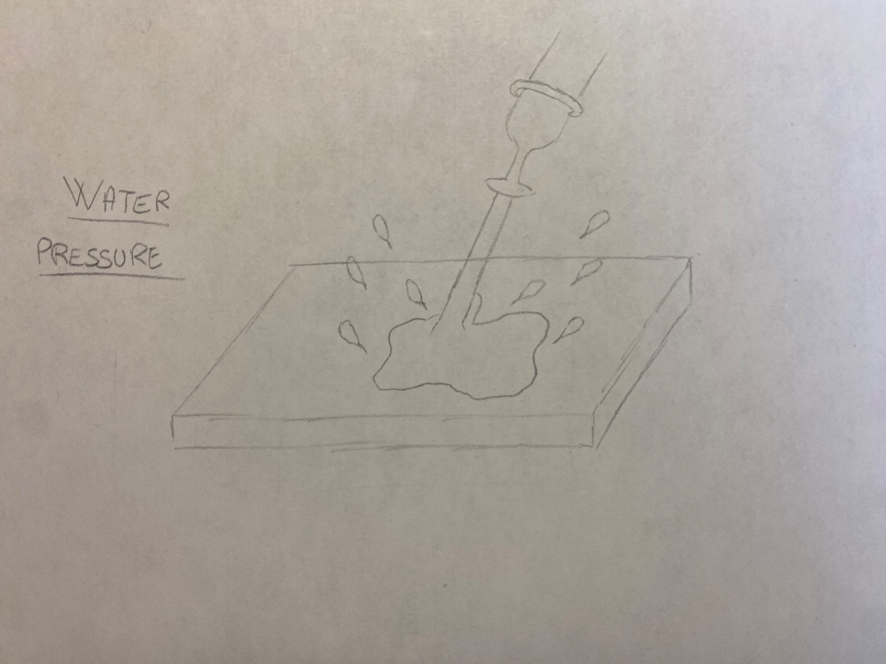
Figure A.1.2. Water Pressure. A classic way to clean the board, there would be a hose coming out of the machine that would spray water at high pressure. The pressure of this last could rinse off chemicals and other products, but the efficiency of it could be questioned. It is indeed an automated concept, but some parts might still be dirty, which would require physical scrubbing by the user, and the whole process might be messy.

- Snails

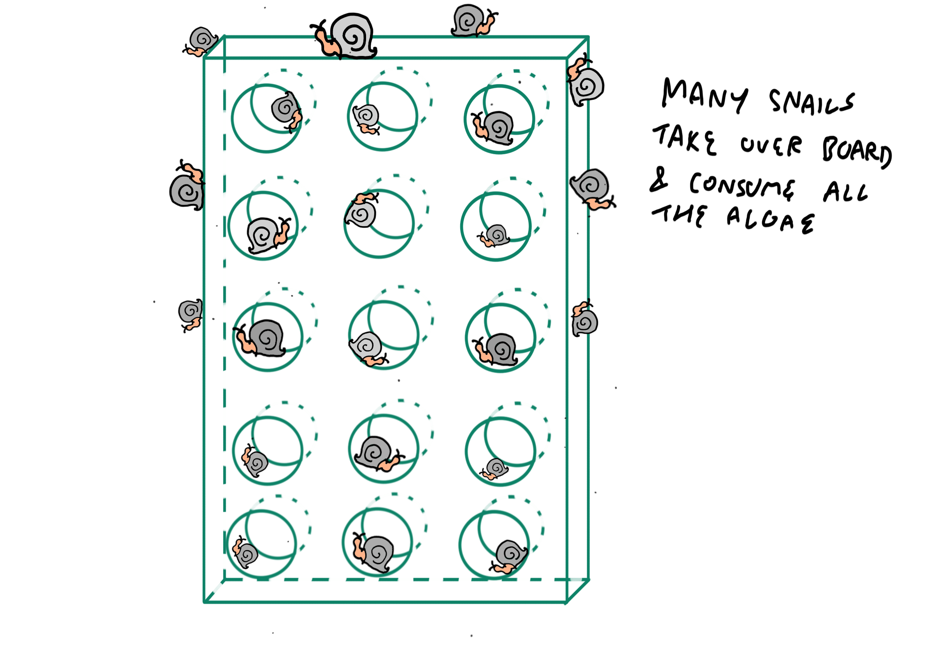
Figure A.1.3. Snail Cleaning. In this concept, the snails consume all the algae. The benefits of this are that it creates a symbiotic relationship between the snails and our rafts; the snails are fed and the rafts are cleaned. This adds to the environmentally friendly aspect of the hydroponics growing system. The drawbacks unfortunately are that it is slow and uncertain.

A.2) Drying

- Sun Dry

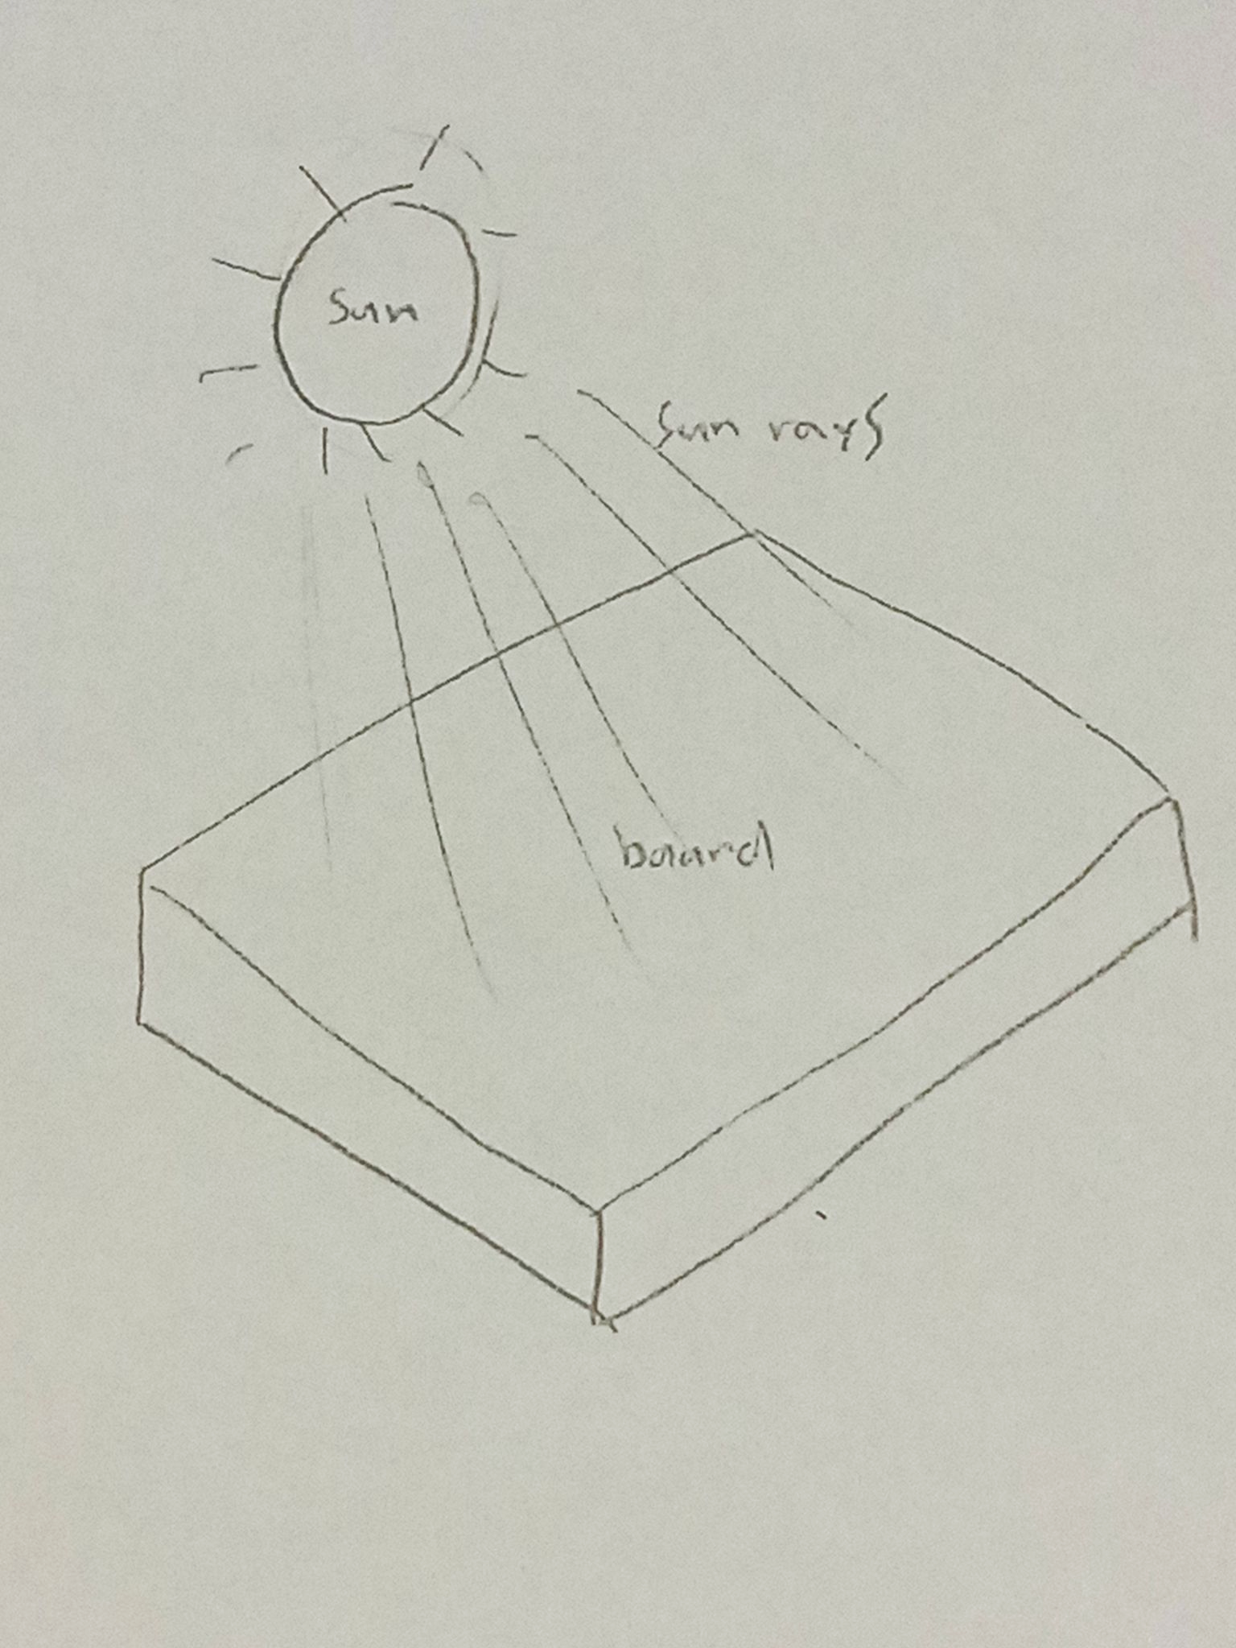
Figure A.2.1. Sun Drying is a very simple concept as all that is required is for the board to have a view to direct sunlight. The sun’s light could be replaced with a lightbulb that simulates the light's rays but either way the drying process is very simple but requires a lot of time until it is dried.

- Heat

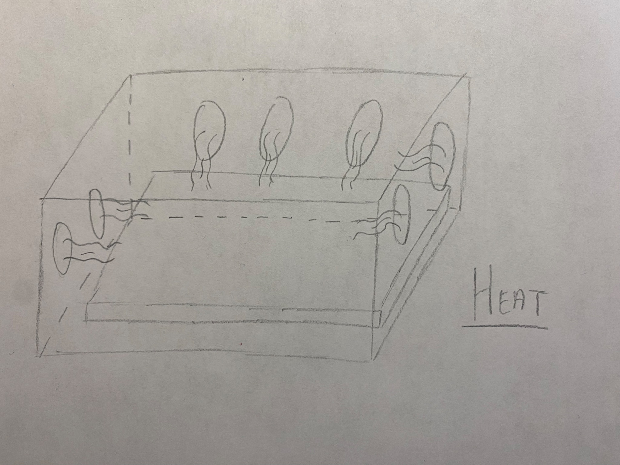
Figure A.2.2. Heat suggests that the machine would evaporate the water located on the board. Using a heating system where the board would be placed inside (like a box) is a very good idea, if it wasn’t for the fact that the heat could eventually wear out the board in a short period of time, if not damage it.

- Sponge
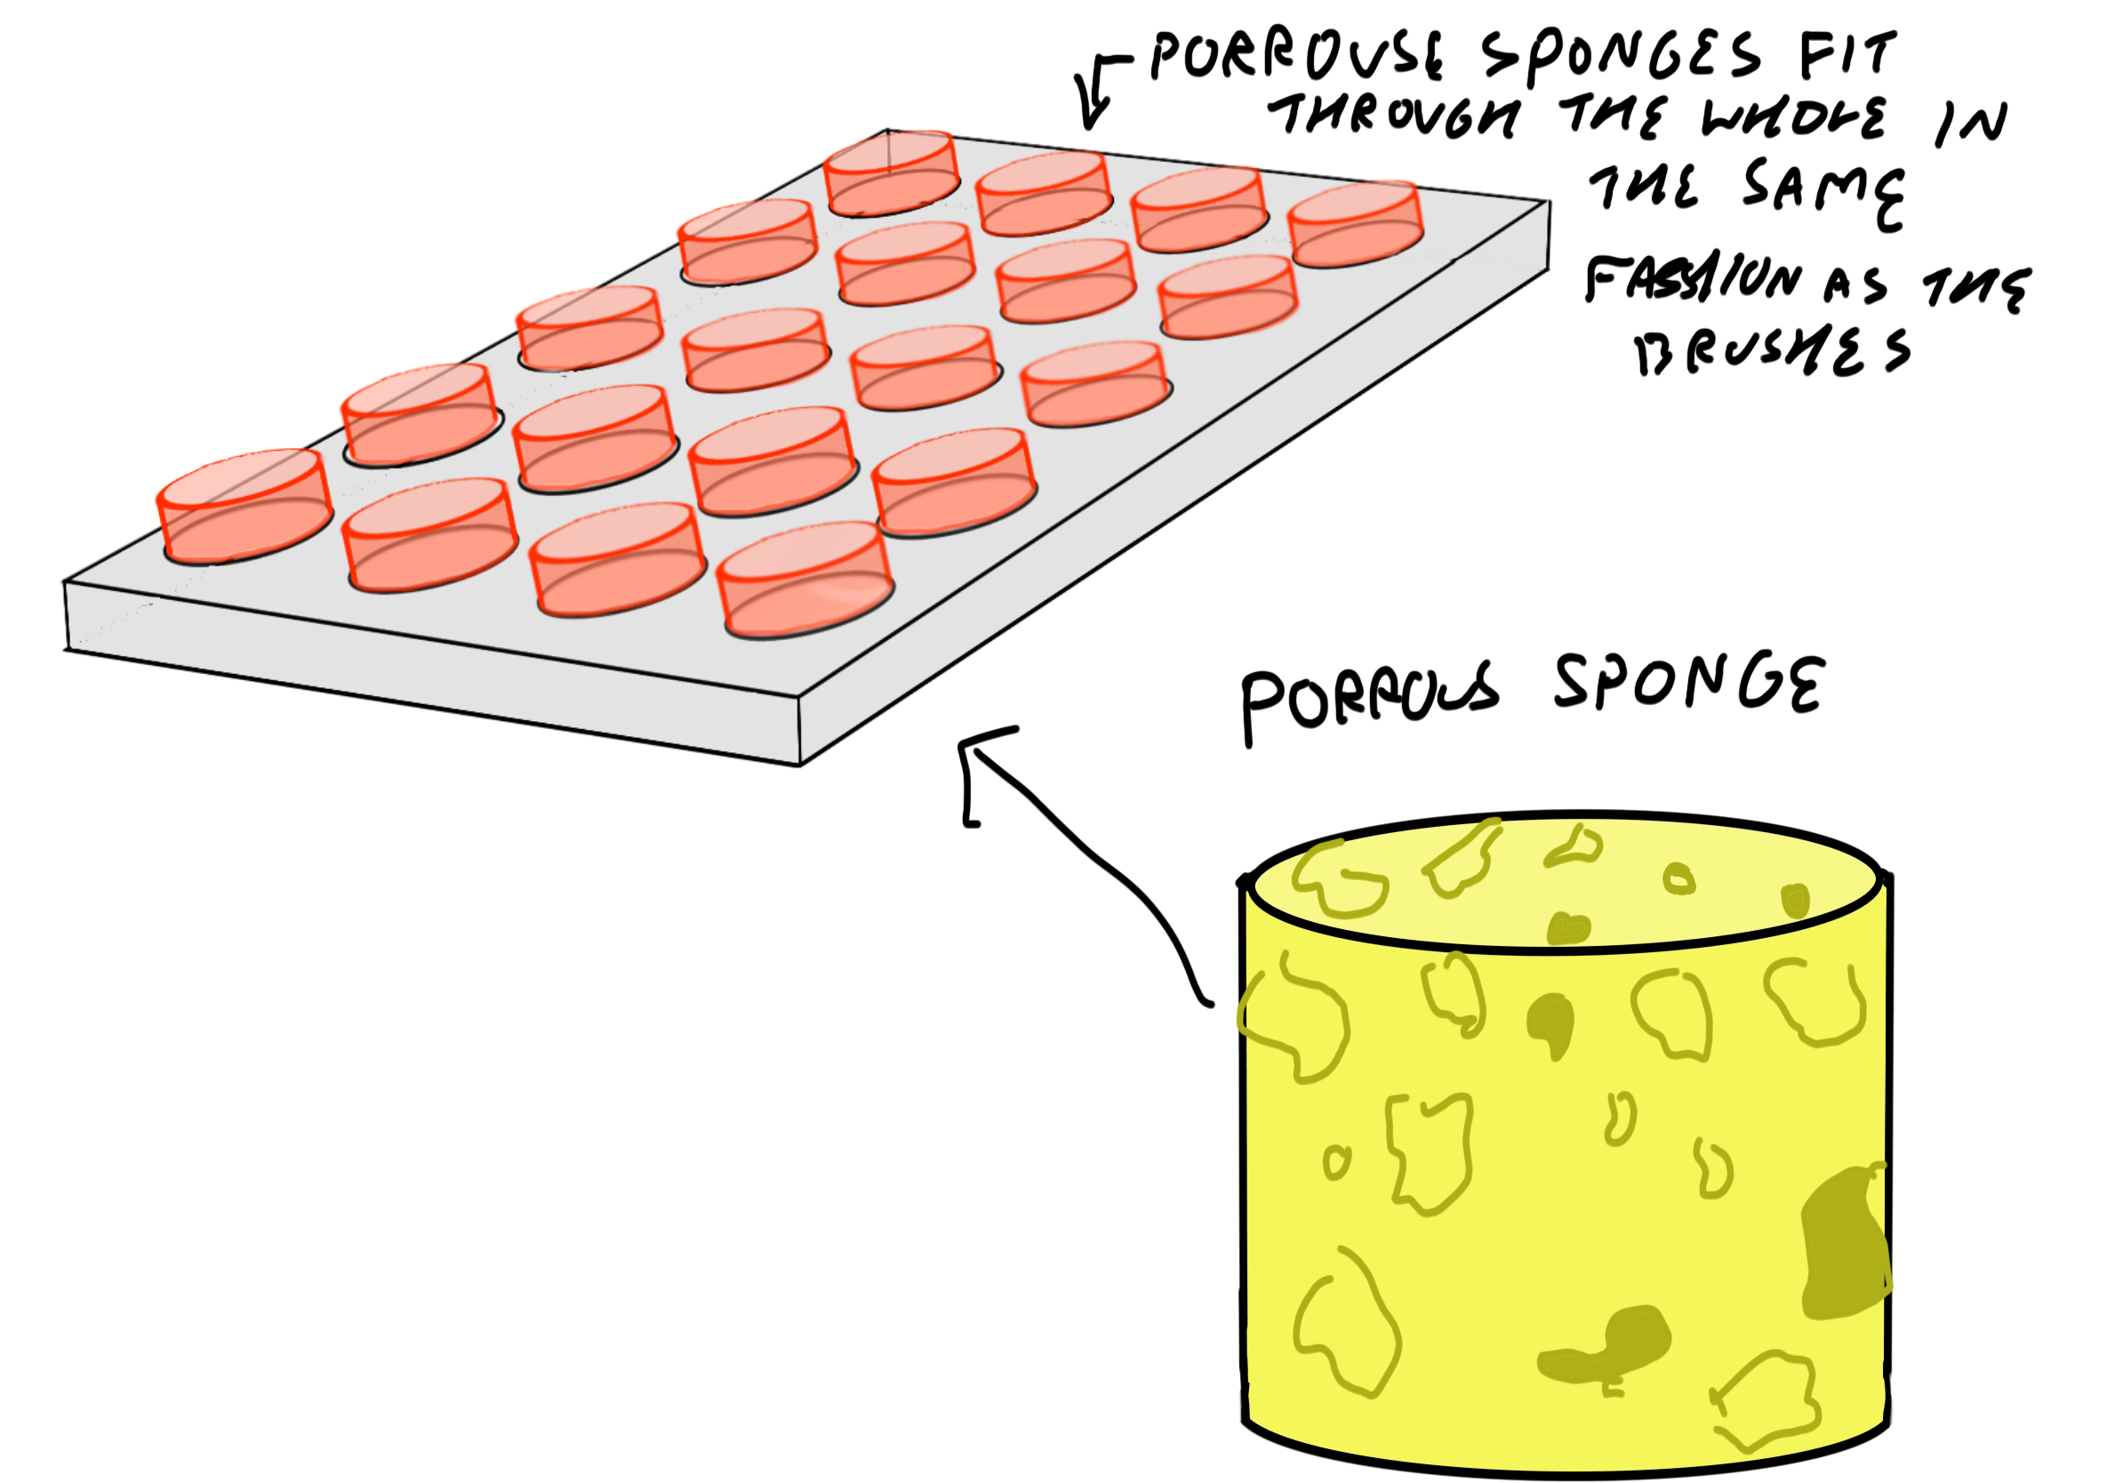
Figure A.2.3. Porous Sponge. Like the rotating brush function idea for the cleaning system, these sponges would rotate inside the holes in the board, absorbing the liquid. Once again, like the rotating brushes, the drawback is that it only focuses on one part of the board and thus would have to be used in combination with another drying function.

- Wipe

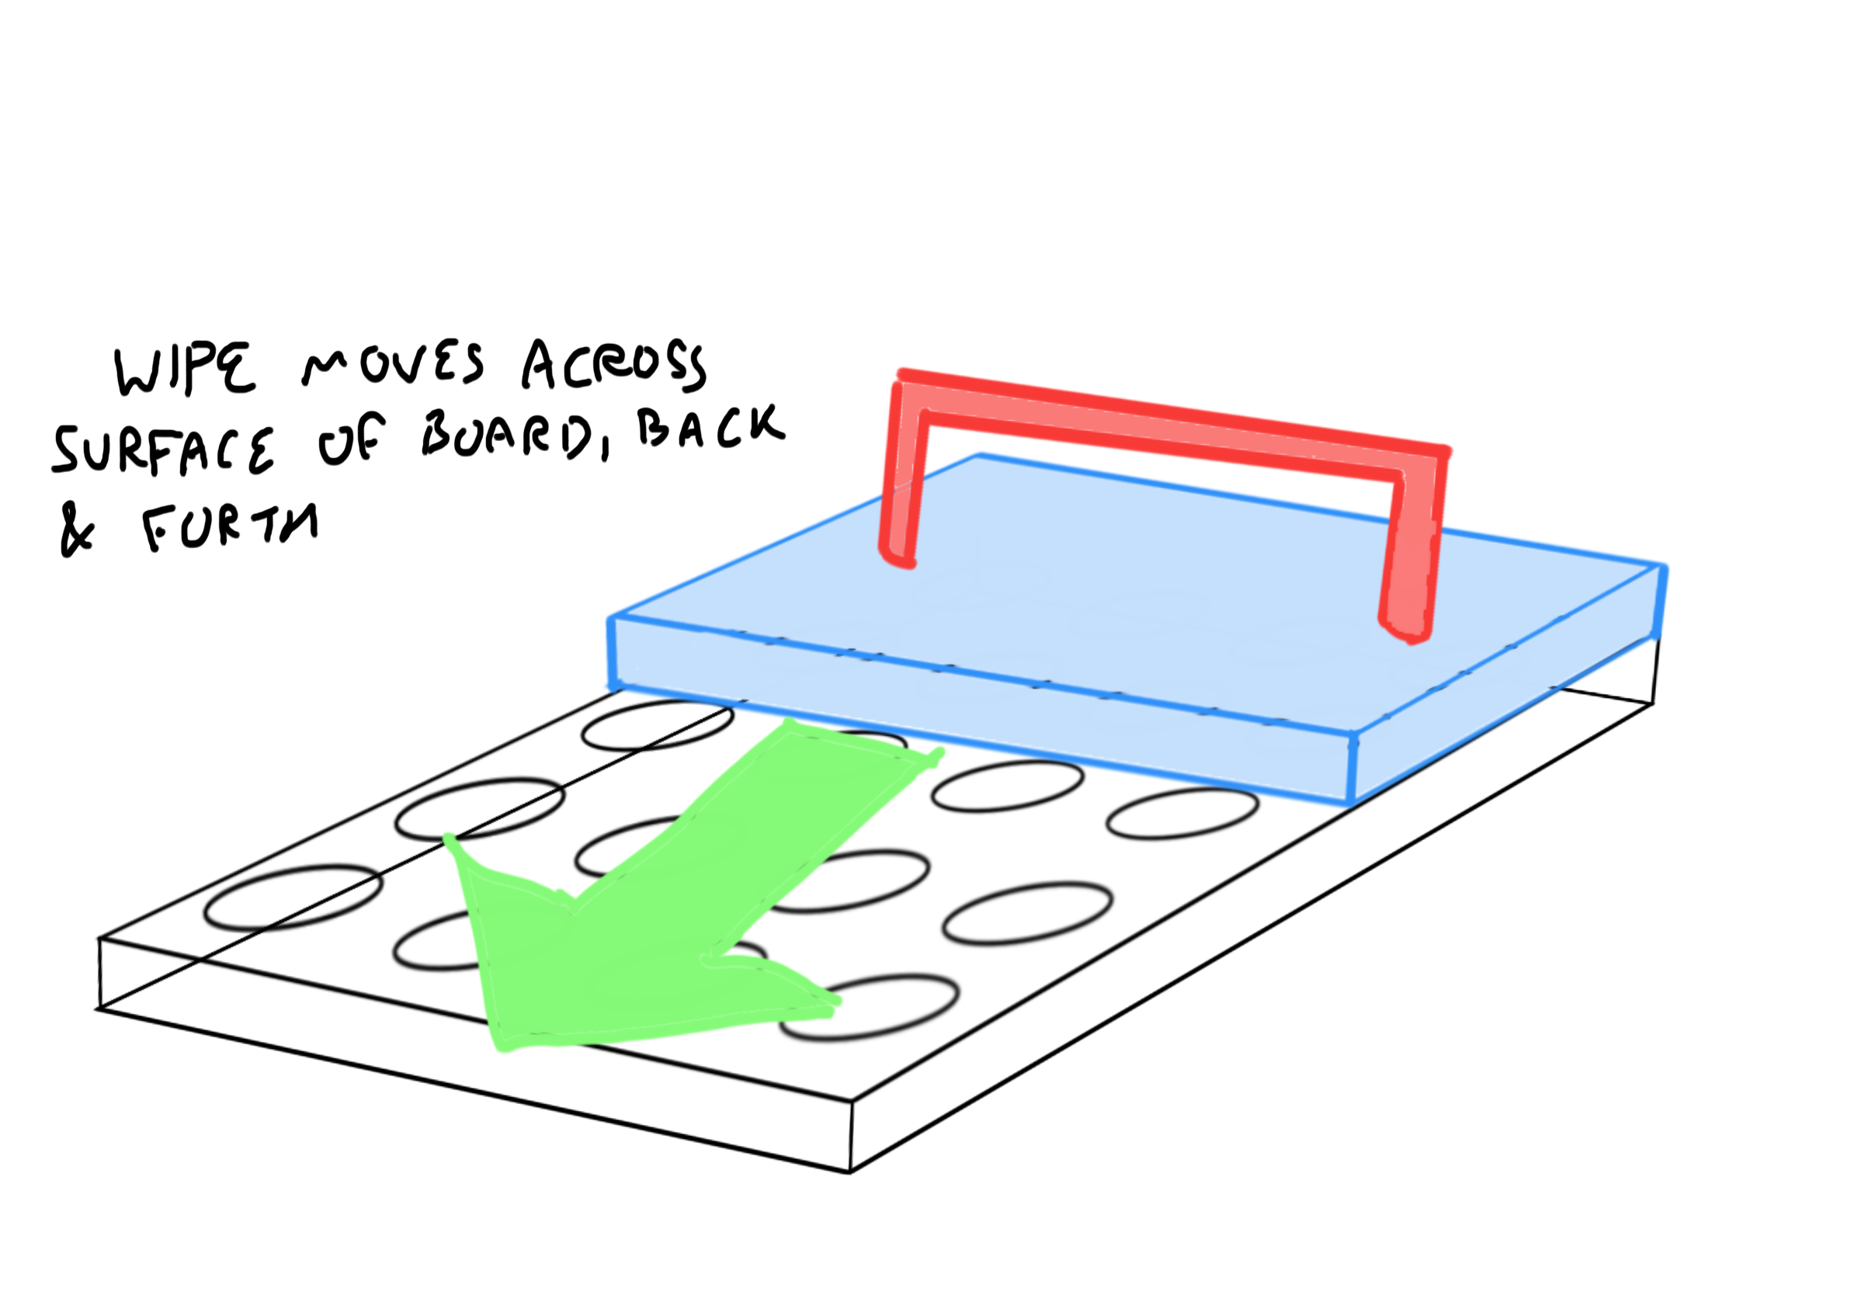

Figure A.2.4. Surface Absorbent Wipe. Simply moves across the board, absorbing the majority (but not all) liquid.

- Chemical Powder
Figure A.2.5. The Chemical Powder is released through holes within the metal frame. This absorbent powder is then collected by the robo-vacuum pictured, which has to be emptied every hour because of the volume of powder released. Inside the panels are canon style pumps which ensure that the powder does not stick to the side panels.

A.3) Frame/Movement

- Roomba (two versions)
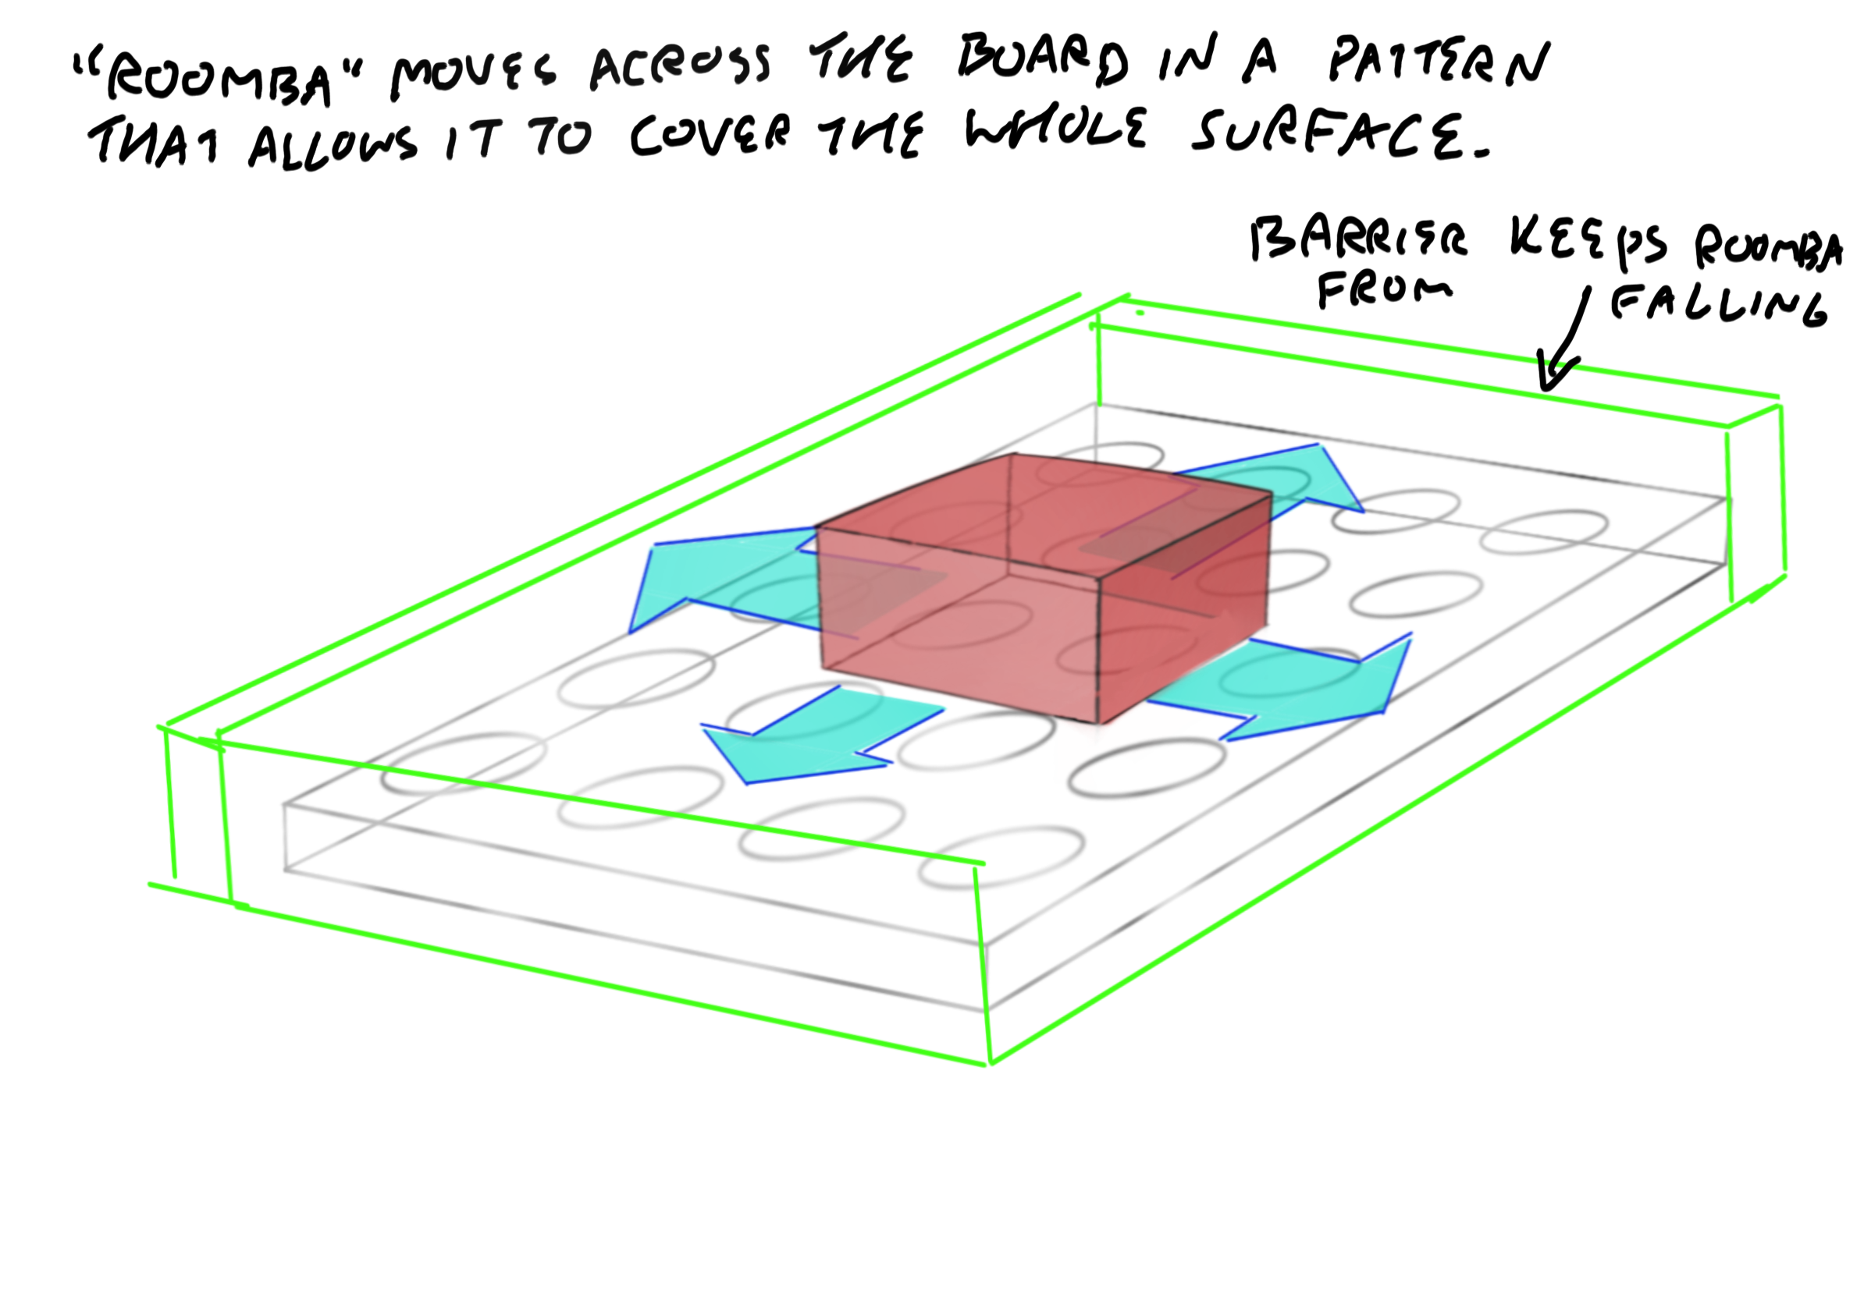
Figure A.3.1.1. Roomba (version one). Unlike the other possible frames, this frame is mobile where the board is stationary. Like a roomba vaccine cleaner, this cleaner would move around the board and clean accordingly.

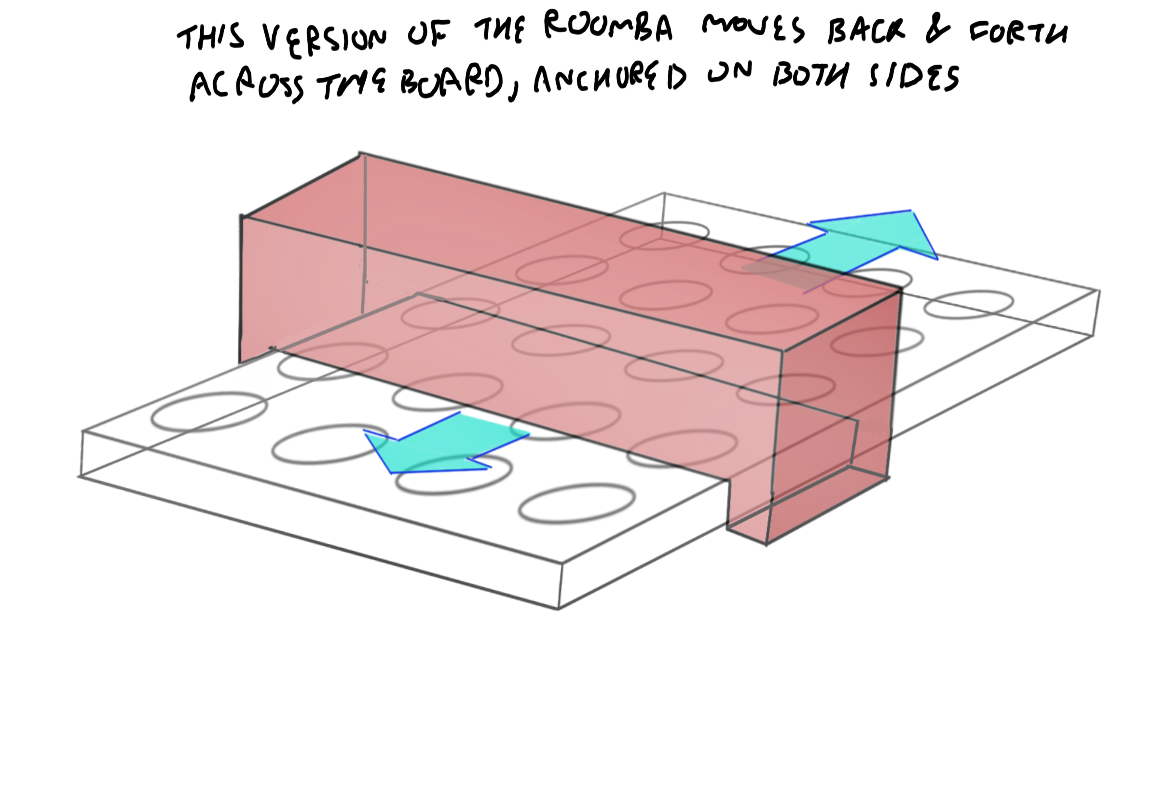
Figure A.3.1.2. Roomba (version two). Derived from the original roomba, this version permits less movement and has more coverage so would potentially be faster. Some of the drawbacks are that it doesn’t reach both ends.

- Rotisserie
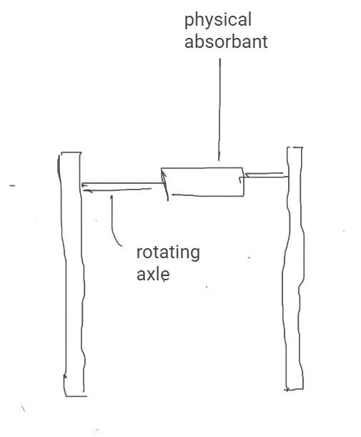
Figure A.3.2. The Rotisserie consists of a horizontal axle that rotates 360 degrees attached to two vertical stands. The axle is powered by a low voltage AC adapter attached to an electrical wall outlet.h

