GNG2101 Project Deliverable C:
Conceptual Design and Project Plan

Submitted by:
[Team Z24]

Hans Rao Ladkoo
Yunsu Lee
Sylvain Quach
Evan Tomietto

May 24, 2022

University of Ottawa

Abstract
This deliverable records the team’s concept generation, concept selection, and finalized conceptual design solution to the Seat Belt Guide problem presented by our client Clinton. Each member of the team generated their own three ideas, generating 12 unique concepts to rank and select from. Weighted decision matrices were developed and utilized to critique the designs based on their functionalities and practical sub-systems. The weighted decision matrices allowed the selection of an optimized final design, fulfilling the client’s needs and target specifications determined in Deliverable B.

Table of Contents
Abstract…………………………………………………………………………………………….i
Table of Contents………………………………………………………………………………….ii
List of Tables………………………………………………………………………...…………...iii
List of Figures…………………………………………………………………………………….iv
1: Introduction…………………………………………………………………………………….. 5
2: Functional Decomposition……………………………………………………………………... 5
3: Conceptual Ideas………………………………………………………………………………. 6
4: Concept Selection Process……………………………………………………………………. 16
5: Finialized Concept……………………………………………………………………………. 18
6: Conclusion……………………………………………………………………………………. 19

List of Tables

Table 1: Product Target Specifications…………………………………………………………..17

Table 2: Decision Matrix……………………………………………………………………...…18

List of Figures
Figure 1: Car Seat Belt System Diagram………………………………………………………….6
Figure 2: High-level Functional Decomposition of the Seat Belt Guide……………….…………6
Figure 3: Design Idea #1…………………………………………………………………………..7
Figure 4: Design Idea #2…………………………………………………………………………..8
Figure 5: Design Idea #3…………………………………………………………………………..8
Figure 6. Design Idea #4…………………………………………………………………………..9
Figure 7. Design Idea #5…………………………………………………………………………10
Figure 8. Design Idea #6…………………………………………………………………………10
Figure 9. Design Idea #7…………………………………………………………………………11
Figure 10. Design Idea #8………………………………………………………………………..12
Figure 11. Design Idea #9………………………………………………………………………..12
Figure 12. Design Idea #10………………………………………………………………………13
Figure 13: Design Idea #11………………………………………………………………………14
Figure 14. Design Idea #12………………………………………………………………………15
Figure 15: Final Conceptual Design……………………………………………………………..17

1: Introduction
To aid in the selection of the best possible conceptual solution to the client’s Seat Belt Guide problem, a plethora of hypothetical concepts were created. The Seat Belt Guide will be broken down into sub-systems through high-level functional decomposition in order for the concepts to be generated with the correct functionalities and to address all the client’s needs. Three concepts created by each of the four team members will bring a total of 12 ideas, which will then be assessed and ranked through weighted decision matrices to determine the best solution. The final concept will then be improved by the team through minimal tweaking and/or combining certain elements from the other concepts generated. The decision matrices will be developed based on the target specifications and client needs determined in Deliverable B. This will allow for an effective concept selection process and to reassess the final concept, ensuring optimally solves the client’s problem.

2: Functional Decomposition
This section will outline the male and female portions of the car seat belt system in order to more technically describe the functional decomposition of the Car Seat Belt Guide. The overall function of the seat belt guide system is to allow Clinton’s daughter with limited mobility and strength to reach the male part of the seat belt and guide it to its female counterpart on the other side, then finally providing the additional force necessary to clasp the two components together. Seen in the following figure, the male part of the seat belt is composed of the latch plate and webbing, which rests in line with the pillar loop and retractor. The female counterpart is the buckle, positioned on the other side of the car seat.
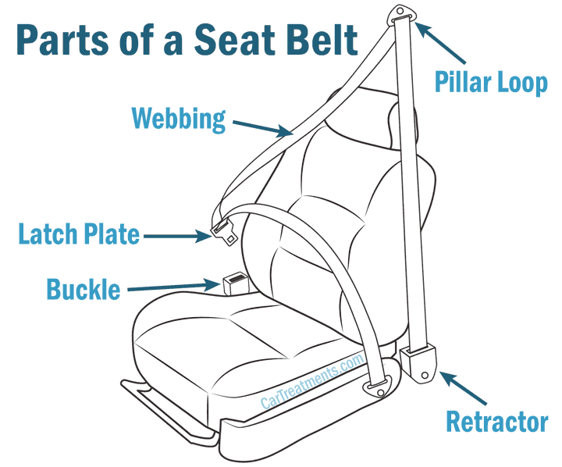
Figure 1: Car Seat Belt System Diagram

The functional decomposition of the Car Seat Belt Guide is as follows: Secure the male (latch plate/webbing) and female (buckle) parts, move the male part towards the female part, clasp the two together, and finally easily remove the product from the car seat.

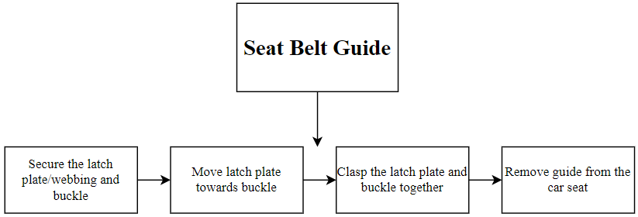

Figure 2: High-level Functional Decomposition of the Seat Belt Guide

3: Conceptual Ideas
Sylvain’s Ideas
Design Idea #1
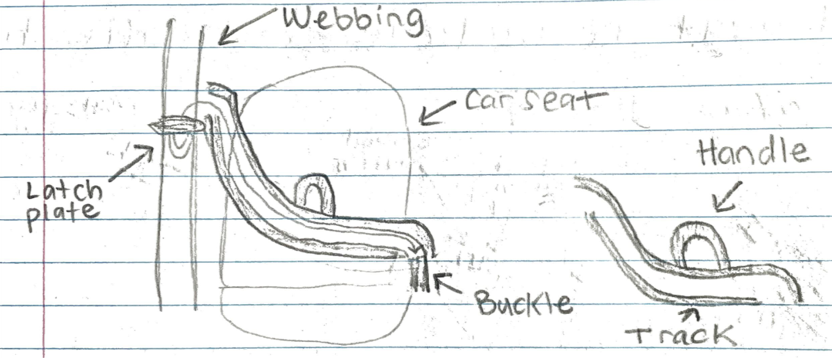
Figure 3: Design Idea #1

This concept involves a track fitted onto both sides of the car seat. One end of the track is positioned where the latch plate and webbing resides, and the other end is positioned right where the buckle is. The track can also be held securely by the handle in the middle, allowing the user to provide even more stability. The latch plate is then inserted into the track and then pushed along the curve of the track, allowing it to make its way to the buckle. This concept allows the user to easily secure the male and female parts and to bring the two closer to clasp them together, all of which can be achieved with minimal mobility and strength.

Design Idea #2
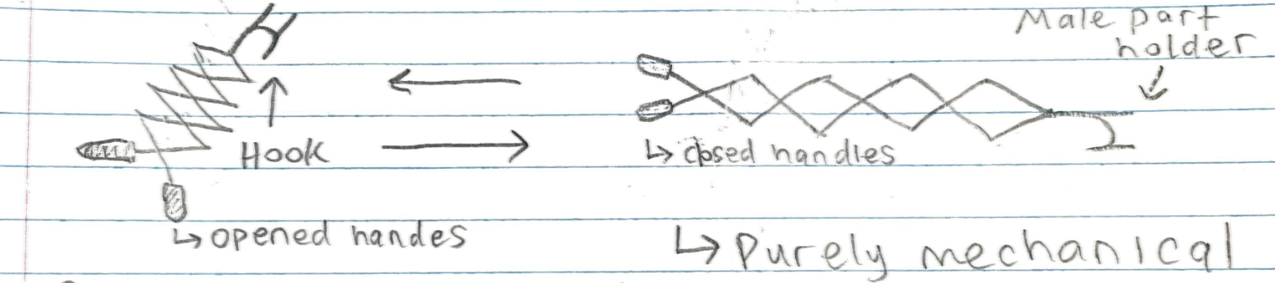
Figure 4: Design Idea #2
This concept involves a purely mechanical hand-held arm. This arm can be retracted by opening the handles, and extended by closing the handles, due to its scissor link system seen in the figure above. The hook would be used to extend and grab the webbing of the seat belt, containing the latch plate also. The latch plate would then be within reach of the user once the arm was retracted, allowing them to place it into the male-part-holder of the arm to finally extend the arm again towards the buckle, clipping the two parts together.

Design Idea #3
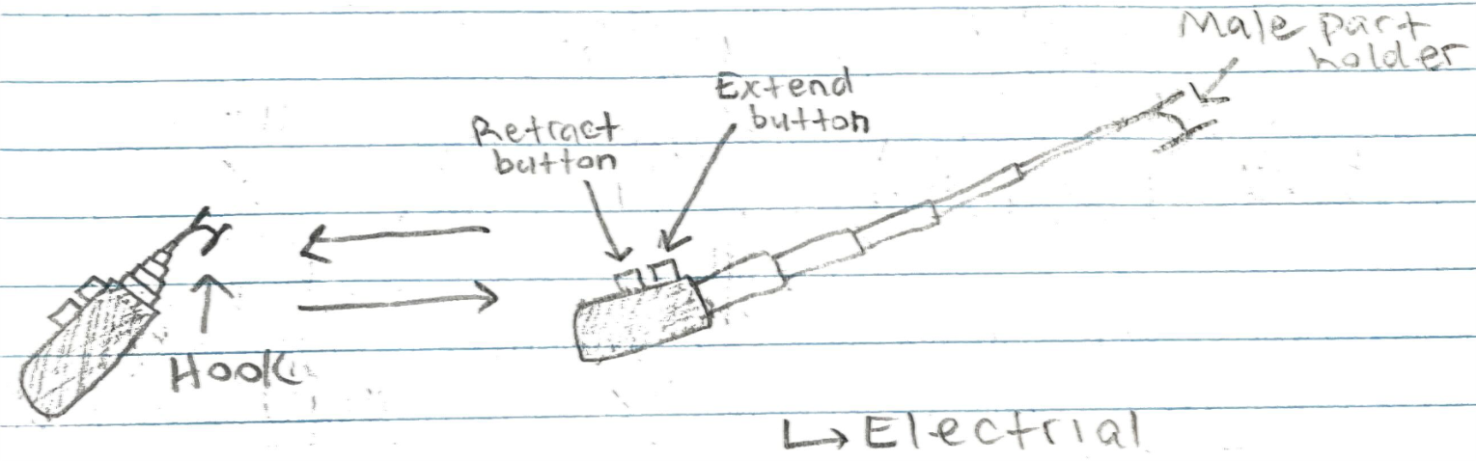
Figure 5: Design Idea #3

The concept is similar to the previous concept, however this arm is powered through electricity. The arm can be retracted and extended by its corresponding buttons. The hook would be used to extend and grab the webbing of the seat belt, which also contains the latch plate. The latch plate would then be within reach of the user once the arm was retracted, allowing them to place it into the male-part-holder of the arm to finally extend the arm again towards the buckle, clipping the two parts together.

Evan’s Ideas
Design Idea #4
Would be on both male and female parts of the seat. As the male part approaches the female part, the handles will interlock. To attach the male and female parts, pull on both buckles (with little force). This will make it easier to bring the male part to the female part while also making it easier to attach the seat belt itself.
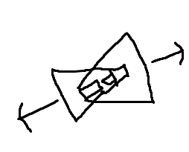
Figure 6. Design Idea #4

Design Idea #5
Small extendable hook that would grab onto a latch on the male part of the seat belt by magnetism making it easier to pull down with little force. The back part would attach to the female part and there would be a button on the hook that would shrink it which would bring the male and female parts of the seat belt together.
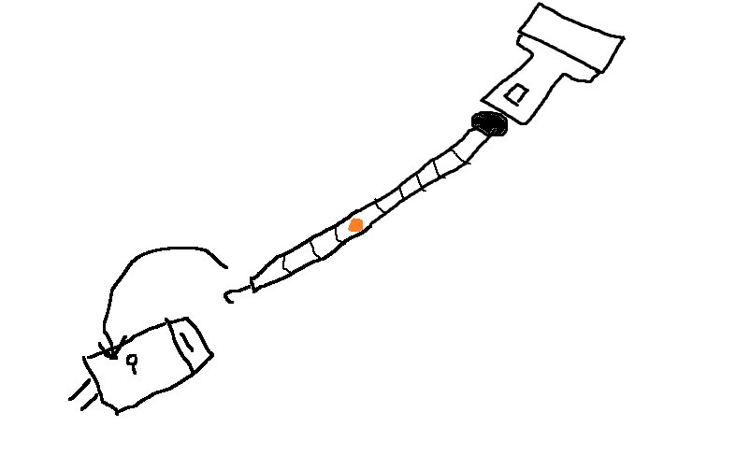
Figure 7. Design Idea #5

Design Idea #6
Extendable ramp that would come out of the female part of the seat belt which would help guide the male part to the female part. There also would be a hook on the female part of the seatbelt that would guide the belt along the track
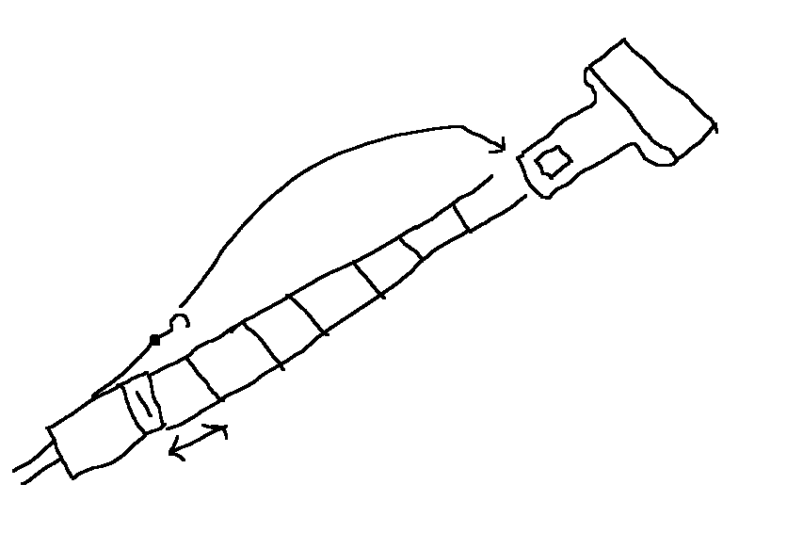
Figure 8. Design Idea #6
Hans’s Ideas
Design Idea #7
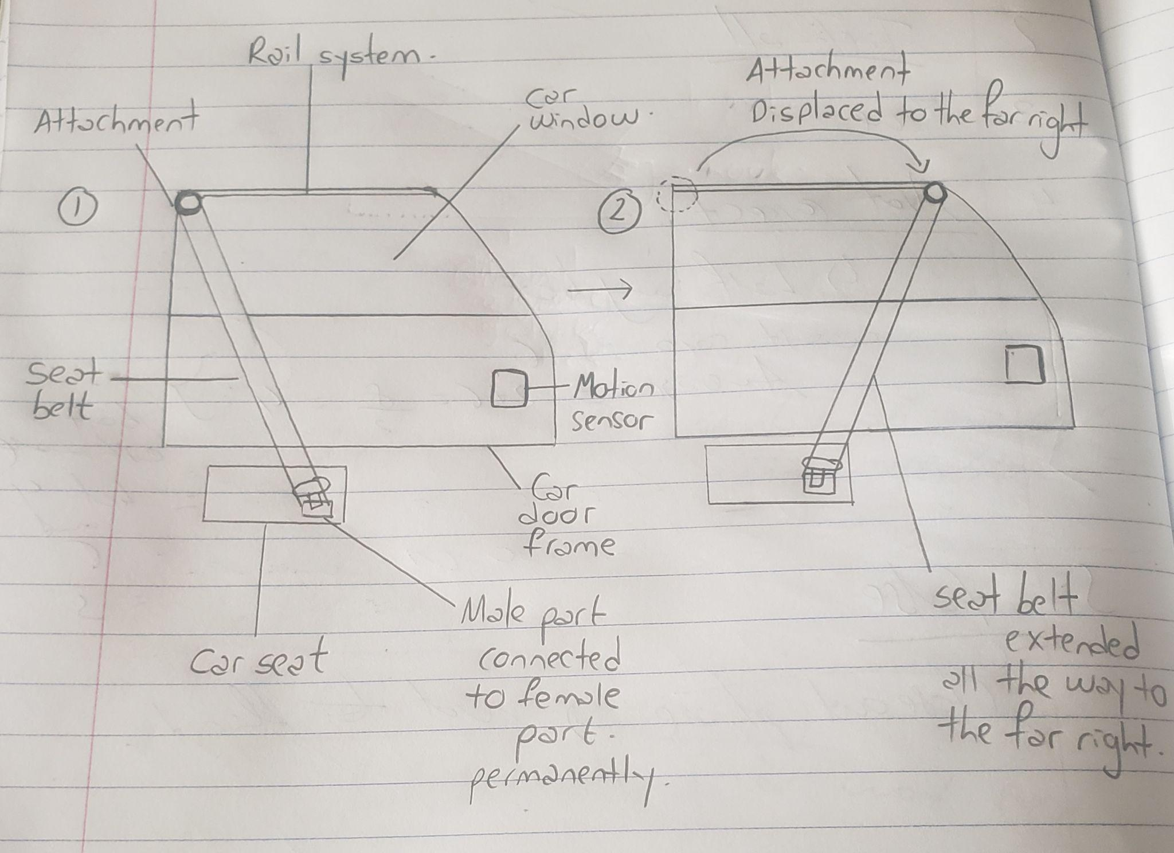
Figure 9. Design Idea #7

This idea is based on the male part of the seat belt being always permanently connected to the female part. When the passenger car door opens, the motion sensor fitted to the car’s door frame detects this motion and this causes the attachment to displace all the way to the right on the rail system, freeing the space for the person to sit. Once the latter sits and closes the door, the motion sensor detects that motion again and the attachment comes back to its initial position.

Design Idea #8
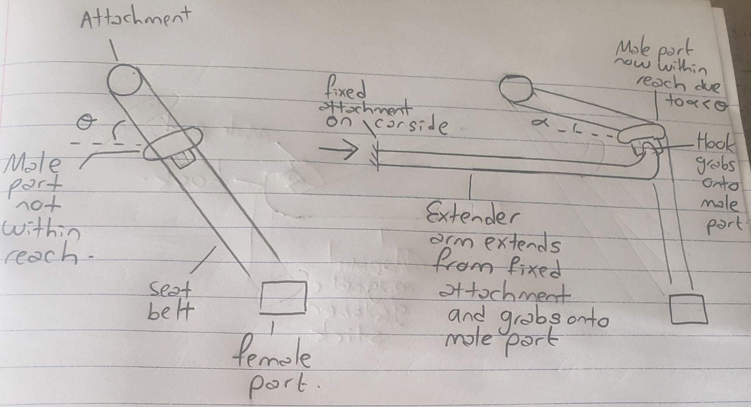
Figure 10. Design Idea #8
When the engine turns on, the extender arm extends from the fixed attachment on the car side and hooks onto the male part thereby making it more accessible for the person to reach and connect it to the female part.

Design Idea #9
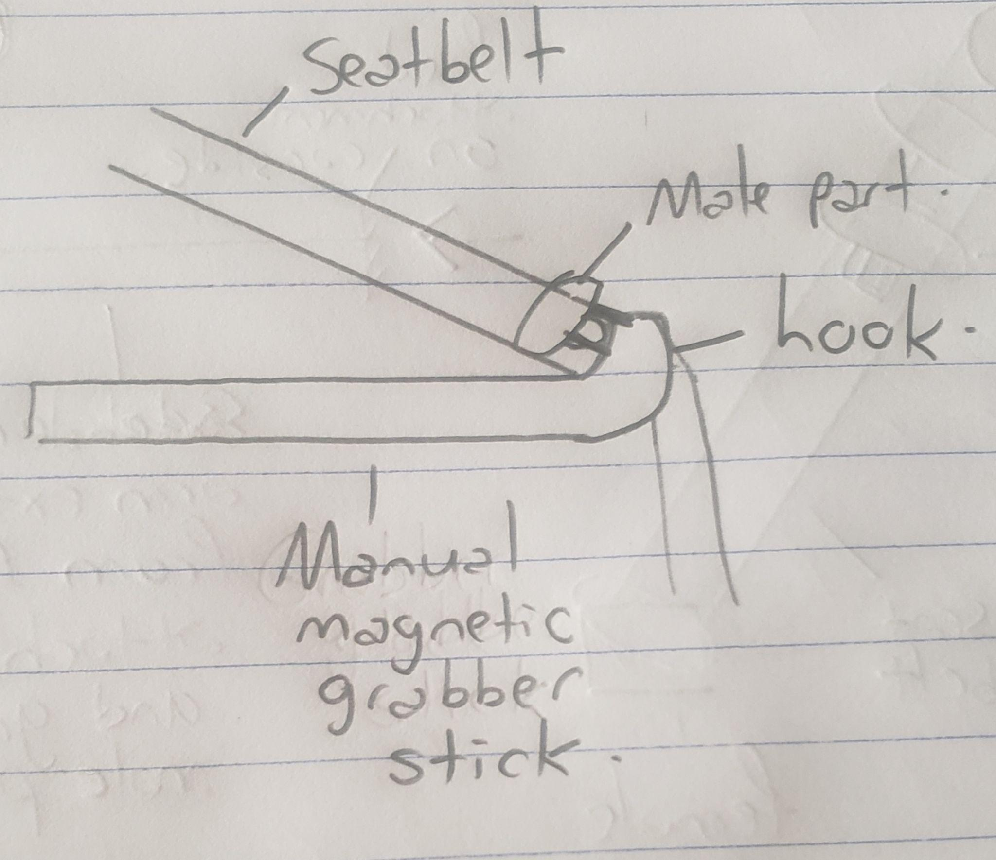
Figure 11. Design Idea #9

This is a modified version of design idea #8 but it is manual. It is also magnetic and hence requires less force to hook onto the male part and connect to the female part, making it more efficient than the regular seat belt strap available on the market.

Yunsu’s Ideas
Design Idea #10

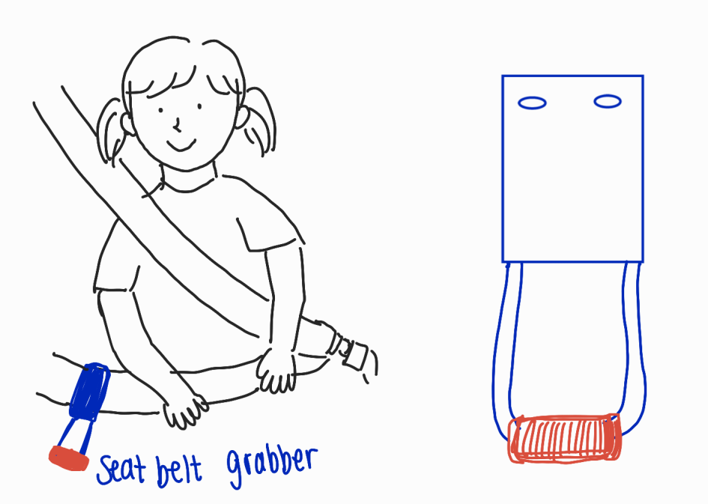
Figure 12. Design Idea #10

This seat belt grabber can be attached around the seatbelt and will give you extra 5-8 inches of reach. Its entire body is made with sturdy rubberized resin, which gives its flexibility and durability. The handle is made with rubber foam so that it gives you more surface area for comfortable grip without slipping. It does not disrupt the normal operation and function of the seatbelt.

Design Idea #11
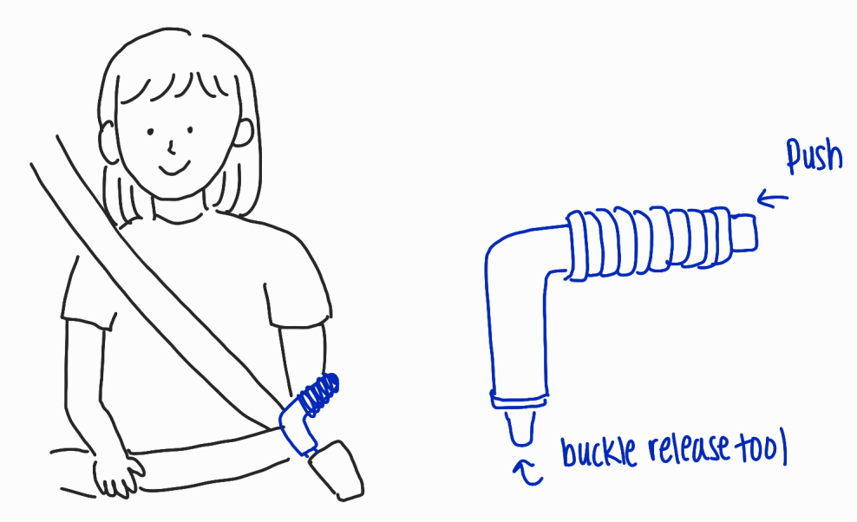
Figure 13: Design Idea #11

This seat belt extender is very similar to the product “JIMMY” from Veigel company. It is clamped to the male part of the buckle, and you can easily reach the handle and pull it to the female part of the buckle. The body is hard plastic and the handle is rubber foam, which provides a comfortable grip. When you push the button at the end, a buckle release tool will disengage the buckle. You do not need much force to unbuckle the seatbelt, which will be great for people with reduced strength.

Design Idea #12
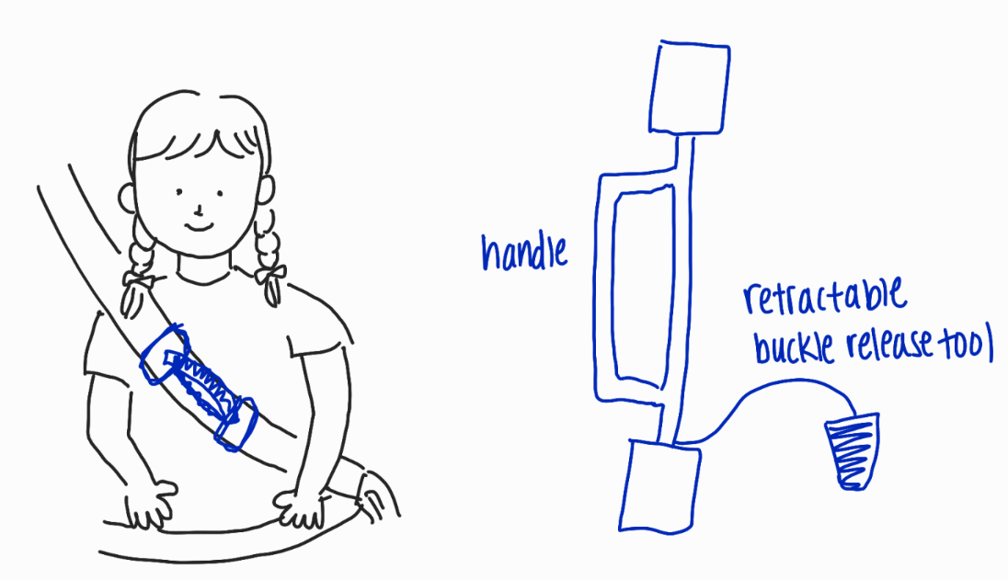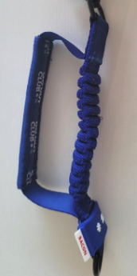
Figure 14. Design Idea #12

This concept design is similar to the first idea but provides more support with its handle. You can easily reach for the handle and pull the male part to the female part of the buckle. It also has a retractable buckle release tool so that the users can unbuckle the seatbelt with much less force. It can be used for people in all age groups and also for people with similar disabilities. It is also a universal design for any car model.

4: Concept Selection Process
The target specifications determined in Deliverable B will be used in the following section in order to evaluate the generated concepts. The decision matrix will compare all the concepts based on the most important target specifications, allowing the concepts to be graded and ranked against each other (1 as the lowest and 5 as the highest score). This concept selection process with the decision matrix will allow the team to determine the most optimal finalized Seat Belt Guide concept.

Table 1: Product Target Specifications

# | Design specifications | Relation | Value | Unit | Verification Method
Functional Requirements
1 | Extra reach for both the female and male parts | = | Yes | N/A | Test
2 | Additional force/pressure provided by the product to pull and clasp the components together | = | Yes | N/A | Test
3 | A guide/track to allow the male part to follow a path towards the female part to be clipped in. | = | Yes | N/A | Test
4 | Does not hinder the safety of the user nor cause any discomfort during use | = | No | N/A | Test
5 | Does not disrupt the normal function of the seatbelt | = | No | N/A | Test
Constraints
6 | Cost | ≤ | 50 | $ | Analyze
7 | Weight | ≤ | 400 | g | Estimate
8 | Length | < | 30 | cm | Estimate
9 | Width | < | 5 | cm | Estimate
10 | Operating Conditions | = | -40 to 60 | $℃$ | Test
Non-Functional Requirements
11 | Quick Installation Time | < | 5 | minutes | Test
12 | Durability | = | Yes | N/A | Test
13 | Aesthetics | = | Yes | N/A | Test
14 | Product life | > | 10 | years | Test
Table 2: Decision Matrix
Concept No. | Reach | Extra Force | Guide / Track | Safety / Comfort | No interference | Cost | Weight | Volume | Usability | Total
1 | 5 | 4 | 5 | 3 | 5 | 3 | 4 | 3 | 5 | 37
2 | 4 | 3 | 4 | 4 | 5 | 3 | 3 | 3 | 3 | 35
3 | 5 | 2 | 4 | 4 | 3 | 3 | 2 | 2 | 3 | 30
4 | 3 | 3 | 2 | 3 | 5 | 5 | 4 | 5 | 3 | 33
5 | 5 | 3 | 4 | 3 | 5 | 3 | 4 | 4 | 3 | 34
6 | 5 | 4 | 4 | 3 | 4 | 4 | 3 | 5 | 3 | 35
7 | 4 | 4 | 4 | 5 | 4 | 3 | 2 | 3 | 2 | 33
8 | 4 | 3 | 4 | 3 | 5 | 2 | 5 | 4 | 3 | 33
9 | 5 | 4 | 4 | 3 | 4 | 2 | 5 | 5 | 4 | 36
10 | 3 | 2 | 2 | 4 | 5 | 5 | 4 | 3 | 2 | 30
11 | 4 | 4 | 2 | 2 | 5 | 4 | 3 | 4 | 2 | 29
12 | 5 | 4 | 2 | 4 | 5 | 4 | 3 | 4 | 3 | 34

5: Finialized Concept
Figure 15: Final Conceptual Design
Concept Idea #1 was chosen as the final concept with a score of 37 (Table 2). This design fulfills the client’s needs: it has attachments to both the male and female parts of the seatbelt to provide extra reach. The product provides the additional force to pull and clamp the components together. Customers can use a guide to follow a path toward the female part to be clipped in and allows the seatbelt to perform its original function without undermining safety. The design is universal and can be installed in any vehicle. The material of the product, dimensions, and installation procedure will be discussed in the next group meeting.

6: Conclusion

In this deliverable, the functional decomposition of the Car Seat Belt Guide was analyzed to better understand the practical ways of achieving the client's needs. Next, twelve conceptual ideas were generated and analyzed by the team members. Each design was evaluated based on the Product Target Specifications that were determined in Deliverable B. Concept Idea #1 was chosen as the final design, and the details of the design, such as the type of material, dimensions and installation procedure, will be specified after the second client meeting.

