GNG2101 Project Deliverable D:
Detailed Design, Prototype 1, BOM, Peer Feedback
and Team Dynamics

Submitted by:
[Team Z24]

Hans Rao Ladkoo
Yunsu Lee
Sylvain Quach
Evan Tomietto

May 29, 2022

University of Ottawa

Abstract
This deliverable overviews the steps and details involving the creation of the first Seat Belt Guide prototype. A preferable conceptual design created by each of the individual group members were chosen for a total of four concepts presented and evaluated by the client. One concept was then chosen by the client for further feedback and development of the team design. The first prototype was then created based on prototype assumptions and client feedback. Testing was performed after a main function was established and results were evaluated for possible future improvements. Finally, the team compiled a bill of materials to prepare for the construction the next refined prototype and planned for the next client meeting.

Table of Contents
Abstract……………………………………………………………………………………………………... i
Table of Contents…………………………………………………………………………………………... ii
List of Tables……………………………………………………………………………………………… iii
List of Figures……………………………………………………………………………………………... iv
1: Introduction……………………………………………………………………………………………… 5
2: Second Client Meeting Overview……………………………………………………………………….. 5
2.1 Client Feedback……………………………………………………………………………………. 5
2.2 Updated Concept…………………………………………………………………………………... 9
3: Prototype 1……………………………………………………………………………………………... 11
4: Third Client Meeting Preparation……………………………………………………………………… 15
5: Bill of Materials………………………………………………………………………………………... 15
6: Conclusion……………………………………………………………………………………………... 16
References………………………………………………………………………………………………… 16

List of Tables
Table 1: Prototyping and Testing Plan……………………………………………...………
Table 2: User Feedback………………………………………………...………………..
Table 3: Bill of Materials…………………………………………………………………

List of Figures

Figure 1: First Benchmarked Product……………………………………………………
Figure 2: Second Benchmarked Product……………………………………………….
Figure 3: Concept #4………………………………………………………………………
Figure 4: Child/Booster Car Seat…………………………………………………………
Figure 5: Updated Concept Idea…………………………………………………………
Figure 6: Updated Concept Idea #1 with Dimensions…………………………………
Figure 7: Concept Sketch #2………………………………………………………………
Figure 8: Standard Selt Belt Width Dimension……………………………………………
Figure 9: Prototype 1………………………………………………………………………
Figure 10: Buckle Booster………………………………………………………………
Figure 11 & 12: Prototype #1 Testing………………………………………………………

1: Introduction
The client is in need of a product/solution that will allow his daughter with arthrofibrosis, causing her to experience limited strength and mobility, to secure herself in a standard 3-point car seat belt on her own. The team translated the client’s needs, functionally decomposed the product into smaller subsystems, and chose four different conceptual designs to present to the client for additional evaluation. The team will take note of the client’s feedback, allow the client to determine his preferred concept, and allow the client to provide advice on what other elements he would like to see in the developing prototypes; the team will use these suggestions to update the original product design to better fit the client’s vision. Critical prototype assumptions will be determined, in order for the prototype to be developed to test for these assumptions. The group will also define the objective of the prototype, provide self performed feedback, and determine future improvements to be made. Finally, the team will prepare what to discuss and present for the next client meeting and also develop a bill of materials based on the next iteration of the prototype.

2: Second Client Meeting Overview

2.1 Client Feedback
During the second client meeting with Clinton, the team presented the Seat Belt Guide’s problem statement, client needs, existing products used for benchmarking, target specifications, and finally the conceptual designs. Clinton expressed that the problem statement, client needs, and target specification fully met his expectations, confirming it was a good basis to begin the prototyping process for the Seat Belt Guide. Regarding the benchmarked products, Clinton preferred the sizing and reach provided by the first benchmarketing product, but confirmed that the second benchmarking product aligned more with the solution he envisioned, as it provides a solid handle for his daughter to reach, grab, and guide the male part of the seat belt to its female counterpart.

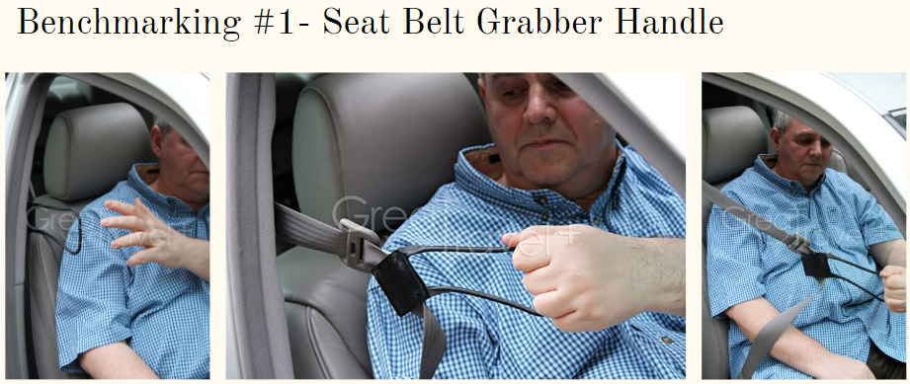
Figure 1. First Benchmarked Product

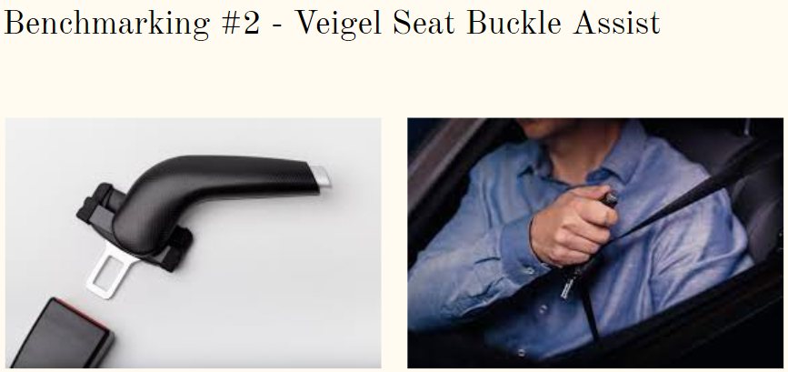
Figure 2. Second Benchmarked Product

Regarding the conceptual designs, Clinton chose concept #4 for further development. Clinton appreciated the extra reach provided by the concept, as well as providing a large and ergonomic handle for his daughter to grab and pull onto.

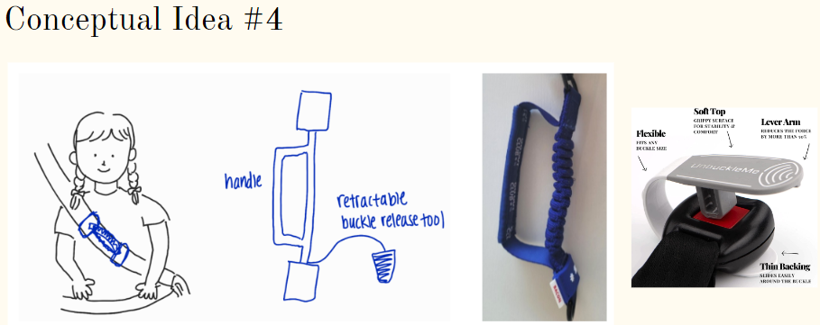
Figure 3. Concept #4

For further development of the fourth concept, Clinton outlined that the product should focus on reaching and grabbing the male part of the seat belt and moving it independently to the female counterpart. He also mentioned how the concept should be changed to have a rigid handle and to potentially have a quick release feature; both of these characteristics would allow his daughter to firmly hold the handle at different angles to pivot/reposition the male part of the seat belt if needed.
Finally, Clinton also provided the team with more background information to better understand the situation for a more optimal solution/product. The child seat is positioned on the furthest left seat (in reference to the user/seated), meaning the user pulls the male part of the seat belt to their left side, where the female counterpart resides. The child seat is a high-back car chair, which simply positions where the seat belt resides and provides extra support/cushioning for the user. Clinton also mentioned how his daughter’s right arm is better with fine motor skills, while her left arm is stronger and better with gross motor skills. These additional details will allow a more specialized prototype to be developed, specifically designed to help Clinton’s daughter’s circumstances.

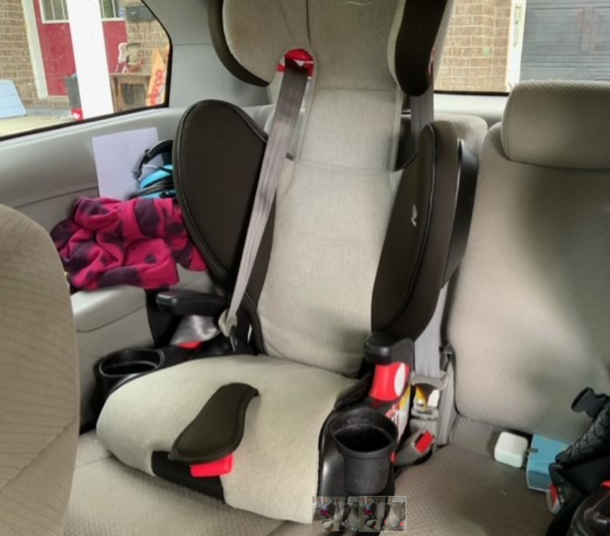
Figure 4. Child/Booster Car Seat

2.2 Updated Concept
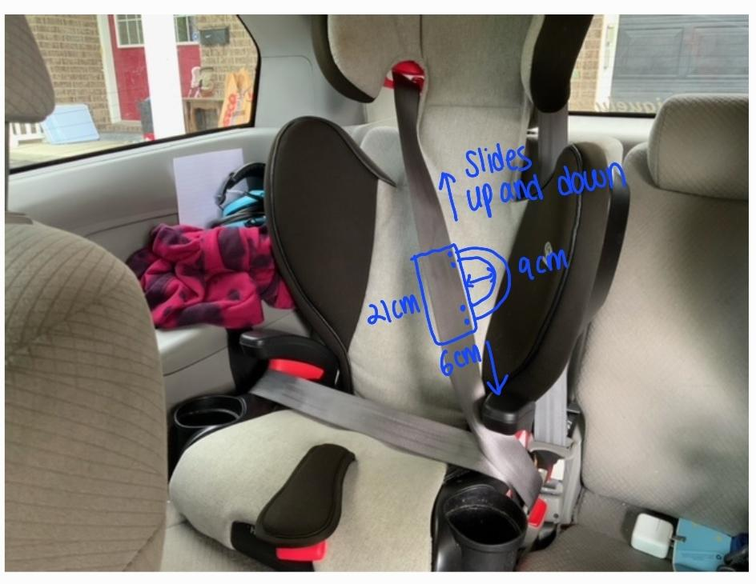
Figure 5. Updated Concept Idea

The team received a photo of the booster seat of the client’s daughter (Figure 5) and updated the conceptual design. The grabber handle will be installed on the webbing part of the seat belt, and it can slide up or down with a slight friction.
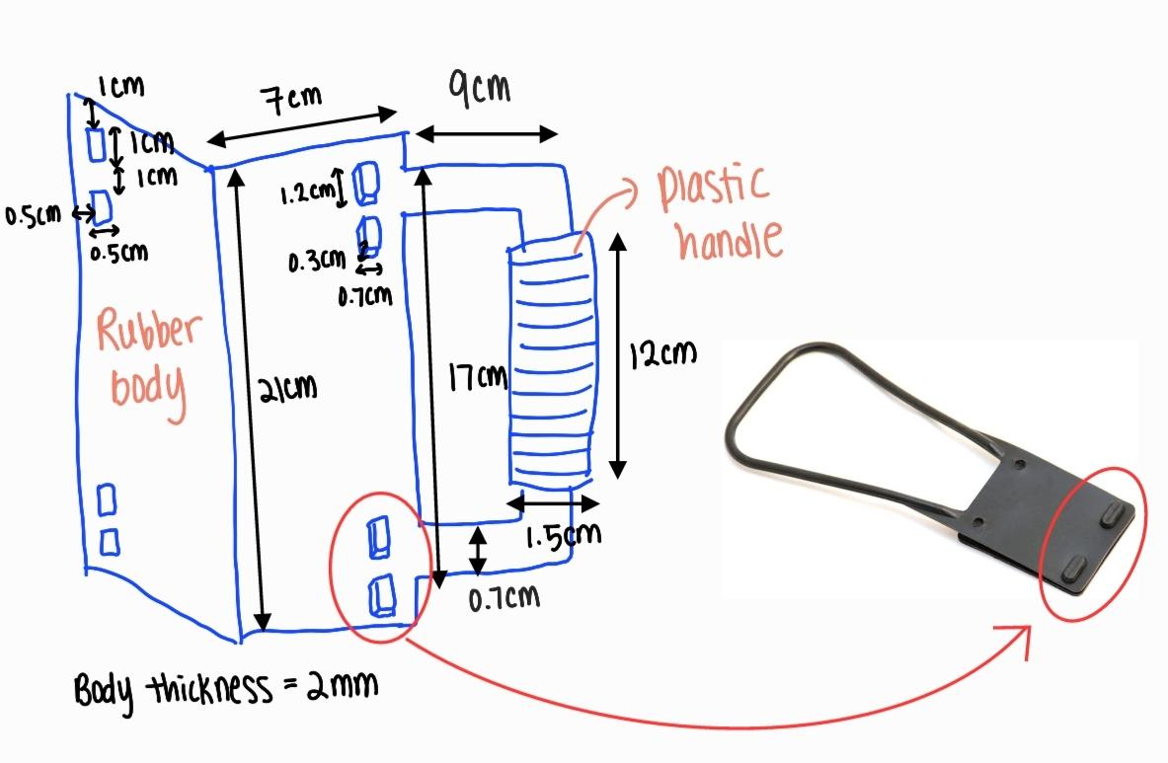
Figure 6. Updated Concept Idea #1 with Dimensions
The updated concept idea #1 focuses on the seat belt grabber handle; the retractable buckle release tool’s design will be discussed in the future group meetings. The handle is designed so that it is compatible with any car model; it can be installed on the right or the left side and with or without a booster seat. Its appropriate dimensions are presented in Figure 6. The body will be made with a rubber foam sheet so it provides flexibility while giving its sturdy texture. The body is folded in half and is simply attached around the safety belt to provide an instant addition of 15cm of reach. The body is clipped together using four rubber buttons just like one of the benchmarking products (Figure 1).

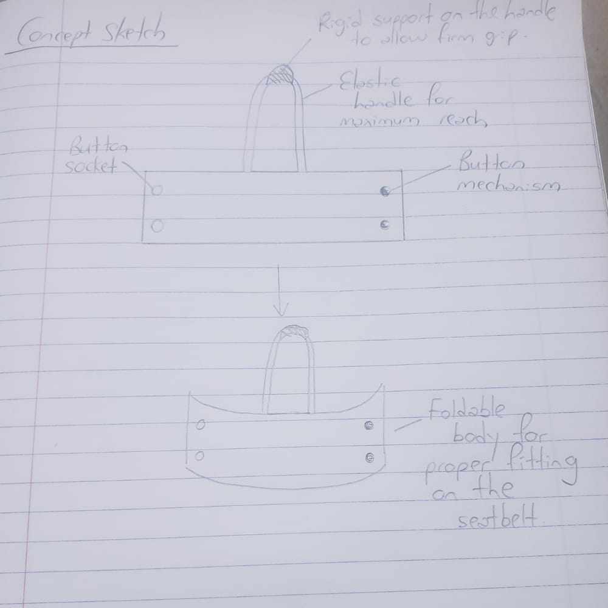
Figure 7. Concept Sketch #2

3: Prototype 1
3.1 Assumptions

After having a second client meeting and gathering feedback from proposed ideas, assumptions were made to improve upon the existing idea selected by the client followed by a prototype development. The device handle should have a sturdy grip so that the client’s daughter is able to hold it firmly and the handle should be elastic enough to be able to increase reach while minimizing force. The device should also be of proper dimensions such that it fits properly on the seatbelt, does not take up too much space but at the same time does not impact on the normal function of the seatbelt. The device body should also be made of a material that is foldable such that it can be wrapped around the seatbelt be long lasting and economic at the same time. A proper fitting mechanism for the body has to be selected, whether it is velcro, magnetic or button attachment ,to ensure that the body stays firm on the seatbelt but can slide up or down and out of the way after operating it.The device should also be ergonomic such that it can be operated by the client’s daughter which is normally seated on the left side of the vehicle and pulls with her right hand. Lastly, the device should also be aesthetic for its marketability

3.2 Development

The prototype was developed in such a way to match the needs of the client as much as possible, with an emphasis on important features such as a sturdy grip, good elasticity of the handle and proper dimensions which were taken into consideration before developing the prototype. Prototype 1 was made with cardboard, a disposable mask, and a highlighter for a rigid handle. The prototype was designed to be used on a regular seat belt with a width of 4.7 cm. It has a stretchy handle: it is 9 cm in length when unstretched and 21 cm when stretched. The handle was stapled onto the body. In the future prototypes, the rubber part of the handle and the body will be one continuous body so that it is more sturdy. The prototype was then tested against the target specifications that were previously established and user feedback was generated.

Table 1. Prototyping and Testing Plan
 | Objective | Type | Fidelity Level | Fidelity Factor | How to Build | When to Build | How to Test | When to Test
Prototype 1 | Demonstrate the overall product concept and set dimensions | Physical | Low | Visual | Cardboard  Tape  Stapler Disposable mask  highlighter | May 27 | Qualitative, quantitative and Visual | May 28

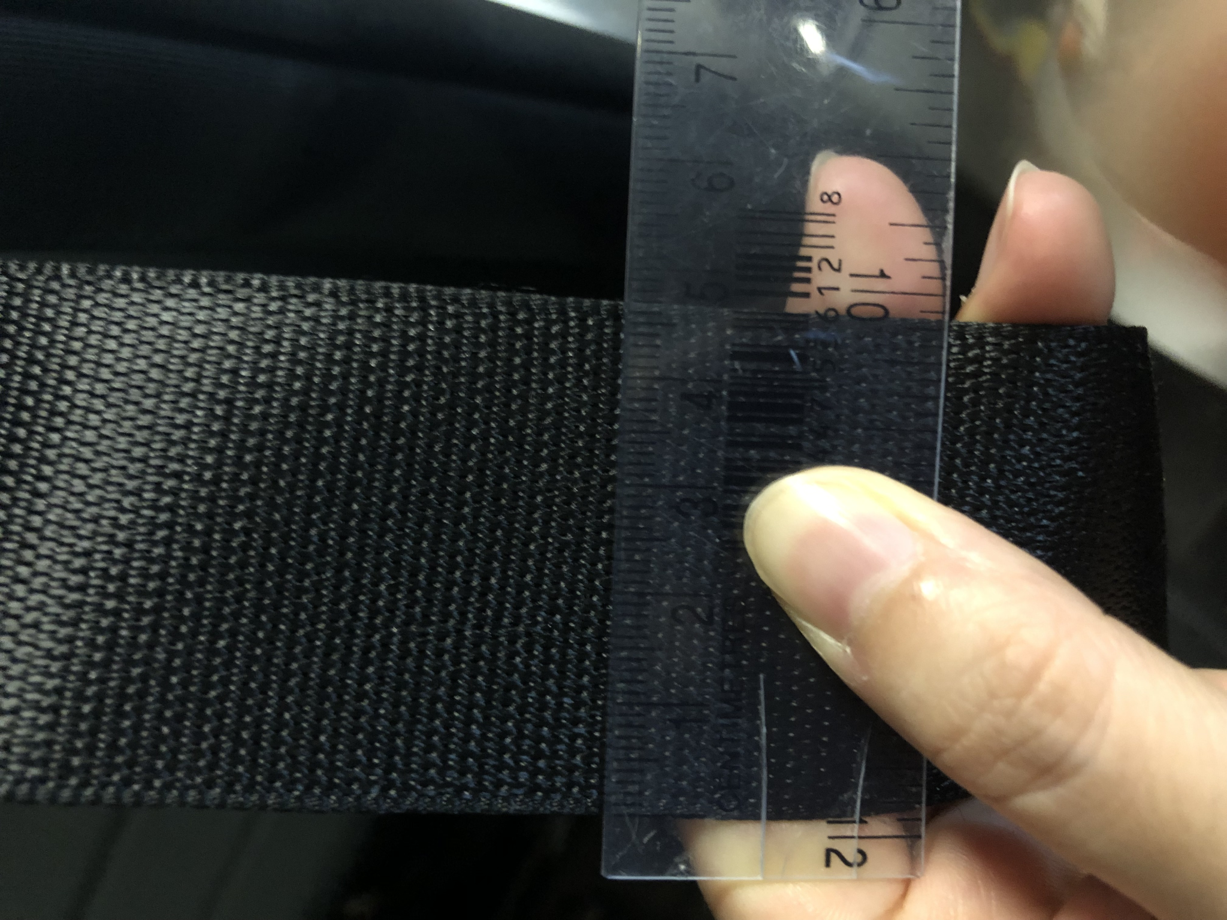
Figure 8. Standard Seat Belt Width Measurement

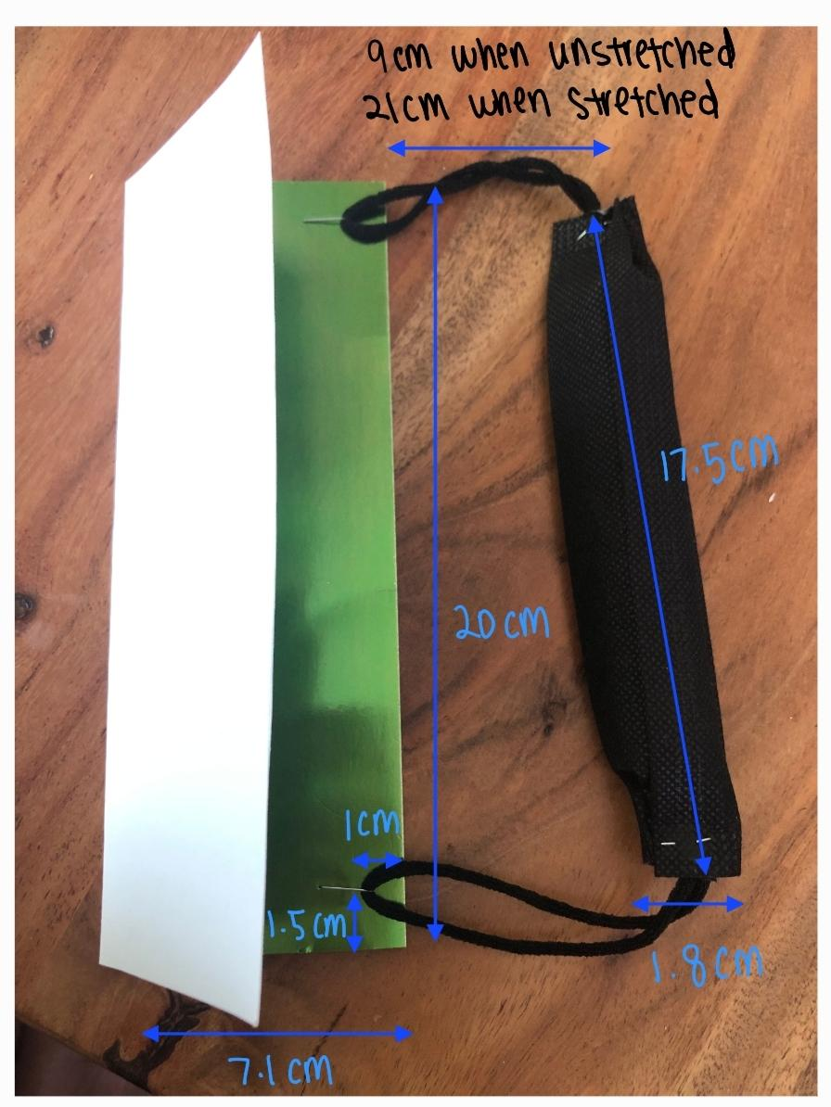
Figure 9. Prototype 1

3.3 Testing

The prototype 1 was tested by three users, and their feedback was recorded in Table 2. The client needs and the problem statement were presented to the users, and they were asked to rate the prototype based on its performance and feasibility.

Table 2. User Feedback
 | Feedback | Improvements to be made
User #1 | The handle is a little bit too thin.  With reduced mobility, it can still be difficult to buckle the seat belt since you need to twist your back to reach for the female part of the seat belt. | Handle diameter to be increased from 1.8 cm to 2.0 cm.  An additional part can be added to the design; a seat belt buckle booster will keep the receptacle upright and accessible, so the client can easily reach for the female part of the seat belt.  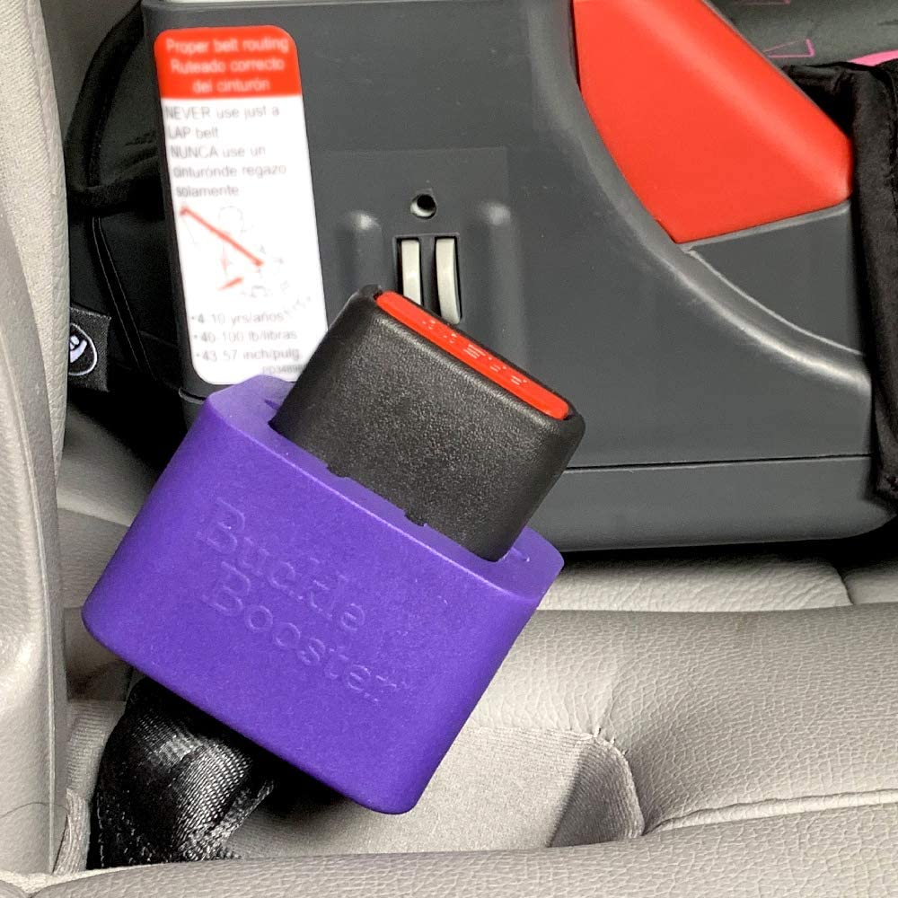  Figure 10: Buckle Booster
User #2 | The handle stretches too much when being pulled. | The maximum length of the handle when stretched will be adjusted from 21 cm to 15 cm. The product can be installed closer to the male part of the buckle.
User #3 | The body is too wide, causing it to slide freely along the webbing. The handle grip is a little slippery. | The width of the body will be changed from 7.1cm to 6 cm. The handle should have a textured surface for more friction and a sturdy grip.

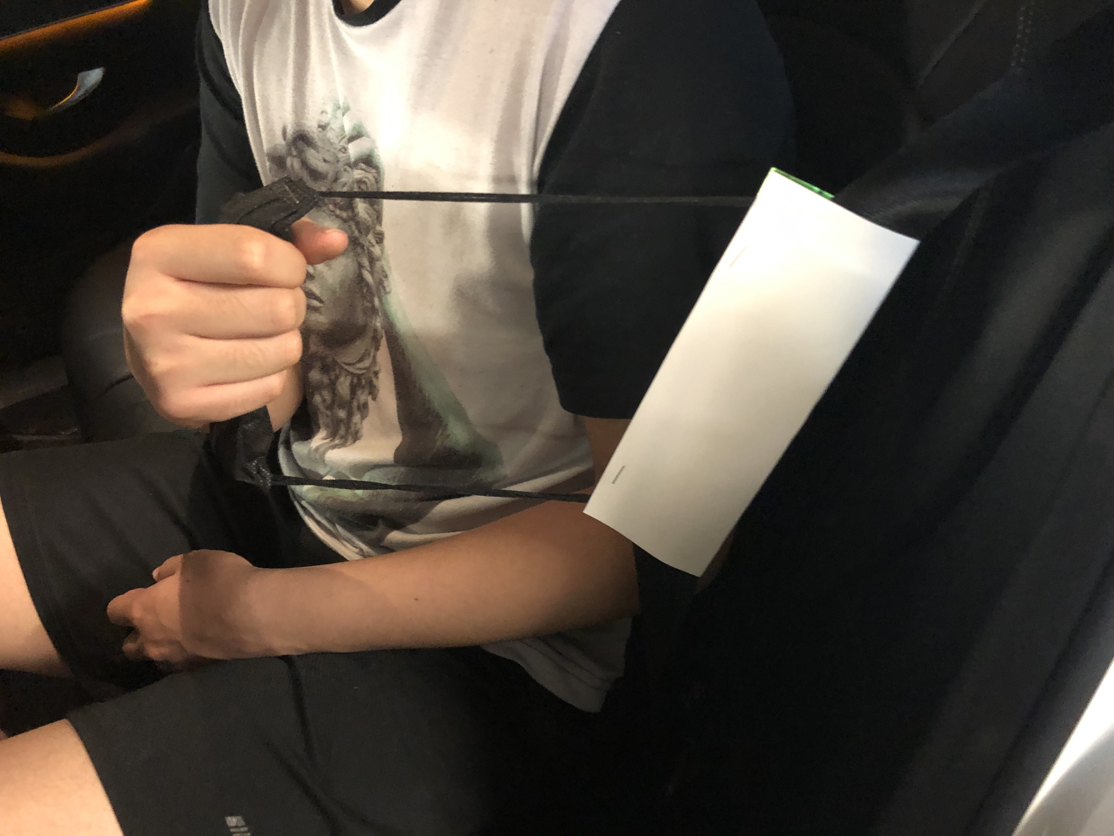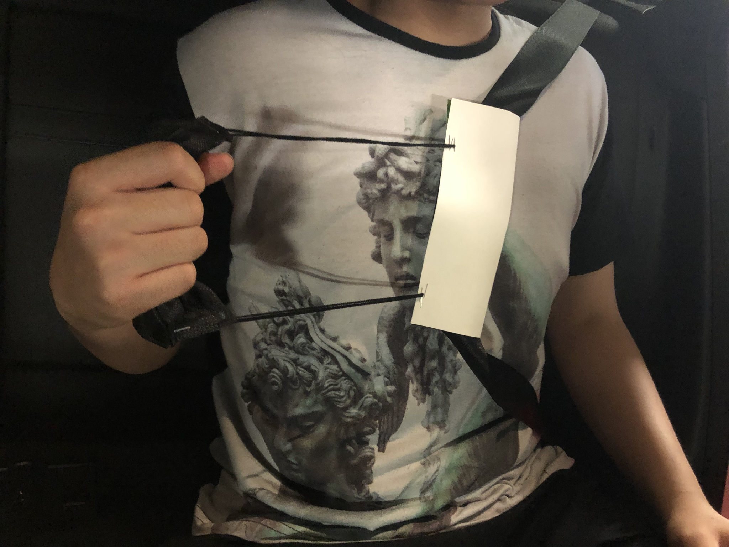
Figure 11 & 12. Prototype #1 Testing

4: Third Client Meeting Preparation

For the third client meeting teams will have to present their second prototype to the client. The team will explain the changes made according to the feedback received during the second client meeting. This includes a rigid handle at the mid section of the seat belt to help reach the male part of the seat belt as well as helping the user attach the seat belt itself. The team will also introduce the specifications of the application that were not shown in the second client meet. The team intends to receive more feedback from the client. Feedback that the team is looking for is comments regarding the ease of use of the application and if the systems meet the expectations of the client. The team’s goal is to gain information from the third client meet to further improve our prototype for the next client meet.

5: Bill of Materials

Table 3. Bill of Materials

Item # | Item Name | Description | Quantity | Unit Cost | Link
1 | Rubber Foam Sheet | Rubber foam sheet from which the shape of the design will be cut out from | 1 | $19.02 | https://www.amazon.ca/Rubber-Neoprene-12x12-Inch-Plumbing-Protection/dp/B01BCMKNW4/ref=sr_1_37?crid=1E25HEQY1K23S&keywords=rubber+sheet&qid=1653876189&sprefix=rubber+sheet%2Caps%2C87&sr=8-37
2 | Materio3D PLA Filament | 3D printed plastic handle, buckle booster | 0.5 | $20.00 | https://makerstore.ca/shop/ols/products/materio3d-pla-3d-filament
3 | Plastic Tubing | Plastic tubing to act as a strap to increase reach for the handle | 1 | $10.00 | https://www.amazon.ca/Proper-Pour-Approved-Multi-Purpose-Aquaponics/dp/B017EA5ST6/ref=asc_df_B017EA5ST6/?tag=googleshopc0c-20&linkCode=df0&hvadid=293032132246&hvpos=&hvnetw=g&hvrand=11622488886943596657&hvpone=&hvptwo=&hvqmt=&hvdev=c&hvdvcmdl=&hvlocint=&hvlocphy=9000686&hvtargid=pla-340687178524&psc=1

6: Conclusion

The team met with the client and proposed their 4 conceptual designs for feedback. The team utilized the feedback to improve their overall concept as well as create prototypes. The team identified their tasks in preparation for the next client meeting as well as creating a bill of materials. The team will begin to work on the different subsystems and aim to have them functioning for the next client meeting. With the product functioning, the team can show that the application can be useful not only to the client, but to others who experience the same type of problem.

References

“JiMMY-Seat Buckle Assist.” Viegel, https://www.veigel-automotive.de/en/ergomotive/jimmy-seat-buckle-assist/#details.
“Seat Belt Buckle Booster.” Amazon, Seat Belt Extender Pros Store, 2019, https://www.amazon.ca/Seat-Belt-Buckle-Booster-Receptacle/dp/B07PRKBL73/ref=sr_1_1_sspa?crid=B1KH8TRF5IJ2&keywords=seat%2Bbelt%2Bbuckle%2Bbooster&qid=1653864961&sprefix=seat%2Bbelt%2Bbuckle%2Bbooster%2Caps%2C75&sr=8-1-spons&smid=A34LWHIP1XDWV&spLa=ZW5jcnlw.
“Seat Belt Grabber Handle.” Amazon, Seat Belt Extender Pros Store, 2017, https://www.amazon.ca/Seat-Belt-Grabber-Handle-4-Pack/dp/B0764J7NL1/?_encoding=UTF8&pd_rd_w=BhGbN&content-id=amzn1.sym.65a883cc-2a99-4757-97c3-17282bb2b972&pf_rd_p=65a883cc-2a99-4757-97c3-17282bb2b972&pf_rd_r=3NR1NVTCC93VDKHH63Z3&pd_rd_wg=mxprL&pd_rd_r=f1a.

