GNG2101 Project Deliverable B:
Needs, Problem Statement, Metrics, Benchmarking and Target Specifications

Submitted by:
[Team Z24]
Hans Rao Ladkoo
Yunsu Lee
Sylvain Quach
Evan Tomietto

May 15, 2022

University of Ottawa

Abstract
Our team held its first meeting with our client, Clinton, to interview him by asking as many questions as necessary to receive further more detailed information on the project and to extract statements that can be used to determine his needs. The client wants a device that will allow his six year old daughter who has shoulder and leg mobility issues to safely connect the male part of the seatbelt to the female part. He is also open to any other mechanical system as long as the safety aspect is not hindered. The client provided enough statements from which we could gather his needs. From the client's needs, we were able to formulate a problem statement to address exactly what he needs. A list of metrics was created to keep score when comparing several concepts that are already on the market, through a technical benchmarking analysis. Finally, target specifications were tabulated to show what we expect from our product.

Table of Contents

Abstract 1
Table of Contents 2
List of Tables 3
List of Figures 4
1: Introduction 5
1.1 Problem 5
1.2 User Applications 5
1.3 Differences from Other Existing Products 6
2: Translated and Prioritized Client Needs Based on Client Statements and Observations 6
3: Problem Statement 7
4: Metrics 8
5: Benchmarking 9
6: Target Specifications 11
7: Reflections 13
8: Conclusion 13
References 14

List of Tables
Table 1: Client Statements and Client Needs……………………………………………...6
Table 2: Client Needs Translated to Units………………………………………………...8
Table 3:Benchmarking on Similar Products………………………………………………9
Table 4: Product Target Specifications…………………………………………………...11

List of Figures
Figure 1: Seat Buckle Assist………………………………………………………………9
Figure 2: Seat Buckle Release…………………………………………………………….9
Figure 3: Seat Belt Handles / Straps………………………………………………………9
Figure 4 :Pregnancy Car Seat Belt Adjuster………………………………………………9

1: Introduction

1.1 Problem
The client is the father of a six-year-old girl who suffers from the condition arthrofibrosis. This condition affects all her joints, especially those in her limbs and extremities, causing her to experience limited mobility and flexion, and reduced strength. These constraints make it difficult for her to complete the everyday task of bulking a car seat belt on her own, as it is difficult for her to reach and use both arms to hold the seat belt components. The client stated that no previous solutions have been attempted as the client’s daughter has just transitioned from a 5-point seat belt to regular 3-point seat belt. The client has not attempted to produce his own solution due to lack of materials, expertise, and equipment (3D printer, CNC laser cutter, etc). The product’s goal is to aid the girl in reaching for the male part of the seatbelt and guide it to the female counterpart, and providing enough pressure at the last 3-4 inches to click them together to secure herself safely.

1.2 User Applications
This product does not only have applications for the specific client with arthrofibrosis, but also for any consumers with limited mobility and strength caused by other physiological conditions, preventing them from buckling their seat belts in with ease. The application can also be marketed towards children or the elderly who need extra assistance in reaching for the male part of the seat belt, guiding it to the female part, and finally pushing them together to buckle. The solution could also be used for people who can only use one arm (amputation or paralysis), allowing them to use the product to buckle themselves in using only one hand on their own.

1.3 Differences from Other Existing Products
While there are many applications on the market that provide extra support in reaching for the male counterpart of the seatbelt, there seems to be no products that aid in the guiding of the male part to the female part, and as well as providing the extra strength required to clasp the two parts together. Group Z24 will create a new product/solution that not only allows the client to reach the seatbelt easily, but to also create a pathway between the two parts, and to provide the user with the extra necessary force to fasten the seatbelt.

2: Translated and Prioritized Client Needs Based on Client Statements and Observations
Table 1: Client Statements and Client Needs
No. | Client Statement | Client Need | Importance
1 | My daughter’s arthrofibrosis condition causes her to experience limited mobility and flexion. | Attachments to both the male and female parts of the seatbelt to provide extra reach. | 1
2 | My daughter’s arthrofibrosis condition causes her to experience reduced arm strength. | Additional force/pressure provided by the product to pull and clasp the components together (especially the last 3-4 inches) | 1
3 | My daughter’s arthrofibrosis condition causes her to experience reduced grip strength. | An ergonomic attachment to the male part, allowing it to be easily held with minimal force. A securing attachment to the female part, allowing it to remain stationary. | 1
4 | Due to her limited mobility, my daughter has difficulty using both hands to hold the male and female parts of the seatbelt at the same time. | A guide/track to allow the male part to follow a path towards the female part to be clipped in. | 1
5 | The product should not disrupt the normal operation/function of the seatbelt. | The product will allow the seatbelt to perform as originally intended, securing the passenger without creating new risks or dangerous situations in the car. | 1
6 | The product should not negatively affect the comfort of the user. | The product will allow the user to be seated comfortably in the car seat, without hindering any mobility or reducing any room for the user to move around in. | 1
7 | Easy installation of the product is ideal. | The product will be straight-forward to install in standardized carseats. | 2
8 | Target market of North American where seatbelt safety standards are similar. | The product installation can be compatible with many different car models. | 2
9 | Product for people with similar physical disabilities or mobility issues. | The product also has applications in other similar physical conditions or disabilities. | 3
10 | Secondary market for seniors and children who have trouble buckling themselves in. | The product also has applications with seniors and children who have limited reach and strength. | 3

3: Problem Statement
The client is in need of a product that will allow his daughter with limited mobility and strength, caused by arthrofibrosis, to secure herself with a 3-point car seat belt on her own. The mechanism will allow her to reach for the male part of the seat belt and guide it to its female counterpart, and then finally providing the additional necessary force to clasp the two together. The product should not hinder any of the seat belt’s original safety, comfortability, and functional features.

4: Metrics
Table 2: Client Needs Translated to Units
Client Need No. | Metric Description | Unit | Functional / Non-Functional / Constraint
1, 2 | Product Dimensions | Centimeters (cm) | Constraint
3 | Force needed to unbuckle | Pounds (lbs) | Functional
4 | Presence of a guide or track | Binary | Functional
5 | Standardized | Binary | Functional
6 | Weight of the product | Grams (g) | Constraint
7 | Installation Time | Minutes (min) | Non-Functional
8 | Production Cost | Dollars ($) | Constraint
9 | Maximum weight the product can withstand | Pounds (lbs) | Functional
10 | Product lifetime | Years (yrs) | Non-Functional

5: Benchmarking
Table 3: Benchmarking of Similar Products
Device | 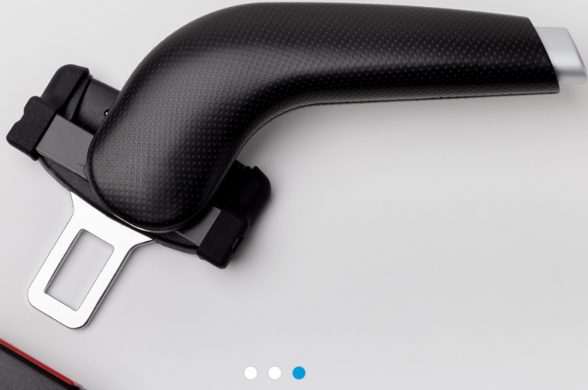  Figure 1: Seat Buckle Assist | 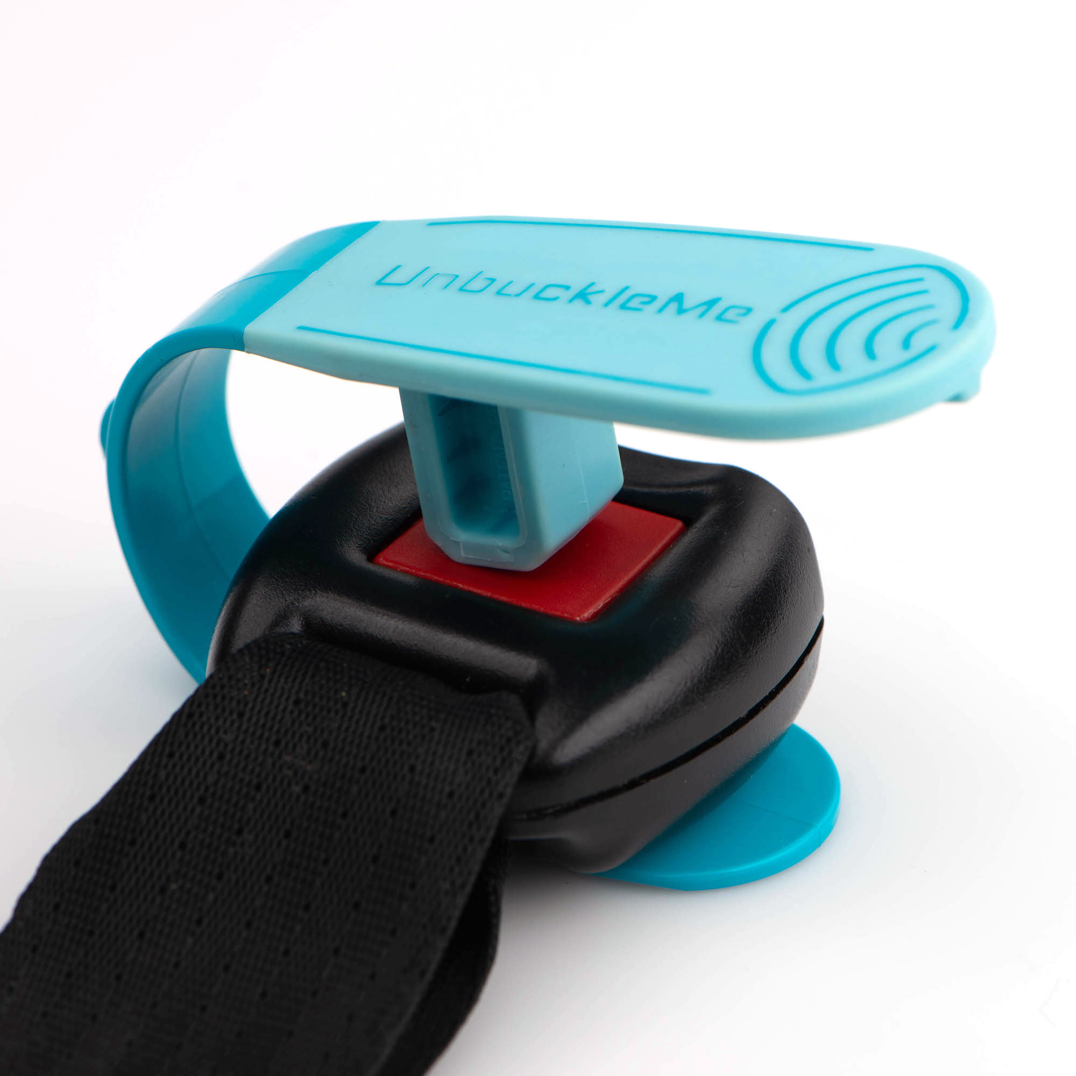  Figure 2: Seat Buckle Release | 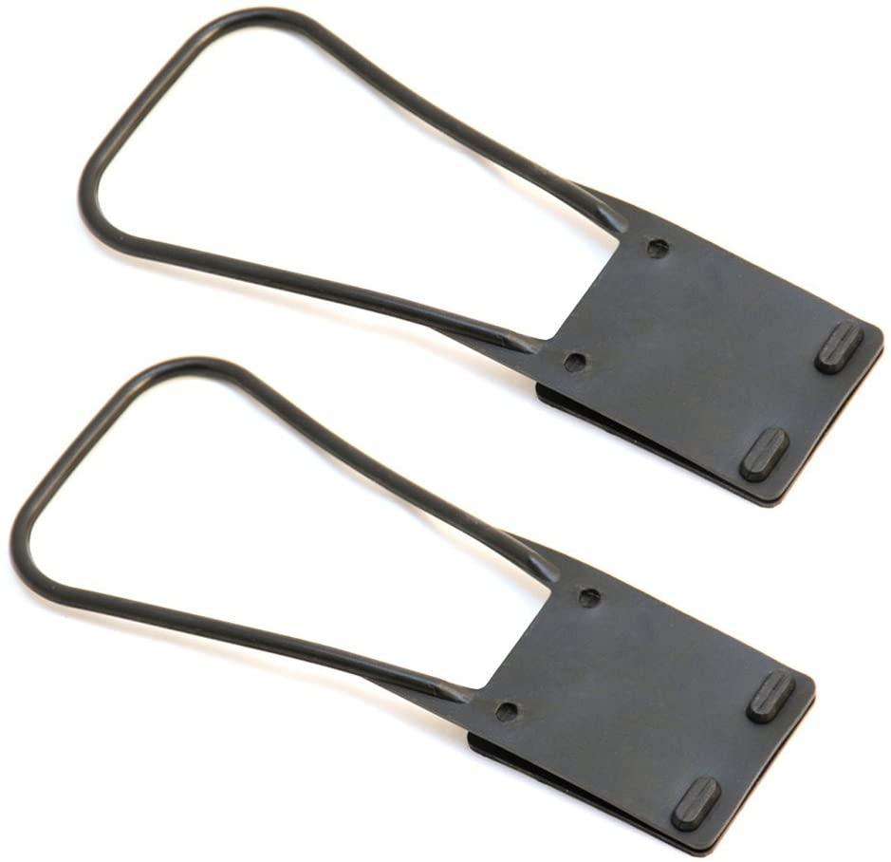  Figure 3: Seat Belt Handles / Straps | 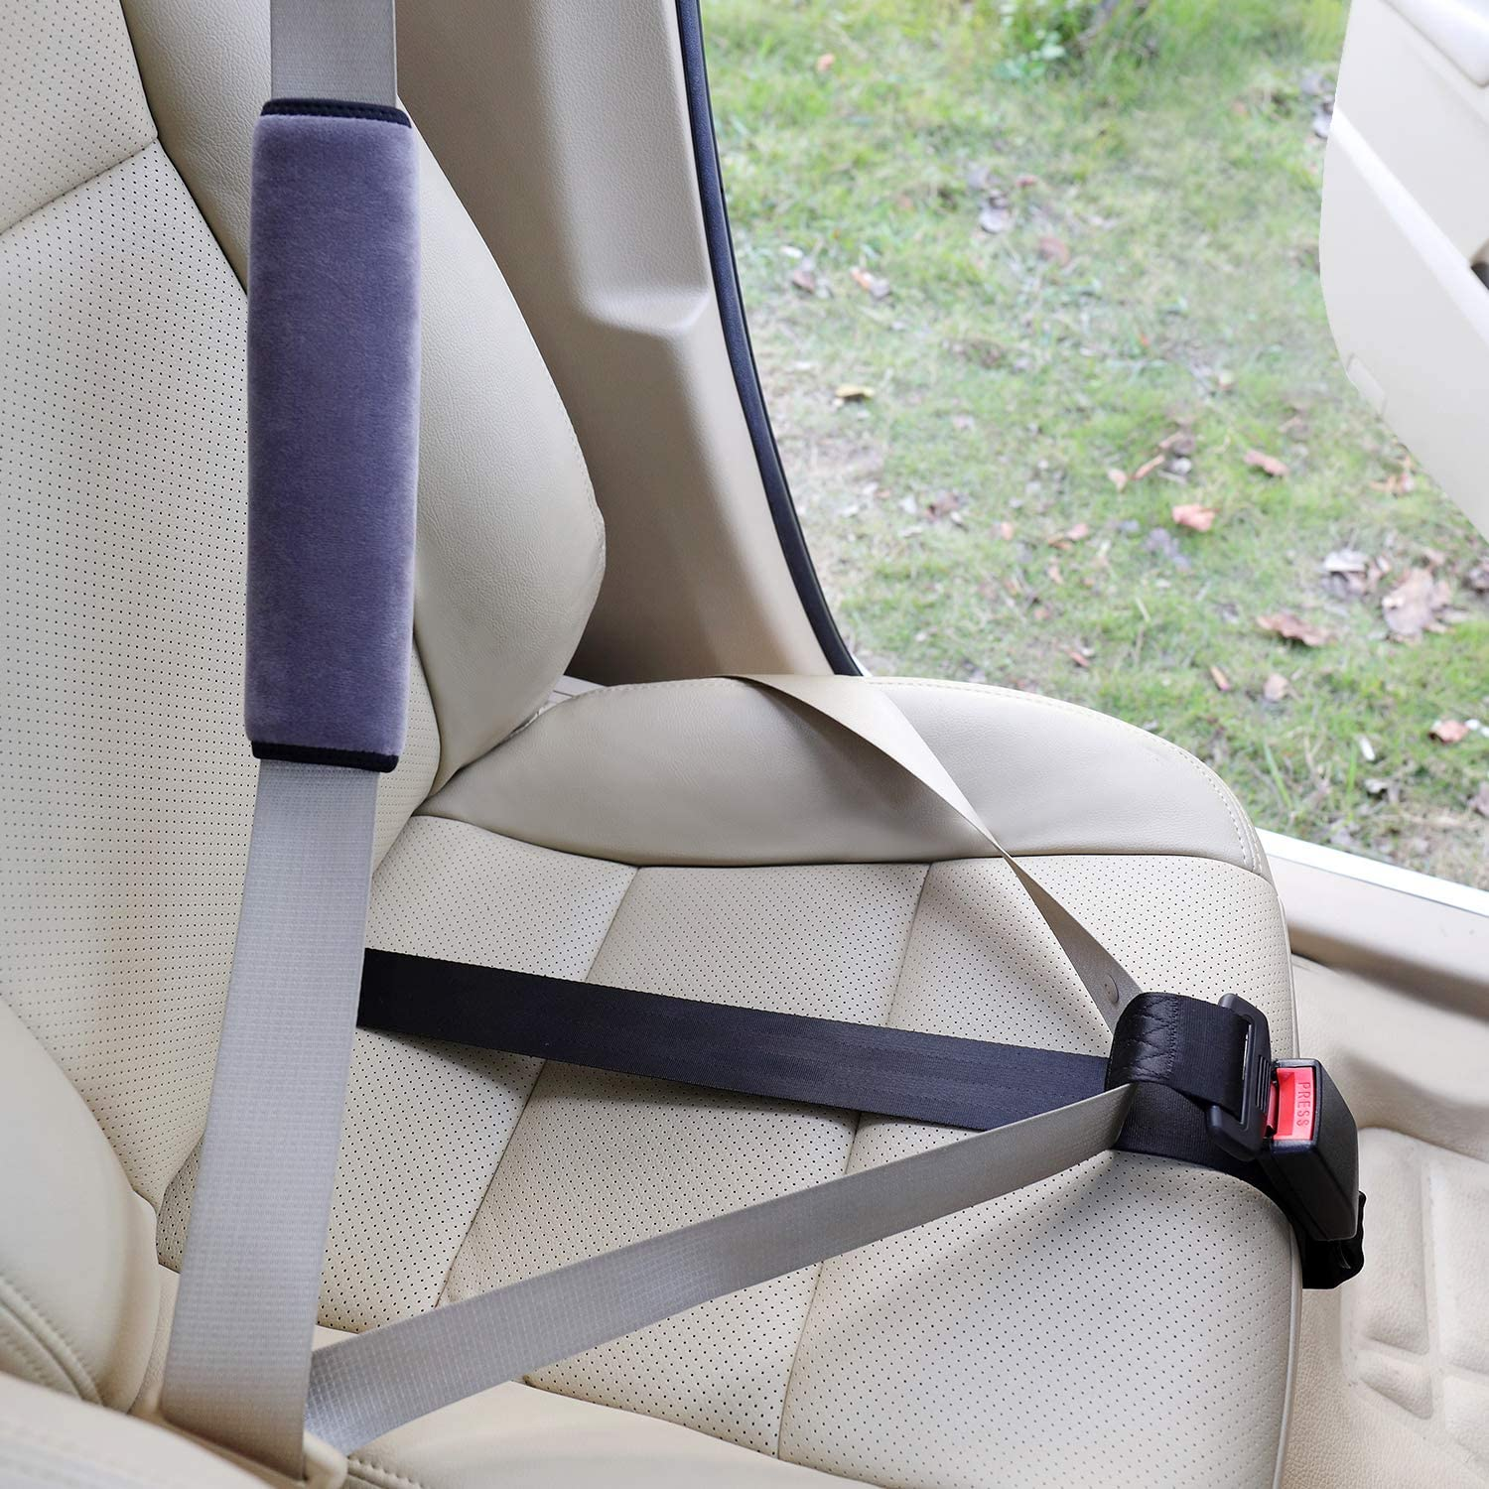  Figure 4: Pregnancy Car Seat Belt Adjuster
Company | Veigel | UnbuckleMe | More of Me to Love | Ayaport
Functional features | -The JIMMY simplifies the buckling and unbuckling of the seat belt. Its ergonomic handle makes it easier to grasp in comparison to the factory seat belt buckle.  -Helpful for those with limited mobility and/or limited space. Contact-free fastening of people (ideal also for driving services) and simplifies fastening and unfastening for children.  • the buckling process is double-secured (no accidental unbuckling is possible) | - patented level arm reduces the force needed to unbuckle any type of seat belt (only 50% of force needed)  - soft and grippy surface keeps it stable and provides a comfortable surface for pressing | -By positioning it where it is most useful, you'll be able to reach across your body towards the seat belt, but about 8 inches less than you would otherwise have to.  -Pull the seat belt across your body using the Seat Belt Grabber Handle.  -With the seat belt metal tongue now much more readily in reach, buckle it into the seat belt receptacle.  -Let the Seat Belt Grabber Handle slide over and sit somewhere out of the way that doesn't bother you while you ride or drive. | - designed to ensure the ultimate safety for pregnant women  - unique lock buckle to keep belt in place  - once installed, only need to click the buckle to fasten or unfasten
Extra Reach | Yes | No | Yes | Yes
Additional force/pressure | Yes | Yes | Yes | Yes
Guide/ track | Yes | No | Yes | Yes
Secure Attachment | Yes | No | Yes | Yes
Size | N/A | 9.4 x 3.3 x 4.32 cm | 7 inches | 28.9 x 13.3 x 5 cm
Weight | N/A but lightweight | 18.14 g | 100g | 410 g
Cost | N/A | $ 19.99 | $14.98 | $27.88
Type of Material | N/A | Synthetic rubber | Sturdy rubberized resin | Polyester
Set-up Time | Minutes | Seconds | Seconds | < 5 minutes
Product Life | >10 years | > 10 years | >10 years | > 7 years
Aesthetics | Ergonomic design | Various | Black | Black
Overall Score | 36 | 26 | 38 | 34

The overall score of each product was calculated based on the importance of the client needs: 5 scores for functional needs, 3 scores for non-functional and constraints. Based on the benchmarking evaluation, “Seat Belt Handles” product has scored the highest with 38, while “Seat Buckle Release” scored the lowest with 26.

6: Target Specifications
Table 4: Product Target Specifications
# | Design specifications | Relation | Value | Unit | Verification Method
Functional Requirements
1 | Extra reach for both the female and male parts | = | Yes | N/A | Test
2 | Additional force/pressure provided by the product to pull and clasp the components together | = | Yes | N/A | Test
3 | A guide/track to allow the male part to follow a path towards the female part to be clipped in. | = | Yes | N/A | Test
4 | Does not hinder the safety of the user nor cause any discomfort during use | = | No | N/A | Test
5 | Does not disrupt the normal function of the seatbelt | = | No | N/A | Test
Constraints
6 | Cost | ≤ | 50 | $ | Analyze
7 | Weight | ≤ | 400 | g | Estimate
8 | Length | < | 30 | cm | Estimate
9 | Width | < | 5 | cm | Estimate
10 | Operating Conditions | = | -40 to 60 | $℃$ | Test
Non-Functional Requirements
11 | Quick Installation Time | < | 5 | minutes | Test
12 | Durability | = | Yes | N/A | Test
13 | Aesthetics | = | Yes | N/A | Test
14 | Product life | > | 10 | years | Test

Table 4 presents the estimated values of the design specifications. Each value was determined based on the translated client needs and benchmarking of similar products. Target specifications #1 to 5 present the crucial functional requirements to fulfill the client’s needs. For example, extra reach and a guide will be the essential parts of this engineering design. Each design specification will be verified using the “test” method. In the “Constraints” session, we set the production cost as well as the product dimensions and weight based on the benchmarking result in Table 3. The product will not be more than 30 cm in length and 5 cm in thickness. To not have too much pressure and weight on customers, the product's weight will be kept to a minimum of 400 g. Since safety is of the utmost importance, durability and product life are also essential parts of the design. Lastly, to make the product universal for all the people with limited mobility and strength, the installation time should be less than 5 minutes.

7: Reflections
The client meeting was successful and was crucial to help us identify the client’s needs from his statements. We were able to empathize with him and allowed him to express fully what he expects from the product. Important information such as a picture of the client’s daughter, his daughter’s limited range of motion, budget estimate, safety aspect of the product as well as the target customer was gathered from his statements. The client’s needs then allowed us to create a list of metrics, do a technical benchmarking analysis on similar existing products on the market. To summarize, the client meeting was necessary to set the team on the proper pathway to design a product that accurately depicts the client’s needs.

8: Conclusion
This kick-off meeting allowed the team to greatly understand the background, motivation, and needs of the client’s problem. Through interview strategies of empathizing with the client, asking open ended questions, and taking note of their non-verbal communication, we were able to record informative client statements that were easily translated into client needs. With these needs, metrics were then assigned to them, allowing for benchmarking of similar existing seat belt solutions on the market. Finally, target specifications were then extracted and determined, allowing us to narrow down our scope to begin our ideation process for the next steps.

References
Ayaport. “Pregnancy Car Seat Belt Bump Belt Adjuster.” Amazon, 2020, https://www.amazon.ca/Pregnancy-Adjuster-Comfort-Maternity-Driving/dp/B088W8T22N/ref=pd_sbs_sccl_3_1/142-0527721-5015736?pd_rd_w=E5UB9&pf_rd_p=5e3de09f-c23c-4218-88f9-a2511d573f0c&pf_rd_r=WHXYS8KW488ZRKVXVP1S&pd_rd_r=529e9a49-79f2-4a3e-bff7-b352fbce257f&pd.
“JIMMY-Seat Buckle Assist.” Veigel, https://www.veigel-automotive.de/en/ergomotive/jimmy-seat-buckle-assist/#details.
“Seat Belt Grabber Handle-Extend Your Reach to the Seat Belt.” Amazon, 2012, https://www.amazon.ca/Seat-Belt-Grabber-Handle-Extend/dp/B008YJD68W/ref=sr_1_2?crid=YVDITKCC11LP&keywords=seat+belt+grabber&qid=1652477956&sprefix=seat+belt+grabber%2Caps%2C298&sr=8-2.
UnbuckleMe. “UnbuckleMe Car Seat Buckle Release Tool.” Amazon, 2019, https://www.amazon.ca/UnbuckleMe-Unbuckle-Grandparents-Children-Invented/dp/B07JJRVXJ1/ref=asc_df_B07JJRVXJ1/?tag=googleshopc0c-20&linkCode=df0&hvadid=459414334071&hvpos=&hvnetw=g&hvrand=14774213700509057099&hvpone=&hvptwo=&hvqmt=&hvdev=c&hvdvcmdl=&hvlocin.

