University of Ottawa
GNG 1103: Engineering Design

Deliverable G- Prototype II and Customer Feedback
March 10th, 2023
Group F-12
Avery Taylor (300366472)
Emily Facette (300109170)
Rashad Nesar (300372555)
Annabelle Osazuwa (300361617)

Abstract

TOC

Introduction and Objectives

Analysis of critical components

Power Connections

Power Supply

Hall Sensor Magnet

Prototype Test plan
For this prototype, a focused physical prototype will be created. This will involve creating a physical model of the TinkerCad simulation from Deliverable F. Upon receiving the motor, it was discovered that we would not need to purchase a mosfet, because it came integrated in the PWM DC Motor Speed Controller which came with the motor.
The parts used in this prototype will include
- The selected motor;
- The chuck;
- The jumper wires;
- The PWM DC Motor Speed Controller;
- The Arduino;
- The battery source;
- The integrated hall sensor;
- A small fridge magnet;
- Tape;
- A piece of wood.
The first step involved fastening the motor to a piece of wood with the brace provided. The Arduino and the PWM DC Motor Speed Controller were attached to the board, and the potentiometer was plugged into the speed controller and fastened with tape. The following figure shows the general layout of the board.
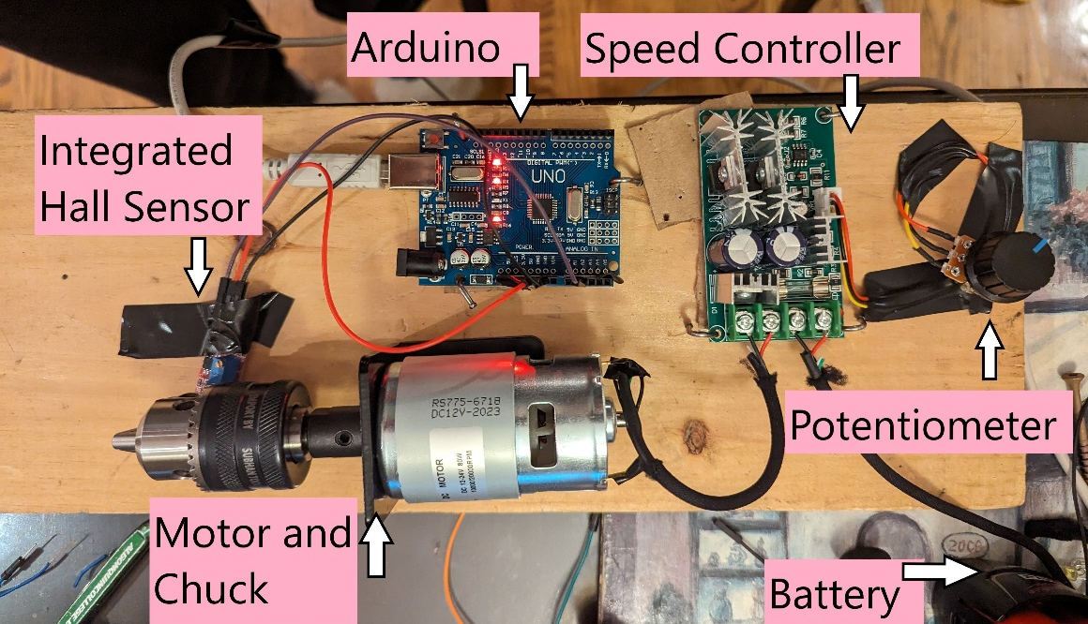
Figure 1: Board Layout
The integrated hall sensor was positioned so that it was close to the motor, as seen in the following figure. A magnet was taped to the motor so that the hall sensor would be able to measure the magnetic field correctly.
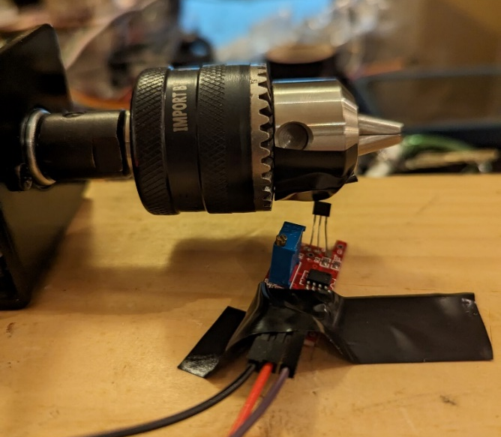
Figure 2: Integrated hall sensor
The TinkerCad simulation was followed for the hall sensor setup. The following figure of the Arduino shows the arrangement of the cables for the hall sensor.
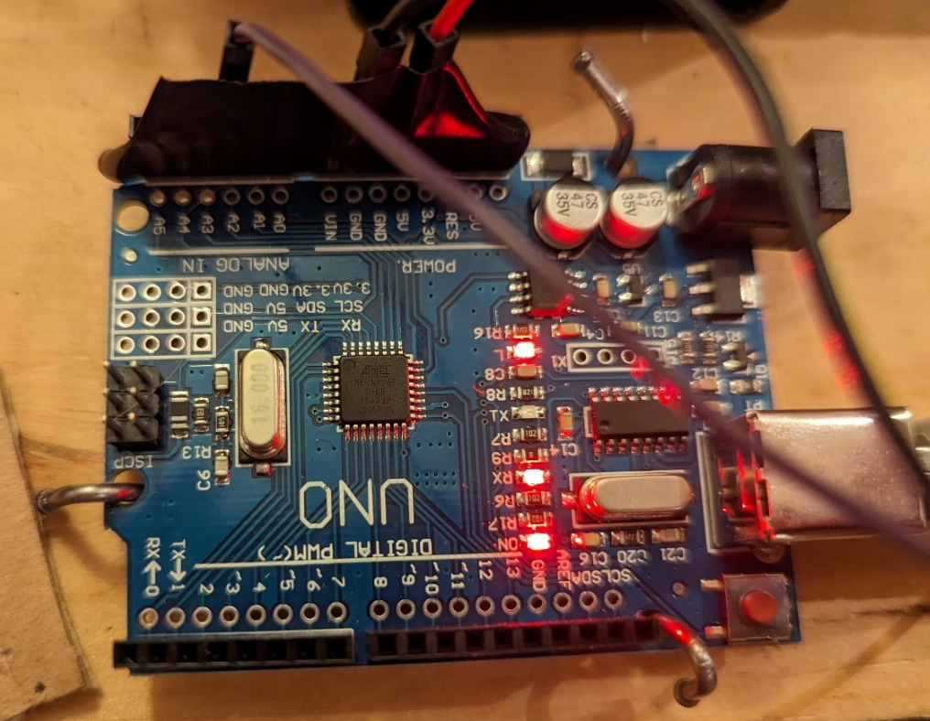
Figure 3: Arduino Setup
The positive and negative wires from the battery were attached to the corresponding terminals on the speed controller, and likewise for the motor to the speed controller. The following figures shows the specific layout for the speed controller.
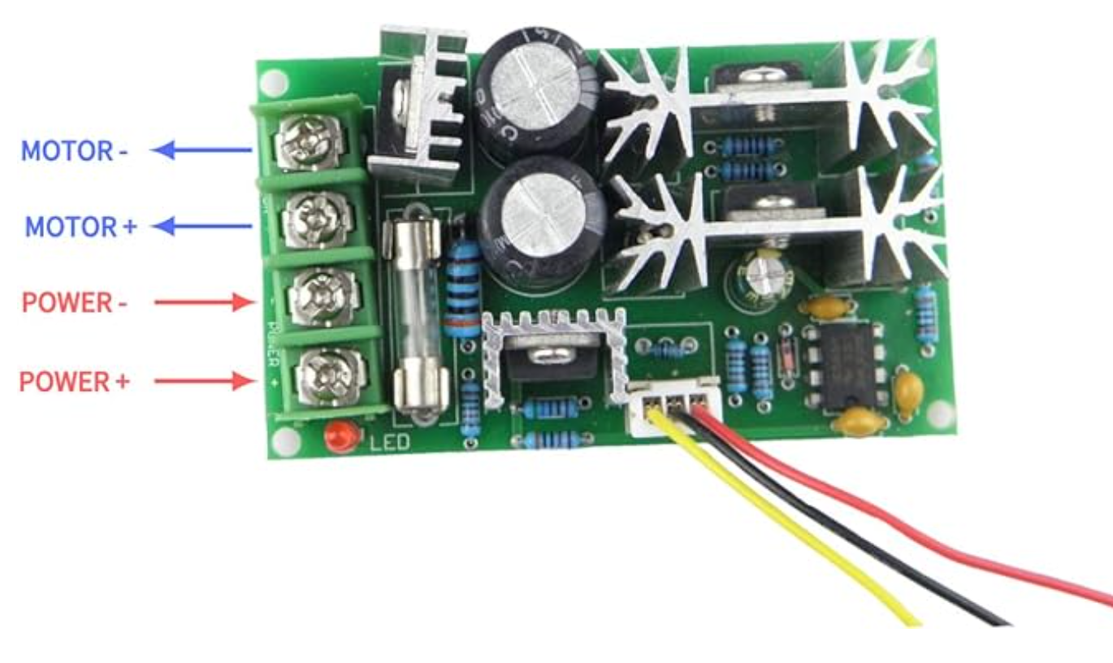
Figure 4: Speed Controller setup
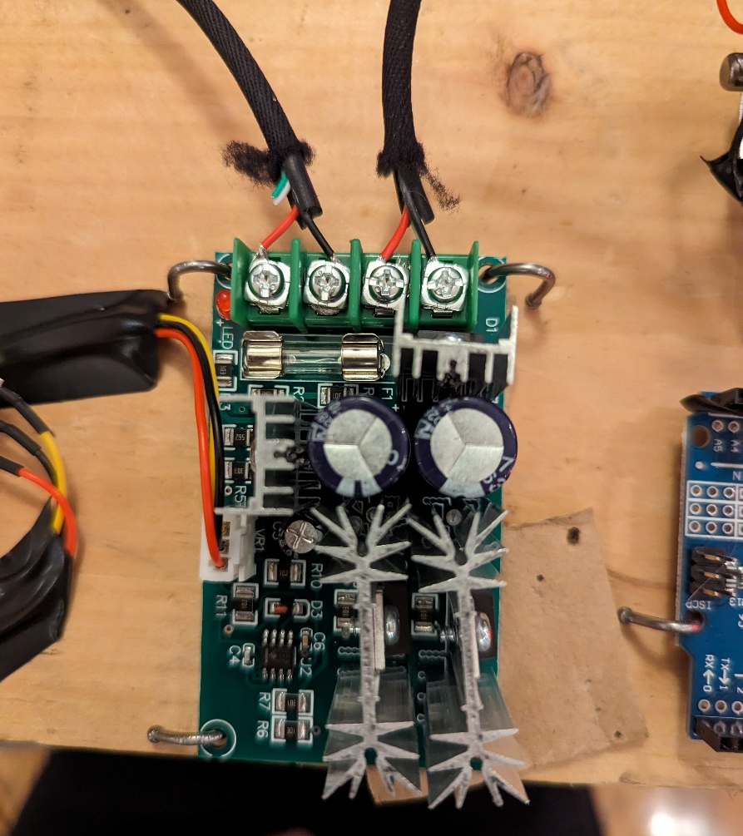
Figure 5: Speed Controller setup on the board
To power the motor, we placed the positive and negative ends of the power wire coming from the speed controller to the corresponding terminals on the battery source. In the next deliverable, we will research further how to implement a switch to control running the motor.

Feedback from Users & Clients
Tony Thatcher (M. Eng) is a retired electrical engineer. He stated that there were many interesting features in the setup, most notably the speed control facilitated by a potentiometer, which will allow users a dynamic experience. He noted that using screws and nails to fasten the apparatus enhanced the safety, ensuring stability and secureness during motor operation. He pointed out, however, that the necessity to manually hold wires to the battery for operation was a drawback. To optimize user experience and mitigate safety risks, he suggested integrating a switch, such as a relay, for switching power on and off, ultimately streamlining functionality and eliminating the need for manual wire handling. Overall, his feedback was very constructive, and we will look into the addition of a switch for the next prototype.

Updated BOM
The bill of materials has not changed significantly since the last deliverable. We switched to an integrated hall sensor instead of a regular hall sensor as it included signal conditioning and processing circuitry, making integrating it into the system much easier. Switching to the integrated hall sensor was available at a lower cost, ultimately lowering the budget by a few dollars.
The updated BOM can be seen attached in the submission of this document.

Prototype III Test Plan

Conclusions and Future Works

References

Appendix

