University of Ottawa
GNG 1103: Engineering Design

Project Deliverable D: Conceptual Design

Group Members:
Name: Student ID Number:
Sofiya Fonareva 300334815
Emma Denis 300291562
Erik Ang 300316725
Hasnain Sahibzada 300220482
Aaron Campos Maldonado 300319896

October 16, 2022

Abstract

In this deliverable, all previously done research is combined into possible design options. The project is divided into three subspaces: sensor, port and storage. For each subspace various design options are outlined and discussed. All options are assessed and ranked to select the ones that fit our client’s needs the most.

Wrike Snapshot: https://www.wrike.com/frontend/ganttchart/index.html?snapshotId=CauAi2yzRP9EU0GXfs8NuQ4ZzaYRb9Qw%7CIE2DSNZVHA2DELSTGIYA

Index
- Introduction 4
- Subsystem 1: Sensors 4
  - Design concept by Hasnain
Figure 2.1.1: Sensor Setup
  - Design concept by Aaron
Figure 2.2.1 Sensor and data transfer
  - Design concept by Sofiya
Figure 2.3.1: Capacitance and pressure sensors
  - Design concept by Emma
Figure 2.4.1: Vibration and pressure sensor
  - Design concept by Erik
Figure 2.5.1: Buoyant Accelerometer/gyroscope and Temperature Sensor
- Subsystem 2: Port 8
  - Design concept by Hasnain
Figure 3.1.1: Sensor to Port connection
  - Design concept by Aaron
Figure 3.2.1 Data warning for irregularities
  - Design concept by Sofiya
Figure 3.3.1: Port location and attachments
  - Design concept by Emma
Figure 3.4.1: Port and connections
  - Design concept by Erik
Figure 3.5.1: Port Attached Arduino with Wi-Fi for Transmitting Data
- Subsystem 3: Storage 12
  - Design concept by Hasnain
Figure 4.1.1: Schematic
  - Design concept by Aaron
  - Design concept by Sofiya
  - Design concept by Emma
  - Design concept by Erik
Figure 4.5.1: Raspberry Pi in an Enclosure
- Analysis and Evaluation 14
- Conclusions 15

- Introduction

Beer making process has a lot of elements incorporated into it. During the fermentation process, there are many steps that can influence the taste and flavor of the resulting beer. Specific gravity and temperature of the wort are just two of the key elements of this process. In this project, we are hoping to create a device that would help our client keep track of these elements and thus control and monitor the fermentation process with ease. In this deliverable, our team divided the project into three subsystems: sensor, port and storage. Then conducted research into possible design options for each subspace. All with the goal in mind to provide our client with the best feasible device solution.

- Subsystem 1: Sensors
  - Design concept by Hasnain

Ultrasonic sensor will be used which will be connected to the Arduino board through the connection slots, and the Arduino board will be connected to a computer.

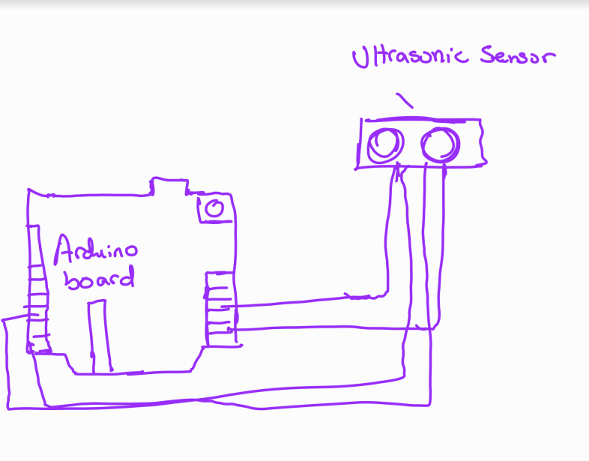
Figure 2.1.1: Sensor Setup

- Design concept by Aaron

An ultrasonic sensor will measure the density, pressure, and, ultimately, the specific gravity. The main differentiating characteristic between this and Hasain design is the modularity of the port which will allow for ease of cleaning and removal.

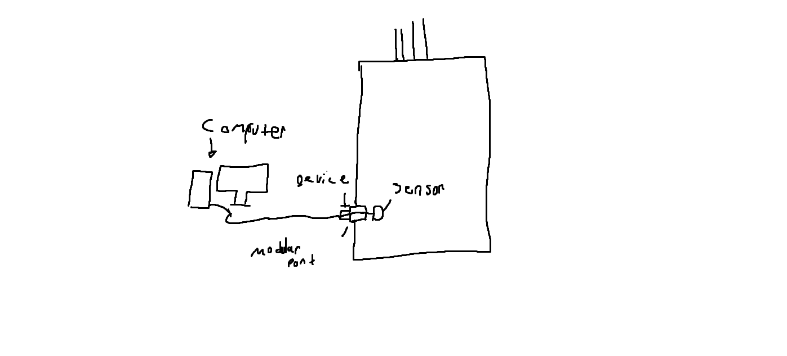
Figure 2.2.1 sensor and data transfer

- Design concept by Sofiya

Capacitance sensors can allow for measurements of water level. This sensor does not need to be fully submerged into water to provide an accurate reading, yet fully waterproof. The process of capacitance sensor is accomplished through an electrode which produces an electric field to create a “fringing effect”. If the liquid is in proximity, the sensor would be able to determine its location and record it. This type of sensor can be located externally, but since the tank is made from conductive material, this sensor will be located internally for this project. Electrodes will be within a fixed tube that is mounted securely inside the tank. The tube will be produced from silicone.

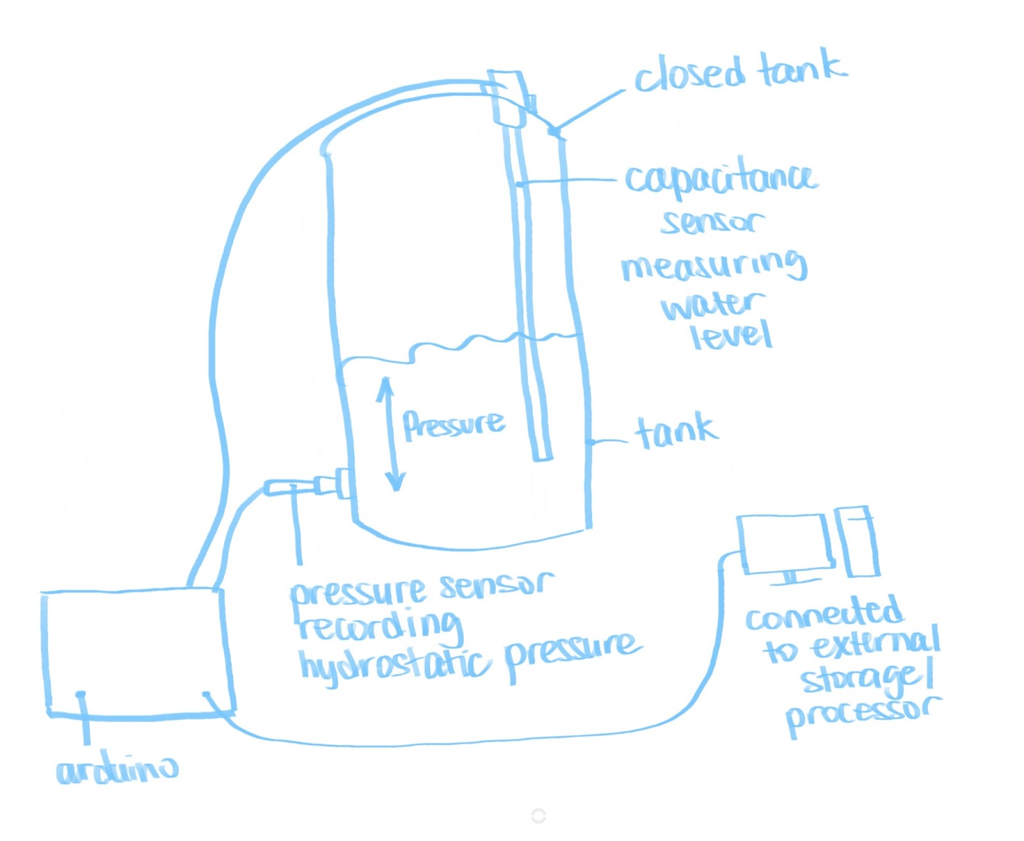
Figure 2.3.1: Capacitance and pressure sensors

Additionally, a second sensor is required near the bottom of the tank. Pressure sensor needs to be installed to deduce the specific gravity of the fermented liquid. It records the weight of the entire water column and can provide very accurate readings even in an enclosed tank. Since the tank has the ability to expel extra CO2 produced during the fermentation process, it can make pressure reading even more accurate. Both sensors would be attached externally to an Arduino board.

- Design concept by Emma

The use of a pressure and vibration sensor will allow for the measurement of specific gravity within a closed tank. The vibrational sensor measures the density of a given liquid through resonants and a tuning like structure to measure frequency. These sensors would then have to be connected to an Arduino board and an external storage system to save all the recorded data in house.
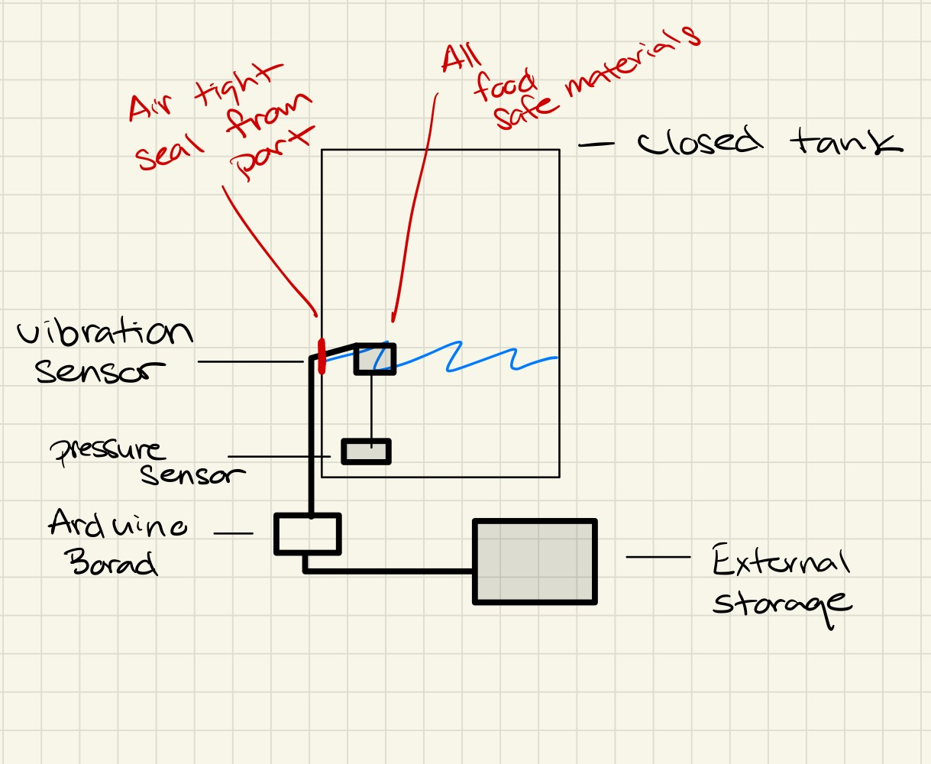

Figure 2.4.1: Vibration and pressure sensor
- Design concept by Erik
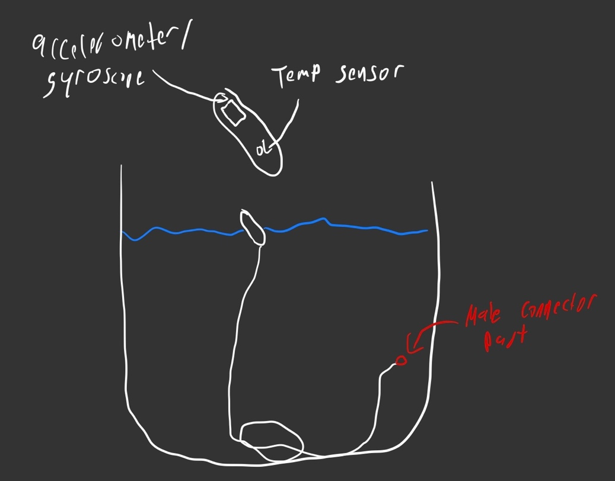

Figure 2.5.1: Buoyant Accelerometer/gyroscope and Temperature Sensor

The accelerometer/gyroscope and temp sensor are floating because to be able to calculate the specific gravity of the beer we require the angle at which they float, which is why the accelerometer/gyroscope is used. An accelerometer/gyroscope can be used to gather the angle. There is also a temperature sensor to get the temperature of the beer and also be used in the calculations for the specific gravity.

- Subsystem 2: Port

  - Design concept by Hasnain

Sensor connected to a silicone wire would be the best material for the wire since it is flexible and can withstand high temperatures (-90 degrees to 200 degrees) comfortably, additionally silicone is food grade. For the brewery the wire will be attached to the machine in the fluid, so thus it is not free floating, but the wire is attached to it. The buoyancy of the fluid will dictate its tilt angle which can then be further used to calculate pressure and density and specific gravities.

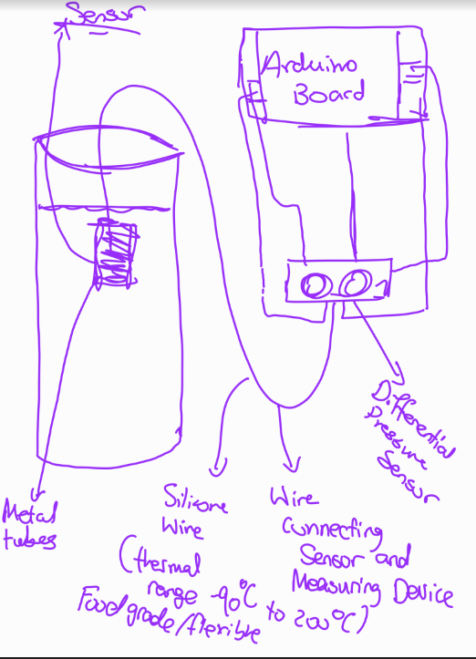

Figure 3.1.1: Sensor to Port connection
- Design concept by Aaron

The device will be plugged into the port while the sensor is in the beer silo. The sensor will be at the end of a wire, allowing for checking for the needed values of liquid while avoiding issues arising from it being free-floating. The device's overall design will allow for easy access during cleaning or maintenance while still giving accurate results on the specific gravity of the liquid. There is also the method by which the data would be transferred by wire to a PC. As well as, if the specific gravity rapidly changes in value, there will be a type of warning system to notify the staff for irregularities. By an auditory alarm so the staff can know of the irregularity.
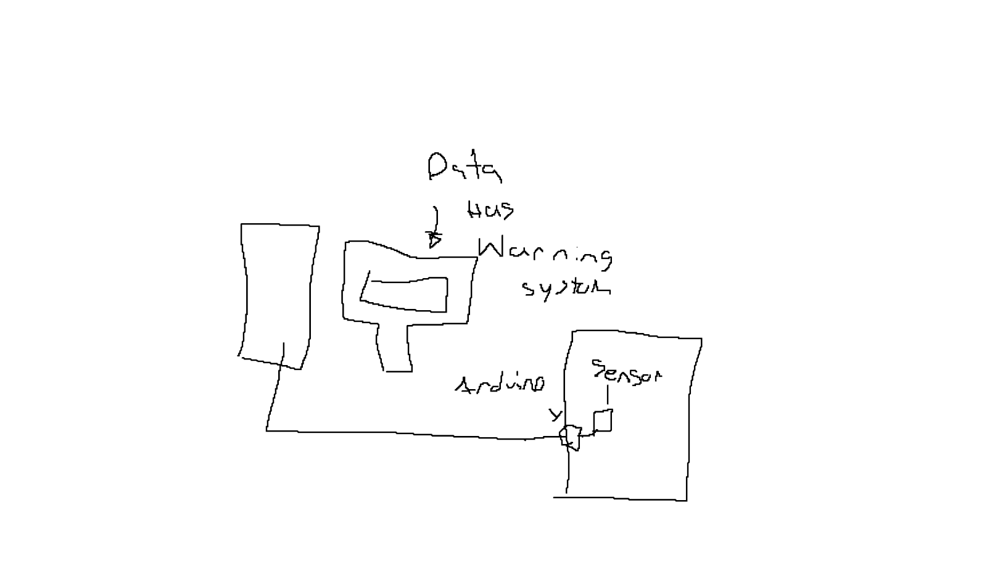
Figure 3.2.1 Data warning for irregularities

- Design concept by Sofiya

The client expressed his desire for something that would not be free-floating in the tank and could be easily removed. For the capacitance sensor, it can be mounted through the opening securely to the side of the tank inside. Since it provides measurements continuously, once set up and calibrated it does not need to be removed or accessed, so the tank can be securely sealed and still provide measurements.

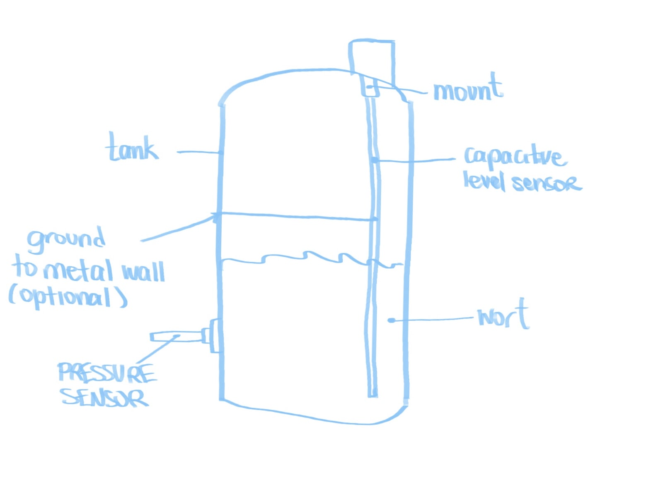
Figure 3.3.1: Port location and attachments

The pressure sensor can be mounted into the bottom side port provided on initial images from our client. The sensor can then provide readings from the bottom of the water column of the hydrostatic pressure there.

- Design concept by Emma

The sensors will need to be supported by food safe wire like silicon since the client doesn’t want the device to be free floating within the tank. To attach to tank the device will need to fit through the porthole and be able to be easily removed for cleaning while still maintaining its structure and data collecting ability. The tank has some pressure within it and therefore the device needs to be able to withstand this pressure while being small enough to fit through the port.
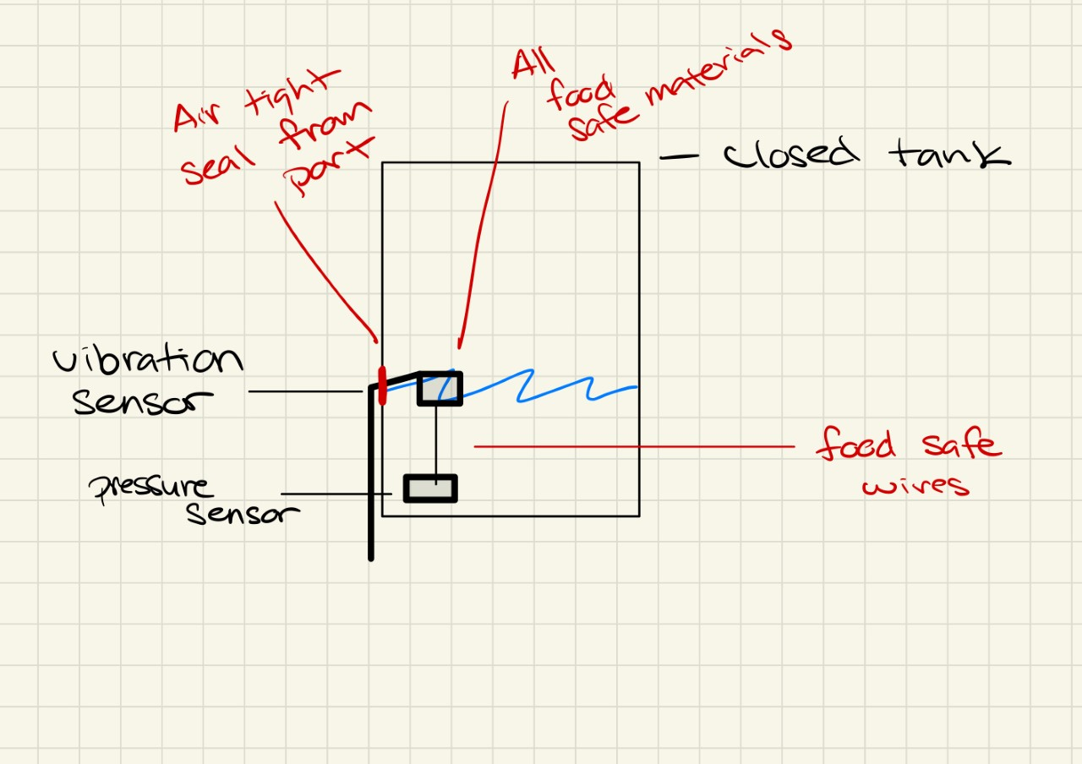

Figure 3.4.1: Port and connections

- Design concept by Erik

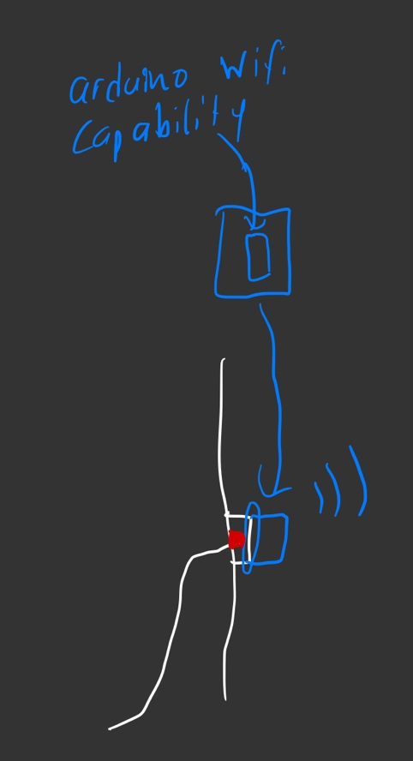

Figure 3.5.1: Port Attached Arduino with Wi-Fi for Transmitting Data

The Arduino with Wi-Fi capability is mounted to the side of the tank and is used to do calculations for the specific gravity and transmit that data through a MQTT connection with subsystem 3. The sensor can be plugged into the Arduino and then the Arduino can continue the rest of the process. The port where the sensor is plugged in and where the Arduino is mounted must remain watertight.

- Subsystem 3: Storage

  - Design concept by Hasnain

Use serial communication to send data from the Arduino to the personal computer and graph result. Required hardware will be an Arduino board and an analog sensor. Connect analog sensor to analog input 0.
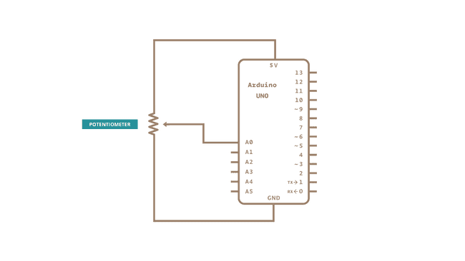
Figure 4.1.1: Schematic

Code and further information regarding Arduino = https://docs.arduino.cc/built-in-examples/communication/Graph

Then we will use the processing sketch which is in the link above to get a graph of the sensor's value.

- Design concept by Aaron

The data will be sent from an Arduino in the device to a PC via wire which then data will be categorized for ease of use and on-demand graphing. While the data will have an active monitoring system, so if the specific gravity is lower or higher will trigger an alarm. This is so the user can work while the specific gravity is being measured. While still having some monitoring system on each beer silo. When the user feels they should manually monitor the specific gravity, they can.
- Design concept by Sofiya

Both sensors would be connected to an Arduino board externally through cables. An Arduino board is to be connected to a PC or other computer of choice to run and provide output information that is read by the sensors. Measurements provided by both sensors are continuous. Data received would be converted using the following formula to find specific gravity:

P = SG*H

Where:
P - hydrostatic pressure or pressure at the bottom of the tank
SG - Specific Gravity or the value that we are looking for
H - Height of the liquid

Each reading must be calibrated to the temperature of the fermented liquid for accuracy since variables such as density of liquid and specific gravity depend on the temperature of the liquid inside the tank. Once specific gravity is calculated, it would be graphed per hour to provide a visual representation of the collected information through the Arduino serial monitor.
- Design concept by Emma

The two sensors would be put through a port and would be supported by a food safe wire to collect the data from the two sensors and ensure they do not become free floating in the tank. These sensors would then have to be connected to an arduino board and an external storage system to save all the recorded data in house. An active monitoring system or live notifications must also be present to alert the client if the specific gravity is dangerously low or high at any given time as the data needs to be real time and constantly updating for the best result.

- Design concept by Erik

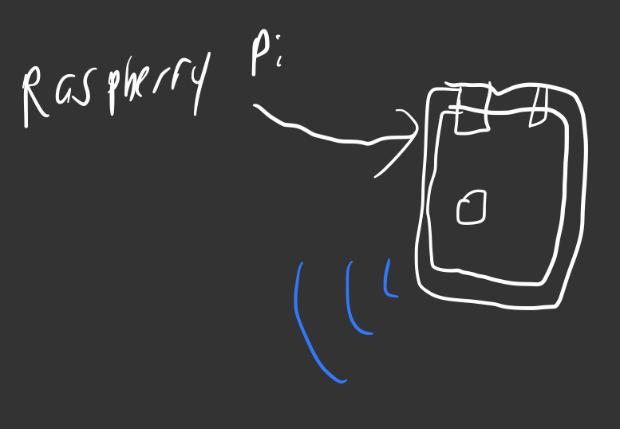

Figure 4.5.1: Raspberry Pi in an Enclosure

A Raspberry Pi is used to run a web server and also connect to the various tanks. A web server is run on the Raspberry Pi to be able to display the data graphically to the user and from anywhere. The Raspberry Pi will use a MQTT connection to collect the data from the various Arduino’s.

- Analysis and Evaluation

Once all designs were researched, we analyzed them as a team. Each had its advantages and disadvantages, but we were able to select our global concepts.
For capacitance and pressure sensor coupling, this option did not suit our needs, so we decided to not proceed with it. As mentioned previously, there are a few advantages to this method, such as the fact that both methods are mounted and produced from food grade materials as per our client’s request. However, capacitance sensors, even though they provide readings consistently, are not very accurate. That said, you have to take a lot of measurements and use average to get a decent result. In our case, accuracy is important. Additionally, capacitance sensors require a lot of calibration. If a tank is fully sealed and the environment is perfect, it may work. Yet, if environmental factors are not perfect, the device would need to be continuously removed and recalibrated to continue receiving perfect measurements. Therefore, this option does not work for our client and will be disregarded by our team.
For designs that used ultrasonic sensors, we decided to not proceed with those as well. We decided that they were not the best fit for our project for a few reasons: they did not provide pressure/specific gravity calculations as requested and the difficulty of using them. They are best suited for calculation of level and position, like the height of the fluid, which in our case isn’t too relevant to what we are doing. Additionally, it would not be easy to get accurate measurement results for specific gravity from this sensor.
Also, the vibration and pressure sensor design wasn’t chosen as it involved extra resources that weren't in budget and also had functionality issues. Since two different types of sensors, and an Arduino were required to create this design it wouldn’t be possible within our $100 limit of this project. The second reason that this device wasn't chosen as our product is because of the size issues with the vibrational sensor and the size of our client’s tanks.
As a team, we chose the design that includes an accelerometer/gyroscope and a temperature sensor that are floating in an enclosed capsule. We decided that it would be a good sensor to use because, first of all, the angle at which something floats in a certain liquid can be used to calculate the liquid's density. Secondly, the sensor performs all of its function within itself without having to rely on external factors. For example, a load sensor that measures weight will require no one to be adding pressure to the tank or a ultrasonic sensor will require there to be nothing in the way.
We also chose this option since it includes a temperature sensor that our client requested. Another reason why it is necessary is because we require the temperature of the liquid to be able to calculate the specific gravity. The reason the two sensors are floating is because based on the angle it floats at we will be able to calculate the specific gravity and a wire is attached so the sensors are not free floating. The sensors are then connected to an Arduino with Wi-Fi, so it can calculate the specific gravity and send it through Wi-Fi using an MQTT connection to a raspberry pi. We don’t know if using a raspberry pi is a viable option due to the $100 budget and the cost of raspberry pi’s being so high. However, it is something we will be reassessing at the next step of our project - cost analysis.
Additionally, we would like to include the automation portion. This system was chosen because it would allow for automatic checking and monitoring of the specific gravity. Because if the value were seen to be too high or low from the needed specific gravity, it would trigger an auditory alarm to the user. While still allowing for the specific gravity to be manually checked by the user via a graph. We think it would provide additional help to the user since he would be notified right away when the fermentation process is entering a specific stage without the need to constantly check the data.

- Conclusions

In conclusion, our team presented various design options for each subspace, such as sensors, port, and storage. We have researched and analyzed different options. In the end, we have decided that the floaty with gyroscope and accelerometer that is able to measure angle of the floater is the design that would fulfill our clients’ needs the most. It would attach to Arduino through the port and collect all necessary measurements. To prevent our client from always needing to check the system, automated notifications would be sent out once the system detects significant changes in specific gravity.

