Deliverable G: Business Model

GNG 2101 - Intro to Product Dev. and Mgmt. for Engineers

Group C3.2 - Power Grabber
Tony Kim - #300087407
Zitai Peng - #300148371
Alan Tan - #300021231
Jingyi Jiang - #300121959
Marie Daoust - #300052381

Company Name:
PowerAdapt Inc.

March 20, 2022

Table of Contents

Table of Contents 2
G.1 - Business Model 3
Key Partners 3
Key Activities 4
Value Propositions 4
Key Resources 4
Customer Relationships 4
Customer Segments 4
Channels 5
Cost Structure 5
Revenue Streams 5
Core Assumptions 5
G.2 Economics report 6
Costs 6
3-year Income Statement: 6
Break-even Point 7
NPV for Expected Sales 8
NPV for Break-even Sales 8
G.3 Project Update 9
Brief 9
Tasks 10

G.1 - Business Model

PowerAdapt Inc. is a Canadian start-up company, debuting with the launch of our battery-powered grabber stick which allows people with limited limb mobility to grab objects.

Our business model is a direct-to-consumer sales model through our website: www.poweradapt.com. We estimate around 70% of our sales are being driven through our website sales. We will also use a network of established medical distributors and suppliers to reach as many of our target customers as possible.

Key Partners
- Suppliers:
- Polymaker
  - Supplies us PLA and PC 3D-printer filament for all our 3D printed components
- Creality
  - Supplies us with 3D printers
- SmallRig
  - Supplies specialized carbon fiber rods originally meant for photography equipment
- McMaster-Carr
  - Supplies misc manufacturing equipment and hardware
- DigiKey
  - Supplies us with electronics components
- Panasonic
  - Supplies us with 18650 batteries

- Distributors:
- National Medical
  - Canada-wide distributor of medical equipment
- McDonalds HHC
  - Distributor of medical equipment in British Columbia
- Amazon Inc.
  - Warehousing and fulfillment solutions

- Operations:
- Shopify Inc.
  - Responsible for our online storefront and order fulfillment.
- Canadian Western Bank
  - Holds liquid assets.

- Advertising:
- Facebook
- Google Advertising

Key Activities
- Manufacturing and sales of electro-mechanical grabber sticks for use by people with limited mobility.
- Research and development of other powered adaptive devices and specialized equipment for use by the disabled.

Value Propositions
- Promote independence for the disabled person.
- Make life easier by enabling someone to reach objects where they could not normally reach without assistance.

Key Resources
- The PowerGrab Mk.I: a physical device our customer will be buying for use to grab objects with the assistance of a powered-claw mechanism with push-button activation.

Customer Relationships
- Self service chatbot on our website.
- 3-year limited warranty on all our products.
- 24/7 outsourced call-center support for returns and warranty support

Customer Segments
- Facebook Users
- Disabled persons, including but not limited to those with the following medical conditions, these conditions may limit the individual’s range of movement and mobility necessitating the use of a stick to grab objects out of reach:
  - Paraplegia, quadriplegia, hemiplegia.
  - Parkinson’s
  - ALS
  - MS
  - Arthritis
  - Osteoporosis
  - Dwarfism
  - Musculoskeletal disorders
- Elderly
- Able-bodied people who just want a grabber stick to their customization.

Channels
- Our Shopify-enabled website processes all of our sales.
- Field sales at trade shows such as the Chicago Abilities Expo
- External Distributors across North America

Cost Structure
- Web hosting costs
- Marketing and sales
- Product manufacturing
- Product research & development
- Raw material costs
- General and administrative
- Distributor charges
- Warehousing costs

Revenue Streams
- Product Sales
- Custom manufacturing projects

Core Assumptions
- Disabled people who can’t reach objects in inaccessible areas exist in the market

G.2 Economics report

Costs

Cost | Amount $/year | Variable/fixed | Direct/indirect
Materials | 100 unit cost x 4,000 sales  = 400,000 | Variable | Direct
Equipment | 100,000 | Fixed | Indirect
Advertisement | 500/month  = 6,000 | Fixed | Indirect
Power | 500/month  = 6,000 | Semi-variable | Direct
Labor | 5 employees average 40,000 yearly income  = 200,000 | Fixed | Indirect
Rent | 1,000/month  = 12,000 | Fixed | Indirect
Interest expenses | 200,000 * 0,05  = 10,000 | Fixed | Indirect
Total costs | 634,000

3-year Income Statement:

Sales (Revenue) | 12,000 sales * 200 unit price  = 2,400,000
- | -
Cost of goods sold | 100 unit cost x 12,000 sales  = 1,200,000
= | =
Gross profit | 1,200,000
- | -
Operating expenses | (6,000 + 6,000 + 200,000 + 12,000) * 3years + 100,000  = 772,000
= | =
Operating income | 428,000
- | -
Interest expenses | 200,000*(1+0.0.5)³ - 200,000  = 31,525
= | =
Earnings before taxes | 396,475
- | -
Income taxes | 396,475 * 0.27  =107,048.25
= | =
Net income | 289,426.75$

Break-even Point

Inflation rate = 5% yearly

NPV for Expected Sales
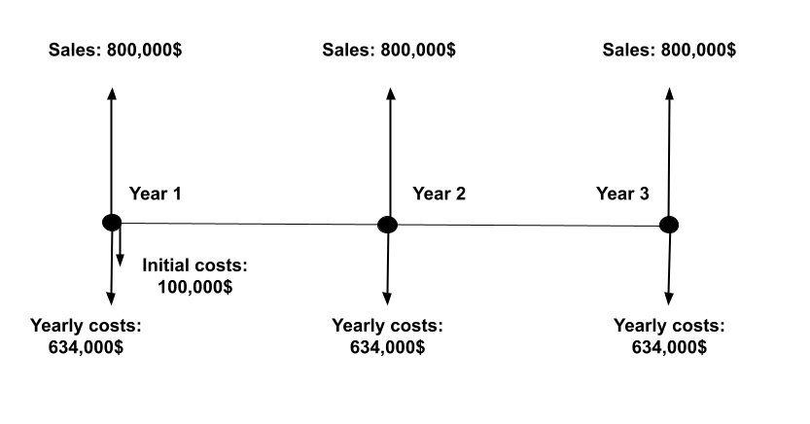

(800,000 - 634,000 - 100,000) + (800,000 - 634,000)*1.05 + (800,000 - 634,000)*1.05²
= 66,000 + 174,300 + 183,015
= 423,315

NPV for Break-even Sales
Total revenue - Total costs = 0
(200n - 134,000 - 100n - 100,000) + (200n - 134,000 - 100n)*1.05 + (200n - 134,000 - 100n)*1.05² = 0
315.25n - 522,435 = 0
n = 1657.21

Therefore, we must sell 1658 units yearly for the next 3 years to break even.

G.3 Project Update
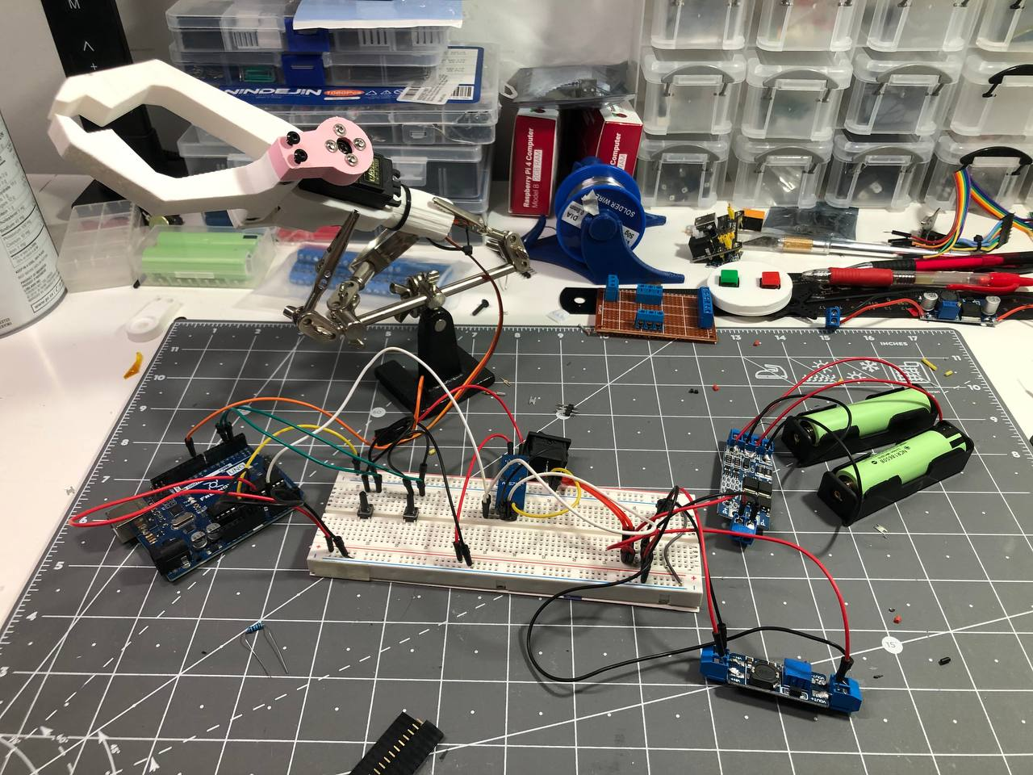

Brief
The electronics system, including the new battery management system and charging circuit, are being tested on breadboard.

A redesigned part is also experimentally printed in pink per the user's request.This part is redesigned so that it can provide a stronger connection between the servo output shaft and the claw finger.

Previously planned pressure sensor for controlling the force of the claw has been replaced with a current sensor measuring the current used by the servo. This change is made because it might give more reliable reading than a physical force sensor.
The firmware for the grabber is also being tested to ensure user-friendliness and safety.

The issue we are facing right now is that the USB power delivery protocol is too difficult to control without using a custom-made PCB. A redesign of the power source might be required.

Tasks
Complete the firmware and hardware testing.
Redesign the handle and arm support part
Redesign the charging circuit.
Print all the parts in pink for the final product

