Deliverable F: Prototype 2

GNG 2101 - Intro to Product Dev. and Mgmt. for Engineers

Group C3.2 - Power Grabber
Tony Kim - #300087407
Zitai Peng - #300148371
Alan Tan - #300021231
Jingyi Jiang - #300121959
Marie Daoust - #300052381

March 6, 2022

Table of Contents

Table of Contents 2
Introduction 3
Client Feedback 3
Assumptions 4
Previous Prototypes 5
Latest Prototype 8
Testing 15
Conclusion 16

Introduction
This report will showcase the development of Group 3.2’s current prototype, the power grabber. In this report previous prototypes, critical assumptions, the current prototype and client feedback on said prototype will be discussed. The goal of this prototype was to determine the remaining steps to complete the power grabber, or what steps need to be added to accommodate any new clients needs.

Client Feedback

Our 3rd client meeting was our first in person meeting. During this meeting we set out to demonstrate our first fully constructed prototype. We went into the meeting with 3 major goals; 1. To make sure Maeve could lift the power grabber and bring it to table height or roughly 1 meter above the ground. 2. To gather more accurate information on her dimensions and how she interacted with the power grabber prototype. 3. To further confirm our design concept ideas with the clients and adjust accordingly to any of their needs. Below is a summarized list of each client’s view on the prototype.

- Clinton
  - Would like to lower the arm support
  - She can lift a 100-200g object to a table above her shoulders
  - Does not want a built in secondary arm support
  - A little lighter
  - The handle is a good size that accommodates Maeve’s future growth
  - The handle shape is ergonomic enough as is
  - Is okay with either activation design of the power grabber
    - Press one button and the claw will close all the way until the pressure sensor says stop and press another button to release the object and return to a fully opened position.
    - Press or hold one button to close the claw little by little and visually judge whether the grip is firm and press or hold another button to open up the claw.
  - Was not sure about having one claw stationary but after the demonstration he likes the idea.
  - The arm can be a little shorter, if it could be adjustable then that’d be even better
- Maeve
  - She would like it to be colored pink
  - She’s compares it to a walking stick
  - She likes the current shape
  - She likes the would like it to be a little lighter
  - The buttons are acceptable shape and size, they are also easy to use
- Paul
  - If possible make the claw rotatable
  - Create an auxiliary arm support so the user can use the other arm to lift the power grabber. This would attack to the arm of the power grabber
  - Larger velcro straps (width)

From this client meeting we were able to successfully accomplish all 3 of our objects. Maeve was able to lift the power grabber to an even higher height than we had anticipated. We were able to see that some parts were too big for Maeve and can now adjust the prototype to better suit her. To do this we will need to redesign the arm support closer to the handle and shrink the length of the arm. Finally we got the thumbs up clear to proceed with our initial concept design described in Deliverable D. We will proceed to implement the electrical system and create a controlled system to operate the claw.

Assumptions

Our most critical product assumption prior to the 3rd client meeting was weight, we were hinging the concept design on the idea that Maeve could lift the power grabber, without a load, with ease. However, after the 3rd client meeting this is no longer an assumption we need to concern ourselves with since she was able to demonstrate her ease of use to us in person with our prototype. The next critical product assumption was material delivery, however, we have all the materials to finalize our prototype. We have confirmed the functionality of the power grabber with the client, so there will be no need to order new parts and hope Amazon delivers our material on time.

At this point our most critical product assumption is that the activation mechanism for the claw will be adequate for use. Though at this point our product is nearly complete so any assumptions will have minor to no setbacks even if they prove wrong. Will it respond fast enough? How fast should the claw open or close? Should the claw open or close all at once or in intervals? If intervals, will it open or close smoothly? Can we design it to not crush the object?

Previous Prototypes

We have many theoretical prototypes for the handle and arm support, as shown below.
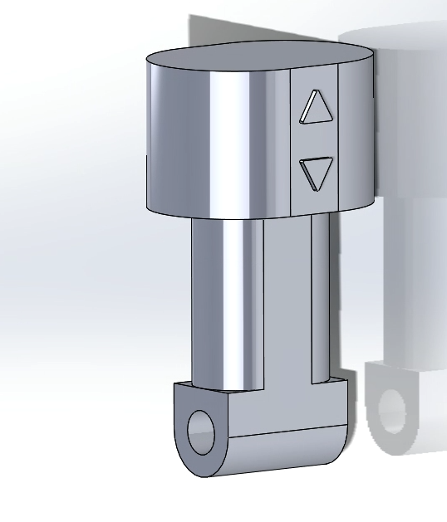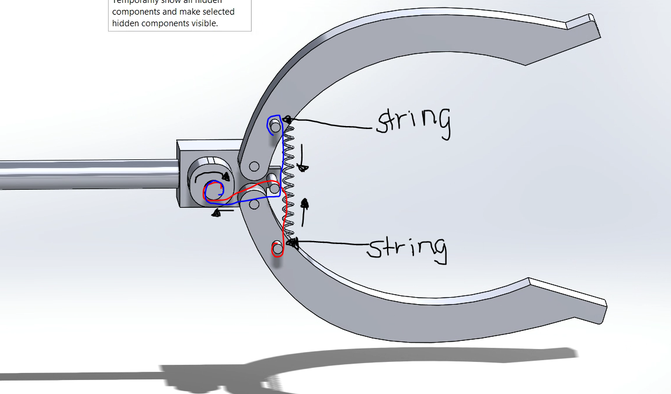
Figure 1: Theoretical handle and claw, independent components
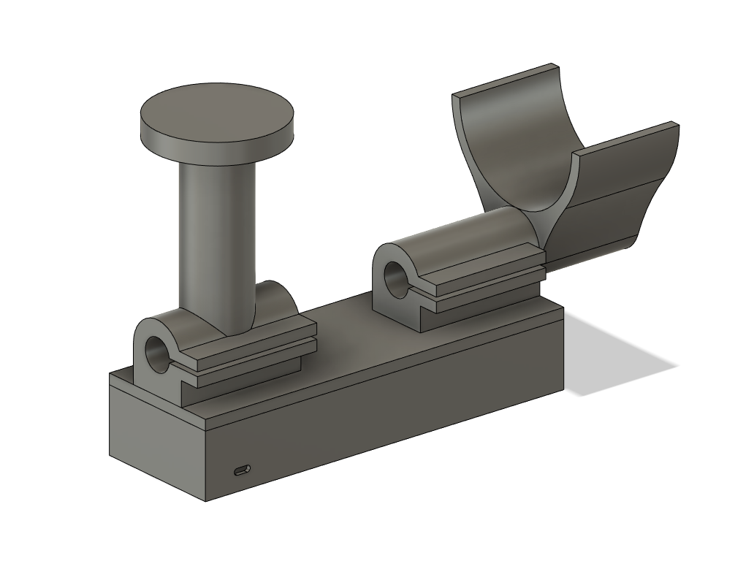
Figure 2: Theoretical handle, electronics box and arm support combined component
Figure 3: Theoretical handle, electronics box and arm support combined component

Then we have some 3D printed prototypes, which we used to prove or disprove our product assumptions.

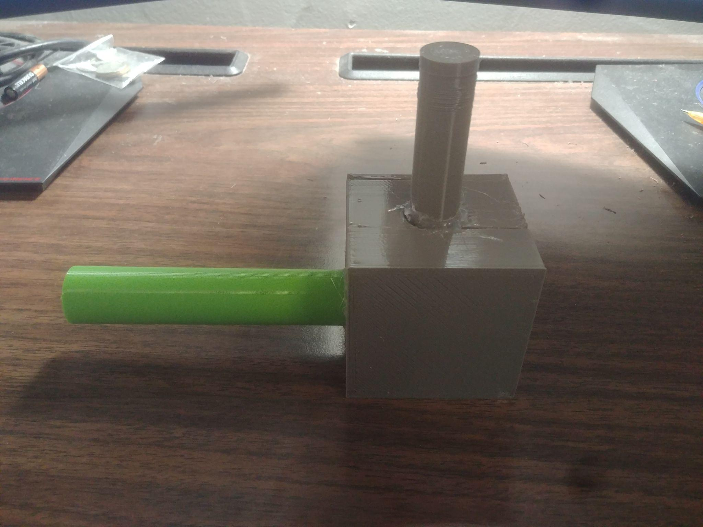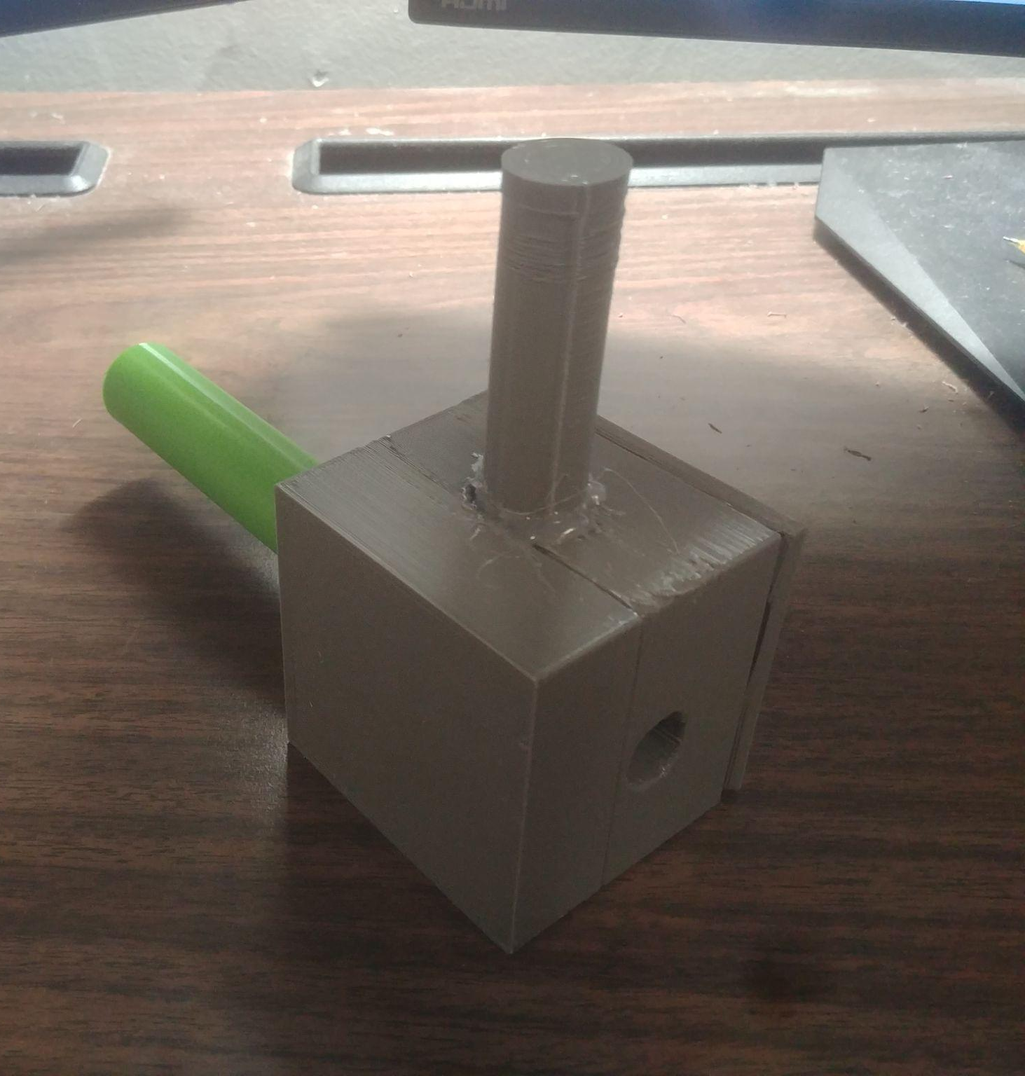
Figure 4: SUPER Low fidelity handle prototype

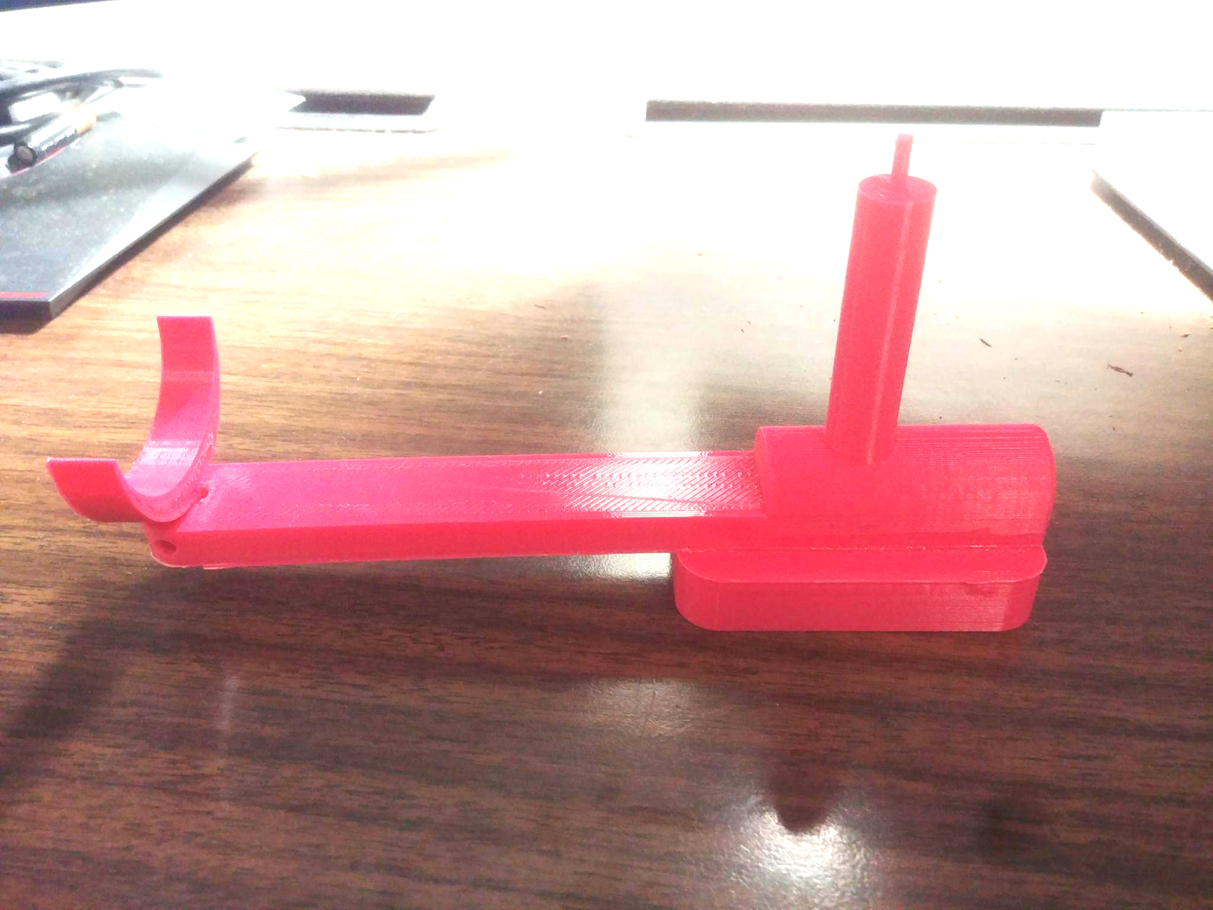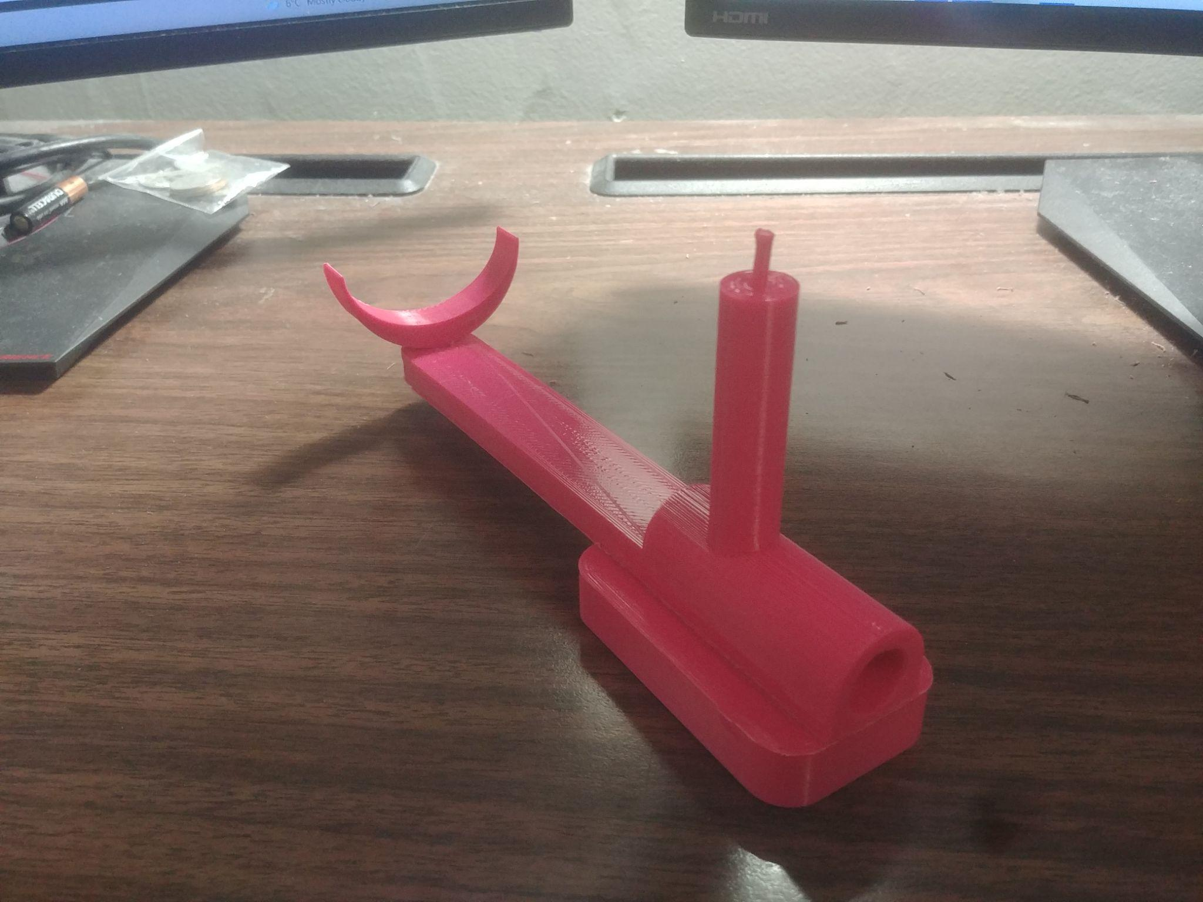
Figure 5: Low fidelity handle, electronics box and arm support prototype
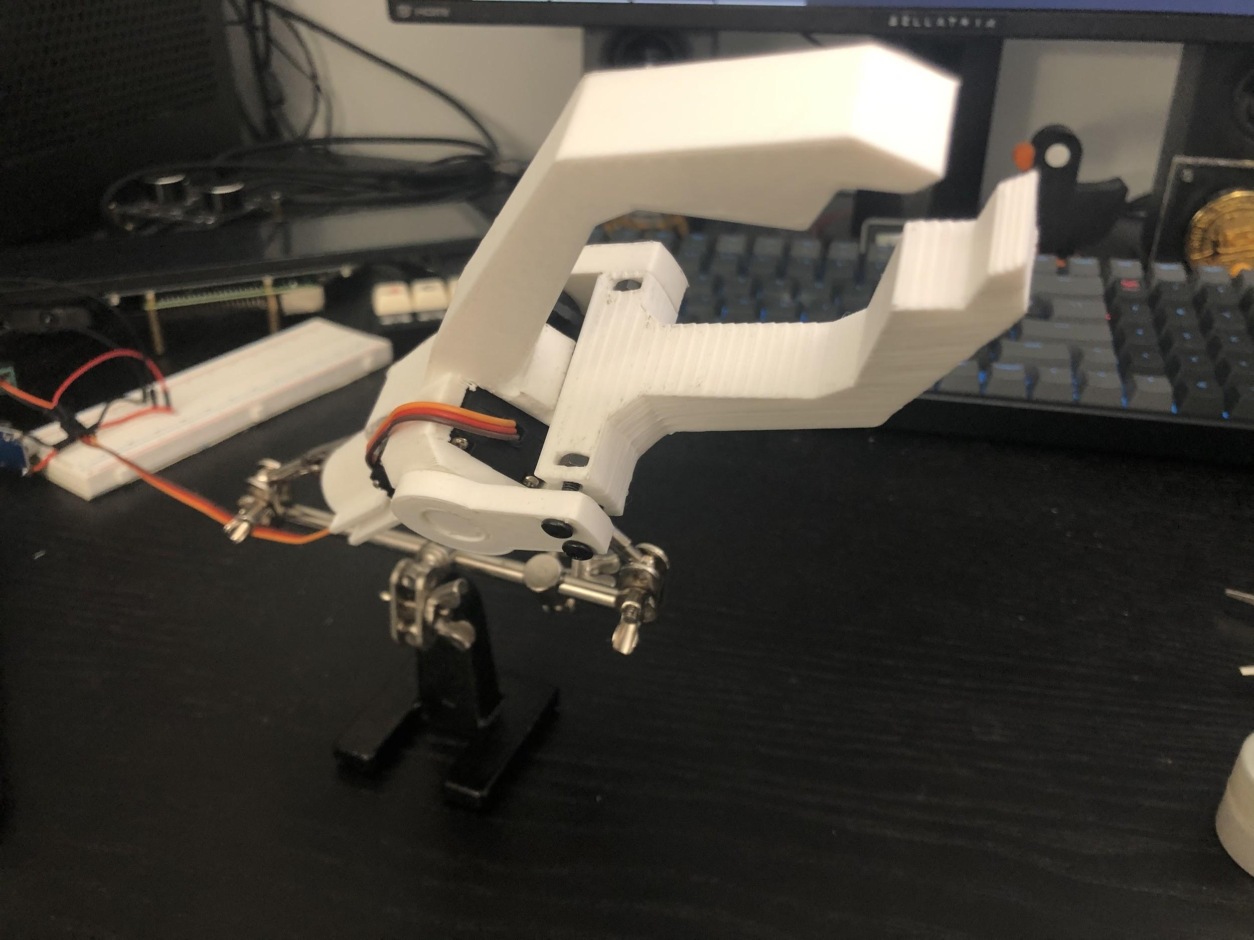
Figure 6: Mid fidelity functioning claw prototype

Using the previous prototypes above, theoretical and practical, we were able to conclude a set of measurements for this new prototype. Namely the length of the electronics box, the handle size, the arm support and the distance from the handle to the arm support. Once we had these we were able to finally put all the individual components together and create our first full system prototype.

Latest Prototypes

Below we have the full system prototype.
Figure 7: Side View of Power Grabber

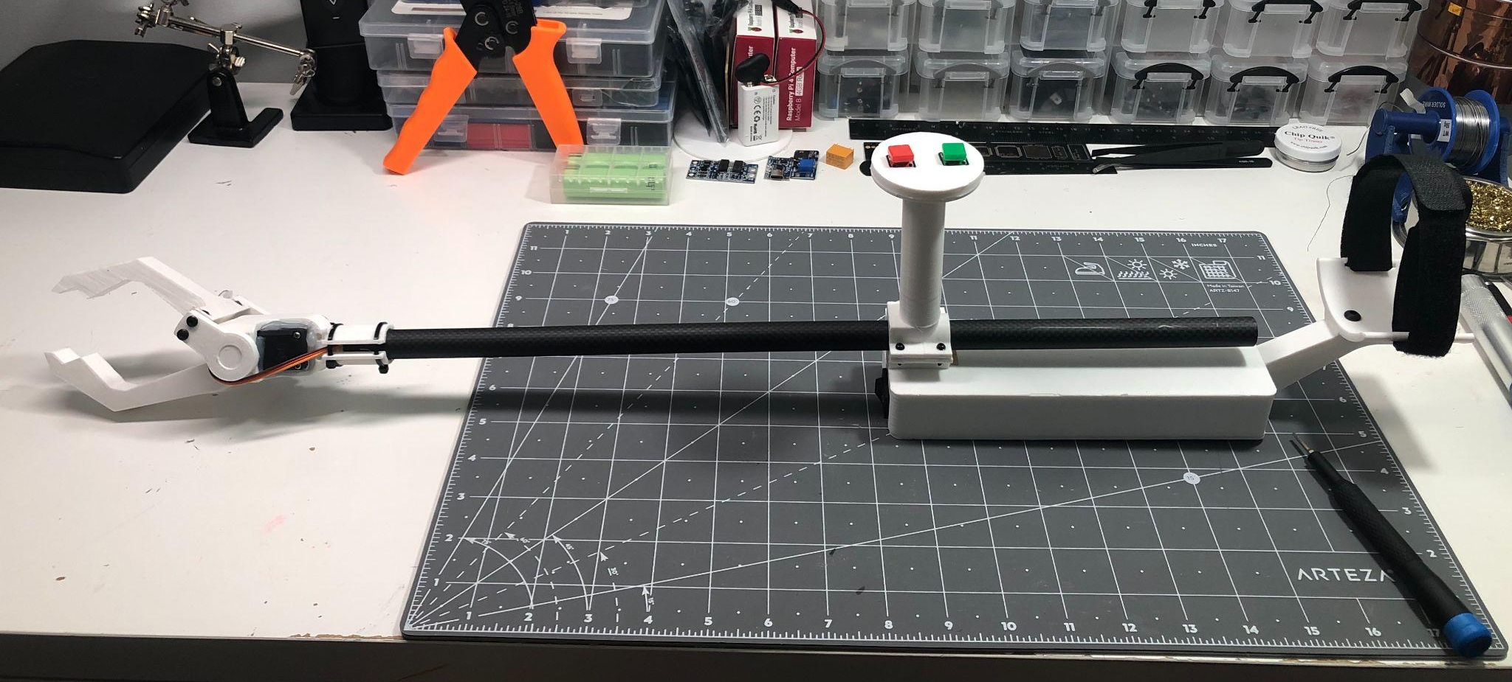
Figure 8: Isometric View of Power Grabber

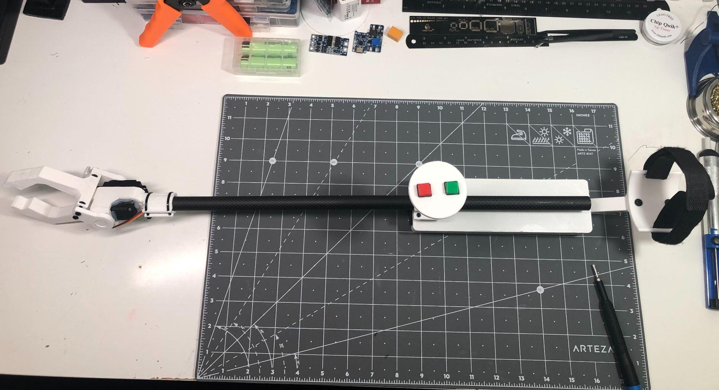
Figure 9: Top View of Power Grabber

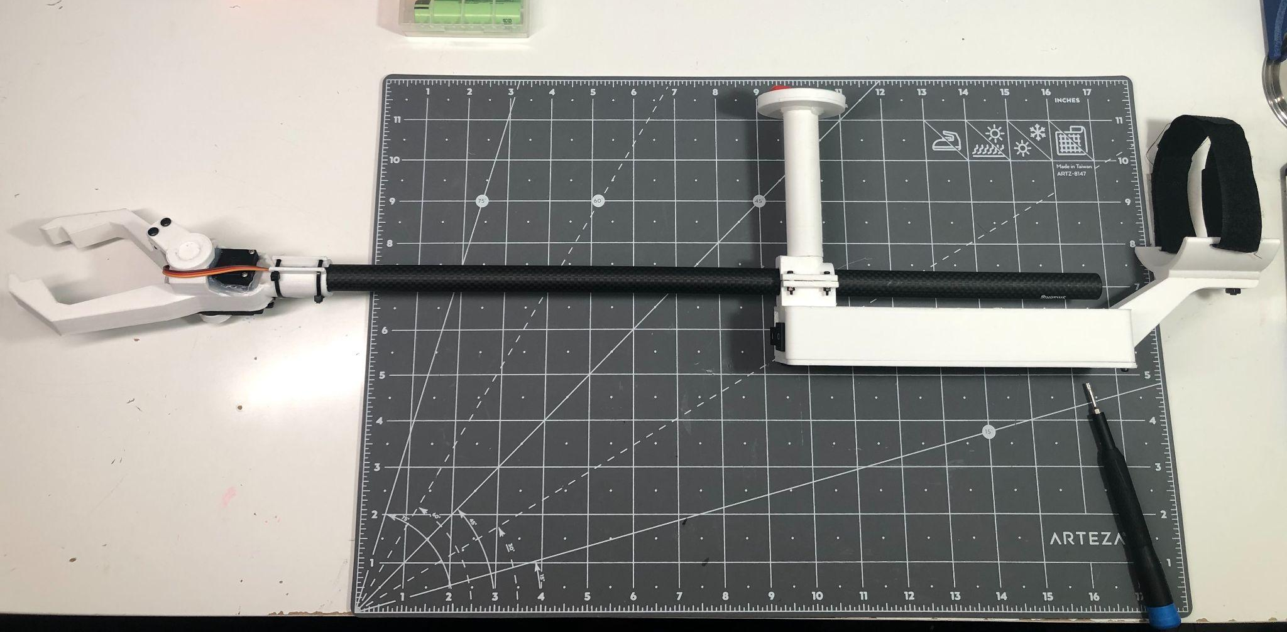
Figure 10: Side Profile of Power Grabber

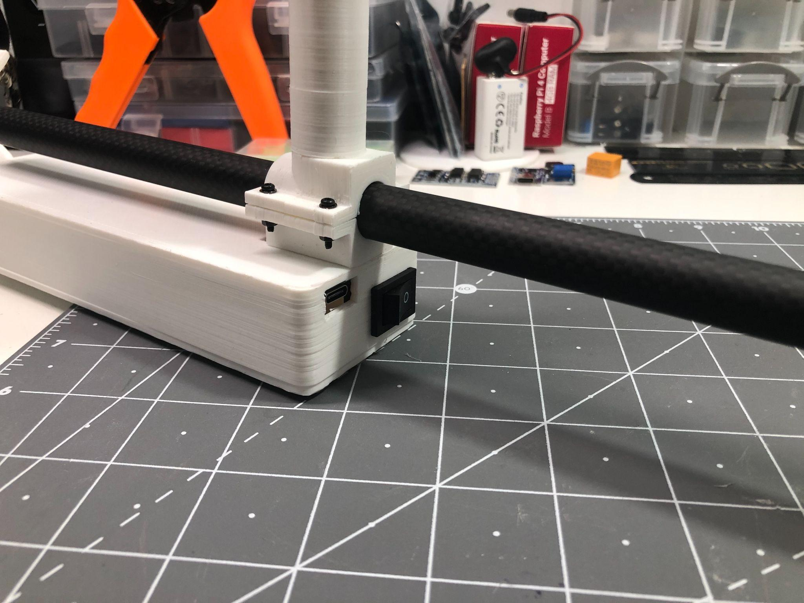
Figure 11: View of Charging Port and On/Off Switch

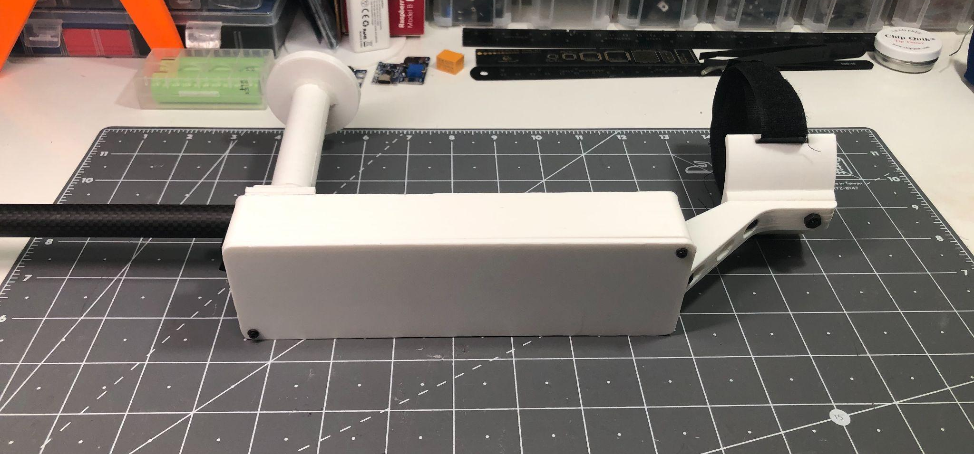
Figure 12: Underside of Electronics box

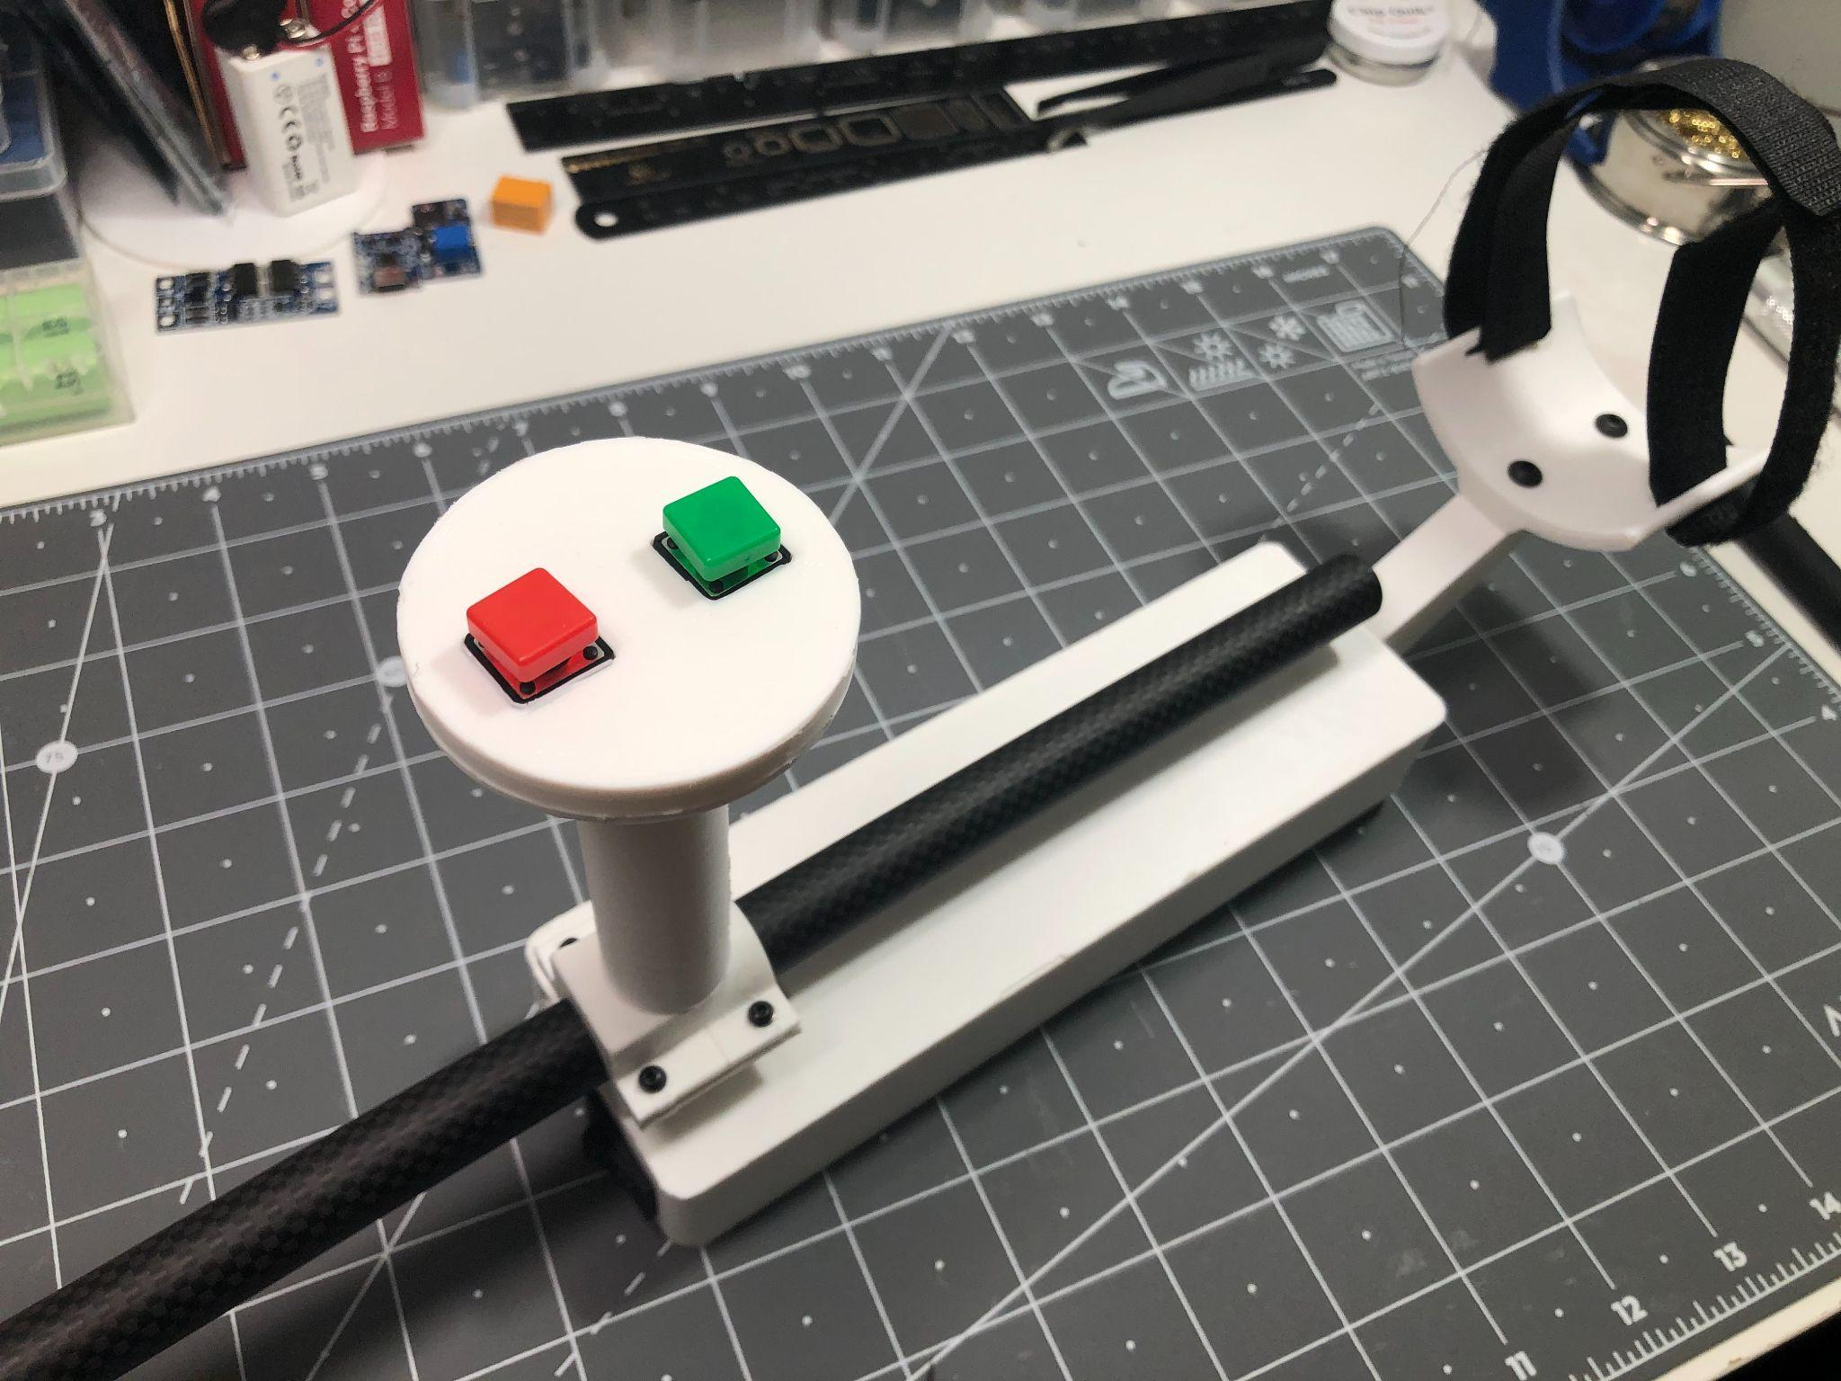
Figure 13: Handle, Electronics Box, Arm Support and Button Activation
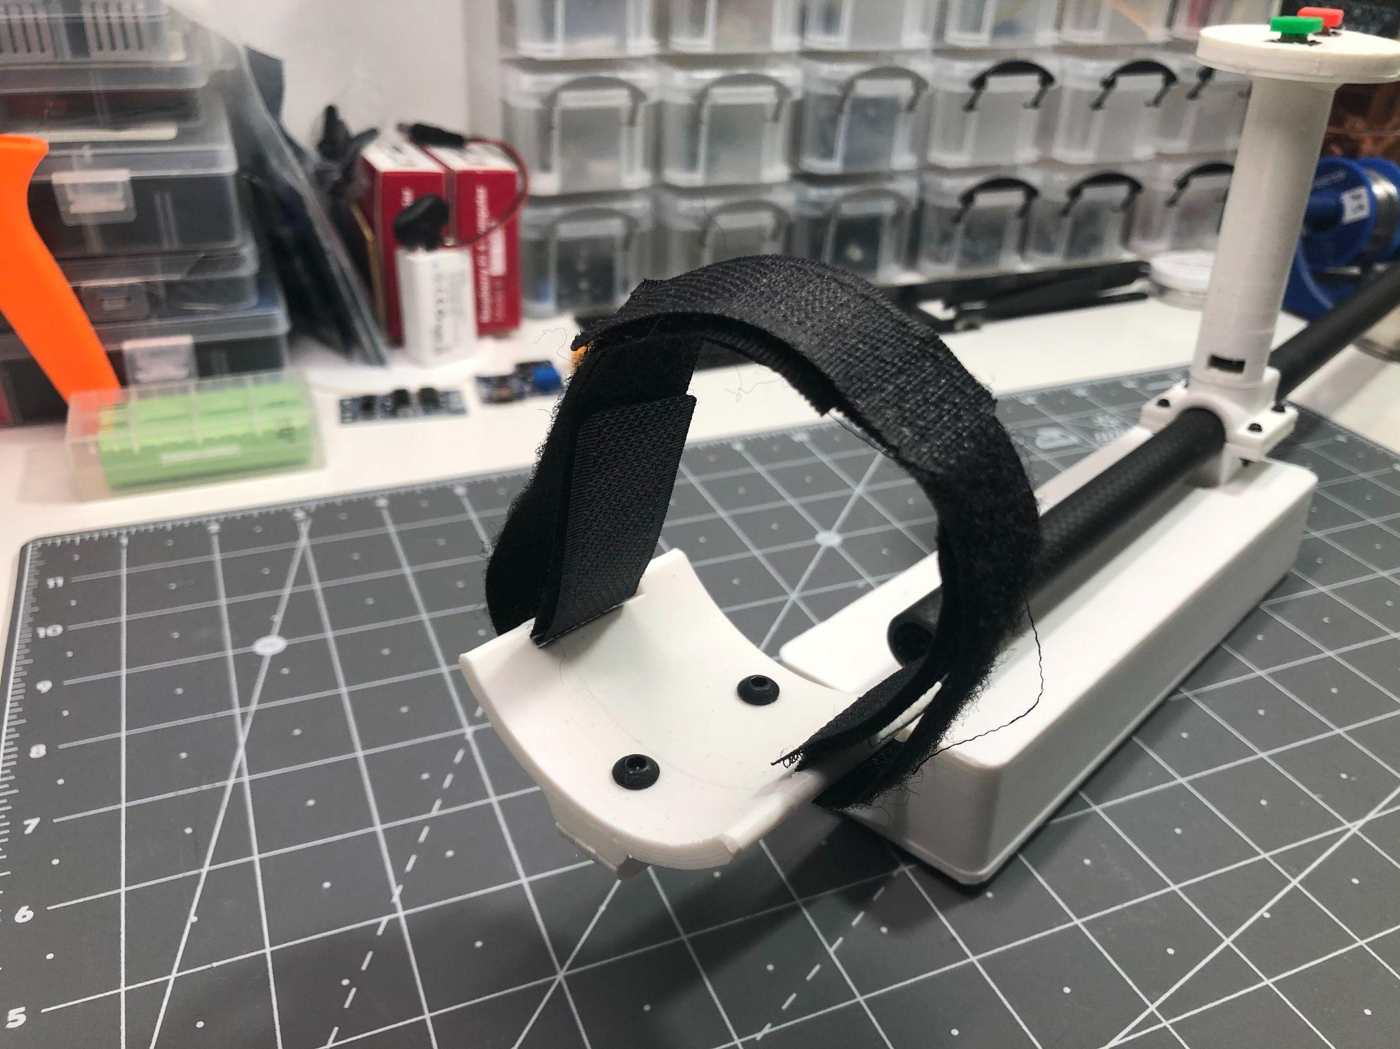
Figure 14: Arm Support and Velcro Strap

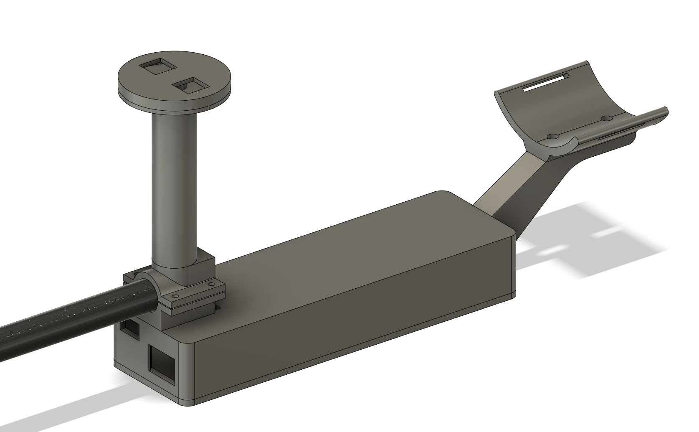
Figure 15: Handle, Electronics Box and Arm Support of Built Prototype
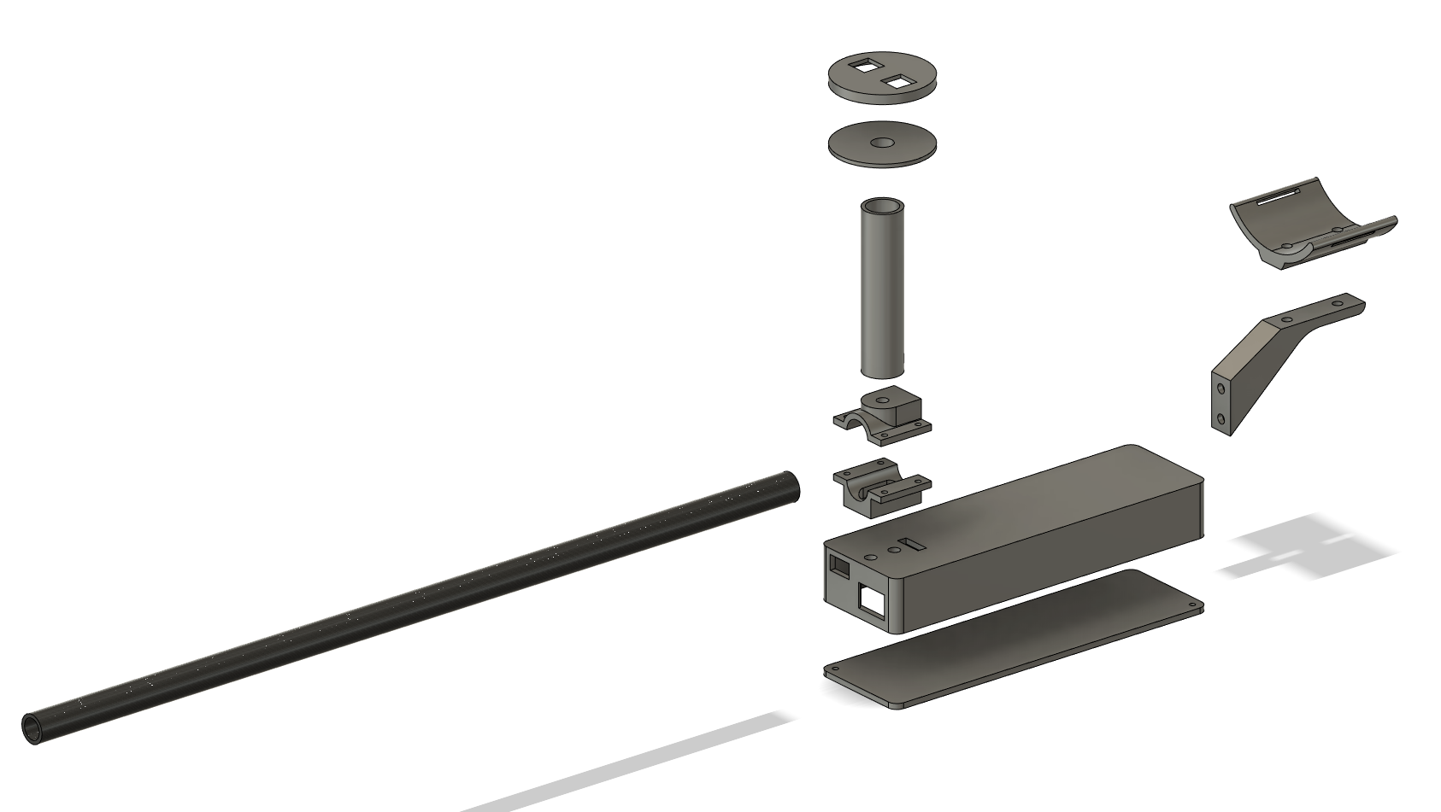
Figure 16: Exploded View of Prototype System Minus Claw
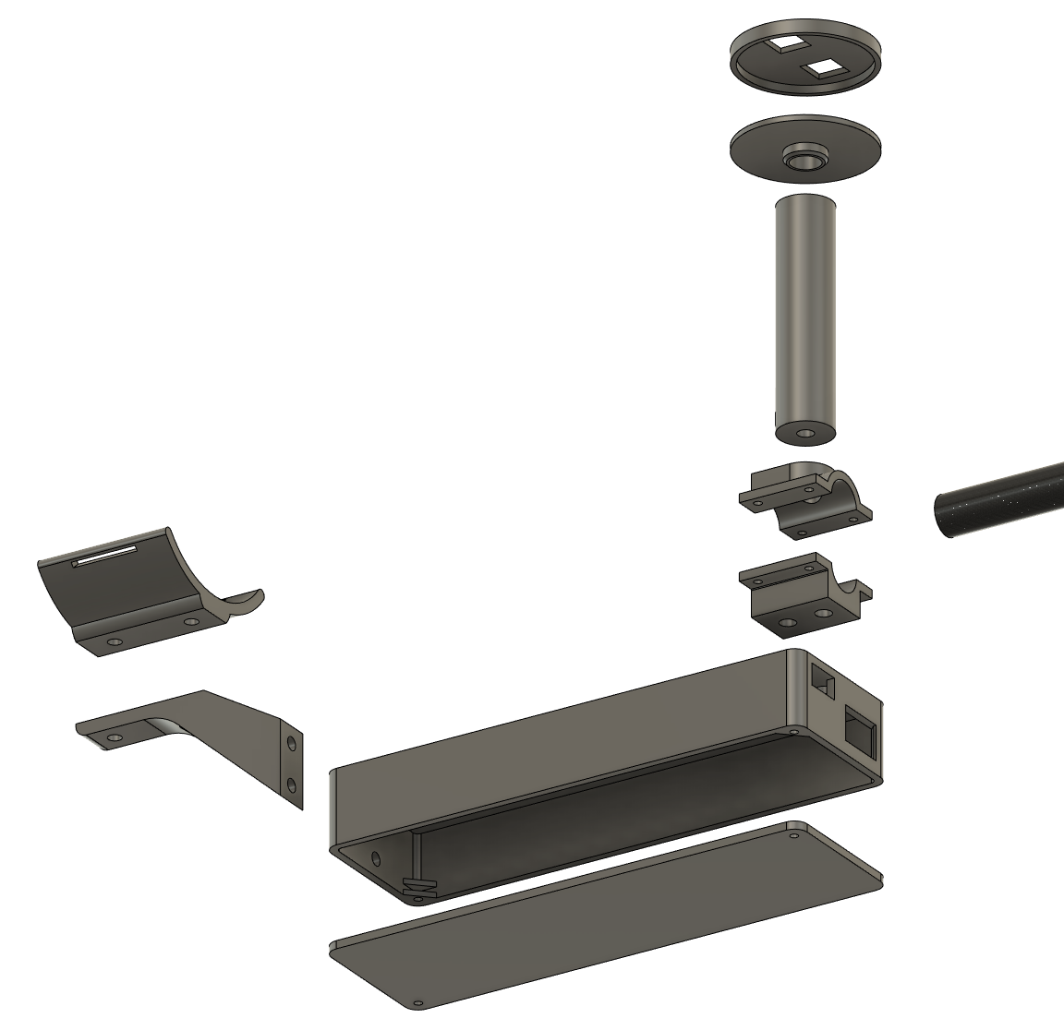
Figure 17: Exploded View of Handle, Electronics Box, and Arm Support

The purpose of this latest prototype was Integration and Learning. This was our first prototype including all physical components of the power grabber. This was also the prototype we used to prove/disprove our previous critical assumption regarding the weight of the system. Whether the power grabber was light enough that Maeve could use it with ease. The prototype is physical and comprehensive. The only difference in the functional decomposition of the prototype final product is that the activation mechanism is a potentiometer.

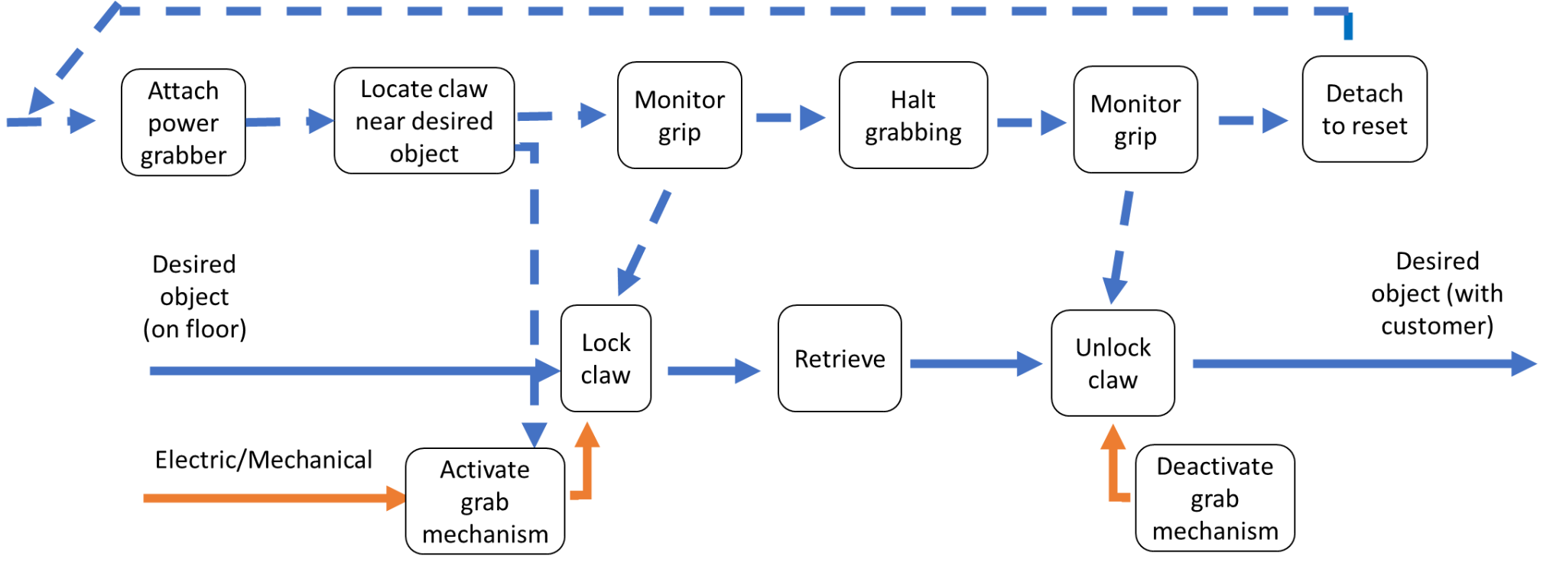
Figure 18: Detailed Functional Decomposition of Power Grabber Final Product

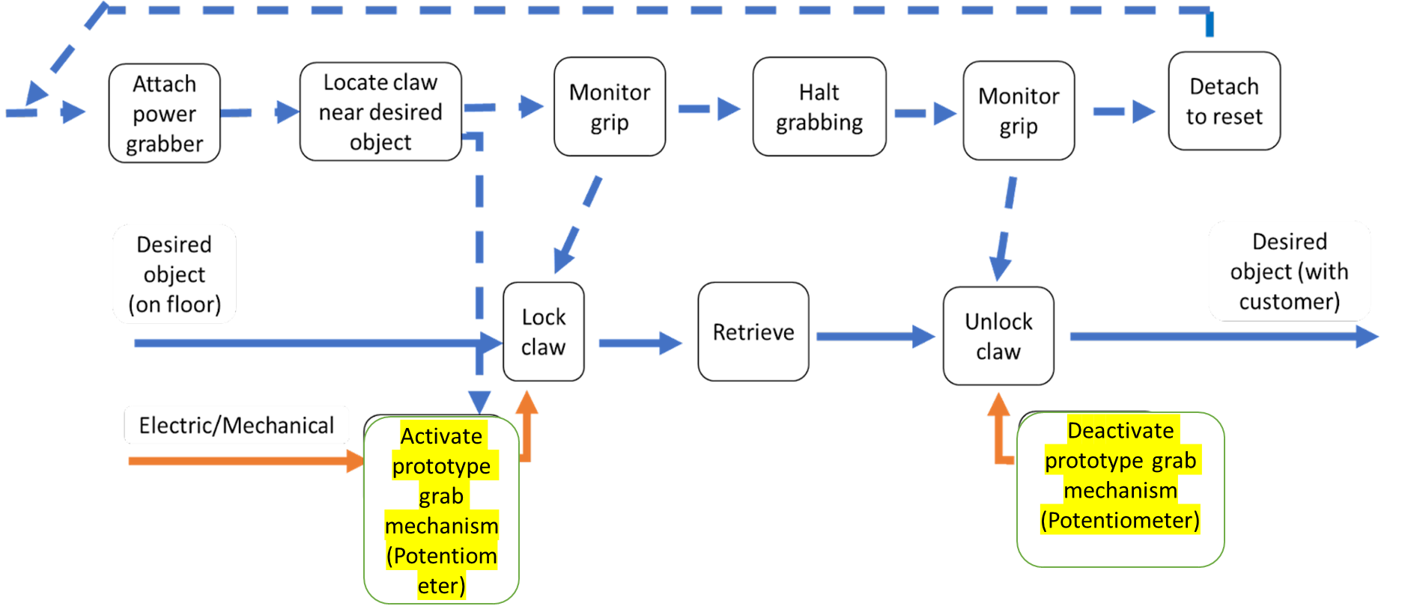
Figure 19: Detailed Functional Decomposition of Power Grabber Latest Prototype

Testing

From our current prototype we updated our design specifications accordingly. From the chart below and taking into account the client feedback, in the Client Feedback Section, we estimate that we can further improve these metrics for the final product: reduce weight, increase item capacity, and increase durability.

Metrics | Target Value | Actual value for prototype 2
Device weight | < 500g | 440g
Item capacity | ~1000g | >500g
User gripping force | <4 N | N/A
Activation control | Button/remote | N/A
Adaptability to hold different items | Max. Force ∽ 20 N  Min. Force ∽ 0 | Exceeding desired range
Ergonomics | Easy to hold and maneuver | Good
Battery life | 1 working day | Testing required
Reactivity | 10ms | N/A
Cost | <100$ | $90.17
Durability | >1 year | Several month
Reach | 45-60cm (1.5-2 feet) | ∽1.8 feet

We were not anticipating that the power grabber would be touching the ground when Maeve equips the power grabber. The client themselves asked for the reach to be 1.5-2 feet so we made it 1.8 feet but even that appears to be too long. If we take this into consideration we can cut off about 0.3 feet which will make the arm lighter and reduce the amount of PLA we need to print, it will only amount to maybe 15g at most but that will still make it lighter. Right now the prototype looks shaky/uncertain past the 500g mark but if we reduce the arm length that will reduce the strain on the part holding the arm, the clamp above the charging port in Figure11, which means we can support more load at the claw. This strain is also the reason the durability is below target but as mentioned above if we shrink the arm length then durability will also increase. We know the power capacity of our batteries but we’d like to run a practical test before giving any decisive numbers.

Conclusion

In conclusion, our current prototype demonstrates values relatively close to our target specifications and the client meeting helped solve our previous critical assumptions. Based on our client feedback our prototype fulfills all their needs, the only issue is the sizing of the components, some need to be smaller and others need to be larger. No new functionality was offered by the clients so we will proceed according to the design written in Deliverable D and according to our Project Plan.

