Deliverable C: Conceptual Design

GNG 2101 - Intro to Product Dev. and Mgmt. for Engineers

Group C3.2 - Power Grabber
Tony Kim - #300087407
Zitai Peng - #300148371
Alan Tan - #300021231
Jingyi Jiang - #300121959
Marie Daoust - #300052381

January 31, 2022

Table of Contents

Table of Contents 2
Functional decomposition 3
Concepts 4
Concept analysis 4
Solution 5
Group design concept 6
Visual representation 7
Relationship to target specifications 14

Functional decomposition
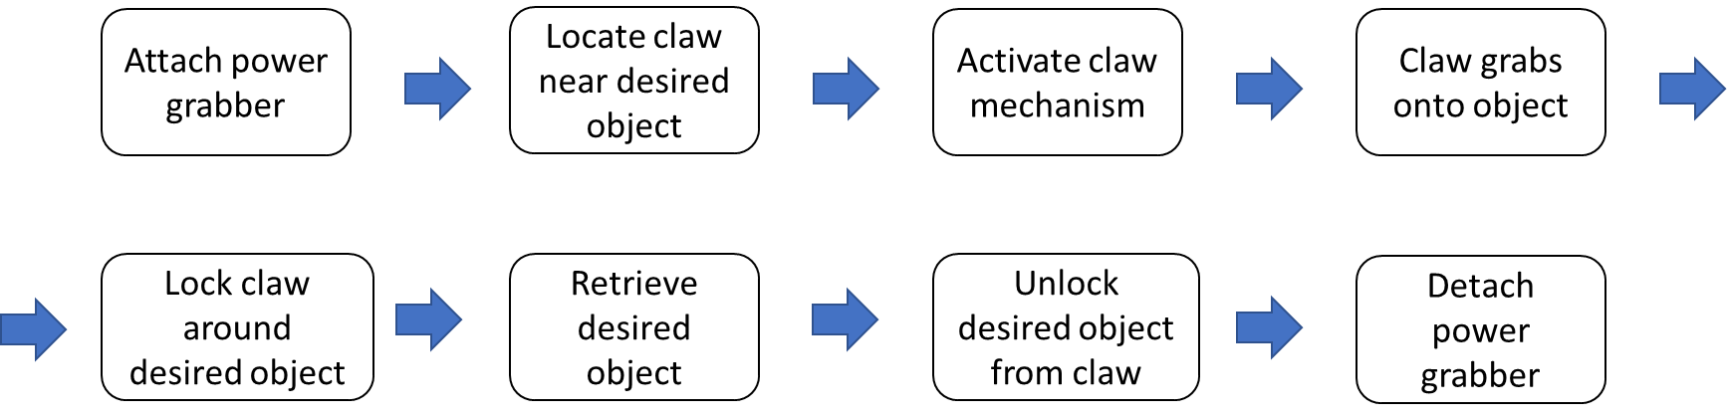
High-level decomposition of power grabber

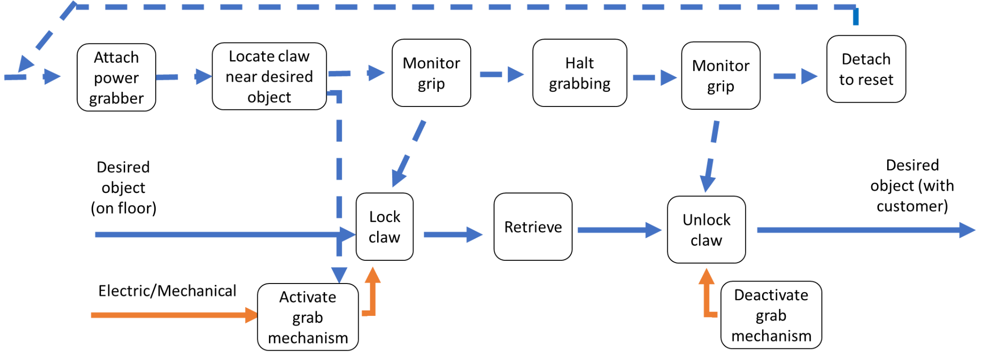
Detailed functional decomposition of power grabber

Function | Sub-Function | Associated need(s)
Control | Buttons
 | Electronics
Arm fixation | Ergonomic handle
 | Anti-slip geometry
 | Supporting cuff
Body | Tube
 | Fixation onto tube
Object holding | Clamps
 | Clamping mechanism

Concepts
Based on the functional decomposition there are 3 main categories, global concepts that we will be basing our concept designs off, grabbing mechanism, retrieving and locking of the claw. The only retrieving focus concepts are located at the end of visual representation, part 6. They include wire, shifting, and incremental retraction. The rest focus on grabbing mechanism, in other words, motorizing the claw. Every concept includes a locking mechanism somewhere.

Subsystem concepts
- Ease of use concepts
  - Magnet at end of claw (Alan)
  - Hook at end of claw (Marie)
  - Forearm support (Tony)
  - Large activation modules (Tony)
  - Handle bumper to assist in retrieving object (Marie)
  - Finger holes (Alan)
  - Angled handle (Marie)
  - Fold up claw (Jingyi)
  - LED light at the end of claw (Alan)
- Electronic concepts
  - Batteries in parallel (Zitai)
  - Chargeable (Zitai)
  - Wireless (Jingyi)
  - Force sensor (Zitai)
- Miscellaneous
  - Soft liner (Jingyi)
- Durability
  - Carbon fiber material (Tony)

Concept analysis
Target values | Ref Prod 2 from BM | Shifting retriever | Retractable retriever | Wire retriever | Carbon fiber | Jingyi | Marie
weight | 0 | 0 | 0 | + | + | 0 | 0
Lift capacity* | 0 | - | - | - | - | - | -
Gripping force | 0 | 0 | 0 | - | + | 0 | 0
Activation control | 0 | 0 | 0 | 0 | 0 | 0 | 0
adaptability | 0 | + | 0 | 0 | - | + | +
ergonomics** | 0 | + | + | + | + | + | +
Battery life** | 0 | + | + | + | + | + | +
reactivity | 0 | 0 | 0 | - | 0 | 0 | 0
cost* | 0 | - | - | - | - | - | -
durability | 0 | 0 | - | - | + | 0 | 0
Reach* | 0 | - | - | - | - | - | -
Number of + | 0 | 3 | 2 | 3 | 5 | 3 | 3
Number of - | 11 | 3 | 4 | 6 | 4 | 3 | 3
Number of 0 | 0 | 5 | 5 | 2 | 2 | 5 | 5
Total score | 0 | 0 | -2 | -3 | 1 | 0 | 0

* The starred specifications will always be minus in this situation, since the reach and lift capacity have been adjusted to meet the client's needs, they will always be worse than the ref. Since we are integrating electronics into the power grabber the cost will always be more than the ref.
** This will always be positive in this situation, since we are including battery and forearm support, these metrics will always be better than the ref.

Solution
Based on the evaluation above the shifting power grabber or the mechanical powered claw are the best design choice, they have the same score for all metrics but function very differently. The metrics will need to be adjusted or added upon in order to further differentiate between the designs. The carbon fiber version has the most positives but the extra weight is undesirable. The crane concept design is the lightest by comparison but probably has the lowest grip strength.

  - Solution 1
    - Handle
- Vertically extending from the device
- Buttons for activation
  - One to tighten clamps and one to release
    - Arm rest
- Presses against bottom of arm to counteract moment force
- Velcro strap to hold device in place
    - Clamps
- 2 symetrical clamps, able to rotate about a fixed point
- 1 clamp turns with the rotation of a motor
- The other turns in the opposite direction of the first du to a pair of gears
- A magnet on one of the hooks to pick up any magnetic items
- A hook on one of the clamps to pick up items with straps or string shaped items
    - Electronics
  - Solution 2
Shifting power grabber.
Issues that remain
How to have adjustable grip strength (user) translate into the claw grip force
Perhaps mechanical wire or electronic transmission
How to retract with a the grip locked
Perhaps have mechanical wire retract with the arm
How to lock the grip
Perhaps have a switch that holds the string, and current tension, in position or electronic lock

Group design concept
The final group design is heavily under debate. It might incorporate a combination of both solutions above, or it might be an improved version of either design concept. The issue with the shifting power grabber above can all be solved with wireless electrical components, however that would require two more Arduino Nanos, which would increase cost and complexity. We are leaving the final concept design decision to the client and will develop from there. There’s also the possibility that we will design a brand new concept after demonstrating these concepts and interviewing the client. But this new concept will most likely include one or more of the three categories we described in part 2. A lot of the concepts we described in this report are subsystem designs so we are able to flexibly adjust to a new concept design.

Visual representation
Tony K.’s design concept:

This is only a concept but is to scale. The idea is to see if the client likes the size and grip mechanism of the design. There is an AR file I have generated for this 3D model so all Apple AR users are able to see a to-scale version of the design. This utilizes an 18-inch long, 15mm-outer-diameter, SmallRig-manufactured Carbon Fiber hollow tube as the rod. It is light and strong and costs under $20 USD per carbon fiber rod unit. The wiring and battery is self-contained within the rod, and the end handle piece is a carriage assembly that twists off to reveal all the circuitry and batteries housed within the rod itself. Total weight would be under 400g. Total price under $100 using 3d printed parts.

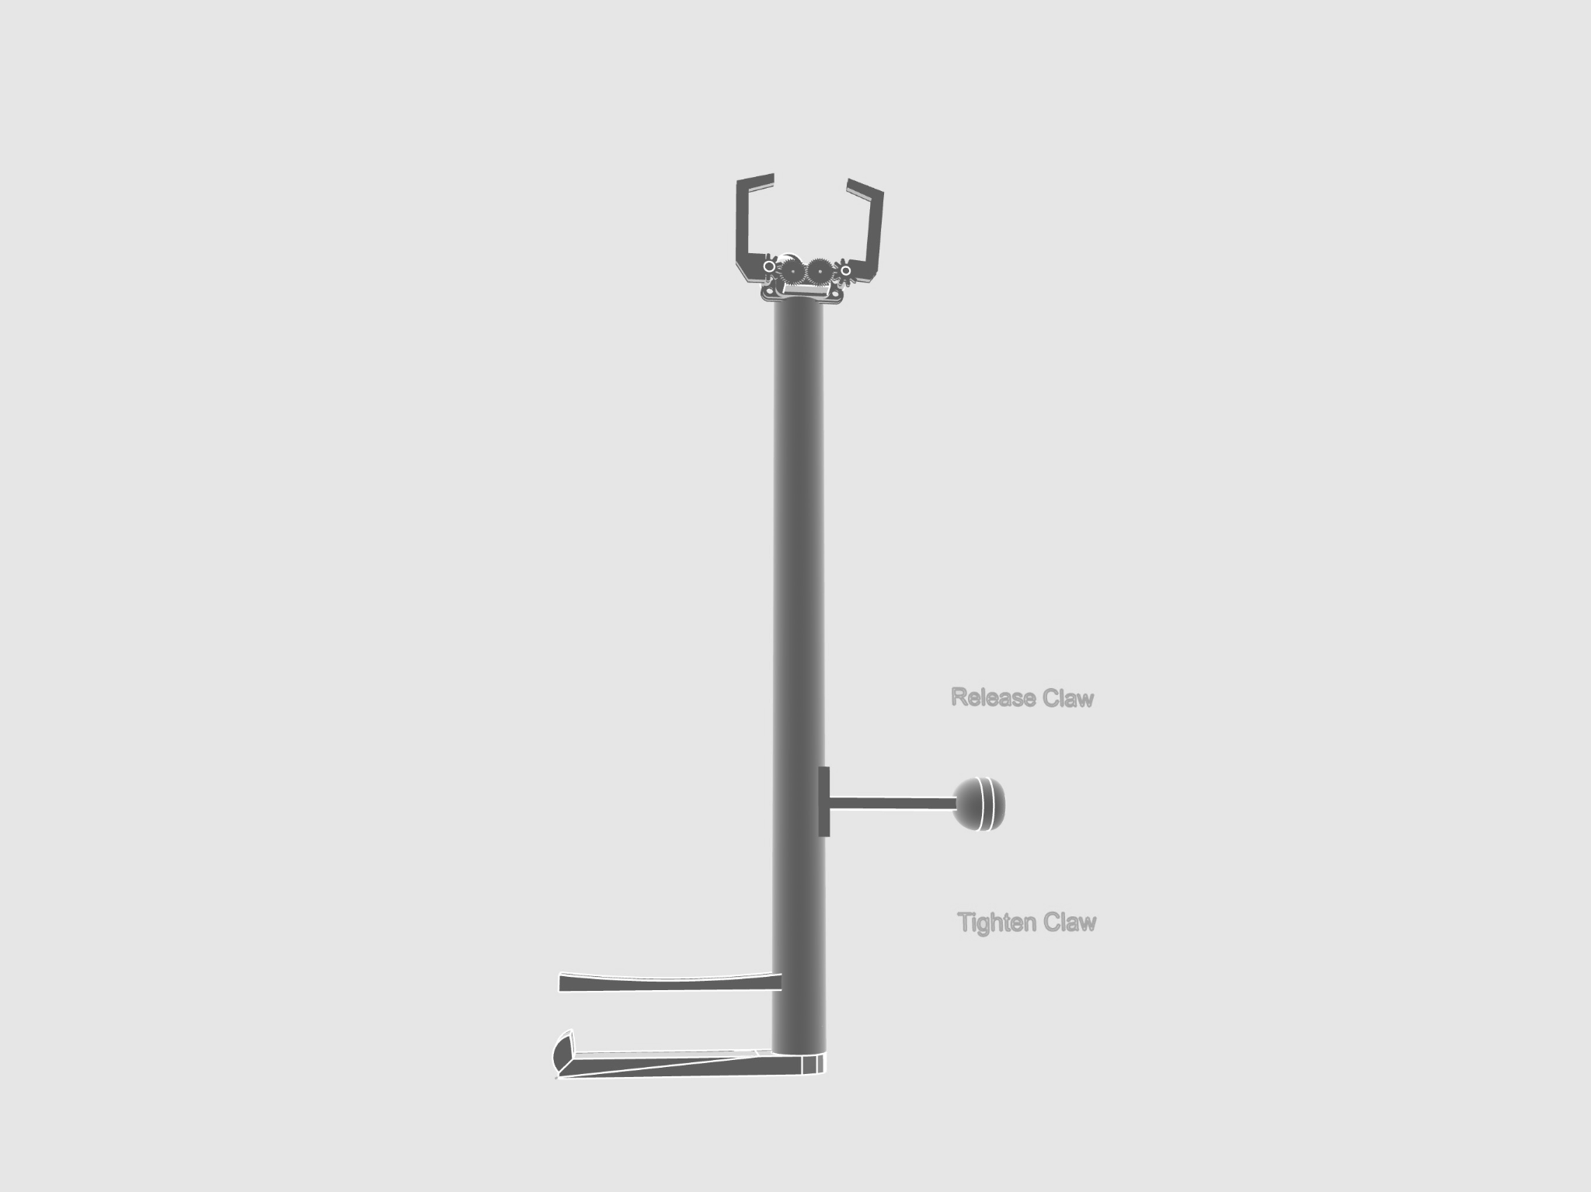

AR model for client sizing trial purposes:
https://drive.google.com/file/d/1NhupMMrbdH9fF02_9a2pM9w6STqSQj5c/view?usp=sharing

Marie D.’s design concept:
Arm rest
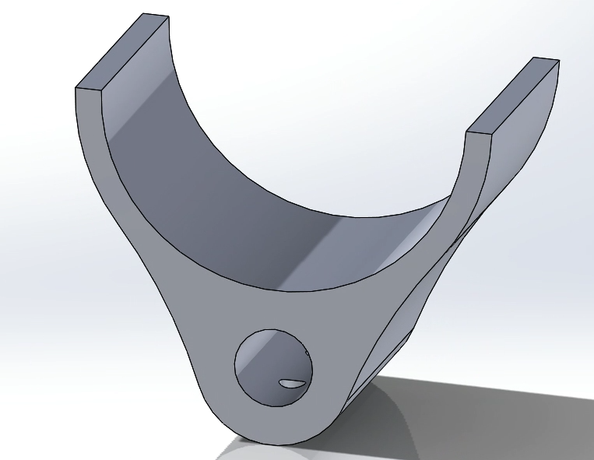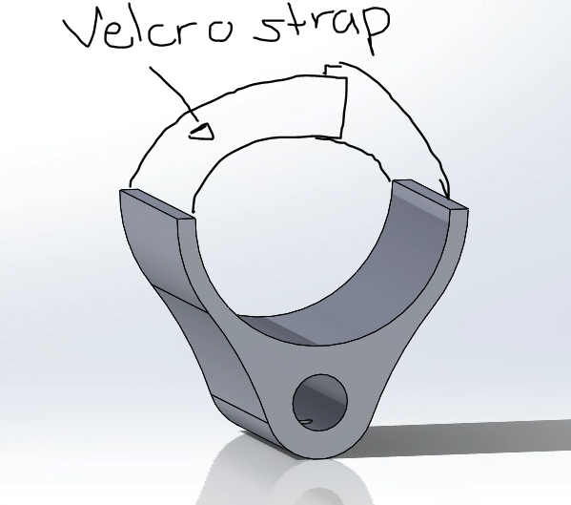(Marie)

Handle
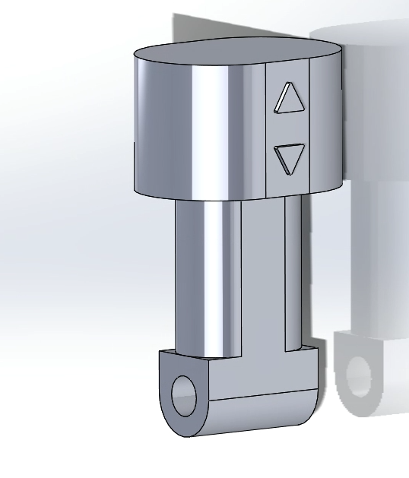(Marie)
Gripper:
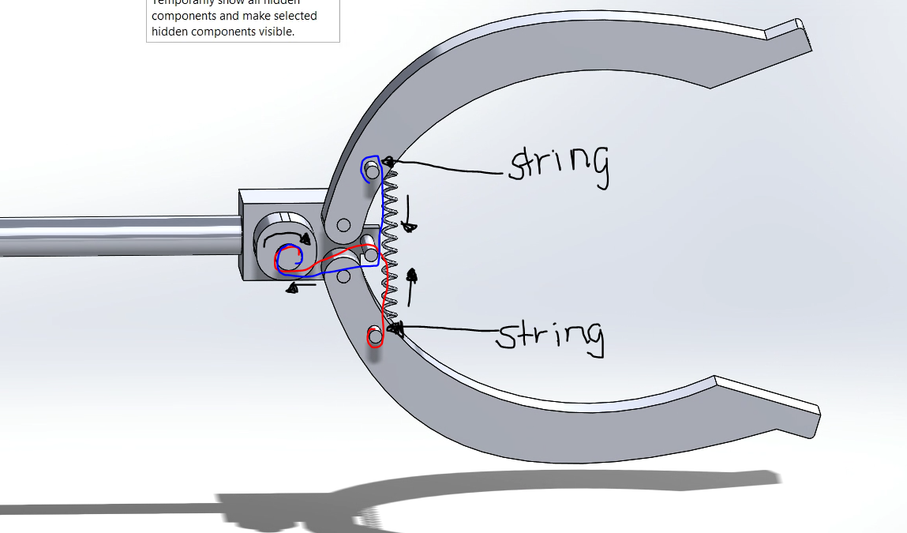(Marie)

Zitai P.’s design concept:
The electrical system of the grabber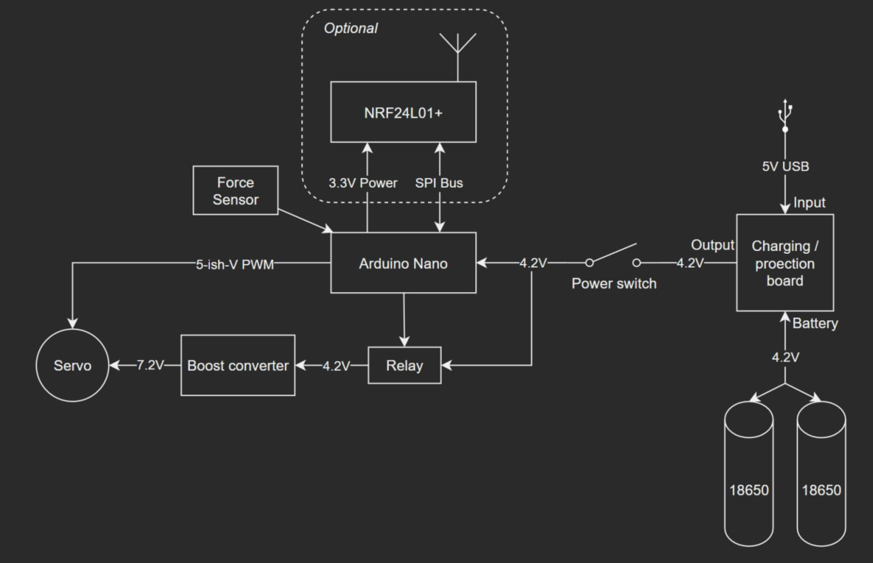

Jingyi Jiang’s design concept:
Top view of the grabber hand: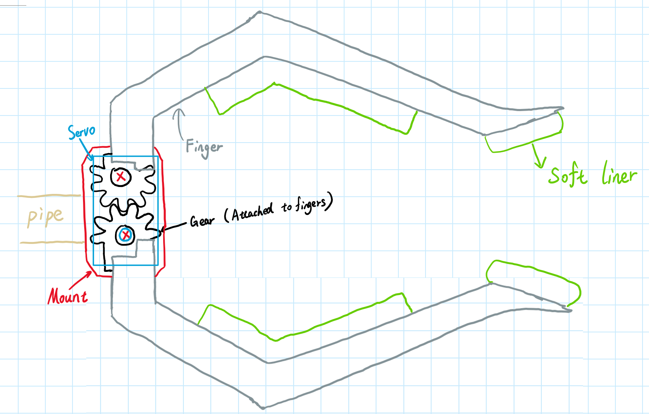
Side view of the grabber hand:
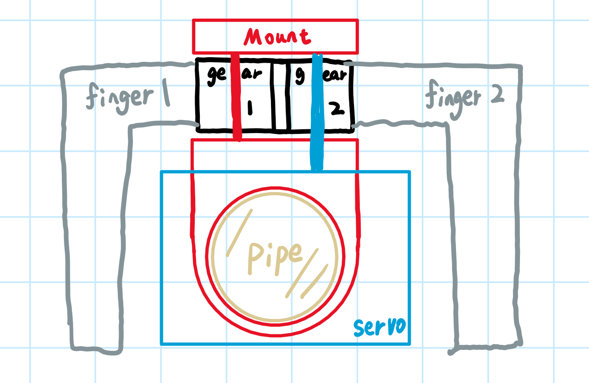

Alan’s design concepts
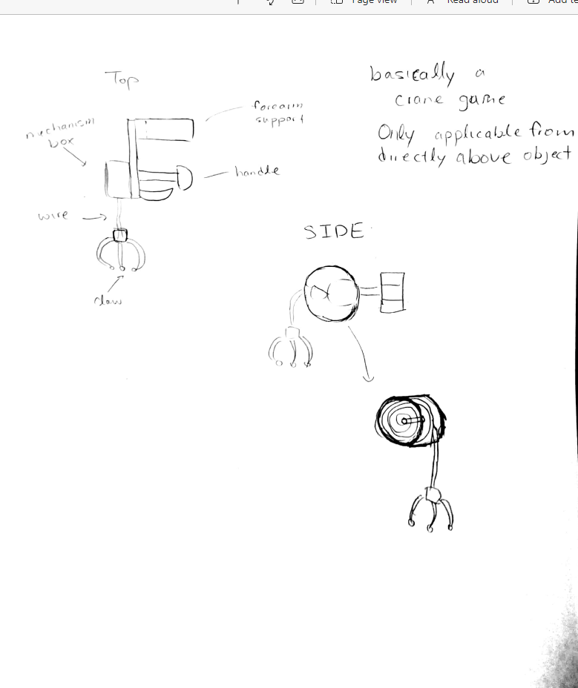
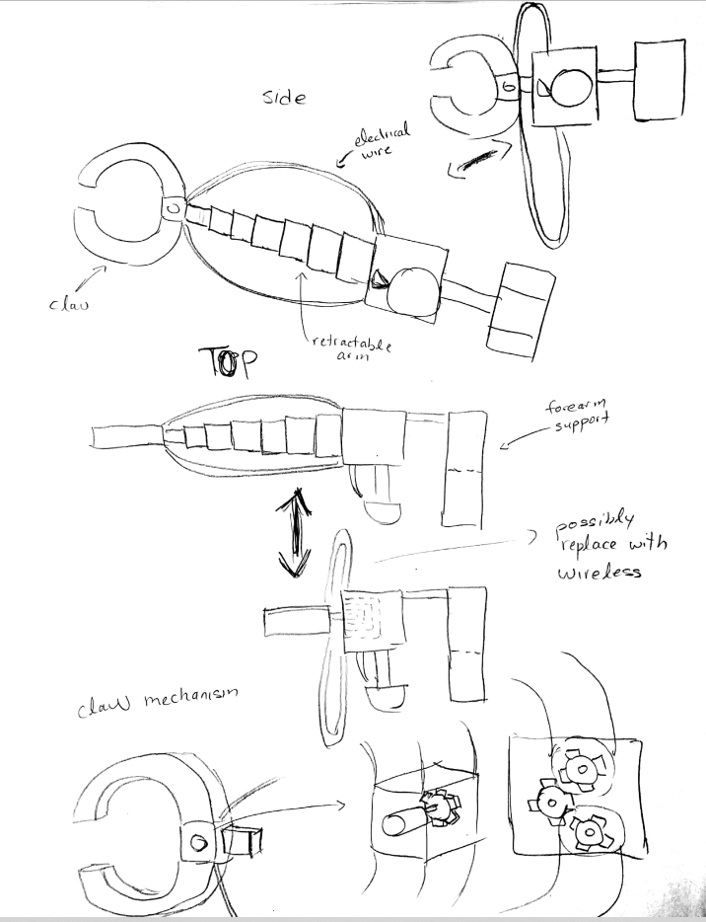

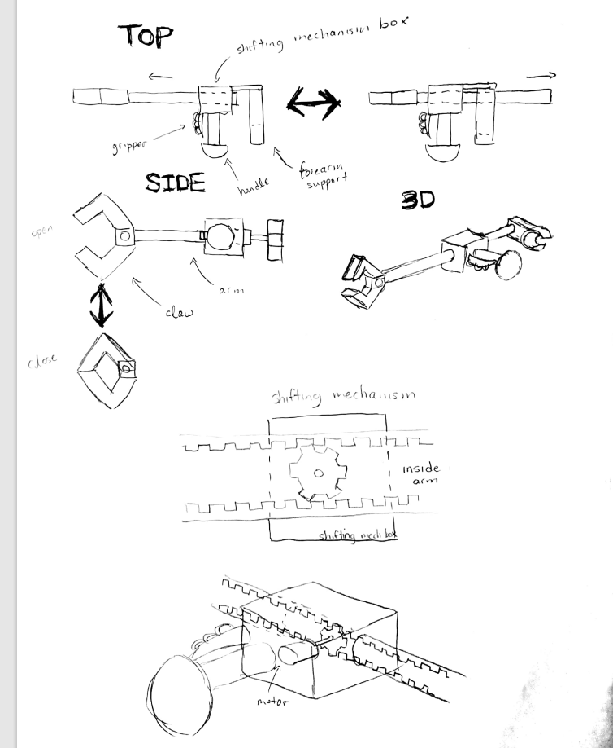
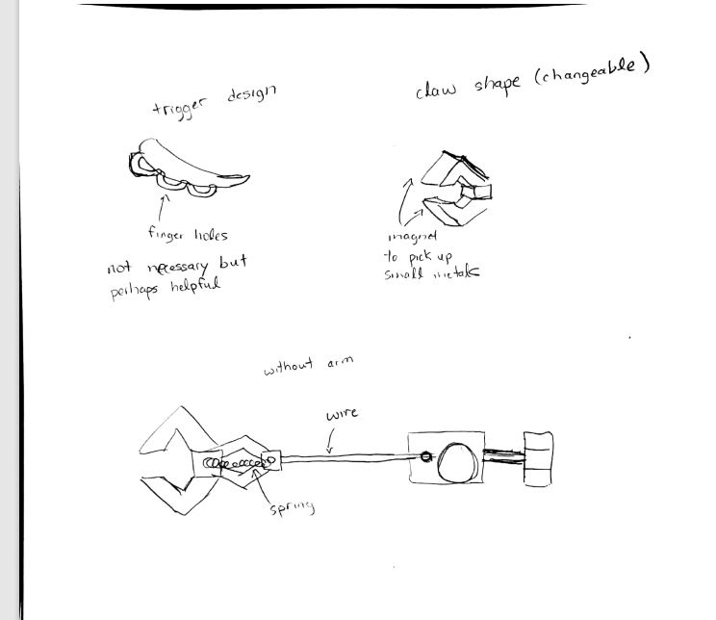

Relationship to target specifications

All of our concepts use an arm length that matches the reach target specification. Our concepts use lightweight material to stay under the target specification. Our designs all have ergonomics in mind, the forearm support, the small accessories on the claw handle, and trigger.

