Deliverable D: Detailed Design

GNG 2101 - Intro to Product Dev. and Mgmt. for Engineers

Group C3.2 - Power Grabber
Tony Kim - #300087407
Zitai Peng - #300148371
Alan Tan - #300021231
Jingyi Jiang - #300121959
Marie Daoust - #300052381

February 4th, 2022

Table of Contents

Table of Contents 2
Client feedback: 3
Detailed design: 3
Physical prototypes: 3
Software prototypes: 4
Bill of Materials: 5
Product assumptions: 5
First Prototype (Sketches/diagrams/pictures): 5
Prototype testing: 5
Preparation for client meeting: 6

Client feedback:
- The client liked the idea of this grabber being operated by a remote control.
- A handle design with wrist support such as the following example work work well:
  - 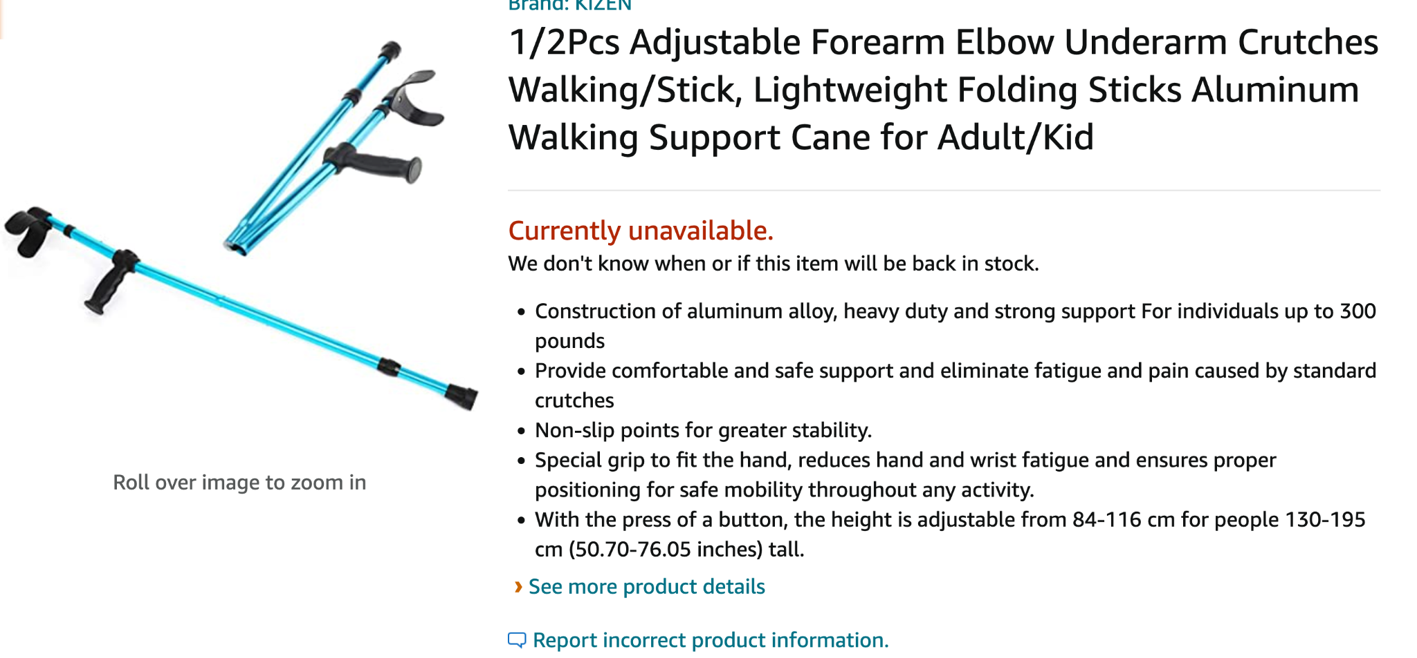
- The handle should have the mushrooms cap at the end so it doesn’t slip out
- Clinton does not want the power grabber to be retractable
- The claw does not need to rotate
- Paul recommended linear actuators and mechanical mechanisms
- Paul also brought up the idea of replaceable parts
- The overall size of the power grabber is low priority
- The control for the claw actuation should be buttons not a joystick

Detailed design:

Physical prototypes:
Our power grabber will consist of 6 subsystems. The first subsystem will be the claw which will consist of a servo motor wrapped in a custom 3d printed mold. The servo motor will have another rotating axial on the opposite side of the rotating bit. The mold will connect to the servo motor using these two points of contact, one on the left and one on the right. The mold will have another connecting point below for the 2nd subsystem, the arm. Finally the mold will have a fixed claw arm attached to it above. This is one change we have made on our power grabber compared to the version in the previous deliverables. Our initial idea was to have one motor rotate 2 gears, one for each claw arm, but now we will have one arm of the claw fixed and the other will rotate with the servo motor. There will be pressure sensors attached to the entire outline of the claw and the wires will run parallel with the servo motor wires. The wires located at the claw will run through the arm, the 2nd subsystem, to the electronics box located near the handle, the 5th subsystem.
The 2nd subsystem, the arm which is pretty much unchanged from the previous deliverables, 1.5-2 feet long.
The 3rd subsystem, the handle, has been modified to allow for the placement of the batteries.
The 4th subsystem, the remote may be attachable to the handle as the overhang of the handle (mushroom), or we will make the remote attachable to some other part of the power grabber. The remote is unchanged as well, it will consist of 2-3 buttons to control the claw actuation, powered by batteries.
The 5th subsystem, the electronics box, will hold the Arduino Nano, breadboard and the antenna.
The 6th subsystem, the arm support is unchanged from the previous deliverables, it will be located furthest from the claw and have a velcro strap to attach to the users arm.

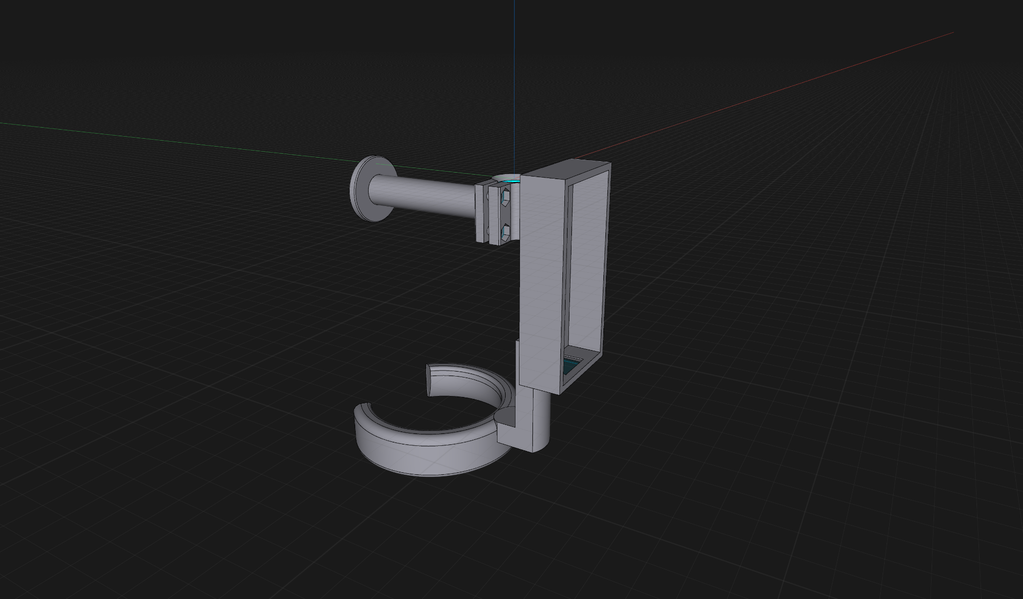

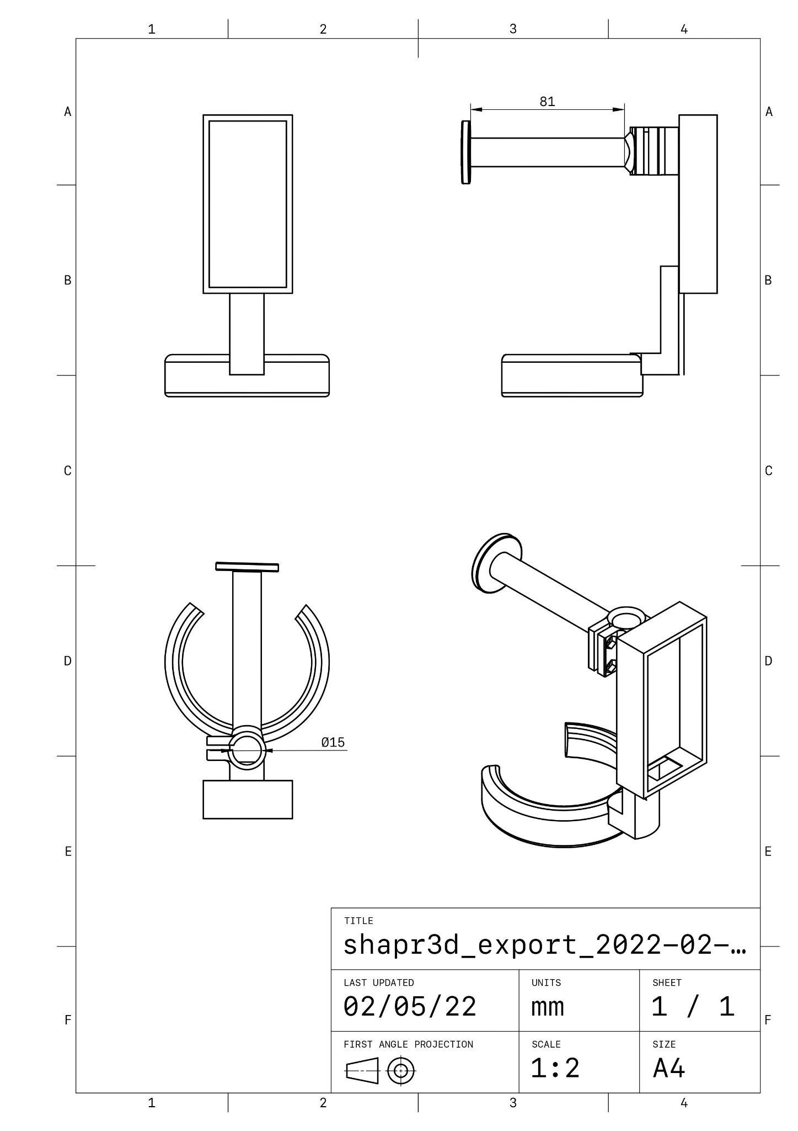

Software prototypes:
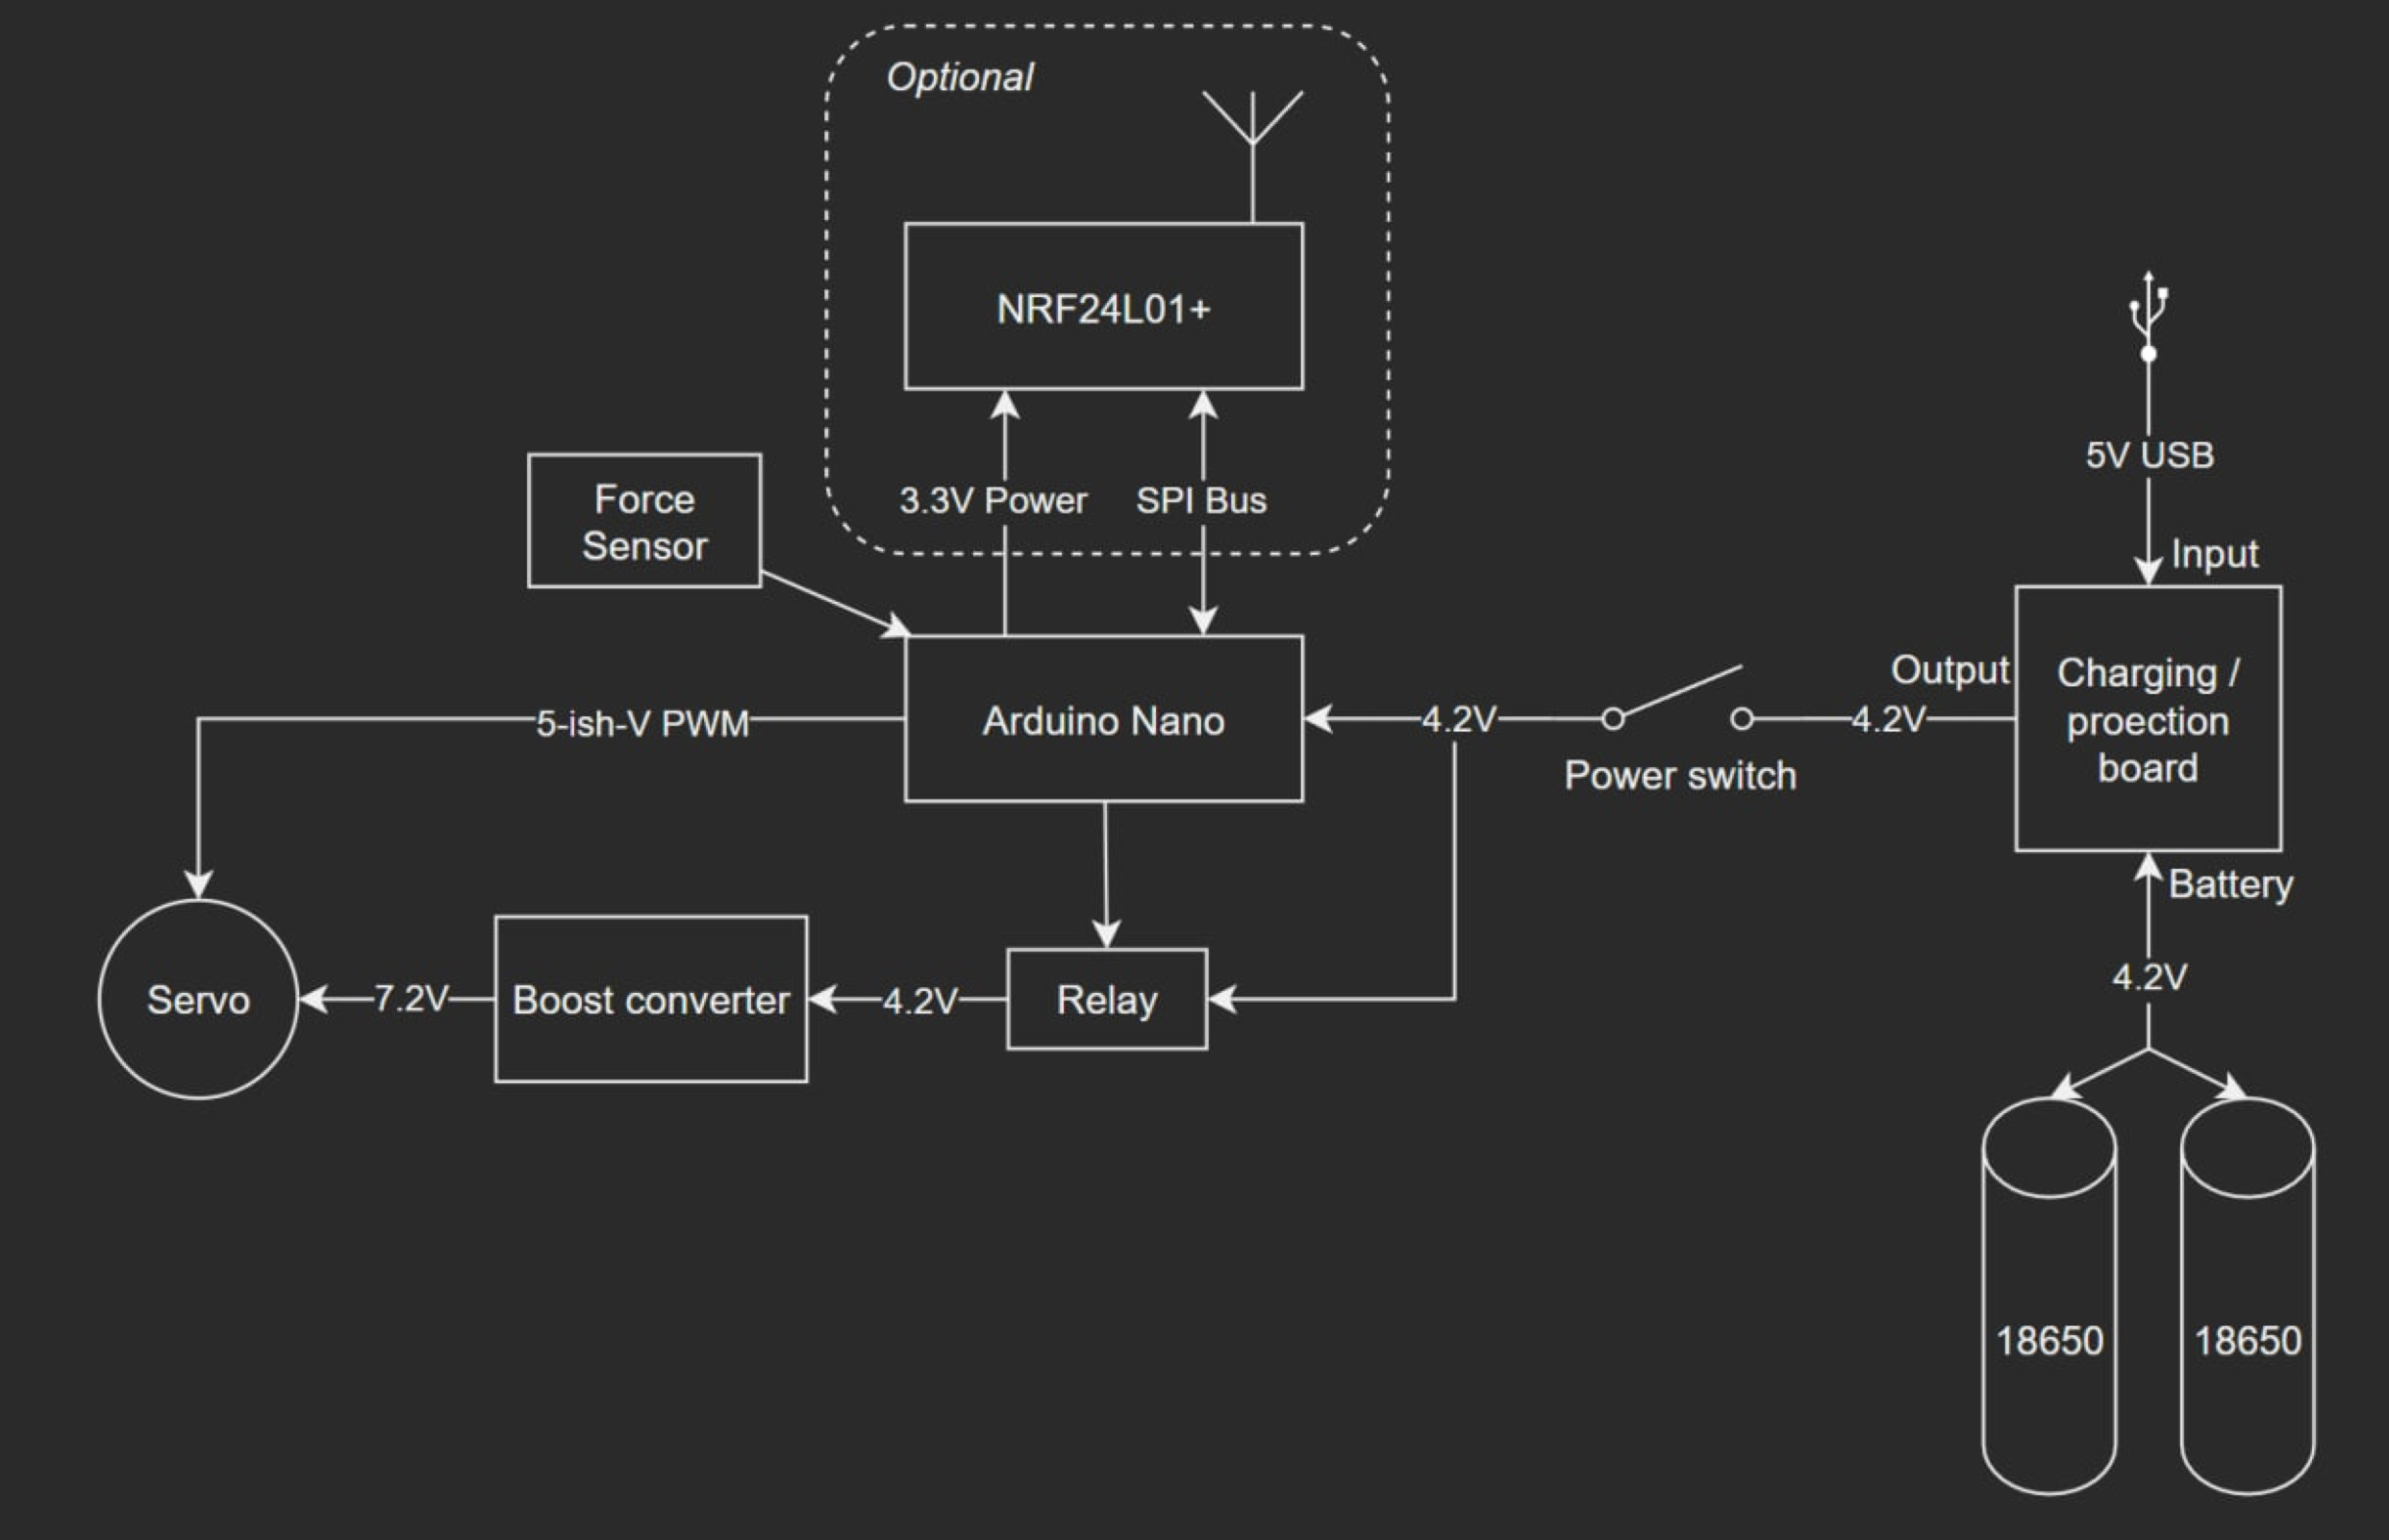

Bill of Materials:

Item # | Name | Description | Qty | Cost | Total cost | Source
1 | Clamps | Plastic 3D modeled clamps | 2 | negligible | negligible | 3D print
2 | Carbon Fiber Tubing | 18” , 15mm carbon fiber tubes x2 | 1 | $49/2 USD | $31.51 CAD | SmallRig
3 | Servo motor | Actuator of the claw | 4 (only using 1) | $36+tax | $10.17 | Amazon
4 | Handle | Plastic 3D modeled | 1 | negligible | negligible | 3D print
5 | 4x 18650 Li-ion batteries | Lithium batteries | 4 (only using 2) | $30+tax | $16.95 | Amazon
6 | AA batteries | Remote batteries | 20 (only using 2) | $20+tax | $2.26 | Amazon
7 | Lithium battery charging board | USB-C charging board for 18650 batteries | 10 (only using 1) | $16.95 +tax | $1.92 | Amazon
8 | DC-DC Boost Converter | Boards to boost voltage | 5 (only using 1) | $12.99 +tax | $2.94 | Amazon
9 | 2.4GHz Antenna Wireless Transceiver | Used for wireless interaction between remote and power grabber | 12 (only using 1) | $13.81+tax | $1.30 | Amazon
10 | Arduino Nano | Control system | 3 (only using 2) | $30+tax | $22.60 | Amazon
Total project cost: |  |  |  |  | $90.17

Product assumptions:
The most critical product assumption we are making is that the claw will have enough force to firmly grip onto the desired object. The claw must be able to exert enough force (20N) to firmly hold at most a 1.5kg item and lift it off the ground. Another product assumption we are making is the budget, there’s a lot more technology then we realized. We’re assuming the product weight distribution will be acceptable or to Maeve’s liking.

First Prototype (Sketches/diagrams/pictures):
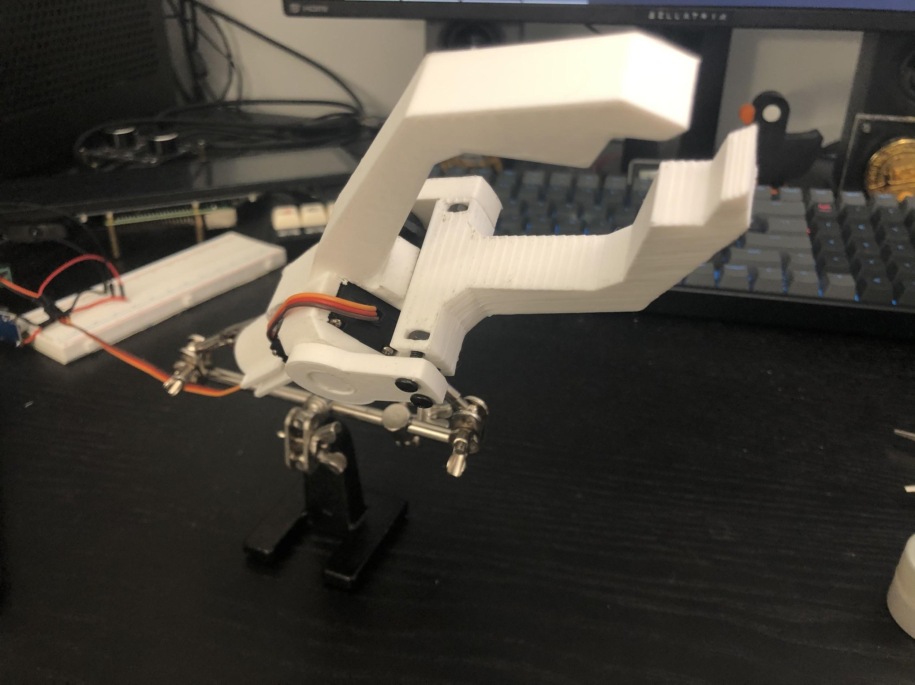
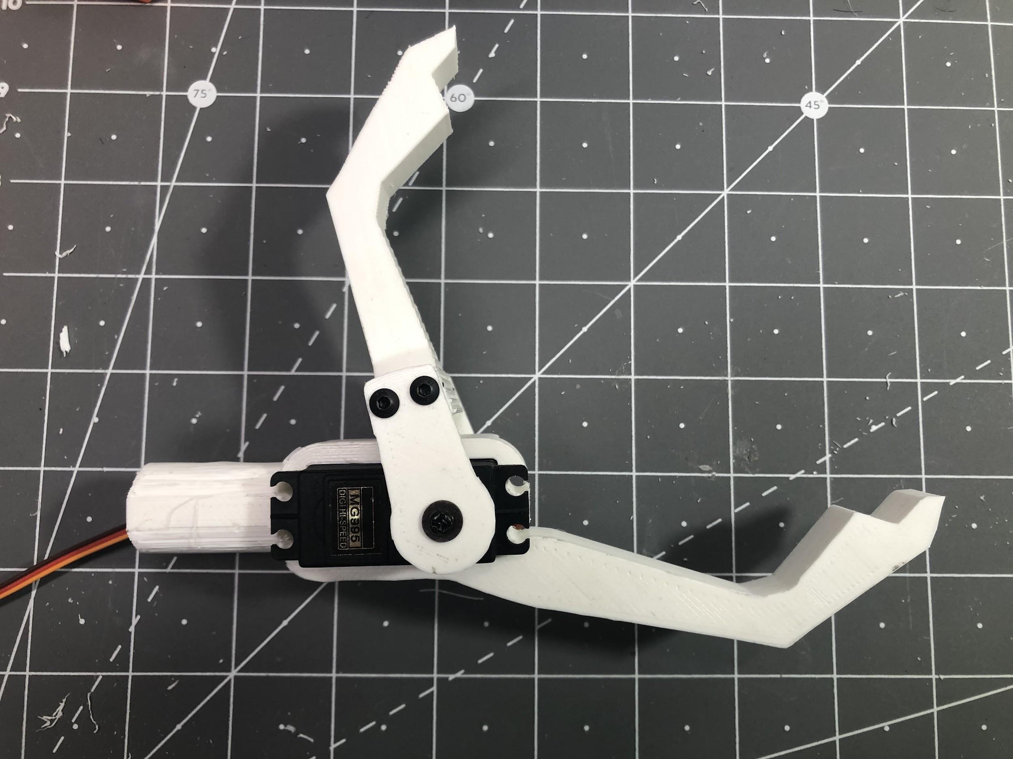
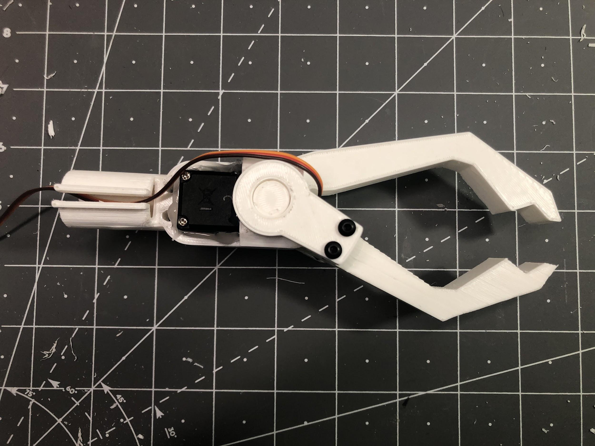
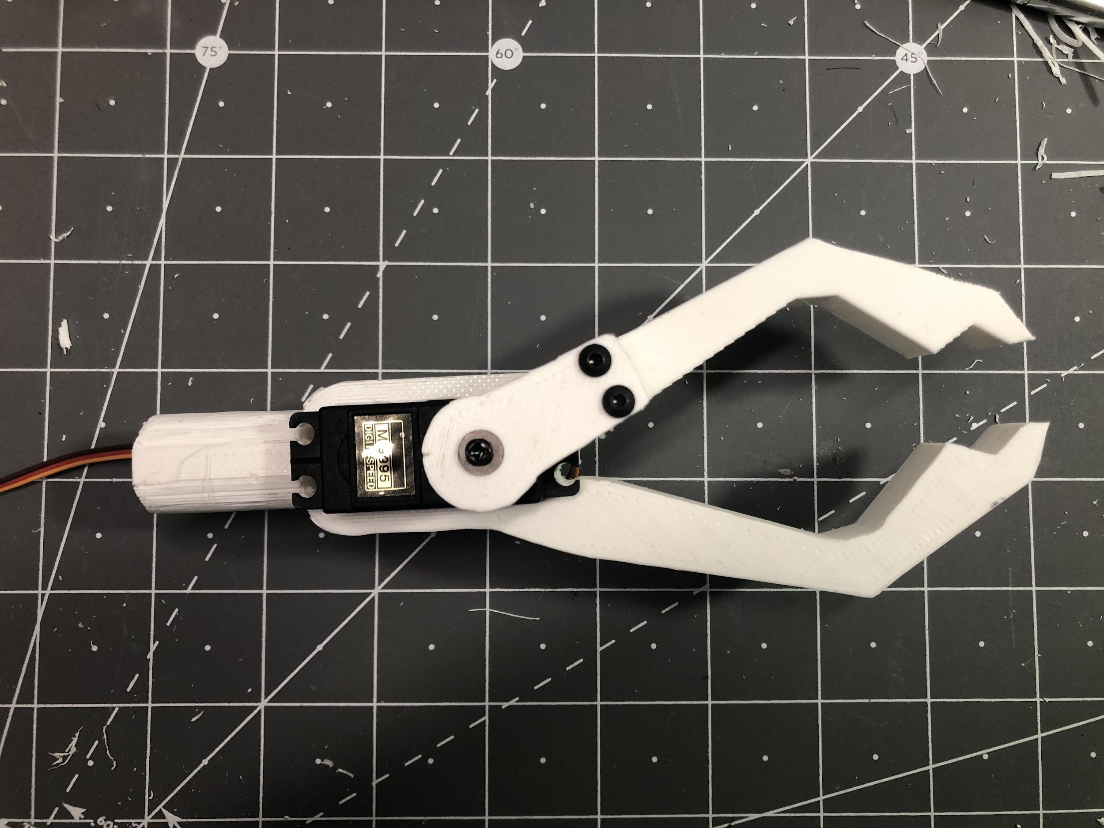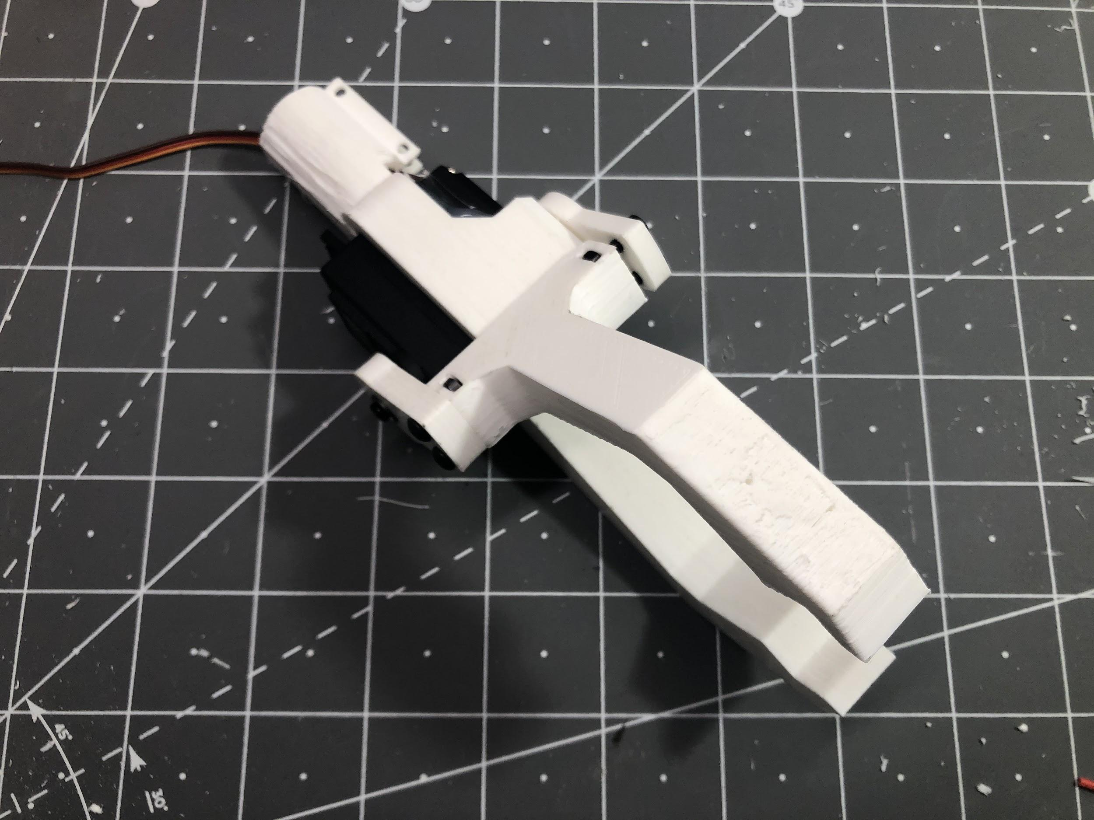
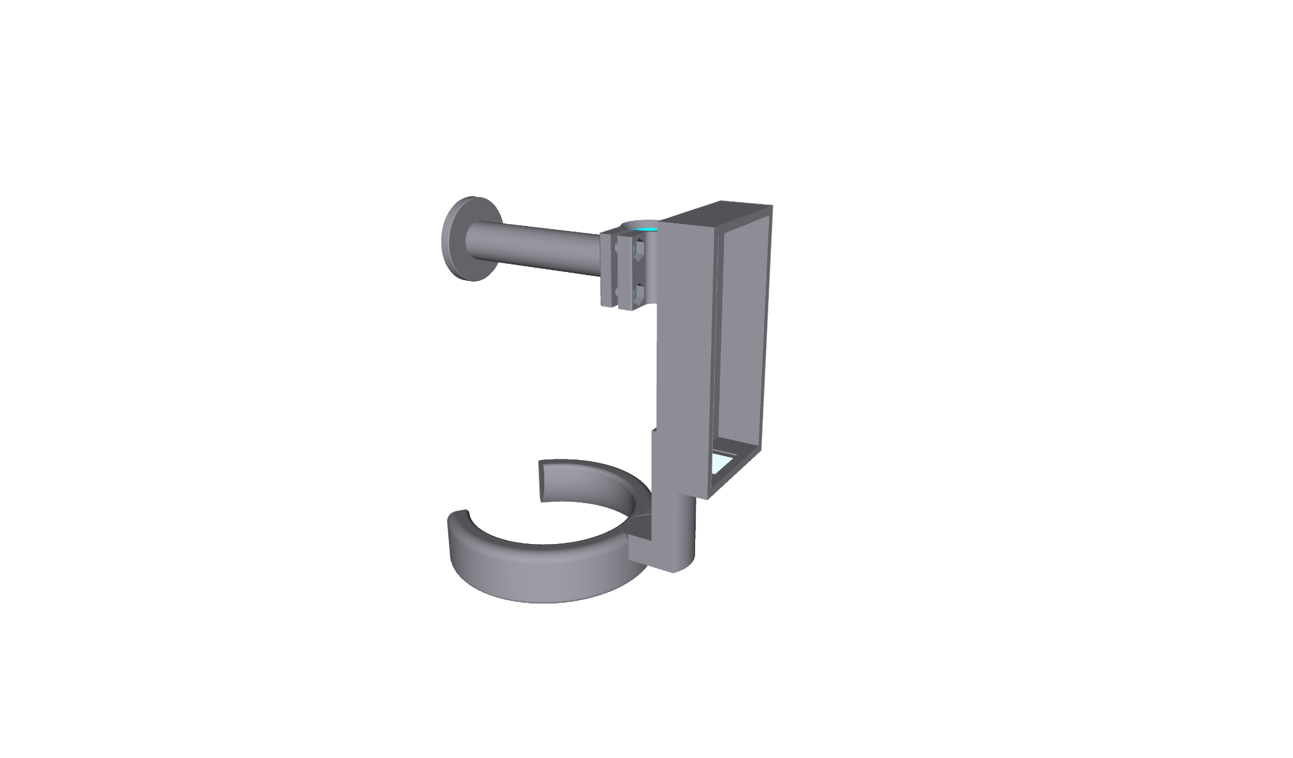

Prototype testing:

Use | Communication: This prototype will be used to show the client what the device will look like and how it will function.  Learning: The prototype will also be able to show us if our choice in mechanism works.  Milestone: The creation of this prototype is also a step we must complete in our project to meet this particular deadline.
Type | Physical and focused
Fidelity | Functional: medium  Visual: low  Content:medium  Depth: low

Metrics | Target Value | Actual value for prototype
Device weight | < 500g | ~500
Item capacity | ~1000g | >1000g
User gripping force | <4 N | 0
Activation control | Button/remote | N/A
Adaptability to hold different items | Max. Force ∽ 20 N  Min. Force ∽ 0 | Exceeding desired range
Ergonomics | Easy to hold and maneuver | Comfortable handle and weight distribution through arm rest
Battery life | 1 working day | N/A
Reactivity | 10ms | N/A
Scalability | <5000cm^3 | N/A
Cost | <100$ | $121.17
Durability | >1 year | N/A
Reach | 45-60cm (1.5-2 feet) | ∽1.8 feet

N/A: Specs have not been addressed in this prototype

To test this prototype, we have assembled the different parts of the grabber en of the device. We then introduced a rotation that can serve as a replacement to the arduino controlled rotation that will be causing the gripper to close. We were able to observe that the movable gripper claw was able to rotate about its pivot point. We could then bring the claws together to close around an object we want to lift. This demonstrates that the mechanism we have chosen for the mechanical part of the grabber end is functional.

Preparation for client meeting:

Due to the fact that client meetings are held online, we will only be able to show the client our prototype via zoom and will not be able to present it to them in person. However we can still have the client observe the functionality of the gripper as we maneuver it for them and the shape of the gripper arm that can be seen in our 3D model. From there, we will be able to get visual feedback on the ergonomics and the functionality. In this meeting, we would also like to gather more information about Mave’s grip, more specifically the size of handle show is able to hold comfortably.

